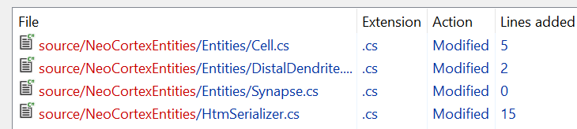

HtmSerializer:

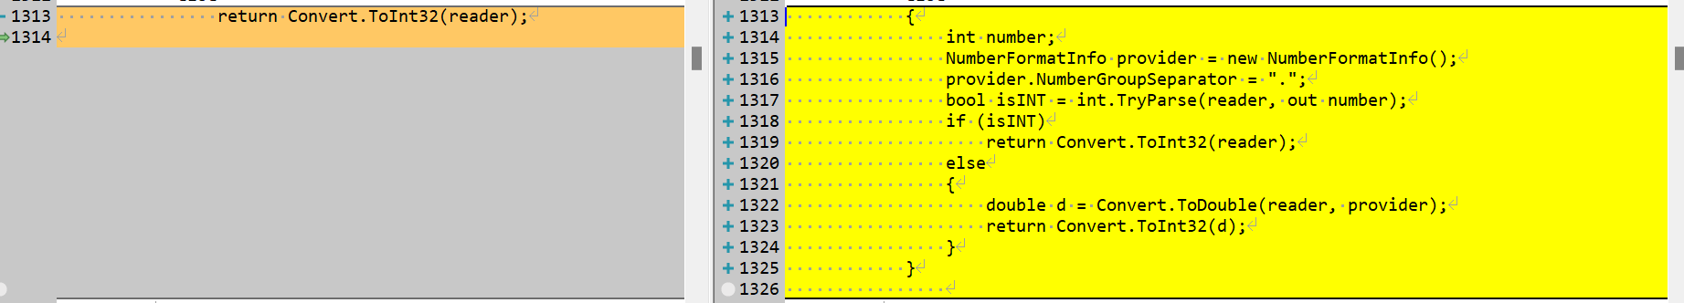

int number;

NumberFormatInfo provider = new NumberFormatInfo();

provider.NumberGroupSeparator = ".";

bool isINT = int.TryParse(reader, out number);

if (isINT)

return Convert.ToInt32(reader);

else

{

double d = Convert.ToDouble(reader, provider);

return Convert.ToInt32(d);

}

Entities/Cell



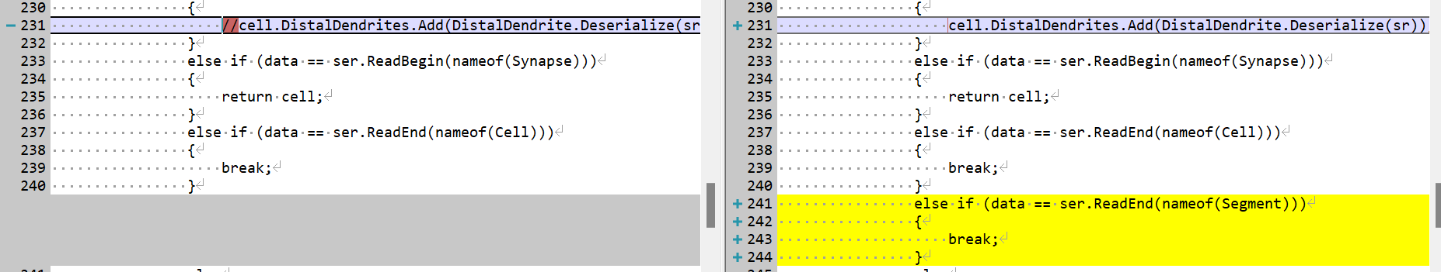

else if (data == ser.ReadEnd(nameof(Segment)))

{

break;

}

DistalDendrite

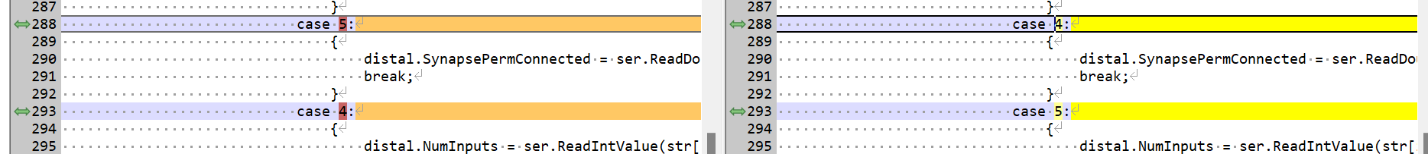

Test method UnitTestsProject.HTMSerializationTests.**SerializeCellTest** threw exception:

System.FormatException: Input string was not in a correct format.

What should be the output of the Cell?

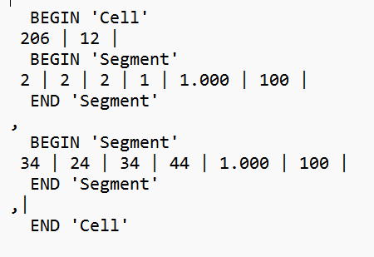

* Error 1: the input string was not in the correct format. The code is written in a way that all the inputs are supposed to be int, but we are giving an double input.

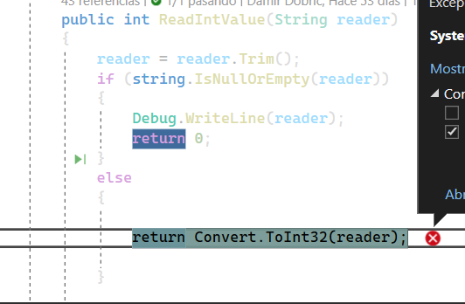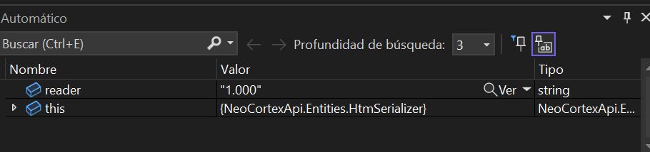

* Error 2: the UnitTest parameters of Cell are not correct

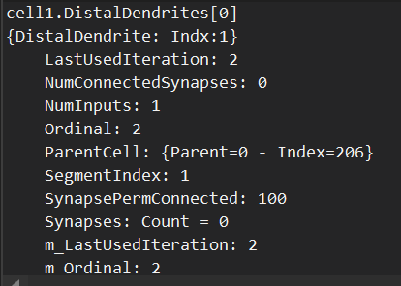 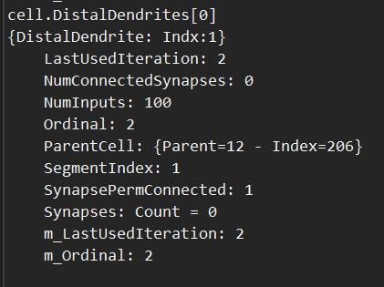

* + The value of NumInputs and SynapsePermConnected are reversed. This is due to an error in the switch loop.

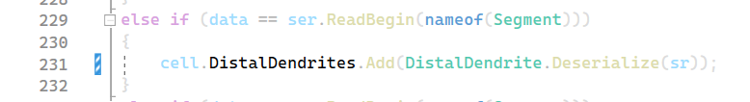

PROBLEM TO SOLVE:

We have discuss that we have to solve 21 UnitTest but most of the problems remains in the function reader cause it is reading a double and it thinks it´s an int. This is the problem causing most of the errors in the UnitTest so we are going to focus on fixing this.