C# Exceptions, Delegates, Collections
LINQ & Quantifiers — Comprehensive Notes with Code
Part 3 of .NET Foundations | Java comparisons throughout | Senior .NET Developer Notes

1. Exceptions & Exception Handling
Exception: an object that represents an error or unexpected condition that disrupts the normal flow of a program. In .NET, all exceptions inherit from System.Exception. The CLR throws an exception when it encounters an illegal operation; you catch it to handle it gracefully.

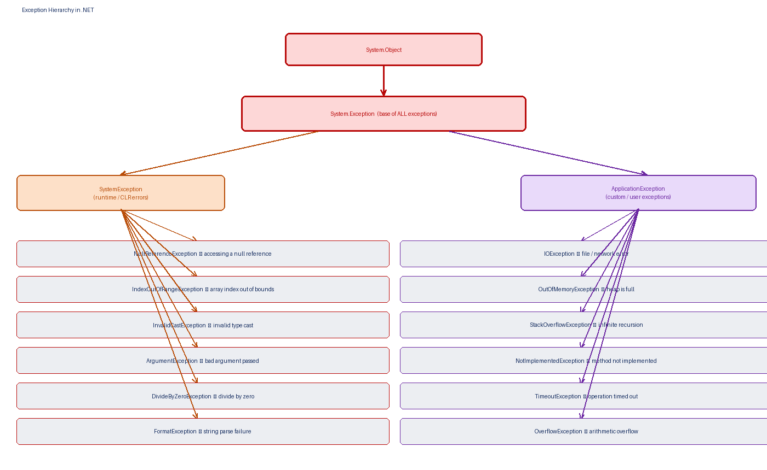
Figure 1 — Exception Hierarchy: System.Object → System.Exception → SystemException / ApplicationException

1.1 Exception Hierarchy
- System.Exception: the base class for every exception in .NET. Every catch block can catch this type as a last resort.
- SystemException: base for runtime exceptions thrown by the CLR itself (e.g. NullReferenceException, OutOfMemoryException).
- ApplicationException: intended base for user-defined exceptions — though modern .NET best practice is to inherit directly from Exception.

Exception Class | Thrown When | Java Equivalent
NullReferenceException | Accessing a member on a null reference | NullPointerException
IndexOutOfRangeException | Array index is negative or ≥ Length | ArrayIndexOutOfBoundsException
ArgumentNullException | null passed where a non-null argument is expected | NullPointerException (informal)
ArgumentOutOfRangeException | Argument value is outside allowed range | IllegalArgumentException
InvalidCastException | Explicit type cast fails at runtime | ClassCastException
DivideByZeroException | Integer divided by zero | ArithmeticException
FormatException | String cannot be parsed to the target type | NumberFormatException
IOException | File / stream / network I/O error | IOException
StackOverflowException | Call stack exceeds its limit (deep recursion) | StackOverflowError
OutOfMemoryException | CLR cannot allocate the requested memory | OutOfMemoryError
NotImplementedException | Method body deliberately not yet written | UnsupportedOperationException
OverflowException | Arithmetic operation overflows checked context | ArithmeticException

1.2 Exception Properties
Property | Type | Description
Message | string | Human-readable description of the error
StackTrace | string | Call stack at the point the exception was thrown
InnerException | Exception | The original exception that caused this one (for wrapping)
Source | string | Name of the application or assembly that caused the error
HResult | int | COM HRESULT error code
Data | IDictionary | Key-value pairs of extra information attached to the exception

1.3 try / catch / finally / throw
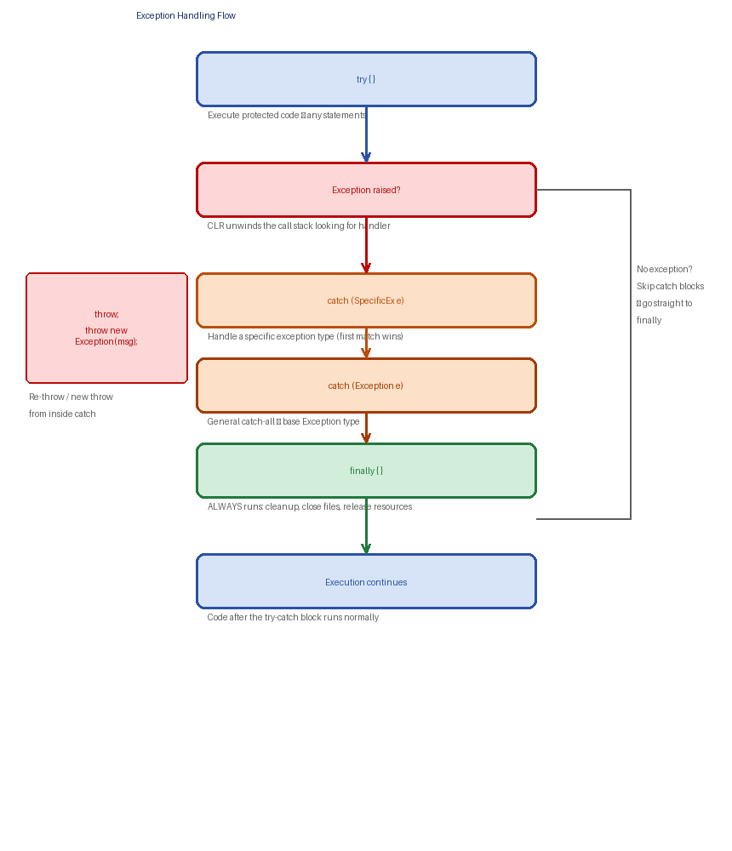
Figure 2 — Exception handling flow: try → exception raised → catch → finally → continue

The four keywords of .NET exception handling:
- try: wraps the code that might throw. If no exception occurs, all catch blocks are skipped.
- catch (ExceptionType e): handles a specific exception type. Multiple catch blocks can follow one try — the FIRST matching type wins.
- finally: always executes, whether or not an exception occurred. Use for cleanup: closing files, releasing locks, disposing resources.
- throw: explicitly throws an exception. throw; (bare) rethrows the current exception preserving the original stack trace. throw new XxxException(...); creates and throws a new one.

public decimal Divide(decimal a, decimal b)
{
try
{
if (b == 0) // guard before division
throw new DivideByZeroException("Divisor cannot be zero.");

return a / b;
}
catch (DivideByZeroException ex) // most specific first
{
Console.WriteLine($"Math error: {ex.Message}");
return 0;
}
catch (OverflowException ex)
{
Console.WriteLine($"Overflow: {ex.Message}");
throw; // rethrow — preserve stack trace
}
catch (Exception ex) // catch-all — always last
{
Console.WriteLine($"Unexpected: {ex.Message}");
throw new ApplicationException("Divide failed", ex); // wrap with InnerException
}
finally
{
Console.WriteLine("finally always runs — cleanup here");
}
}

Rule: catch blocks must go from MOST SPECIFIC to MOST GENERAL. Catching Exception before DivideByZeroException is a compile error because the latter can never be reached.

1.4 Custom Exceptions
Custom Exception: a user-defined class that inherits from Exception (or a more specific subclass), used to represent domain-specific error conditions with a meaningful name and additional data.

// Define a custom exception
public class InsufficientFundsException : Exception
{
public decimal Shortfall { get; } // extra domain data

public InsufficientFundsException(decimal shortfall)
: base($"Insufficient funds. Shortfall: {shortfall:C}")
{
Shortfall = shortfall;
}

// Always provide these 3 constructors for proper serialisation
public InsufficientFundsException() : base() { }
public InsufficientFundsException(string msg) : base(msg) { }
public InsufficientFundsException(string msg, Exception inner) : base(msg, inner) { }
}

// Usage
public void Withdraw(decimal amount)
{
if (amount > balance)
throw new InsufficientFundsException(amount - balance);
balance -= amount;
}

// Catching it
try { account.Withdraw(5000m); }
catch (InsufficientFundsException ex)
{ Console.WriteLine($"Need {ex.Shortfall:C} more."); }

1.5 when clause — Exception Filters
C# 6+ allows a when clause after catch to add an additional condition, without swallowing the exception if the filter doesn't match:
catch (HttpRequestException ex) when (ex.StatusCode == HttpStatusCode.NotFound)
{
Console.WriteLine("404 — resource not found");
}

2. Delegates
Delegate: a reference type that holds a type-safe reference to a method (or a chain of methods). A delegate is essentially a pointer to a method — but unlike a raw function pointer in C++, it is type-safe, object-oriented, and can hold multiple methods simultaneously (multicast).

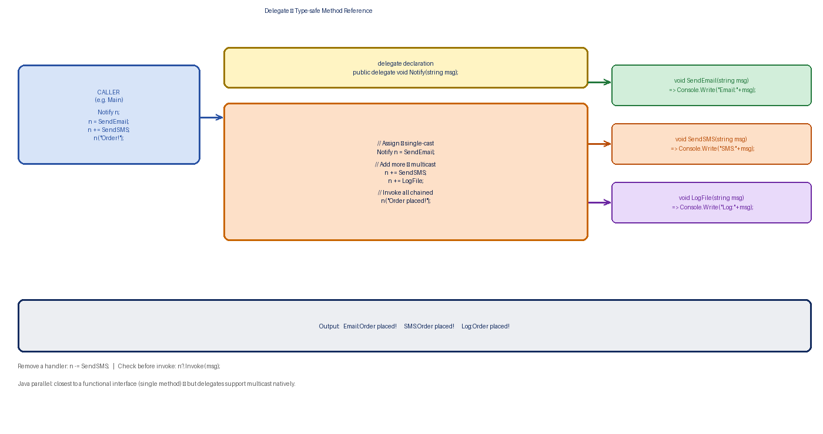
Figure 3 — Delegate: declaration, instantiation, multicast, and invocation

2.1 Declaring and Using a Delegate
- Step 1 — Declare the delegate type: defines the method signature (return type + parameter types) the delegate can point to.
- Step 2 — Create an instance: assign a method that matches the signature.
- Step 3 — Invoke: call the delegate like a method — it calls all attached methods.

// Step 1 — declare delegate type
public delegate int MathOp(int a, int b);

// Step 2 — methods that match the signature
public int Add(int a, int b) => a + b;
public int Multiply(int a, int b) => a * b;

// Step 3 — create instance and invoke
MathOp op = Add; // single-cast
Console.WriteLine(op(3, 4)); // 7

op = Multiply; // reassign
Console.WriteLine(op(3, 4)); // 12

2.2 Multicast Delegates
Multicast Delegate: a delegate that holds references to more than one method. When invoked, ALL chained methods are called in the order they were added. Use += to add and -= to remove handlers.

public delegate void Notify(string message);

void SendEmail(string msg) => Console.WriteLine($"Email: {msg}");
void SendSMS(string msg) => Console.WriteLine($"SMS: {msg}");
void LogToFile(string msg) => Console.WriteLine($"Log: {msg}");

Notify notify = SendEmail; // first handler
notify += SendSMS; // add second
notify += LogToFile; // add third

notify("Order placed!");
// Email: Order placed!
// SMS: Order placed!
// Log: Order placed!

notify -= SendSMS; // remove one handler
notify?.Invoke("Updated"); // null-safe invoke

2.3 Built-in Generic Delegates
Since .NET 3.5, you almost never need to declare your own delegate type — the BCL provides three generic delegates that cover every use case:

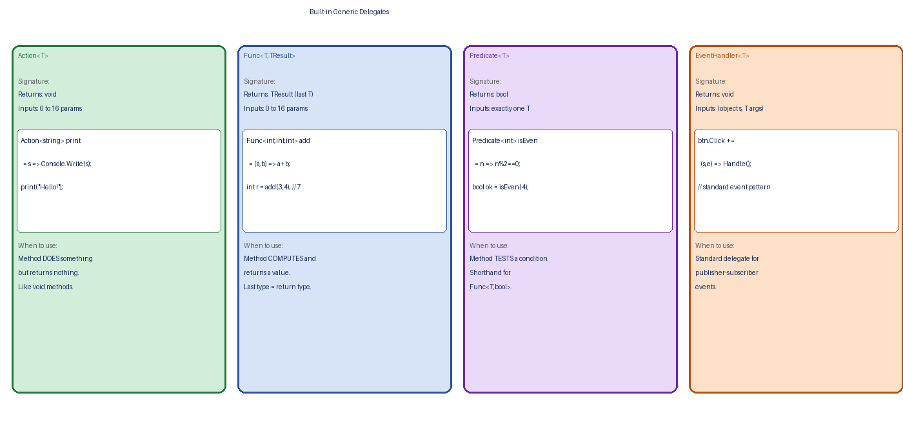
Figure 4 — Action<T>, Func<T,TResult>, Predicate<T>, EventHandler<T>

Delegate | Return Type | Parameters | Typical Use Case | Java Equiv.
Action | void | None to 16 | Do something — print, save, send | Runnable / Consumer<T>
Action<T> | void | 1 to 16 | Accept T and process it | Consumer<T>
Func<TResult> | TResult | None | Produce a value | Supplier<T>
Func<T,TResult> | TResult | 1 to 16 | Transform T → TResult | Function<T,R>
Predicate<T> | bool | 1 | Test a condition | Predicate<T>
EventHandler<T> | void | 2 (sender, args) | Event handling (UI/component) | EventListener

// Action — void return
Action<string> log = msg => Console.WriteLine($"[LOG] {msg}");
log("Application started");

// Func — returns a value (last type param = return type)
Func<int, int, int> add = (a, b) => a + b;
Func<string, int> length = s => s.Length;
Console.WriteLine(add(10, 5)); // 15
Console.WriteLine(length("hello")); // 5

// Predicate — returns bool
Predicate<string> isLong = s => s.Length > 10;
Console.WriteLine(isLong("Hello World")); // true

// Used in List<T>.FindAll
List<int> nums = new List<int> { 1, 2, 3, 4, 5, 6 };
List<int> evens = nums.FindAll(n => n % 2 == 0); // Predicate<int>

2.4 Lambda Expressions
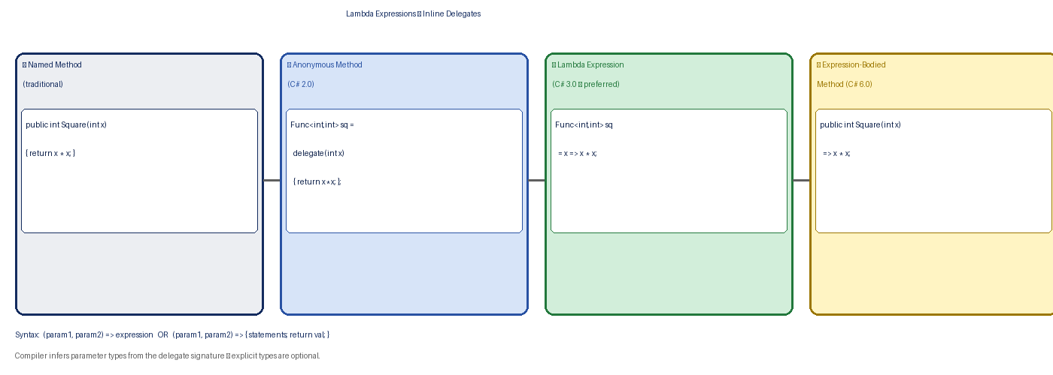
Figure 5 — Evolution: Named Method → Anonymous Method → Lambda → Expression-Bodied

Lambda Expression: a concise inline anonymous function written as (parameters) => expression or (parameters) => { statements; }. The compiler infers parameter types from the delegate signature.

// Expression lambda — single expression, implicit return
Func<int,int> square = x => x * x;
Func<int,int,int> add = (a,b) => a + b;

// Statement lambda — multiple statements in { }
Action<List<int>> printAll = list =>
{
foreach (var n in list)
Console.Write(n + " ");
Console.WriteLine();
};

// Capturing variables from the outer scope (closure)
int multiplier = 3;
Func<int,int> triple = x => x * multiplier; // captures 'multiplier'
Console.WriteLine(triple(5)); // 15

2.5 Events (Delegates in the Publisher-Subscriber Pattern)
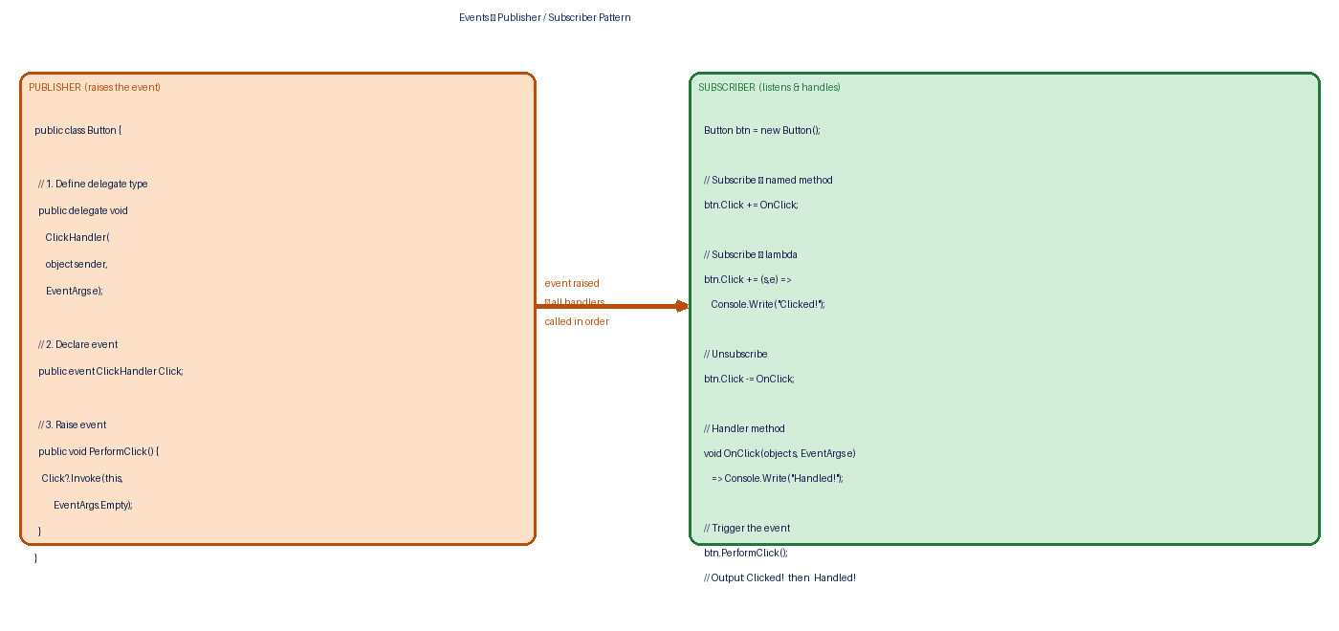
Figure 6 — Events: Publisher raises them; Subscribers handle them

Event: a special wrapper around a delegate field that restricts external code to only subscribing (+=) or unsubscribing (-=), not directly invoking or replacing the delegate. Events enforce the publisher-subscriber (observer) pattern.

// Complete real-world event example using EventHandler<T>
public class OrderEventArgs : EventArgs
{
public string OrderId { get; set; }
public decimal Total { get; set; }
}

public class OrderService // Publisher
{
public event EventHandler<OrderEventArgs> OrderPlaced;

public void PlaceOrder(string id, decimal total)
{
Console.WriteLine($"Order {id} saved.");
OrderPlaced?.Invoke(this, new OrderEventArgs { OrderId=id, Total=total });
}
}

// Subscriber
OrderService svc = new OrderService();
svc.OrderPlaced += (s, e) =>
Console.WriteLine($"Email sent for order {e.OrderId}, ₹{e.Total}");
svc.OrderPlaced += (s, e) =>
Console.WriteLine($"Inventory updated for {e.OrderId}");

svc.PlaceOrder("ORD-001", 1499m);
// Order ORD-001 saved.
// Email sent for order ORD-001, ₹1499
// Inventory updated for ORD-001

3. Collections — Generic & Non-Generic
Collection: a data structure that groups multiple elements together and provides operations to add, remove, search, and iterate over them. .NET provides three namespaces of collections: System.Collections (non-generic), System.Collections.Generic (generic — preferred), and System.Collections.Concurrent (thread-safe).

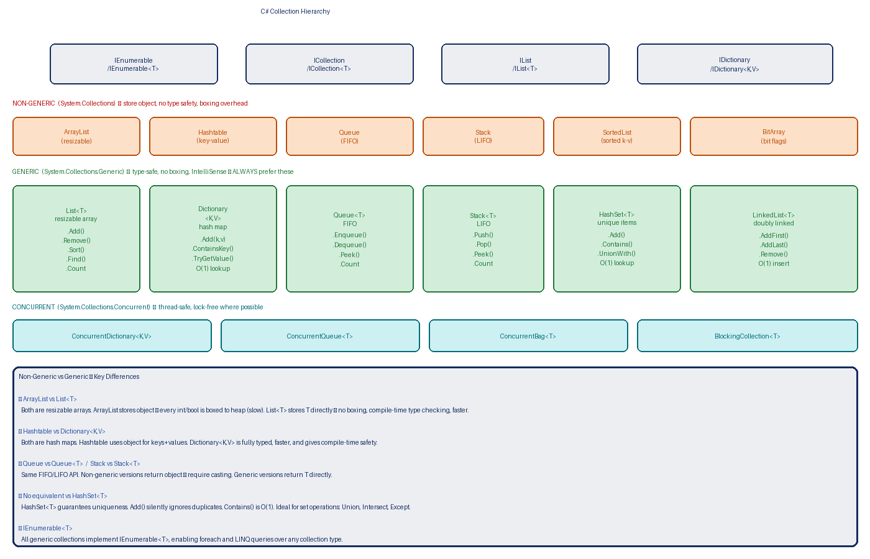
Figure 7 — Collection Hierarchy: Interfaces → Non-Generic → Generic → Concurrent

3.1 Non-Generic Collections (System.Collections)
Non-generic collections store everything as object. This means every value type (int, bool, struct) is boxed to the heap when added, and you must cast back when reading. This is slow and error-prone. Only use them when maintaining old .NET 1.x code.

using System.Collections;

// ArrayList — resizable array, stores object
ArrayList list = new ArrayList();
list.Add(42); // int is BOXED to object
list.Add("hello");
list.Add(3.14);
int n = (int)list[0]; // explicit CAST required — unsafe!

// Hashtable — key-value, any type
Hashtable ht = new Hashtable();
ht["name"] = "Varun";
ht["age"] = 26;
string name = (string)ht["name"]; // cast required

// Queue — FIFO
Queue queue = new Queue();
queue.Enqueue("first");
queue.Enqueue("second");
object front = queue.Dequeue(); // object returned

// Stack — LIFO
Stack stack = new Stack();
stack.Push(10);
int top = (int)stack.Pop(); // cast required

3.2 Generic Collections (System.Collections.Generic)
Generic collections are type-safe, faster (no boxing), and give full IntelliSense support. They are the standard in all modern .NET development. Always prefer them over non-generic equivalents.

List<T> — Resizable Array
List<T>: a dynamically-sized, ordered, indexed collection. The most commonly used collection in .NET. Equivalent to Java's ArrayList<T>.
List<string> names = new List<string> { "Alice", "Bob", "Charlie" };

names.Add("Dave"); // add at end
names.Insert(1, "Zara"); // insert at index
names.Remove("Bob"); // remove by value
names.RemoveAt(0); // remove by index
names.Sort(); // sort in place

bool found = names.Contains("Dave"); // true
int idx = names.IndexOf("Charlie"); // 0-based index
List<string> filtered = names.FindAll(n => n.StartsWith("A"));

foreach (string name in names)
Console.WriteLine(name);

Dictionary<TKey, TValue> — Hash Map
Dictionary<TKey,TValue>: a key-value hash map providing O(1) average lookup, insertion, and deletion. Keys must be unique. Equivalent to Java's HashMap<K,V>.
Dictionary<string, int> scores = new Dictionary<string, int>();

scores["Alice"] = 95; // add or update
scores["Bob"] = 88;
scores.Add("Charlie", 72); // throws if key exists

// Safe read — TryGetValue avoids KeyNotFoundException
if (scores.TryGetValue("Alice", out int aliceScore))
Console.WriteLine($"Alice: {aliceScore}");

bool hasKey = scores.ContainsKey("Dave"); // false
scores.Remove("Bob");

// Iterate
foreach (KeyValuePair<string,int> kv in scores)
Console.WriteLine($"{kv.Key} → {kv.Value}");

// Shorthand with var
foreach (var (key, value) in scores) // C# 7+ deconstruction
Console.WriteLine($"{key}: {value}");

Queue<T> — FIFO
Queue<T>: a First-In-First-Out (FIFO) collection. Items enqueued first are dequeued first. Use for task queues, message processing, BFS graph algorithms.
Queue<string> taskQueue = new Queue<string>();

taskQueue.Enqueue("SendEmail");
taskQueue.Enqueue("GenerateReport");
taskQueue.Enqueue("Backup");

Console.WriteLine(taskQueue.Peek()); // SendEmail (does not remove)
string next = taskQueue.Dequeue(); // removes and returns SendEmail
Console.WriteLine(taskQueue.Count); // 2

Stack<T> — LIFO
Stack<T>: a Last-In-First-Out (LIFO) collection. Items pushed last are popped first. Use for undo history, expression parsing, DFS graph algorithms.
Stack<string> history = new Stack<string>();

history.Push("Page1");
history.Push("Page2");
history.Push("Page3");

Console.WriteLine(history.Peek()); // Page3 (does not remove)
string last = history.Pop(); // removes and returns Page3
Console.WriteLine(history.Count); // 2

HashSet<T> — Unique Elements
HashSet<T>: an unordered collection of unique elements. Adding a duplicate is silently ignored. Contains() is O(1). Supports set operations: UnionWith, IntersectWith, ExceptWith.
HashSet<int> a = new HashSet<int> { 1, 2, 3, 4 };
HashSet<int> b = new HashSet<int> { 3, 4, 5, 6 };

a.Add(2); // silently ignored — already exists
bool has3 = a.Contains(3); // O(1), true

a.UnionWith(b); // a = { 1,2,3,4,5,6 }
a.IntersectWith(b); // a = { 3,4,5,6 }
a.ExceptWith(b); // a = elements in a but not b

3.3 Collection Interface Hierarchy
Interface | Adds over parent | Implemented by
IEnumerable<T> | GetEnumerator() — supports foreach and LINQ | All collections
ICollection<T> | Count, Add, Remove, Contains, Clear | List, HashSet, Queue, Stack, Dictionary
IList<T> | Indexed access: this[int index], IndexOf, Insert, RemoveAt | List<T>, arrays
IDictionary<K,V> | Key-value pair access, Keys/Values collections | Dictionary<K,V>, SortedDictionary<K,V>
ISet<T> | Set operations: UnionWith, IntersectWith, ExceptWith | HashSet<T>, SortedSet<T>

Non-Generic | Generic Equivalent | Key Improvement
ArrayList | List<T> | No boxing, type-safe, no casting
Hashtable | Dictionary<K,V> | Type-safe keys and values, faster
Queue | Queue<T> | Returns T directly, no cast
Stack | Stack<T> | Returns T directly, no cast
SortedList | SortedDictionary<K,V> | Type-safe sorted map
(none) | HashSet<T> | Unique element set, O(1) lookup

4. LINQ — Language Integrated Query
LINQ: Language Integrated Query — a set of C# language features and .NET library methods that let you write strongly-typed queries directly in C# to filter, sort, group, and transform data from any IEnumerable<T> source (arrays, lists, XML, databases, APIs) using a consistent, SQL-inspired syntax.

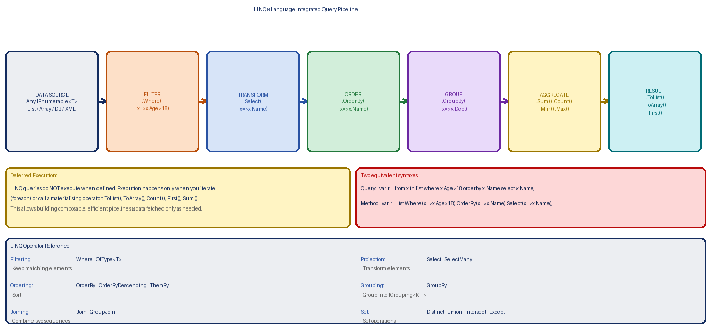
Figure 8 — LINQ Pipeline: Source → Filter → Transform → Order → Group → Aggregate → Result

Java parallel: LINQ = Java Streams API. Both are lazy (deferred execution), both support filter/map/reduce-style operations, and both can query collections and databases. C# had LINQ from 2007 (C# 3.0); Java got Streams in Java 8 (2014).

4.1 Two Syntaxes — Same Result
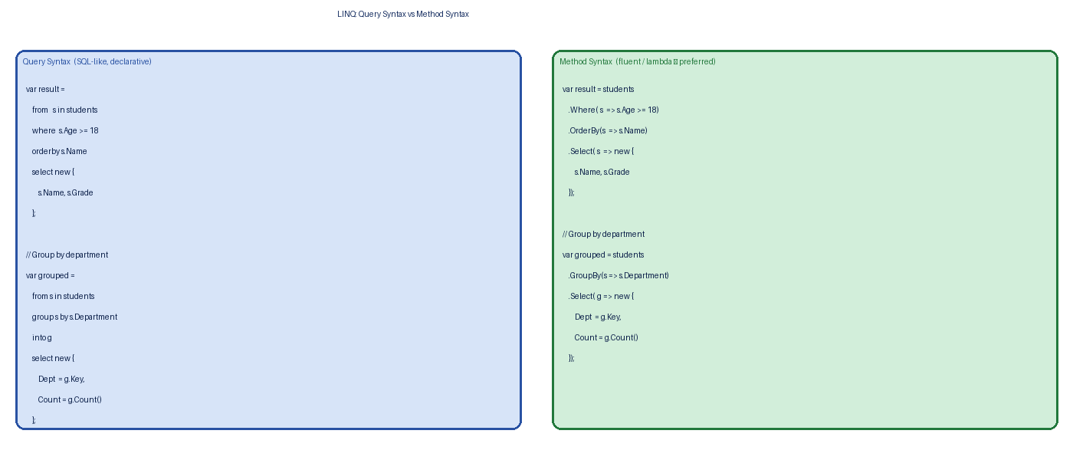
Figure 9 — Query Syntax (SQL-like) vs Method Syntax (fluent lambdas)

var students = new List<Student>
{
new Student { Name="Alice", Age=20, Grade=90, Dept="CS" },
new Student { Name="Bob", Age=17, Grade=75, Dept="Maths" },
new Student { Name="Charlie",Age=22,Grade=85, Dept="CS" },
new Student { Name="Dave", Age=19, Grade=60, Dept="Maths" },
};

// ── QUERY SYNTAX ──────────────────────────────────────────
var result1 =
from s in students
where s.Age >= 18
orderby s.Grade descending
select new { s.Name, s.Grade };

// ── METHOD SYNTAX (preferred) ────────────────────────────
var result2 = students
.Where( s => s.Age >= 18)
.OrderByDescending(s => s.Grade)
.Select( s => new { s.Name, s.Grade });

// Both produce the same output when iterated
foreach (var r in result2)
Console.WriteLine($"{r.Name}: {r.Grade}");

4.2 Deferred vs Immediate Execution
- Deferred (lazy): the query is NOT executed when you define it. It executes each time you iterate over it (foreach) or call a materialising operator. Most LINQ operators are deferred.
- Immediate: forces execution right now and stores the result. Triggered by: ToList(), ToArray(), ToDictionary(), Count(), Sum(), First(), Single(), Any(), All(), Contains().

List<int> numbers = new List<int> { 1, 2, 3, 4, 5 };

// Deferred — query defined but NOT yet executed
var query = numbers.Where(n => n > 2); // no execution here

numbers.Add(10); // add AFTER query definition

foreach (var n in query) // NOW it executes — includes 10!
Console.Write(n + " "); // 3 4 5 10

// Immediate — executes NOW, snapshot captured
List<int> snapshot = numbers.Where(n => n > 2).ToList();
numbers.Add(99); // too late — snapshot already taken
// snapshot does NOT contain 99

4.3 Filtering — Where
var adults = students.Where(s => s.Age >= 18);

// Multiple conditions
var csAdults = students.Where(s => s.Age >= 18 && s.Dept == "CS");

// OfType<T> — filter by runtime type
List<object> mixed = new List<object> { 1, "hello", 2, "world", 3 };
var ints = mixed.OfType<int>(); // 1, 2, 3
var strings = mixed.OfType<string>(); // "hello", "world"

4.4 Projection — Select & SelectMany
// Select — transform each element
var names = students.Select(s => s.Name); // IEnumerable<string>
var info = students.Select(s => new { // anonymous type
s.Name,
ScoreLabel = s.Grade >= 80 ? "A" : "B"
});

// SelectMany — flatten nested collections
List<List<int>> matrix = new List<List<int>>
{
new List<int> { 1, 2, 3 },
new List<int> { 4, 5 },
new List<int> { 6 }
};
var flat = matrix.SelectMany(row => row); // 1,2,3,4,5,6

4.5 Ordering
// OrderBy — ascending (default)
var byGrade = students.OrderBy(s => s.Grade);

// OrderByDescending — descending
var topFirst = students.OrderByDescending(s => s.Grade);

// ThenBy — secondary sort
var sorted = students
.OrderBy(s => s.Dept)
.ThenByDescending(s => s.Grade);

4.6 Grouping — GroupBy
// GroupBy — returns IEnumerable<IGrouping<TKey, TElement>>
var byDept = students.GroupBy(s => s.Dept);

foreach (var group in byDept)
{
Console.WriteLine($"Dept: {group.Key} ({group.Count()} students)");
foreach (var s in group)
Console.WriteLine($" {s.Name} - {s.Grade}");
}

// Project each group into a summary object
var deptSummary = students
.GroupBy(s => s.Dept)
.Select(g => new {
Department = g.Key,
Count = g.Count(),
AvgGrade = g.Average(s => s.Grade),
TopStudent = g.OrderByDescending(s=>s.Grade).First().Name
});

4.7 Joining
var departments = new List<Department>
{
new Department { Id=1, Name="CS" },
new Department { Id=2, Name="Maths" }
};

// Inner Join
var joined = students.Join(
departments,
s => s.DeptId, // outer key
dep => dep.Id, // inner key
(s, dep) => new { // result selector
s.Name,
DeptName = dep.Name
});

// Left outer join (GroupJoin + DefaultIfEmpty)
var leftJoin = departments.GroupJoin(
students,
dep => dep.Id,
s => s.DeptId,
(dep, studs) => new {
dep.Name,
Students = studs.DefaultIfEmpty()
});

4.8 Aggregation
int total = students.Count();
int adults = students.Count(s => s.Age >= 18);
double avg = students.Average(s => s.Grade);
int max = students.Max(s => s.Grade);
int min = students.Min(s => s.Grade);
int sum = students.Sum(s => s.Grade);

// Aggregate — custom accumulator (like Java Stream.reduce)
string allNames = students.Aggregate("",
(acc, s) => acc + (acc == "" ? "" : ", ") + s.Name);
// "Alice, Charlie, Dave"

4.9 Set Operations
var cs = students.Where(s => s.Dept == "CS");
var top = students.Where(s => s.Grade >= 80);

var csOrTop = cs.Union(top); // union — unique combined
var csAndTop = cs.Intersect(top); // intersection — in both
var csNotTop = cs.Except(top); // difference — in cs but not top
var unique = students.Distinct(); // remove duplicates

4.10 Partitioning
var top3 = students.OrderByDescending(s=>s.Grade).Take(3);
var skip2 = students.Skip(2);
var page2 = students.Skip(10).Take(10); // pagination: page 2, size 10

// TakeWhile / SkipWhile
int[] nums = { 1, 3, 5, 8, 10, 12 };
var odds = nums.TakeWhile(n => n % 2 != 0); // 1, 3, 5 (stops at 8)
var evens = nums.SkipWhile(n => n % 2 != 0); // 8, 10, 12

5. LINQ Quantifiers & Element Operators
Quantifier: a LINQ operator that returns a single bool by testing one or more conditions across the elements of a sequence. Quantifiers trigger immediate (not deferred) execution because a bool result is needed right away.

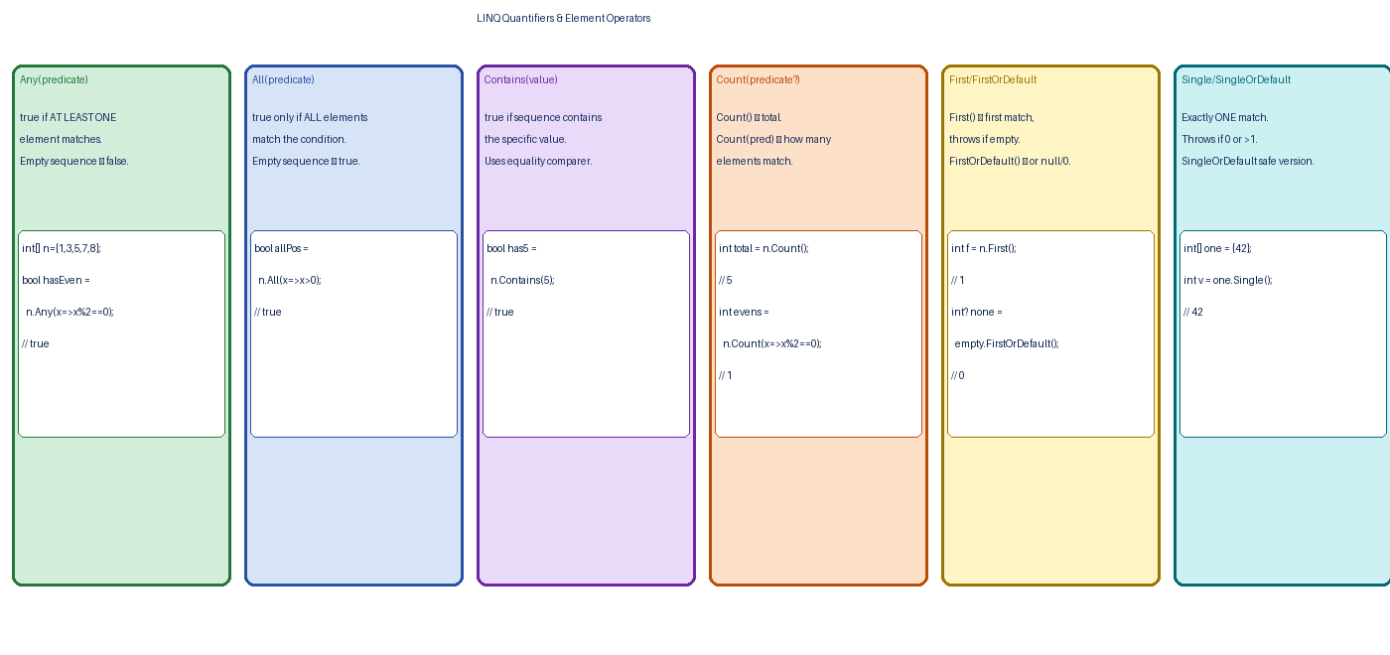
Figure 10 — Any, All, Contains, Count, First, Single — with examples

5.1 Any()
Any(): returns true if the sequence is non-empty. Any(predicate) returns true if at least one element satisfies the predicate. Short-circuits as soon as a match is found — does NOT scan the whole collection.
int[] nums = { 1, 3, 5, 7, 8 };

bool hasAny = nums.Any(); // true (not empty)
bool hasEven = nums.Any(n => n % 2 == 0); // true (8 is even)
bool hasNeg = nums.Any(n => n < 0); // false

// Real-world use
bool hasPending = orders.Any(o => o.Status == "Pending");
if (!customers.Any()) Console.WriteLine("No customers yet.");

5.2 All()
All(predicate): returns true only if ALL elements satisfy the predicate. Returns true for an empty sequence (vacuous truth). Short-circuits as soon as a failing element is found.
bool allPositive = nums.All(n => n > 0); // true
bool allEven = nums.All(n => n % 2==0);// false (1,3,5,7 are odd)

// Empty list — vacuous truth
bool emptyAll = new List<int>().All(n => n > 0); // true

// Real-world
bool allApproved = invoices.All(i => i.IsApproved);

5.3 Contains()
Contains(value): returns true if the sequence contains the specified element, using the default equality comparer (or a custom IEqualityComparer<T> overload).
bool has5 = nums.Contains(5); // true
bool has100 = nums.Contains(100); // false

// String contains (case-sensitive by default)
List<string> names = new List<string> { "Alice", "Bob" };
bool hasAlice = names.Contains("Alice"); // true
bool hasBob = names.Contains("bob"); // false — case-sensitive!

// Case-insensitive with comparer
bool hasBobCI = names.Contains("bob",
StringComparer.OrdinalIgnoreCase); // true

5.4 Count() and Count(predicate)
int total = students.Count(); // all students
int adults = students.Count(s => s.Age >= 18); // only adults
int csTop = students.Count(s => s.Dept=="CS"
&& s.Grade>=80); // CS students with A

5.5 Element Operators
Operator | Behaviour | Empty Sequence | Code Example
First() | First element (or first matching) | Throws InvalidOperationException | students.First(s=>s.Age>18)`
FirstOrDefault() | First element or default(T) | Returns null / 0 / false | students.FirstOrDefault(s=>s.Age>18)`
Last() | Last element (or last matching) | Throws InvalidOperationException | nums.Last()`
LastOrDefault() | Last or default(T) | Returns null / 0 | nums.LastOrDefault(n=>n>10)`
Single() | Exactly one matching element | Throws if 0 or more than 1 | students.Single(s=>s.Id==42)`
SingleOrDefault() | One or default(T) | Returns default if 0; throws if >1 | students.SingleOrDefault(s=>s.Id==42)`
ElementAt(i) | Element at index i | Throws if out of range | nums.ElementAt(2)`
ElementAtOrDefault(i) | Element at index or default | Returns default(T) | nums.ElementAtOrDefault(99)`

// First vs Single — important distinction
// First() — I expect AT LEAST one; give me the first
var first = students.First(s => s.Dept == "CS");

// Single() — I expect EXACTLY one; throw if there are 0 or 2+
var varun = students.Single(s => s.Id == 1001);

// Safe versions with default fallback
var maybeStudent = students.FirstOrDefault(s => s.Name == "Zara");
if (maybeStudent != null) // null check before use
Console.WriteLine(maybeStudent.Grade);

6. Quick Reference — Java ↔ C# Cheat Sheet
Java Concept | C# Equivalent | Notes
try/catch/finally | try/catch/finally | Identical structure; C# adds when filter
throw new Ex() | throw new Ex() | Identical
throw (rethrow) | throw; (bare) | C# bare throw preserves original stack trace
checked exception | (no equivalent) | C# has no checked exceptions — all are unchecked
Functional Interface / method ref | Delegate / lambda | C# delegates are typed; multicast is built-in
Consumer<T> | Action<T> | void, 1 input
Supplier<T> | Func<T> | 0 inputs, returns T
Function<T,R> | Func<T,R> | 1 input, returns R
Predicate<T> | Predicate<T> | 1 input, returns bool
EventListener / Observer | event + EventHandler<T> | Built into the language
ArrayList<T> (Java) | List<T> | Resizable array, same API style
HashMap<K,V> | Dictionary<K,V> | Hash map, TryGetValue is safer than get()
HashSet<T> | HashSet<T> | Identical concept
LinkedList<T> | LinkedList<T> | Doubly-linked, same concept
ArrayDeque / PriorityQueue | Queue<T> / Stack<T> | FIFO / LIFO
Streams API | LINQ | Both lazy; LINQ in C# since 2007, Streams since Java 8
stream.filter() | .Where() | Filtering
stream.map() | .Select() | Projection / transform
stream.flatMap() | .SelectMany() | Flatten nested collections
stream.sorted() | .OrderBy() / .ThenBy() | Sorting
Collectors.groupingBy() | .GroupBy() | Grouping
stream.anyMatch() | .Any() | At least one match
stream.allMatch() | .All() | All match
stream.collect(toList()) | .ToList() | Materialise to List
stream.count() | .Count() | Element count
stream.findFirst() | .FirstOrDefault() | First element (safe)

End of notes — Part 3: Exceptions · Delegates · Collections · LINQ · Quantifiers

