C# Advanced Async Programming & Threading Architecture
Complete Senior Developer Study Guide

1. Fundamentals: Processes, Threads, and Multithreading

Process vs Thread
Definition: A Process is an executing instance of an application containing its own memory space. A Thread is the smallest sequence of programmed instructions managed by a scheduler, living inside a Process.
Internal Working: Processes are highly isolated. Threads share the heap memory of the process but maintain their own stack. Context switching between threads is much faster than between processes.
Interview Q: What is the difference between a process and a thread?
A process provides an isolated execution environment with its own memory. A thread is a worker within that process. Multiple threads share the process's heap but have unique stacks.

Thread Lifecycle
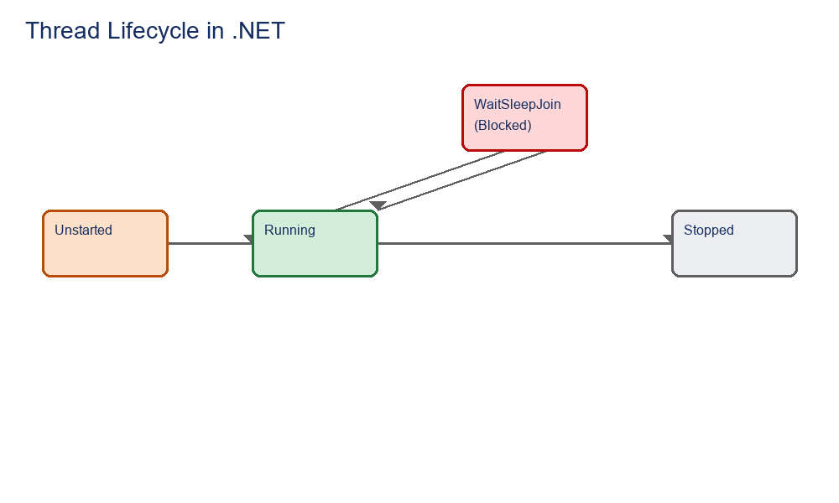
- Unstarted: Thread is created but Start() isn't called.
- Running: CPU is executing the thread.
- WaitSleepJoin: Thread is blocked (Thread.Sleep, waiting for lock).
- Stopped: Execution completed or aborted.
Thread t = new Thread(() => Console.WriteLine("Running"));
t.Start();
t.Join(); // Blocks calling thread until t finishes

Thread Pool Architecture
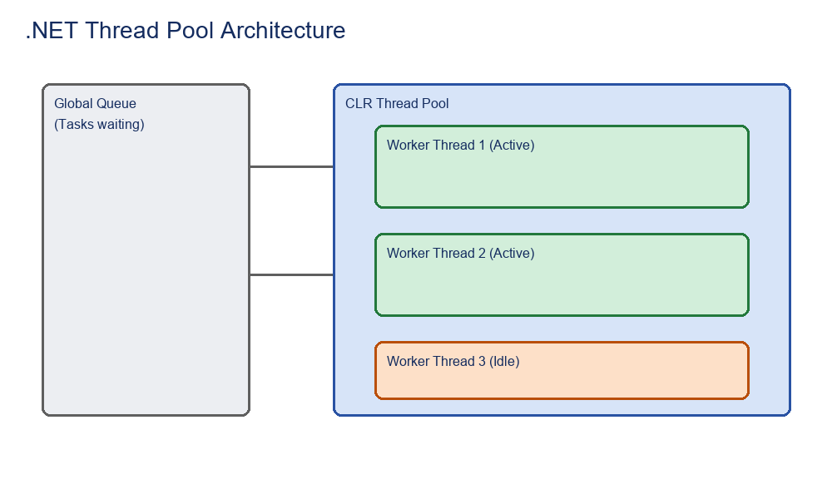
Definition: A managed collection of background threads maintained by the CLR. Instead of creating and destroying threads (which is expensive), the runtime reuses them.
Interview Q: Why use the ThreadPool instead of manually creating Threads?
Creating a Thread object takes time and consumes ~1MB of memory for the stack. The ThreadPool reuses existing threads, significantly reducing overhead and preventing thread starvation.

2. Task Parallel Library (TPL)

Task and Task<T>
Definition: A Task represents an asynchronous operation. Task<T> represents an operation that returns a value of type T. Tasks sit on top of the ThreadPool but offer state management, continuations, and cancellation.
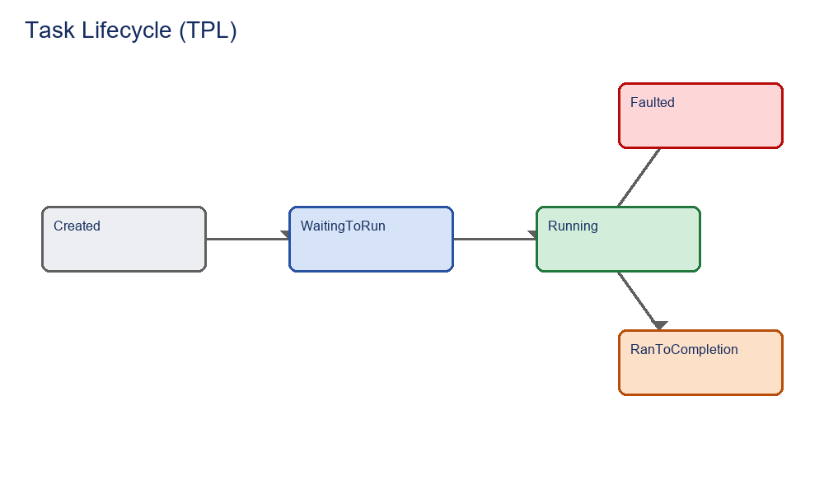
Task<int> myTask = Task.Run(() => {
Thread.Sleep(1000);
return 42;
});
int result = await myTask;
Interview Q: What is the difference between Thread and Task?
A Thread is a low-level OS concept. A Task is a higher-level framework concept (TPL) that usually runs on the ThreadPool, supports async/await, returning results, and chaining operations.

3. Async and Await Deep Dive

Sync vs Async Execution
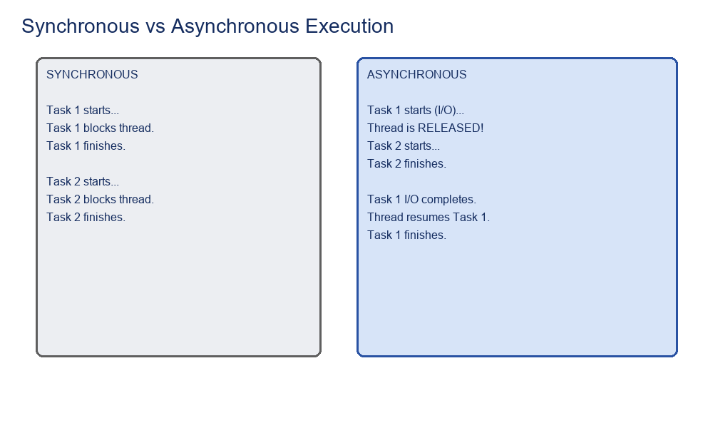

Internal Working of Await (State Machine)
Explanation: 'await' does not block the thread. When the compiler sees 'await', it splits the method into a state machine (IAsyncStateMachine).
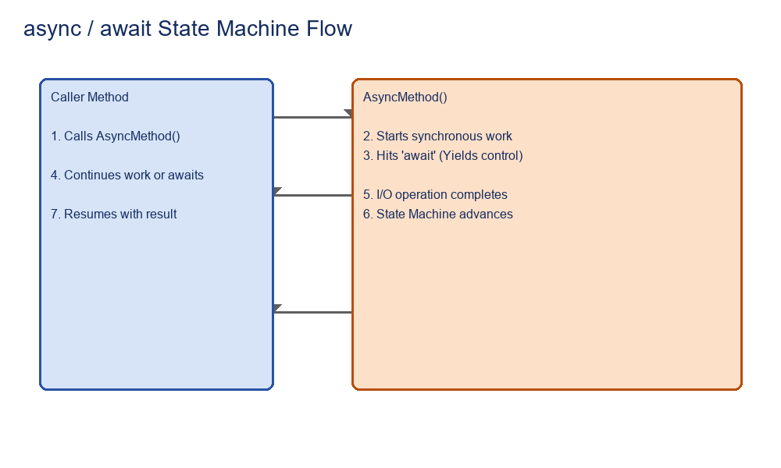
- 1. Execution runs synchronously until the first incomplete await.
- 2. If the operation (e.g., DB call) is pending, the current thread is RELEASED back to the ThreadPool.
- 3. When the I/O completes, an IO Completion Port (IOCP) signals the CLR, which grabs a free thread from the pool to resume the state machine.

Blocking vs Non-Blocking
Blocking means the thread is stuck waiting and cannot do other work (.Wait(), .Result, Thread.Sleep). Non-blocking means the thread is freed while waiting (await, Task.Delay).
// BAD: Blocks thread (Deadlock risk in UI/ASP.NET Core prior to 3.0)
var data = GetDataAsync().Result;

// GOOD: Non-blocking
var data = await GetDataAsync();

Task.Delay() vs Thread.Sleep()
Thread.Sleep() freezes the actual OS thread. Task.Delay() creates a timer and yields the thread back to the pool, resuming execution when the timer expires.

4. Workloads: CPU-Bound vs IO-Bound
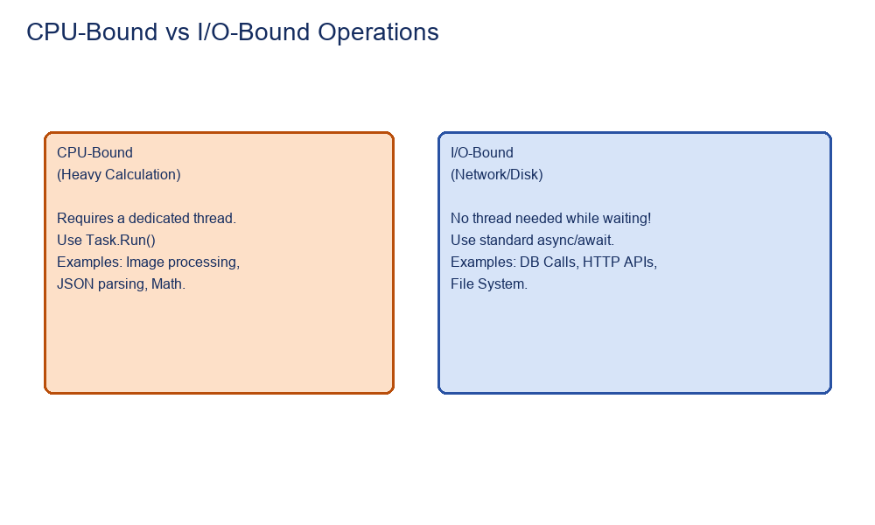
CPU-Bound: Work requires active CPU cycles (Math, parsing). Use Task.Run() to offload this to a background thread so it doesn't freeze the UI.
IO-Bound: Work involves waiting for external hardware (Network, Disk, DB). No actual thread is needed while waiting. Standard async/await is used.
Interview Q: Should I use Task.Run for I/O operations?
No. Using Task.Run for I/O bounds is 'Async over Sync' anti-pattern. It wastes a ThreadPool thread just to wait. Use native async I/O APIs (e.g., HttpClient.GetAsync).

5. Parallel Programming & Coordination

Task.WhenAll vs Task.WhenAny
Task.WhenAll: Returns a single task that completes when ALL provided tasks complete. Great for concurrent I/O.
Task.WhenAny: Completes as soon as the FIRST task completes. Great for redundancy or timeouts.
var t1 = FetchData(url1);
var t2 = FetchData(url2);
await Task.WhenAll(t1, t2);

CancellationToken
Allows cooperative cancellation of long-running operations.
CancellationTokenSource cts = new CancellationTokenSource();
cts.CancelAfter(5000); // 5 sec timeout
await GetDataAsync(cts.Token);

6. Concurrency & Synchronization

Race Condition
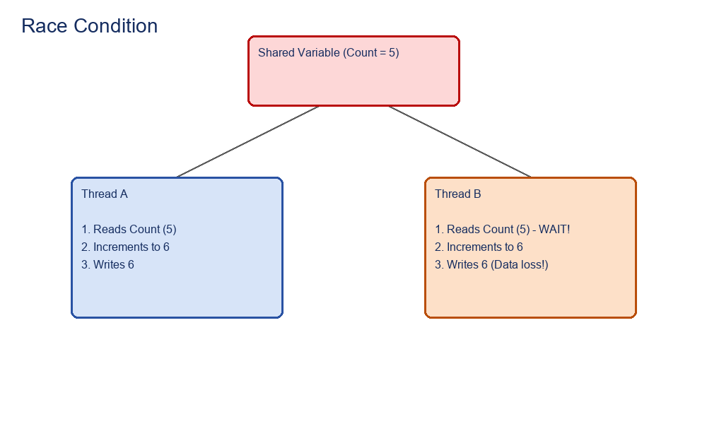
Definition: Occurs when two or more threads access shared data simultaneously, and the outcome depends on the timing of execution.

Deadlock
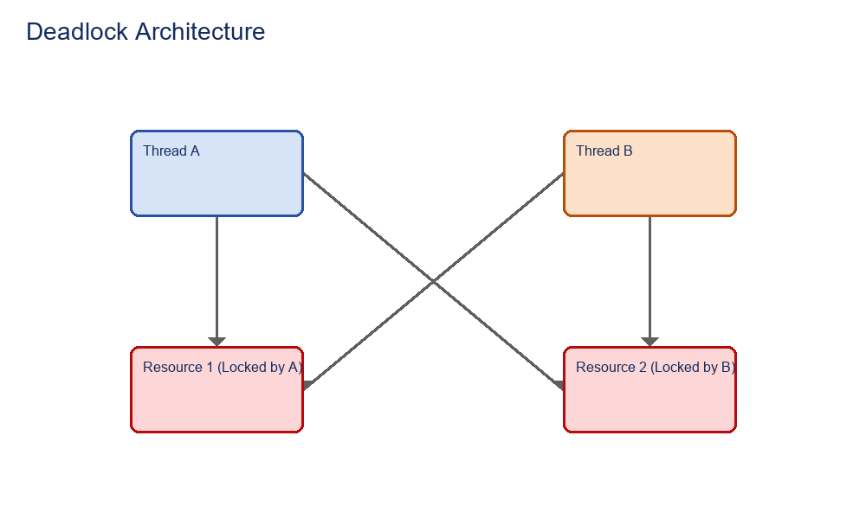
Definition: Occurs when two threads hold locks that the other thread requires, resulting in both threads waiting indefinitely.

Synchronization Primitives: lock, Monitor, Mutex, Semaphore
- lock: Syntactic sugar for Monitor.Enter/Exit. Ensures only one thread enters a critical section. Works only within a single process.
- Mutex: Similar to lock, but works across multiple processes on the OS level (heavier).
- Semaphore / SemaphoreSlim: Limits concurrent access to a specific number of threads (e.g., max 3 threads can access the DB connection).
private static readonly object _syncRoot = new object();
public void Update() {
lock(_syncRoot) { /* thread safe */ }
}
Interview Q: What is SemaphoreSlim?
It is the lightweight, local-process version of Semaphore. Crucially, SemaphoreSlim supports WaitAsync(), making it the only lock mechanism safely usable with async/await.

7. Web API Request Flow & SyncContext
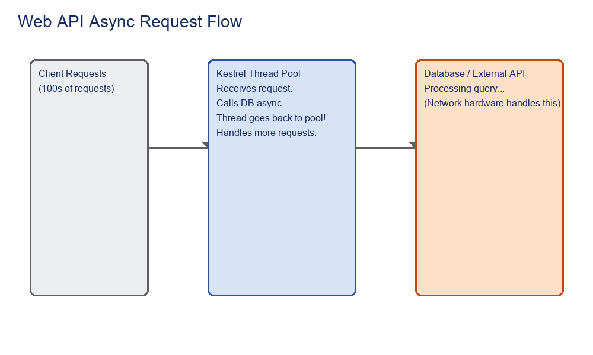

SynchronizationContext
Definition: An abstraction that dictates where a thread resumes execution after an 'await'. UI applications (WPF/WinForms) have a specific context to force continuations on the UI thread. ASP.NET Core removed the SynchronizationContext entirely for maximum performance, meaning threads can resume on any ThreadPool thread.
Interview Q: Why use ConfigureAwait(false)?
In library code, ConfigureAwait(false) tells the runtime NOT to force the continuation back onto the original SynchronizationContext. This improves performance and prevents deadlocks in legacy UI/ASP.NET apps.

