.NET & C# Foundations
Core Concepts, Architecture & Execution Model
Notes prepared for a Java / Spring Boot developer transitioning into .NET

1. What Is .NET?
.NET: a free, open-source, cross-platform developer platform created by Microsoft for building many kinds of applications - web, desktop, mobile, cloud, games, IoT and microservices - using multiple programming languages (C#, VB.NET, F#) that all compile down to a common intermediate format and execute on a common runtime.

Coming from Java/Spring Boot, the best mental model is a direct analogy: where Java relies on the JVM to run bytecode compiled from Java, Kotlin or Scala, .NET relies on the CLR (Common Language Runtime) to run MSIL (Microsoft Intermediate Language) compiled from C#, VB.NET or F#. The platform, not just the language, is the unit of interoperability.
- Multi-language: C#, VB.NET, F#, and others all target the same runtime and class libraries.
- Multi-platform: modern .NET runs on Windows, Linux, and macOS.
- Multi-purpose: web APIs (ASP.NET Core ≈ Spring Boot), desktop apps (WPF/WinForms), mobile (MAUI/Xamarin ≈ something like a native Android/iOS SDK), cloud-native services, and more.

2. The .NET Ecosystem
Historically, “.NET” was not one single thing - it was a family of related but separate implementations that all conformed to a shared standard. The diagram below (from the original course material) shows the three major branches and what each was designed for.
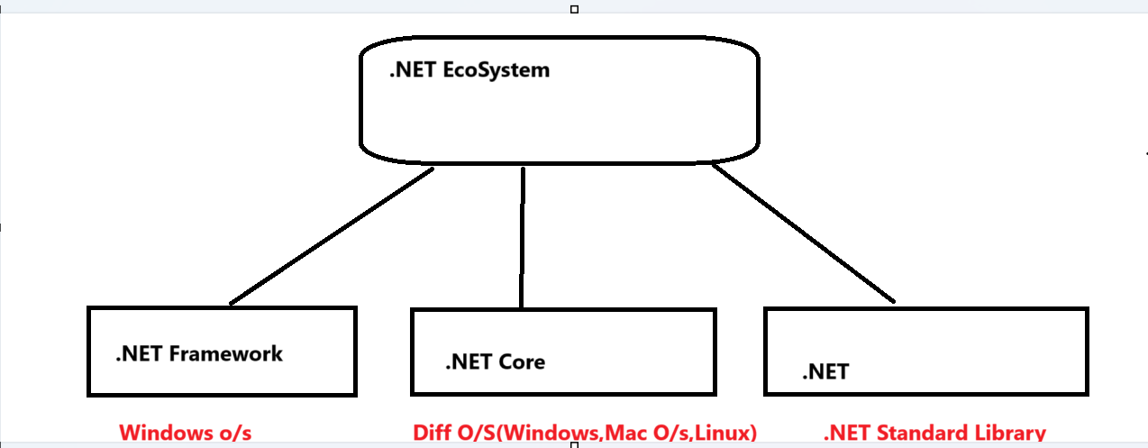
Figure: The .NET Ecosystem — three implementations, one standard
Implementation | Target OS | Typical Use
.NET Framework | Windows only | Legacy Windows desktop (WinForms/WPF) & on-prem web apps (ASP.NET)
.NET Core | Windows, Linux, macOS | Cross-platform console apps, ASP.NET Core web APIs, cloud/microservices
.NET (Xamarin / MAUI) | Windows, macOS, iOS, Android | Cross-platform mobile and native client apps built with .NET Standard Library

Since .NET 5 (2020), Microsoft unified .NET Core, .NET Framework's relevant pieces, and Xamarin/Mono under a single product simply called “.NET”, dropping the word “Core”. .NET Framework still exists for legacy Windows apps but is in maintenance mode (4.8 is final); all new development happens on modern .NET (5, 6, 7, 8…).

3. .NET Framework
.NET Framework: a software development framework from Microsoft, released in 2002, for building and running applications on Windows only. Its latest and final version is 4.8.

- Windows-only runtime and library set - tightly coupled to the Windows OS.
- Used for traditional desktop apps (WinForms, WPF) and on-premise web apps (ASP.NET, ASP.NET MVC).
- In maintenance mode: Microsoft only ships security/bug fixes, no new features.
- Roughly comparable to running Java SE/EE applications tied to a specific OS-bound JVM distribution - except .NET Framework is Windows-locked while the JVM itself is cross-platform.

4. .NET Core
.NET Core: Microsoft's open-source, cross-platform redesign of .NET, introduced in 2016, used to build cross-platform console apps, ASP.NET Core web applications, and cloud services that run on Windows, Linux and macOS.

- Open source and cross-platform (Windows / Linux / macOS) — unlike .NET Framework.
- Last release under this name was .NET Core 3.1; version numbering then jumped to .NET 5.0 to avoid confusion with .NET Framework 4.x (so “4.x” was deliberately skipped).
- From .NET 5 onward, the word “Core” was dropped from the name, and the unified platform supports more app types and platforms than either .NET Core or .NET Framework alone.
- This is the .NET you should treat as the present/future - directly analogous to how Spring Boot is the modern, cloud-friendly evolution path compared to older Java EE app-server deployments.

5. Xamarin
Xamarin: a free, cross-platform, open-source application platform for building Android and iOS apps using .NET and C#.

- Built on top of Mono, an open-source implementation of the .NET platform that lets developers build cross-platform applications independent of Microsoft's own runtime.
- Evolution path: Mono → Xamarin → (today) .NET MAUI, which merges Xamarin.Forms into the unified .NET stack.
- Conceptually similar to choosing Kotlin Multiplatform or React Native from a Java background: one shared codebase/language targeting multiple native mobile platforms.

6. .NET Framework vs .NET Core vs Xamarin - Side by Side
Each of the three implementations exposes its own “app models” (the UI/app frameworks you build on top of) and its own base library, but all three ultimately sit on a shared common infrastructure (compilers, languages, runtime components). This is what made portable code possible even before everything was merged into a single .NET.
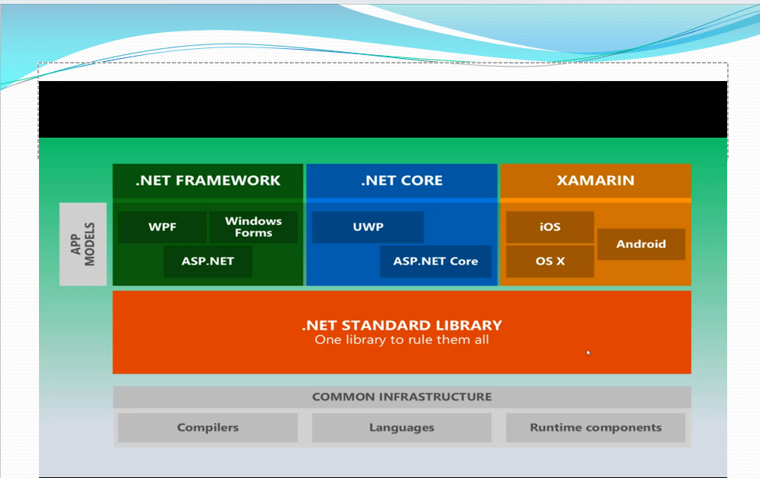
Figure: App models for .NET Framework, .NET Core, and Xamarin
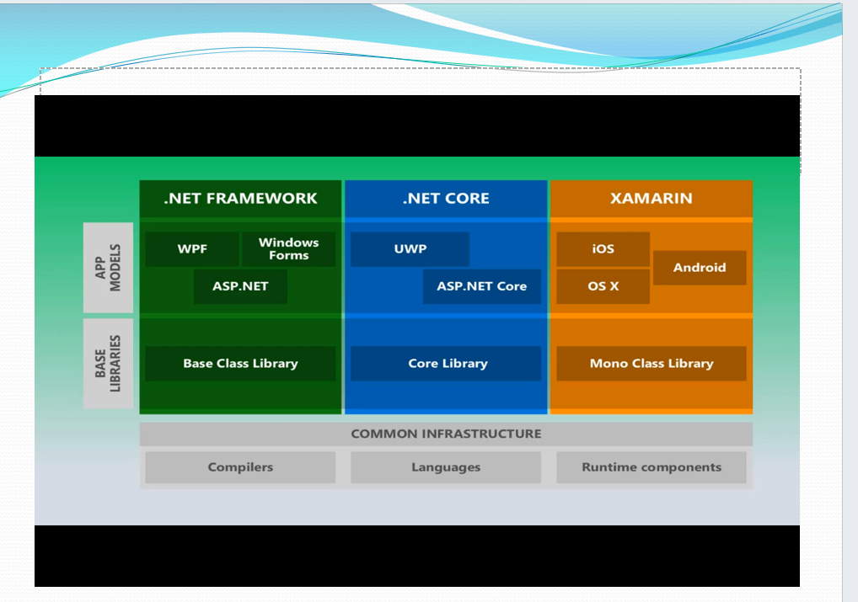
Figure: Each implementation has its own base library (BCL / Core Library / Mono Class Library), unified by the .NET Standard Library

Layer | .NET Framework | .NET Core | Xamarin
App models | WPF, WinForms, ASP.NET | UWP, ASP.NET Core | iOS, Android, OS X
Base library | Base Class Library (BCL) | Core Library | Mono Class Library
Shared layer | .NET Standard Library — “one library to rule them all”
Foundation | Common Infrastructure: Compilers, Languages, Runtime components

7. Components of .NET Framework
Underneath any .NET implementation sit five core building blocks that work together to let multiple languages interoperate on one runtime.
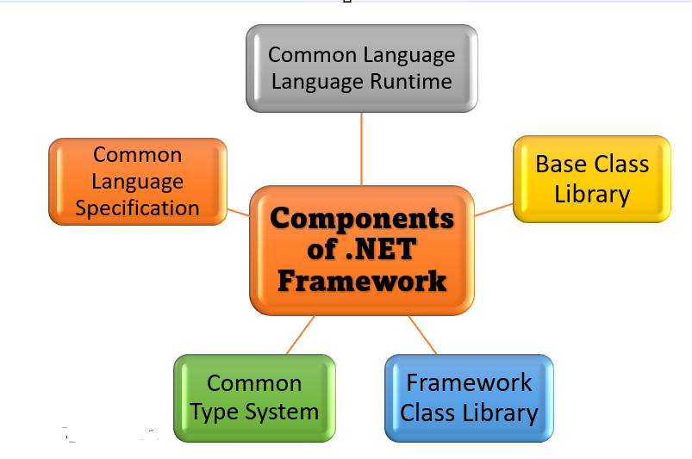
Figure: Components of .NET Framework

- Common Language Runtime (CLR): the execution engine - manages memory, threads, exceptions, and security for running code (≈ the JVM).
- Common Language Specification (CLS): the set of rules every .NET language must follow to guarantee cross-language interoperability.
- Common Type System (CTS): defines how types are declared, used and managed at runtime, so every .NET language shares the same data type model.
- Base Class Library (BCL): the foundational set of classes (collections, IO, threading, etc.) available to every .NET language.
- Framework Class Library (FCL): the larger superset of BCL plus additional libraries (ASP.NET, ADO.NET, WPF, WinForms, etc.) for building full applications.

8. Common Type System (CTS)
CTS: a component of .NET's runtime engine that defines a common set of data types shared across all .NET languages, so that a type created in one .NET language is fully understood by code written in another.

- Guarantees that an int in C# and an Integer in VB.NET are represented identically at runtime.
- Defines two broad categories of types: value types (e.g. int, struct - stored on the stack, hold data directly) and reference types (e.g. class, string - stored on the heap, hold a reference to the data).
- Without CTS, classes from different .NET languages wouldn't be able to talk to each other - this is what makes true language interoperability possible.

Java parallel: the JVM also has a defined type system, but it is fixed to one language family by design philosophy (the JVM spec was largely written for Java itself, even though other JVM languages now target it). CTS makes this multi-language guarantee an explicit, first-class part of the .NET design.

9. Common Language Specification (CLS)
CLS: a set of basic rules and restrictions that every .NET language must follow to ensure language independence and language interoperability. CLS is a subset of CTS.

- Role of CLS: it lets you write code in one .NET language and consume it from another .NET language - i.e., language interoperability.
- CLS-Compliant: languages (or members/types) that follow the rules defined by CLS are described as “CLS-Compliant”.
- Practical implication: CLS-compliant code written in any one supported language can be referenced and used from code written in any other CLS-compliant .NET language - for example, a C# library can expose a public class that a VB.NET project consumes directly.

10. Common Language Runtime (CLR)
CLR: the runtime execution engine of .NET - it loads, manages, and executes compiled .NET code (MSIL), and is responsible for memory and type safety, security, and exception handling. In short: CLR is the runtime environment for .NET, directly analogous to the JVM for Java.

CLR Responsibilities
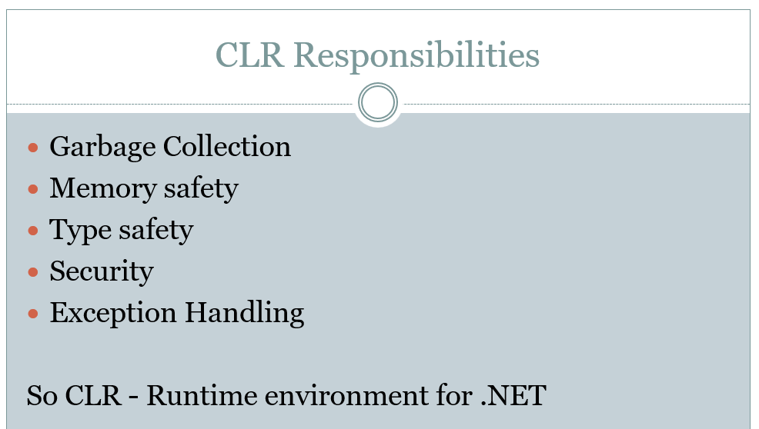
Figure: Core responsibilities of the CLR
- Garbage Collection — automatically reclaims memory used by objects no longer referenced (≈ JVM's GC).
- Memory safety — prevents invalid memory access (no manual pointer arithmetic in managed code).
- Type safety — enforces that operations on a type are valid for that type, using rules from CTS.
- Security — enforces code access security and permissions before executing managed code.
- Exception handling — provides a structured, language-agnostic mechanism (try/catch/finally) for handling runtime errors across all .NET languages.

11. Base Class Library (BCL)
BCL: the core set of class libraries shipped with .NET that provide fundamental, language-agnostic functionality - collections, I/O, security, networking, threading, serialization, and more - available to every .NET application regardless of which language it's written in.
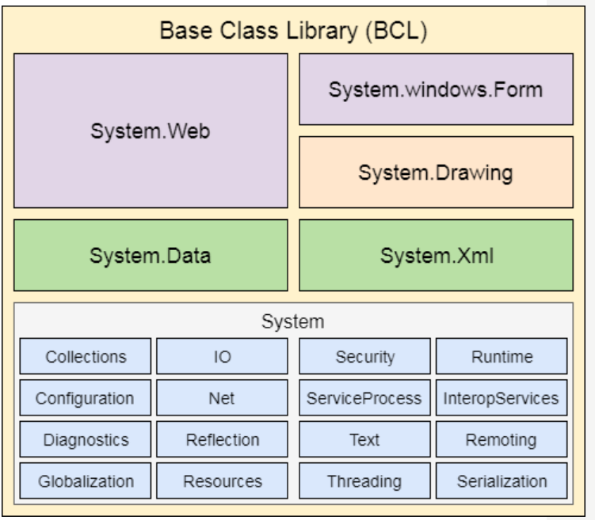
Figure: Structure of the Base Class Library

Each shaded block groups related namespaces:
- System.Web: classes for building web applications (the predecessor to ASP.NET Core's own libraries).
- System.Windows.Forms / System.Drawing: classes for building Windows desktop UI applications and 2D graphics.
- System.Data / System.Xml: data access (ADO.NET) and XML processing.
- System (root namespace): the foundation - Collections, IO, Security, Runtime, Configuration, Net, ServiceProcess, InteropServices, Diagnostics, Reflection, Text, Remoting, Globalization, Resources, Threading, Serialization.

Java parallel: BCL plays the same role as the java.* / javax.* core packages bundled with the JDK (java.util, java.io, java.net, etc.) - a baseline toolkit every program can rely on without adding external dependencies.

12. Compilation and Execution Model
This is the single most important mental model for understanding how .NET code actually runs, and it maps almost one-to-one onto how Java code runs.

12.1 Development Environment vs Production Environment
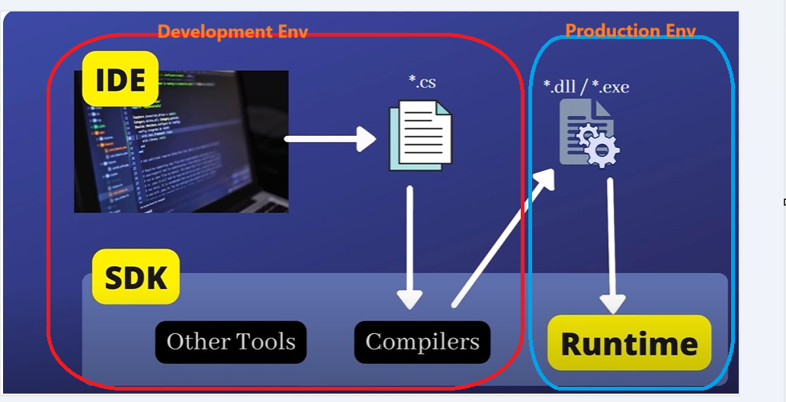
Figure: Development tools (IDE, SDK, compilers) vs the production runtime

- IDE (e.g. Visual Studio / Visual Studio Code / STS-equivalent): where you write .cs source files.
- SDK (Software Development Kit): bundles the compilers and other tools needed to build a .NET project; it produces the compiled output.
- Compilers: translate .cs (or .vb, .fs) source into managed assemblies (.dll / .exe) containing MSIL.
- Runtime: in the production environment, the CLR loads and executes the compiled .dll/.exe - this is the only thing required on a machine that just needs to run the app, not build it.

12.2 Source Code → MSIL → Native Code
Every .NET language compiler turns source code into the same intermediate language, which is what makes cross-language interoperability and a single shared runtime possible.
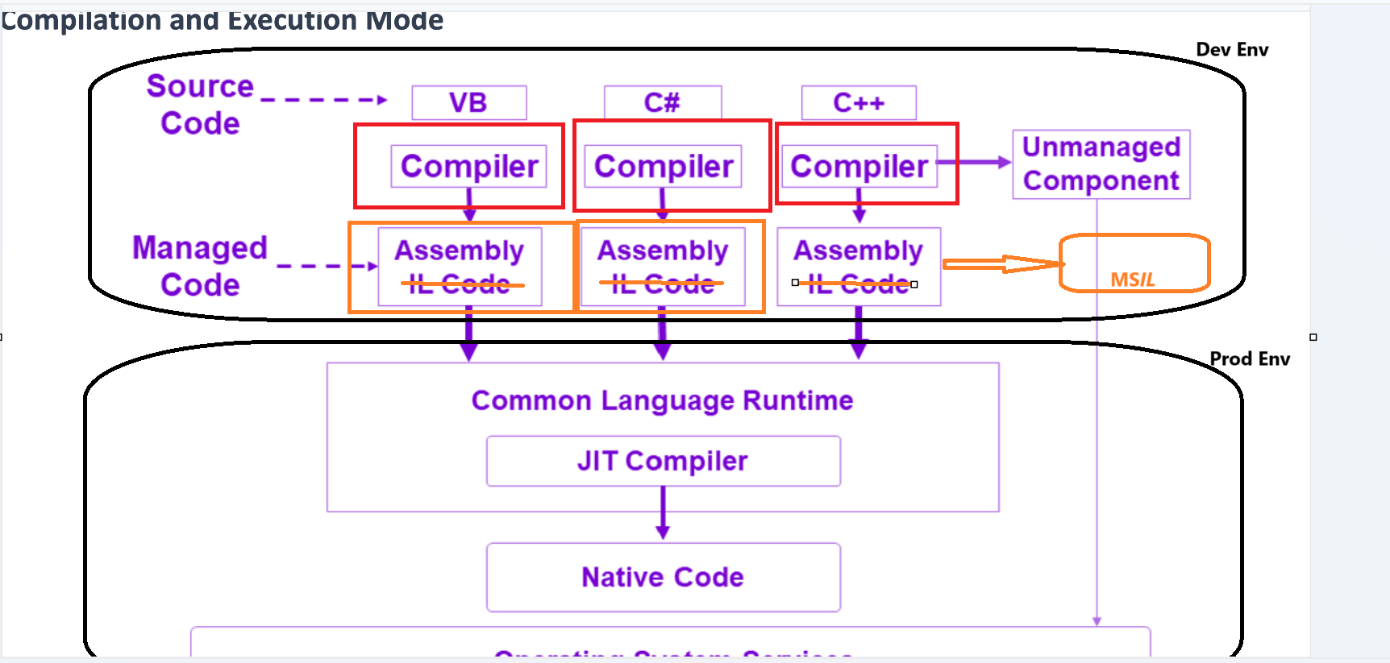
Figure: Compilation and execution mode across languages

Source Code (C# / VB / C++) | Language Compiler | Assembly (MSIL / IL Code) | CLR (JIT Compiler) | Native Machine Code
↓ (compiled / processed by next stage) ↓

- Source Code: written in any .NET language (C#, VB.NET, C++/CLI, F#).
- Language Compiler: each language has its own compiler (csc for C#, vbc for VB.NET) - this is the Dev-Env step.
- MSIL (Microsoft Intermediate Language), also called CIL: a CPU-independent, partially-compiled bytecode that all .NET compilers produce - this is what's stored inside an Assembly. Analogous to Java .class bytecode.
- Assembly: the compiled, deployable unit (.dll or .exe) that contains MSIL plus a manifest describing the code (types, versions, references) - analogous to a Java .jar file.
- CLR + JIT Compiler: at runtime, the CLR's Just-In-Time compiler converts MSIL into native machine code for the specific CPU/OS it's running on, right before that code executes - analogous to the JVM's JIT compiler.
- Native Code: the final machine instructions the OS actually executes.

.NET application workflow, summarised end-to-end:
.NET Application (C#, VB, F#) | MSIL (Intermediate Language) | CLR + JIT Compiler | Machine Code

12.3 Managed vs Unmanaged Code
- Managed code: code that targets and runs under control of the CLR (gets garbage collection, type safety, exception handling, security for free).
- Unmanaged code: code compiled directly to native machine instructions outside the CLR's control (e.g. raw C++ binaries) - the CLR cannot manage its memory or enforce its safety guarantees.

13. Project & Solution Structure
Visual Studio organizes C# code using two levels of grouping: the Project and the Solution. This is the closest .NET equivalent to a Maven/Gradle module and a multi-module parent project in Java.

13.1 Project
Project: a directory containing source files (.cs) and a single .csproj file that defines how that code should be compiled - its target framework, dependencies (NuGet packages), output type, etc.
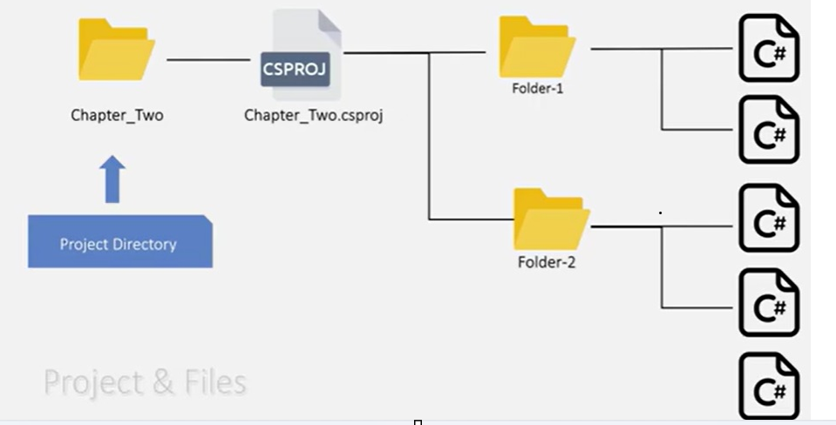
Figure: A project directory and its .csproj file
- The .csproj (“C# project”) file is XML-based and is conceptually equivalent to Maven's pom.xml or Gradle's build.gradle - it lists dependencies and build settings.
- A project compiles into a single assembly (.dll or .exe).

13.2 Solution
Solution: a container that groups one or more related Projects together, defined by a single .sln file at the solution directory's root.
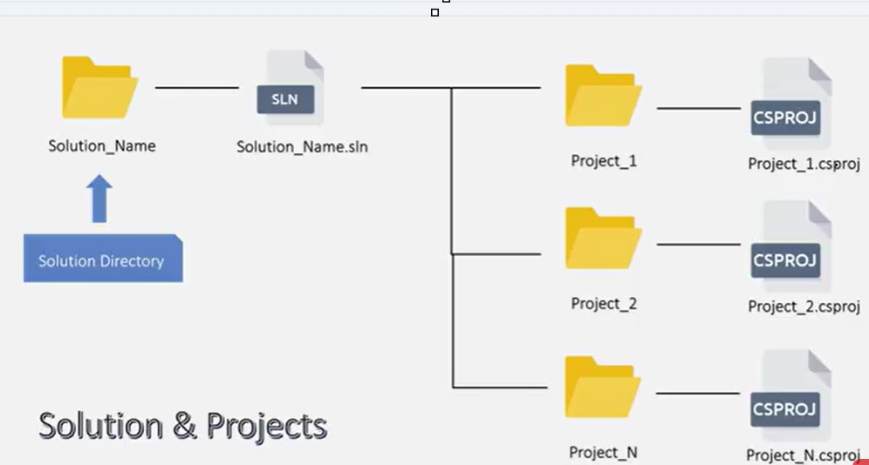
Figure: A solution containing multiple projects
- The .sln file references each project's .csproj and is conceptually equivalent to a multi-module Maven/Gradle parent project tying several modules together.
- Typical layout: one solution might contain a Web API project, a class-library project for shared models, and a test project - mirroring how a Spring Boot multi-module setup might separate api, domain, and persistence modules.

14. C# Language Features
C#: a modern, general-purpose, object-oriented programming language developed by Microsoft as the primary language for .NET, designed to be simple, type-safe, and component-oriented.
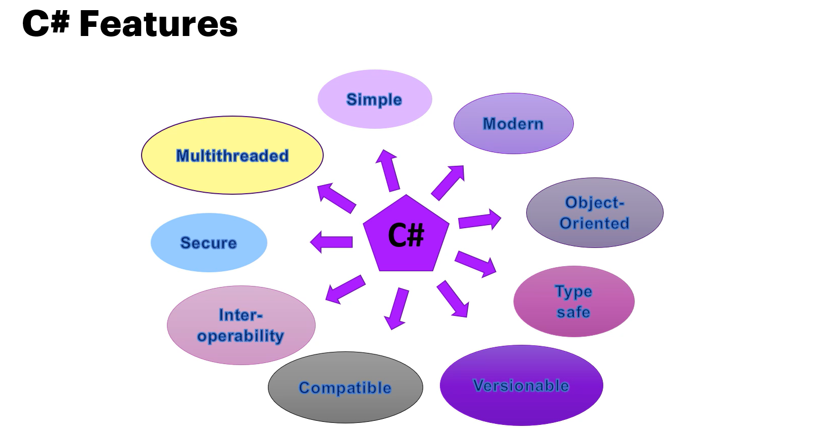
Figure: Core features of C#

- Simple: clean, readable syntax inspired by C/C++/Java, without their lower-level complexity (no manual pointers in normal code).
- Modern: regularly updated with contemporary language features (pattern matching, records, nullable reference types, async/await, LINQ).
- Object-Oriented: fully supports encapsulation, inheritance, and polymorphism, same OOP principles as Java.
- Type-safe: the compiler and CLR (via CTS) enforce that operations are only performed on compatible types, catching many errors at compile time.
- Versionable: language and runtime are designed to evolve without breaking existing compiled assemblies.
- Compatible: interoperates with other .NET languages thanks to CLS/CTS, and can call into unmanaged/native code when needed.
- Interoperability: can consume COM components and native libraries via interop services.
- Secure: benefits from CLR-enforced memory safety, type safety and code access security.
- Multithreaded: built-in language and library support for concurrent programming (Task, async/await, Thread, Parallel) - conceptually parallel to Java's java.util.concurrent and CompletableFuture.

15. Quick Reference: Java/Spring Boot ↔ .NET Equivalents
Since you're approaching .NET from a Java/Spring Boot background, this table is the fastest way to map what you already know onto the new ecosystem.
Java World | .NET World | Role
JVM | CLR | Runtime that executes intermediate bytecode/IL
.class bytecode | MSIL / CIL | CPU-independent intermediate language
.jar file | Assembly (.dll / .exe) | Compiled, deployable unit
java.*/javax.* core packages | BCL (Base Class Library) | Foundational built-in libraries
JDK | .NET SDK | Tools + compilers + runtime for development
JRE | .NET Runtime | Just what's needed to run a compiled app
Maven pom.xml / Gradle build.gradle | .csproj | Build/dependency definition for one module
Multi-module Maven/Gradle parent project | .sln (Solution) | Groups multiple projects/modules together
Spring Boot | ASP.NET Core | Web/API application framework
Spring Security | ASP.NET Core Identity / JWT middleware | Authentication & authorization
Hibernate / JPA | Entity Framework Core | ORM for database access
JVM's JIT compiler | CLR's JIT compiler | Compiles intermediate code to native code at runtime
Kotlin/Scala on the JVM | VB.NET/F# on the CLR | Alternate languages on the same runtime

End of notes

