DAY 10

**1)Create recipes for Update row, search row and get rows from google sheets(also add the error handling functionality)**

1.CREATE GOOGLE SHEET

LINK : <https://app.workato.com/recipes/48045157-googlesheet#recipe>

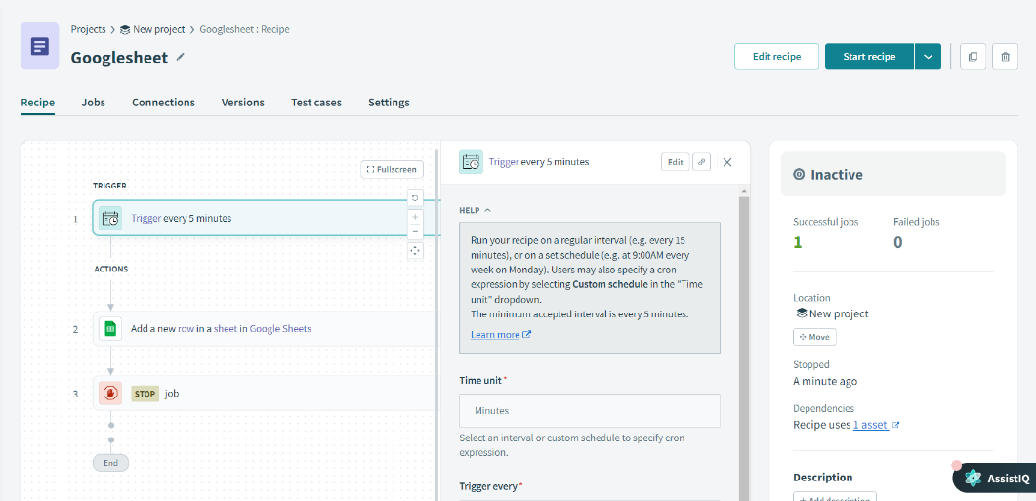

Output:

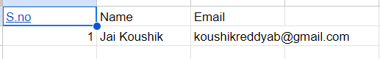

2.UPDATE GOOGLE SHEET

LINK: <https://app.workato.com/recipes/48045256-googlesheetupdate#recipe>

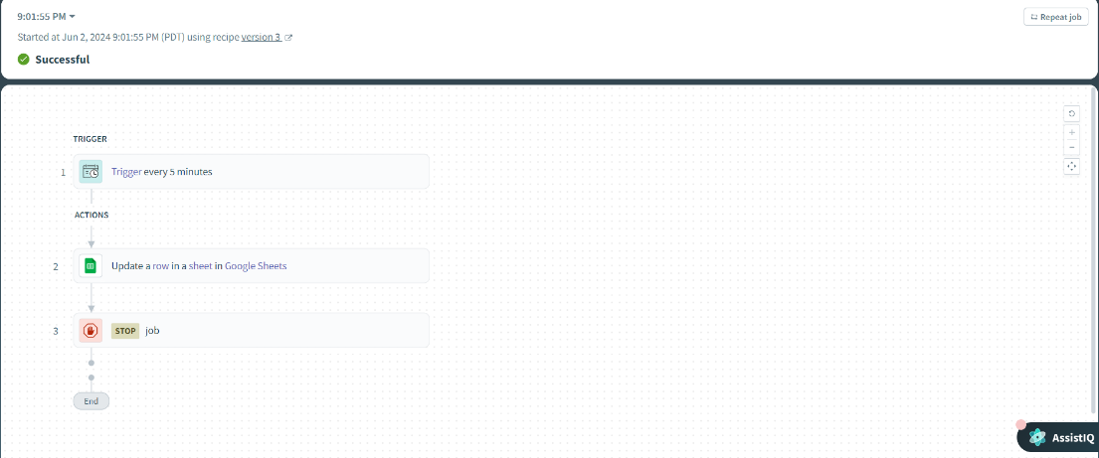

Output:

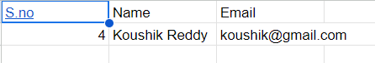

SHEET TO ACTIVEMQ

LINK :

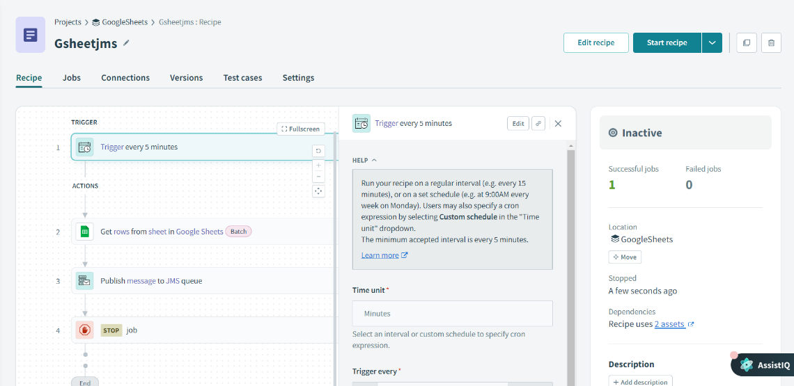

ERROR HANDLING

LINK : <https://app.workato.com/recipes/48175501-errorhandler#recipe>

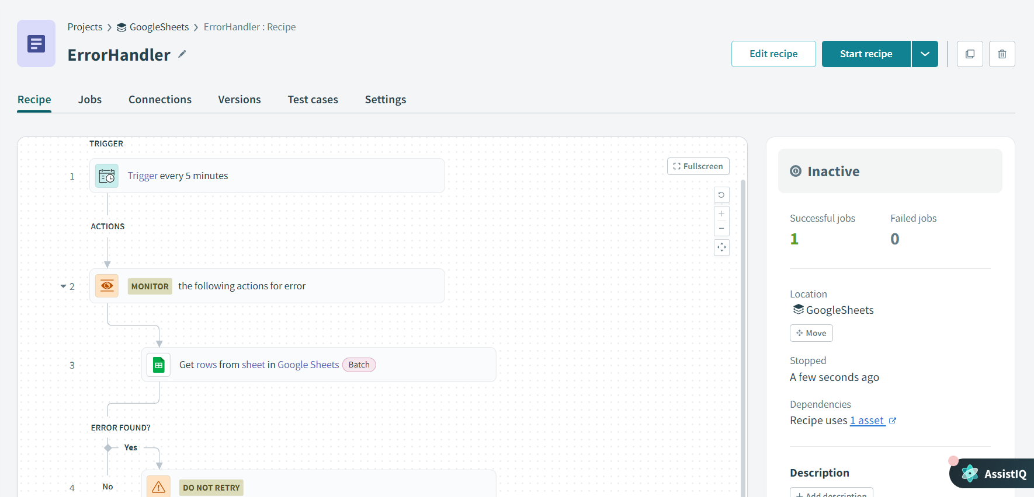

In this project, I used Workato to automate the creation of a Google Sheet from form responses. I started by logging into Workato and creating a new recipe with a trigger that activates when a new response is submitted through a Google Form. I then connected the

Google Sheets app and configured an action to create a new spreadsheet, specifying the name of the spreadsheet and the columns required (Email ID, Name, Age, Feedback, Preferred Contact Method). Additionally, I set up another action to insert the form data into the newly created Google Sheet. This automation ensures that every time a form is submitted, the responses are automatically captured and organized in a Google Sheet without any manual intervention. The setup also includes error handling to manage any issues that arise during the data insertion process, providing a seamless and reliable workflow.