DAY 6 AND 7

1.FILE TO FILE

LINK : https://app.workato.com/recipes/47849472-file_to_file#recipe

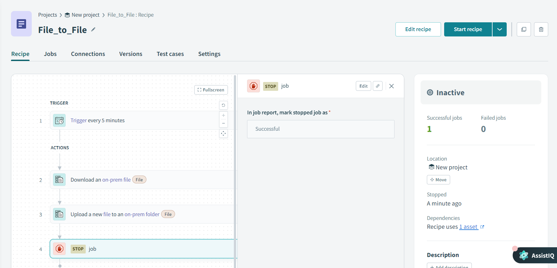

2.FTP TO FTP

LINK : <https://app.workato.com/recipes/47925673-ftp_to_ftp#recipe>

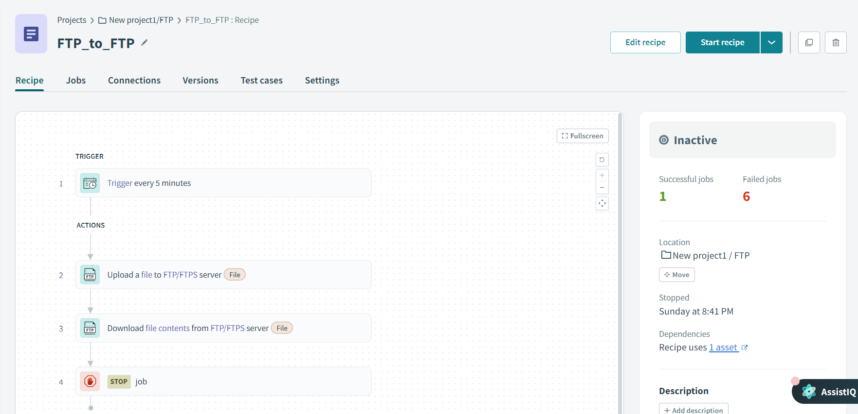

3.FTP TO FILE

LINK : <https://app.workato.com/recipes/48045265-ftp_to_file#recipe>

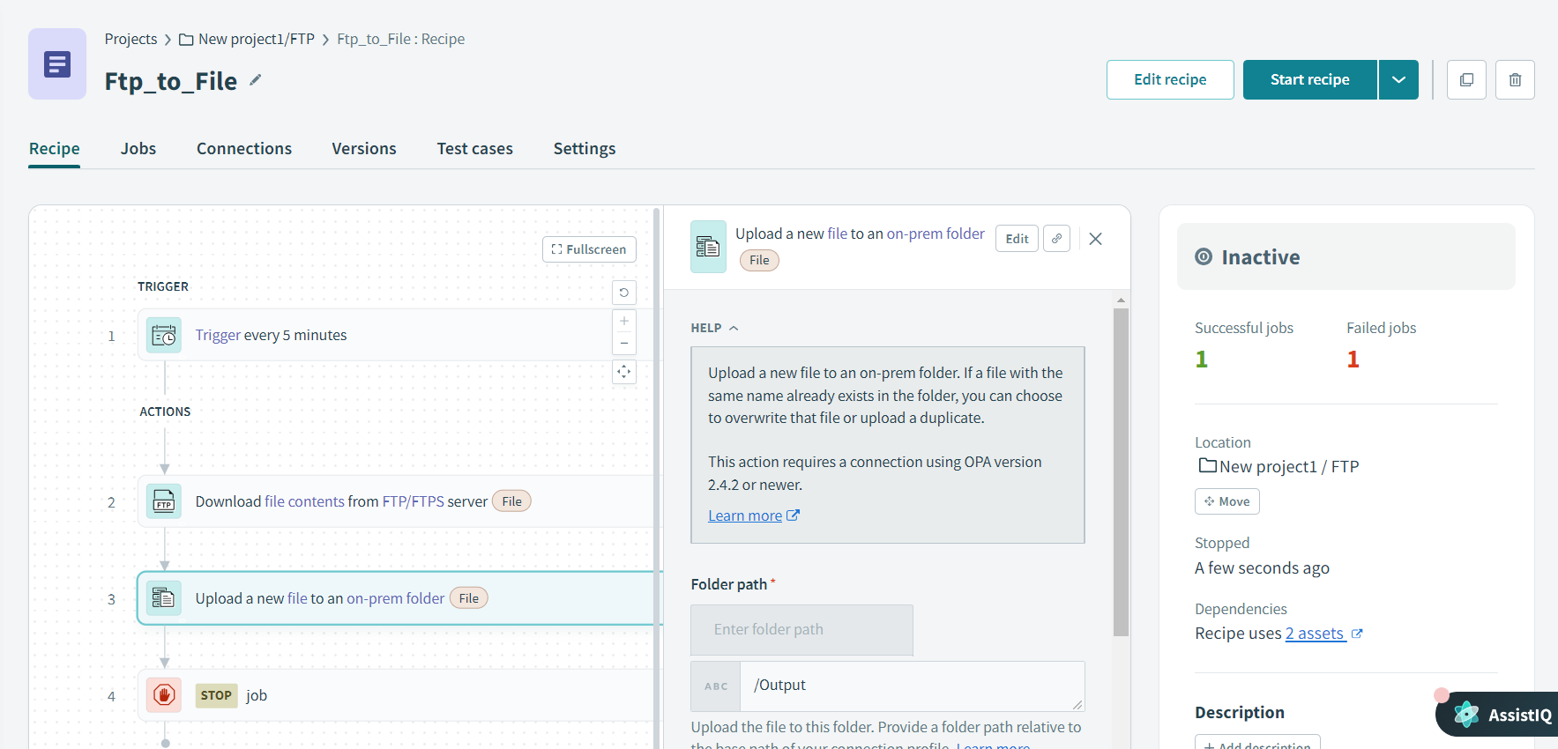

4.FILE TO FTP

LINK : <https://app.workato.com/recipes/48155048-file_to_ftp#recipe>

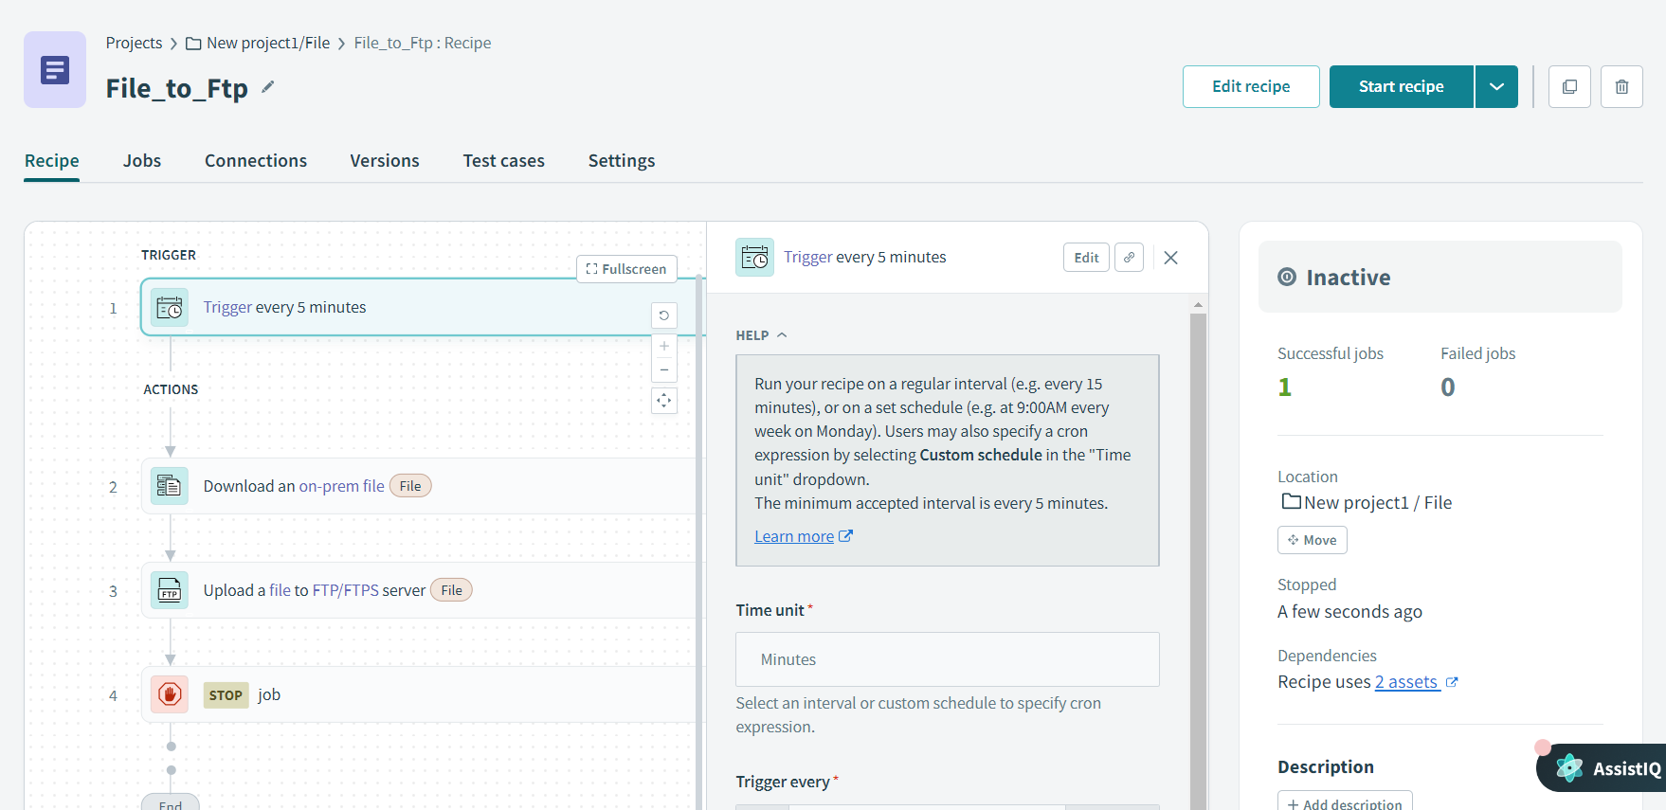

5.FILE TO ACTIVEMQ

LINK : <https://app.workato.com/recipes/48045956-file-to-activemq#recipe>



6.ACTIVEMQ TO FTP

LINK : <https://app.workato.com/recipes/48155317-activemq_to_ftp#recipe>

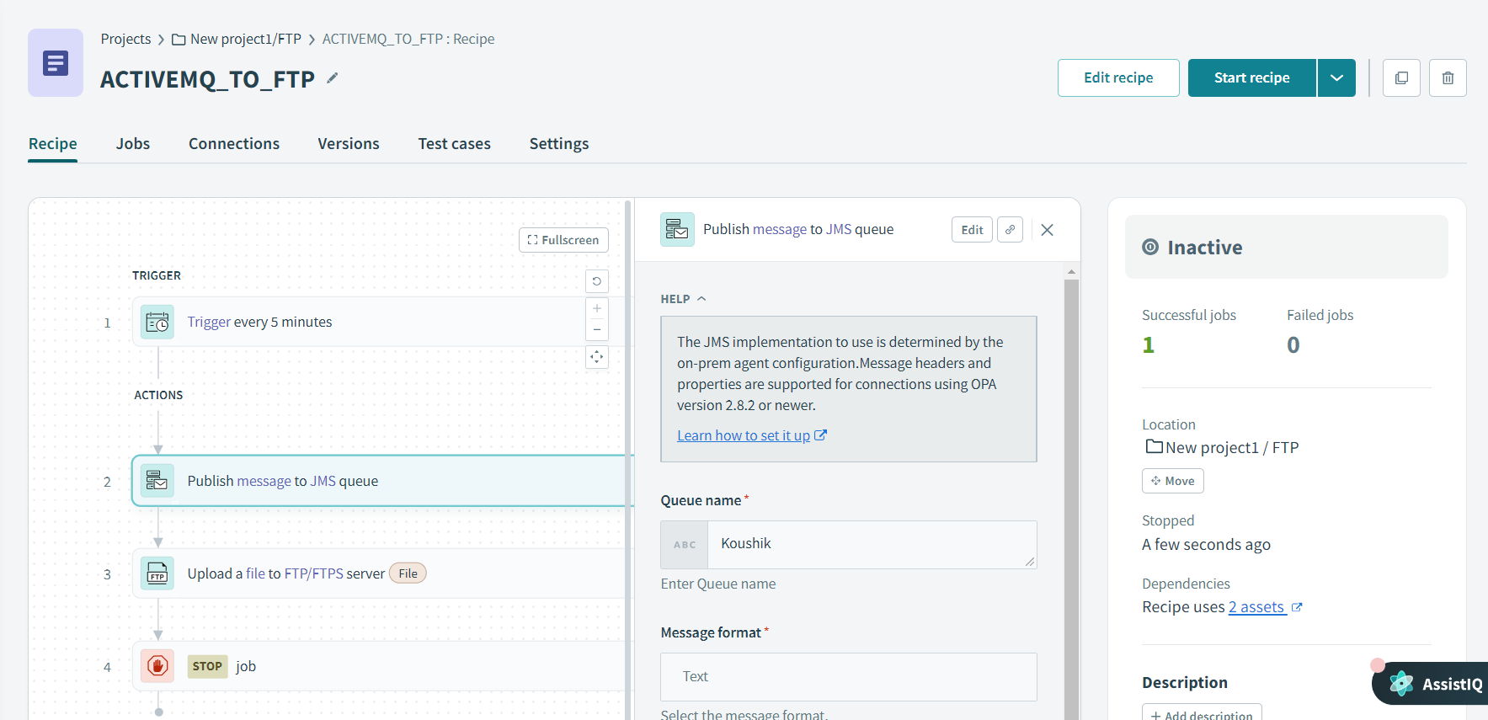

7.ACTIVEMQ TO MAIL

LINK : <https://app.workato.com/recipes/48155743-activemq_to_email#recipe>

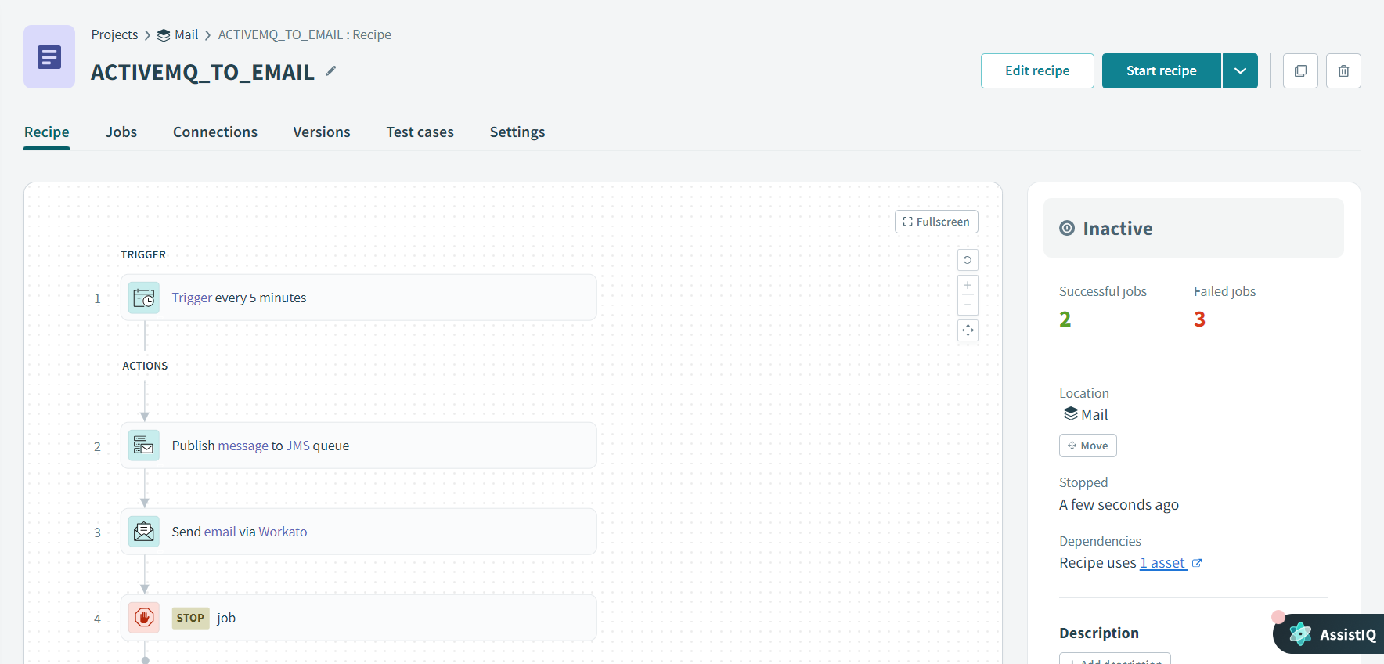

8.FILE TO MAIL

LINK : <https://app.workato.com/recipes/48045615-file_to_mail#recipe>



9.XML TRANSFORMATION FILE INSTEAD OF JSON

LINK : <https://app.workato.com/recipes/48158757-xmltransform#recipe>

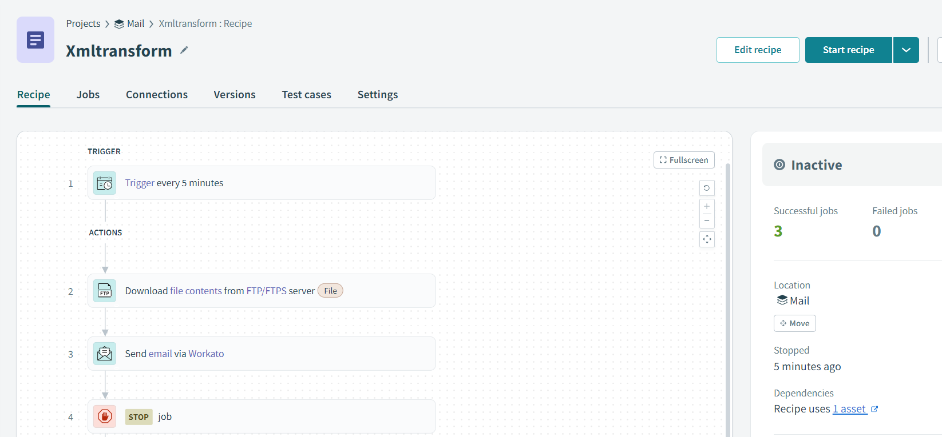

OUTPUT:

