DAY 9

1.CREATE

LINK : <https://app.workato.com/recipes/48045483-create#recipe>

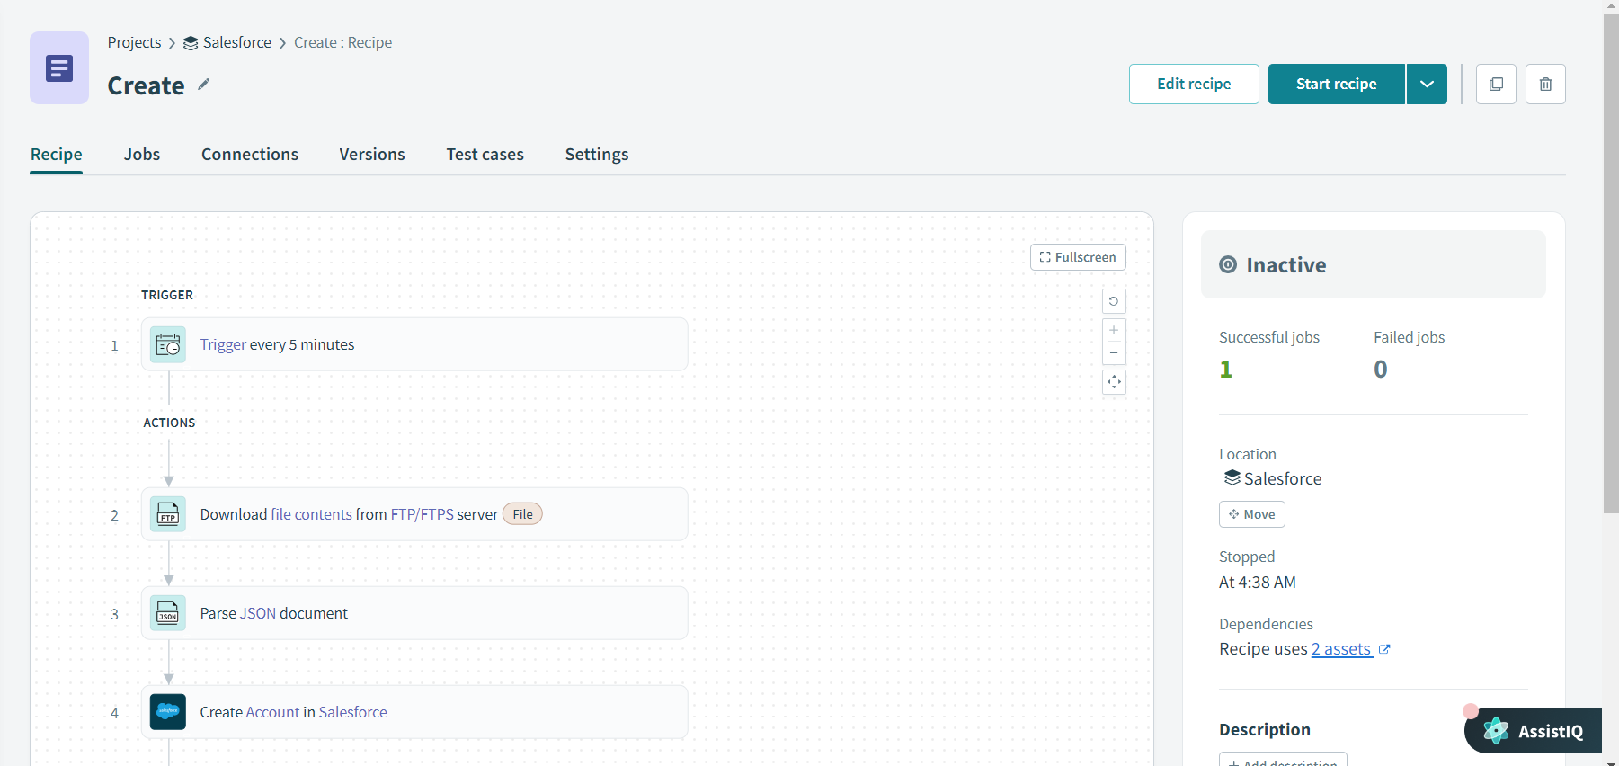

Output:

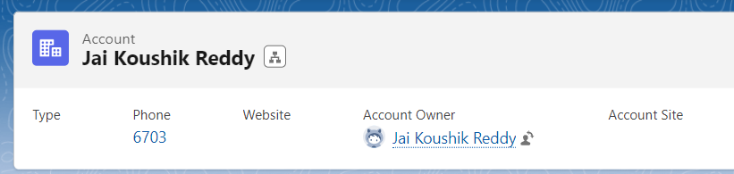

2.READ

LINK : <https://app.workato.com/recipes/48171925-read#recipe>

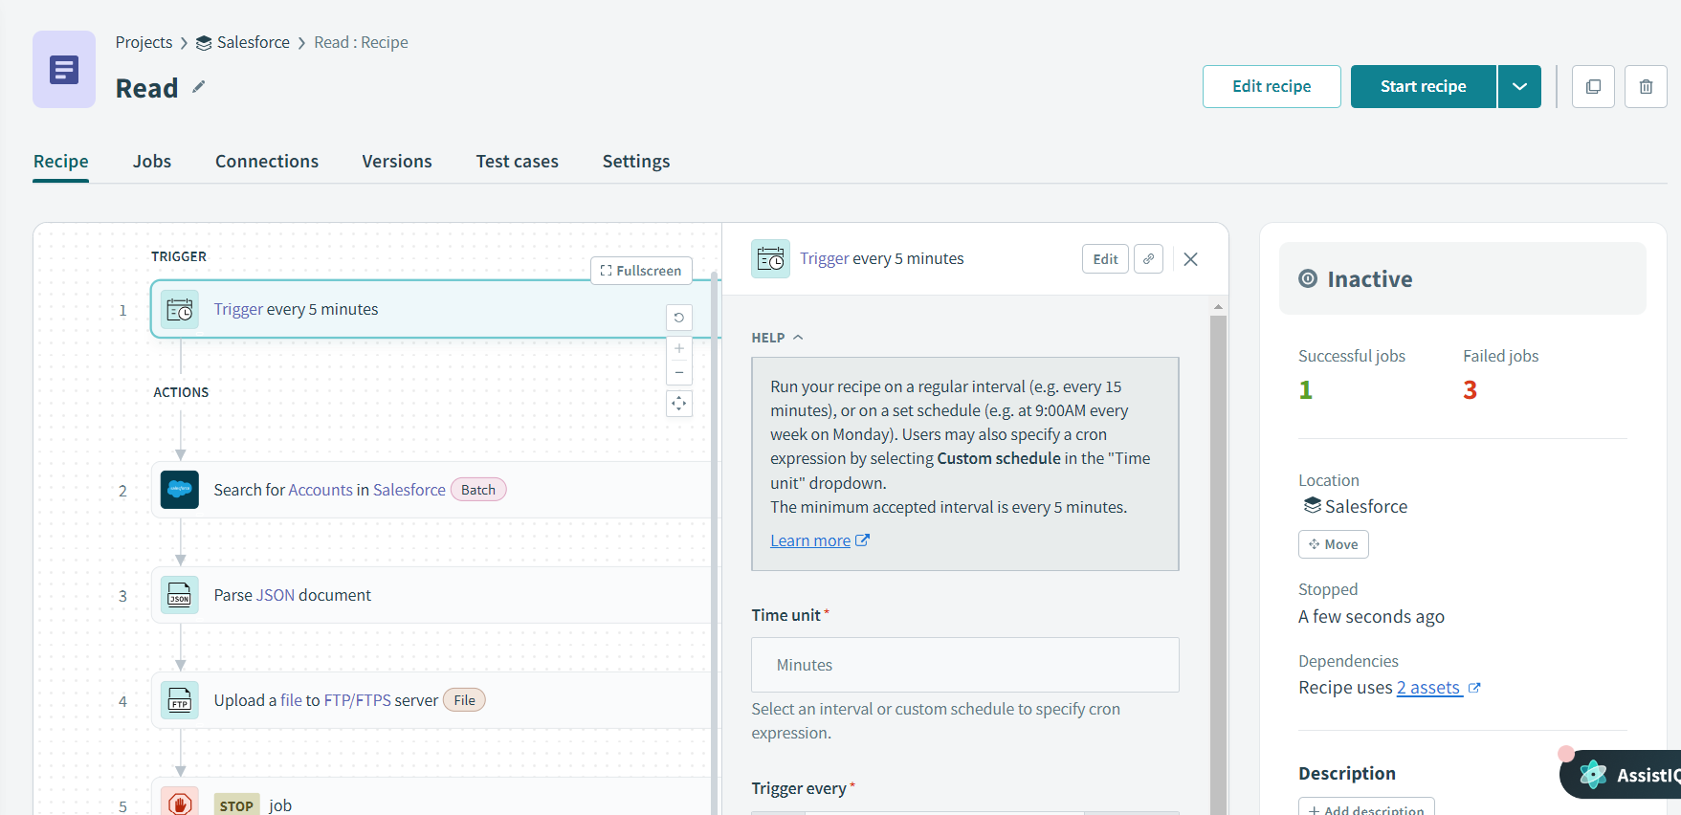

Output:

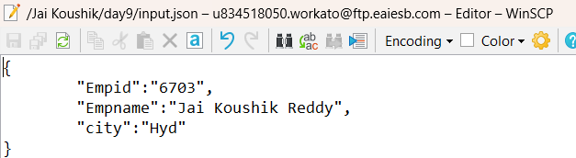

3.UPDATE:

LINK : <https://app.workato.com/recipes/48173513-update#recipe>

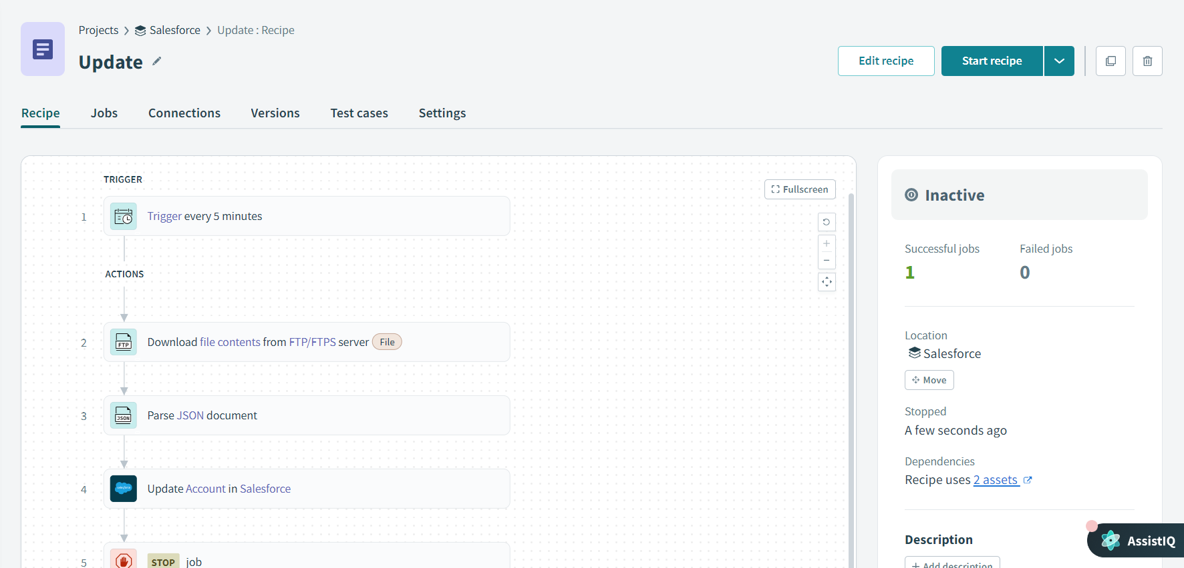

Output:

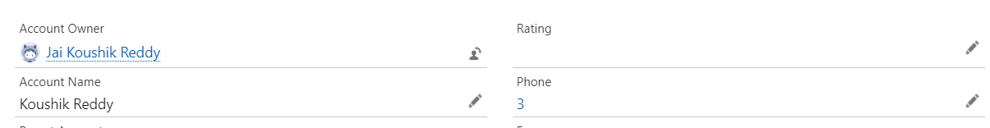

4.DELETE - LINK : <https://app.workato.com/recipes/48173880-delete#recipe>

