DAY 8

1.CREATE

LINK : <https://app.workato.com/recipes/48162472-create#recipe>

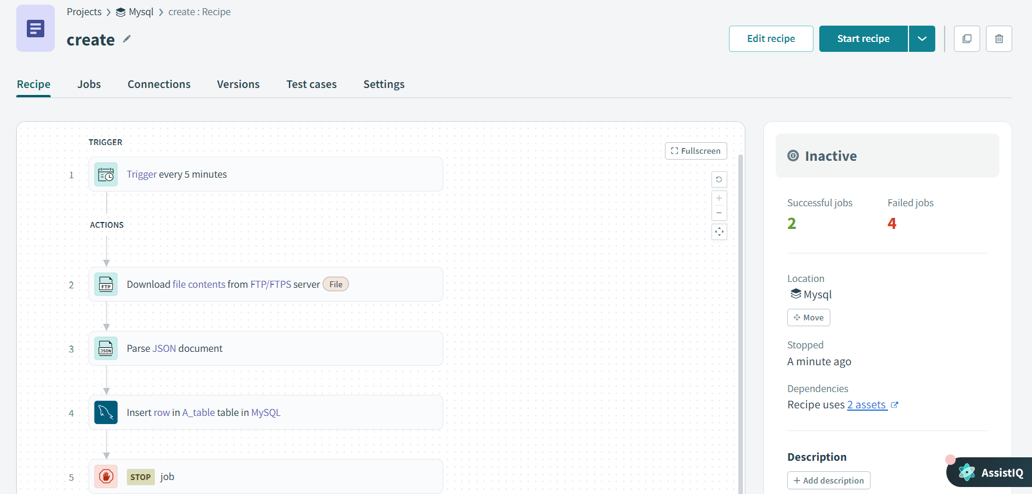

Output:



2.READ

LINK : <https://app.workato.com/recipes/48164172-read#recipe>

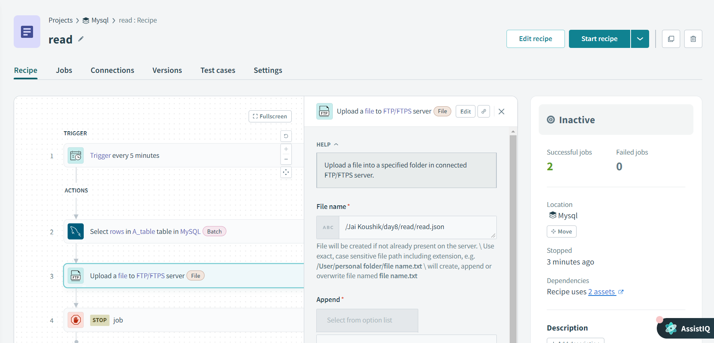

Output:



3.UPDATE

LINK : <https://app.workato.com/recipes/48167882-update#recipe>

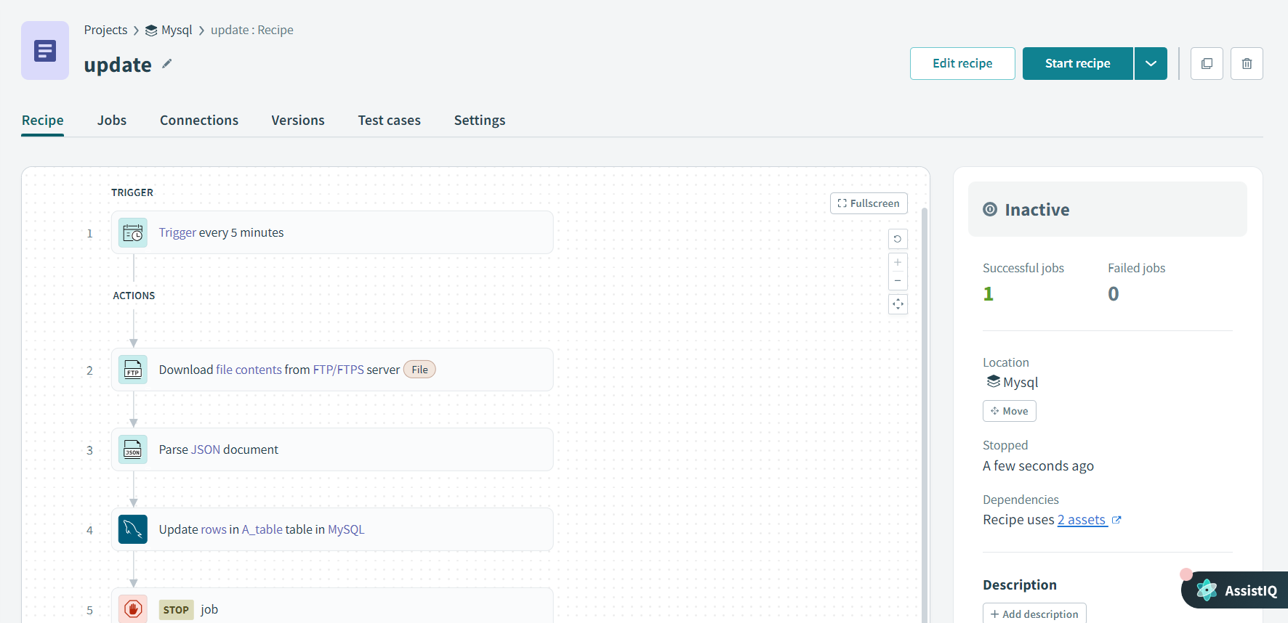

Output:



4.DELETE

LINK : <https://app.workato.com/recipes/48168377-delete#recipe>

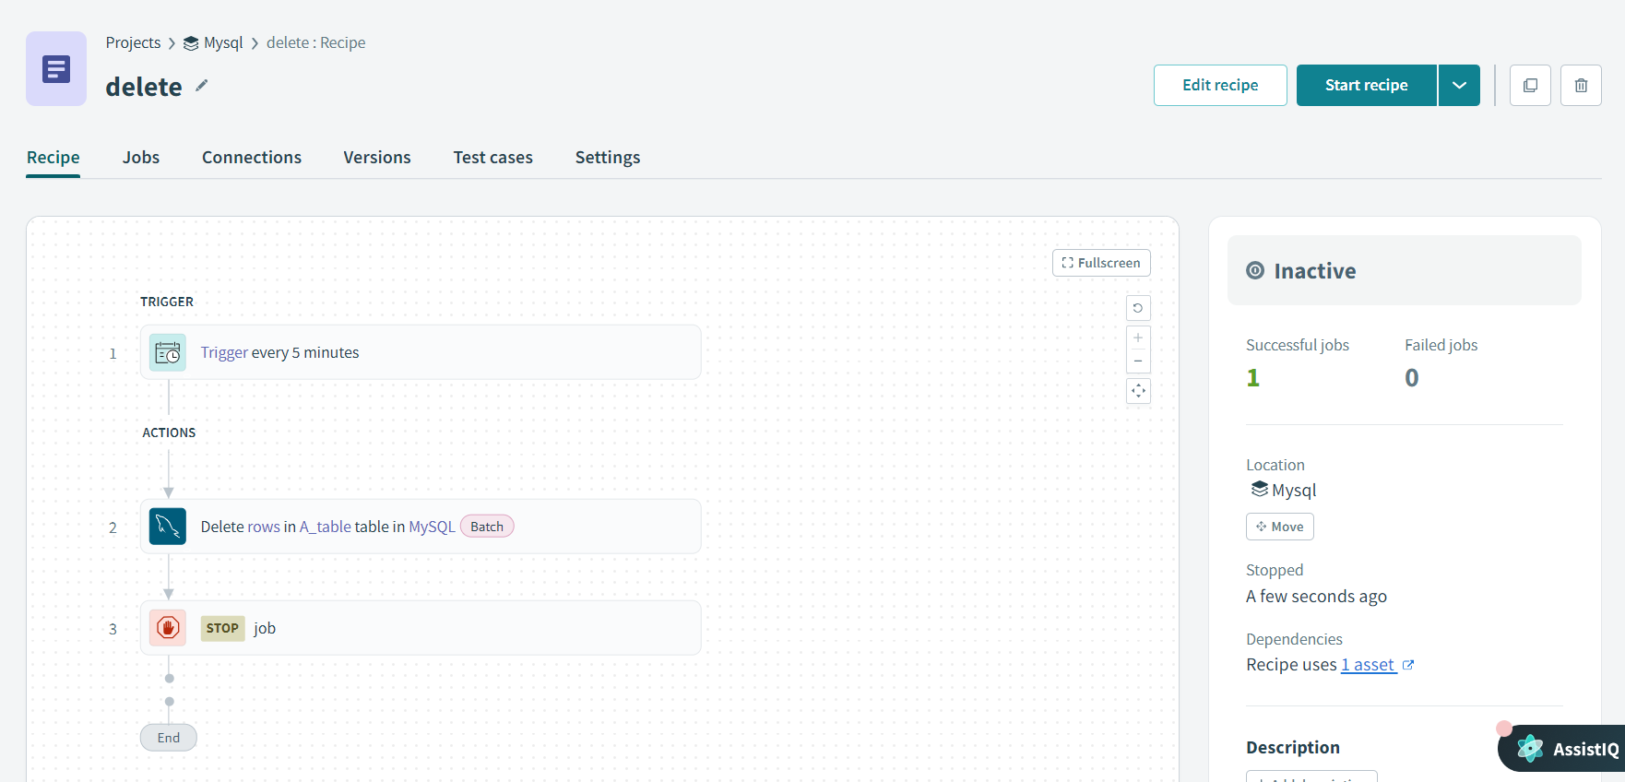

MONGODB

1.CREATE

LINK : <https://app.workato.com/recipes/48226181-create#recipe>

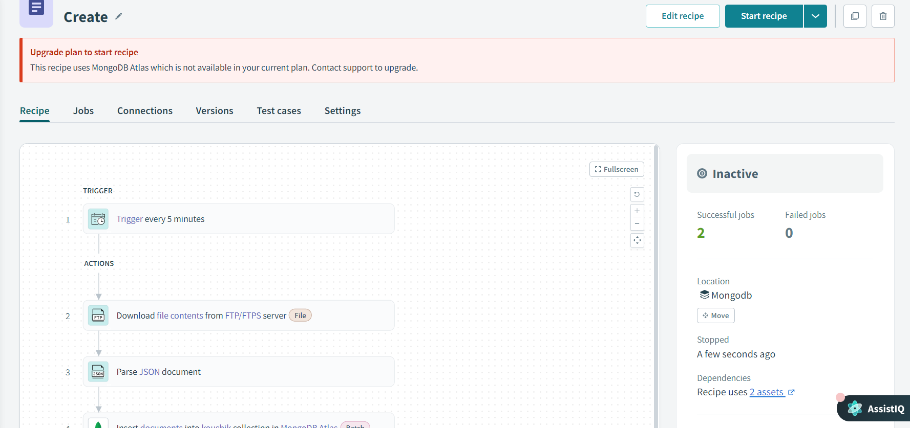

Output:

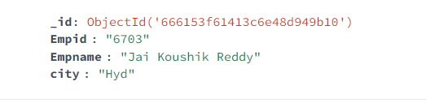

2.READ

LINK : <https://app.workato.com/recipes/48232555-read/test?job_id=j-AMgJdRXs-8coGom>

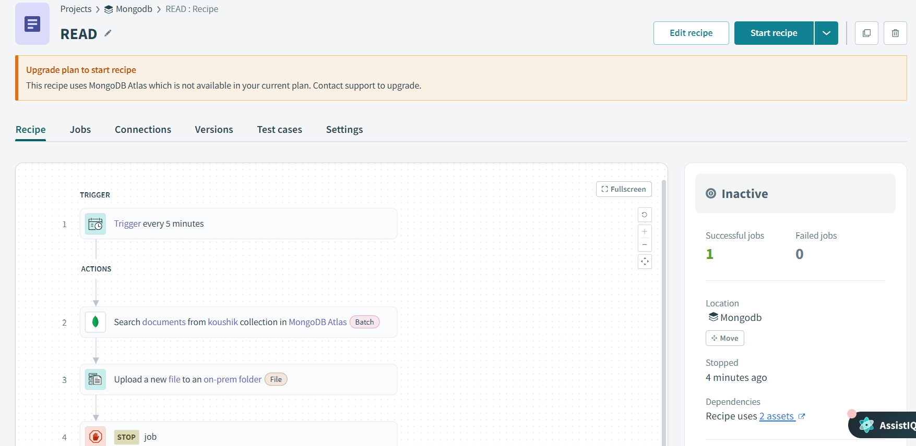

Output:

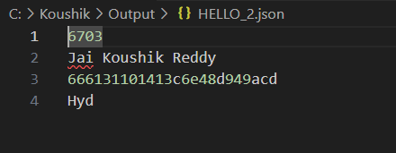

3.UPDATE

LINK : <https://app.workato.com/recipes/48233057-update#recipe>

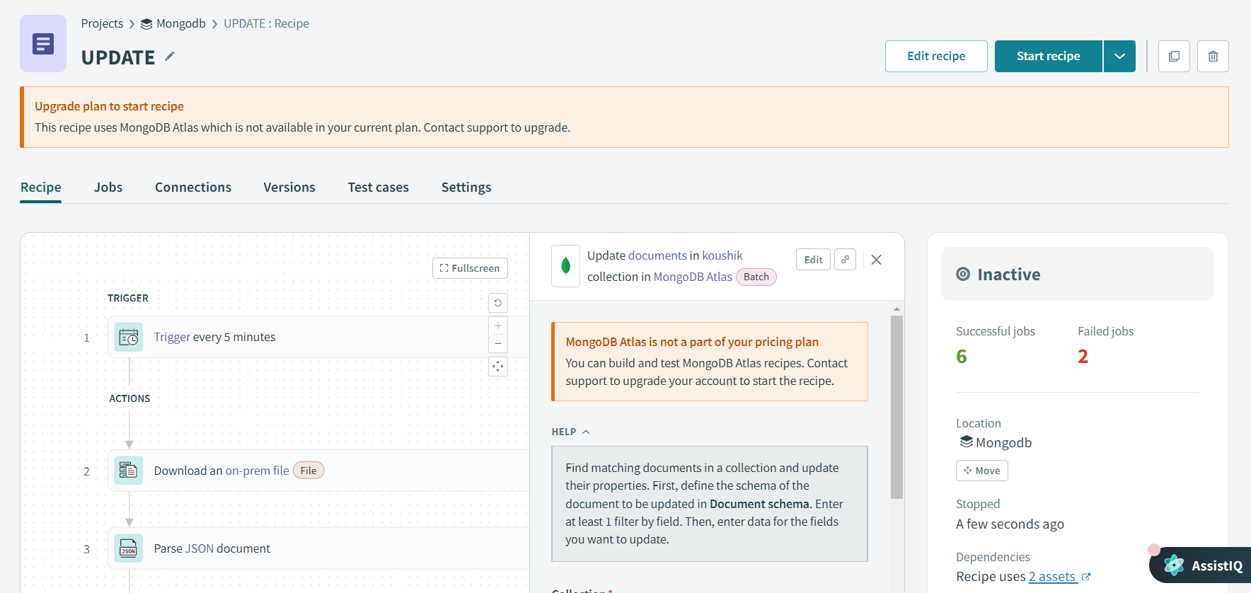

Output:

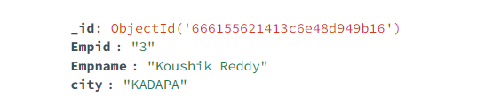

4.DELETE:

LINK : <https://app.workato.com/recipes/48234511-delete#recipe>

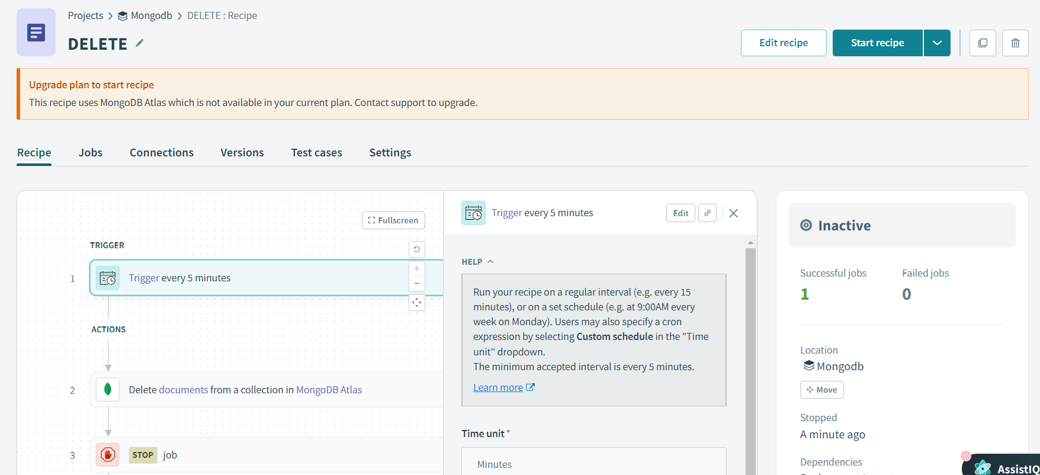

Output:

