Day 9 - Amazon S3

1.PUSH FILE TO AWS

LINK : <https://app.workato.com/recipes/48234688-push#recipe>

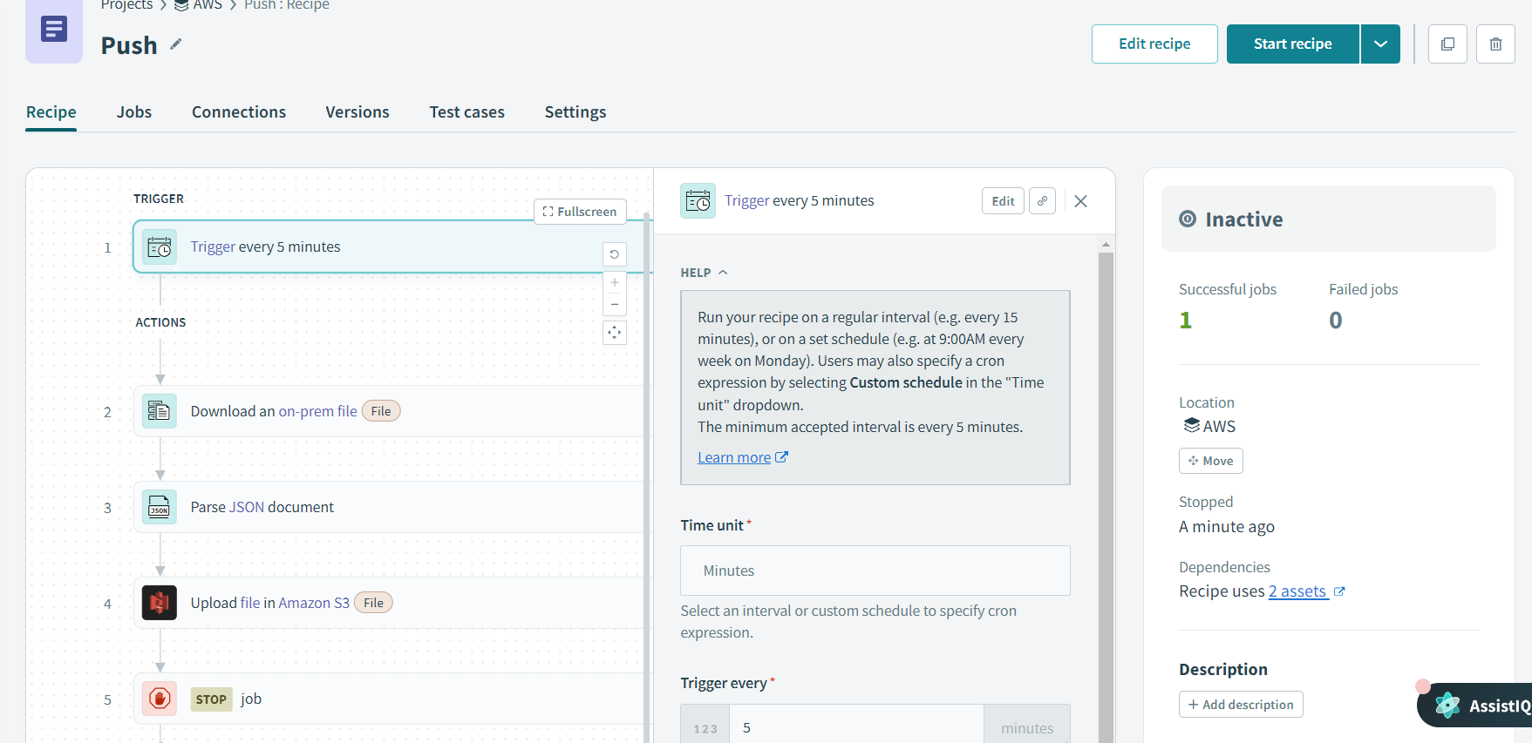

Output:

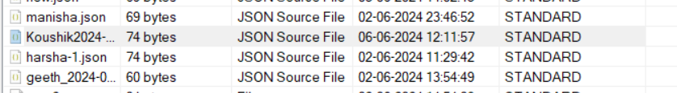

2.READ

LINK : <https://app.workato.com/recipes/48235025-read#recipe>

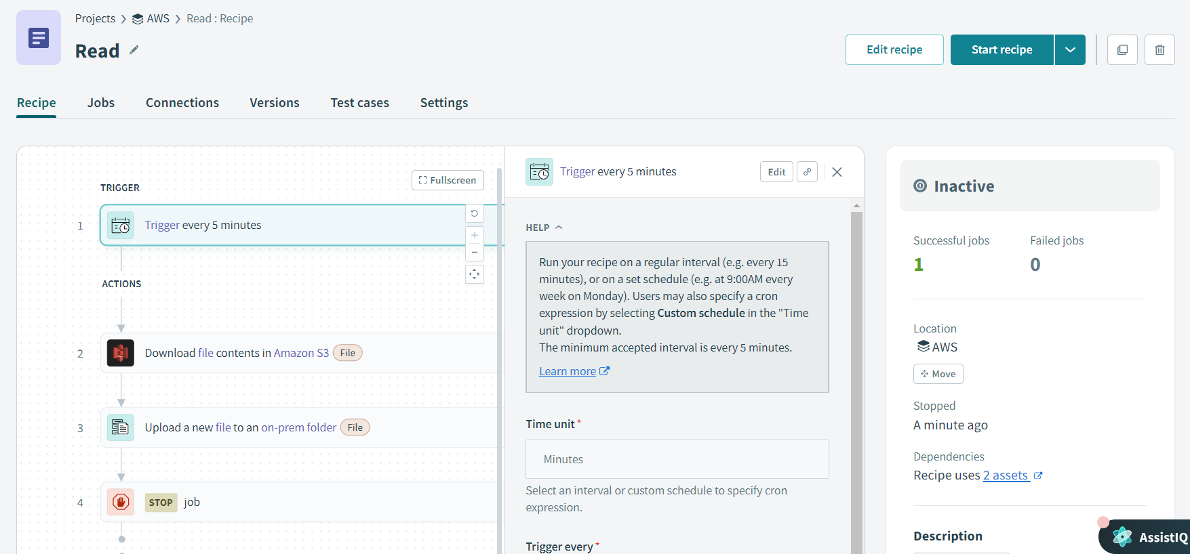

Output:

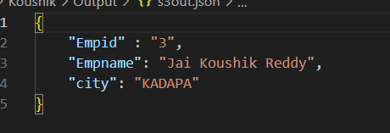

3.DELETE

LINK : <https://app.workato.com/recipes/48235243-delete#recipe>

