

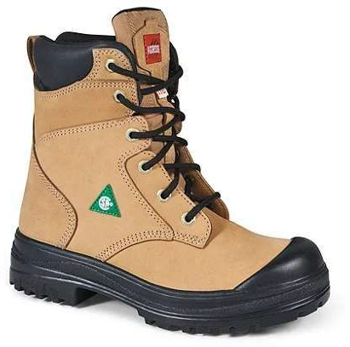
This authorization will be redeemed by the Corporation of the City of Kitchener from a supplier with whom the Corporation has a contract for provision of safety footwear, provided that the authorization has been surrendered by an employee of the Corporation at the time of purchasing CSA approved safety footwear, and that the terms of the contract have been met.
Employee Name:
PO Number:
Employee ID:
v_name
v_po
v_eid
Maximum Value:
Expiry Date:
v_value
v_epy_date

The employee must provide valid photo identification to the vendor upon purchase of the safety footwear.

Note: This voucher must NOT be photocopied and may be used to purchase one or more pair of safety footwear only for the designated employee up to the voucher limit. The voucher may only be used once. Any unauthorized purchase will require the employee to reimburse the Corporation of the City of Kitchener for the unauthorized amount.

Employee Signature:

For Internal Use Only: | V_folder
Date Voucher Issued: | v_issued_date
Time Issued: | v_issued_time
Division: | v_division
Cost Centre: | v_cost_centre
GL: | v_gl
Issued By: | v_issued_by
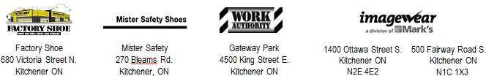
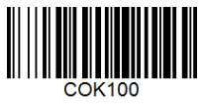


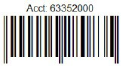
Vendors: If you have any questions, call Supply Services, Mon-Fri 8:30am-5pm, (519) 741-2200 ext. 7217

