

Employee Name:
PO Number:
Employee ID:
Johnathan Doe
PO-998877
EID-112233

Maximum Value:
Expiry Date:
$275.50
September 20, 2026

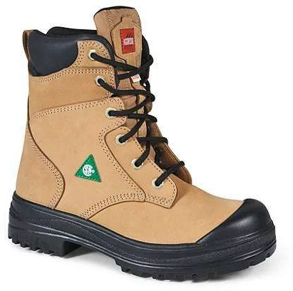
This authorization will be redeemed by the Corporation of the City of Kitchener from a supplier with whom the Corporation has a contract for provision of safety footwear, provided that the authorization has been surrendered by an employee of the Corporation at the time of purchasing CSA approved safety footwear, and that the terms of the contract have been met.

The employee must provide valid photo identification to the vendor upon purchase of the safety footwear.

Note: This voucher must NOT be photocopied and may be used to purchase one or more pair of safety footwear only for the designated employee up to the voucher limit. The voucher may only be used once. Any unauthorized purchase will require the employee to reimburse the Corporation of the City of Kitchener for the unauthorized amount.

Employee Signature:

For Internal Use Only: | c:\documents\awards
Date Voucher Issued: | September 20, 2025
Time Issued: | 02:15 PM
Division: | Advanced Tech Division
Cost Centre: | CC-98765
GL: | GL-54321
Issued By: | Ms. Supervisor

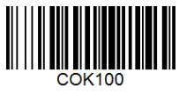


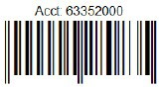
Vendors: If you have any questions, call Supply Services, Mon-Fri 8:30am-5pm, (519) 741-2200 ext. 7217

