MICROSERVICES

A micro service architecture – a variant of the service-oriented architecture structural style – arranges an application as a collection of loosely-coupled services. In a micro services architecture, services are fine-grained and the protocols are lightweight.

Micro services work independently of one another but remain loosely connected. Unlike the monolithic style, the micro services approach to software development allows for better scalability. You can expand applications based on user demand without affecting other micro services.

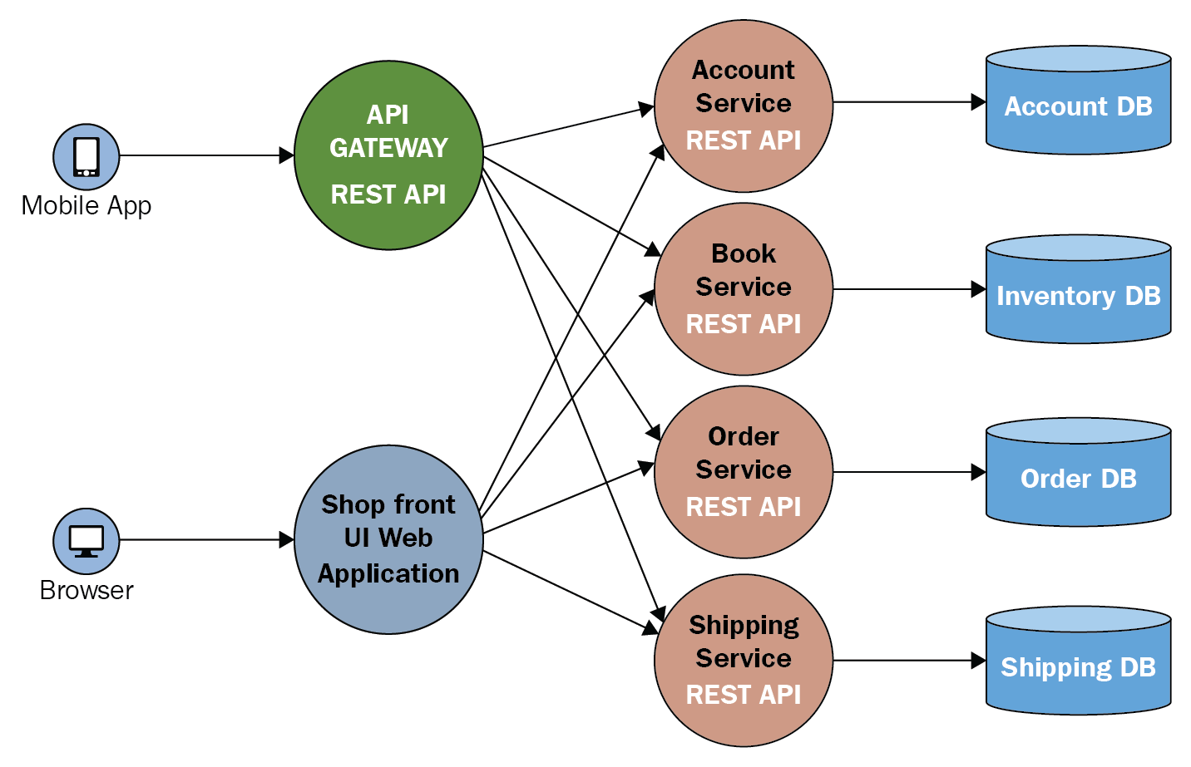

Advantages
- Micro services are self-contained, independent deployment module.
- The cost of scaling is comparatively less than the monolithic architecture.
- Micro services are independently manageable services. It can enable more and more services as the need arises. It minimizes the impact on existing service.
- It is possible to change or upgrade each service individually rather than upgrading in the entire application.
- Micro services allows us to develop an application which is organic (an application which latterly upgrades by adding more functions or modules) in nature.
- It enables event streaming technology to enable easy integration in comparison to heavyweight interposes communication.
- Micro services follows the single responsibility principle.
- The demanding service can be deployed on multiple servers to enhance performance.
- Less dependency and easy to test.
- Dynamic scaling.
- Faster release cycle.

Disadvantages

- Micro services has all the associated complexities of the distributed system.
- There is a higher chance of failure during communication between different services.
- Difficult to manage a large number of services.
- The developer needs to solve the problem, such as network latency and load balancing.
- Complex testing over a distributed environment.

Monolithic

Monolith means composed all in one piece. The Monolithic application describes a single-tiered software application in which different components combined into a single program from a single platform. Components can be

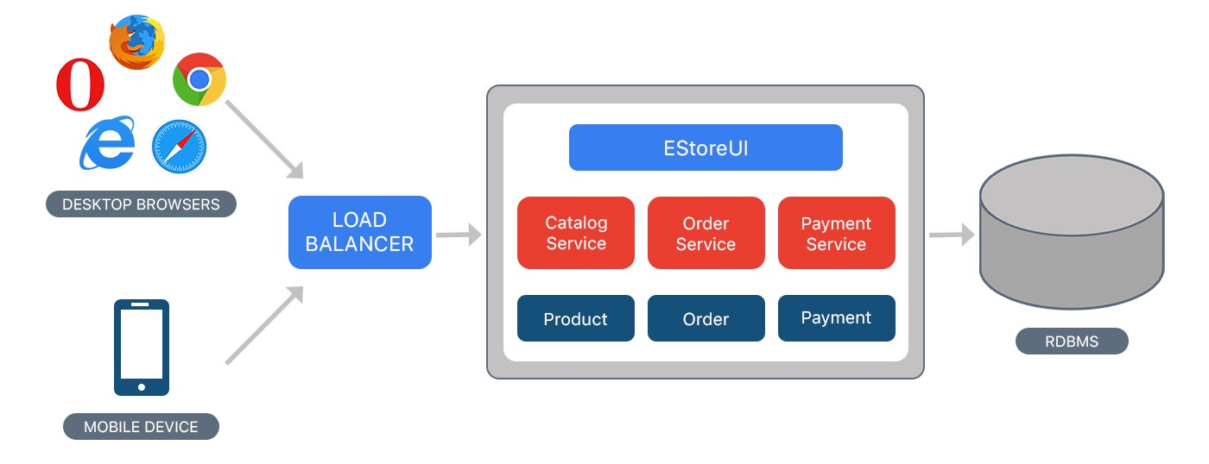

- Authorization — responsible for authorizing a user
- Presentation — responsible for handling HTTP requests and responding with either HTML or JSON/XML (for web services APIs).
- Business logic — the application’s business logic.
- Database layer — data access objects responsible for accessing the database.
- Application integration — integration with other services (e.g. via messaging or REST API). Or integration with any other Data sources.
- Notification module — responsible for sending email notifications whenever needed.
Advantages
- Simple to develop — At the beginning of a project it is much easier to go with Monolithic Architecture.
- Simple to test. For example, you can implement end-to-end testing by simply launching the application and testing the UI with Selenium.
- Simple to deploy. You have to copy the packaged application to a server.
- Simple to scale horizontally by running multiple copies behind a load balancer.

Disadvantages
- Maintenance — If Application is too large and complex to understand entirely, it is challenging to make changes fast and correctly.
- The size of the application can slow down the start-up time.
- You must redeploy the entire application on each update.
- Monolithic applications can also be challenging to scale when different modules have conflicting resource requirements.
- Reliability — Bug in any module (e.g. memory leak) can potentially bring down the entire process. Moreover, since all instances of the application are identical, that bug impact the availability of the entire application
- Regardless of how easy the initial stages may seem, Monolithic applications have difficulty to adopting new and advance technologies. Since changes in languages or frameworks affect an entire application, it requires efforts to thoroughly work with the app details, hence it is costly considering both time and efforts.

CASE STUDY

TWITTER

Twitter is an American micro blogging and social networking service on which users post and interact with messages known as "tweets". Registered users can post, like, and re tweet tweets, but unregistered users can only read those that are publicly available.

WHY TWITTER USE MICROSERVICE

Microservices enable IT organizations to be more agile. And build more scalable applications. Microservices translate into faster development and change cyclesOriginally, Twitter ran their public APIs through a single Ruby-on-Rails application (“Monorail”), which had grown into one of the largest Rails codebases in the world. And so it was increasingly difficult to update. By 2014, Twitter went the route of microservices, migrating the API service to a set of 14 microservices, running on an internal Java Virtual Machine (JVM)-based framework (“Maccaws”).

Twitter Architecture

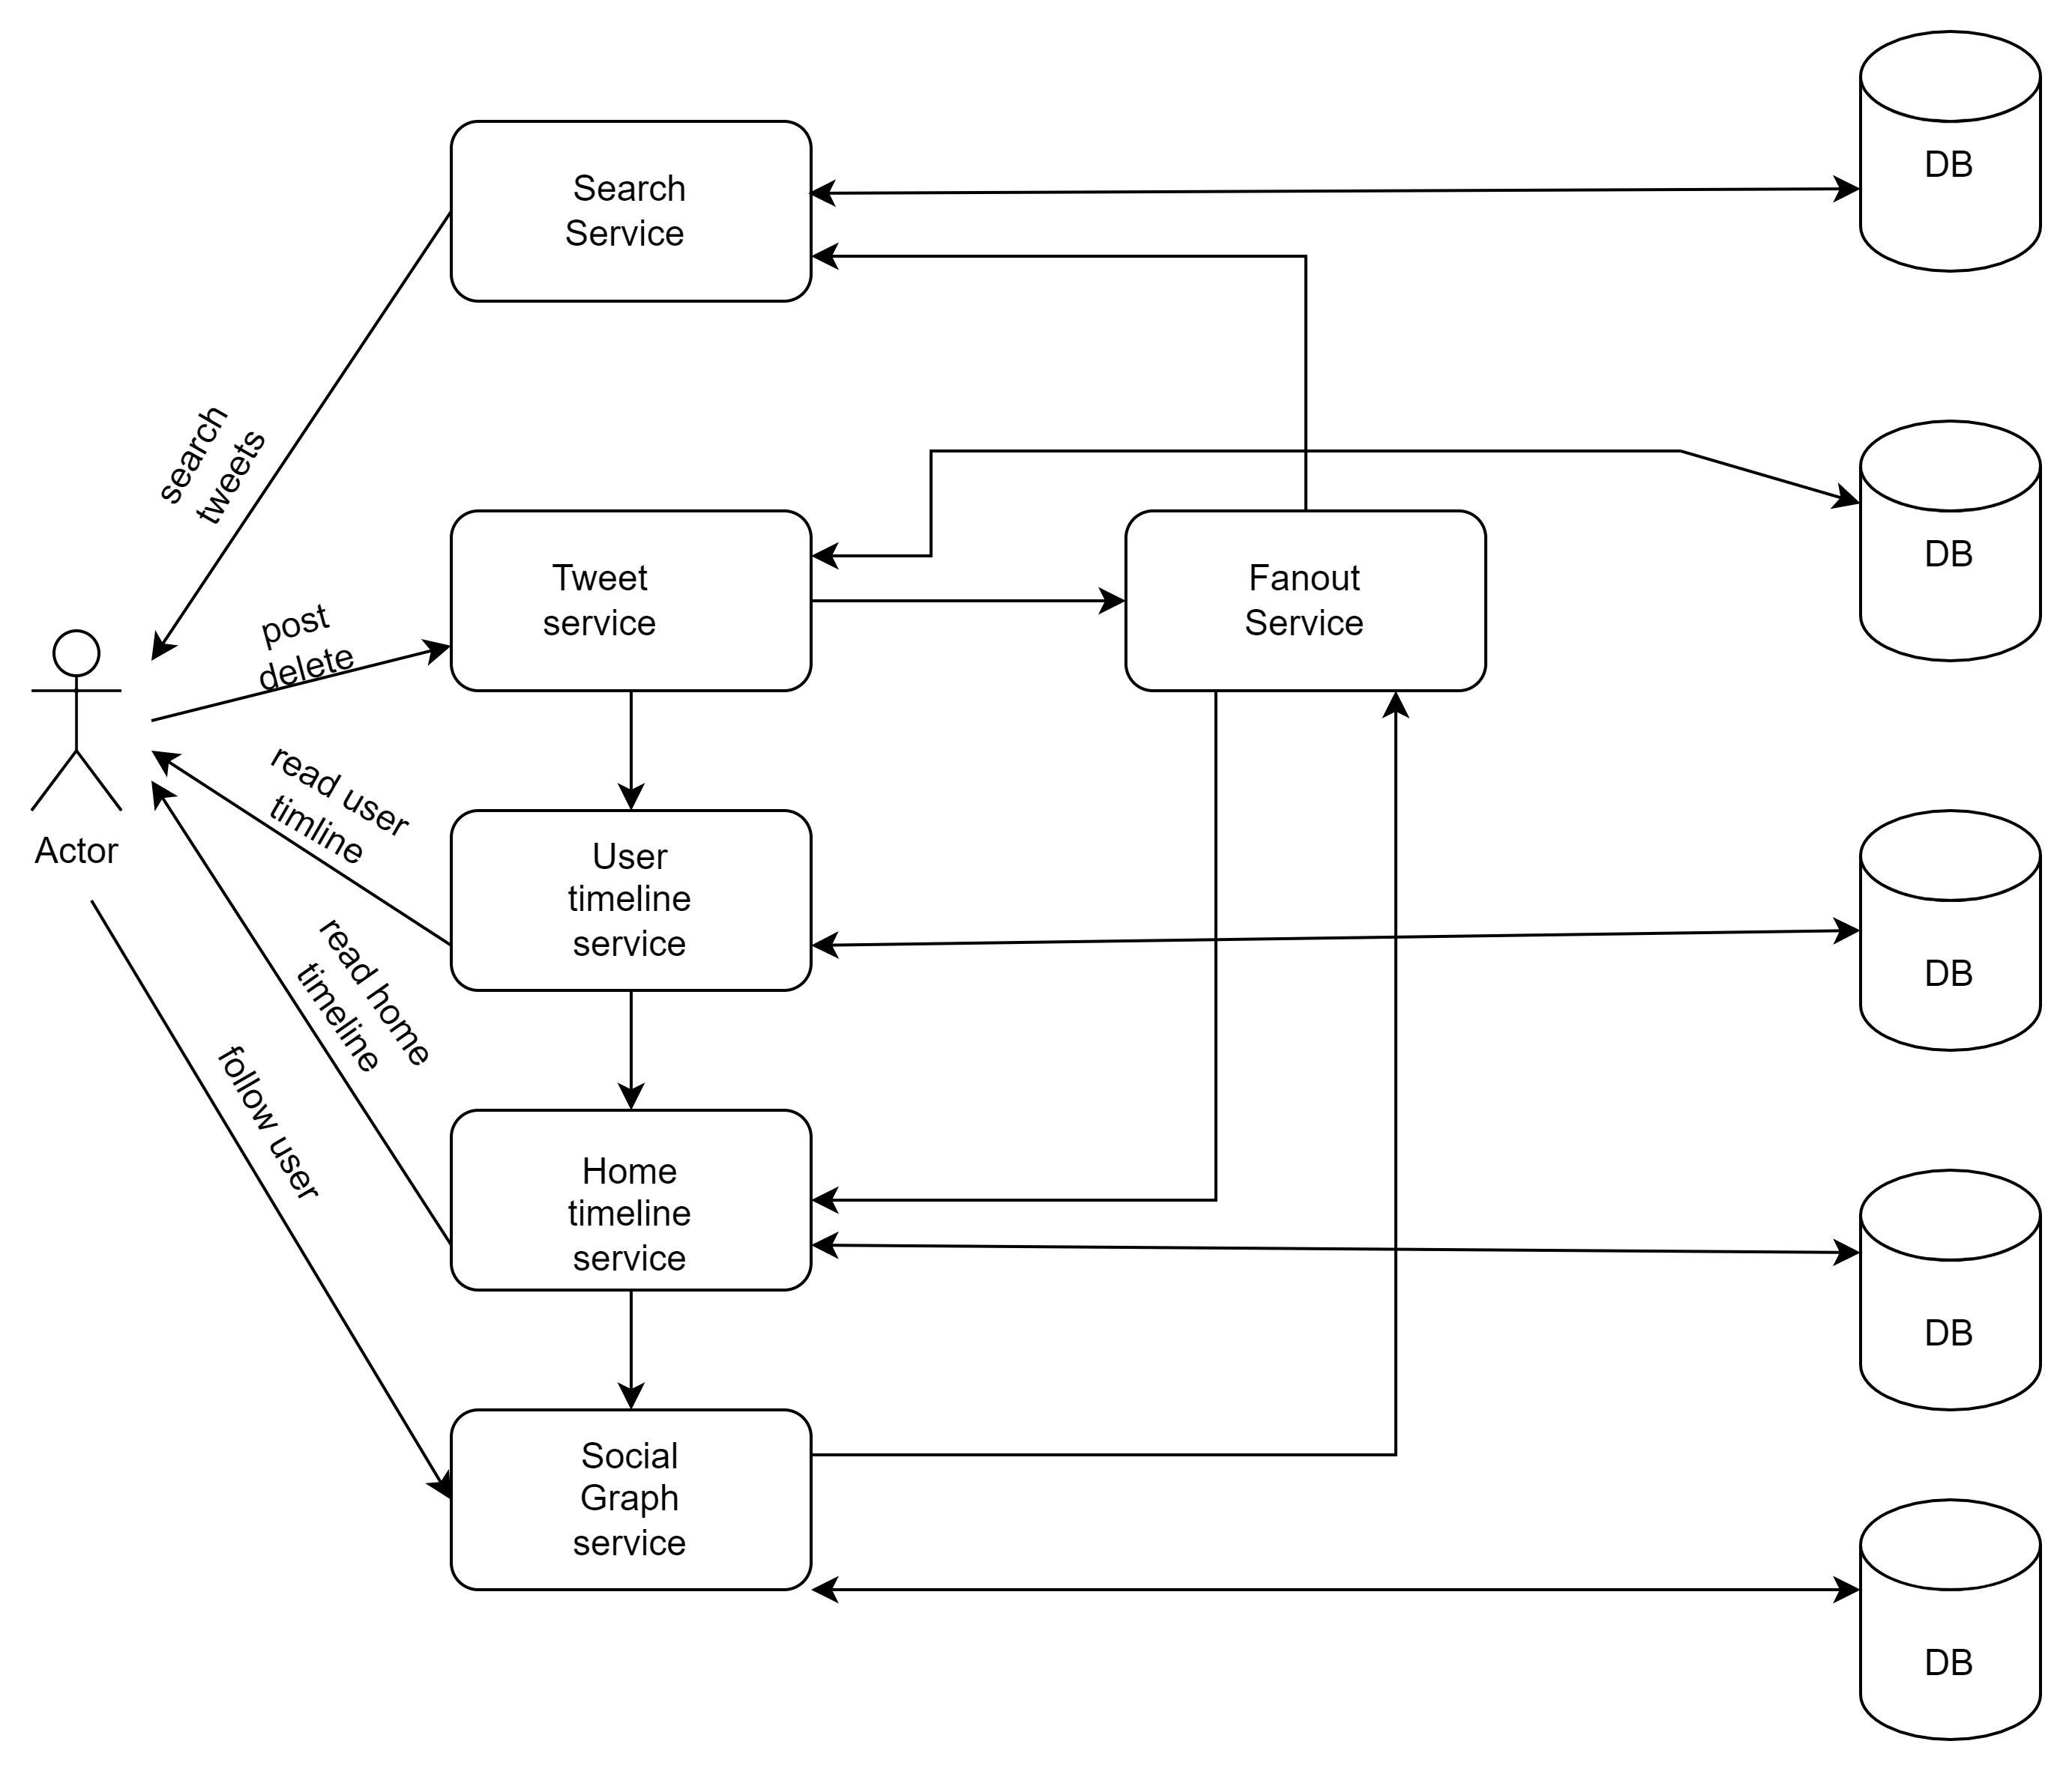
Twitter micro service architecture

References

Microservice

https://en.wikipedia.org/wiki/Microservices
https://www.logicmonitor.com/blog/what-are-microservices

Monolithic

https://medium.com/koderlabs/introduction-to-monolithic-architecture-and-microservices-architecture-b211a5955c63

Twitter

https://thenewstack.io/how-airbnb-and-twitter-cut-back-on-microservice-complexities/

https://en.wikipedia.org/wiki/Twitter

