# ASSIGNMENT 2

1. Git Hub Finder:

Source:

**Login.html**

<!doctype html>

<!--[if lt IE 7]> <html class="no-js lt-ie9 lt-ie8 lt-ie7" lang=""> <![endif]-->

<!--[if IE 7]> <html class="no-js lt-ie9 lt-ie8" lang=""> <![endif]-->

<!--[if IE 8]> <html class="no-js lt-ie9" lang=""> <![endif]-->

<!--[if gt IE 8]><!-->

<html class="no-js" lang="">

<!--<![endif]-->

<head>

<meta charset="utf-8">

<meta http-equiv="X-UA-Compatible" content="IE=edge,chrome=1">

<title>Finder for Github Users</title>

<meta name="description" content="">

<meta name="viewport" content="width=device-width, initial-scale=1">

<link rel="apple-touch-icon" href="apple-touch-icon.png">

<link rel="stylesheet" href="css/bootstrap.min.css">

<link rel="stylesheet" href="css/basscss.min.css">

<link rel="stylesheet" href="css/main.css">

<script src="js/vendor/modernizr-2.8.3-respond-1.4.2.min.js"></script>

</head>

<body>

<!--[if lt IE 8]>

<p class="browserupgrade">You are using an <strong>outdated</strong> browser. Please <a href="http://browsehappy.com/">upgrade your browser</a> to improve your experience.</p>

<![endif]-->

<!-- Main jumbotron for a primary marketing message or call to action -->

<section class="section jumbotron">

<div class="container">

<h1>Finder for Github Users</h1>

<p class="lead">Enter username to fetch info and repos</p>

<br>

<input type="text" class="form-control" id="searchUser" placeholder="Github Username">

<br>

</div>

</section>

<section class="section section-result">

<div class="container"></div>

</section>

<script src="//ajax.googleapis.com/ajax/libs/jquery/3.2.1/jquery.min.js"></script>

<script>

window.jQuery || document.write('<script src="js/vendor/jquery.min.js"><\/script>')

</script>

<script src="js/vendor/bootstrap.min.js"></script>

<script src="js/main.js"></script>

</body>

</html>

**Register.html**

<!DOCTYPE html>

<!--[if lt IE 7 ]> <html lang="en" class="no-js ie6 lt8"> <![endif]-->

<!--[if IE 7 ]> <html lang="en" class="no-js ie7 lt8"> <![endif]-->

<!--[if IE 8 ]> <html lang="en" class="no-js ie8 lt8"> <![endif]-->

<!--[if IE 9 ]> <html lang="en" class="no-js ie9"> <![endif]-->

<!--[if (gt IE 9)|!(IE)]><!--> <html lang="en" class="no-js"> <!--<![endif]-->

<head>

<meta charset="UTF-8" />

<!-- <meta http-equiv="X-UA-Compatible" content="IE=edge,chrome=1"> -->

<meta name="viewport" content="width=device-width, initial-scale=1.0">

<meta name="description" content="Login and Registration Form with HTML5 and CSS3" />

<meta name="keywords" content="html5, css3, form, switch, animation, :target, pseudo-class" />

<meta name="author" content="Codrops" />

<link rel="shortcut icon" href="../favicon.ico">

<link rel="stylesheet" type="text/css" href="css/demo.css" />

<link rel="stylesheet" type="text/css" href="css/style.css" />

<link rel="stylesheet" type="text/css" href="css/animate-custom.css" />

</head>

<body>

<div class="container">

<!-- Codrops top bar -->

<header>

<h1>GitHub User Finder <span>Login and Registration Form</span></h1>

</header>

<section>

<div id="container_demo" >

<!-- hidden anchor to stop jump http://www.css3create.com/Astuce-Empecher-le-scroll-avec-l-utilisation-de-target#wrap4 -->

<a class="hiddenanchor" id="toregister"></a>

<a class="hiddenanchor" id="tologin"></a>

<div id="wrapper">

<div id="login" class="animate form">

<form action="mysuperscript.php" autocomplete="on">

<h1>Log in</h1>

<p>

<label for="username" class="uname" data-icon="u" > Your email or username </label>

<input id="username" name="username" required="required" type="text" placeholder="myusername or mymail@mail.com"/>

</p>

<p>

<label for="password" class="youpasswd" data-icon="p"> Your password </label>

<input id="password" name="password" required="required" type="password" placeholder="eg. X8df!90EO" />

</p>

<p class="keeplogin">

<input type="checkbox" name="loginkeeping" id="loginkeeping" value="loginkeeping" />

<label for="loginkeeping">Keep me logged in</label>

</p>

<p class="login button">

<a href="index.html" class="to_register">Login</a>

</p>

<p class="change_link">

Not a member yet ?

<a href="#toregister" class="to_register">Join us</a>

</p>

</form>

</div>

<div id="register" class="animate form">

<form action="mysuperscript.php" autocomplete="on">

<h1> Sign up </h1>

<p>

<label for="usernamesignup" class="uname" data-icon="u">Your username</label>

<input id="usernamesignup" name="usernamesignup" required="required" type="text" placeholder="mysuperusername690" />

</p>

<p>

<label for="emailsignup" class="youmail" data-icon="e" > Your email</label>

<input id="emailsignup" name="emailsignup" required="required" type="email" placeholder="mysupermail@mail.com"/>

</p>

<p>

<label for="passwordsignup" class="youpasswd" data-icon="p">Your password </label>

<input id="passwordsignup" name="passwordsignup" required="required" type="password" placeholder="eg. X8df!90EO"/>

</p>

<p>

<label for="passwordsignup_confirm" class="youpasswd" data-icon="p">Please confirm your password </label>

<input id="passwordsignup_confirm" name="passwordsignup_confirm" required="required" type="password" placeholder="eg. X8df!90EO"/>

</p>

<p class="signin button">

<input type="submit" value="Sign up"/>

</p>

<p class="change_link">

Already a member ?

<a href="#tologin" class="to_register"> Go and log in </a>

</p>

</form>

</div>

</div>

</div>

</section>

</div>

</body>

</html>

**Screenshots:**

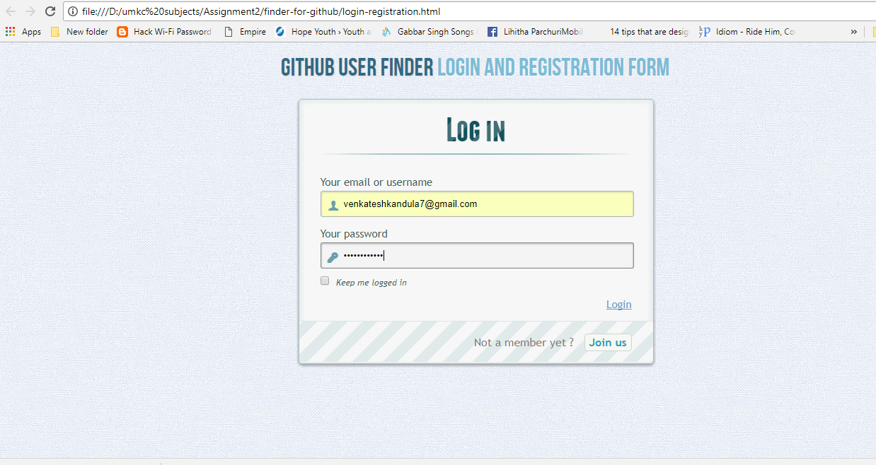

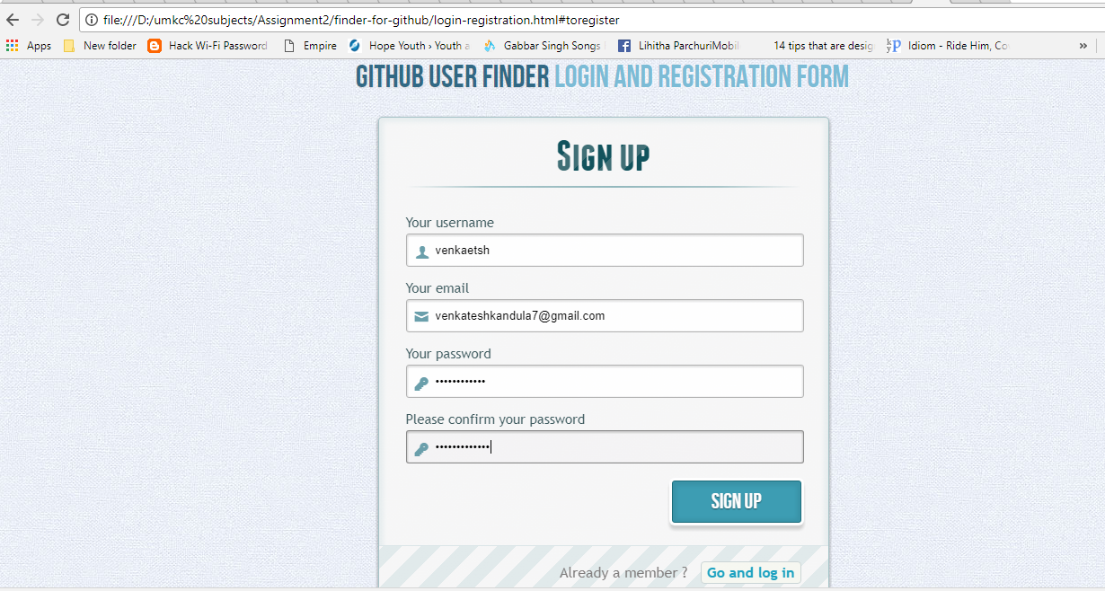

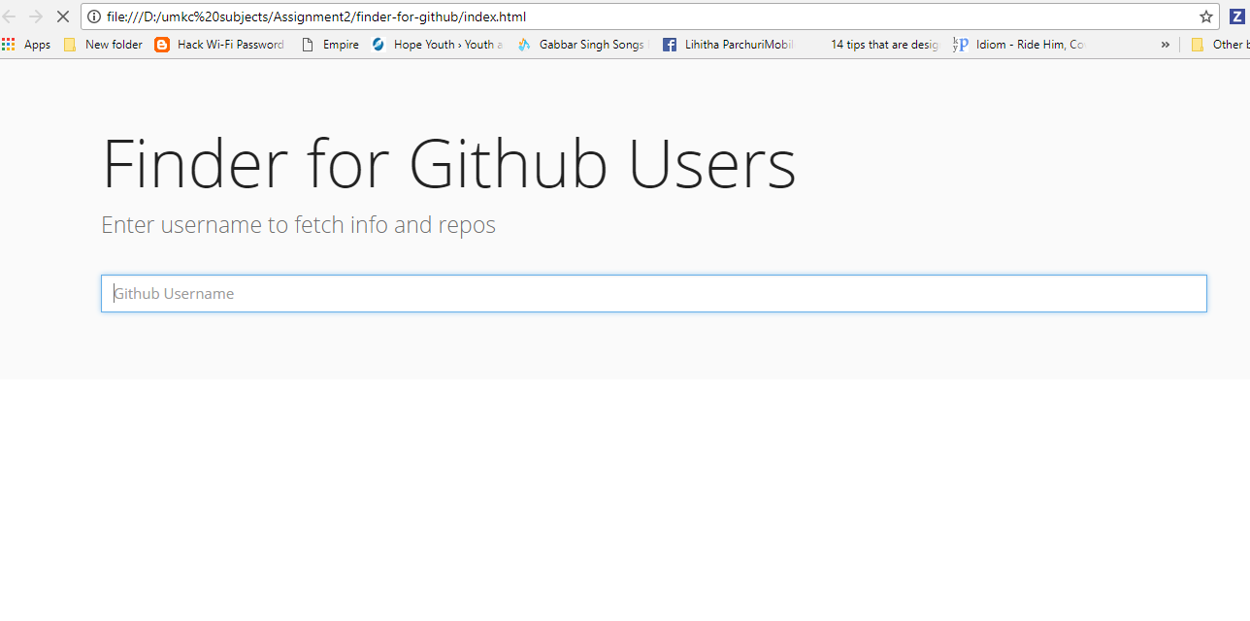

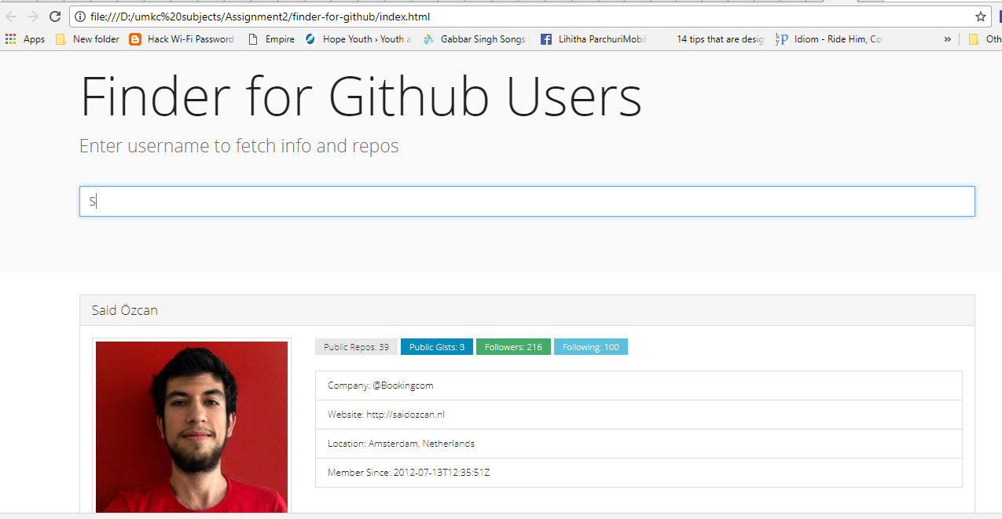

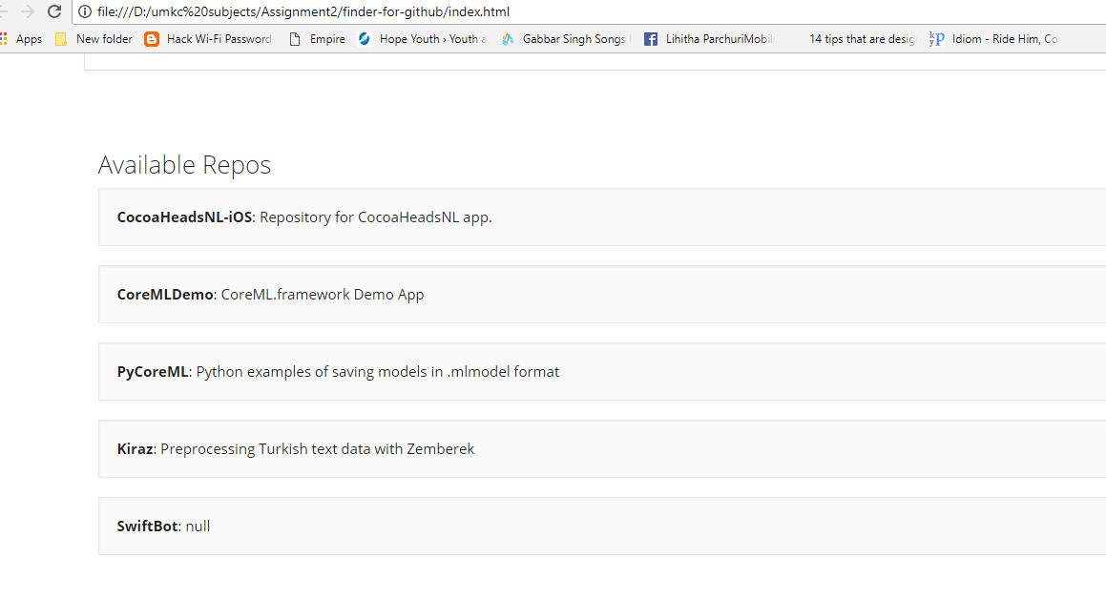

1. **Angular 2 tictactoe game**

**Source:**

**Index.html**

<html>

<head>

<link rel="stylesheet" type="text/css" href="style.css">

</head>

<body ng-app="ticTacToe">

<div class="game" ng-controller="TicTacToeCtrl">

<div class="row" ng-repeat="row in rows">

<div class="cell" ng-class="{'winning-cell' : cell.winningCell}" data-position="{{cell.position.x}}, {{cell.position.y}}" ng-repeat="cell in row.cells" ng-click="cellClick($event)" >

{{cell.value}}

</div>

</div>

</div>

<script src="angular.js"></script>

<script src="ticTacToeService.js"></script>

<script src="ticTacToeCtrl.js"></script>

</body>

</html>

**TICTACTOE CNTRL.JS**

(function() {

angular.module('ticTacToe')

.controller('TicTacToeCtrl', ['$scope', 'TicTacToeService', function($scope, service) {

var rows = [];

for (var i=0; i<3; i++) {

var row = {},

cells = [];

for (var j=0; j<3; j++) {

cells.push({position: {x: j, y: i}, value: ''});

}

row.cells = cells;

rows.push(row);

}

$scope.rows = rows;

$scope.cellClick = function(event) {

if ($scope.gameOverFlag) {

return;

}

var el = angular.element(event.currentTarget);

var position = el.attr('data-position').split(',');

var isX = $scope.isX;

var clickedCell = $scope.rows[parseInt(position[1])].cells[parseInt(position[0])];

if (!clickedCell.value) {

clickedCell.value = isX ? 'O' : 'X';

$scope.isX = !isX;

}

var winner = $scope.gameOver();

if (winner) {

alert("Player " + winner + " Wins!!");

$scope.gameOverFlag = true;

return;

} else if (!$scope.tieAlerted && $scope.boardFilled()) {

alert("It's a tie!!");

$scope.tieAlerted = true;

}

};

$scope.gameOver = function() {

return service.strategy($scope.rows);

};

$scope.boardFilled = function () {

var rows = $scope.rows;

for (var y = 0; y < rows.length; y++) {

var row = rows[y],

cells = row.cells;

for (var x = 0; x < cells.length; x++) {

if (!row.cells[x].value) {

return false;

}

}

}

return true;

};

}]);

})();

**TICTACTOE SERVICE.JS**

(function() {

angular.module('ticTacToe', [])

.service('TicTacToeService', [function() {

this.strategy = function (rows) {

var horizontal, vertical, diagonal, diagonal1, diagonal2,

horizontalLoser, verticalLoser, winner;

//horizontal

if (!winner) {

var winningRow = -1;

for (var y=0; y<3; y++) {

var thisRowIsWinner = true;

for (var x=1; x<3; x++) {

if (!rows[y].cells[x].value || (rows[y].cells[x].value !== rows[y].cells[x-1].value )) {

thisRowIsWinner = false;

break;

}

}

if (thisRowIsWinner) {

horizontal = true;

winningRow = y;

winner = rows[winningRow].cells[0].value;

//paint winning combination

for (var x=0; x<3; x++) {

rows[winningRow].cells[x].winningCell = true;

}

}

}

}

//vertical

if (!winner) {

var winningCol = -1;

for (var x=0; x<3; x++) {

var thisColIsWinner = true;

for (var y=1; y<3; y++) {

if (!rows[y].cells[x].value || (rows[y].cells[x].value !== rows[y-1].cells[x].value) ) {

thisColIsWinner = false;

verticalLoser = rows[y].cells[x].value;

break;

}

}

if (thisColIsWinner) {

vertical = true;

winningCol = x;

winner = rows[0].cells[winningCol].value;

//paint winning combination

for (var y=0; y<3; y++) {

rows[y].cells[winningCol].winningCell = true;

}

}

}

}

//diagonal

if (!winner) {

var centerValue = rows[1].cells[1].value;

diagonal1 = centerValue && rows[0].cells[0].value === centerValue &&

centerValue === rows[2].cells[2].value;

diagonal2 = centerValue && rows[0].cells[2].value === centerValue &&

centerValue === rows[2].cells[0].value;

diagonal = diagonal1 || diagonal2;

if (diagonal) {

winner = centerValue;

//paint winning combination

rows[1].cells[1].winningCell = true;

if (diagonal1) {

rows[0].cells[0].winningCell = rows[2].cells[2].winningCell = true;

} else {

rows[0].cells[2].winningCell = rows[2].cells[0].winningCell = true;

}

}

}

return winner;

};

}]);

})();

**Screenshots:**

