Exploratory performance analysis of states of India in School Education System

India consists of 29 States and 7 Union Territories, where each of theses states formulate their own education policies. Education in India is a state subject and they have the complete control over it.

It is difficult to have one single metric available to compare the performance of different states in area of education system. This problem has been approached by creating a tool which helps users to explore each of 20 important attributes individually and see how different states of India are performing with respect to each other. The users can choose the attribute that they are interested in among the list of available attributes and see how different states are performing with respect to each other. The tool focuses more on the lower income groups of society as the attributes taken into consideration are very basic in nature.

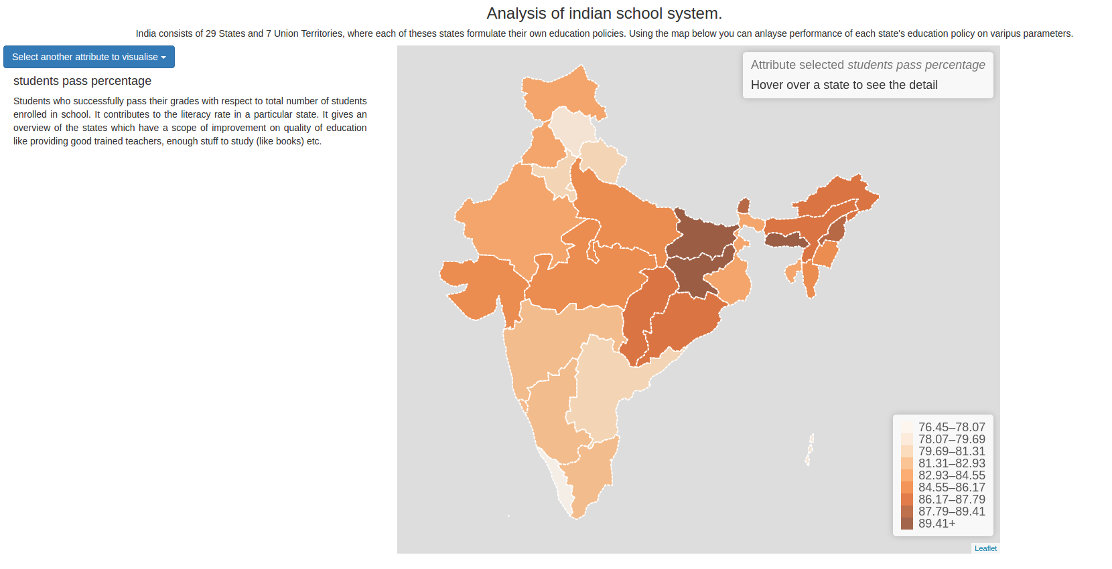
Illustration 1: Visualization showing States' performance based on attribute selected
And all the above attributes can be grouped into four main categories as follows:
- Faculty strength - Schools availability, Teachers availability, Trained teacher percentage and Full time teachers percentage
- Student performance - Students pass percentage, Schools drop out percentage and Students per 100 people
- Infrastructure and School indicators – Toilet , Drinking water, hand wash, mid day meal, concrete building, boundary wall, playground, electricity connection, computer availability in percentage and Literacy rate
- Government role - Govt schools percentage, Private schools percentage, Text books received schools percentage

Gini coefficient, the statistical dispersion measure of inequality, here, in our case, measure the inequality among the performance of different states with respect to listed attributes. A higher Gini index refers to few states who are performing very well when compared to other states and a lower Gini index refers that they are all performing uniformly either good or bad.
A higher Gini index value is shown by attributes like school drop out percentage, availability of schools and teachers, private schools percentage, electricity connection, hand wash facility and boundary walls presence. Attributes such as students per 100 people, student pass percentage, literacy rate, text books received, toilet facility, concrete building facility, mid-day meal and drinking water facility have lower Gini value which is even below 0.1.

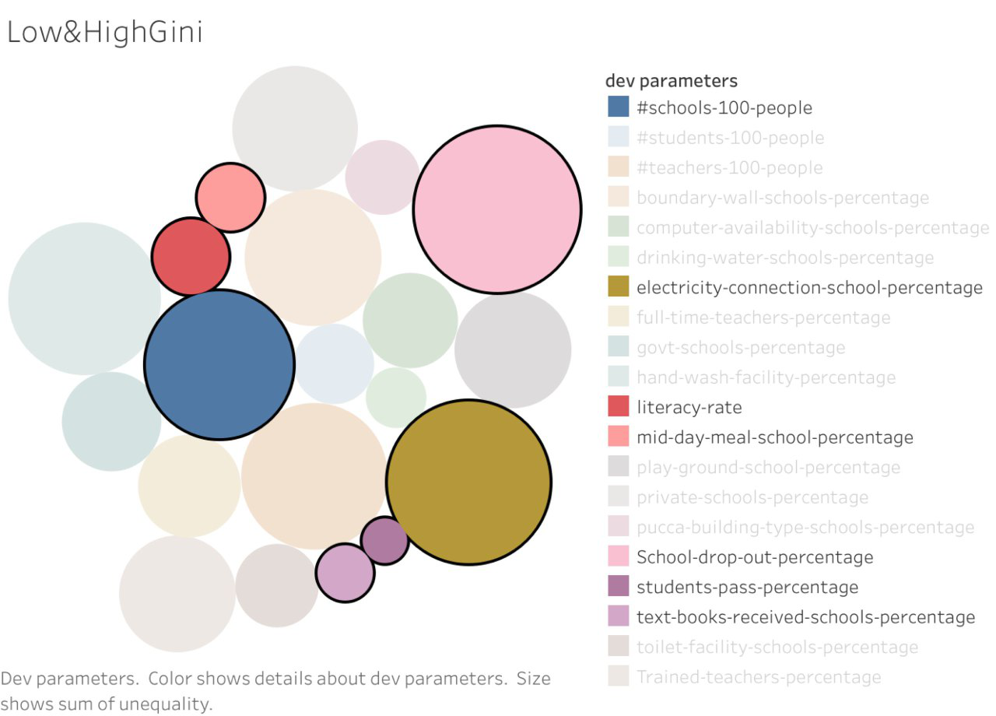
Illustration 2: Low Gini and High Index

Gini coefficient depicts that small states, like Kerala, Goa, Tripura, Mizoram and Himachal Pradesh, are generally doing good than other bigger states in various attributes. Bigger states like Uttar Pradesh, Rajasthan and Madhya Pradesh are generally bad at their performance.
The bigger states can get inspired from other smaller state’s policies and figure out the factors they need to improve on.

Data
The data used in this interactive visualization is taken from the Indian Government’s open data website http://data.gov.in

Tools - All this is built using leaflet and Tableau.

