# 1. END-OF-SEMESTER TEST MATRIX FRAMEWORK IN MATH – GRADE 11

|  |  |  |  |  |  |  |  |  |  |  |  |  |  |
| --- | --- | --- | --- | --- | --- | --- | --- | --- | --- | --- | --- | --- | --- |
| **Content/unit of knowledge** | **Level of assessment** | | | | | | | | | | | | **Total % score** |
| **Remember** | | **Understand** | | **Apply** | | **Analyze** | | **Assess** | | **Creative** | |
| **TN** | **TL** | **TN** | **TL** | **TN** | **TL** | **TN** | **TL** | **TN** | **TL** | **TN** | **TL** |
| 1. ***Matching events*** | 1 |  | 5 |  |  | 1a | 11 |  |  |  |  |  | **12,5%** |
| 1. ***Delivery events*** | 2 |  | 6 |  |  | 1b | 12 |  |  |  |  |  | **12,5%** |
| 1. ***Conflict events*** | 3 |  |  |  |  |  |  |  |  |  |  |  | **2,5%** |
| 1. ***Independent events*** | 4 |  |  |  |  |  |  |  |  |  |  |  | **2,5%** |
| 1. ***Probabilistic addition formula*** |  |  | 7 |  | 9 | 2a | 13,14 | 3a | 17 |  |  |  | **27,5%** |
| 1. ***Probability multiplication formula*** |  |  | 8 |  | 10 | 2b | 15,16 | 3b | 18 | 4a | 19 |  | **35%** |
| 1. ***Formula for addition and multiplication of probabilities*** |  |  |  |  |  |  |  |  |  |  | 20 | 4b | **7,5%** |
| **TOTAL** | **4** | **0** | **4** | **0** | **2** | **4** | **6** | **2** | **2** | **1** | **2** | **1** |  |
| **Percentage %** | **10%** | | **10%** | | **30%** | | **30%** | | **10%** | | **10%** | | **100%** |

**3.** TEST Time to do the test: 60 minutes, excluding the time to play the test

I. MULTIPLE-CHOICE SECTION: Choose the correct option from options A, B, C, D.  
**Question 1: .** If $A$ and $B$ are two conflicting events of a test, then $P\left(A∪B\right)$ equal to

A. $P\left(A\right).P\left(B\right).$

B. $P\left(A\right)+P\left(B\right).$

C. $P\left(A\right)-P\left(B\right).$

D. $P\left(A\right):P\left(B\right).$

**Verse 11.** If $A$ and $B$ are two independent events of a test, then $P\left(A∩B\right)$ equal to

A. $P\left(A\right).P\left(B\right).$

B. $P\left(A\right)+P\left(B\right).$

C. $P\left(A\right)-P\left(B\right).$

D. $P\left(A\right):P\left(B\right).$

**Q9.** Let two events $A$ and $B$ be a subset of the sample space $Ω.$ Element $x∈A∪B$ when

A. $x∈A$ or $x∈B.$

B. $x∈A$ and $x∈B.$

C. $x∉A$ and $x∈B.$

D. $x∈A$ and $x∉B.$

**Q10**. Let two events $A$ and $B$ be a subset of the sample space $Ω.$ Element $x∈A∩B$ when

A. $x∈A$ and $x∈B.$

B. $x∈A$ or $x∈B.$

C. $x∉A$ and $x∈B.$

D. $x∈A$ and $x∉B.$

**Verse 12.** Randomly select a positive integer less than 21. Consider event A: "The selected number is divisible by 2", event B: "The selected number is divisible by 3". As a result $P\left(A∪B\right)$,

A. $\frac{13}{20}.$

B. $\frac{4}{5}.$

C. $\frac{3}{10}.$

D. $\frac{3}{20}.$

**Question 13:** A box has 12 blue balls and 8 red balls, the balls are the same size and mass. Randomly take two balls simultaneously. Calculate the probability of two balls taking out the same color.

A. $\frac{47}{95}.$

B. $\frac{33}{95}.$

C. $\frac{14}{95}.$

D. $\frac{47}{190}.$

**Question 14:** Let the pyramid be even $S.ABCD$ (side pictured). What is the angle between the two lines $SA$ and $BC$ which is the following ?

**A. $\hat{SAB}.$**  **B. $\hat{SAD}.$**

**C. $\hat{SAC}.$**  **D. $\hat{SBC}.$**

**Question 15:** Give the cube $ABCD.A'B'C'D'$. Which of the below lines $AB$**is not** perpendicular to a straight line?

**A. $AC.$**  **B. $AA^{'}.$**  **C. $AB.$**  **D. $AD.$**

**Question 16**: The volume $V$ of a prism whose base area is equal to $B$ the height $h$ is:

**A. $V=Bh.$ B. $V=\frac{1}{3}Bh.$ C. $V=\frac{1}{2}Bh.$ D. $V=\frac{1}{6}Bh.$**

**Question 17:** Let the tetrahedron $SABC$ be a $ABC$ right triangle at $B$ and $SA⊥\left(ABC\right)$. Which plane is the line $BC$ perpendicular to below?

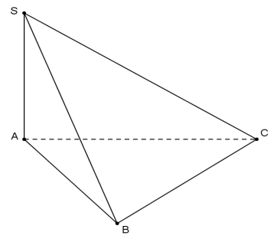

**A. $\left(SAC\right).$ B. $\left(ABC\right).$ C. $\left(SAB\right).$ D. $\left(SBC\right).$**

**Question 18:** Let the pyramid $S.ABC$ whose base be an isosceles triangle at $C$ and called $SA⊥(ABC).$ the midpoint of the $M$ Angle between two lines $AB.$ and $CM$ equal $SB$

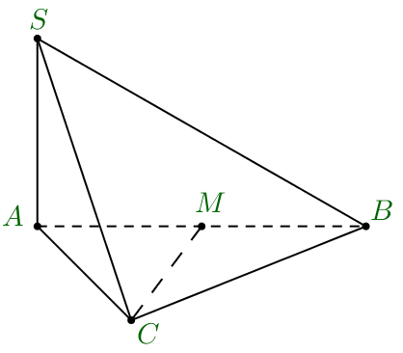

**A. $30^{0}.$**  **B. $45^{0}.$**  **C. $60^{0}.$**  **D. $90^{0}.$**

**Question 19:** Let the pyramid $S.ABC$ whose $ABC$ base be a right triangle at $B,$ the perpendicular projection $H$ of the vertex $S$ on the base be the midpoint of the edge The $AC.$ line $SH$**is not** perpendicular to any of the following lines?

**A. $AC.$**  **B. $SB.$**  **C. $AB.$**  **D. $BC.$**

**Question 20:** Give the cube $ABCD.A'B'C'D'$. $\left(ACC^{'}A^{'}\right)$ Which of the below planes perpendicular to the plane?

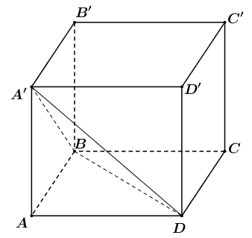

**A. $\left(ABCD\right)$** . **B. $\left(ABB^{'}A^{'}\right)$** .

**C. $\left(ADD^{'}A^{'}\right)$** . **D. $\left(A^{'}B^{'}C^{'}D^{'}\right)$** .

**Question 21:** Let the pyramid $S.ABC$ have $SA⊥\left(ABC\right)$ and . $AB⊥BC$ Call $I$ it midpoint $BC$. What is the angle between the two planes $\left(SBC\right)$ and $\left(ABC\right)$ which is below?

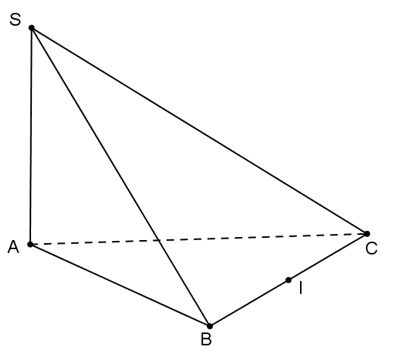

**A. $\hat{SCA}.$ B. $\hat{SCB}.$ C. $\hat{SBA}.$ D. $\hat{SIA}.$**

**Verse 22**. (TH) Let the pyramid $S.ABC$ have $SA⊥\left(ABC\right)$ and the base $ABC$ be a right triangle at $A$. Which of the following assertions **is false**?

**A. $\left(SAB\right)⊥\left(ABC\right)$** .

**B. $\left(SAC\right)⊥\left(ABC\right)$** .

**C. $\left(SBC\right)⊥\left(ABC\right)$** .

**D. $\left(SBC\right)⊥\left(SAB\right)$** .

**Verse 23.** (NB) For the cube $ABCD.A^{'}B^{'}C^{'}D^{'}$. The common perpendicular segment of the two lines $AB$ and $B^{'}C^{'}$ is

**A. $BB^{'}$** .

**B. $BC^{'}$** .

**C. $AB^{'}$** .

**D. $AC^{'}$** .

**Verse 24**. (TH) Give the cube the $ABCD.A^{'}B^{'}C^{'}D^{'}$ edge $a$. The distance from the point $A$ to the plane $\left(BDD^{'}B^{'}\right)$ is equal to

**A. $a$** .

**B. $\frac{a}{2}$**

**C. $a\sqrt{2}$**

**D. $\frac{a\sqrt{2}}{2}$**

**Verse 25**. (TH) Let $S.ABCD$ the pyramid have a base of $\left(ABCD\right)$ square edges $a\sqrt{2}$, $SA⊥\left(ABCD\right)$ and $SA=a\sqrt{2}$. Distance from straight line $AB$ to $\left(SCD\right)$ plane plane

**A. $a$** .

**B. $\frac{a}{2}$**

**C. $a\sqrt{2}$**

**D. $\frac{a\sqrt{2}}{2}$**

**Verse 26**. (NB) Of the following clauses, which of the following is true?

**A.** Two planes perpendicular to each other, every line in one plane will be perpendicular to the other.

**B**. Two distinct planes perpendicular to the same plane are perpendicular to each other.

**C**. Two distinct planes that are both perpendicular to one are parallel to each other.

**D**. Two planes perpendicular to each other, every line in one plane and perpendicular to the intersection of two planes will be perpendicular to the other.

**Verse 27**. (NB) For rectangular boxes $ABCD.A^{'}B^{'}C^{'}D^{'}$. The dihedral plane angle $\left[A,BC,B^{'}\right]$ is

**A. $\hat{ABB^{'}}$** .

**B. $\hat{AB^{'}B}$**

**C. $\hat{ACB^{'}}$**

**D. $\hat{AB^{'}C}$**

**Verse 28.** (TH) Let the pyramid $S.ABC$ have $SA⊥\left(ABC\right)$ and the base $ABC$ be a right triangle at $B$. The dihedral plane angle $\left[S,BC,A\right]$ is

**A. $\hat{SBA}$** .

**B. $\hat{SCA}$**

**C. $\hat{ABC}$**

**D. $\hat{SAB}$**

**II. ESSAY SECTION:Lesson  
 1 (0.5 points):** Calculating the derivative of the function: $y=x^{3}-x$

**Lesson 2 (1.0 points):** A gunner fires 2 bullets at a target in turn. The probability of hitting the first and second rounds is $0,8$ respectively and $0,7.$ Know that the results of the shots are independent of each other.

**a) (0.5 points)** Calculate the probability of the event "both shots hit the target".

**b) (0.5 points)** Calculate the probability of the event "only 1 shot on target".

**Lesson 3 (1.5 points):**

**a) (0.75 points)** Let the $S.ABCD$ pyramid whose base $ABCD$ be a square edge equal $a.$ to Know that $SA⊥\left(ABCD\right)$ and $SA=a\sqrt{2.}$ Calculate the volume of the pyramid $S.ABCD$.

**b) (0.75 points)** To prepare for an international exhibition, jewelry of great value is securely placed in quadrangular spire blocks as shown and placed on top of a rectangular box-shaped pillar with $1m,$ a square bottom height $50cm.$ next to the event organizers plan to use isosceles triangular tempered glass panels with sides $60cm$ to assemble again into the aforementioned pyramidal mass. Calculate the distance from the top of the pyramid to the floor where the exhibition takes place.

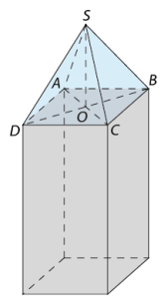

**4. INSTRUCTIONS FOR MARKING EXAMS AT THE END OF SEMESTER II**

**Subject: MATHS, Year 11**

**I. MULTIPLE-CHOICE SECTION:** *0.25 points / 1 correct answer*

**II. ESSAY SECTION**

|  |  |  |
| --- | --- | --- |
| **CARD** | **ANSWER** | **DIEM** |
| **1** | Calculating the derivative of the function: $y=x^{3}-x$ | **0,5** |
| $y'=3x^{2}-1$ (each correct element gets 0.25) | 0,5 |
| **2** | A gunner fired 2 rounds at a target in turn. The probability of hitting the first and second rounds is $0,8$ respectively and $0,7.$ Know that the results of the shots are independent of each other.  **a)** Calculate the probability of the event "both shots hit the target". | **0,5** |
| It' $A$ s called the "first hit" event. We have: $P\left(A\right)=0,8$ It' $B$ s called a "second hit" incident. We have $P\left(B\right)=0,7$ | 0,25 |
| Since $A,B$ they are two independent events, the probability that both shots will hit the target is $$P\left(AB\right)=P\left(A\right).P\left(B\right)=0,8⋅0,7=0,56$$ | 0,25 |
| **b)** Calculate the probability of the event "only 1 hit the target". | **0,5** |
| $$P\left(\overline{A}\right)=0,2;P\left(\overline{B}\right)=0,3$$ | 0,25 |
| The probability to have only 1 hit on target is $P\left(A\overline{B}\right)+P\left(\overline{A}B\right)=P\left(A\right).P\left(\overline{B}\right)+P\left(\overline{A}\right).P\left(B\right)=0,8⋅0,3+0,2⋅0,7=0,38$ | 0,25 |
| **3a** | Let the $S.ABCD$ pyramid whose base $ABCD$ be a square equal $a.$ to Know that $SA⊥\left(ABCD\right)$ and $SA=a\sqrt{2.}$ Compute the volume of the pyramid $S.ABCD$. | **0,75** |
| We have: $h=SA=a\sqrt{2}$ | 0,25 |
| The square $ABCD$ has an area of $S_{ABCD}=a^{2}.$ | 0,25 |
| So $V_{S.ABCD}=\frac{1}{3}S_{ABCD}⋅SA=\frac{\sqrt{2}}{3}a^{3}$ | 0,25 |
| **3b** | To prepare for an international exhibition, jewelry of great value is securely placed in quadrangular pyramidal blocks as shown and placed on top of a rectangular box-shaped pillar $1m,$ with a square bottom height $50cm.$ next to the event organizers plan to use isosceles triangular tempered glass panels with sides $60cm$ to assemble into blocks aforementioned spire. Calculate the distance from the top of the pyramid to the floor where the exhibition takes place. | **0,75** |
| We have $ABCD$ is the square edged equal $0,5m$ to and $SA=SB=SC=SD=0,6m$. The inference $S.ABCD$ is uniformly pyramidal.  Then: $OC=\frac{1}{2}AC=\frac{1}{2}⋅0,5.\sqrt{2}=\frac{\sqrt{2}}{4}.$ | 0,25 |
| Inferred: $SO=\sqrt{SC^{2}-OC^{2}}=\sqrt{0,6^{2}-{\left(\frac{\sqrt{2}}{4}\right)}^{2}}=\frac{\sqrt{94}}{20}$ | 0,25 |
| The distance from the top of the pyramid to the floor where the exhibition takes place is $$SO+1=\frac{\sqrt{94}}{20}+1=\frac{20+\sqrt{94}}{20}m$$ | 0,25 |