Design and Implementation of an Automated Framework for Extracting and Analysing Browser Artifacts from Private Browsing Sessions
STUDENT ID: 33637359
Submitted in partial fulfilment of
the requirements of Leeds Beckett University
for the Degree of
MEng Cyber Security and Digital Forensics

School of Built Environment, Engineering and Computing
Leeds Beckett University
May 2026

Abstract

In the modern digital world, almost all internet users have at some point of making use of private browsing mode on their browsers. Often these users are under the impression that all their online actions taken during this browsing session is completely anonymous and deleted once their session is concluded. Unfortunately, this is not strictly true. During a digital forensic investigation, some artefacts left behind from these private browsing sessions can still be uncovered through manual investigation. This project aims to improve the overall digital forensic process through the automation of this task. This resulted in a Python tool that, when provided with an .E01 file generated from the EnCase digital forensic tool, can automatically identify all browser artefacts stored on a piece of digital evidence, extract them to a chosen location and then present them to a user and identify those possibly left over from private browsing sessions. Whilst not all private browser artefacts can be identified due to them typically not having any identifiable properties, this tool is capable of performing the same job with the same results as a digital investigator, allowing them to focus on other areas of the overall investigation. Future work for the tool would be the expansion of its capabilities such as processing data from a Linux device as well as the compression of the extracted artefacts or filtering those deemed unimportant to an investigation.
Candidate’s Declaration

I, Joshua Stevenson, confirm that this dissertation and the work presented in it are my own achievement.
Where I have consulted the published work of others this is always clearly attributed;
Where I have quoted from the work of others the source is always given. With the exception of such quotations this dissertation is entirely my own work;
I have acknowledged all main sources of help;
I have read and understand the penalties associated with Academic Misconduct.
Signed:
Joshua Stevenson
Date:
23/03/2026
Student ID No:
33637359
Contents
1 Introduction & Rationale 9
1.1 Introduction 9
1.2 Aim & Objectives 10
1.3 Research Gap and Justification 10
1.4 Methodology Alignment 11
2 Literature Review 12
2.1 Web Browsers and Browser Artefacts 12
2.2 Artefact File Structures 14
2.2.1 Chrome 15
2.2.2 Edge 16
2.3 Private Browsing 17
2.4 Digital Forensic Investigations 18
2.4.1 Tools and Techniques 18
2.4.2 Memory Forensics in Private Browser Analysis 19
2.4.3 Automation 20
3 Product Development Approach / Methodology 22
3.1 Methodology Overview 22
3.2 Tools and Tool Requirements 22
3.2.1 Tools Used 22
3.2.2 Functional Requirements 23
3.2.3 Non-Functional Requirements 24
3.3 Python Build 24
3.3.1 Advantages 24
3.3.2 Disadvantages 25
3.3.3 Module Utilization 25
3.4 Test Data Generation 25
3.4.1 VM Actions for Artefact Generation 26
3.4.2 Artefact Summary 28
3.5 .E01 vs .VMDK Testing 28
3.6 AIM Utilization 29
4 Product Design, Implementation & Evaluation 29
4.1 Design 29
4.1.1 OOP 29
4.1.2 GUI 30
4.1.3 Modular Architecture 33
4.1.4 File Structure 33
4.2 Implementation 34
4.2.1 Window Setup 34
4.2.2 Mounting and Unmounting .E01 37
4.2.3 Browser Artefact Extraction 39
4.2.4 Representation of Data 42
4.2.5 Private Browser Artefacts 45
4.2.6 Verifying Forensic Integrity 48
4.3 Challenges 49
4.3.1 Processing .E01 and Mounting Drives 49
4.3.2 File Permissions 50
4.4 Tool Demonstration 50
4.5 Evaluation 58
4.5.1 Functionality 58
4.5.2 Performance and Usability 58
4.5.3 EnCase Comparison 58
5 Conclusion 61
5.1 Results 61
5.2 Limitations 61
5.3 Future Improvements 62
6 Project Management 64
7 Ethics 65
7.1 Security of Testing Data 65
7.2 Personal Data Use 65
8 References 66
9 Appendices 71
9.1 Ethics Approval 71
9.2 Originality and Use of Generative Artificial Intelligence (GAI) Statement 71

Table of Figures
Figure 1 - Screenshot of the WorldWideWeb 13
Figure 2 - StatCounter Browser Statistics 14
Figure 3 - DSRM Model 23
Figure 4 - EnCase Browser Artefact View 25
Figure 5 - Initialisation of Window Class 31
Figure 6 - Early Prototype GUI 32
Figure 7 - Tool Stylesheet 33
Figure 8 - Tool Main Window 33
Figure 9 - Tool Files 34
Figure 10 - Main.py Code 35
Figure 11 – Colour Palettes Prepared 36
Figure 12 - Colour Palettes Assigned 36
Figure 13 - "_show_welcome" Function 37
Figure 14 - Welcome Message 37
Figure 15 - "Select & Process File" Button 38
Figure 16 - "Select & Process File" Button Code 38
Figure 17 - "store_drives_and_mount" Function 38
Figure 18 - "Select a File" Window Code 38
Figure 19 - .E01 File in "Select a File" Window 39
Figure 20 - Code to Mount .E01 as Read-Only Drive 39
Figure 21 - Code to Unmount .E01 Drive 40
Figure 22 - Browser Pattern and Browser Directory Lists 41
Figure 23 - "is_browser_artefact" Function 41
Figure 24 - Artefact Extraction Progress Bar 42
Figure 25 - "extract_browser_artefacts_from_mounted" Function Part 1 42
Figure 26 - "extract_browser_artefacts_from_mounted" Function Part 2 43
Figure 27 - "view_artefacts_folder" Function 44
Figure 28 - "show_user_dropdown" Function 45
Figure 29 - Initial Browser Artefact Viewing 46
Figure 30 - "check_chromium" Function 47
Figure 31 - "_check_chromium_temproal_gaps" Function Part 1 48
Figure 32 - "_check_chromium_temproal_gaps" Function Part 2 48
Figure 33 - "hash_file" Function 49
Figure 34 - "write_manifest_hashes" Function 50
Figure 35 - Access to User Folder Denied 51
Figure 36 - Highlighted "Select & Process" Button 52
Figure 37 - Highlighted .E01 File in "Select File" Window 53
Figure 38 - Extraction Progress Bar 54
Figure 39 - Extraction Results 55
Figure 40 - Initial Artefact Viewer 56
Figure 41 - Private Browser Artefact Detection 57
Figure 42 - Forensic Integrity Verification 57
Figure 43 - Private Browser Artefacts View 58
Figure 44 - Browser Artefact Viewer Filters 60
Figure 45 - EnCase Browser Artefact File Structure 60
Figure 46 - EnCase Flagging Files 61
Figure 47 - EnCase View Flagged Files 61
Figure 48 - Ethics Approved with Favourable Opinion 72

List of Abbreviations

AIM – Arsenal Image Mounter
CLI – Command Line Interface
DSRM – Design Science Research Methodology
GB – Gigabyte
GUI – Graphical User Interface
HDD – Hard Disk Drive
ID – Identification Document
IDE – Integrated Development Environment
ISO – Optical Disk Image
MB – Megabyte
OOP – Object Orientated Programming
OS – Operating System
RAM – Random Access Memory
URL – Uniform Resource Locator
USB – Universal Serial Bus
VM – Virtual Machine

Introduction & Rationale

Introduction
In the modern age of the 21st century, the internet is one of the most important pillars supporting the everyday functions of society. By extension, web browsers are critically important by providing people with a platform which they can use to access this vast archive of collective knowledge and methods of communication (Anand and Saxena 2013). With the number of internet users constantly growing by the day, so too does the interest in keeping some of their online activities private and to themselves (Leith, 2021).
To ease the public’s concerns surrounding their online privacy and safety, many browsers added a new feature widely known as a “private browsing mode”. This new form of browsing claimed to prevent any storing or tracking of a user’s online activities including but not limited to their search queries and visited URLs (Habib, Colnago, Gopalakrishnan, Pearman, Thomas, Acquisti, Christin and Cranor, 2018). This introduction of a method of browsing the internet without being tracked ended being incredibly popular with internet users, with 46.1% of American internet users having utilised one in 2017 (Duckduckgo.com, 2017).
Even with claims of complete privacy or anonymity during the use of private browsing, conducting research within the field of digital forensics has uncovered that private modes are not necessarily as private as they are made out to be. During typical browser use, browser artefacts are created to track the users activities and store needed data. Despite stating that this information is not saved during private browsing, these artefacts are still necessary for the browser to function. To circumvent this, these artefacts are stored in RAM, volatile storage, meaning that they are deleted once the browser is closed (Spiteri, 2024). Certain artefacts however, such as bookmarks or downloads, are still stored in non-volatile memory, meaning they persist despite being created during a private browsing session.
The existence of these residual artefacts from private browsing sessions, as well as regular browser artefacts, can prove to be invaluable to digital forensic investigators. In cases such as a fatal arson fire in 2020 (Slevin, 2023), browser artefacts can help to provide crucial evidence to an overall investigation. The assumption by users that private browsing implies that all their actions are deleted presents great opportunity to digital forensic investigators as the identification and analysis of these residual artefacts can often lead to breakthroughs in an investigation.
In terms of the use of browser artefacts by digital forensic investigators, the process of their extraction and analysis is established in the industry with the use of digital forensic tools such as Autopsy, EnCase and FTK Imager through manual investigation (Adamu, Ahmad, Hassan and Gambasha 2021). The manual processing of these artefacts can often prove to require a substantial amount of time, mainly due to the amount of data needing to be analysed by the investigators. Further to this, as browsers continue to improve over time, often becoming more complex in their functionality, the time requirement for investigating browser artefacts continues to steadily increase.
This project aims to both reduce the time required to analyse browser artefacts as well as reducing the risk of human error by automating this process. This will be done through the creation of an automated forensic tool that can extract and analyse browser artefacts for the use of digital forensic investigations. In automating this task, it is the hope that the overall digital forensic process will be improved, allowing for better analysis of evidence and an increase in general efficiency.

Aim & Objectives
The main goal for this project is the creation of an automated digital forensics tool designed for the task of extracting and analyzing browser artefacts that were generated from within a browser with its “private mode” enabled by the user. The objective tool is to fill an automation gap within the digital forensic process and by doing so, increase the efficiency of the overall process by improving the consistency and repeatability of browser artefact analysis. In addition, this tool will also aim to provide an insight into the security and effectiveness (or lack thereof) of private browsing modes within their respective browsers.
The main objectives that this project aims to achieve are as follows:
- The design of modular architecture for the purpose of automated browser artefact extraction
- The parsing and reporting of browser artefacts including alerting the user of possible artefacts generated during private browsing sessions
- Implementation of a prototype extraction tool built using the Python programming language that has the capability to extract and process browser artefacts generated from multiple different browser types
- Provide a user with a method of observing extracted browser artefacts for the purpose of a forensic investigation in a way that is easy to understand
- Evaluate the effectiveness of the created tool based on pre-established methods of manual browser artefact analysis using other forensic tools such as EnCase and Autopsy

Research Gap and Justification
As previously mentioned in 1.1, the field of digital forensics is very important for criminal investigations in the modern world and often it will need to be performed as quickly and efficiently as possible. Because of this, the use of automation in this process becomes highly valued as the processing of large amounts of data can often be time consuming and prone to human error (Jarrett and Choo, 2021). However, by automating tasks, usually using automated forensic tools, this risk can be significantly reduced thanks to its repeatability and reliability. Until the completion of this project, however, there was no automated tool for the extraction and analysis of browser artefacts.
The non-existence of an automated tool for this process presented an excellent opportunity for the creation of one, as in so doing would likely further increase the efficiency of the digital forensic process. With this newly created tool, it is idealized that forensic investigators will have the capacity to shift some of their focus away from the manual investigation of browser artefacts and instead be able to spend more time on other areas of their investigation, email records for instance. Additionally, by the removal of some of the manual parts of this process (an investigator will still need to examine the tool’s results), the risk of human error during investigation will also be reduced. Through this, the investigation should be less vulnerable to scrutiny if presented to a court of law.

Methodology Alignment
The methodology selected to be used during this project was the DSRM methodology. This methodology is used widely within the field of digital forensics (Fernando, Hussain, and Jayathilaka, 2025) and supports the process of development, testing and improving software, see 3.1 for a more detailed explanation of its processes. It proved to be incredibly useful, especially with the number of interlocking processes and functions that needed to be used to fulfill the requirements of this project. Each time a new process was changed or created, it needed to be tested and then edited to ensure that it functioned in the desired manner, thus closely aligning with the DSRM methodology.

Literature Review

Web Browsers and Browser Artefacts
Ever since its official birth 1st January 1983, the internet has become a major foundation of modern society (Cohen-Almagor, 2012). During its period as what is referred to as “Internet 1.0” or “Web 1.0” (considered as the time between its birth and “Web 2.0” proposed in September 2005), its main functions were e-mail, live conversations, music downloading, network gaming, e-commerce and especially information seeking and browsing (Beauvisage, Beaudouin and Assadi, 2007). The very first of these browsers was known as the “WorldWideWeb” , see Figure 1, and was developed in 1989 by Tim-Berners Lee as means to automate information sharing between scientists and universities (Cern, 2026).
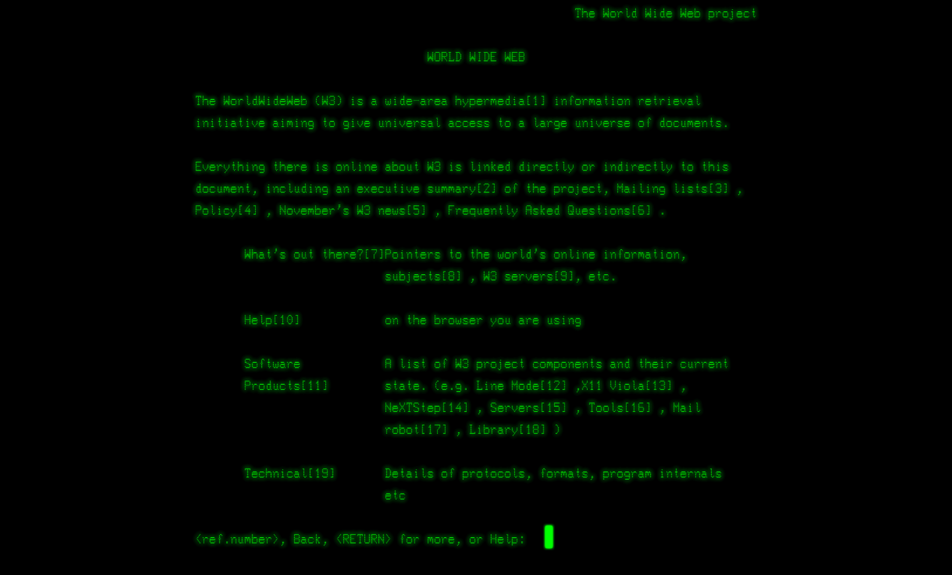
Figure 1 - Screenshot of the WorldWideWeb
Around a decade later on 15th December 1994, a new browser known as “Netscape Navigator” was released which marked a great change in internet access at the time (Heiney, 2023).
For the general population at the time, Internet 1.0 primarily consisted of a variety of brochure sites (Chada, Parashar, Singh, Rastogi, Singh, & Raja, 2025) whereas the introduction of Web 2.0 introduces more interactive websites requiring a more robust and adaptable browser (Alley, Kolt, Duncan, Caperchione, Savage, Maeder, Rosenkranz, Tague, Van, Kerry, & Vandelanotte, 2018).
Many years later there is now a wide variety of different web browsers for users to choose from, all of which appear much more user-friendly than the command line style of the WorldWideWeb. As of March 2026, the most used browsers are Chrome (66.7%), Safari (17.9%), Edge (5.79%), Samsung Internet (2.06%) and Opera (2%) (StatCounter Global Stats 2026), see Figure 1. There are also many other browsers, one such being Internet Explorer for example, however their usage only totals 3.22%. Whilst this is greater than both Samsung Internet and Opera, this is a collective total as individually their usage amount can be deemed statistically insignificant.
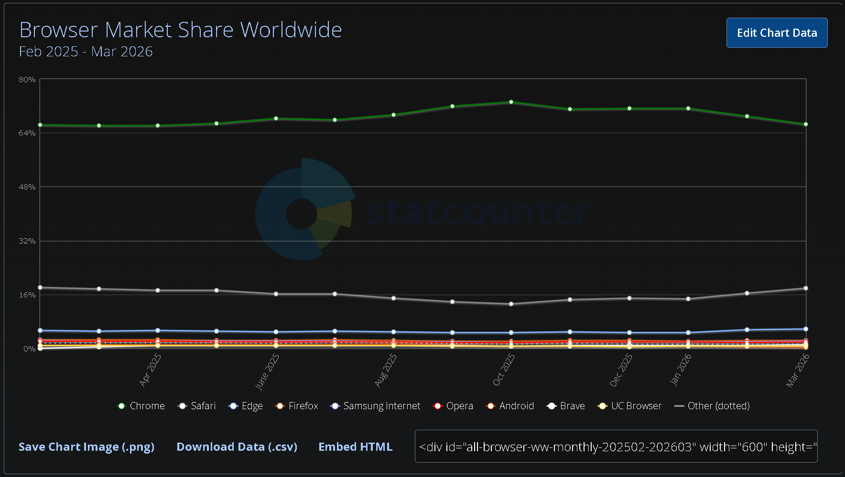
Figure 2 - StatCounter Browser Statistics
From these most used browsers, 3 of them (those being Chrome, Edge and Opera) are all run on Chromium (Undetectable Browsers, 2026). Chromium is an open-source code developed by Google in 2008 as a platform for developers to use in making their own software (New Releases Blog, 2023). This means that their functionality is the same, using the same classes and fields to perform those tasks (Choi, Bang, Lee and Park, 2023). This is what enables Opera to import a user’s history, cookies, extensions and bookmarks etc. from another chromium-based browser when being set up for the first time (Opera Help, 2018). Using the previous usage statistics, at least 74.49% of all web browsing is done via a chromium-based browser, or about 3 out of 4 searches, meaning that it is by far the most used code base for web browsing. The fact that most of the popular browsers use chromium can prove especially useful during a digital forensic investigation, due to the similarities in functionality that they each have.
For every action performed using a web browser, whether it be a user creating bookmarks or simply searching for cat pictures, the browser needs some way of storing this data so that it can be used in the future. These pieces of information can be referred to as browser artefacts. Their main purpose is simply to store information for the browser to utilize, this is typically done under the user’s directory on their local machine, but the switch or router used to connect the machine to the wider internet will store artefacts of its own tracking user activity. This can also be used to check a user is not trying to access websites restricted by the network they are on, for example some websites could be deemed unsuitable to be visited on a schools’ network. Some examples of browser artefacts include search queries, cookies, downloads, visited URLs and much more.
Browser artefacts are quite easy for an average computer user to understand. History, cookies, visited websites etc. However, not all of them are stored as basic plain text within a user’s file system. A good example of this is cookies surrounding saved login details. If these cookies were stored as plain text, it would be quite easy for a malicious party to obtain all a user’s login details by gaining access to their machine, posing a substantial security risk. It is because of this risk that these details are encrypted (Paul, Biswas, Khalid, Biswas, Dutta, Saha and Das, 2018) so that even if the cookies were to be obtained, the malicious party would not be able to make use of them.
Artefacts have varying ways in which they are stored and used. A prime example of this is how some are stored in volatile memory whilst they are in use, particularly with private browsers, and others are stored permanently in non-volatile memory (Mistry, Gajjar and Junare, 2022). Table 1 shown below lists some of the browser artefacts and whether they are stored in volatile or non-volatile memory.
Artefacts in Volatile Memory | Artefacts in Non-Volatile Memory
Web page content | Internet Browser cache
Browser tabs and Windows | Browsing History
Cookies | Cookies
Cache Entries | Bookmarks
Network Requests and Responses | Download History
Form Data | Form Autofill Data
Search Terms | Session Data
Session History | Browser Preference
Email Fragments | Browser Extensions and Add-ons
URLs | DNS cache
Table 1 - Browser Artefact Storage

Artefact File Structures
Below are some basic view (3 subfolders deep) examples as to the file structure used by the two most popular web browsers to store their browser artefacts, Safari and Android Internet have been omitted due to being specific to a certain OS. Each user on a machine will store these artefacts within their own directories so on a machine with multiple users there will be multiple copies of these file structures. These file structures will be of great interest to the overall project as their differences mean that each one will need its artefacts extracted via a different file path due to their locations not being identical.

Chrome
- Chrome
  - User Data
    - ActorSafetyLists
    - AmountExtractionHeuristicsRegexes
    - AutofillStates
    - BrowserMetrics
    - CertificateRevocation
    - ClientSidePhishing
    - Component_crx_cache
    - CookieReadinessList
    - Crashpad
    - Crowd Deny
    - Default
    - Extensions_crx_cache
    - FileTypePolicies
    - FirstPartySetsPreloaded
    - GraphiteDawnCache
    - GrShaderCache
    - Hyphen-data
    - MediaFoundationWidevineCdm
    - MEIPreload
    - Notification Resources
    - OnDeviceHeadSuggestModel
    - OpenCookieDatabase
    - Optimization_guide_model_store
    - OptimizationHints
    - OriginTrials
    - PKIMetadata
    - PrivacySandboxAttestationsPreloaded
    - Profile 1
    - RecoveryImproved
    - Safe Browsing
    - SafetyTips
    - Segmentation_platform
    - ShaderCache
    - Snapshots
    - SSLErrorAssistant
    - Subresource Filter
    - SwReporter
    - System Profile
    - ThirdPartyModuleList64
    - TpcdMetadata
    - TrustTokenKeyCommitments
    - WasmTtsEngine
    - Webstore Downloads
    - WidevineCdm
    - ZxcvbnData

Edge
- Edge
  - Local
    - local
  - Remote
  - User Data
    - Ad Blocking
    - Autofill
    - AutoLaunchProtocolsComponent
    - BrowserMetrics
    - CertificateRevocation
    - Component_crx_cache
    - Crashpad
    - Default
    - Domain Actions
    - EADPData Component
    - Edge Data Protection Lists
    - Edge Notifications
    - Extensions_crx_cache
    - FirstPartySetsPreloaded
    - GraphiteDawnCache
    - GrShaderCache
    - Nurturing
    - OriginTrials
    - Safe Browsing
    - SafetyTips
    - ShaderCache
    - SmartScreen
    - TrustTokenKeyCommitments
    - Web Notifications Deny List
    - WorkspacesNavigationComponent
Whilst there are many similarities between how browsers store data, each one has a different method of doing so. The similarities between them are due to the browsers functioning from chromium, see 2.1, and due to their similar function will need similar data with which to work with.

Private Browsing
With its first instance from Apple’s Safari browser during its 2.0 release in April 2005 (Britannica.com), a private mode has become a standard addition to most internet browsers used in the modern world. For the users on the internet who choose to utilize this form of internet browsing, the attraction of private browsing is their claim of leaving no trace of activity behind on the user’s computer after they conclude their browsing session (Aggarwal, Bursztein, Jackson and Boneh, 2010). However, this is not always the case as several studies have shown that whilst enabling private browsing does not leave behind typical data artefacts, like browser history for example, however some artefacts from private browsing can still be recovered from volatile and non-volatile memory (Spiteri, 2024).
During their regular non-private mode usage, web browsers will typically store their respective artefacts locally within specific file and folder structure on a user’s machine within their file system (Choi, Lee, Park, Lee and Lee 2012). During activity using a browser’s private mode, the storing of these artifacts should not occur which, unfortunately, is not entirely true. Certain artefacts generated during use such as DNS requests, router logs and cached files will still be stored on the user’s machine (Flowers, Mansour, and Khateeb, 2016). This contradicts the average user’s belief that their browsing session being “Private” means that none of their activity can be tracked or recovered as the existence of these artefacts contradicts this statement. As most users believe this about their sessions, these unknown artefacts can sometimes be vital during digital investigation as any private activity uncovered will be activity the user wants to remain secret.
Most internet users will often overestimate the degree of enabling their browsers private mode will hide their activity (Wu, Gupta, Wei, Acar, Fahl and Ur, 2018). As previously mentioned, there will still be residual evidence left on their local machine after the user has concluded their browsing session. However, there have been cases where data privacy has been almost false. In 2020, it was discovered that through a technicality, Google had been tracking its user’s activity on Chrome’s Incognito mode without the user’s knowledge since 2016 (Bryd, 2024). The incident resulted in a settlement fee of $5 billion being paid out by Google as well as this tracking being disabled. This incident shows that whilst web browsers claim that none of your actions are tracked, you can never be completely sure of this as Google may not be the only company tracking users through a technicality.
For each browser that has its own form of private browsing mode, there is a policy alongside it that details what enabling the mode actual does for the user, varying slightly between different browsers. This is down to wording but in some cases some browsers will differ in what they claim to do with additional functionality. For example, Opera GX states that they do not even track installations of their browser, making you “completely anonymous” to even themselves (Opera.com, n.d). The file structure of Opera, see 2.2.3, also reflects this in its small scale against other browsers. By comparison, the policy Chrome uses for its “incognito” mode states that once the user completes their browsing session, Chrome will not record any data nor track the sites the user has visited (Google.com, n.d).

Digital Forensic Investigations

Tools and Techniques
During an investigation into an incident, evidence may be seized containing digital evidence that may prove to be of importance, for example an HDD or USB stick found inside a crime scene. This is where digital forensics will come in. Digital forensics is the use of scientifically proven methods for the collection and validation of digital evidence collected from digital sources for the purpose of reconstructing events (John Wiley & Sons, 2017). There is a large variety of different tools used to perform digital forensics, many of which specialize for several types of devices from PCs and Laptops to mobile devices and even drones (Wu, Breitinger and O’Shaughnessy 2020).
When investigating a device, it is crucial that the original data is not contaminated by the actions of the investigator. To achieve this, any digital evidence seized will be sealed within a static proof bag and will have a strict LOC adhered to. If an investigator wishes to examine the evidence, then the opening of the bag will be recorded in the LOC and once they are finished, it will be resealed into a new bag containing the previous bag as well. This procedure prevents tampering (keeping the bag sealed) and ensures that there can be no suspicion of such if the evidence would be presented in a court of law by keeping it forensically sound (Prayudi, Ashari and Priyambodo, 2020).
For an investigator to view the data on a piece of seized evidence, they must do so in a way that does not change the original data, such as last access values of files. To prevent this, a forensic image of the evidence will be created. An example of a way this can be done is through the tool EnCase where the device is connected to a write blocker and from the write blocker it is connected to the investigator’s machine running EnCase. EnCase will then image the device and create an evidence file, allowing the investigator to browse through the evidence without affecting the original copy (Patzakis, 2001). It is this evidence file that will be the intended target for the tool made in this project. By analyzing this file and not the physical machine it will make the tool more forensically sound and can even be validated in the chain of custody to prove that the evidence being analyzed is the evidence collected from the target machine.
At some point during the digital forensic process, browser artefacts and internet activity will be examined by an investigator. To achieve this, the forensic tools Autopsy and Volatility will be utilized for the analysis due to both tools being well established within the field of digital forensics for several years as well as their wider usability in other areas of digital investigation (Behzad, Carlos, Cristian, Mozhdeh, Zahra and Serguei, 2020). Alternatively, if the device being investigated is of the mobile variety, then then a specialized mobile forensic tool such as Paraben (Alhassan, Oguntoye, Misra, Adewumi, Maskeliūnas, and Damaševičius, 2018) will be used due to how data on the device uses different formats and will be stored and managed differently to that of a PC or Laptop (Ahmed and Dharaskar, 2008).
The tools Autopsy and Volatility are both fully capable of being used to analyze browser artefacts from a device however this task must be done manually by the investigator and as such can often become time consuming, especially if there are artefacts from multiple browsers on the device. Additionally, due to the manual nature of the analysis of these artefacts there will always be room for human error. This can lead to inconsistencies within reports as well as crucial information surrounding the case being missed. Errors such as these when presented within a courtroom can potentially harm the entire investigation if the discrepancies are deemed severe enough.

Memory Forensics in Private Browser Analysis
Whilst the idea/intention of private browsing modes are to prevent the tracking of a user / the string of data from browsing sessions, some data will still be stored during an active session so that the browser can function (Hariharan, Thakar and Sharma, 2022).To prevent the storing of this needed data, the browser will opt to use the machine’s RAM. This creates a big opportunity during forensic analysis as the acquisition and analysis of this volatile data will only be possible whilst the browser remains active. In other words, the machine must stay on with the browser running.
Whilst being able to analyze private browser artefacts within RAM, this also presents a problem to investigators, this being that whilst the machine is running, it is possible for other data on the machine to be changed, either by last open times of files being changed or by a third party remotely accessing the machine to change or even delete data. As such, a live extraction is never performed during a digital forensic investigation (Mrdovic, Huseinovic and Zajko, 2009) as the first action taken is to power down any digital evidence, thus deleting the artefacts stored in RAM.
However, not all private browser artefacts are stored in RAM. Others such as Downloads and Bookmarks are stored as they would regularly in the browser’s file directory (Flowers, Mansour and Khateeb, 2016). Due to artefacts that should be associated with these being missing, such as keyword searched or visited URLs, a digital forensic investigator can infer which of these artefacts could have been generated through a private browsing session. This is the method in which private browser artefacts and private browsing sessions can be identified however, it is possible for false positives to be obtained from occasions where a suspect user has deleted portions of their browser history.

Automation
During a digital investigation, one of the largest issues that is faced by an investigator is the time constraint of the investigation (Casey, Ferraro and Nguyen, 2009). As a digital investigation will often be gathering evidence that will be presented during court, there will always be a maximum amount of time that the investigators have to gather and report their findings else the court date will have passed and potentially incriminating evidence (or evidence that proves innocence) could be missed due to a lack of efficiency. A recent ruling in Europe (Eurojust, n.d.)to help this issue, has put more pressure on law enforcement to focus on their investigations more, rather than a blanket extraction to reduce the risk of missing evidence due to lack of time.
Additionally, it is imperative that there be no gaps in the data uncovered by investigators. As mentioned in 2.3, this can lead to the case being harmed and could even potentially allow for suspects in a case to be wrongfully sentenced due to discrepancies. It is completely possible for a digital investigator to uncover all the data on a piece of digital evidence and even recover data that was attempted to be hidden by a suspect, private browsing data for instance.
To combat these issues, the automation of tasks is the best way to expedite the digital forensic process. Within the EnCase application is the ability for an investigator to write automation scripts, known as EnScripts, with the software (Cassidy, Chavez, Trent and Urrea, 2007), most of the time this will be an automation of search queries through the evidence or grouping and labelling of files with similar names or contents. This simple automation can result in saving a lot of time during an investigation as otherwise investigators would have to go through each file directory, or have all files selected, to accomplish this with only a file name sort which would typically take longer. By comparison, the forensic tool FTK Imager does not have a built-in scripting equivalent to the EnScripts of EnCase. An investigator can however make an external python script, this can be done with EnCase also, to automate tasks.
With the use of automation, as well as reducing the time taken to complete the analysis of digital evidence, the potential for human error has also decreased. With the amount of data that a digital investigator needs to analyze during an investigation, there will always be the risk that they overlook something, as mentioned in 2.3.1, as such the more the risk of this can be reduced, the better. The automation of tasks during analysis reduces this as by completing certain steps the exact way each time, there is no risk that something will be overlooked. For example, say an investigator needs to look through 1000 files to find all instances of the name “John Doe”. There is a remarkably high chance that at least one instance will be missed. However, if an automated script is instructed to do this, each one is guaranteed to be found.

Product Development Approach / Methodology

Methodology Overview
Throughout the planning and development of this tool, the DSRM methodology was utilized to ensure steady and regular progress. The primary reason this methodology was chosen for this project is due to how it lays out the research fundamentals of principles, practices and procedures (Haryanti, Rakhmawati, Subriadi and Tjahyanto 2022/11/4-2022/11/5). As demonstrated in Figure 3 below, the DSRM model can be separated into seven distinct sections, five of which being iterated through as the project progresses. This repetition of processes allows for smooth testing, updating and re-testing of the tool as it goes through its life cycle.
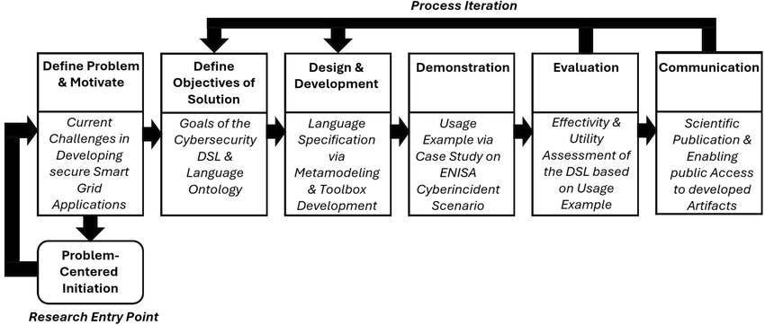
Figure 3 - DSRM Model
The first two phases of the DSRM model, with the start point indicated as the “Research Entry Point in Figure 3 can be considered as the design phase of a project. They go back and forth repeatedly as problems requiring solutions are encountered until the design can be completed and includes solutions to each of these problems. For instance, with this project there was a problem of how to interpret an .E01 file, see 4.3.1, which had the solution of mounting the file as a read-only file. After this, the iterative process of the other five sections is repeatedly used to develop and test the tool as previously mentioned.

Tools and Tool Requirements

Tools Used
During this project, several tools were used for the development, use and testing of the final product. The tools that were used alongside their version number and reason for use are detailed here:
- Arsenal Image Mounter v3.12.331 – utilized through the command line during the tools extraction process to mount the .E01 file as a read-only drive on the local machine before unmounting once extraction is completed
- EnCase v22.3 – Used to generate an .E01 file for the tool to process, as well as manually analysis of browser artefacts to learn their location, contents and as a comparison for the finished tool
- GitHub – used to store committed changes of the tool as well as backup storage
- VMware Workstation 17 Player – used to generate and run a Windows 10 Pro VM that will itself be used to generate browser artefacts for testing the functionality of the final tool
- Visual Studio Code v1.116.0 – used as the IDE for developing in the automated tool using Python v3.10.11 as well as committing the changes to the GitHub repository

Functional Requirements
The main requirement for this tool is the successful automated extraction of browser artefacts from a machine. To accomplish this, it will be a method of being given the target data, an .E01 file generated from the machine using EnCase. It will then need a way to interpret the provided information to identify the browser artefacts to be extracted, as well as identifying any possible private browser artefacts that may exist on the machine.
Upon detecting browser artefacts located within the chosen .E01 file, the tool will then need to extract them. This can be done by creating a folder at a chosen location and copying the files from the .E01 file into it, however this will not be done randomly. To improve upon the way EnCase represents browser artefacts, grouped by browser as shown in Figure 4, they will first be organized by user and then by browser to allow for better organization and artefact association to users.
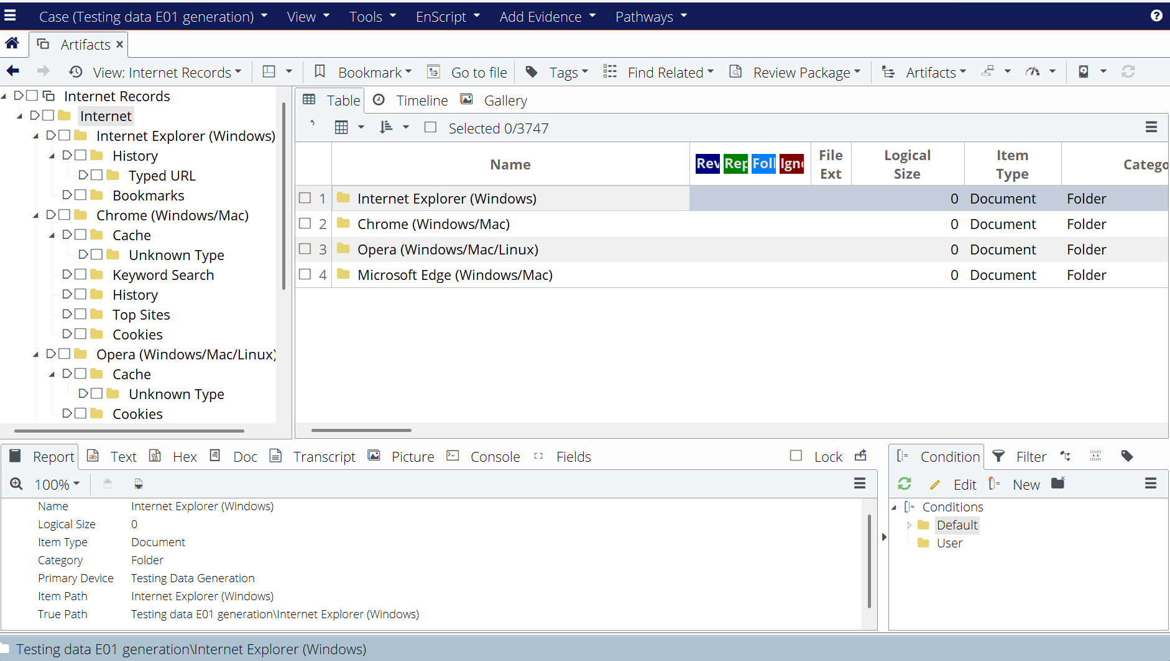
Figure 4 - EnCase Browser Artefact View
The final requirement for this tool to be considered functional is a method to view the browser artefacts that it has extracted. Without a method of doing this, the tool may as well just be an EnScript within EnCase that extracts all the files to a folder otherwise it would be considered over-engineered. With this functionality, the tool can also go through and flag any detected private browser artefacts, a feature that does not exist within EnCase and in so doing would be considered an improvement in efficiency, the overall goal for this project.

Non-Functional Requirements
The only real “non-functional” requirement for this project is how it looks and how the extracted artefacts are viewed inside it. The goal was to show it in a way that could be easily understood as well as being organized and efficient, using similar organization as that of the extracted artefact folder described in 3.2.2 to allow a digital forensic investigator to quickly go through and analyze all the extracted artefacts.

Python Build

Advantages
A major advantage of utilizing the Python language for the creation of this tool is its great versatility when it comes to completing any task (Consortium eLearning Network Pvt Ltd 2023). This comes from its wide variety of pre-existing programming libraries and frameworks allowing it to do anything from simple random number generation to even running a website. This widespread capacity makes it a very useful language as instead of having to learn a new language to do a new task, all that is needed is to import a new library that has the functionality required for said task.
Another strong advantage is Python’s strong embeddability within other languages. During the early days of planning this project, around the time it was discovered that Python could not natively deal with a .E01 file further explained in 4.3.1, it was not obvious that the tool could be completed with Python as its only language. The ability to embed Python within other languages such as C++ would have meant that if a problem were to occur later with Python being unable to solve it, another language could be used to fill the gap in its functionality (van Rossum and Python Development Team, 2018).

Disadvantages
Although its capability to complete almost any task is very impressive, the downside of Python being capable of doing this is that it is not a specialized language for a specific task. For example, whilst Python is fully capable of operating using OOP, it is not a requirement nor is it specifically designed to do so. On the other hand, Java is a programming language that is mainly designed to function using OOP and as such is more efficient than Python in doing so, despite them both having the capability (Stephen, 2021).

Module Utilization
Every part of this tool was programmed in Python version 3.10.11 using Visual Studio Code version 1.110.1 as its IDE. The Python modules that were used for this were tkinter, os, string, shutil, sqlite3, subprocess and threading.

Test Data Generation
All testing data being used for this tool will be generated from a Windows 10 Pro x64 VM from within the VMware Workstation 17 Player application. The web browsers that will be focused on for this tool shall be Google Chrome (the most popular browser as mentioned in 2.1), Microsoft Edge (it is automatically installed with the Windows OS) and Opera GX (a more modern browser designed for more user control). These browsers are also all Chromium-based which should in theory mean there are some similarities in the artefacts they generate.
To generate these artefacts, the VM will initially be set up with 2 different users, named “Person1” and “Person2”, to show that the tool can group the artefacts based on both the user and the browser. Once the VM and these users have been set up correctly, Google Chrome and Opera GX will then both be installed using Microsoft Edge, with Opera GX being installed with private mode enabled for Person1 and the reverse being true for Person2 (Chrome gets installed to all users). All actions taken on the machine have been recorded in 3.4.1 for cross referencing purposes when examining what artefacts have been created and in the case of when private mode is enabled, what artefacts can be salvaged. Once all actions have been completed and recorded, an .E01 file of the VM will be generated using EnCase for the tool to process.

VM Actions for Artefact Generation
Below is a list of each action that was taken during the creation of the testing data. The browsers used are as follows: Microsoft Edge v147.0.3912.86, Google Chrome v148.0.7778.97 and Opera GX v131.0.5877.24.
- VM named “Testing Data Generation” created in VMware using Windows10 ISO file, stored as a single file with a max file size of 64 GB and 2048 MB of memory allocated
- Language and time set to English, keyboard set to United Kingdom layout
- Windows 10 Pro selected and installed as installation only, without a product key, and machine restarted once installed
- Region and keyboard layout set to United Kingdom
- Selected options for personal use with an offline account (no email required)
- “Person1” user added with password: “LETMEIN”, security questions “What was your childhood nickname”, “What was your first pet’s name?” and “What is the first name of your oldest cousin?” selected with responses “John Doe”, “Dog” and “Jane Doe” respectively
- Browser data selected to not be imported
- Location and Find my Device disabled
- Selected only required diagnostic data be sent to Microsoft
- Improved inking, diagnostic data and advertising ID use disabled
- Customized experience skipped
- Cortana disabled from using personal information
- “Person2” user added by navigating to Settings – Accounts – Family and Other Users, password set to “Cookies”, security questions “What was your childhood nickname”, “What was your first pet’s name?” and “What is the first name of your oldest cousin?” selected with responses “Jane Doe”, “Cat” and “John Doe” respectively
- Microsoft Edge opened, “customize browser” tab closed and “Google Chrome Install” searched, cookies rejected from Microsoft
- URL https://www.google.com/chrome/index.html visited, link to https://www.google.com/chrome/next-steps.html clicked which installed “ChromeSetup.exe”
- ChromeSetup.exe ran on VM and allowed to make changes to device
- Google Chrome opened automatically after installing to all users, sign in skipped and set as default browser before closing
- Chrome installation tab on Edge closed
- New “incognito” tab opened and “Opera GX Install” searched, Microsoft cookies rejected
- URL https://www.opera.com/Ip/video-streaming?utm_source=bing&utm_medium=pa&utm_campaign=WW&20-%20Performance%20max%20-%20EN%20-%20f%20-%20STREAM%20-%20MKT&msclkid=fca7970fb80513ee5c29fee0c948d6fe&utm_term=www.opera.com&utm_content=%231%20messaging%20highlighting%20the%20features%20and%20multitasking visited and necessary cookies allowed, link to https://www.opera.com/computer/thanks?ni=stable&os=windows&utm_source=bing&utm_campaign=WW&20-%20Performance%20max%20-%20EN%20-%20f%20-%20STREAM%20-%20MKT&utm_term=www.opera.com&utm_content=%231%20messaging%20highlighting%20the%20features%20and%20multitasking&msclkid=fca7970fb80513ee5c29fee0c948d6fe clicked which installed “OperaSetup.exe”
- OperaSetup.exe ran on VM, data collection disabled and Opera GX installed and automatically opening “Speed Dial” and “Welcome” tabs before being closed
- All browsers closed and user switched to Person2, Action 14 – Action 21 repeated for Person2, with Opera GX set as the default browser
- Opera GX opened by Person2 with 3 tabs opening automatically: “Your personal browser is almost ready”, “Opera One” and “Speed Dial”
- A new tab was opened and “how does a duck fly” followed by clicking on a link to www.ducks.ca/stories/conservator/how-duck-flight-works
- “Youtube” was searched and the link to www.youtube.com/feed/history was followed
- An Opera GX private tab was then opened and “digger video” was searched, the video “Diggers, Tractor, Excavator, Garbage Truck & Muddy Construction Vehicles For Kids | Gecko’s Garage” was watched for a few seconds before closing Opera GX
- Google Chrome was opened and the term “computer” was searched before switching to an “incognito” tab and searching “hidden lmao”
- Chrome was closed and Microsoft Edge was reopened
- “hello” was searched in Edge and then the browser extension “Grammarly: AI Writing and Grammar Checker App” was installed
- Google Chrome was then closed, and the user was switched back to Person1
- Opera GX was opened by Person1 and in a new tab, “fish swimming” was searched, followed by “green trees” being searched in a new “private” tab
- Opera GX was then closed, and Google Chrome was opened
- “Red Penguin” was searched in Chrome followed by a new incognito tab being opened and “T-Rex” being searched
- Google Chrome was then closed and the VM was shut down

Artefact Summary
Based on the actions taken within the VM in 3.4.1, the following browser artefacts were generated:
Person1
Action | Browser | Private/Not Private
Chrome installed | Edge | Not Private
Opera installed | Edge | Private
Searched “fish swimming” | Opera | Not Private
Searched “green trees” | Opera | Private
Searched “Red Penguin” | Chrome | Not Private
Searched “T-Rex” | Chrome | Private

Person2
Action | Browser | Private/Not Private
Chrome installed | Edge | Private
Opera installed | Edge | Not Private
Searched “how do ducks fly” | Opera | Not Private
Visited www.ducks.ca/stories/conservator/how-duck-flight-works | Opera | Not Private
Searched “Youtube” | Opera | Not Private
Visited www.youtube.com/feed/history | Opera | Not Private
Watched video “Diggers, Tractor, Excavator, Garbage Truck & Muddy Construction Vehicles For Kids | Gecko’s Garage” | Opera | Private
Searched “computer” | Chrome | Not Private
Searched “hidden lmao” | Chrome | Private
Searched “hello” | Edge | Not Private
Installed extension “Grammarly: AI Writing and Grammar Checker App” | Edge | Not Private

.E01 vs .VMDK Testing
The reasoning for the tool using a .E01 instead of the .vmdk file that the VM is stored as is quite simple. If the tool were to be designed to use .vmdk files, then the only machines that could process the browser artefacts off would be VMs. In a digital investigation this would not be particularly useful as they are investigating the full physical machine or devices rather than a singular VM file stored on said device. By comparison, a .E01 file can be produced from a .vmdk file and can also be generated from a regular machine or device as well. A .E01 file is also likely to be generated anyway during a digital investigation using EnCase as it is a by-product of its processing and analyzing its data so digital forensic investigators do not tamper with the original data.
As both a regular machine or device and a .vmdk file can both be processed into a .E01 file, it allows us to use the .vmdk file as the testing data whilst giving it the same properties that an actual machine or device would have. Being able to use a VM will make the generation of testing data more efficient as setting up a fresh VM is much quicker than completely wiping a machine and setting it up from scratch so there is no residual data.

AIM Utilization
A crucial part of the functionality of this tool is its utilization of the AIM application developed by Arsenal Recon. The main use of this application is the mounting of data as a complete disk in Windows, thus allowing users to treat them as they would any of their other physical disks (Arsenalrecon.com n.d.). For the functionality of this tool, AIM v3.12.331 has been used to mount a .E01 file generated from EnCase as a readable disk on its current machine. This requires AIM to be running with Administrator privileges on its machine and as the tool uses it during its processing, it too is required to be run with Administrator privileges. Whilst only being used briefly during the functioning of this tool, without mounting the .E01 file the tool would be unable to interpret its data.

Product Design, Implementation & Evaluation

Design

OOP
During the programming of this tool, OOP was implemented as a programming paradigm for the generation of the window GUI mentioned later in 4.1.2. The reason that this was used was to better organize and classify functions being called from different sections of the tool, such as the mounting function for instance. Using OOP worked nicely alongside the Tkinter library which also operated this way regarding its functions and properties.
Figure 5 below shows how the main window for the tool is constructed using an OOP class with various methods assigned to it. This method of initializing the image was useful during development as it allowed for better organization of the source code and allows a developer to easily trace the execution order of the program despite it being large. Whilst there is a list of methods called during its initialization, there are many not shown in this image that are called by user actions such as clicking the buttons in the tool or selecting different options for the dropdown boxes.
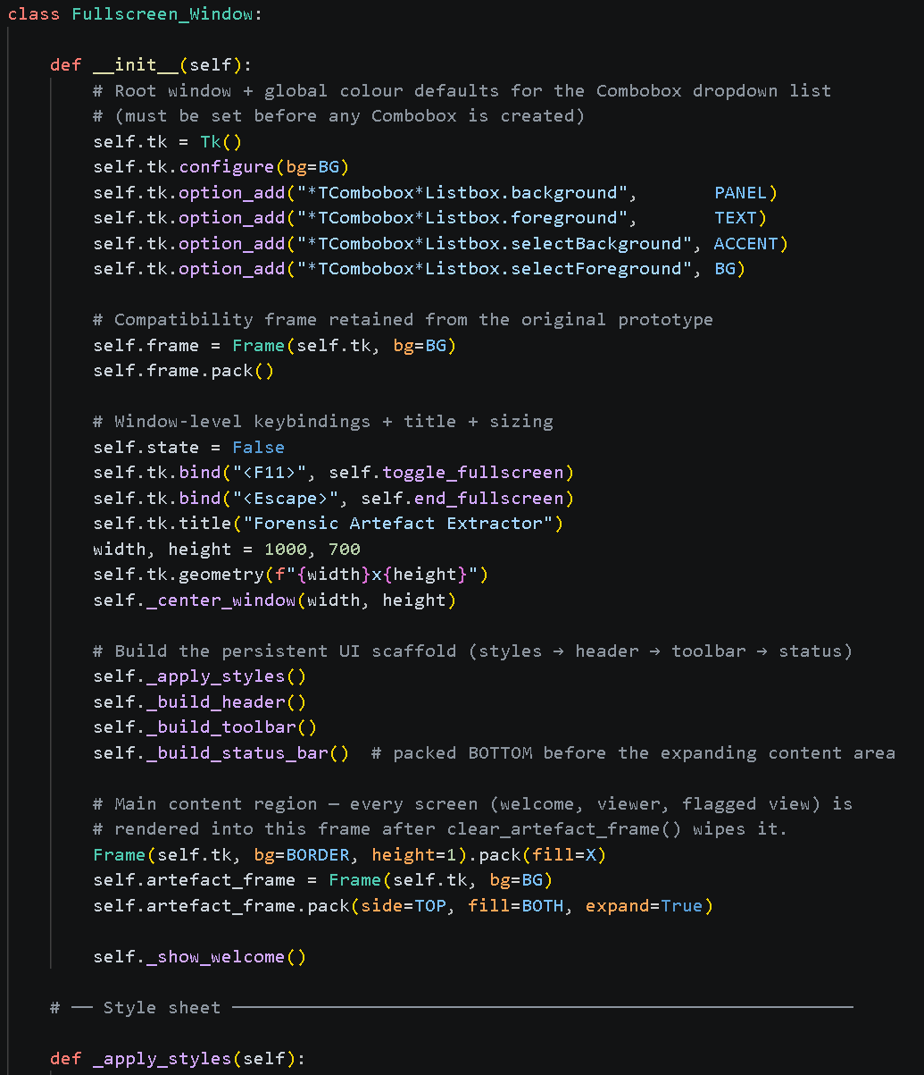
Figure 5 - Initialisation of Window Class

GUI
To make this tool more user-friendly, instead of being run through a command prompt with limited visual representations for displaying the data, the choice to create a GUI was made. This GUI was created through using the Tkinter Python library which operates in a similar way to the creation of a website in terms of adding items to a window instead of a browser page. During the early development of the tool, the GUI was simply 3 buttons on a taskbar that would dictate the basic functions of the tool that would later be combined to form a single, clean process. See Figure 6.
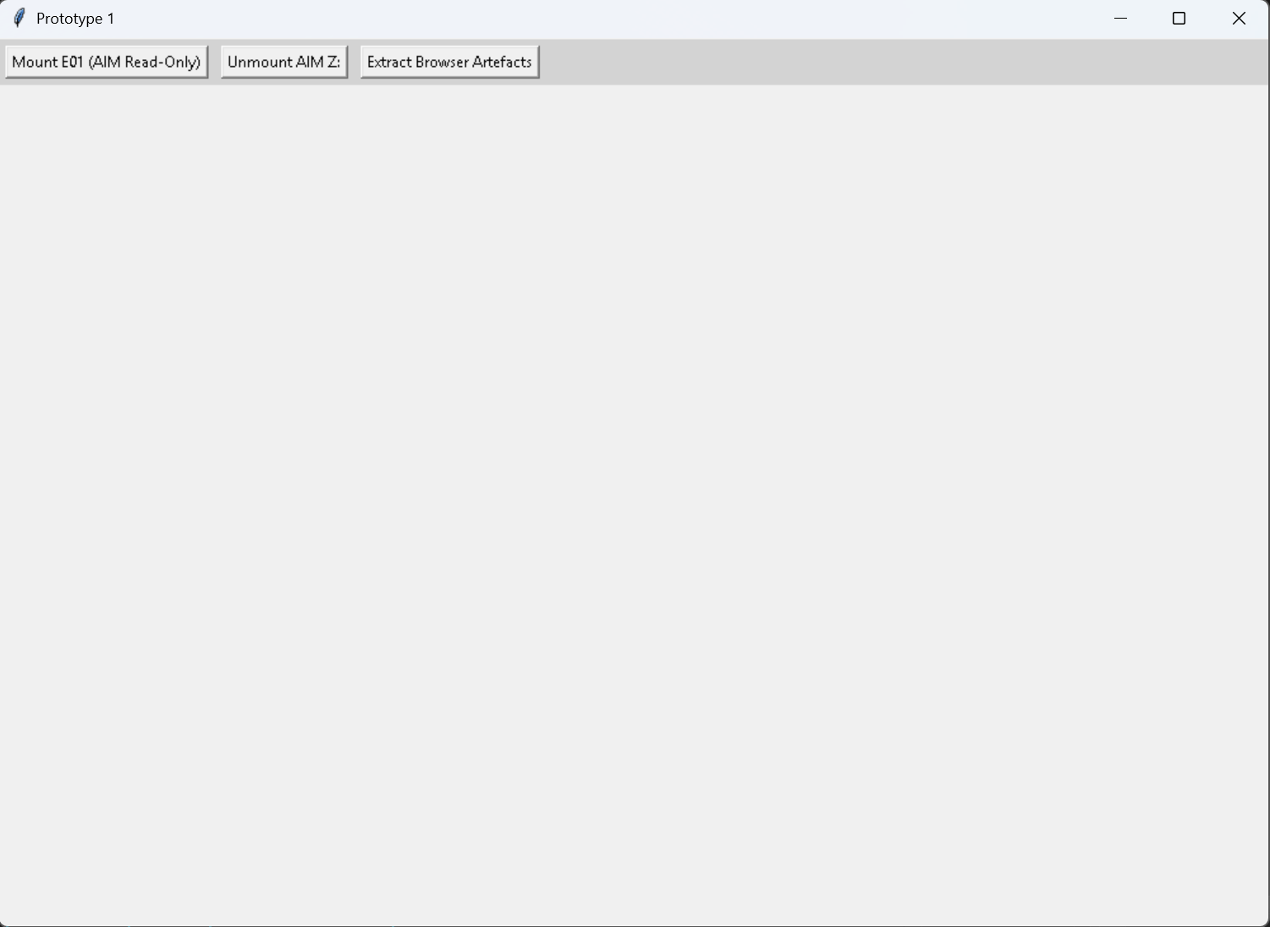
Figure 6 - Early Prototype GUI
Eventually, these 3 initial buttons were combined into one smooth process, explained later in 4.2.3 and 4.2.4. As other functionality was added such as the viewing of the artefacts etc. described in 4.2.6, the original design for the tools GUI changed drastically, with message boxes appearing to inform the user of processes, progress bars for artefact extraction and even buttons and drop down boxes that would only appear at certain points in the tool’s functionality. It was at this point that it was decided that the design of the GUI needed an overhaul to look more like a professional product rather than something quickly put together.
This change in GUI design primarily came from the addition of a “color palette” section to its source code. This section of code would assign values such as background color, text size, fonts etc. in a similar way to how CSS is used in the front-end design of websites. All these options being built into Tkinter but set as variables so that, for instance, whenever a button is created, it would have the same design as all the other buttons within the window. As shown below in Figure 7, this section does not have many lines of code and once set, would only need to be referenced in the generation of objects within the window. Figure 8 shows the starting window for the tool prototype after its finished development and applying the GUI changes.
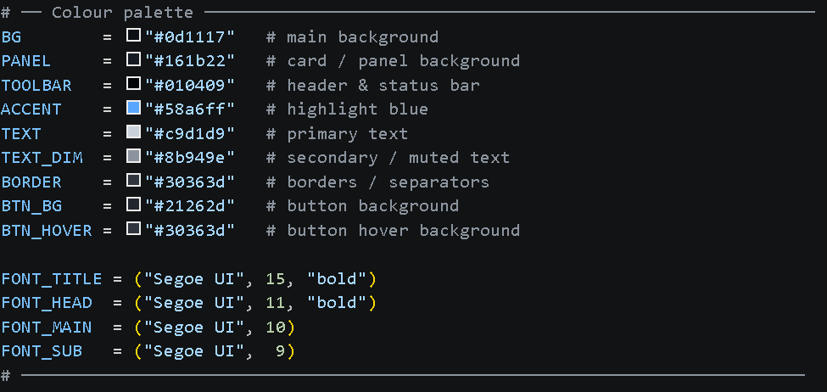
Figure 7 - Tool Stylesheet
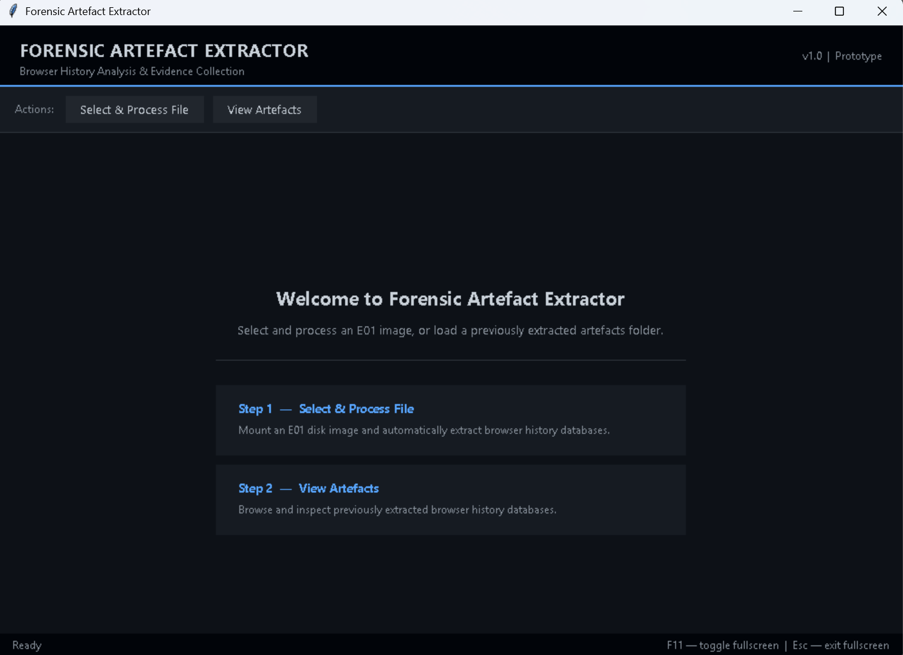
Figure 8 - Tool Main Window
After these changes to the starting window of the tool were made, the style for the overall tool would remain consistent throughout its use, even when new windows such as loading bars or forensic verification window (see 4.2.6) were opened, they would all use the same design palette. Overall, this made the tool appear much more professional than its earlier stages of development.

Modular Architecture
To encourage further development of this tool and to make its code more understandable to humans, it was designed with modular architecture in mind. The tool being built using OOP, see 4.1.1, also helped to reinforce this. By having distinct functions that don’t interact with each other or do not begin unless prompted by the user, adding additional functionality can become a much simpler process.
A good example of two functions that do not interact would be the mounting of the .E01 file as a read-only drive and the verification of the extracted artefact’s forensic integrity. These functions are both crucial to the overall performance of the tool, but do not directly affect each other’s individual processes. This means that one can be updated and changed and, if the output remains the same, the other will not be affected, allowing for modular changes to take place within the code.
This modular design also provided great benefit during the development of the tool prototype itself. As new features were added or others extended, they could be done so without affecting existing ones. Once a function was deemed to work as required, its output could then be taken elsewhere for a new function to work with. This meant that much less “back and forth” programming of the tool was required and helped to improve the rate of its development.

File Structure
During the early development of the tool, the decision was made to separate its functions into separate Python files that would call functions from each other during their respective process, with the tool ultimately being run from a Main.py file. This was primarily for organizational purposes. For example, any functions to do with the extraction of the browser artefacts were all kept together within the Extract_Artefacts.py file due to their similar use. Another advantage was that this allowed several sections of the tool to be viewed simultaneously instead of having to go back and forth between different lines of code when checking that inputs and outputs were being correctly dealt with when a function was being implemented. Each of the files containing the source code for the tool can be seen below in Figure 9.
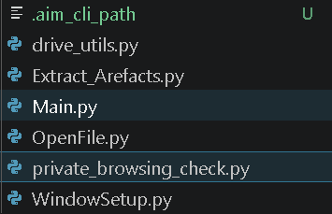
Figure 9 - Tool Files
As development of the tool continued, most new functions that were being added to the program ended up not being grouped into their own files. This was done as the number of functions that were using the same imported browsers was steadily increasing and it was decided that repeatedly importing the same browsers would only reduce the efficiency of the tool, therefore going against its main purpose of reducing the time taken during a digital forensic investigation. The original files containing similar functions were left as they were to avoid messing up the functionality of the tool, but all new functions were added to the WindowSetup.py.

Implementation

Window Setup
As shown previously in 4.1.2, the main window for this tool was implemented through a combination of the Tkinter python library and OOP structure. Its initialization as a Create_Window() object is the first thing that is called when the Main.py file of the tool is executed as shown below in Figure 10.
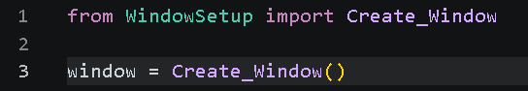
Figure 10 - Main.py Code
When the object is created, it is then set as a Tkinter object to allow it to be created as a window and a frame is added to it. It is this frame that will allow other Tkinter objects to be added and organized within this window. Then, several of the GUI color palettes are applied to it as shown in Figure 11. The code below in Figure 12 is then executed to assign its attributes all the correct values, such as the size of the window, its state and adding a Title.
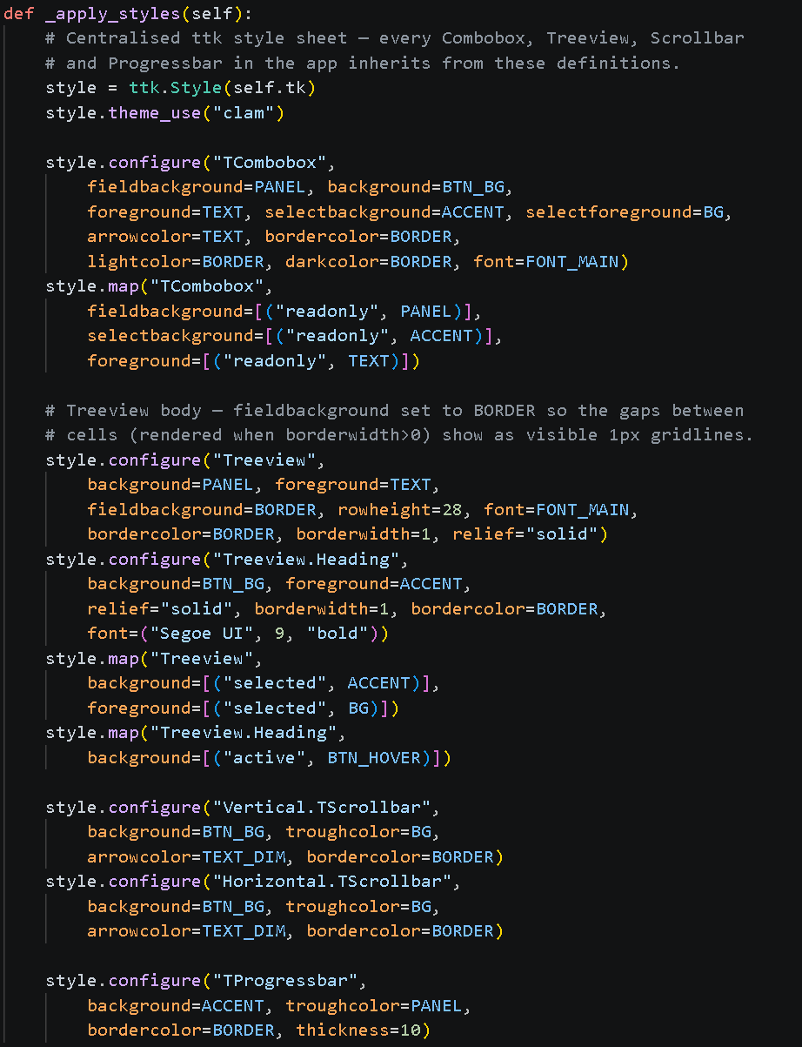
Figure 11 – Colour Palettes Prepared
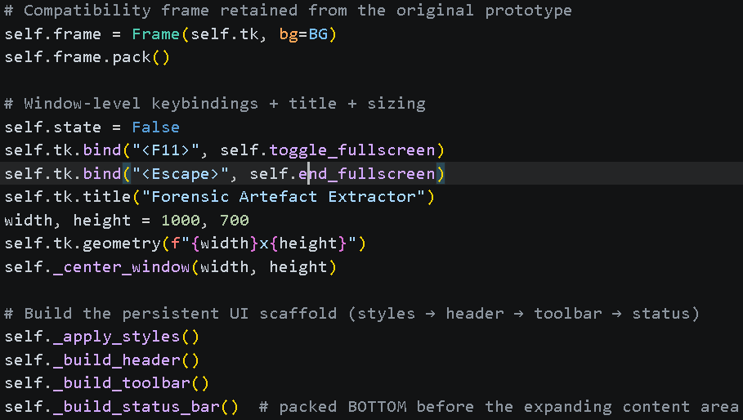
Figure 12 - Colour Palettes Assigned
The functions shown at the end of Figure 12 above are what build/adds all the objects in the frame of the window, such as the buttons. Some were placed inside a toolbar towards the top of the window whereas others were arranged elsewhere based on what their requirements were. After all the objects had been added into the window and the tool was ready to be used, a welcome message was then shown using the _show_welcome() function as shown below in Figure 13 that would briefly explain to the user the purpose of the tool as shown in Figure 14.
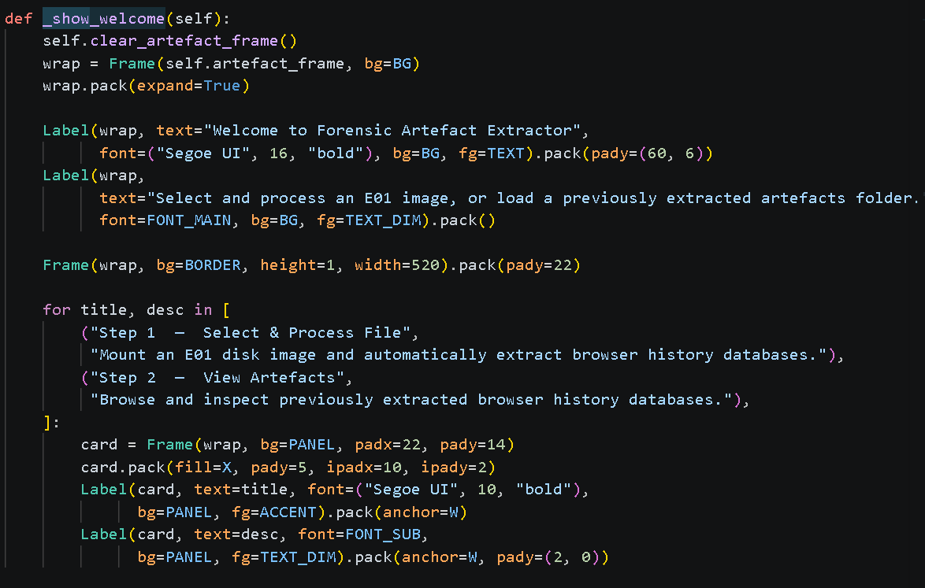
Figure 13 - "_show_welcome" Function
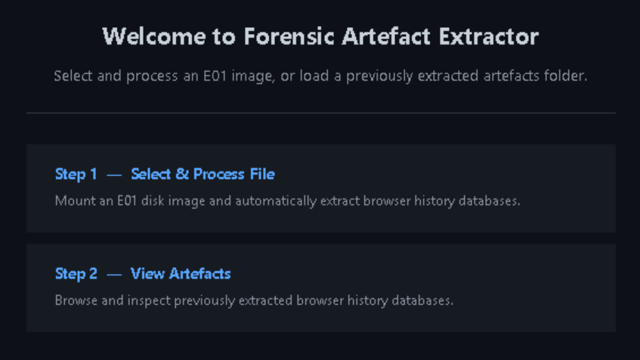
Figure 14 - Welcome Message

Mounting and Unmounting .E01
When a user wishes to extract the browser artefacts from an .E01 file using this tool, they must select the “Select & Process File” button from the window’s taskbar, see Figure 1 5 below. This button then initializes this process by calling the store_drives_and_mount() function, see Figure 16, which itself calls several functions, see Figure 17from within the OpenFile.py file to complete the process of mount, extract then unmount using AIM (after recording which drives are already currently mounted to identify newly mounted ones).
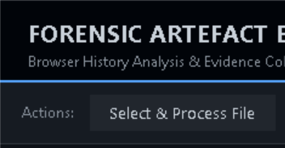
Figure 15 - "Select & Process File" Button
Figure 16 - "Select & Process File" Button Code
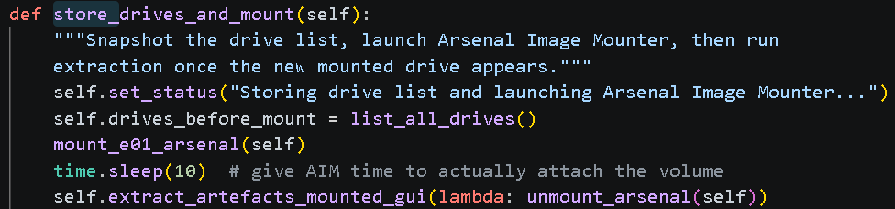
Figure 17 - "store_drives_and_mount" Function
Before the tool can begin the process of mounting the file, extracting the data and unmounting the file, there first needed a way for the user to select the file in which to perform the process on. This was done by using “filedialog” from within the Tkinter Python library Figure 18. By using some default filters, in this case files ending in .E01 or all files, this would open a window similar to File Explorer that would allow the user to navigate through their directories to select the file they wished to examine Figure 19.
Figure 18 - "Select a File" Window Code

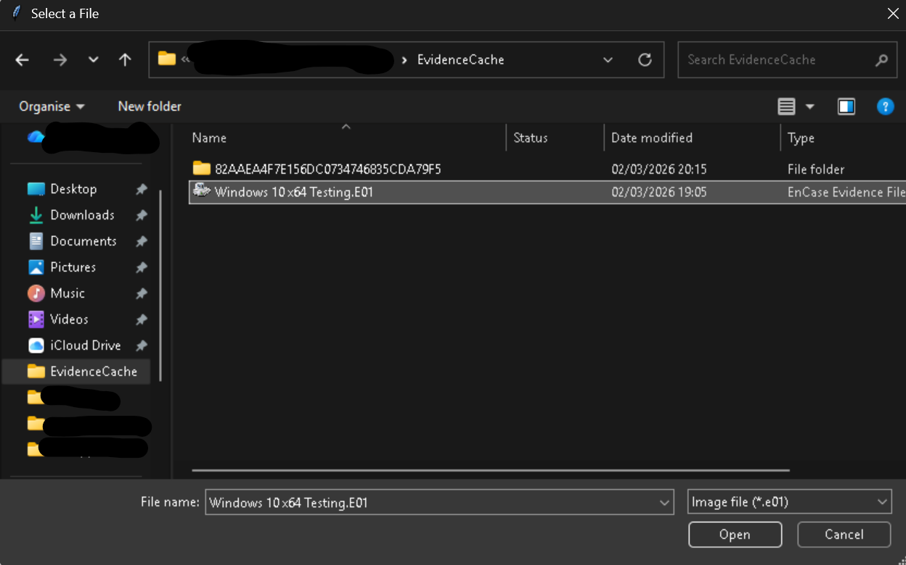
Figure 19 - .E01 File in "Select a File" Window
Once the user has selected the correct .E01 file, the file then needs to be mounted so that the artefacts can be extracted. It is at this point that the AIM CLI is called via the command line by the tool to mount the file as a read-only drive on the user’s machine. This is run as a background process to prevent the tool from becoming unresponsive during the process, see Figure 20.
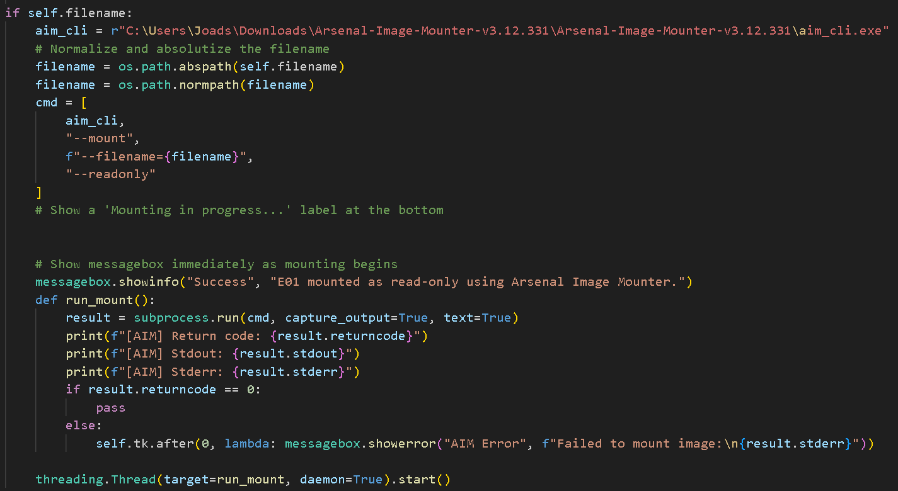
Figure 20 - Code to Mount .E01 as Read-Only Drive
Finally, once all the artefacts have been extracted either successfully or unsuccessfully, with those that were not being recorded to a .txt file, then the mounted drives will need unmounted from the user’s machine. This is done by the tool once again calling AIM CLI via the command line to do so and informs the user via a Tkinter “messagebox” as the whether the process has been completed successfully, see Figure 21.
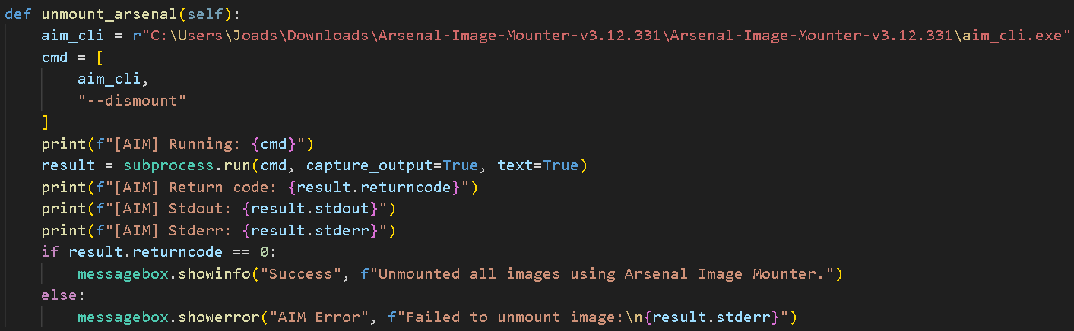
Figure 21 - Code to Unmount .E01 Drive

Browser Artefact Extraction
In between the mounting and unmounting of the selected .E01 file, see 4.2.2 for details, is the time in which it extracts all the browser artefacts from the file. This is the most important part of the tool’s functionality as it provides the required data to all other additional functions in the tool. The first step in this process is to identify the browser artefacts stored in the .E01 file so that the tool can know which files to extract and which to ignore. After creating this list of artefacts, the tool then extracts them to a chosen file location with the following structure: Datetime Stamped Folder -> Users -> Browsers. Through this, the tool copies the file structure of each browser whilst also organizing them under each user as well. Once this process is completed and all artefacts are extracted, then the .E01 file is unmounted and the process is ended.
To begin identifying which artefacts to extract, the tool walks through the .E01 recursively, looking for a list of known filenames and folder directories of browsers as shown in Figure 22. The way in which the tool checks if a file matches these conditions is through the “is_browser_artefact” function, see Figure 23. This function compares each file with the known lists and confirms whether the file is a browser artefact or not.
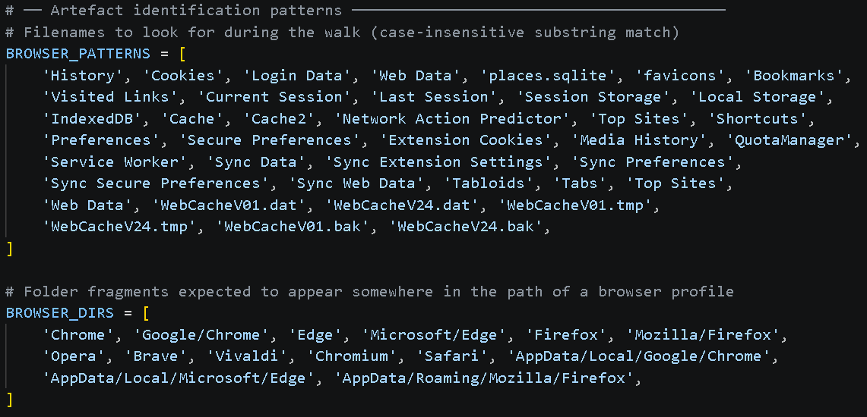
Figure 22 - Browser Pattern and Browser Directory Lists
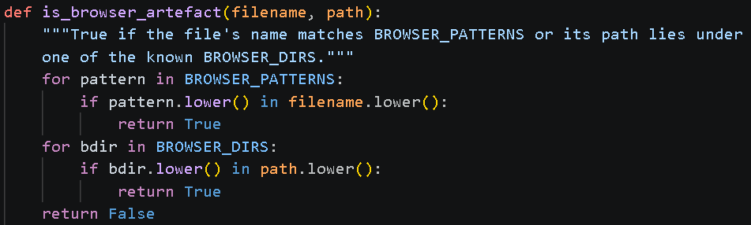
Figure 23 - "is_browser_artefact" Function
Whilst utilizing this loop on each file located within the .E01 file, the tool confirms whether each file is a browser artefact or not and upon successful identification adds them to a list of files to be extracted. This list of artefacts is also used for the progress bar window that appears during extraction, see Figure 24, to show the user the progress of the extraction process based on the total number of artefacts. The code in Figure 25 shows the function “extract_browser_artefacts_from_mounted” which is the main function/loop for this process. The for loop shown is what collects the list of browser artefacts through walking the file system of the mounted .E01 file.
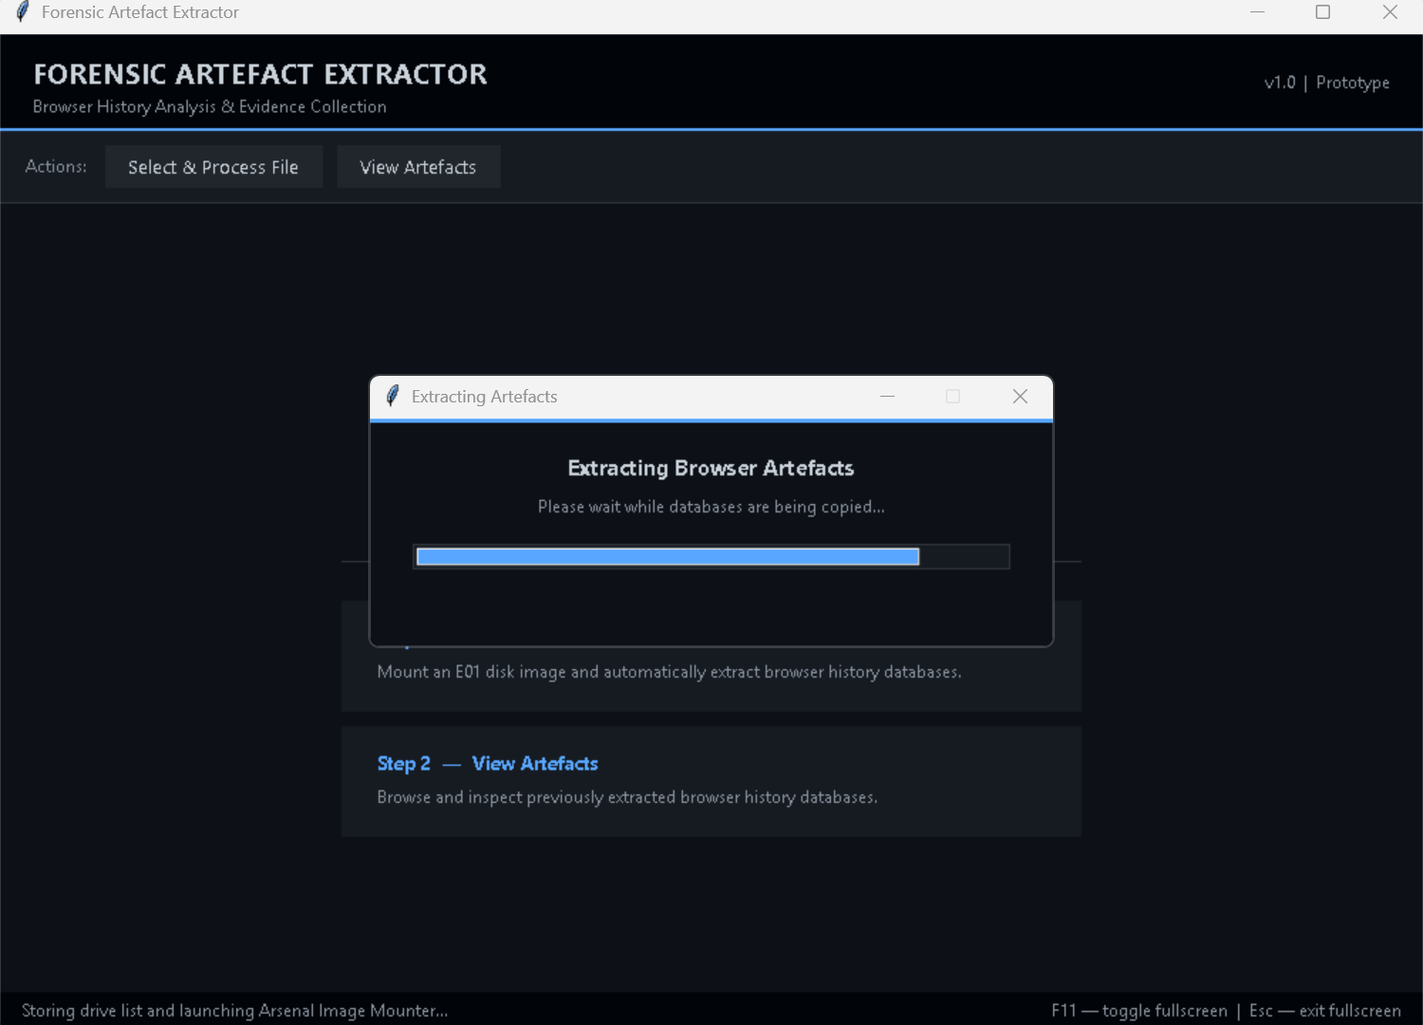
Figure 24 - Artefact Extraction Progress Bar
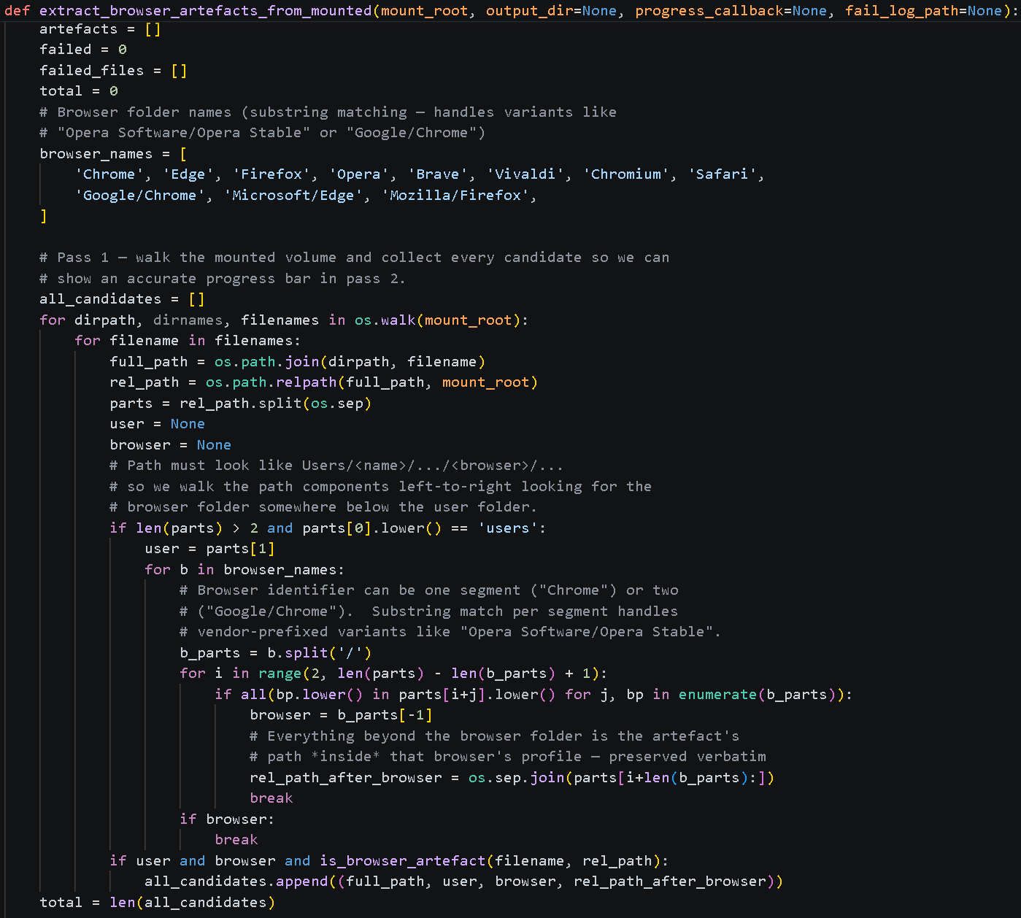
Figure 25 - "extract_browser_artefacts_from_mounted" Function Part 1
The second section of code within this function, see Figure 26 is what performs the actual extraction of the identified browser artefacts. It goes through each file in the list and extracts them into a folder at a location previously set by the user. During this, it also organizes these artefacts as well, grouping the artefact from each browser together and subsequently grouping these under each user as well, meaning that there may be several occurrences of a folder named “Chrome” within the file structure of the extracted artefacts. If an artefact happens to fail to be extracted from the .E01 file, the tool makes a note of its full file path and makes a list of each of these instances as well as the reason for extraction failure. Later, this list of failed extractions is written to a text file so the user can observe how many artefacts failed and the reason why for documentation purposes. It is also during this process that the hash values of the extraction are calculated to be used later, see 4.2.6 for further details.
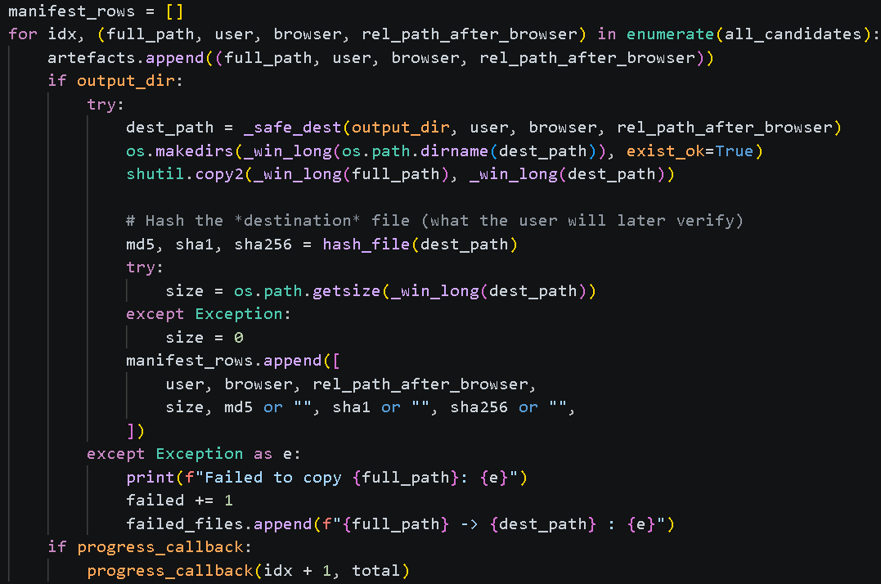
Figure 26 - "extract_browser_artefacts_from_mounted" Function Part 2

Representation of Data
Once all the artefacts from the selected .E01 file had been extracted, there then needed to be a way for the tool to display any extracted data to the user. If this function was not implemented, then the function of the tool would be no different then selecting all the internet artefacts within EnCase and selecting “Export File”. To view the extracted data, the user selects the “View Artefacts” button which calls the “view_artefacts_folder” function within the program, see Figure 27. This begins the process by the user selecting the folder the extracted artefacts are stored in and changing the display within the tool to begin viewing them.
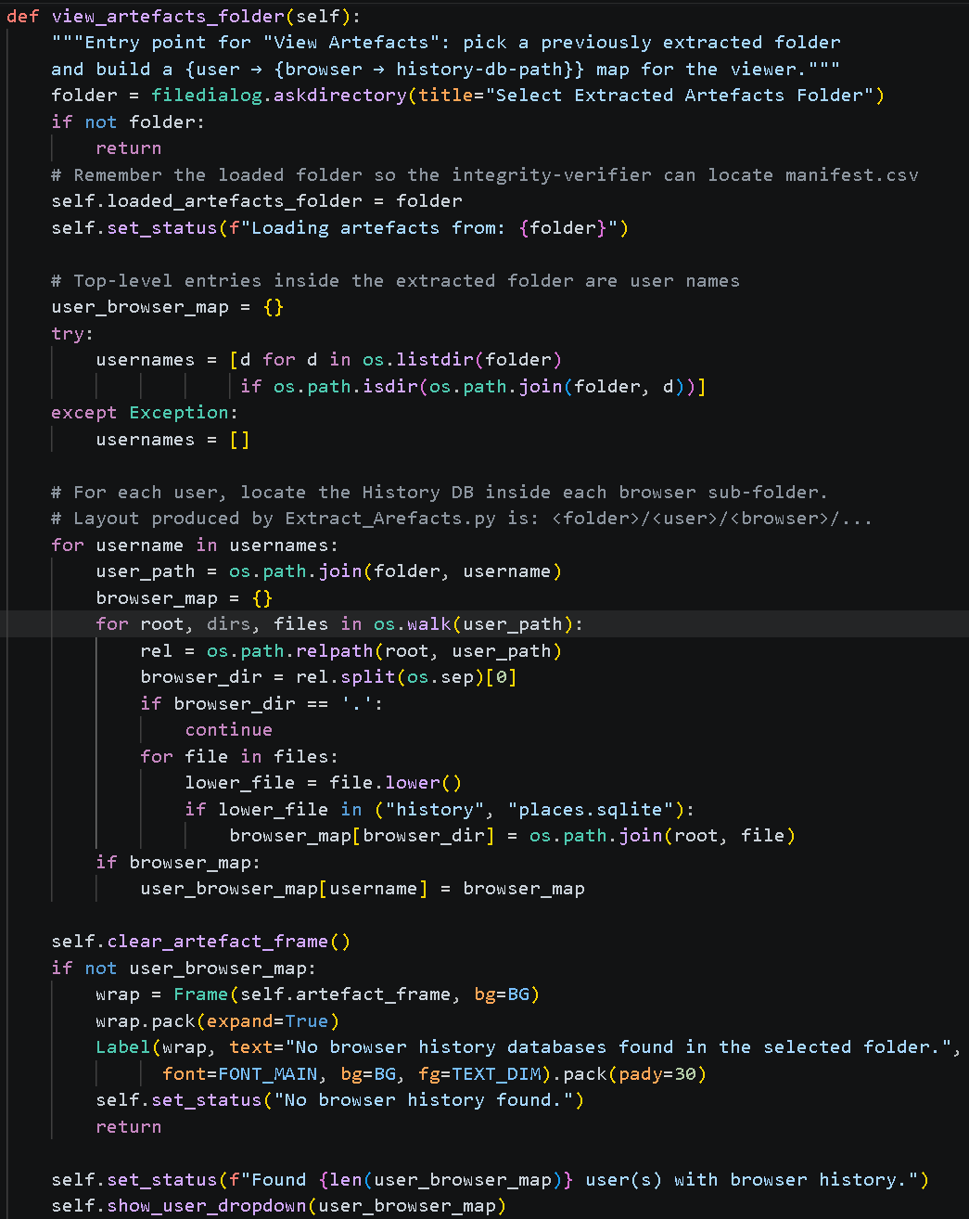
Figure 27 - "view_artefacts_folder" Function
Once the folder has been selected and confirmed as a browser extraction folder by the existence of the previously mentioned history database, the program first creates a dictionary for each user on the extraction and their associated browsers. It does this by utilizing the names of the user folders within the extraction folder and each browser folder that the subsequently store, cycling through a nested for loop until the dictionary has been completed. If no users or browsers are detected, then the user is informed of such, after clearing the “welcome” frame regardless of the outcome. Upon success, the dictionary containing the mapped browsers to users is sent to the “show_user_dropdown” function of the window, see Figure 28.
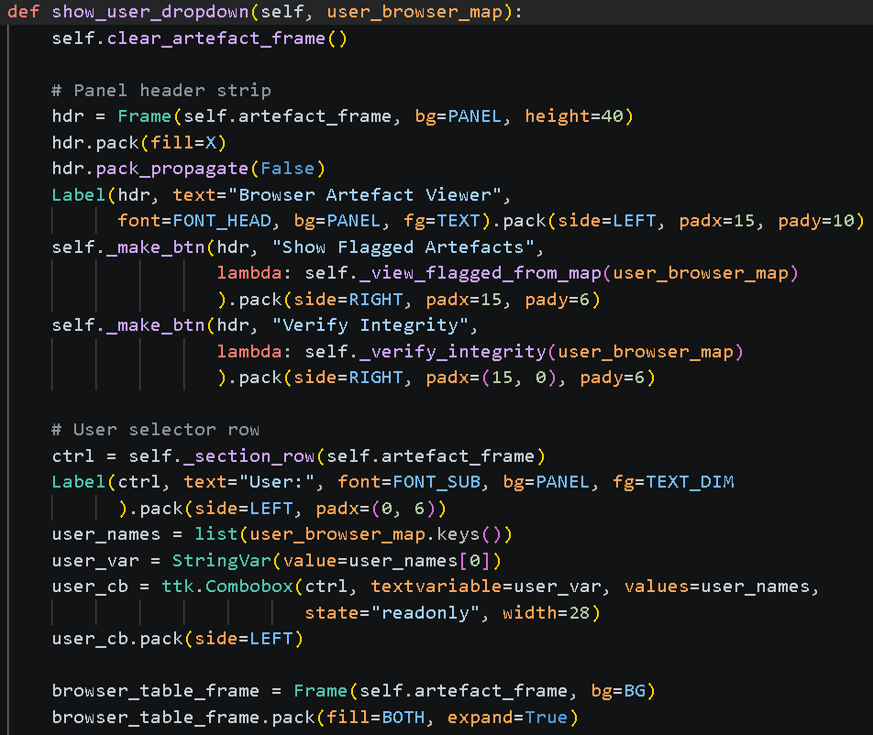
Figure 28 - "show_user_dropdown" Function
It is this function that also displays the artefacts within the main window of the tool, the function also adds the buttons labelled “Show Flagged Artefacts” and “Verify Integrity”, further explained in 4.2.5 and 4.2.6 respectively. The way in which the artefacts are displayed is in a table format based off the “history” database browser artefact. Three drop boxes are associated with it to determine which table the user wishes to look at. These drop boxes determine the username (on the extracted artefacts not the local user’s username), the browser and then which table, see Figure 29. The options for these drop boxes a retrieved from correlating the dictionary previously created with the tables stored within the corresponding history database. for an example where the “meta” table from the “Chrome” browser of “Person1” is selected.
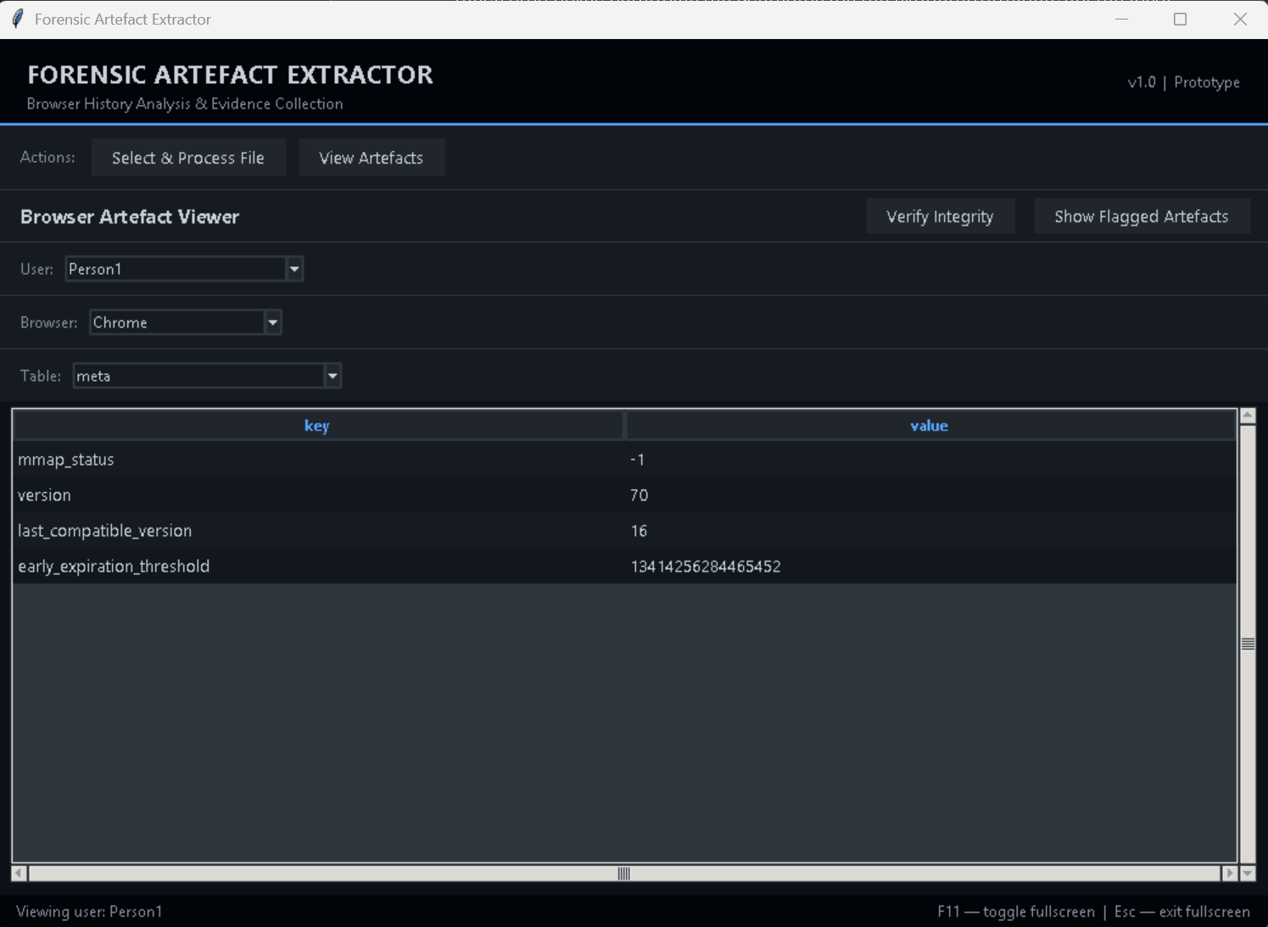
Figure 29 - Initial Browser Artefact Viewing

Private Browser Artefacts
Once the tool was fully capable of extracting all browser artefacts from an .E01 file, it then needed a method of determining which of these artefacts were generated from private browsing sessions. As previously outlined in 2.4.2, the manual method of doing this is to identify artefacts that are stored in non-volatile memory during private browser use and then cross reference their missing artefacts that were stored, and subsequently deleted, in RAM. It was decided that the tool would implement a method of replicating / automating this comparison within its function to identify possible private browser artefacts. The reason that the tool only detects possible private browser artefacts instead of confirming it is due to variables that could have changed the file contents of the browser before being acquired for investigation.
To identify possible private browsing sessions within the extracted data, two different methods were implemented into the tool to be more reliable in its detection. The first of these checks is a schema-level analysis. For example, this is where there is an artefact for the download of a file is present, but the URL or history table is completely empty. As it is incredibly unlikely that these tables will be empty unless a user has deleted their entire browsing history, this check is only semi-reliable at identifying possible private browser artefacts but is still worth performing, nonetheless. See Figure 30 for the code of function “_check_chromium” that performs this schema-level check on all chromium-based browsers due to all using the same History database scheme, other functions with slight changes are used for other browsers.
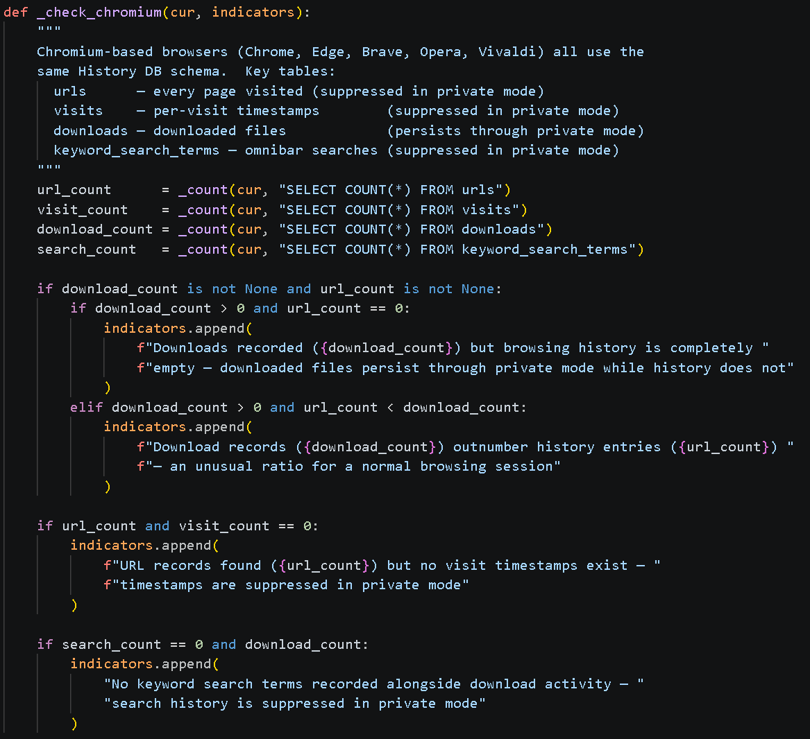
Figure 30 - "check_chromium" Function
The second and more reliable check the tool performs is on temporal gap correlation. This is where the tool looks for browser artefacts with timestamps that fall inside of what it defines as a “quiet window”, a period where no browser activity (new artifacts being created) has been detected. This is considered the strongest identifier for private browsing activity as it is not correlating specific artefacts with each other but rather the timestamps of all other artefacts. For this check, a quiet window takes place after 30 minutes of no browser activity. See Figure 31 and Figure 32 for the code of the function “_check_chromium_temporal_gaps” which performs the task of checking for temporal gaps within chromium-based browsers, again with other browsers having dedicated functions.
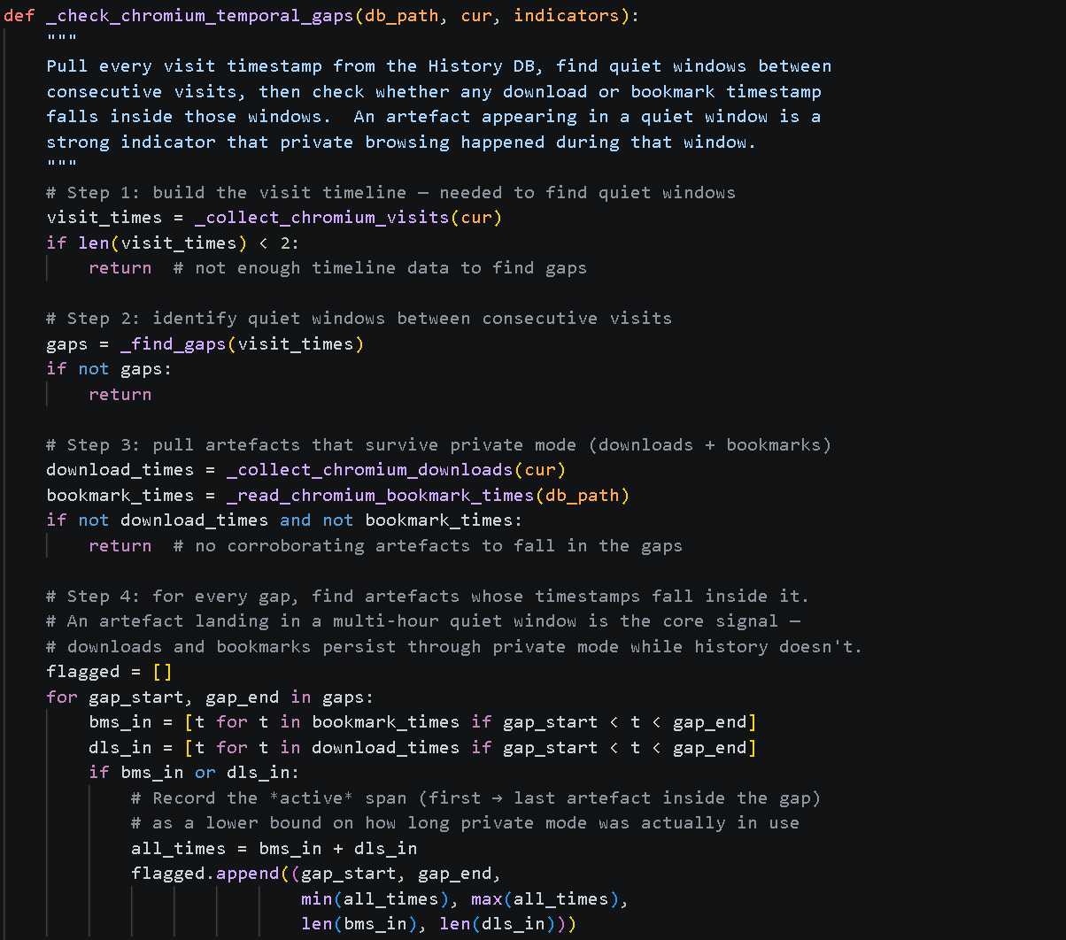
Figure 31 - "_check_chromium_temproal_gaps" Function Part 1
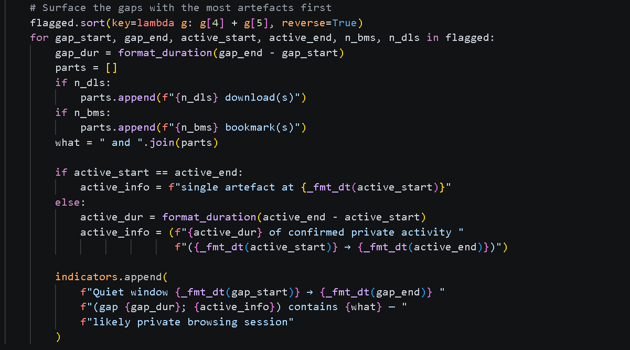
Figure 32 - "_check_chromium_temproal_gaps" Function Part 2

Verifying Forensic Integrity
For this tool to be capable of being used within a real digital forensic investigation, there needed to be a method of proving its forensic integrity. With digital investigations, this is done through the calculation of two hash values, in the case of generating an .E01 file this is done before and after processing the evidence and ensuring that they are matching to prove that no data has changed during the operation. As such, this tool would need to do the same: calculate a hash value before extracting the artefacts and then when the artefacts are viewed within the tool. To further increase the forensic integrity and remove the room for scrutiny, three different hashing functions were used: MD5, SHA-1 and SHA-256.
The first time these hash values are calculated, as previously mentioned, is before the browser artefact extraction begins. The function “hash_file” is called from within the “wrtite_manifest_hashes” function and the three hash values are calculated, see Figure 33 and Figure 34. Upon completion (if failed then null values are returned) these values are stored within a .csv file for comparison purposes later on.
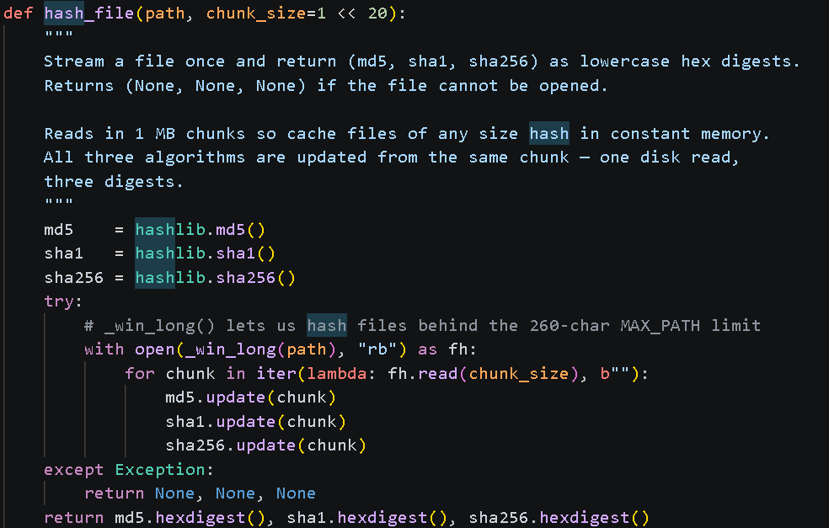
Figure 33 - "hash_file" Function
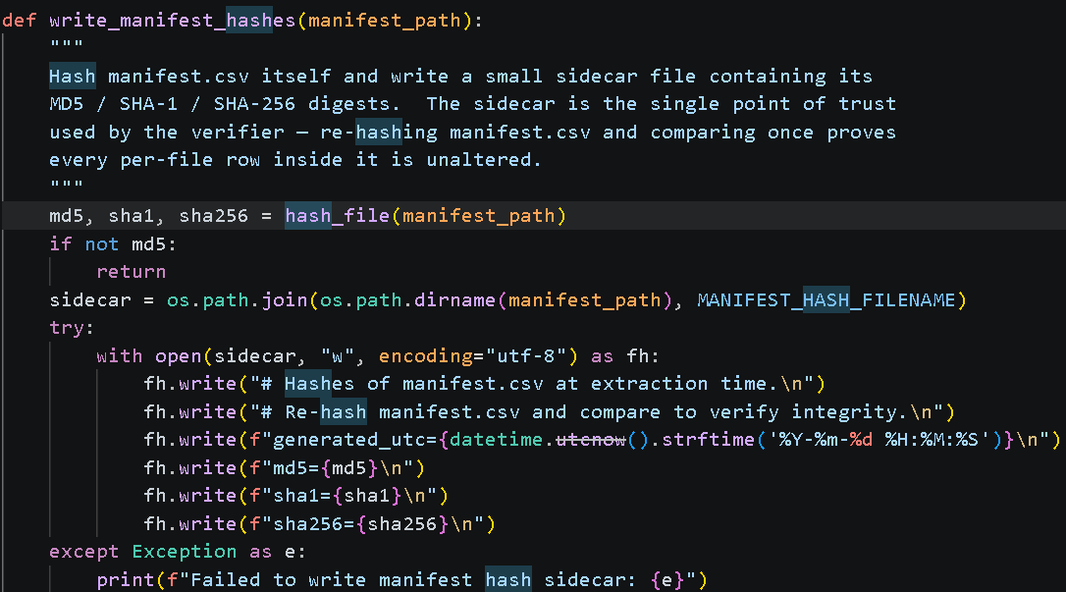
Figure 34 - "write_manifest_hashes" Function

Challenges

Processing .E01 and Mounting Drives
Once the tool could select the file to extract the browser artefacts from, the next problem was how to deal with the selected .E01 file as it cannot be natively interpreted by Python in the way that a .txt file can, for example, read line by line. Instead, a method of turning the .E01 into a format that could be interpreted by Python was necessary. It was at this point where the idea of mounting the file as a read-only drive was thought of as this meant that if successful, the tool would be able to treat the .E01 file as a file system like how it is displayed when opened using the EnCase application.
To mount the file on the machine, application AIM v3.12.331 was used. Initial testing of mounting the file using AIM’s GUI resulted in multiple drives being mounted from the single .E01 file. After inspecting these drives, it was uncovered that only one of them contained the files for the users meaning that during the tool’s extraction process, it would not only need to be capable of identifying which drives are newly mounted, but also which one contained the browser artefacts.
Before attempting to extract the correct files from the correct drive, however, the tool first needed a way to interact with AIM to automatically mount and unmount the .E01 file without having the user use AIM’s GUI. This was done by executing command prompts to execute the operations through the AIM CLI. During the testing of these operations, it was discovered that the tool would stop responding whilst the actions were being carried out. To circumvent this issue, it was decided that these commands would be run as a background process as previously mentioned in 4.2.3. In doing so, the command line instructions would still be carried out as normal whilst the tool remained responsive to the user.

File Permissions
During the early testing of the application, the newly mounted drives were examined with File Explorer to ensure that the data from the .E01 file had been mounted successfully. After a brief look it was discovered that even with running File Explorer with Administrator privileges, File Explorer could only go as deep as the individual user folders of the mounted drive containing them as it did not have the correct permissions to go deeper Figure 35. This was due to the drive being mounted as read-only.
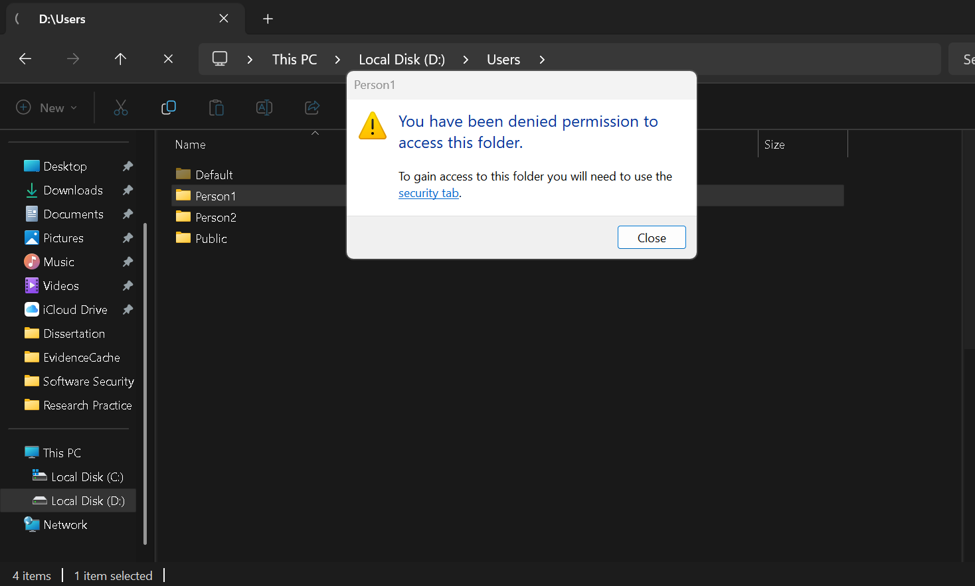
Figure 35 - Access to User Folder Denied
When this was first discovered, it was believed that the tool would also not be capable of accessing deeper into the file system either. This was not the case however and the tool was fully capable of accessing all the files within the drive and extracting them to the chosen location. The inability to access the files with File Explorer was eventually seen as a good thing and a feature as it meant that the user could not interfere with any files on the mounted drive during the extraction process, further increasing the tool’s forensic integrity.

Tool Demonstration
To demonstrate the use of this tool, a user with admin rights on the demonstrating machine must be used due to the requirement of the tool to be run with Administrator privileges to allow for the mounting of the drives using the .E01 file with the AIM CLI. To begin, the program is run and the chosen .E01 file for browser artefact extraction is selected by the user by them clicking the “Select & Process File” button, see highlighted in Figure 36.
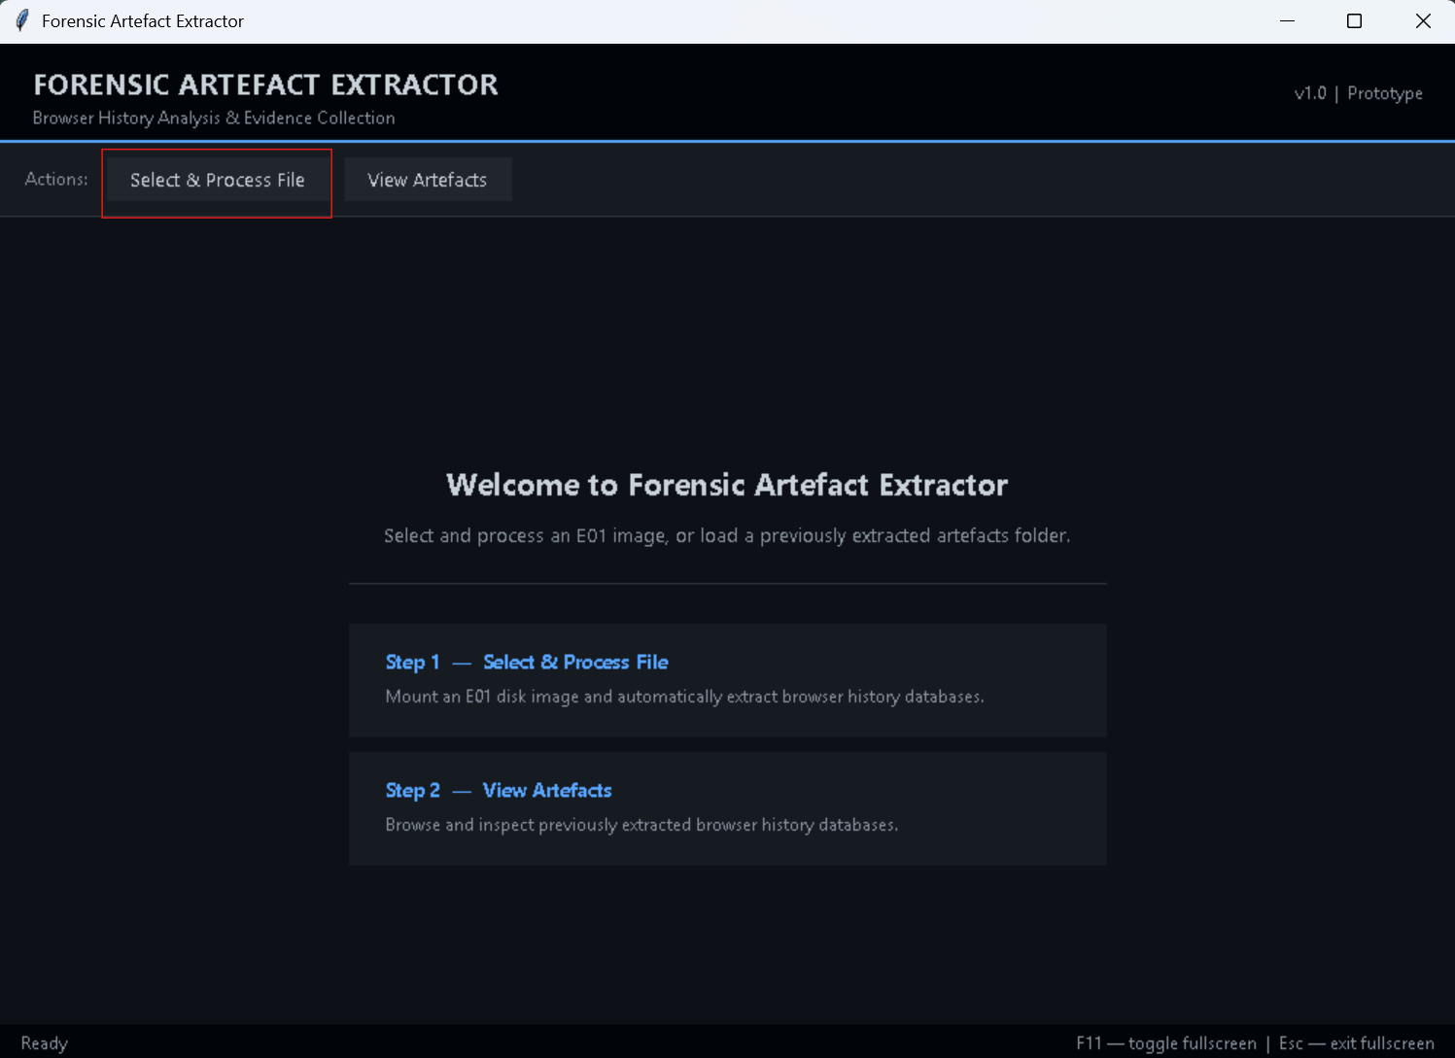
Figure 36 - Highlighted "Select & Process" Button
Following this, a file explorer window opens, in which the user can browse through their files to find and select the required .E01 file (the file generated from the testing data shown highlighted in Figure 37).
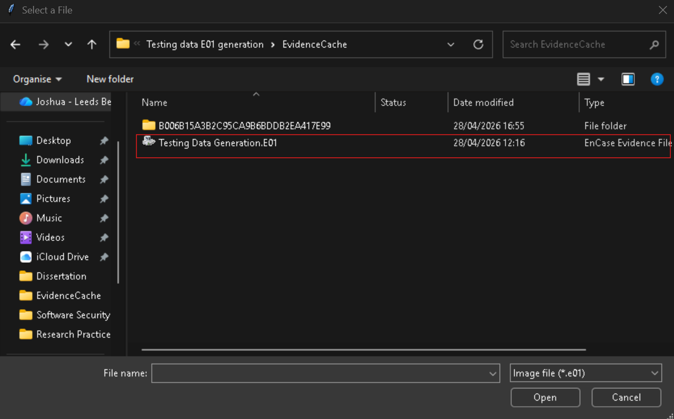
Figure 37 - Highlighted .E01 File in "Select File" Window
Once the file has been selected, several alert windows pop up to prompt the user to ensure that the .E01 file has been mounted successfully. Following which, another file explorer window opens for the user to select the output folder of the extracted artefacts, these are assigned a time-date stamp automatically so they can be differentiated. Once this is confirmed, the “Extracting Artefacts” window opens with a loading bar window appears to show the user the current progress of the browser artefact extraction process, see Figure 38.
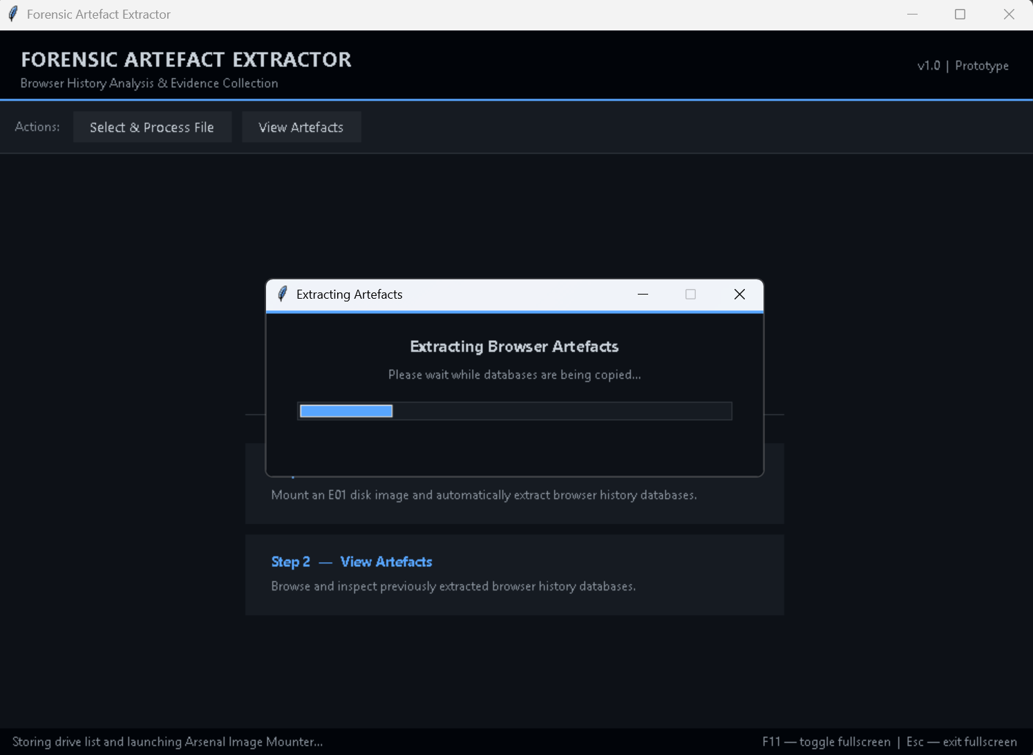
Figure 38 - Extraction Progress Bar
Once this process has been completed (taking ~5 minutes for the testing data), two more alert windows open that inform the user of several pieces of information. The first one informs that that the drives have been unmounted from their local machine. The second window has several pieces of information for the user: the number of artefacts successfully extracted, the number of artefacts failed to extract and the file location where they have been saved. See Figure 39 for the information presented regarding the testing data, that being the successful extraction of 7224 artefacts to file location "C:\Users\Joads\OneDrive - Leeds Beckett University\Year 4\Dissertation\Artefact Outputs\artefacts_20260512_124417".
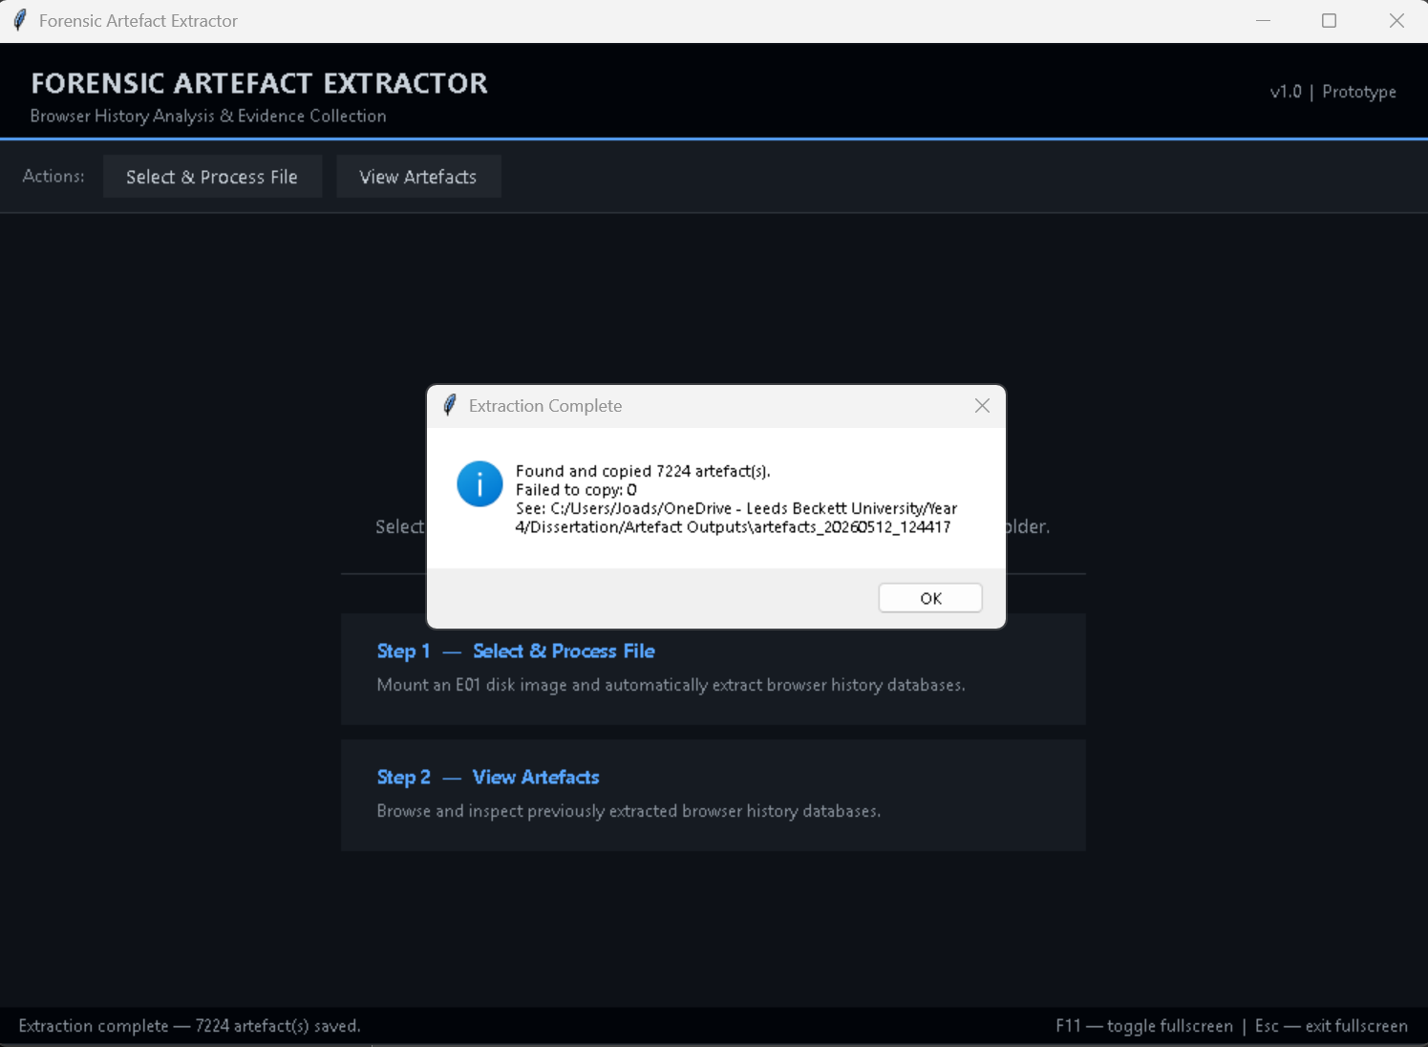
Figure 39 - Extraction Results
Following a successful extraction, the user can then view the extracted artefacts. This is done by them clicking the “View Artefacts” button and selecting the folder that the artefacts were extracted to. The initial view shows a series of drop-down boxes to sort by user and browser as well as a table which shows the filtered artefacts. See Figure 40 for the initial view from the testing data.
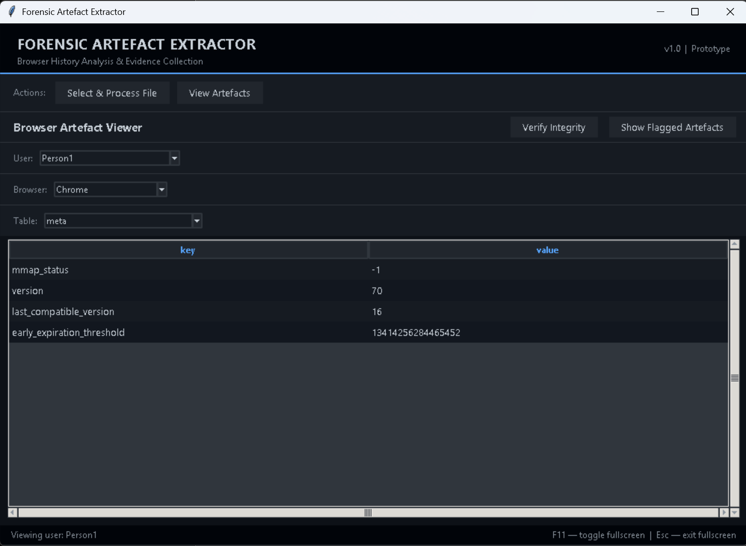
Figure 40 - Initial Artefact Viewer
From this point, any more actions can be performed at the user’s discretion. They can go through the different filters and tables to look through all the artefacts extracted whilst being alerted to any potential private browser artefacts see Figure 41for the testing data. They can verify the forensic integrity of the artefacts using the “Verify Integrity” button which opens the “Integrity Verification” window, see Figure 42 for the testing data. Finally, they can also view all the artefacts flagged as potentially generated from a private browsing session using the “Show Flagged Artefacts” button, see Figure 43 for the testing data.
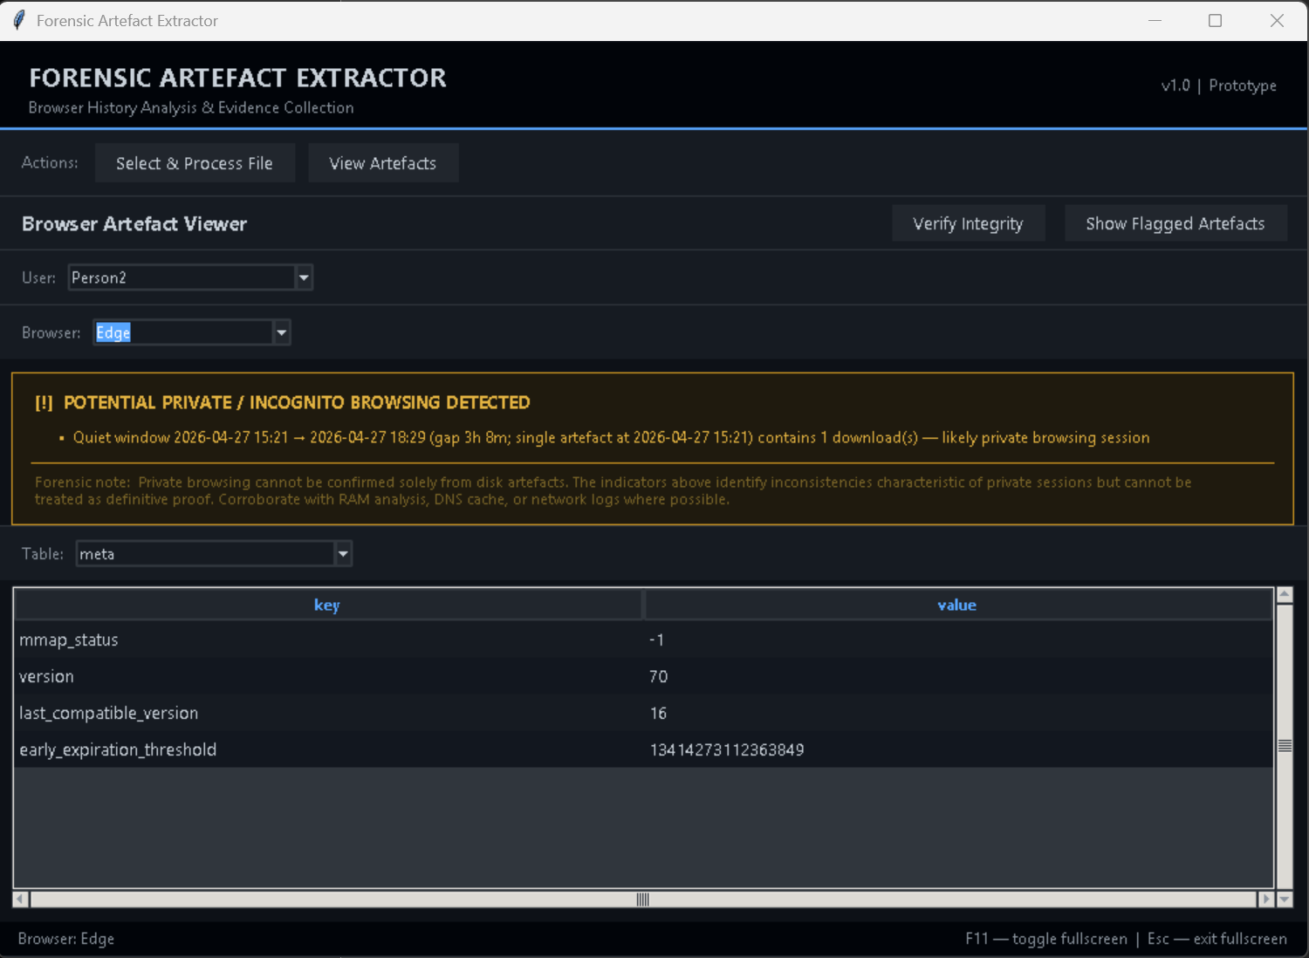
Figure 41 - Private Browser Artefact Detection

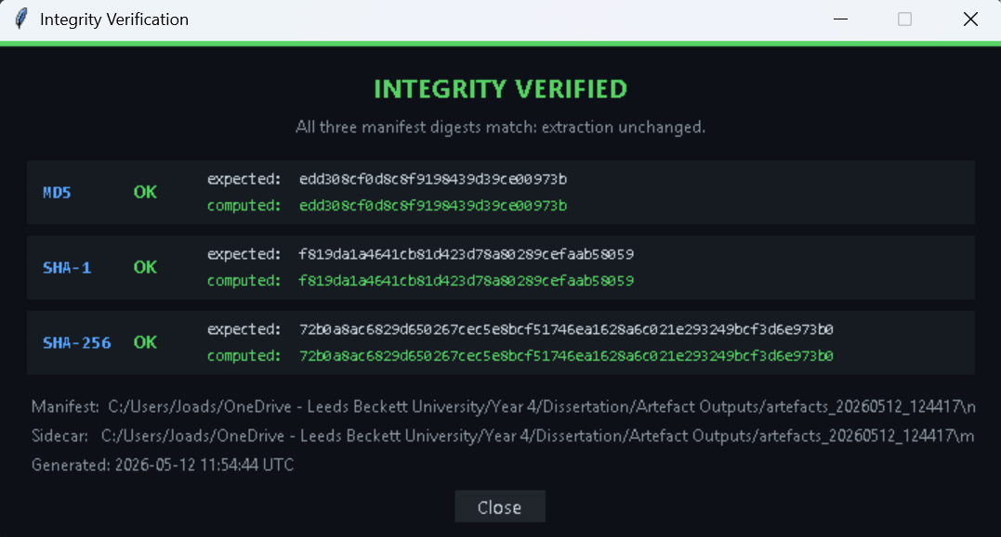
Figure 42 - Forensic Integrity Verification

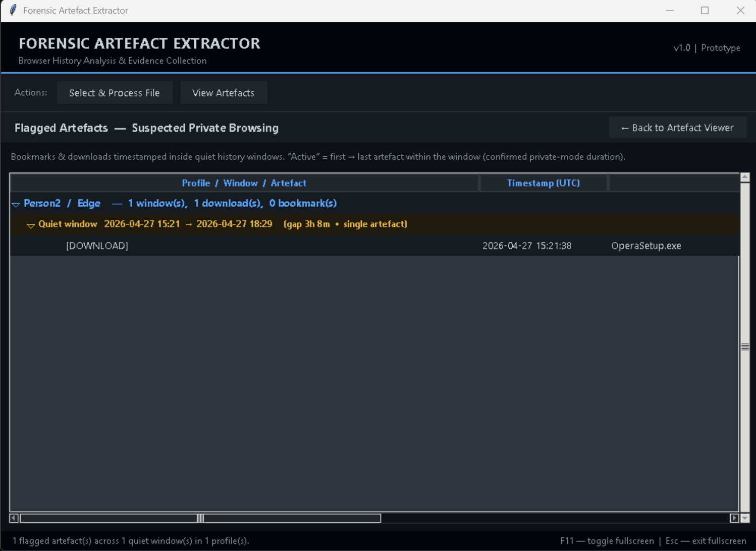
Figure 43 - Private Browser Artefacts View

Evaluation

Functionality
In terms of the tool prototype being able to perform all base tasks successfully, it can be considered a functional tool. It can take a user selected .E01 file, identify all the browser artefacts stored upon it, extract these artefacts to a chosen location and then allow the user to view the extracted artefacts within it. Its additional features such as verifying the integrity of the extracted artefacts and flagging potential private browser artefacts also functions successfully, even grouping all the private browser artefacts into a new table for the user to observe and analyze more easily.

Performance and Usability
The testing data that was used during the demonstration of this tool ended up with an extraction of 2GB (2,139,977,539 bytes) of data. With an extraction time of 6m 25s, this comes to an extraction of 5.3MB/sec (5,551,173 bytes/sec), in addition to programs such as screen recording software running alongside. For reference, the specs for the machine running the tool are as follows:
Device Specifications
Device Name | DESKTOP-SOQ994L
Processor | 11th Gen Intel(R) Core(TM) i7-1165G7 @ 2.80GHz (2.80 GHz)
Installed RAM | 16GB (15.7GB Usable)
Device ID | 65B61133-74E6-4E71-B3DC-89EA139EC91D
Product ID | 00325-97269-54138-AAOEM
System Type | 64-bit operating system, x64-based processor
Pen and Touch | Touch support with 2 touch points
Table 2 - Device Specifications
Windows Specifications
Edition | Windows 11 Home
Version | 25H2
Installed on | 21/04/2025
OS Build | 26200.8246
Experience | Windows Feature Experience Pack 1000.26100.297.0
Table 3 - Windows Specifications

EnCase Comparison
Primarily, the biggest difference between this tool and EnCase is when it comes to examining/finding private browser artefacts. When using this tool, possible private browsing sessions are flagged to the user based on artefacts that are stored in non-volatile memory such as downloads and then cross-referencing this with artefacts that correlate to it. When these don’t exist, a private browsing session is highly likely. By comparison, EnCase does not have such a functionality. Instead, an examiner must manually go through each of these artefacts to see if any are missing, which will likely take much longer than the automated flagging of this tool.
When it comes to viewing the artefacts in general, not specifically private browser artefacts, viewing and understanding them is much easier than with EnCase. For example, in this tool the artefacts are grouped by username and then by browser, ensuring that the owner/generator of each artefact remains obvious throughout examination Figure 44. On the other hand, EnCase only groups the artefacts by browser Figure 45. Granted the user for the artefacts can be found by looking at the metadata, having a more organized method of investigating the artefacts is much more preferrable. The tool essentially acts as a filtering system for this data and is grouping it as such. This is possible in EnCase as it does also possess filtering functionality but to have a similar result a specific EnScript would likely have to be written to accomplish this.
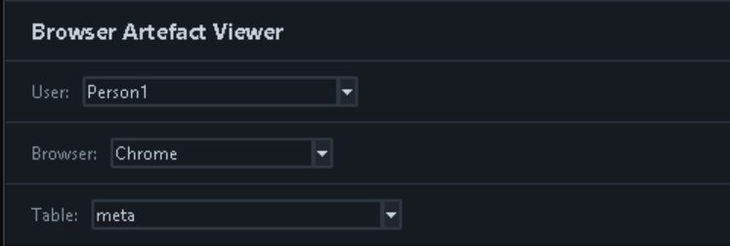
Figure 44 - Browser Artefact Viewer Filters
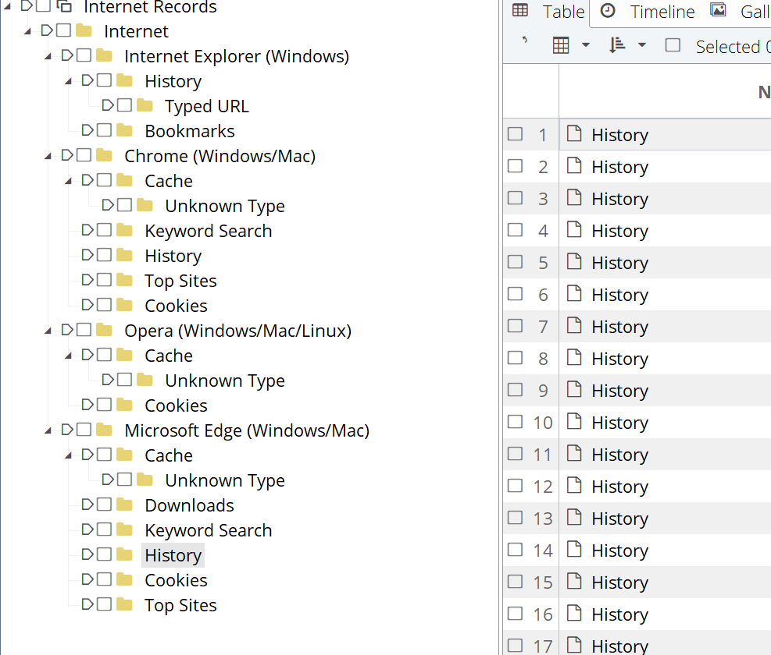
Figure 45 - EnCase Browser Artefact File Structure
A function of EnCase that this tool prototype does not have is the ability for a user to flag specific files or groups of files with a specific term such as “review” or “add to report”, see Figure 46. This feature allows the user of EnCase to group together files to look at as a group, helping along with the digital forensic process by reducing the need to be constantly switching between different file directories to look at two different files that may be related. Instead, these files can be flagged and then viewed together, see Figure 47, ultimately allowing for a much smoother process.
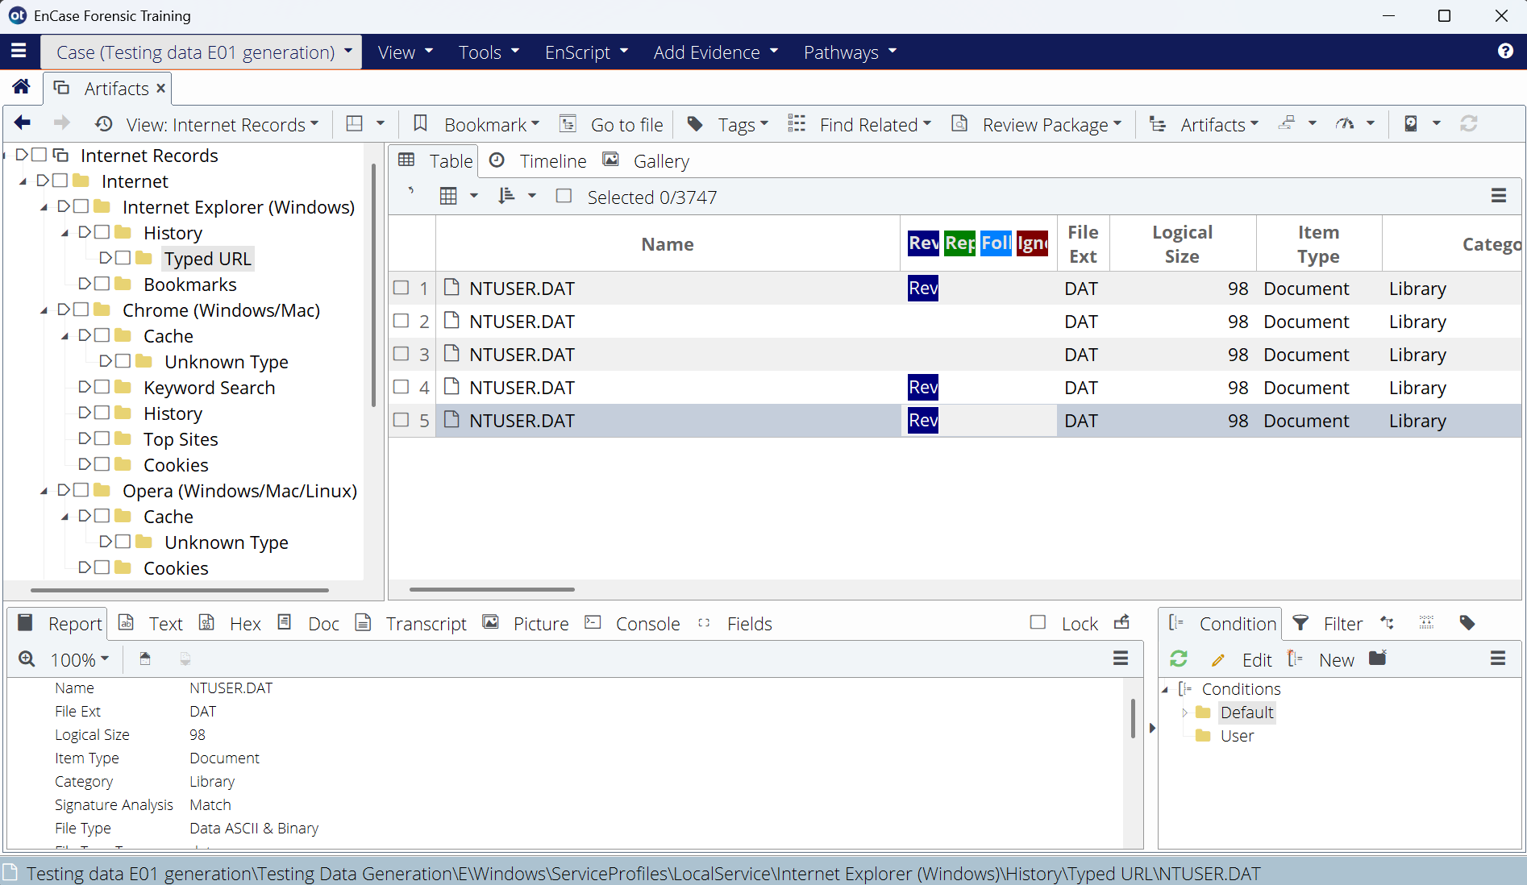
Figure 46 - EnCase Flagging Files
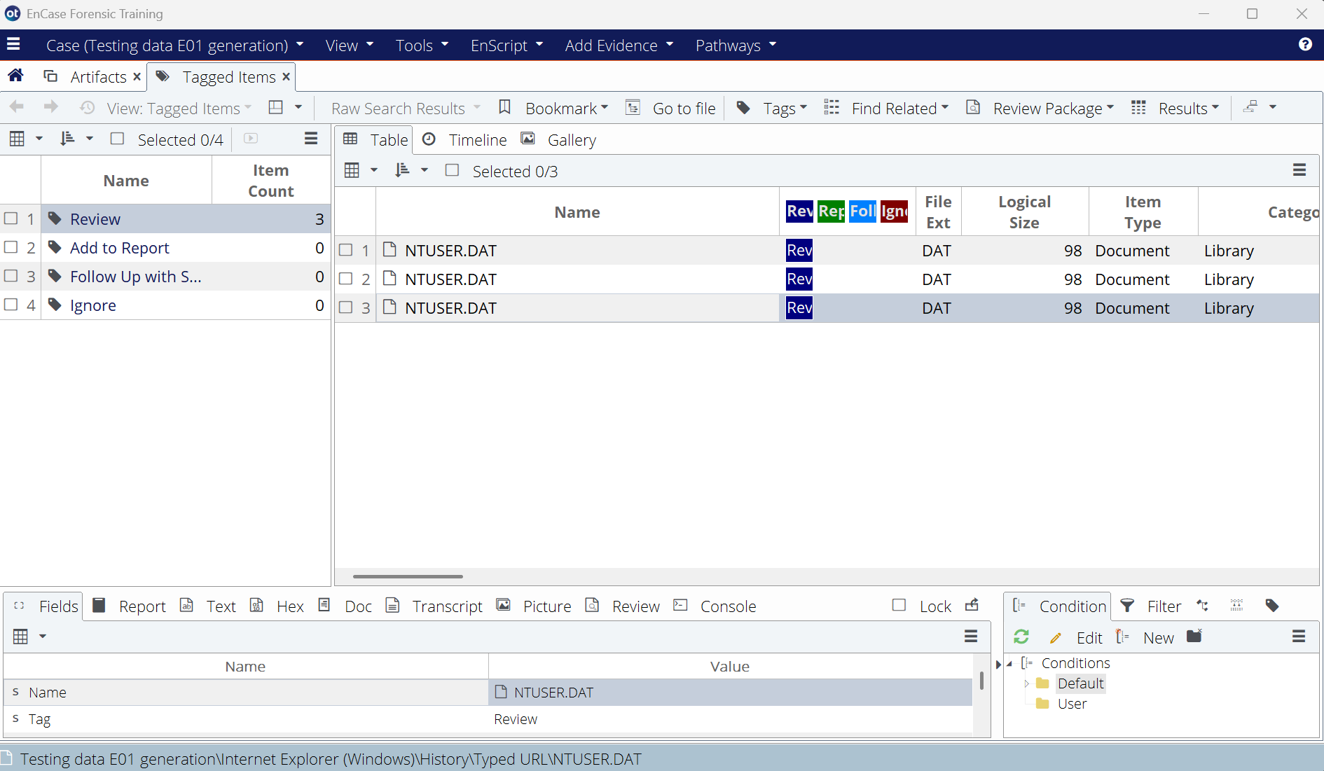
Figure 47 - EnCase View Flagged Files

Conclusion

Results
The main aim to design, create and test an automated forensic tool used for the capturing and analysis of browser artifacts generated through private browser sessions was completed with the creation of the tool prototype displayed throughout this report. It was created using a modular architecture through the distinct separation of its functions (such as the extraction of artefacts and the viewing of artefacts) as per the first objective. The tool can parse through extracted artefacts and alert the user to potential private browser artefacts, thus meeting the second objective. The tool was created entirely using the Python programming language as outlined by the third objective. For the fourth objective, the tool can display the extracted browser artefacts in a simple manner for a user to view and understand. Finally, the tool was compared against current methods of manual analysis, see 4.4.3, completing the fifth and final objective.
From meeting each one of the aims and objectives previously laid out in 1.2, the overall completion of this project can be considered a success. Whilst there are several limitations present within the prototype tool, outlined in 5.2, each of these can be improved upon by working on the prototype further in the future, see 5.3 for further details. The addition of more features is also likely and will be easily achievable thanks to the tool’s modular architecture, allowing for changes to be made without affecting or impeding other functionalities of the tool.

Limitations
With this tool, there are unfortunately several limitations when it comes to its use and functionality. Currently, its biggest limitation is that it is only designed to work with Windows OS. This means that if a user were to attempt to use this tool to extract and analyze browser artefacts from a machine running on Linux (in other words an .E01 file generated from a Linux machine), it would not be capable of doing so. This limitation means that this tool whilst this tool can be used during a digital forensic investigation, it may not always be fit for purpose, the increase in efficiency of this being the main goal for this project.
Furthermore, about efficiency is the extraction time of the browser artefacts and the storage they use. When using the testing data, see 3.4, the time taken for the extraction to complete was rounded to 5 minutes with a size of 2GB which is a very large amount of data. For the data extracted, this amount of time is not awful but could absolutely be better. Additionally, the size of the extraction is very substantial and during a full investigation the size will likely be several times larger and could possibly take far longer consequently.
Another limitation for the tool lies in how it detects private browser use on the machine it has extracted browser artefacts from. The way it does is by comparing the artefacts that are non-volatile memory no matter if private mode is enabled or not with ones that are stored in RAM during private browser use, comparing downloads to key word searches for instance. If the tool finds that some of these non-volatile artefacts have missing artefacts that should correlate to them, then it flags this artefact as one created during a private browsing session. Unfortunately, as artefacts can be lost either due to errors during browser use or a user deleting their search history, this can lead to the tool having false positives where a regular browser artefact has been flagged as a private one. This means that it can only indicate that the artefact was potentially generated from a private browsing session, not guarantee it.
In addition to having false positives, the tool can also produce false negatives when no private browsing sessions have been detected when one has taken place, like with the testing data in 3.7. This is mainly due to these artefacts being stored in RAM, meaning that to analyze them, a live extraction must take place which is not possible both with this testing data (as it is a VM) nor with a real-world digital forensic investigation as one of the first actions taken is to turn off and unplug any machines to be used as evidence, see 2.4 for further details.
Finally, there is a limitation with how the browser artefacts are displayed within the tool. This comes from the fact that the tables that the tool displays have a limit of only showing the first 100 rows of artefacts of a certain type, or in other words the 100 most recently created artefacts of that type. During the investigation of new machines where a suspect may not have created more than 100 artefacts of a certain type this does not present an issue, but during cases when machines that may be a few years old are involved, there will almost certainly be more than 100 artefacts of a certain type.

Future Improvements
Firstly, the most substantial new feature that could be added to the tool would be the ability to process .E01 files generated from a machine running using a Linux OS. No change would need to be made to the beginning of the extraction process, the mounting of the .E01 file on the local machine, as Linux drives can be mounted upon a Windows machine (Banoth and Godishala, 2025), of which the tool is designed to be run on. The first requirement would be to detect the OS that the .E01 file or mounted drive is originally from and use this information to switch between which method of extracting the artefacts is used due to their differences in functionality and file structure.
Another new feature that could be implemented into this tool in the future would be the ability for the user to flag artefacts themselves. As mentioned previously in 4.4.3, a big feature of EnCase is the user’s ability to group together multiple files/artefacts by flagging them with certain values, for example if a file needs further investigation, it could be flagged as “important” for instance. This flagging to group files also allows them to be viewed together as well. Implementing a similar feature into this tool could be very useful. By expanding its current flagging of private browser artefacts, having the user be able to flag their own could allow for smoother investigation when observing artefacts concerning a similar topic but not created close to each other.
Whilst not necessarily a new feature, something that could be improved upon is the storage of the extracted browser artefacts, specifically the size of the extraction. As mentioned in 5.3, the testing data resulted in an extraction of 2GB worth of files which is a substantial amount. One method with which this size could be reduced would be through the automatic compression of the files into a .ZIP file instead of being extracted to a folder. Though, this would also require it to be decompressed to be used within the program and thus reducing the tool’s efficiency which is not ideal. As such, other methods such as only extracting relevant artefacts or giving the user the option of performing extractions only on a certain user or browser could also be explored and implemented.
A much smaller improvement for the tool would be to its internal file structure. Initially, as outlined in 4.1.4, the plan was to store functions in different files for organizational purposes during development, however after some time this stopped happening. There are, however, some functions still stored in this way and as such an improvement would be to migrate these functions onto a single Python file so the tool can be stored as a single file, rather than a set of files that don’t function without each other.
Finally, an additional function of this program that was briefly considered before its beginning but was later dropped was a method of exporting the extracted data as a report to some form of text file. How this could be done is by listing all potential private browser artefacts as well as sections for the case number, examiner, date etc. A section based on the user flagging of artefacts previously discussed in this section could also be added, grouping together flagged artefacts in the same way the tool viewer would.

Project Management
For the management of the allotted time for this project, a few meetings with the project advisor were arranged to ensure that its completion remained on track between the dates of 26/01/2026 and 15/05/2026. The first of these meetings was scheduled for 18/02/2026, during this meeting the overall project and current progress (at the time a basic Tkinter window and some research) were discussed, with the advice of potentially creating a survey to see people’s private browser usage. This idea was later dismissed as only a small sample of data would be able to be gathered whereas online public statistics would have a much larger data set and be more viable.
Another meeting with the advisor took place on 09/03/2026. By this point, the first draft of the Literature Review for this project was also submitted for feedback from the advisor. During this meeting, the progress of the project was displayed as well as discussing plans for the next few sections of the report. The advisor also suggested researching some real-world incidents where private browsing information was not as private as it seemed which would be later added into this report.
Upon receiving feedback about the Literature Review, sections to add and others to elaborate on, this advice was acted upon. After doing so, progress of the overall project rapidly increased due to approaching deadlines for a video presentation and other reports from other modules. This concluded with the working prototype of the tool being completed on 03/05/2026.

Ethics

Security of Testing Data
An important part of evaluating this product is its testing data and as such, its integrity and security are also important. To this effect, the .E01 used in testing can be reproduced exactly at any time providing that the original file for the VM still exists, meaning that even if it is lost or corrupted testing can carry on as normal. As for the file for the virtual machine, this will be stored within a password-locked folder within Microsoft OneDrive as stated in 3.4.1. By doing this, it can be ensured that it is stored securely in cloud storage and even if someone were to gain access to this cloud storage, they would still not have immediate access to the file in question.

Personal Data Use
All data intended to be used at any point during this project will not include any form of personal data or confidential information. No accounts will be logged into whilst making browser queries and any queries that appear to be from a specific person are purely coincidental, as mentioned previously in 3.4, all search queries will match between browsers and are purely for the generation of browser artefacts on the VM.
Subsequently because of having no browser login being used, all browser artefacts generated will only have come from the machine in question. For example, no browser history from other machines will be used as data. Additionally, no personal information will be used when creating the users on the VM either. If some form of personal information would be required by the machine, then the false names of “John Doe” and “Jane Doe” will be used to simulate an actual person.

References
Adamu, H., Ahmad, A. A., Hassan, A. and Gambasha, S. B. (2021) Web Browser Forensic Tools: Autopsy, BHE and Net Analysis. International Journal of Research and Innovation in Applied Science [Online], 06 (05), pp. 103–107. Available from: <https://doi.org/10.51584/ijrias.2021.6506>.
Aggarwal, G., Bursztein, E., Jackson, C. and Boneh, D. (2010) An Analysis of Private Browsing Modes in Modern Browsers. USENIX Security Symposium [Online], pp. 79–94. Available from: <https://www.usenix.org/legacy/event/sec10/tech/full_papers/Aggarwal.pdf> [Accessed 31 December 2025]
Ahmed, R., and Dharaskar, R. V. (2008) Mobile Forensics: An Overview, Tools, Future Trends and Challenges from Law Enforcement Perspective. 6th international conference on e-governance, iceg, emerging technologies in e-government, m-government.
Alhassan, J. K., Oguntoye, R. T., Misra, S., Adewumi, A., Maskeliūnas, R. and Damaševičius, R. (2018) Comparative Evaluation of Mobile Forensic Tools. In: Proceedings of the International Conference on Information Technology & Systems (ICITS 2018). Cham: Springer International Publishing, pp. 105–114.
Alley, S. J., Kolt, G. S., Duncan, M. J., Caperchione, C. M., Savage, T. N., Maeder, A. J., Rosenkranz, R. R., Tague, R., Van Itallie, A. K., Kerry Mummery, W. & Vandelanotte, C. (2018) The Effectiveness of a Web 2.0 Physical Activity Intervention in Older Adults - a Randomised Controlled Trial. The international journal of behavioral nutrition and physical activity [Online], 15 (1), p. 4. Available from: <https://www.ncbi.nlm.nih.gov/pubmed/29329587> [Accessed 22 November 2019].
Anand, V. and Saxena, D. (2013/12/26-2013/12/28) Comparative Study of Modern Web Browsers Based on Their Performance and Evolution. In: 2013 IEEE International Conference on Computational Intelligence and Computing Research, 2013/12/26-2013/12/28. IEEE.
Arsenalrecon.com (n.d.) [Online]. Arsenalrecon.com. Available from: <https://arsenalrecon.com/products/arsenal-image-mounter> [Accessed 21 April 2026].
Banoth, R. and Godishala, A. K. (2025) The Windows Operating System, Linux Overview. In: Building a Secure Infrastructure. Cham: Springer Nature Switzerland, pp. 19–106.
Beauvisage, T., Beaudouin, V. and Assadi, H. (2007) Internet 1.0: Early Users, Early Uses. annals of telecommunications - annales des télécommunications [Online], 62 (3–4), pp. 283–304. Available from: <https://doi.org/10.1007/bf03253262>.
Behzad Shoarian Satari, Carlos Rivas, Cristian Florin Stanciu, Mozhdeh Yamani, Zahra Zohoorsaadat, Serguei A. Mokhov (January-March 2020) Evaluation of Autopsy and Volatility for Cybercrime Investigation: A Forensic Lucid Case Study. International Journal of Digital Crime and Forensics.
Britannica.com (n.d.) Safari | Internet Browsers [Online]. Britannica.com. Available from: <https://www.britannica.com/technology/Safari-browser> [Accessed 24 March 2026].
Byrd, A. (2024) Google Admits That Chrome’s Incognito Mode Doesn’t Truly Camouflage Users Data [Online]. AdMonsters. Available from: <https://www.admonsters.com/chromes-incognito-mode-doesnt-camouflage-users-data/> [Accessed 2 April 2026].
Casey, E., Ferraro, M. and Nguyen, L. (2009) Investigation Delayed Is Justice Denied: Proposals for Expediting Forensic Examinations of Digital Evidence. Journal of Forensic Sciences [Online], 54 (6), pp. 1353–1364. Available from: <https://doi.org/10.1111/j.1556-4029.2009.01150.x>.
Cassidy, R. F., Chavez, A., Trent, J. and Urrea, J. (2007) Remote Forensic Analysis of Process Control Systems. In: IFIP International Federation for Information Processing. Boston, MA: Springer US, pp. 223–235.
Cern (2026) The Birth of the Web [Online]. Home.cern. Available from: <https://home.cern/science/computing/birth-web> [Accessed 29 March 2026].
Chada, L. M., Parashar, H. V., Singh, I., Rastogi, M., Singh, S. & Raja, S. P. (2025) A Comparative Analysis of Web 3.0, Web 2.0, and Web 1.0: Evolution and Implications. International Journal of Learning and Change, 17 (1), pp. 1–55.
Choi, G., Bang, J., Lee, S. and Park, J. (2023) Chracer: Memory Analysis of Chromium-Based Browsers. Forensic Science International Digital Investigation [Online], 46 (301613), p. 301613. Available from: <https://doi.org/10.1016/j.fsidi.2023.301613>.
Choi, J.-H., Lee, K.-G., Park, J., Lee, C. and Lee, S. (2012) Analysis Framework to Detect Artifacts of Portable Web Browser. In: Lecture Notes in Electrical Engineering. Dordrecht: Springer Netherlands, pp. 207–214.
Cohen-Almagor, R. (2012) Internet History. In: Moral, Ethical, and Social Dilemmas in the Age of Technology. IGI Global, pp. 19–39.
Consortium eLearning Network Pvt Ltd (2023) Recent Trends in Programming Languages. Consortium eLearning Network Pvt Ltd.
Duckduckgo.com (2017) A Study on Private Browsing: Consumer Usage, Knowledge, and Thoughts [Online]. Duckduckgo.com. Available from: <https://duckduckgo.com/download/Private_Browsing.pdf> [Accessed 22 December 2025].
Eurojust (n.d.) European Investigation Order [Online]. Eurojust. Available from: <https://www.eurojust.europa.eu/judicial-cooperation/instruments/european-investigation-order> [Accessed 14 May 2026].
Fernando, K. K. S., Hussain, L. M. F. and Jayathilaka, W. A. T. S. (2025) Enhancing Digital Forensics Investigation Process through Large Language Model.
Flaglien, A., Sunde, I. M., Dilijonaite, A., Hamm, J., Sandvik, J. P., Bjelland, P., Franke, K. and Axelsson, S. (2017) Digital Forensics. Nashville, TN: John Wiley & Sons.
Flowers, C., Mansour, A. and Khateeb, H. M. A. (2016) Web Browser Artefacts in Private and Portable Modes: A Forensic Investigation. International Journal of Electronic
Google.com (n.d.) Browse in Incognito Mode [Online]. Google.com. Available from: <https://support.google.com/chrome/answer/95464?hl=en&co=GENIE.Platform%3DDesktop> [Accessed 3 April 2026].
Habib, H., Colnago, J., Gopalakrishnan, V., Pearman, S., Thomas, J., Acquisti, A., Christin, N. and Cranor, L. F. (2018) Away From Prying Eyes: Analyzing Usage and Understanding of Private Browsing [Online]. Usenix.org. Available from: <https://www.usenix.org/system/files/conference/soups2018/soups2018-habib-prying.pdf> [Accessed 11 May 2026].
Hariharan, M., Thakar, A. and Sharma, P. (2022/6/23-2022/6/25) Forensic Analysis of Private Mode Browsing Artifacts in Portable Web Browsers Using Memory Forensics. In: 2022 International Conference on Computing, Communication, Security and Intelligent Systems (IC3SIS), 2022/6/23-2022/6/25. IEEE.
Haryanti, T., Rakhmawati, N. A., Subriadi, A. P. and Tjahyanto, A. (2022/11/4-2022/11/5) The Design Science Research Methodology (DSRM) for Self-Assessing Digital Transformation Maturity Index in Indonesia. In: 2022 IEEE 7th International Conference on Information Technology and Digital Applications (ICITDA), 2022/11/4-2022/11/5. IEEE.
Heiney, J. J. (2023) Release of Netscape Navigator 1.0 | EBSCO [Online]. EBSCO Information Services, Inc. | www.ebsco.com. Available from: <https://www.ebsco.com/research-starters/computer-science/release-netscape-navigator-10>.
Jarrett, A. and Choo, K.-K. R. (2021) The Impact of Automation and Artificial Intelligence on Digital Forensics. WIREs. Forensic Science [Online], 3 (6). Available from: <https://doi.org/10.1002/wfs2.1418>.
Leith, D. J. (2021) Web Browser Privacy: What Do Browsers Say When They Phone Home? IEEE Access: Practical Innovations, Open Solutions [Online], 9, pp. 41615–41627. Available from: <https://doi.org/10.1109/access.2021.3065243>.
Mistry, N. R., Gajjar, K. and Junare, S. O. (2022) Volatile Memory Forensics of Privacy Aware Browsers. International Journal of Information and Computer Security [Online], 18 (3/4), p. 313. Available from: <https://doi.org/10.1504/ijics.2022.125255>.
Mrdovic, S., Huseinovic, A. and Zajko, E. (2009/10/29-2009/10/31) Combining Static and Live Digital Forensic Analysis in Virtual Environment. In: 2009 XXII International Symposium on Information, Communication and Automation Technologies, 2009/10/29-2009/10/31. IEEE.
New Releases Blog (2023) What Is Chromium Technology, and How Does It Enhance Your Browser? [Online]. Edge. Available from: <https://www.microsoft.com/en-us/edge/learning-center/what-is-chromium-how-does-it-enhance-your-browser?form=MA13I2> [Accessed 2 April 2026].
Opera.com (n.d.) Is Opera Browser Safe? [Online]. Opera.com. Available from: <https://www.opera.com/secure-private-browser> [Accessed 2 April 2026].
Opera Help (2018) Explore Advanced Features [Online]. Opera Help. Available from: <https://help.opera.com/en/opera36/explore-advanced-features/> [Accessed 2 April 2026].
Patzakis, J. (2001) Chapter 3: The EnCase Process. In: Casey, E. ed., Handbook of computer crime investigation: Forensic tools and technology. Turtleback Books, p. 57.
Paul, P., Biswas, B. A., Khalid, Z., Biswas, S., Dutta, N., Saha, H. N. and Das, M. (2018) Using Browser Cookies for Event Monitoring and User Verification of an Account. In: 2018 IEEE 9th Annual Information Technology, Electronics and Mobile Communication Conference (IEMCON), 2018/11/1-2018/11/3. IEEE.
Prayudi, Y., Ashari, A. and Priyambodo, T. K. (2020) The framework to support the digital evidence handling: A case study of procedures for the management of evidence in Indonesia. Journal of Cases on Information Technology [Online], 22 (3), pp. 51–71. Available from: <https://doi.org/10.4018/jcit.2020070104>.
Security and Digital Forensics [Online], 8 (2), p. 99. Available from: <https://doi.org/10.1504/ijesdf.2016.075583>.
Slevin, C. (2023) Colorado Court Upholds Google Keyword Search Warrant Which Led to Arrests in Fatal Arson [Online]. AP News. Available from: <https://apnews.com/article/google-search-arson-suspects-colorado-4321aa7326bd96749f51b252d32ddf20> [Accessed 22 December 2025].
Spiteri, B. (2024) Unveiling Data Artefacts in Private Web Browsing: A Comparative Digital Forensics Study. Luleå University of Technology Department of Computer Science, Electrical and Space Engineering.
StatCounter Global Stats (2026) Browser Market Share Worldwide [Online]. StatCounter Global Stats. Available from: <https://gs.statcounter.com/browser-market-share> [Accessed 2 April 2026].
Stephen, N. (2021) Comparative Review of JAVA and Python [Online]. Ijrdase.com. Available from: <https://ijrdase.com/ijrdase/wp-content/uploads/2022/03/Comparative-Review-of-JAVA-and-Python.pdf> [Accessed 19 April 2026].
Undetectable Browser (2026) Top Chromium Based Browsers Reviewed for Optimal Performance in 2026 [Online]. Undetectable Browser. Available from: <https://undetectable.io/blog/chromium-based-browsers/> [Accessed 2 April 2026].
Wu, T., Breitinger, F. and O’Shaughnessy, S. (2020) Digital Forensic Tools: Recent Advances and Enhancing the Status Quo. Forensic Science International Digital Investigation [Online], 34 (300999), p. 300999. Available from: <https://doi.org/10.1016/j.fsidi.2020.300999>.
Wu, Y., Gupta, P., Wei, M., Acar, Y., Fahl, S. and Ur, B. (2018/4/23-2018/4/27) Your Secrets Are Safe: How Browsers’ Explanations Impact Misconceptions about Private Browsing Mode. In: Proceedings of the 2018 World Wide Web Conference on World Wide Web - WWW ’18, 2018/4/23-2018/4/27. New York, New York, USA: ACM Press, pp. 217–226.

Appendices

Ethics Approval
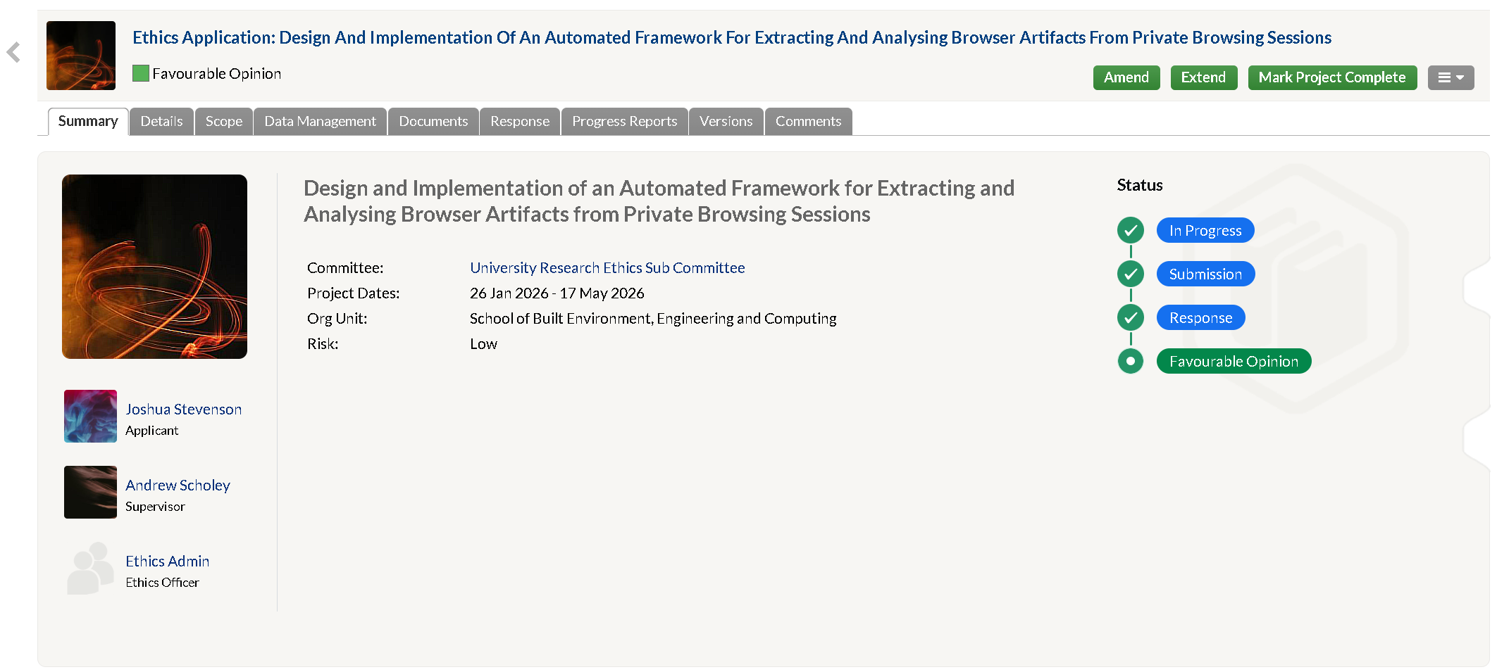
Figure 48 - Ethics Approved with Favourable Opinion

Originality and Use of Generative Artificial Intelligence (GAI) Statement

- I understand that to use the work and ideas of others, including generative AI output, without full acknowledgement, is academic unfair practice.
- I confirm that this coursework submission is all my own, original work and that all sources, summaries, paraphrases and quotes are fully referenced as required by the LBU Academic Regulations.
DECLARATION OF GENERATIVE AI USE (This is an example, you can modify, adapt, delete as appropriate):
I did not use Generative AI technology in the development, writing, or editing of this assignment.

