**Simple Guide to using the Ethical Dilemma Game App.**

**1. Run the Game app**

**Steps to run the apps.**

* 1. Open your file system and navigate to wherever you have stored the EthicalDilemmaGame folder.
  2. Go to whatever app folder you want to run
     + EthicalDilemmaScenarioBuilder (Scenario building tool)
     + EthicalDilemmaGameBuilder (Game packaging tool)
     + GameFiles (The game itself)
  3. Go to the backend folder inside the app folder:
     + A blue and white rectangular sign with black text

       Description automatically generated
  4. Double click on the MacAndLinux file if on a mac or a linux computer or double click on the Windows file if on a windows computer.
     + A close up of a logo

       Description automatically generated
  5. This should now open a web-browser with the app running on it.
  6. If the web-browser does not automatically open, open up whatever terminal the game is running on (command prompt for example) and you should see an IP address:
     + 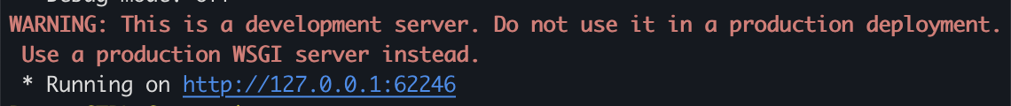
  7. Enter this IP address (including the http) into your web-browser and the game should run.
  8. If this does not work, or you do not see anything in the terminal, please follow the manual instructions.

**Steps to run the apps manually.**

* 1. Open up the command prompt for Windows or terminal for Mac (if you did not enable PATH during installation this will need to be the Anaconda prompt) .
  2. Using terminal commands navigate to where you have stored the EthicalDilemmaGame folder.
     + Check the manual terminal instructions video if you are having trouble.
  3. Continuing to use terminal commands, navigate to the app folder you want to run, and then enter the backend folder.
  4. Here you either type in
     + ./MacAndLinux(name of app).sh for Mac



* + - Windows(name of app).bat for Windows



* + - You can find the name of the file you need to run by using the command ls (Mac) or dir (Windows)
  1. This should now open a web-browser with the app running on it.
  2. If the web-browser does not automatically open, open up whatever terminal the game is running on (command prompt for example) and you should see an IP address:
     + 
  3. Enter this IP address (including the http) into your web-browser and the game should run.

1. **Playing the Game**

**Main Screen.**

* Once the game is running, a browser should open with the main screen on it

* Here we have the

1. The Title of the game.
2. The story of the scenario.
3. The players Role.
4. The amount of lives the player has.
5. The current dilemma.
6. The choices the player can make.
7. The questions the player can ask.

* To make a choice, the player simply clicks on the button with the choice they want to make.
* If the player makes the right choice, they will be shown the outcome of their choice and prompted with a continue button to move onto the next dilemma.

* If they make the wrong choice, they will lose a life and be prompted with a try again button.

* If they make the completely wrong choice or ‘lose’ choice, they will fail the scenario and be prompted to either restart it or move onto the next scenario.

* The player can also ask questions by clicking on each of the clarifying question buttons

* Once the player reaches the final dilemma, the right choice will show a finish message and prompt the player to either replay the scenario move onto the next one.

* If there are no more scenarios, and the player clicks the next scenario button they will be brought to the reflections screen. This screen shows the total scenarios completed, total lives lost, wrong choices made and failures.
* It also has a textbox where the player will enter their reflections on how the scenarios went.
* Finally, they can then download their reflection screen and send it on to their educator.

