**Simple Guide to using the Scenario Builder App.**

**1. Run the Scenario Builder app**

**Steps to run the apps.**

* 1. Open your file system and navigate to wherever you have stored the EthicalDilemmaGame folder.
  2. Go to whatever app folder you want to run
     + EthicalDilemmaScenarioBuilder (Scenario building tool)
     + EthicalDilemmaGameBuilder (Game packaging tool)
     + GameFiles (The game itself)
  3. Go to the backend folder inside the app folder:
     + A blue and white rectangular sign with black text

       Description automatically generated
  4. Double click on the MacAndLinux file if on a mac or a linux computer or double click on the Windows file if on a windows computer.
     + A close up of a logo

       Description automatically generated
  5. This should now open a web-browser with the app running on it.
  6. If the web-browser does not automatically open, open up whatever terminal the game is running on (command prompt for example) and you should see an IP address:
     + 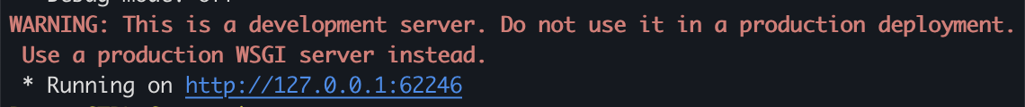
  7. Enter this IP address (including the http) into your web-browser and the game should run.
  8. If this does not work, or you do not see anything in the terminal, please follow the manual instructions.

**Steps to run the apps manually.**

* 1. Open up the command prompt for Windows or terminal for Mac (if you did not enable PATH during installation this will need to be the Anaconda prompt) .
  2. Using terminal commands navigate to where you have stored the EthicalDilemmaGame folder.
     + Check the manual terminal instructions video if you are having trouble.
  3. Continuing to use terminal commands, navigate to the app folder you want to run, and then enter the backend folder.
  4. Here you either type in
     + ./MacAndLinux(name of app).sh for Mac



* + - Windows(name of app).bat for Windows



* + - You can find the name of the file you need to run by using the command ls (Mac) or dir (Windows)
  1. This should now open a web-browser with the app running on it.
  2. If the web-browser does not automatically open, open up whatever terminal the game is running on (command prompt for example) and you should see an IP address:
     + 
  3. Enter this IP address (including the http) into your web-browser and the game should run.

1. **Using the Scenario Builder**

**Main Screen.**

* Once the app is running you should see the main screen on your browser:

* Here we have the

1. Game Title
   * This will be the title and filename of the game.
2. Game Description
   * A short description of the game, this will not show up in the end game.
3. Role
   * This is the role the player will take on for the for the scenario, e.g. a Humanitarian Truck Driver
4. Story
   * This is the general story of the scenario, here the user should specify the general situation the player will be placed in. This will be shown at all times during the games duration and it should give the player a general sense of the situation they’re in. An example story is:

**Adding Dilemmas**

* Dilemmas are the problems the players find themselves in. To add a Dilemma, simply click the Add Dilemma button.

* Once a Dilemma has been added, a text box will show up, with different options to fill out.

* The different options here are

1. The Dilemma text
   * This is the question or problem posed to the player, an example of a dilemma in a game would be:

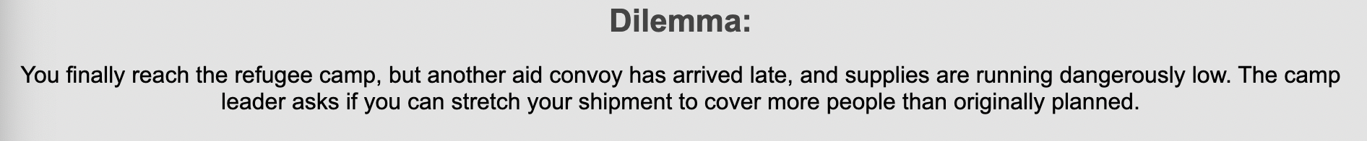

1. The X button
   * This allows you to delete a dilemma, by clicking on it. You will be prompted again to ensure you mean to delete the dilemma and all its contents
2. Add Choice button
   * This button allows you to add a choice to a dilemma. These are the choices the player will have when playing the game. Once this button is pressed a new textbox will appear with more options to fill out the choice. An example of some choices is:

* The textbox for the choices looks like this:

* The Choice text is the text shown in the blue box above, it is the action the player takes by clicking it.
* The outcome text is the text shown once the player has made that choice. This is what happens within the scenario once that choice is made.
* The dropdown menu allows the user to assign a ‘type’ to the current choice. There are 3 types, right, wrong and lose.

* The right type, allows the player to continue the scenario, giving them a new dilemma (if it exists). The wrong type takes one of the player’s 3 lives, and prompts them with a try again button which takes them back to the same dilemma. The lose type takes all the player’s lives and makes them fail the scenario. The game then prompts them to either restart their current scenario or continue on to the next scenario (if it exists).
* If you want to end the scenario, go to the dropdown menu, select either the wrong or lose type and then reselect the right type. This will now allow you to enter text into the finish message text box.

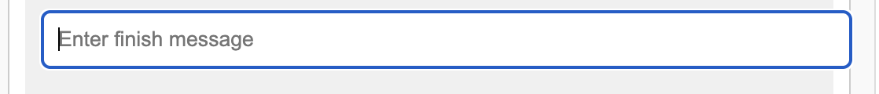

* This should only be filled out if you want that choice to end the scenario i.e. it is the last choice someone should make before beating the scenario. It is an extra message shown alongside the outcome text. An example is:



* The X button allows you to delete a choice and all its contents.

1. The Add Clarifying Question button
   * This button opens another textbox which allows you to add a clarifying question to a dilemma. These are questions the player can ask to get more information about the scenario and current dilemma.

* The clarifying question textbox is the text of the question, i.e. it is the question that will be asked.
* The answer textbox is the answer that will be shown once the question is asked. An example of some questions and an answer would be:

* The X button allows you to delete a question and all its contents.

1. The Save Game button saves the scenario as a JSON (.json) file to the scenarios folder. If this folder does not exist for some reason it will create it. This is the final file which a game creator would then add to the scenarios folder in the GameFiles folder in order for the scenario to be a part of a playable game.

* A close up of a logo

  Description automatically generated

1. **Final Touches**

* You can add as many dilemmas, choices and questions as you like. I would recommend having all the text already typed out so you can simply copy and paste into the scenario builder. You should only have ONE choice with a finish message as this will end the game if selected by the player. Remember, you must then copy these files to the Scenarios folder when packaging the game.