
LAB REPORT
Software Project Management
2025-2026

Student Name: Nguyễn Phi Hùng
ID: 22666811
Class: DHKTPM18BTT
Course: 2025-2026
Contents
Module 1: 3
Exercise 1: Creating a link 3
Exercise 2: Setting duration 4
Exercise 3: Creating phases 5
Exercise 4: Noah - Linking 6
Exercise 5: Pyramid - Multi level grouping 7
Exercise 6: Creating a plan for Staff Training 8
Exercise 7: Recurring tasks 9
Exercise 8: Travelling task calendar 10
Module 2: CALENDARS AND SCHEDULING 11
Exercise 1: Changing Working Time 11
Exercise 2: Changing Working Time 15
Exercise 3: Changing Working Time 18
Exercise 4: Change working time 21
Exercise 5: Create the private Time for a project 23
Exercise 6: Your project 24
Module 3: TASK MODE 27
Exercise 1: Changing Working Time 27
Exercise 2: Changing Working Time 28
Exercise 3: Changing Working Time 30

Module 1:

Exercise 1: Creating a link
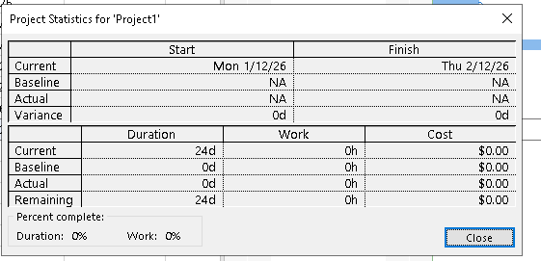
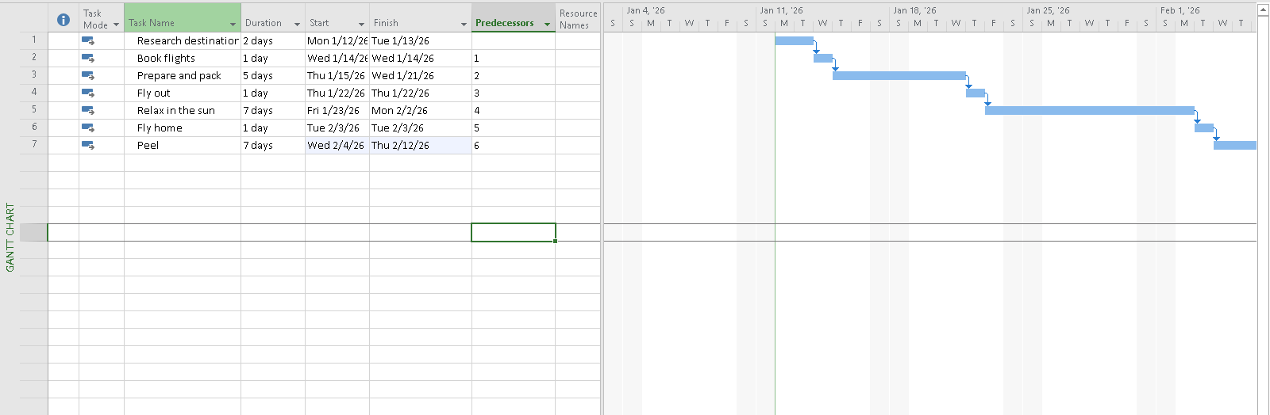
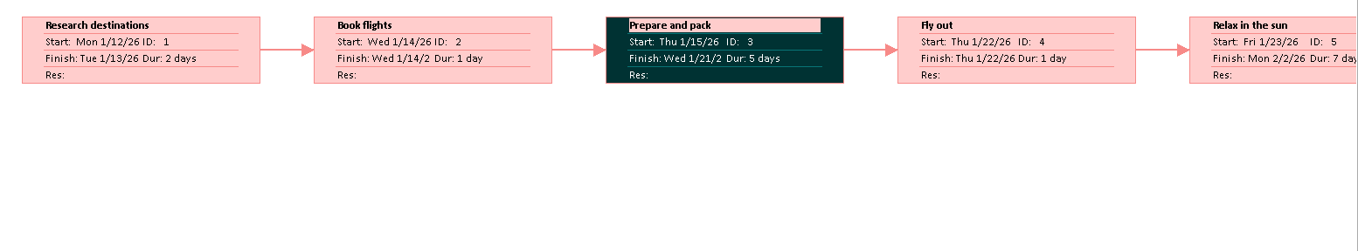

Exercise 2: Setting duration
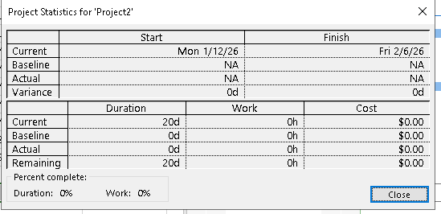
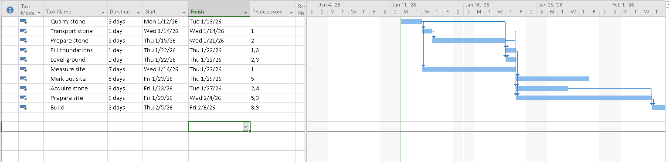
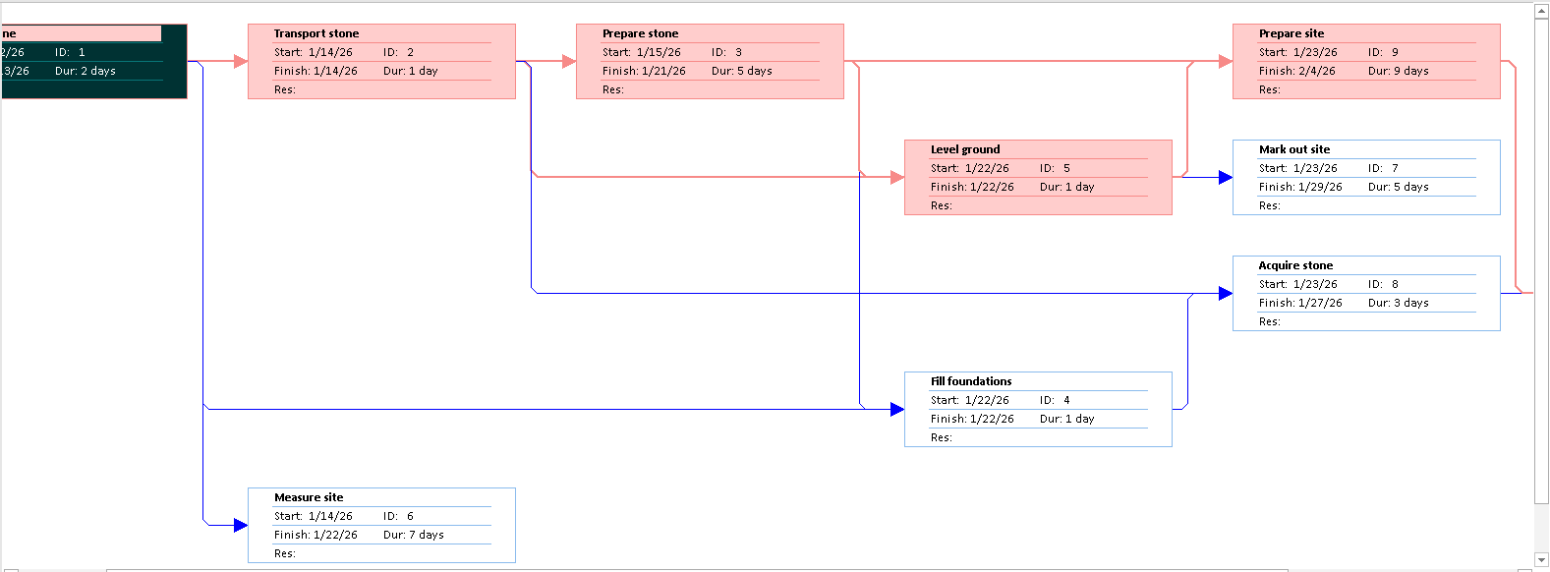

Exercise 3: Creating phases
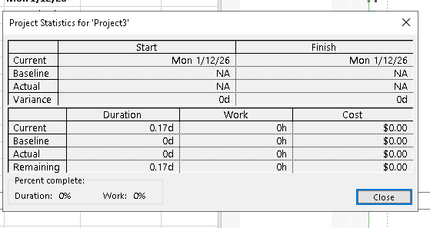
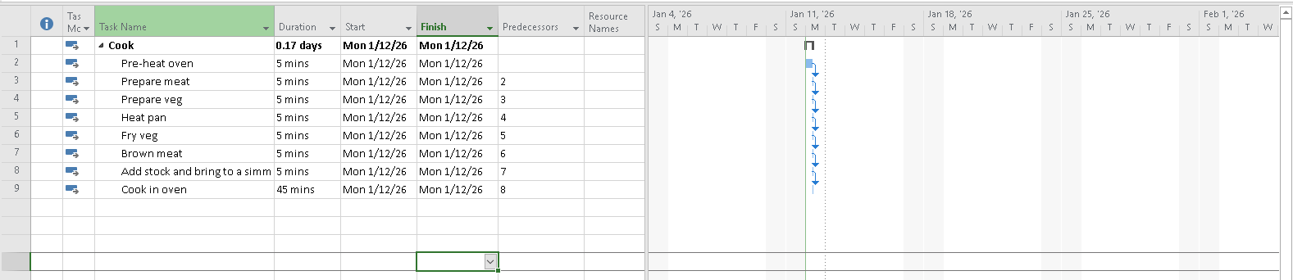
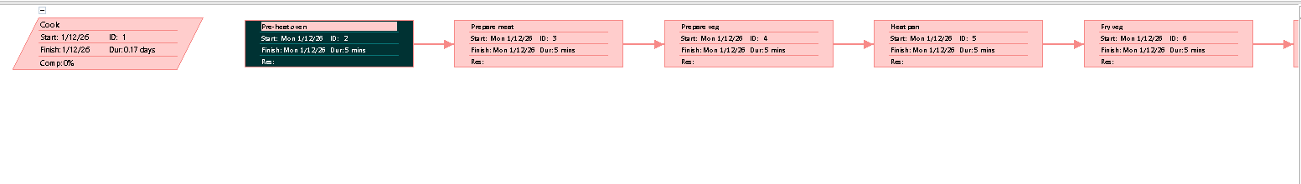

Exercise 4: Noah - Linking
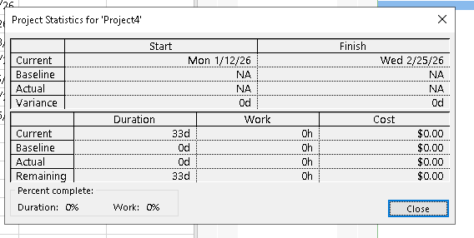
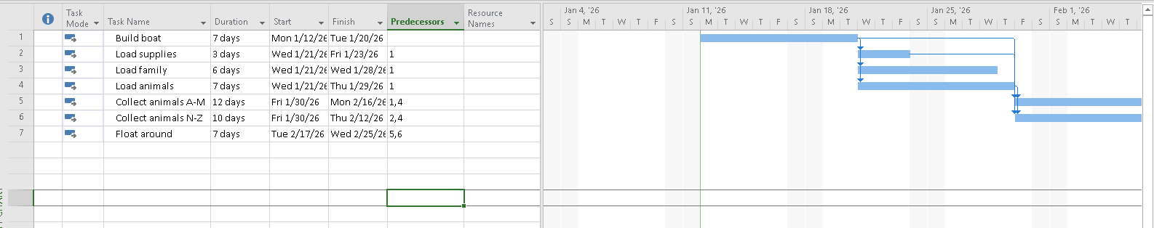
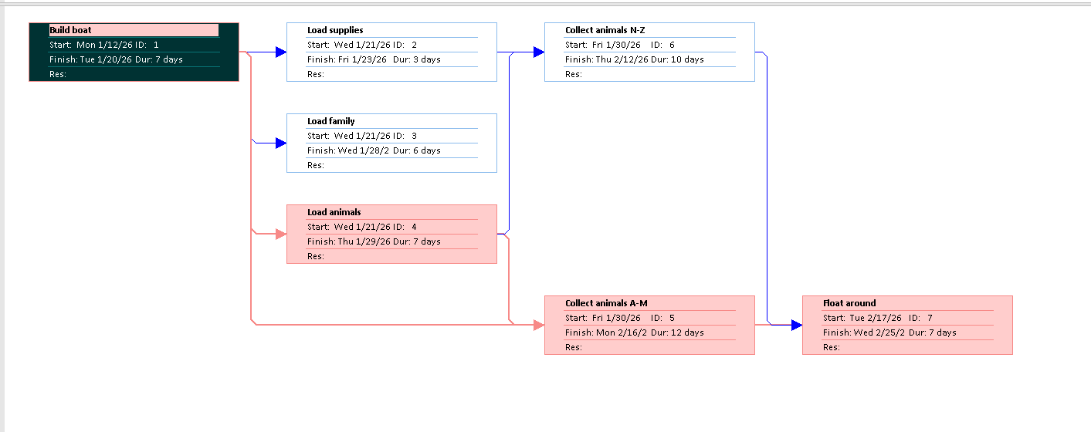

Exercise 5: Pyramid - Multi level grouping
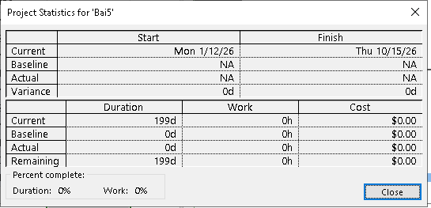
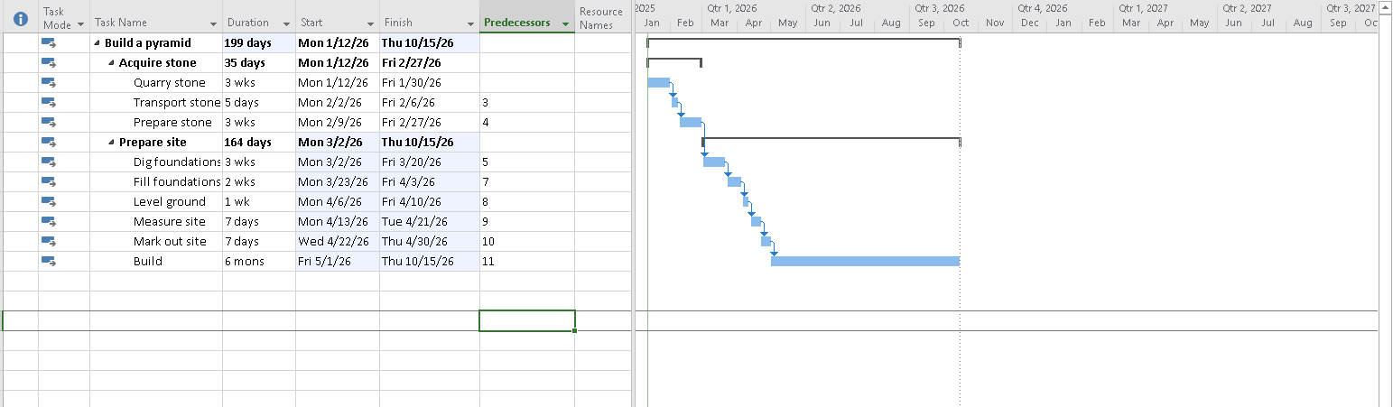
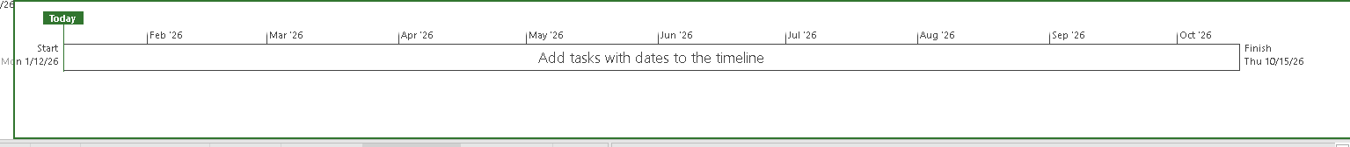
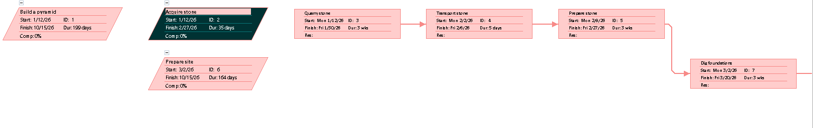

Exercise 6: Creating a plan for Staff Training
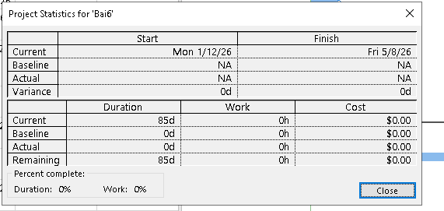
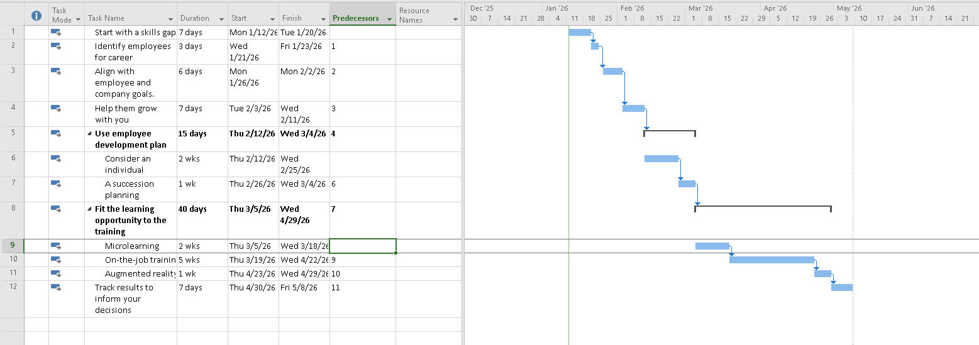

Exercise 7: Recurring tasks
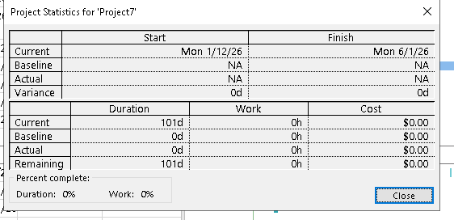
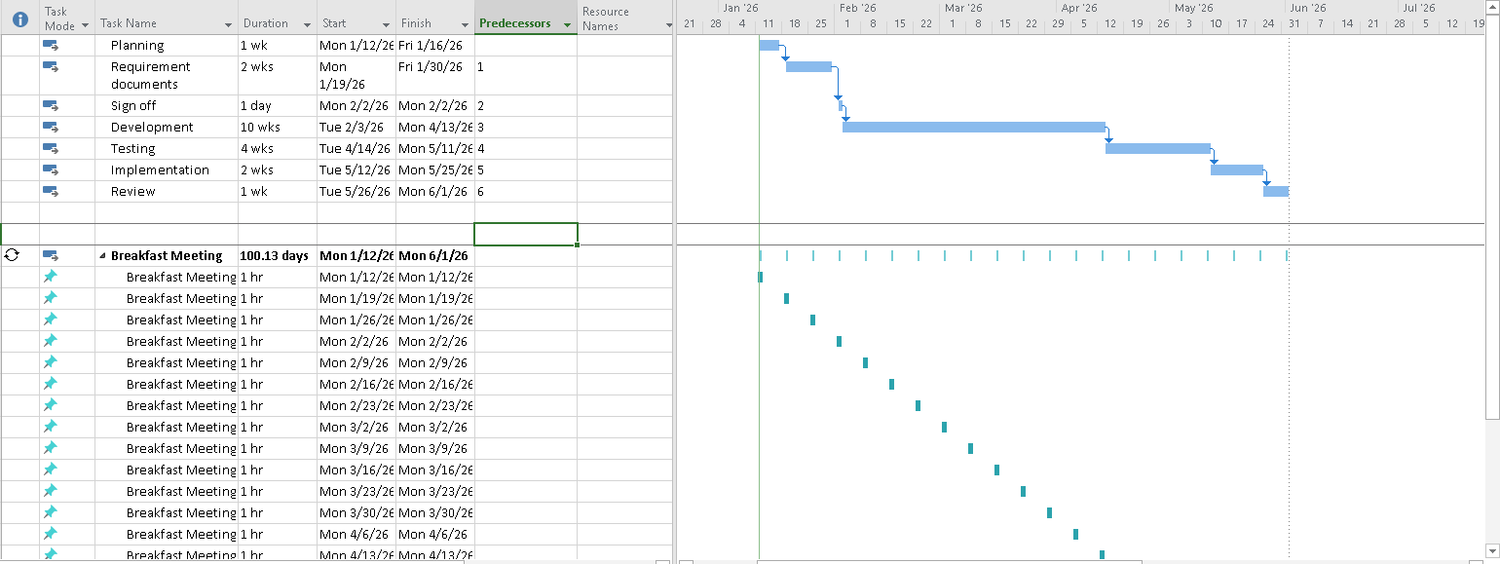
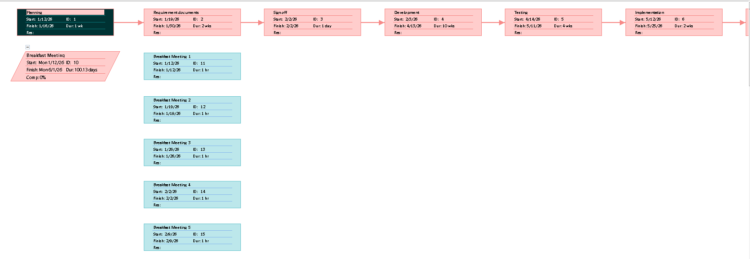

Exercise 8: Travelling task calendar
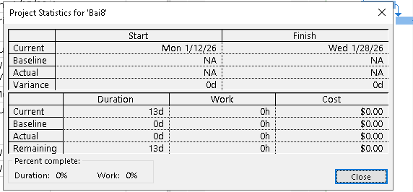
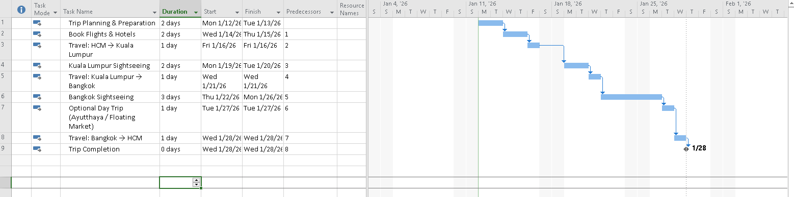

Module 2: CALENDARS AND SCHEDULING

Exercise 1: Changing Working Time
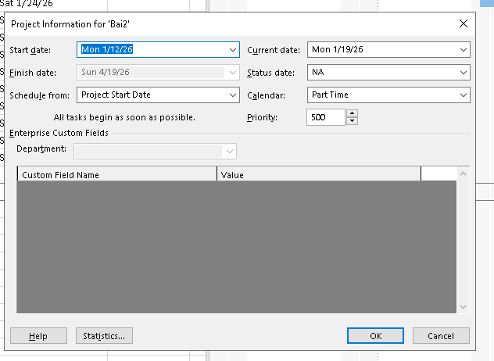
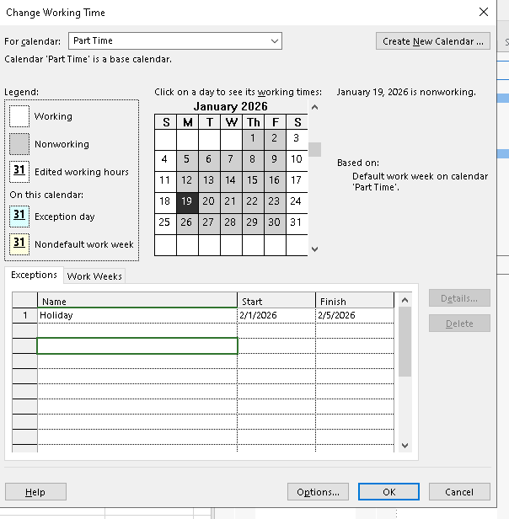
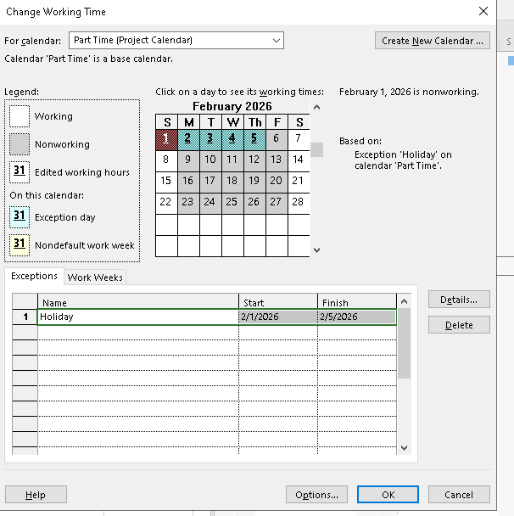
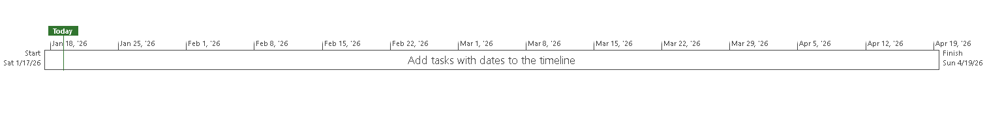
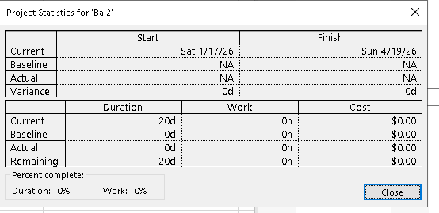

Exercise 2: Changing Working Time
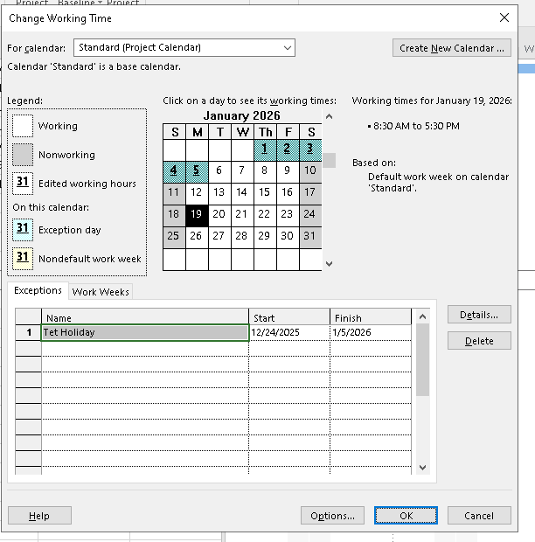
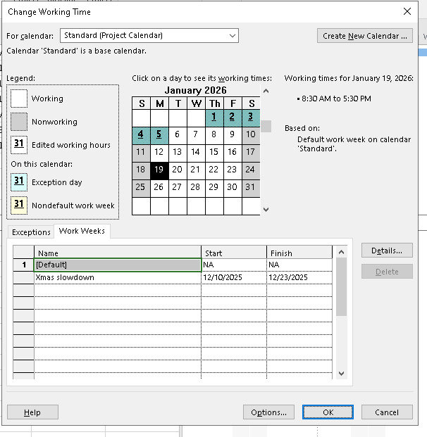
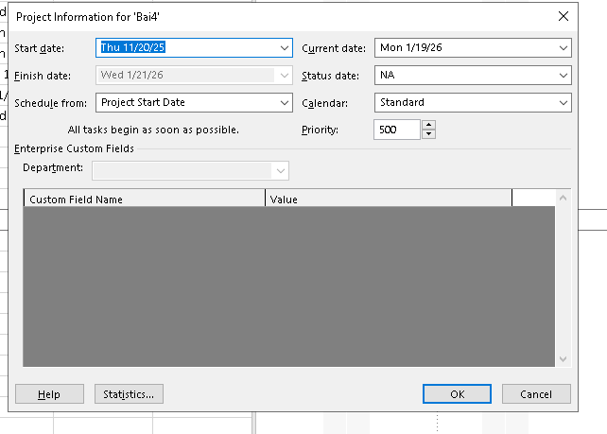
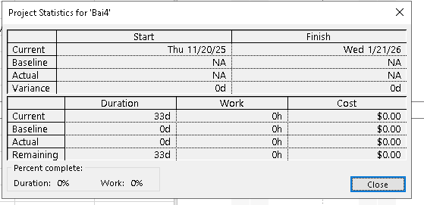

Exercise 3: Changing Working Time

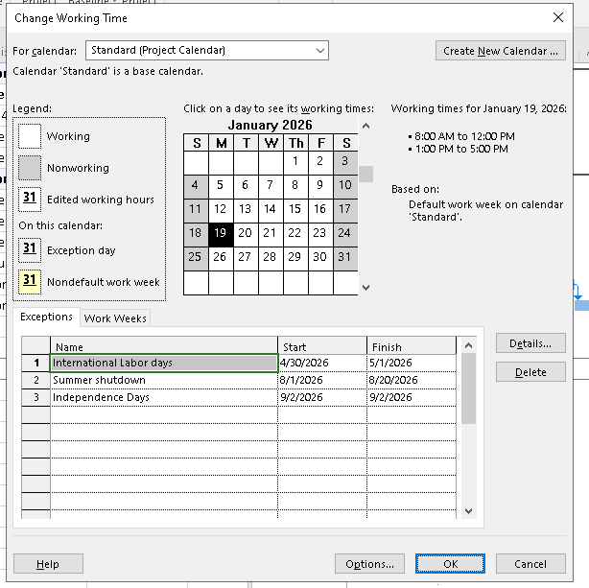
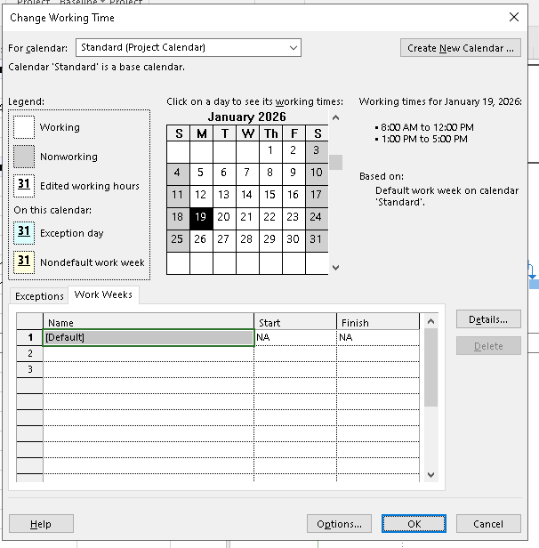
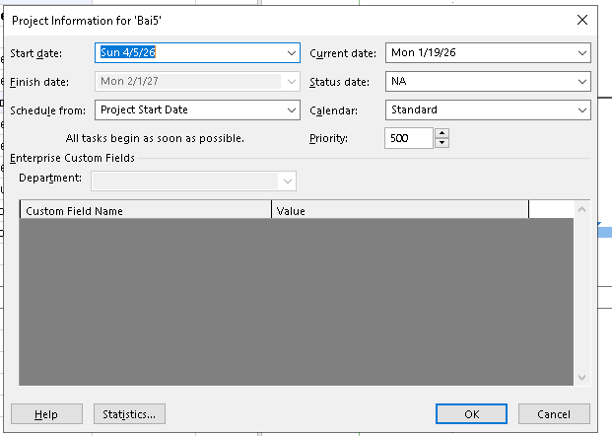
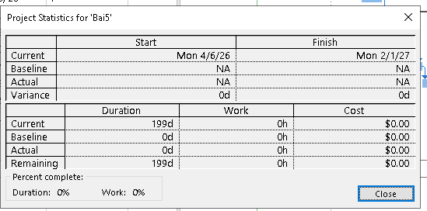

Exercise 4: Change working time

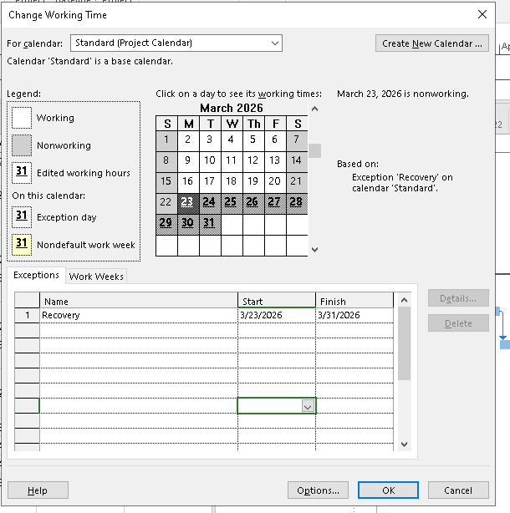
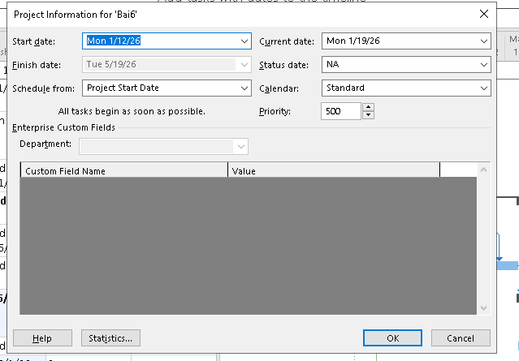
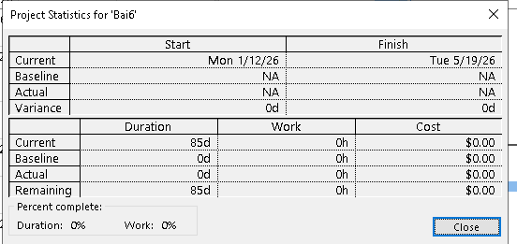

Exercise 5: Create the private Time for a project
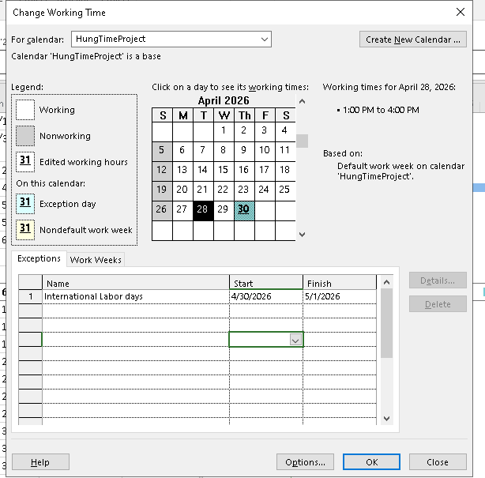
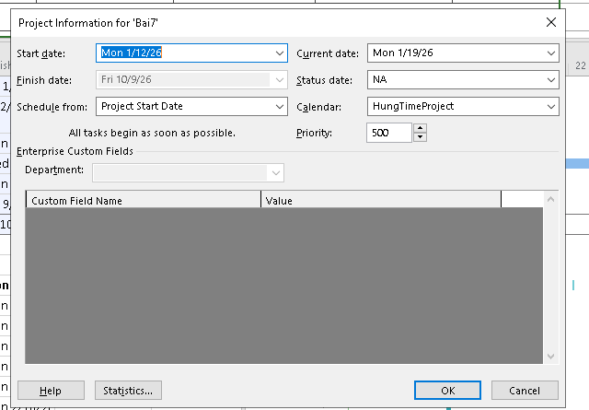
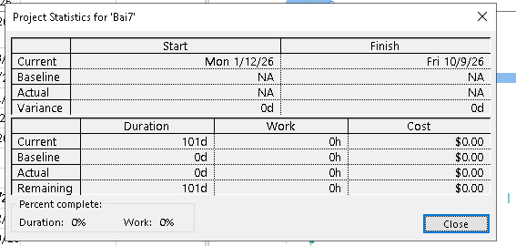

Exercise 6: Your project

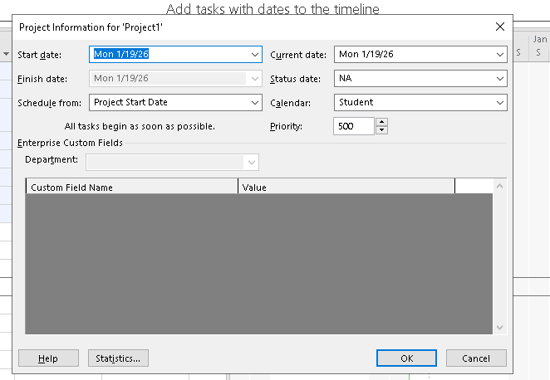
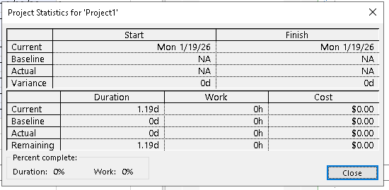
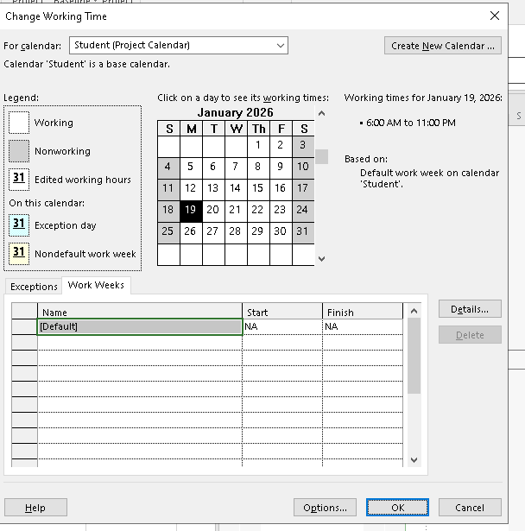

Module 3: TASK MODE

Exercise 1: Changing Working Time
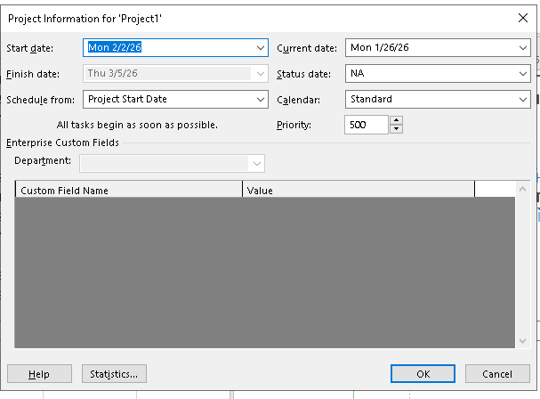
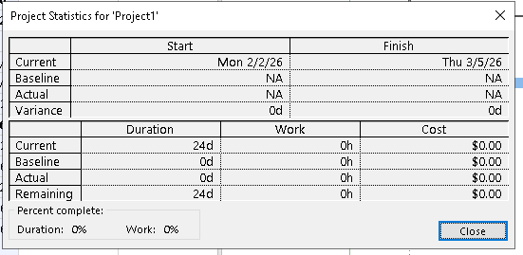
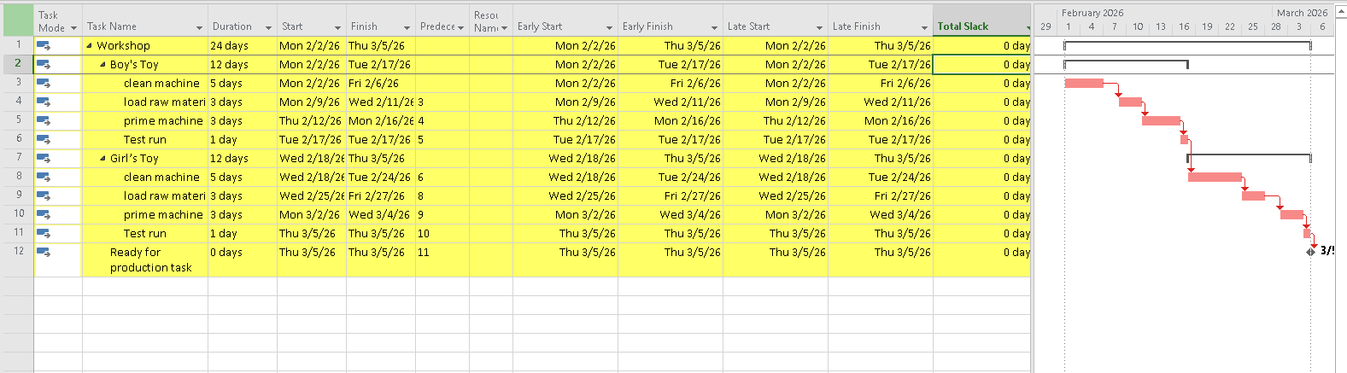
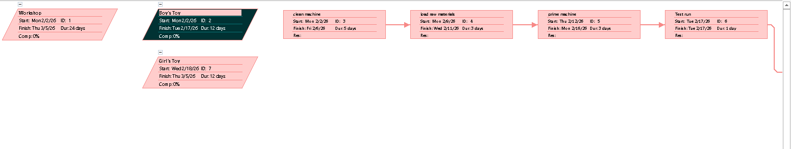

Exercise 2: Changing Working Time
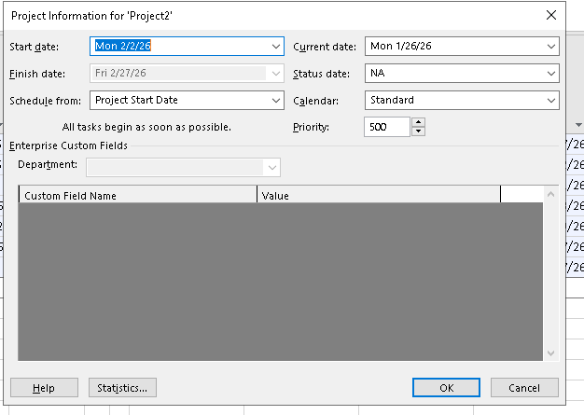
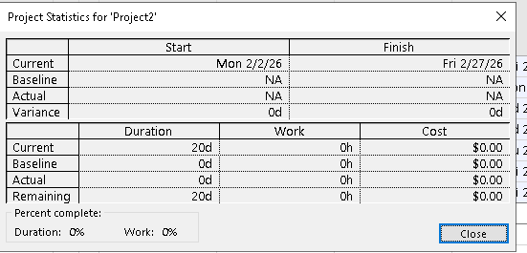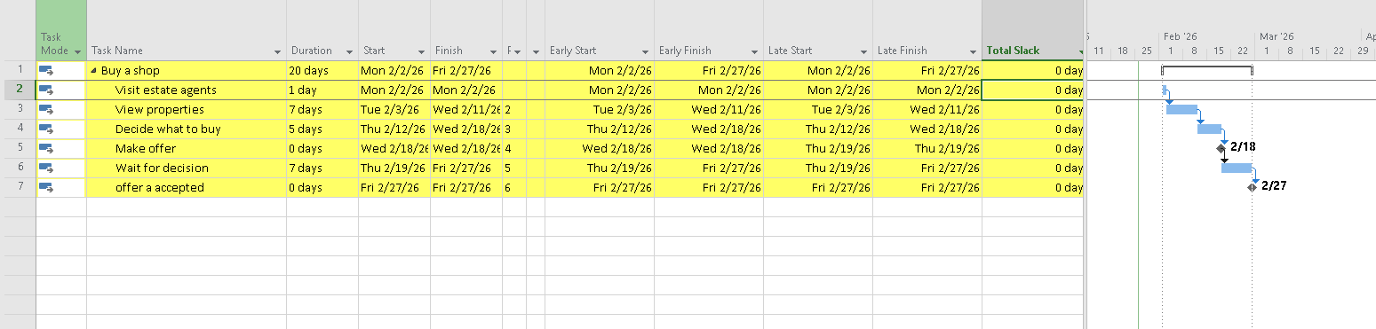

Exercise 3: Changing Working Time
