**REPORT FOR FLYING WHELL**

**INTRODUCTION**

FlyingWhale Airline, a prominent international airline, is on a mission to elevate its business intelligence capabilities. With a focus on enhancing customer experience, understanding travel behaviors, and optimizing loyalty programs, FlyingWhale seeks to harness the power of data analytics. In this case study, we delve into FlyingWhale's datasets, analyzing Customer Flight Activity and Loyalty History. Through strategic insights derived from these datasets, FlyingWhale aims to make informed decisions, driving operational excellence and customer satisfaction to new heights in the competitive airline industry.

**DATA SOURCE**

Data: You have access to two key datasets:

1. **Customer Flight Activity:**

• Loyalty Number: A unique identifier for each customer's loyalty account.

• Year and Month: Period details for analysis.

• Flights Booked: Number of flights booked by the member during the period.

• Flights with Companions: Number of flights booked with additional passengers.

• Total Flights: Combined total of Flights Booked and Flights with Companions.

• Distance: Flight distance traveled in kilometers during the period.

• Points Accumulated: Loyalty points earned in the period.

• Points Redeemed: Loyalty points redeemed during the period.

• Dollar Cost Points Redeemed: Dollar equivalent for points redeemed in Canadian Dollars (CDN).

1. **Customer Loyalty History:**

• Loyalty Number: A unique identifier for each customer's loyalty account

. • Demographics: Country, Province, City, Postal Code, Gender, Education, Salary, Marital Status. • Loyalty Card: Current loyalty card status •

Customer Lifetime Value (CLV): Total invoice value for all flights ever booked by the member.

• Enrollment Details: Enrollment Type (Standard / 2018 Promotion), Enrollment Year, Enrollment Month.

• Cancellation Details: Cancellation Year and Month if applicable.

**Data Preprocessing:**

**Customer Flight Activity Dataset**

▪ There are 405624 entries and 10 columns in the dataset.

▪ There are NO missing values in the dataset.

▪ There are 1864 duplicate entries in the dataset.

**Customer Loyalty History Dataset**

▪ There are 16737 entries and 16 columns in the dataset.

▪ There are missing values in Salary, Cancellation Year, and Cancellation Month.

▪ There are 20 negative values in the Salary column.

▪ There are NO duplicate entries in the dataset.

**Data Analysis:**

Create a table for Customer Loyalty Cancellation

▪ A new table extracted from Customer Loyalty History table for loyalty members that have cancelled their enrollment.

And then create additional Columns of (Till Date) and Enrollment Duration (Till Months)

Create a table for cancelation 2013 to 2018 and then create additional column of Max Cancelation Month.

Create table for cancelation by demographic.

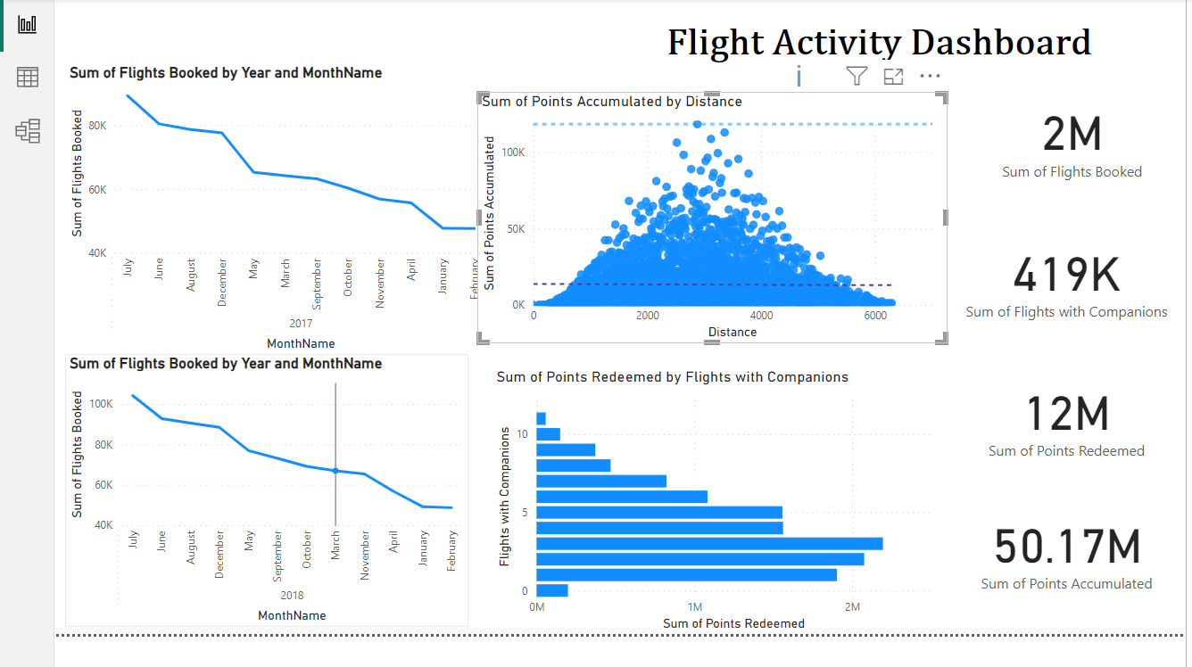

**. Sum of Flights Booked by Year and MonthName**

This line graph shows the monthly trends of flights booked over two consecutive years, 2017 and 2018. The data points indicate:

A decreasing trend in the number of flights booked from July 2017 to February 2018.

This trend suggests a possible seasonal variation in flight bookings or could be indicative of other factors like changes in pricing, airline operations, or consumer demand.

**2. Sum of Points Accumulated by Distance**

This scatter plot illustrates the relationship between the distance of flights and the points accumulated through a loyalty program:

Most of the data points cluster at shorter distances, showing that shorter flights are more common.

Points tend to increase with distance, but the increase does not appear to be strictly linear. There are flights at longer distances that accumulate higher points, which is expected as longer flights typically cost more and thus might offer more points.

**3. Sum of Points Redeemed by Flights with Companions**

This bar graph presents the points redeemed on flights booked with companions:

The x-axis represents the sum of points redeemed and the y-axis shows the number of flights with companions.

A clear downward trend is visible: as the number of points redeemed increases, the number of flights decreases. This could indicate that fewer passengers redeem higher amounts of points, possibly due to saving points for more valuable redemptions.

**4. Key Metrics**

Sum of Flights Booked: 2 million - Total number of flights booked across the observed period.

Sum of Flights with Companions: 419,000 - Flights booked with one or more companions, indicating a significant portion of travel is not solo.

Sum of Points Redeemed: 12 million - Total points redeemed, reflecting engagement with the loyalty program.

Sum of Points Accumulated: 50.17 million - Total points accumulated by all passengers, suggesting a robust accumulation through the loyalty program.

**Overall Insights:**

The airline sees a significant seasonal or yearly variation in the number of flights booked.

There is a robust engagement with the loyalty program, as evidenced by the large number of points both accumulated and redeemed.

The data suggests that passengers might tend to accumulate points on shorter flights to redeem them possibly on more costly or premium options.

The visualization can help the airline identify trends in consumer behavior and adjust marketing or operational strategies accordingly.

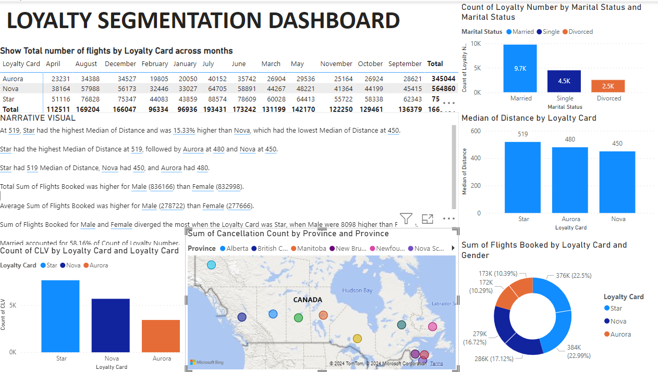

**1. Total Number of Flights by Loyalty Card Across Months**

This table and narrative visual provide data on flight bookings per month broken down by loyalty card types (Aurora, Nova, Star):

Nova shows the highest total flight bookings for the year, indicating high engagement or preference among its cardholders.

Seasonal Fluctuations: Bookings peak during specific months such as August and December, possibly due to holiday travel or seasonal promotions.

**2. Count of Loyalty Number by Marital Status and Marital Status**

This bar chart shows the loyalty program enrollment segmented by marital status:

Married individuals dominate loyalty program participation, followed by single and then divorced. This could reflect stability or a greater inclination towards frequent travel among married individuals.

**3. Median of Distance by Loyalty Card**

This bar chart compares the median flight distance traveled by holders of different loyalty cards:

Star cardholders travel the farthest on average (median distance of 519 miles), which might suggest benefits that appeal to longer-distance travelers.

Aurora and Nova have similar median distances but are significantly less than Star.

**4. Sum of Flights Booked by Loyalty Card and Gender**

This section includes a pie chart and additional data points:

Gender Differences: Total flights booked by males are slightly higher than by females. Particularly, males with the Star loyalty card book significantly more flights than females.

The pie chart displays the distribution of flight bookings by loyalty card type, with Nova representing the largest share.

**5. Sum of Flights Booked by Loyalty Card and Gender**

This bar chart highlights differences in flight bookings by gender across different loyalty cards:

Star shows the greatest disparity, with male bookings far exceeding those by females.

In contrast, for Aurora and Nova, the difference between male and female bookings is less pronounced.

**Overall Insights:**

Loyalty Engagement: Nova has the highest total engagement in terms of flight bookings, but Star cardholders travel the longest distances and show significant gender disparities in bookings.

Marital Status Impact: Married individuals are more engaged in loyalty programs, which may indicate a target demographic for marketing efforts or program design.

Seasonal Patterns: The data suggests strong seasonal trends in flight bookings, which could inform promotional or pricing strategies to capitalize on peak travel times.

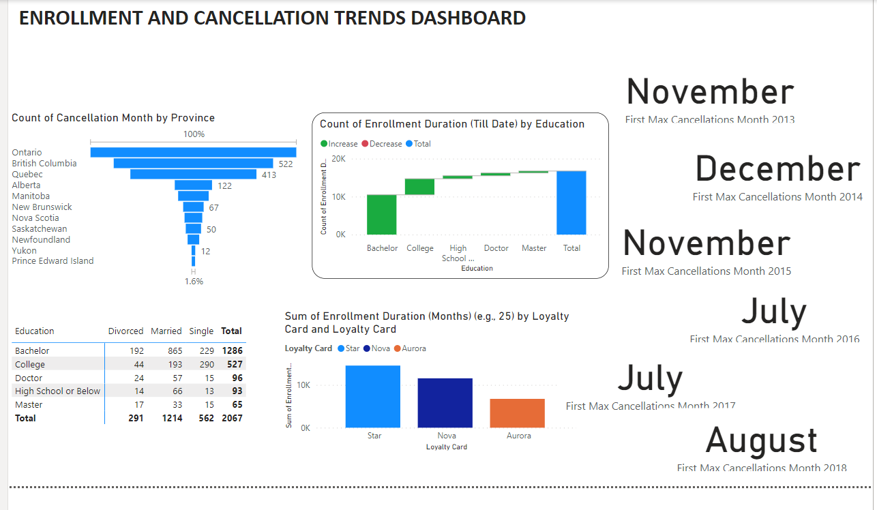

**1. Enrollment by Province**

This bar chart displays the number of enrollments by province:

Ontario and British Columbia show the highest enrollment numbers, significantly higher than other provinces.

This suggests either a larger population in these areas or possibly more offerings or opportunities that attract enrollments.

**2. Enrollment by Education Level and Marital Status**

This table provides a detailed view of enrollments segmented by education level and marital status:

The majority of enrollments are by married individuals, followed by single and then divorced individuals.

Individuals with a Bachelor's degree represent the largest group by education level, indicating this program might be more appealing or accessible to those with higher educational qualifications.

**3. Count of Enrollment by Education Level**

This bar chart compares the count of enrollments across different education levels:

Again, those with a Bachelor's degree dominate the enrollments.

The trend decreases with increasing educational attainment, with Doctorate holders being among the least to enroll.

**4. Sum of Enrollment Duration by Loyalty Card Type**

This bar chart shows the total enrollment duration segmented by the type of loyalty card:

The "Star" loyalty card holders have the highest total enrollment duration, followed by "Nova" and then "Aurora".

This suggests different engagement levels with the program based on the type of loyalty card, possibly indicating varying benefits or motivations associated with each card type.

**5. Months with Maximum Cancellations**

This section lists the months and years when the highest number of cancellations occurred:

A trend is seen where the maximum cancellations often occur towards the end of the year (November and December) and mid-year (July).

This pattern might suggest seasonality in cancellations, possibly due to financial year-end considerations, holiday seasons, or academic calendars.

Geographic Distribution: Enrollment is concentrated in more populous or urban provinces like Ontario and British Columbia.

Demographic Insights: Enrollment trends suggest higher engagement among married individuals and those holding a Bachelor's degree, possibly indicating targeted marketing or program appeal to these groups.

Program Loyalty: Different loyalty cards correlate with varying engagement levels, which could guide strategies for program improvement or customer retention.

Cancellation Trends: Seasonal patterns in cancellations could inform better scheduling or promotional strategies to mitigate these peaks.

**RECOMMENDATIONS**

**1. Enhanced Targeting and Personalization**

Marital Status: Since married individuals dominate loyalty enrollments, consider creating personalized marketing campaigns that cater to couples or families, offering specific rewards or discounts for family travel plans.

Gender-Specific Offers: With noticeable differences in flight bookings between genders, especially for the Star loyalty card, develop gender-targeted promotions to balance the usage across male and female cardholders.

**2. Program Optimization for Loyalty Cards**

Distance Benefits: Since Star cardholders tend to travel longer distances, consider introducing or enhancing benefits that cater to long-haul travelers, such as upgrades, lounge access, or additional mileage points.

Balance Engagement: Given that Nova cardholders have the highest overall flight bookings, investigate why this is the case and potentially apply successful elements from Nova to other cards to increase their attractiveness.

**3. Seasonal Campaigns and Promotions**

Leverage Seasonality: The data shows peaks in bookings during specific months like August and December. Launch targeted promotions or loyalty point multipliers during these months to maximize bookings and cater to the holiday travel crowd.

Off-Peak Incentives: To balance the load and increase off-peak travel, introduce special offers or increased reward points for traveling during quieter months.