

OfstedReady UI/UX Research Report

Executive Summary
This report analyses the user experience requirements of OfstedReady, a web-based platform proposed to support continuous Ofsted readiness in degree apprenticeship provision. The project materials supplied by the team define a clear operational problem: evidence is dispersed across multiple documents, progress information is difficult to retrieve at the point of need, and programme teams lack a single view of learner risk, assessment status and supporting quality evidence. Those problems align closely with current inspection expectations in further education and skills, where inspectors place emphasis on the quality of leaders’ decisions, the visibility of learner progress, the coherence of curriculum and workplace learning, and the credibility of evidence used to demonstrate improvement (Ofsted, 2025a; Ofsted, 2025b).
The revised report therefore focuses on the part of the project that sits within the UI/UX workstream: understanding users, defining task flows, evaluating the wireframes already produced by the group, and translating public usability and accessibility guidance into design decisions suitable for the MVP. The document uses the team’s internal artefacts as the primary project evidence base, then strengthens the discussion through external sources on usability, accessibility, data minimisation and interface evaluation, including WCAG 2.2, QAA guidance for higher education in apprenticeships, Nielsen’s usability heuristics, the GOV.UK Design System, and Brooke’s System Usability Scale (QAA, 2022; W3C, 2024; Nielsen Norman Group, 2024; GOV.UK Design System, 2025a; Brooke, 1996).
The central design conclusion is that the current OfstedReady concept is viable because it is built around real administrative tasks rather than abstract dashboards alone. The strongest screens are the dashboard, grade import, evidence log and assessment tracking views, all of which directly address the need to reduce retrieval time, improve oversight and support defensible decision-making. The most important improvements are not visual decoration; they are better validation, clearer permission logic, stronger accessibility, and a formal evaluation plan that can show the final prototype is usable, auditable and fit for an inspection-sensitive educational context.
1. Project Context and Research Basis
The project brief supplied by the group frames OfstedReady as a platform for continuous quality assurance in degree apprenticeships. The internal PID identifies recurring operational problems: fragmented evidence handling, inconsistent documentation practices, limited visibility of programme progress, and delays in retrieving the right information when it is needed by programme teams. The same internal materials define six core MVP areas: dashboard, schedule generator, grade import, KSB mapping, assessment tracking and evidence log. Taken together, these indicate that the platform is intended to function as a working administrative system rather than a one-off reporting dashboard (Project Team, 2026a).
This direction is consistent with the wider policy environment. Ofsted’s inspection framework and further education inspection information emphasise the quality and impact of leaders’ decisions, curriculum coherence, learner progress, and evidence of improvement rather than narrow compliance checking alone (Ofsted, 2025a; Ofsted, 2025b). QAA guidance on higher education in apprenticeships similarly stresses the distinctive character of apprenticeship provision, especially the need to integrate on-the-job and off-the-job learning, maintain clear programme design, and coordinate multiple stakeholders around the learner journey (QAA, 2022). A digital system for this context must therefore support traceability, shared understanding and timely intervention, not just data storage.

Evidence base used in this report
Source | What it contributes | How it is used in this report
Project PID and implementation content | Defines the problem context, MVP modules, user roles and system scope | Used to ground the user, task and interface analysis (Project Team, 2026a).
Database implementation notes | Clarifies actual MVP data priorities, SQLite-first decisions, grade import fields and status rules | Used to align screen design with what the team can realistically build in the prototype (Project Team, 2026b).
Wireframes and architecture diagrams | Show navigation model, screen structure, data tables, cards, upload flow and system boundaries | Used for screen-level UX critique and interface rationale (Project Team, 2026a).
Public standards and guidance | Provide external justification for usability, accessibility, privacy and evaluation choices | Used to strengthen the academic quality of the report and support explicit design recommendations.
2. Users, Roles and Task Structure
The internal materials identify four main user roles: programme lead, academic staff, coach or mentor, and employer. From a UX perspective, those roles do not simply represent different permissions; they represent different mental models and different frequencies of use. Programme leads need cross-programme overview, academic staff need efficient operational update tools, coaches or mentors need low-friction progress visibility and feedback submission, and employers need a narrow, confidence-building window into progress and evidence. Designing all four personas into the same interface requires careful control of complexity, because overloading infrequent users with staff-level navigation would reduce clarity and trust.
User role | Primary goal | Most frequent tasks | Key UX implication
Programme lead | Monitor readiness and risk | Review KPI cards, locate evidence, check assessment status, identify at-risk learners | Needs a concise overview first, then drill-down without losing context.
Academic staff | Update module and learner data | Import grades, review modules, upload evidence, update assessment progress | Needs efficient tables, strong validation and minimal repeated data entry.
Coach/mentor | Provide contextual learner feedback | View learner progress and submit mentor commentary | Needs very limited navigation, clear permissions and simple forms.
Employer | Understand progress at a glance | Read progress summary and selected evidence outputs | Needs constrained, read-oriented access that communicates trust and relevance.
Key task flows
• Find current programme risk quickly: users should be able to understand overall status within one dashboard view, then move directly into the affected module, learner group or evidence item.
• Import and validate grades safely: the system should help staff upload a structured CSV or spreadsheet, confirm field mapping, identify row-level errors and show the result in plain language before the data becomes authoritative.
• Review KSB coverage and assessment readiness: users need a route from curriculum mapping into operational follow-up, rather than a static matrix with no action path.
• Store and retrieve evidence confidently: evidence records must be searchable, categorised and linked to purpose, because retrieval speed is central to inspection readiness.
3. UX Principles and Design Criteria
The report adopts a user-centred interpretation of usability: a system should allow specified users to achieve specified goals with effectiveness, efficiency and satisfaction in a defined context of use (ISO 9241-11, cited in ISO, n.d.). In practice, that means the OfstedReady interface should minimise effort for repeated administrative tasks, make status visible at each stage of a workflow, support recognition rather than recall, and prevent avoidable errors before they become data quality problems. These ideas are strongly aligned with Nielsen’s widely used heuristics, particularly visibility of system status, consistency and standards, error prevention, recognition rather than recall, and help with diagnosis and recovery when errors occur (Nielsen Norman Group, 2024).
Principle | Why it matters here | Concrete UI implication
Visibility of status | Inspection-sensitive systems depend on credible, current signals rather than hidden states. | Use summary cards, row statuses, progress bars, import logs and timestamps.
Consistency across modules | Users move between dashboard, tables, uploads and evidence views. Consistency lowers cognitive load. | Keep shared page structure, repeated filter positions, consistent button styles and table behaviour.
Error prevention | Grade uploads and evidence handling are high-risk tasks. | Add file-type rules, template guidance, mapping confirmation, row-level validation and clear rollback options.
Recognition over recall | Programme staff should not have to remember codes, categories or hidden rules. | Expose labels, helper text, visible status thresholds and in-screen explanations.
Trust and auditability | Users need confidence that records are accurate and attributable. | Display who changed what, when a file was imported, and whether a record passed validation.
Accessibility by default | The service may be used by a wide range of staff across devices and conditions. | Meet WCAG 2.2 AA expectations, use keyboard-friendly components and never rely on colour alone.
4. Information Architecture and Navigation
The wireframes use a left-side navigation menu with six functional areas: dashboard, module schedule, grade import, KSB mapping, assessment tracking and evidence log. This is a sensible information architecture for the MVP because it maps directly to the working tasks already identified in the PID. It also reflects a strong administrative design pattern: users begin with an overview, then move into a specific workflow, then return to the dashboard or evidence base. That is preferable to mixing all workflows into a single screen or burying critical tasks behind deep navigation layers.
From a UX perspective, the navigation should remain deliberately shallow. The MVP should avoid adding a seventh or eighth primary area unless there is a strong operational reason. Complex navigation would be difficult to justify in a system whose main value lies in quick access to evidence and status. The better pattern is to keep top-level areas stable and use page-level filters, tabs and side panels to handle local complexity.
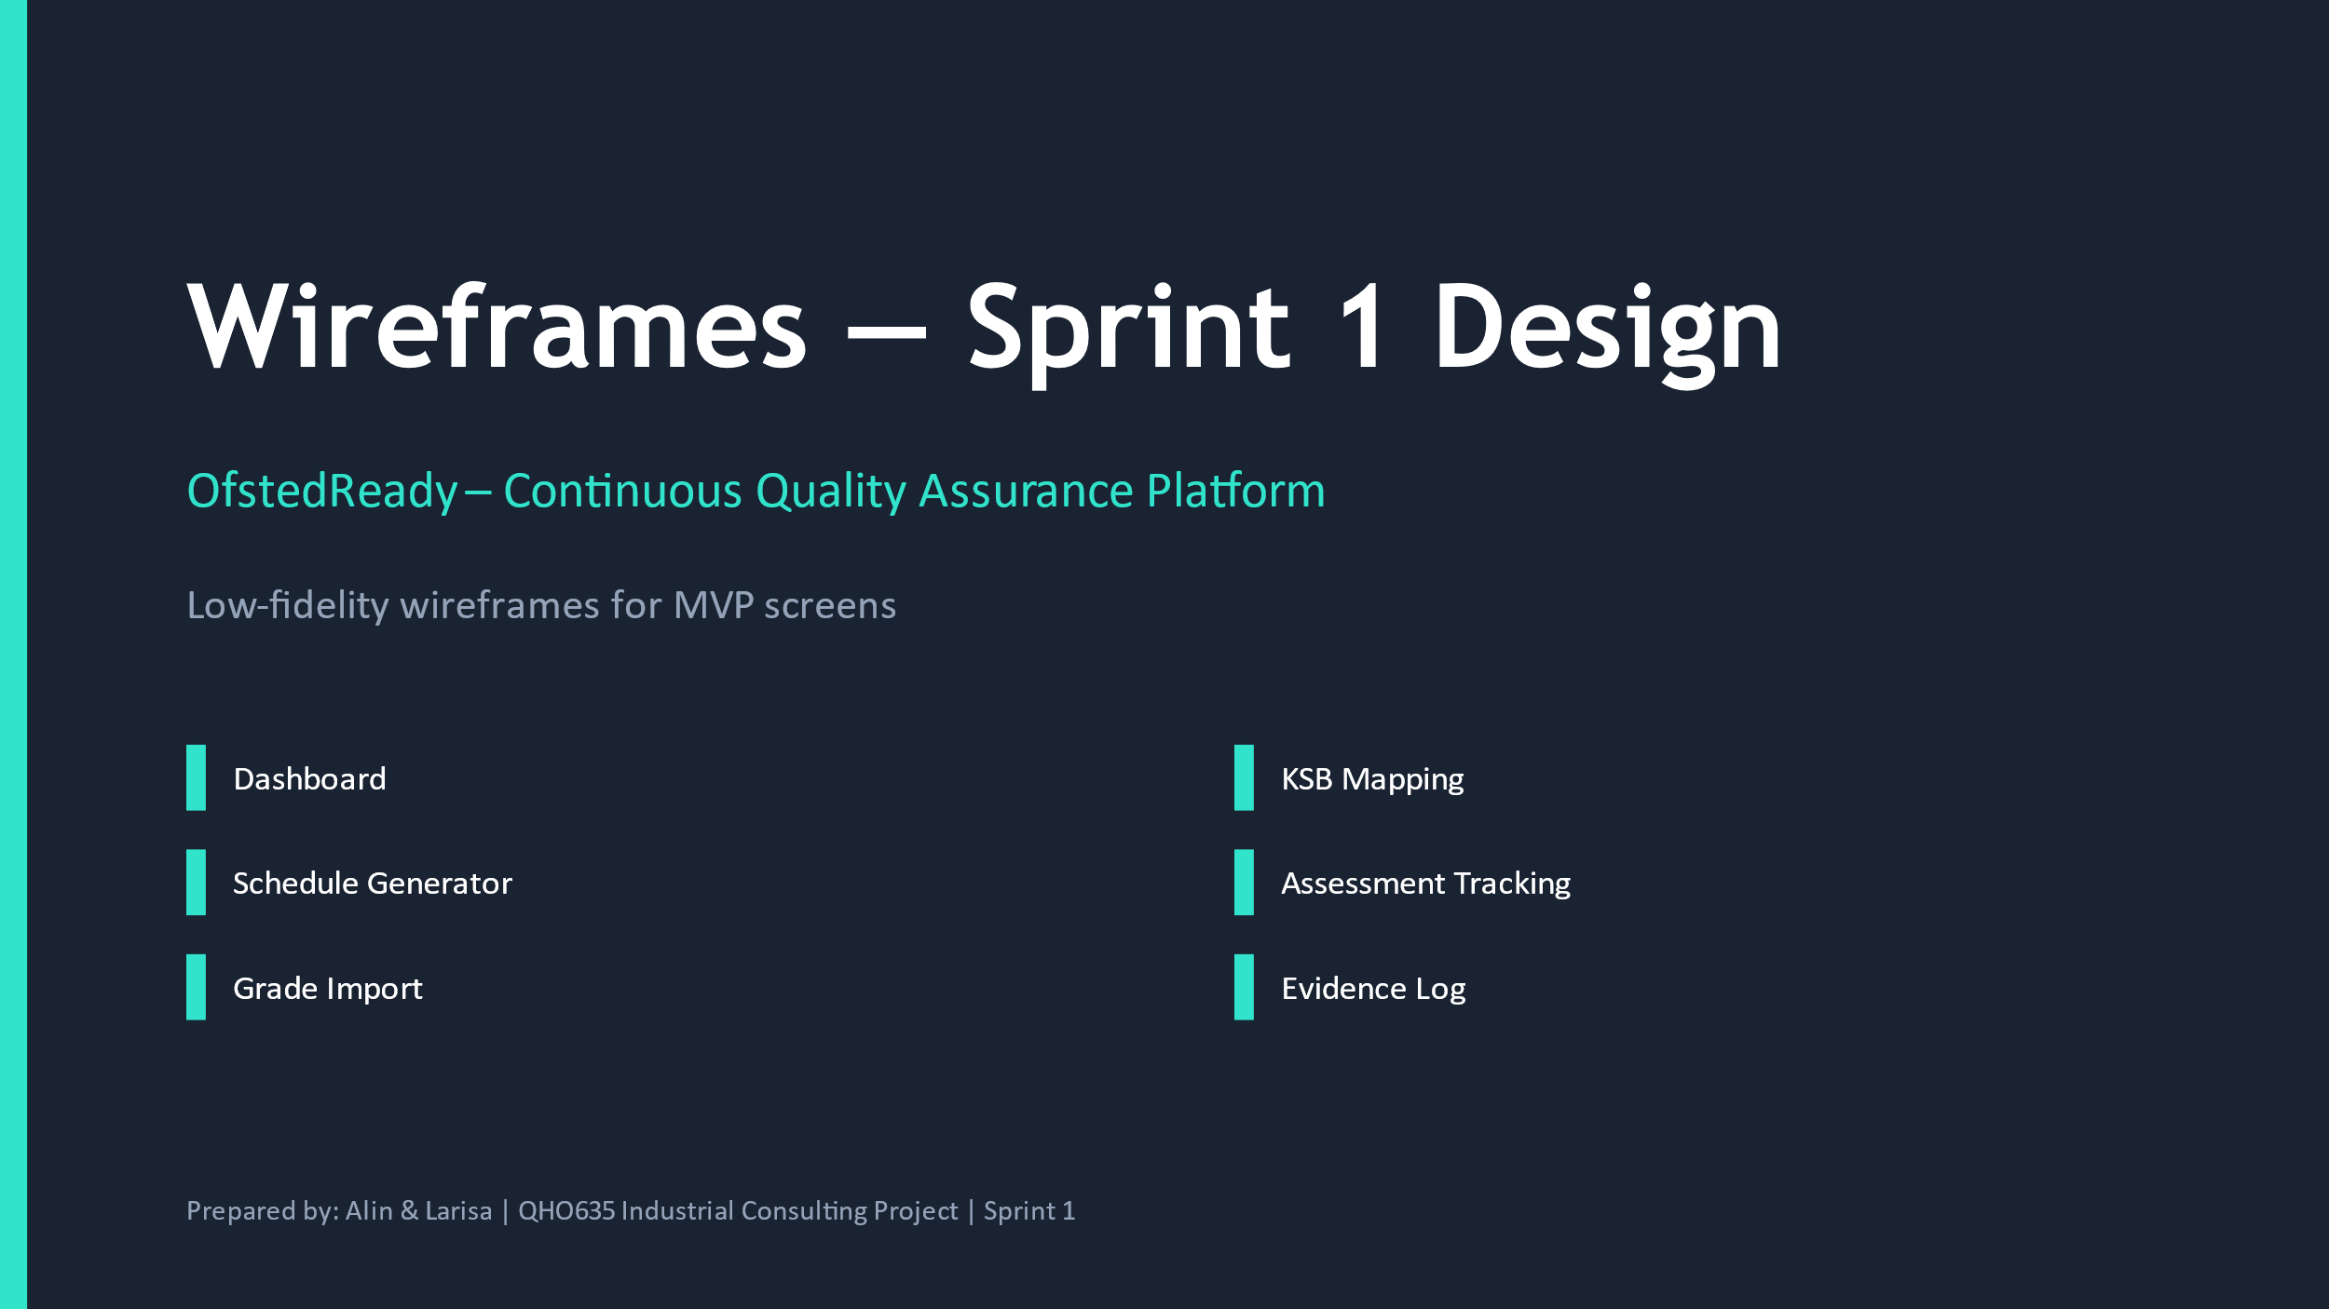  Wireframe cover and module set | 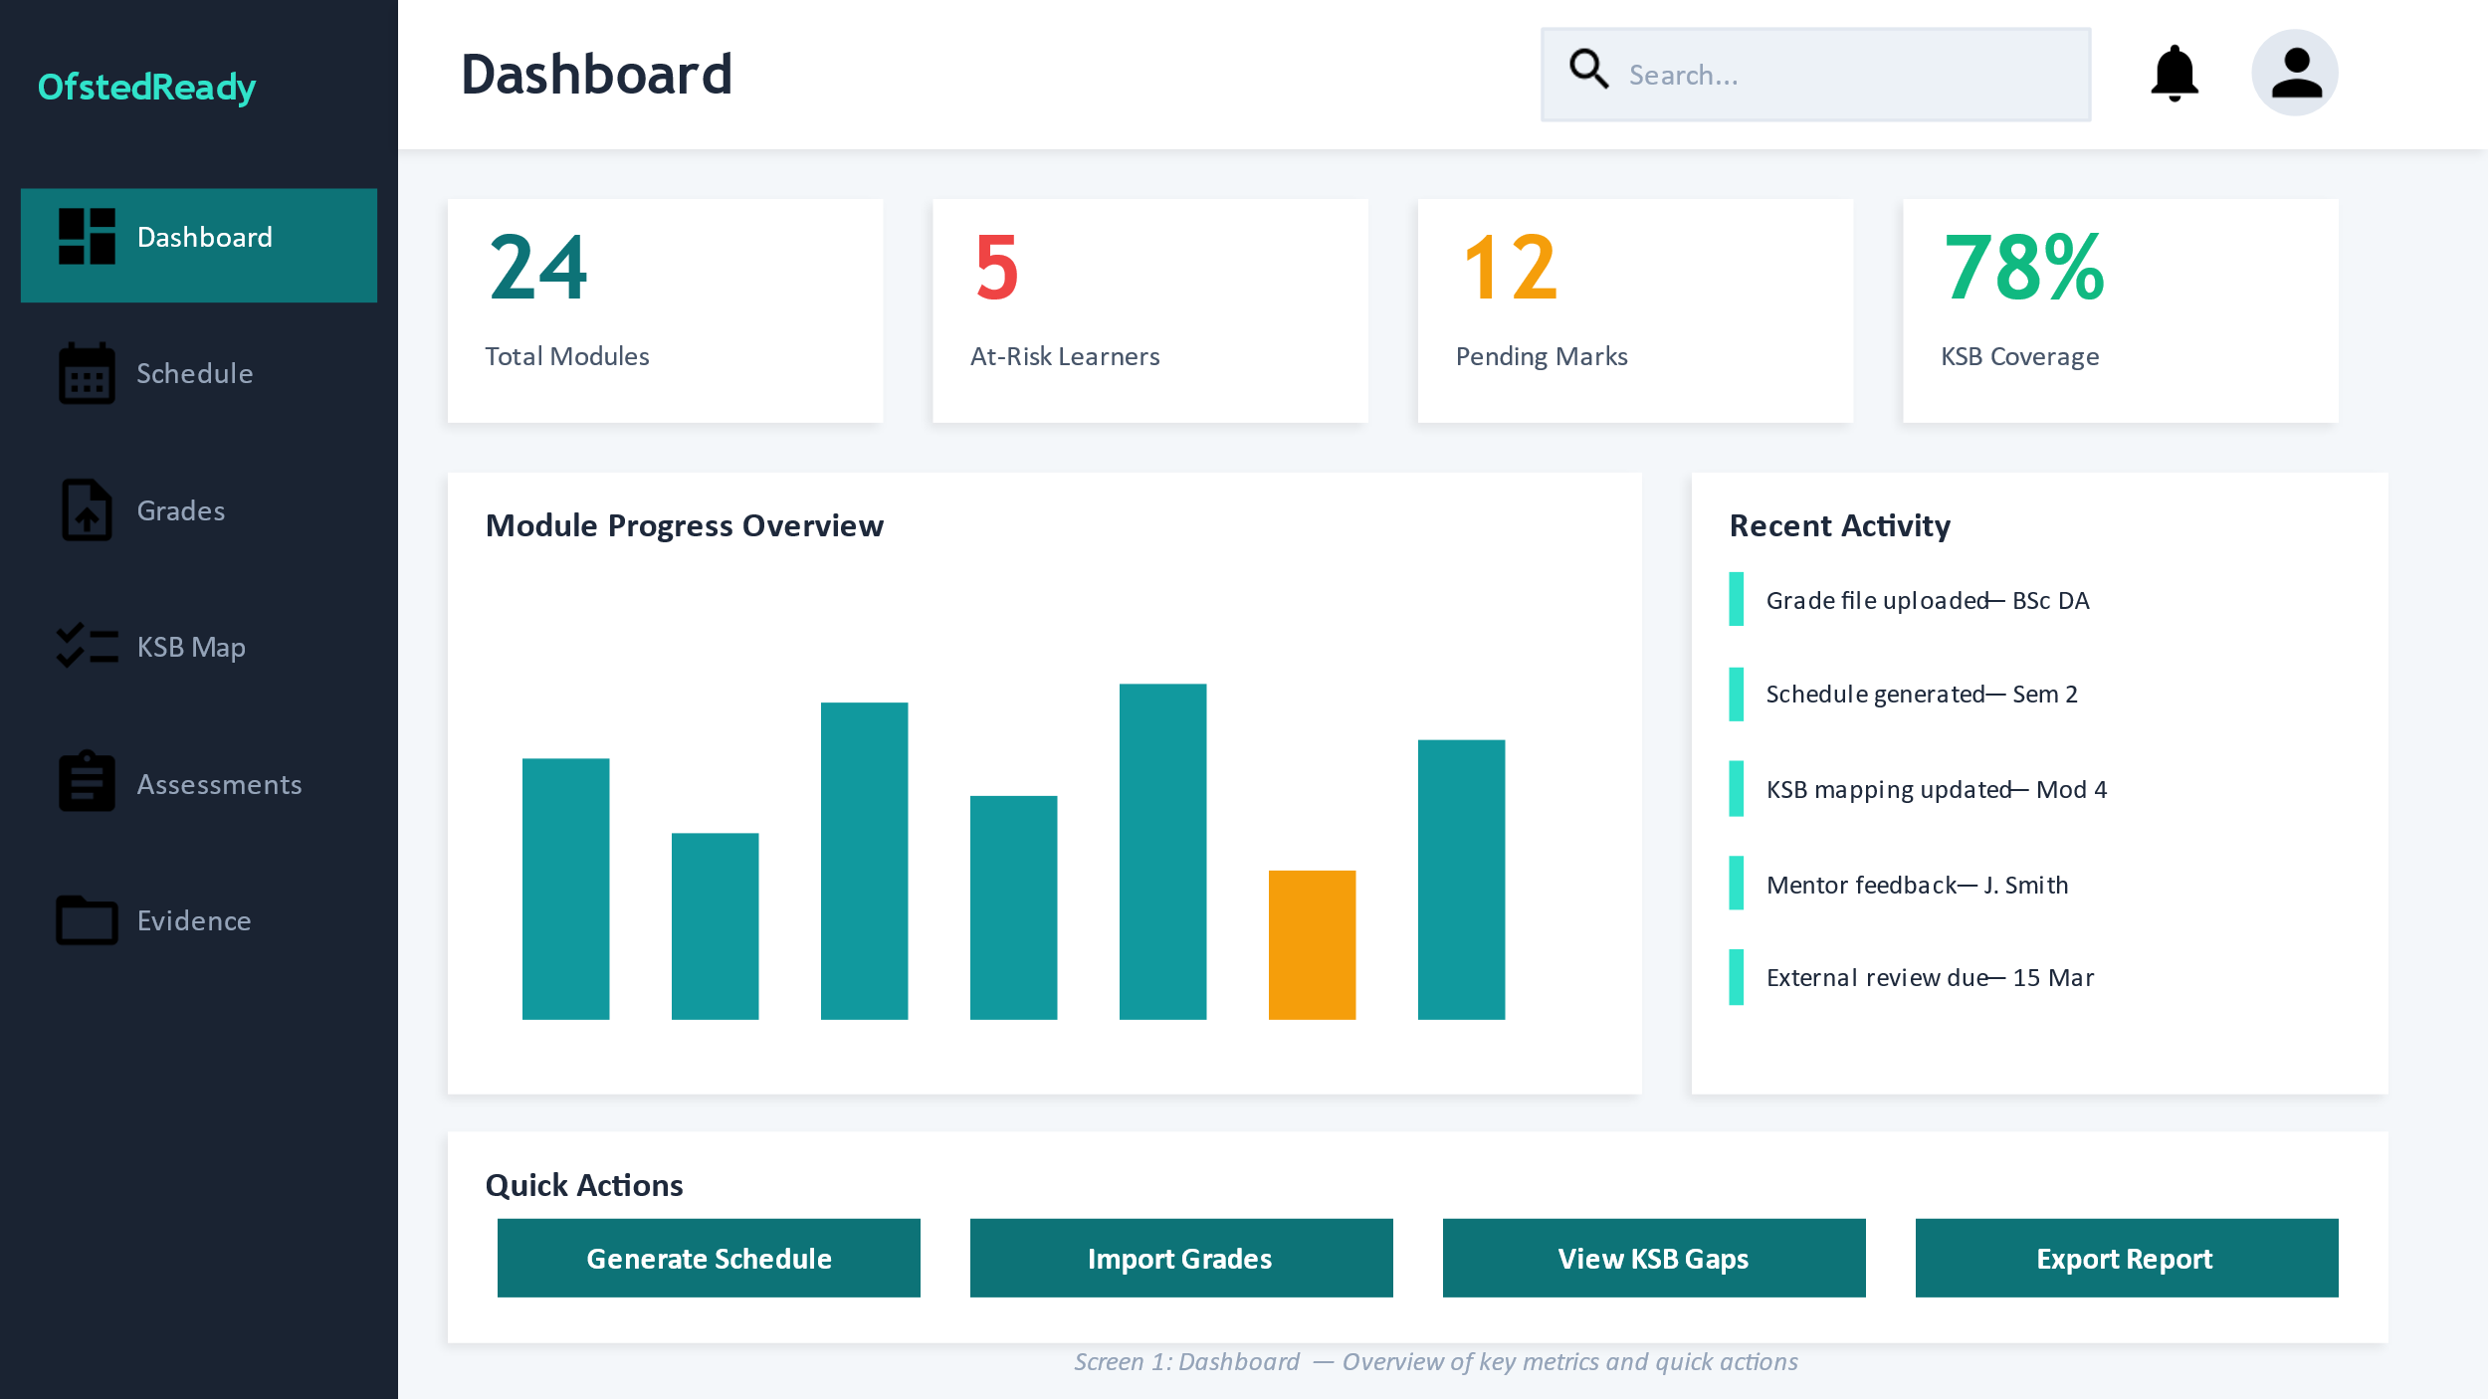  Dashboard overview
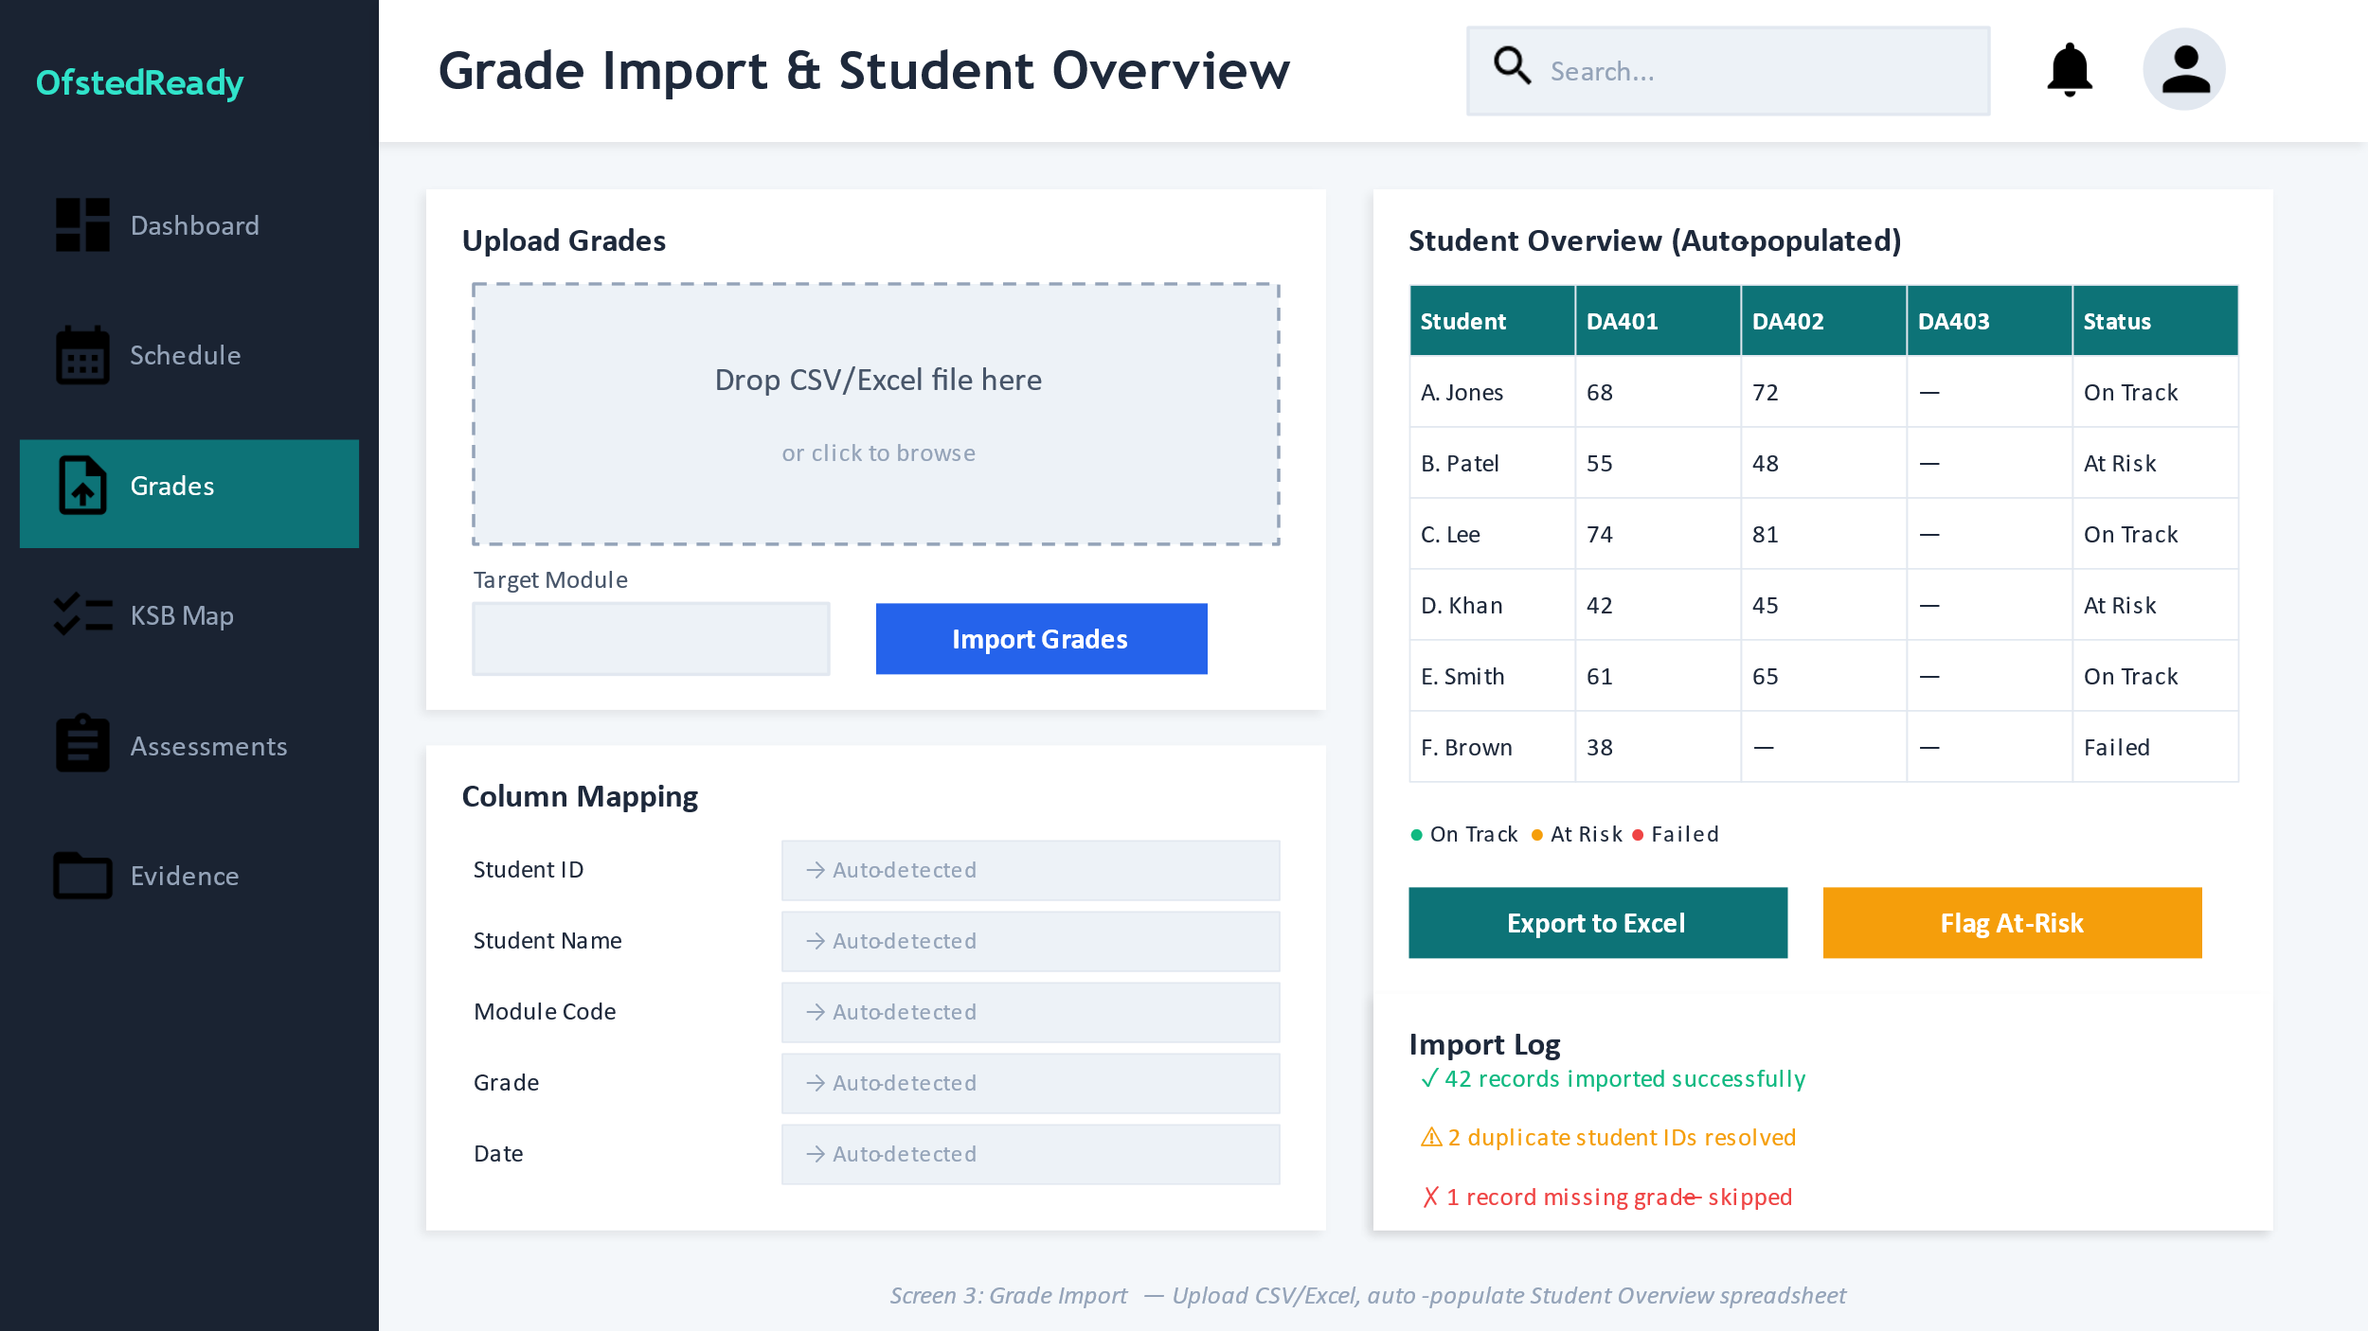  Grade import workflow | 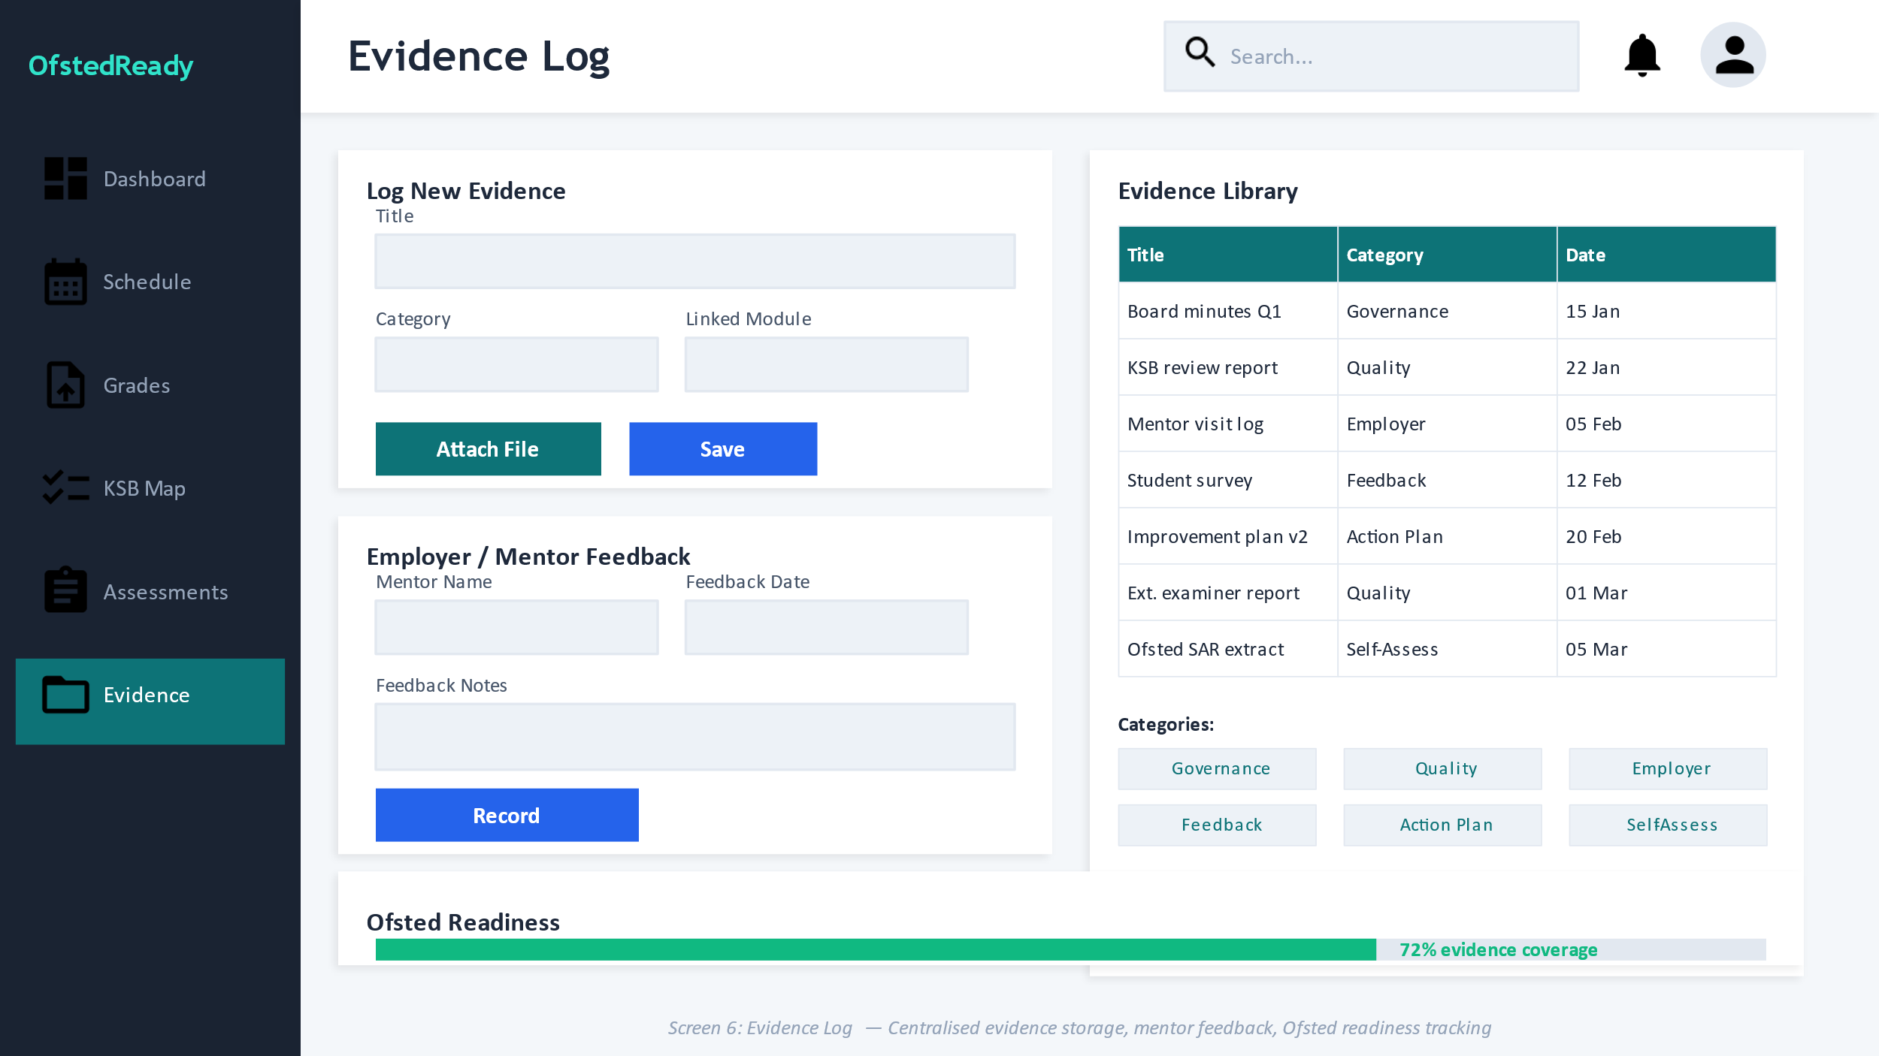  Evidence log workflow
Figure 1. Selected wireframes showing the shared navigation frame and representative task screens used as the basis for this analysis.
5. Screen-Level Interface Analysis
The existing wireframes are strong enough to support meaningful design analysis because they already show repeated layout rules, status cards, data tables, search patterns and action buttons. The critique below focuses on how each screen contributes to the user journey and where further refinement is required before implementation.
  Dashboard |   Grade Import
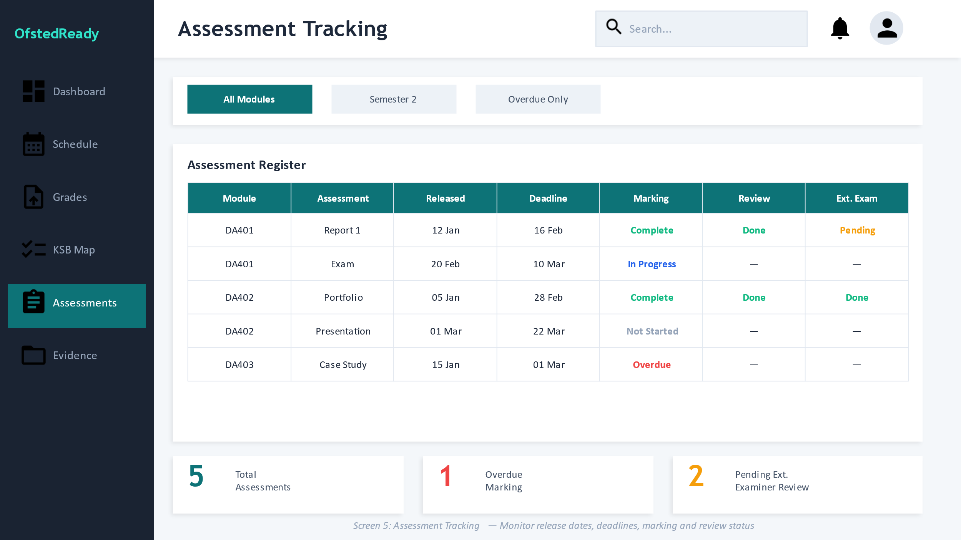  Assessment Tracking |   Evidence Log
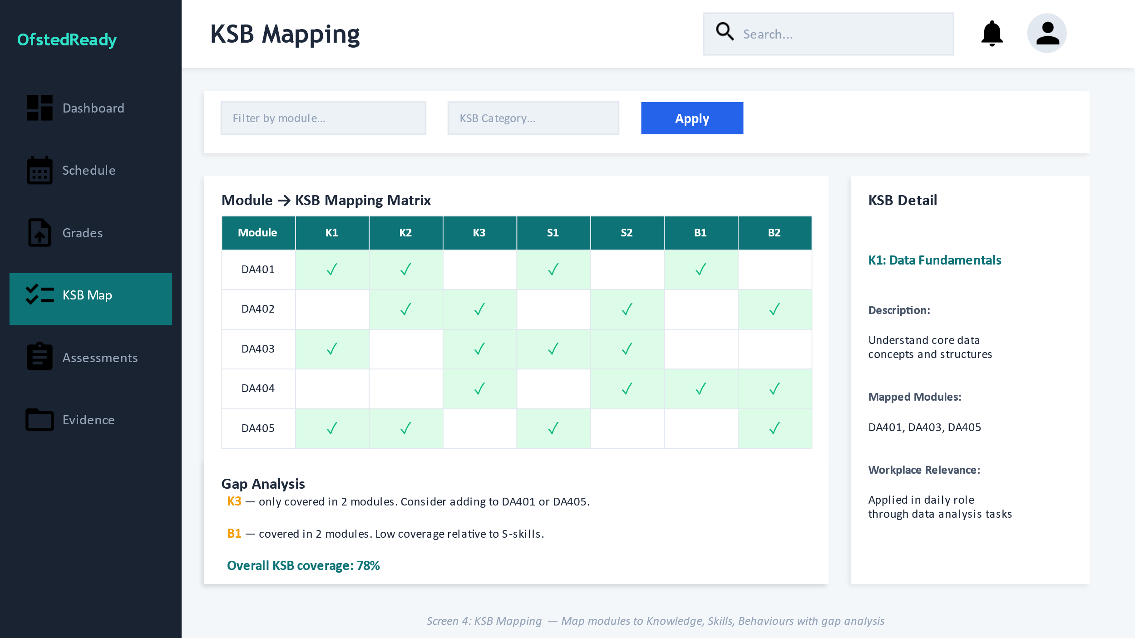  KSB Mapping | 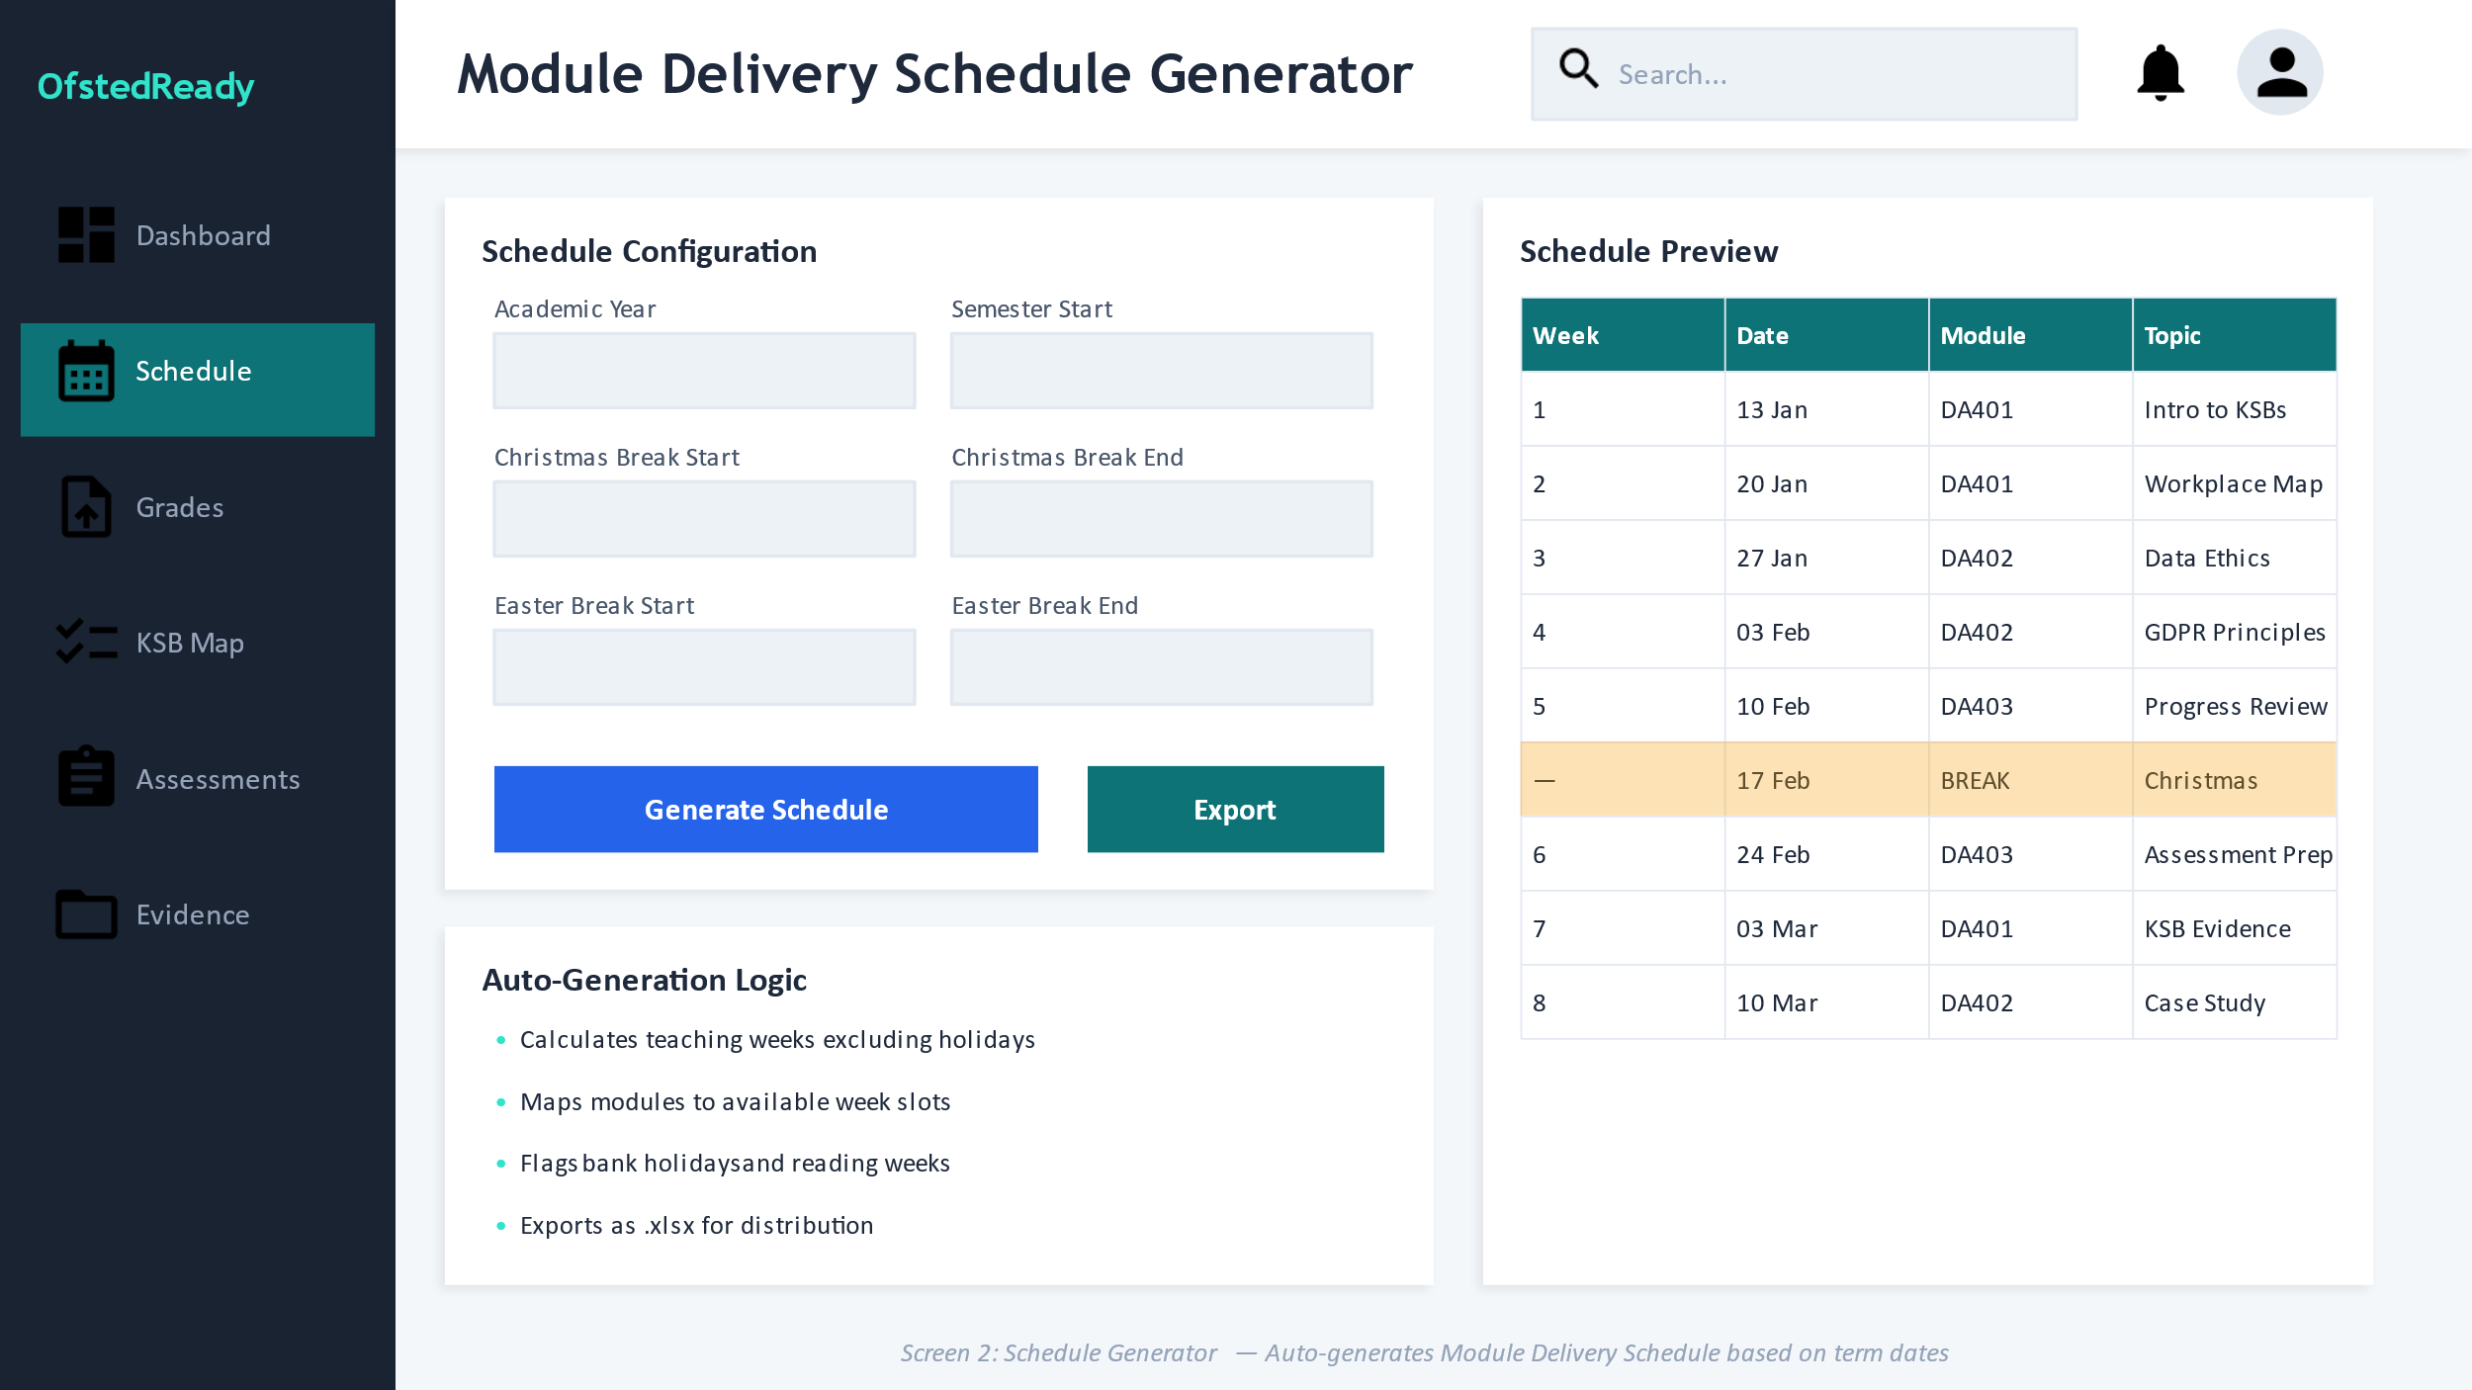  Schedule Generator
Dashboard
The dashboard works because it translates programme complexity into four or five immediately readable signals. KPI cards reduce scanning effort, while the chart and recent activity area support fast orientation. The next improvement is to make each card actionable so users can move from summary to detail in one click.
Grade Import and Student Overview
This is one of the most valuable MVP screens because it connects file upload, field mapping, validation and outcome status into a single flow. The screen should keep the mapping panel visible during upload, use plain-language validation messages, and provide a clear preview before committing imported rows.
Assessment Tracking
Assessment tracking is important because it links deadlines, marking progress and review status. The table structure is appropriate, but status labels should be standardised and sortable so users can move quickly from overdue items to specific modules or assessment records.
Evidence Log
The evidence log is central to the inspection-readiness value proposition. It already combines data entry, categorisation and a searchable library. The most important refinement is stronger filtering and metadata discipline, so evidence can be found by category, module, date, owner or inspection theme.
KSB Mapping
The matrix view expresses curriculum coverage effectively, especially when paired with a gap analysis panel. To improve readability, the MVP should allow filters by module and KSB type and include a plain-language explanation of what counts as under-coverage.
Schedule Generator
The schedule generator is structurally sound because it pairs input controls with a preview table. Before implementation, the screen should make holiday exclusions and export rules explicit, since schedule logic is only trusted when the assumptions are visible to the user.
The grade import, evidence log and assessment tracking screens are the three most important from a usability perspective. They represent the tasks where the system either saves the project team time or fails to do so. For that reason, they should be the primary focus of future prototype testing, because users can quickly judge whether an interface truly helps them complete these workflows. By contrast, the KSB mapping and schedule views are important but less frequent; they benefit most from clarity, explanation and robust defaults rather than from highly interactive behaviour.
6. Accessibility, Inclusion and Trust
Accessibility should be treated as a functional requirement from the beginning rather than as a final-stage audit. WCAG 2.2 remains the core external benchmark for accessible web interfaces, and government guidance makes clear that services should meet WCAG 2.2 AA and avoid relying on colour, complex layouts or inaccessible document patterns to communicate meaning (W3C, 2024; GOV.UK Service Manual, 2018; GOV.UK, 2025). That matters directly for OfstedReady because the system uses status labels, tables, upload controls and evidence files, all of which can become exclusionary if implemented carelessly.
Trust is equally important. In this project, usability is not only about speed; it is also about confidence that records are correct, attributable and protected. The team’s implementation notes already move in that direction by prioritising foreign keys, upload logging, role-based access and data minimisation. Those choices should remain visible in the interface. Users should be able to see who uploaded a file, which import batch produced a status change, and whether they have permission to edit or only to view a record (Project Team, 2026b; ICO, n.d.).
• Use colour together with text labels, not by itself. An “At Risk” item should remain understandable in grayscale, by screen reader, or for users with colour vision differences.
• Use accessible error handling. GOV.UK guidance recommends field-level errors plus an error summary for invalid submissions, which is especially relevant for uploads and date inputs (GOV.UK Design System, 2025b; GOV.UK Design System, 2025c).
• Keep data tables simple. W3C and GOV.UK both recommend using tables for real data, with clear headers and no decorative complexity; this suits the learner, module and assessment tables in the wireframes (W3C WAI, n.d.; GOV.UK, n.d.).
• Support keyboard navigation and visible focus states throughout the interface, especially in upload forms, matrix filters and table actions.
• Apply data minimisation in form design. Only collect the learner, module and evidence details needed for the task, and avoid asking for extra identifiers that do not contribute to the workflow (ICO, n.d.).
7. Evaluation Method and Validation Plan
Because this report is intended to support the UI/UX workstream, it should end with a defensible evaluation method rather than sprint administration. A credible academic evaluation for the prototype can be built from four complementary methods: heuristic review, task-based usability testing, accessibility checking and a short post-test usability questionnaire. This creates a stronger evidence chain than relying on opinion or visual polish alone.
Method | Purpose | Participants / artefacts | Output
Heuristic evaluation | Identify interface issues early using recognised design principles. | 3–5 reviewers comparing the prototype against usability heuristics. | Issue list ranked by severity (Nielsen Norman Group, 2022; Nielsen Norman Group, 2024).
Task-based usability test | Measure whether typical users can complete key workflows. | Programme lead and academic-staff scenarios using dashboard, grade import and evidence log. | Completion rate, time on task, observed errors and comments.
Accessibility review | Check the prototype against core accessibility expectations. | Keyboard testing, colour/contrast checks, table and form review against WCAG 2.2. | Accessibility findings and remediation list (W3C, 2024).
SUS questionnaire | Capture a quick, comparable measure of perceived usability. | Post-test questionnaire completed by participants. | A numerical SUS score with qualitative comments (Brooke, 1996).
Recommended test scenarios
• Locate which module or learner group currently needs the most urgent attention using only the dashboard and linked drill-down actions.
• Upload a grade file, map the required columns, identify one validation problem and correct it before confirming import.
• Find a specific evidence item linked to a module and check whether it can be filtered, opened and understood without assistance.
• Review one assessment that is overdue for marking and identify what action is expected next.
• Check whether the prototype remains usable with keyboard-only navigation and whether status information can be understood without colour.
An evaluation structure like this is more suitable for the assignment than a sprint management section because it directly demonstrates how the UX work will be validated. It also creates traceable evidence for the final report: the team will be able to show which interface problems were found, which changes were made, and whether users found the final prototype understandable and efficient. That is closer to accepted user-centred design practice, where usability testing is treated as a core part of iterative development rather than an optional afterthought (Schumacher, Lowry and Bright, 2010; Lowry et al., 2012).
8. Design Implications for the MVP
• Prioritise the dashboard, grade import and evidence log as the first fully interactive flows. They produce the clearest user value and the strongest basis for evaluation.
• Build reusable table, card and form components so the interface remains consistent across all six modules.
• Expose validation rules visibly instead of hiding them in documentation. Users should know acceptable file types, required columns and status thresholds on the screen itself.
• Keep permission logic narrow for mentor and employer roles. Simpler, role-aware screens will reduce training effort and lower the chance of accidental data exposure.
• Treat audit data as part of the interface, not only as backend metadata. Import batch history, uploader name, edit timestamps and evidence category labels should be visible wherever they matter.
Conclusion
The revised report shows that OfstedReady already has a credible UI/UX direction, but its strength lies less in visual style than in the fit between the proposed screens and the real administrative tasks they support. The wireframes make sense because they are organised around how programme teams actually work: checking risk, importing grades, monitoring assessments, reviewing KSB coverage and retrieving evidence. That functional grounding is what gives the project its strongest design argument.
This revision also addresses the main weakness in the earlier version. Instead of discussing sprint management, it now provides a clearer academic structure built around evidence, design principles, accessibility requirements and a formal evaluation method. That makes the report more suitable for submission as a UI/UX research document. It demonstrates not only what the interface looks like, but why it is structured in this way, which public standards support those choices, and how the final prototype can be tested in a defensible manner.
References
Brooke, J. (1996) “SUS: A quick and dirty usability scale.” In: Jordan, P.W., Thomas, B., Weerdmeester, B. and McClelland, I.L. (eds.) Usability Evaluation in Industry. London: Taylor & Francis.
GOV.UK (2025) Publishing accessible documents. Available at: GOV.UK guidance.
GOV.UK (n.d.) Tables. Content design guidance. Available at: GOV.UK guidance.
GOV.UK Design System (2025a) File upload. Available at: GOV.UK Design System.
GOV.UK Design System (2025b) Error message. Available at: GOV.UK Design System.
GOV.UK Design System (2025c) Error summary. Available at: GOV.UK Design System.
GOV.UK Service Manual (2018) Understanding WCAG. Available at: GOV.UK Service Manual.
ICO (n.d.) Data minimisation. UK GDPR guidance. Available at: Information Commissioner’s Office.
ISO (n.d.) ISO 9241-11 Ergonomics of human-system interaction. Available at: ISO Online Browsing Platform.
Lowry, S.Z. et al. (2012) Technical Evaluation, Testing, and Validation of the Usability of Electronic Health Records. NISTIR 7804. National Institute of Standards and Technology.
Nielsen Norman Group (2022) How to Conduct a Heuristic Evaluation. Available at: Nielsen Norman Group.
Nielsen Norman Group (2024) 10 Usability Heuristics for User Interface Design. Available at: Nielsen Norman Group.
Ofsted (2025a) Education inspection framework: for use from November 2025. Available at: GOV.UK.
Ofsted (2025b) Inspection information for further education and skills providers: for use from November 2025. Available at: GOV.UK.
Project Team (2026a) OfstedReady – PID Implementation Content. Internal project document.
Project Team (2026b) OfstedReady database implementation notes and MVP data model. Internal project document.
QAA (2022) Higher Education in Apprenticeships Characteristics Statement. Gloucester: Quality Assurance Agency for Higher Education.
Schumacher, R.M., Lowry, S.Z. and Bright, T.J. (2010) Guide to the Processes Approach for Improving the Usability of Electronic Health Records. NISTIR 7741. National Institute of Standards and Technology.
W3C (2024) Web Content Accessibility Guidelines (WCAG) 2.2. World Wide Web Consortium.
W3C WAI (n.d.) Tables Tutorial. Web Accessibility Initiative.

