Chapter 1
INTRODUCTION
  - Project Context
Technology's rapid development had profoundly impacted numerous industries, including communication, business, and education. Individuals increasingly depended on internet-based systems—such as social networks, e-commerce, and e-learning platforms—because these provided personalized services based on users' past interactions. According to Riza Shafiloo et al. (2021), personalization enhanced the user experience by delivering tailored content and efficient services that responded to specific needs. Aligned with this technological shift, the Pangasinan State University–San Carlos Campus Web-Based Guidance System integrated automated record management, appointment scheduling, and employee reporting features to modernize the guidance office's manual and traditional procedures. By utilizing a data-driven and customized approach, the system improved accessibility, reduced errors, and ensured that instructors and students received relevant and timely support. The digital storage and retrieval of guidance-related documents also enhanced operational efficiency by promoting a more structured and responsive student assistance system.
According to D. Y. Sari and W. Yahyan (2024), students were required to meet with their supervisors in person as part of the Guidance Process, which was traditionally conducted face-to-face. However, several challenges hindered the effective implementation of this process. These included limited communication time, incompatible schedules between students and lecturers, difficulties in monitoring guidance progress due to large student loads, supervisors' activities or personal matters that caused delays, financial constraints faced by students, and the reliance on paper-based files that resulted in wasted resources during revisions.
Livamianti et al. (2024), emphasized that maintaining student discipline was a crucial step in creating a productive and comfortable learning environment. To ensure timely and protocol-based corrective measures, discipline violations needed close monitoring. However, many schools still recorded and handled disciplinary cases manually. This conventional method—typically involving written logs or physical archives—was time-consuming, prone to data loss, vulnerable to inaccuracies, and often resulted in delayed responses. Such issues made it increasingly difficult to properly manage and address student infractions.
To expand on this, R. Livamianti et al. (2024), explained that a technology-based solution was necessary to improve the effectiveness and accuracy of student disciplinary management. A web-based tool could digitize the documentation, tracking, and reporting of student disciplinary violations more efficiently. Through web-based technology, this system enabled real-time, accessible, and more accurate data management for administrators and students.
Pangasinan State University (PSU) San Carlos Campus, located at Roxas Blvd., San Carlos, Pangasinan 2420, was recognized as a distinguished institution committed to providing quality higher education and promoting academic excellence in the region. Offering programs such as Bachelor of Elementary Education, Bachelor of Secondary Education, Bachelor of Science in Business Administration, and Bachelor of Science in Information Technology, the campus had supported thousands of students through its dedicated employees and administrative staff. However, as enrollment increased, the campus faced growing challenges in managing student data, counseling assessments, and employee responsibilities. The institution relied on a manual information management system dependent on paperwork and scattered digital files. This outdated method resulted in inefficiencies such as data discrepancies, delayed processing, and difficulties in resource allocation, all of which hindered effective decision-making and academic support.
The Guidance Office of PSU San Carlos Campus continued to encode and maintain student data using antiquated manual procedures. These processes were time-consuming and highly prone to human error, increasing the likelihood of misplaced or lost student documentation. For example, students received printed inventory forms that they had to return to the office after completion. Administrators were then required to manually sort and organize these bulky paper documents, creating an arduous and time-intensive task.
According to R. G. Guntara et al. (2023), manual procedures were typically less efficient and effective than automated ones. The guidance office’s reliance on traditional methods significantly limited its operational capacity, causing unnecessary delays and reducing the overall quality of services provided to students. Furthermore, the possibility of misplacing important information during the paperwork management process heightened the risk of additional administrative problems.
Guntara et al. (2023), further emphasized that their research aimed to develop an innovative, effective, and standardized web-based evaluation and supervision model. This involved system design, testing, and integration to create a website-based evaluation and monitoring system. Using multi-agent technology and a client/server architecture, the system enabled users to efficiently access databases and relevant information to perform their tasks.
Yahya (2020), stated that arranging counseling sessions for students needing guidance remained a major concern. Without an efficient scheduling mechanism, students faced significant challenges when attempting to meet with guidance counselors. Schedule conflicts resulted in delays and missed counseling opportunities, leading to frustration among both students and administrators. The lack of clear communication about available appointment times further contributed to misunderstandings. Manual management also increased the risk of double bookings or overlooked appointments.
As the student population continued to grow, the administrative workload associated with maintaining records and counseling schedules intensified. The inefficiencies of the existing system overwhelmed guidance office personnel, potentially leading to burnout and reduced job satisfaction. These challenges also increased stress levels among administrators and students, who struggled to keep up with the demands of a manual system. As a result, there was a pressing need for a streamlined and efficient method of managing student data and counseling processes to enhance the office’s ability to provide timely support while reducing administrative burdens.
The proposed Web-Based Guidance System was envisioned to significantly improve the operations of the PSU San Carlos Campus Guidance Office by addressing long-standing issues associated with manual data management and inefficient service delivery. For students, the system offered a more accessible and user-friendly platform to schedule counseling sessions, receive timely support, and track their guidance records, fostering both academic and personal development. Employees benefited from streamlined reporting tools and real-time access to guidance data, allowing them to provide more informed and responsive mentorship. For administrators, the system automated routine tasks, reduced paperwork, and provided data analytics for improved decision-making and resource allocation. By integrating these components into a centralized digital platform, the system contributed to a more efficient, responsive, and student-centered guidance service aligned with the institution’s commitment to academic excellence and student welfare.
1.2 Objectives of the Project
The main objective of this study is to design and develop a system that streamlines the Guidance System of PSUSCs Guidance Office. The specific aims of the study are:
- Design the proposed information management and guidance process for Pangasinan State University San Carlos Campus Guidance Office;
- Determine the features of the proposed system in terms of functional and non-functional requirements; and,
- Test the acceptability of the proposed system.
1.3 Significance of the Project
The development of this research marked a revolutionary advancement in improving Competence Bridge's operational capabilities and customer service satisfaction. This research was significant across various dimensions:
Pangasinan State University San Carlos Campus. By simplifying administrative and data management procedures, the information management support system's deployment improves operational efficiency. Staff workload is lessened, enabling the Guidance Office to manage more students with more accuracy and fewer data inconsistencies. Consequently, the system contributes to upholding high levels of institutional efficacy and support.
Administrators. Administrators may easily organize and access student data, timetables, and institution record due to an effective and user-friendly guidance information management support system. Better workflow, less administrative labor, and timely and accurate information management are all made possible by this technology, which enhances institutional effectiveness and decision-making.
Employee. The system streamlines employee reporting by enabling online submissions of student concerns, reducing paperwork and in-person visits. This increases productivity, guarantees that the guidance office will respond promptly, and frees up employee time to concentrate on instruction while keeping track of students' progress.
Students. Students can seek advice services in a more efficient and accessible manner with the help of the system. It enables smooth appointment scheduling, reduces errors, and get rid with manual form submissions. This guarantees prompt assistance, better documentation, and an easier way to handle both personal and academic issues.
Developers. This study will give the developers involved a chance to use revolutionary technologies in a practical environment, which will improve their knowledge and expertise. It also functions as an inventory item that would show off their capacity to use software to revolutionize commercial operations.
Future Developers. A model for future developers working on related technological solutions is provided by the system and its development process. By providing educational resources and references that motivate and direct further research, this documentation, the issues it addresses, and the incorporation of user feedback promote a cycle of innovation and advancement within the tech industry.
1.4 Purpose and Description
The purpose of the capstone project entitled "Web-Based Guidance System for Pangasinan State University-San Carlos Campus" was to develop a system that lessens and refines the manual process of managing. This project's main goal is to provide a more accurate, accessible, and efficient system that reduces administrative burdens and enhances the standard of services offered to staff, professors, and students. Ineffective record administration, schedule conflicts, human errors in documentation, and laborious manual transactions are only a few of the issues with the conventional paper-based system. The system aims to address these issues and implement a more automated and structured method of guidance-related operations by switching to a web-based platform.
The automation of student inventory forms, which removes the need for students to manually complete paper-based forms, is a key component of this system. This guarantees that records are safely kept and may be quickly retrieved when needed, in addition to lowering data encoding errors.
Faculty members can also report issues or send students to the guidance office more easily and effectively thanks to the system. Faculty can save time and effort while preserving the authenticity and confidentiality of their reports by submitting them online rather than in person at the office and enduring tiresome procedures.
Additionally, the use of this web-based platform brings with it an improved scheduling/appointment system that makes it easy for staff and students to make appointments with the guidance office. Ineffective time management and schedule conflicts are common outcomes of the conventional walk-in consultation approach. By using this technology, guidance counselors can better manage their calendars and students may make online appointment bookings, guaranteeing a seamless consultation process free from needless delays or conflicting appointments. In furtherance of enhancing scheduling and documentation, the system will act as a consolidated database for records pertaining to guidance, which will facilitate administrators' ability to keep an eye on student concerns, monitor progress, and produce reports as needed. The Guidance Office's decision-making procedures are improved by this data-driven approach, which also guarantees that all necessary data is accurately recorded and available when needed.
This initiative aimed to replace outdated manual scheduling methods with a robust, user-friendly online platform that facilitates better client interactions and improves operational efficiency. Overall, the Web-Based Guidance System for Pangasinan State University San Carlos Campus is expected to have a significant and transformative impact on the operational efficiency of the Guidance Office. By leveraging modern technology, it not only minimizes the administrative burden on guidance counselors and staff but also provides students and faculty with a more accessible, reliable, and user-friendly platform for communication and support. This initiative aligns with the university’s goal of integrating technology-driven solutions to improve institutional processes, ultimately contributing to a more efficient and student-centered academic environment.
1.5 Scope and Limitations
This study primarily focused on the development of the Web-Based Guidance System for Pangasinan State University–San Carlos Campus. In this section, the developers outlined the scope and limitations of the system as encountered during the development cycle. The system was designed with three levels of user access—Administrator, Employees, and Students—each configured to meet specific operational needs and assigned privileges within the platform.
The Administrator account, which oversaw the entire system, possessed the highest level of access and authority. It managed employee and student accounts, roles, permissions, student records, appointment scheduling, and announcements while ensuring the accuracy of the stored data. By restricting certain functions to prevent unauthorized modifications, the system maintained both security and platform stability. Administrators also had the capability to restore archived data when necessary and exclusive access to system logs for activity monitoring.
Students were able to easily review their guidance records through a personalized dashboard that allowed them to track any recorded concerns, previous consultations, or interventions made by the Guidance Office. They could also complete and submit their individual inventory forms online, removing the need for physical paperwork and minimizing potential data entry errors. Additionally, students could view the Administrator’s latest announcements, ensuring that they remained informed about important updates regarding policies, service schedules, or campus events.
Employees, on the other hand, were able to submit detailed reports regarding their concerns about students, providing the Guidance Office with a more structured and efficient method of communication. Through this feature, teachers could record academic, behavioral, or personal concerns, ensuring that these issues were documented accurately and addressed promptly. By filing reports online, employees eliminated the need to visit the Guidance Office in person, thereby streamlining the reporting process and supporting faster intervention when necessary. The system also allowed employees to monitor the status of their submitted reports, promoting transparency and strengthening collaboration between educators and guidance personnel in supporting students’ academic performance and overall well-being.
Despite its advantages, the system had several limitations. It was intended solely for use within the Guidance Office of Pangasinan State University–San Carlos Campus. Since the system depended on stable internet connectivity, any network interruptions could affect its accessibility and functionality. Furthermore, while the system enhanced digital record-keeping and online transactions, in-person counseling sessions remained essential for providing comprehensive guidance and support, as digital tools could not fully replace personal interaction. The system’s effectiveness also relied heavily on user compliance and active participation from administrators, instructors, and students.
Another important limitation was the exclusion of psychological test questions from the system. These assessment instruments could not be integrated into the platform because they were legally protected and restricted from public distribution. To comply with educational and ethical regulations, the system only accommodated general records and documentation, without including any proprietary or confidential psychological testing materials.
1.6 Definition of Terms
In this section, the developers provided clear and precise definitions of key terms and concepts integral to understanding the capstone project. This ensured consistency and clarity throughout the document, allowing readers to fully grasp the subject matter without ambiguity. The following terms were defined for reference:
Faculty: the entire teaching and administrative force of a university, college, or school. The teaching staff and academic staff at Pangasinan State University-San Carlos Campus who use the Web-Based Guidance System to report student concerns, monitor the status of reported cases, and interact with the Guidance Office about student behavior, academic performance, or well-being are referred to as faculty in this study.
Counseling Appointment: Is a planned meeting that is set up via the Web-Based Guidance System between a student and a guidance counselor. Students can seek advice and help about academic, personal, or emotional issues during this visit, which guarantees a well-organized and planned consultation procedure to successfully meet their needs.
Cross-Device: The capacity of a system to work flawlessly across a variety of platforms, such as desktop computers, tablets, and smartphones, is referred to in this study as cross-device. This feature enhances convenience, accessibility, and system usability by guaranteeing that users—including administrators, instructors, and students—can access the Web-Based Guidance System at any time and from any location.
Functional Requirements: the specific functions and features that the Guidance System for Pangasinan State University – San Carlos Campus is designed to perform. These include core system operations such as user account registration and login, appointment scheduling between students and counselors, storing and retrieving counseling records, managing student profiles, and generating reports. Functional requirements define what the system should do to support the day-to-day processes of the Guidance Office, ensuring that guidance counselors, administrators, and students can efficiently perform their tasks within the digital platform.
Non-Functional Requirements: The specific quality attributes that the Guidance System for Pangasinan State University – San Carlos Campus must meet to ensure dependable and user-centered operation. These include system performance (such as fast response time during data access), data security through encrypted authentication methods like JSON Web Tokens (JWT), user-friendly interface design for ease of use by guidance counselors, students, and administrators, and system reliability through regular backups and fault tolerance. These requirements determine how well the system performs under various operational conditions and directly impact its usability, security, and stability.

Chapter 2
REVIEW OF RELATED LITERATURE AND SYSTEMS
2.1 Technical Background
In order to guarantee dependability, scalability, and usability, the technologies, frameworks, and design principles utilized in the development of the Web-Based Guidance System for PSUSC are described in detail in this section of the document.
JavaScript was used as the primary programming language for both the front-end and back-end development, providing consistency across the entire development stack. This uniform approach reduced the learning curve for developers, simplified debugging, and accelerated the creation of system features. The back-end operated on Node.js, a runtime environment designed for real-time and event-driven applications. Node.js efficiently handled asynchronous tasks and multiple concurrent requests, making it suitable for managing numerous appointment bookings without performance issues. Express.js, a lightweight framework for Node.js, further supported server-side development by offering organized routing, middleware integration, and structured API management.
For data management, MongoDB was used as the system’s database. As a NoSQL database, MongoDB accommodated flexible, evolving, and unstructured data—an important requirement for handling user profiles, appointment records, and system logs that changed over time. Its schema-less design and ability to scale horizontally ensured fast data retrieval and stable performance as system usage increased. This allowed the system to adapt to growth without the need for major database restructuring.
RESTful APIs were implemented to manage communication between system components. These APIs followed standard HTTP protocols, making data exchange lightweight, secure, and platform-independent. Through this architecture, the system maintained smooth interactions between the client interface, server processes, and database operations. The use of RESTful APIs also supported potential integration with external services and future system enhancements.
Security was addressed through the implementation of JSON Web Tokens (JWT) for authentication and session handling. JWT provided a secure, stateless method of verifying user identities, reducing risks associated with session hijacking and unauthorized access. Its stateless nature improved scalability by eliminating the need for storing session data on the server.
The system was deployed on Vercel, a cloud hosting platform known for its reliability and automated deployment capabilities. Vercel provided continuous integration, serverless functions, and automatic scaling, ensuring that updates were deployed without interrupting system availability. This environment maintained stable system performance even during periods of high user activity.
Throughout development, Visual Studio Code functioned as the primary code editor, supplying debugging tools, syntax support, and productivity-enhancing extensions. GitHub was utilized for version control, allowing developers to track code changes, manage branches, and collaborate efficiently. Postman was used to test and validate API endpoints, enabling the team to detect and resolve issues early in the development process. By simulating real user scenarios, Postman ensured reliable API behavior and stable system performance.
Together, these technologies formed a robust and scalable system architecture that supported the needs of the Pangasinan State University San Carlos Campus Guidance Office. The selected development tools, frameworks, and deployment platform enabled efficient operation, secure data handling, and a reliable appointment scheduling experience for its users.

2.2 Review of Related Literature/Systems
In the Review of Related Literature/Systems, the aim was to provide a comprehensive overview of existing research, studies, and systems relevant to the topic under investigation. This involved summarizing key findings and conclusions from various sources, thereby establishing a conceptual framework for the current study.
2.2.1 Related Literature
The focus was on reviewing literature related to the study. This involved synthesizing findings and theories from various studies to provide a comprehensive understanding of the subject matter.

Foreign Literature
According to Simanjuntak et al. (2024), Technology continues to develop rapidly and is currently influencing every facet of human endeavor. Website-based information systems are one of the most popular technologies in use today. A website is a group of pages that provide information in several media, including text, pictures, sound, animation, video, or a mix of these. Through a network of pages, these pages—which can be either static or dynamic—form an interconnected system. In practically every industry, including education, the website has evolved into a vital resource. Guidance and counseling services are one area of education that can benefit from the use of websites. The process by which a professional helps individuals or entities overcome their present obstacles is referred to as guidance and counseling. Furthermore, guiding and counseling can be viewed as an initiative to assist people in becoming the best versions of themselves through proactive and methodical actions, enhancing behavioral efficacy, improving perspectives on their environment, and becoming more visible in it.
The overview provided identifies a number of problems. The Pangasinan State University San Carlos Campus Guidance Office still records guidance and counseling outcomes by hand, using handwritten notes in books. This approach is thought to be inefficient and unsuccessful, particularly when attempting to locate past therapy documents. Managing, organizing, and updating the existing content takes more time and effort when recording through manually. Guidance and counseling teachers want a quicker and simpler mechanism to retrieve student data and track academic achievement because the old approach makes these tasks challenging. To justify what is stated above. Simanjuntak et al. (20024), stated that a more contemporary and effective counseling procedure is impeded when a university lacks an adequate digital counseling system. While digitizing the counseling system can lower errors and improve student data security, manual documentation is equally vulnerable to human error and data loss. The counseling system urgently has to be updated to match modern norms and requirements due to the quick development of technology.
The study conducted by Müftüoğlu and Şahin (2024), developed a web-based career counseling information system designed to integrate labor market data with career guidance services in higher education. Their system aimed to enhance students’ decision-making by providing access to real-time employment trends and labor market indicators, thereby bridging the gap between academic preparation and career opportunities. The authors emphasized the importance of involving career counselors in the design process to tailor the system to user needs. This study is highly relevant to the current research as it demonstrates the practical benefits of incorporating dynamic, web-based tools into guidance systems. For PSUSC, implementing a similarly adaptive web-based platform could improve the institution’s ability to deliver timely and relevant career guidance, directly supporting student success in an increasingly competitive job market.
The study by Angelina (2022), highlighted that administrative procedures within the guidance and counseling area are therefore methodical, goal-oriented, and carefully thought-out attempts to administer services in order to accomplish preset goals. Administrative duties such as regular record-keeping, paperwork, correspondence management in accordance with relevant legislation, and report preparation are all part of this set of organizational operations. Therefore, in order to achieve the intended results, administrative tasks are equally as crucial as student counseling. However, it is indisputable that handling administrative tasks in guidance and counseling, particularly when conducted by hand, can take up a considerable amount of counseling teachers' time and mental energy. Considering they are connected to the certification criteria for guidance and counseling teachers, administrative requirements consequently take precedence. In these circumstances, counseling teachers frequently become mired in administrative routines and overlook their core responsibility of offering students the best services possible.
Marlena (2025), investigation into the development of a smart digital interactive service for higher education counseling highlights how integrating intelligent technologies can transform traditional guidance approaches. The study demonstrated that digital services could significantly increase the accessibility and interactivity of counseling, making support services more flexible and responsive to student needs. The author argued that digital tools facilitate not only more efficient communication but also enhanced personalization of guidance, which is critical in contemporary educational contexts. This finding justifies the integration of smart, user-friendly interfaces within PSUSC’s web-based guidance system, ensuring that students receive customized support aligned with their unique academic and career paths.
Gan et al. (2025), conducted a comprehensive review of digital mental health interventions targeted at university students, demonstrating the efficacy of fully automated online tools in reducing symptoms of anxiety and depression. Their meta-analysis revealed that digital platforms offer scalable and accessible support for mental health, a critical component of holistic student guidance services. This research underscores the importance of incorporating mental health resources into web-based guidance systems like that proposed for PSUSC. By embedding digital mental health interventions, the system can address both academic and emotional well-being, fostering a supportive educational environment.
The research by Bangkara et al. (2022), investigated how digital applications can enhance counseling services in educational institutions, particularly within the context of the Merdeka Curriculum. The study illustrated that platform such as WhatsApp, Facebook, and Instagram facilitated ongoing communication and consultation during the COVID-19 pandemic, ensuring continuity of support despite physical restrictions. This study’s findings emphasize the practical value of digital tools in maintaining effective guidance and counseling services, aligning closely with the goals of PSUSC’s web-based system to provide seamless and accessible student support, especially under fluctuating conditions that limit face-to-face interactions.
Rosmalina (2023), mixed-methods study analyzed student satisfaction with digital counseling platforms used during online learning, finding a positive relationship between platform usability and student engagement. The research highlighted that well-designed digital counseling services can effectively meet students’ needs even in remote learning scenarios. This insight reinforces the need for a carefully designed user interface and responsive features in PSUSC’s web-based guidance system, ensuring that students can easily access counseling resources and remain actively engaged with support services regardless of their physical location or mode of study.
Zhang (2025), focused on developing a big data-enabled student counseling and career guidance platform that delivers accurate employment information and tailored recommendations for higher education students. The study demonstrated how integrating big data technologies can enhance the relevance and effectiveness of counseling services by providing students with actionable insights about their career prospects. For PSUSC, this approach justifies the incorporation of data-driven analytics into the guidance system, enabling the institution to offer evidence-based counseling that better aligns students’ academic choices with real-world labor market demands.
Muhammad (2024), systematic literature review explored the impact of technological integration on educational counseling services, concluding that technology enhances both the accessibility and efficiency of such services. The review underscored that technology-mediated counseling improves communication, reduces barriers to service utilization, and allows counselors to manage caseloads more effectively. These findings support the adoption of a comprehensive web-based guidance system at PSUSC, which can streamline counseling workflows while expanding students’ access to critical academic and emotional support services.
Walsh et al. (2024), conducted a systematic review to evaluate online academic support systems, revealing that such systems assist students in developing skills and knowledge essential for course completion. However, the authors noted the need for further research into specific features that contribute to the effectiveness of online support. Their findings justify the continuous evaluation and iterative improvement of PSUSC’s web-based guidance platform to ensure it meets evolving student needs and effectively supports academic success through tailored assistance and resources.
Kaznosky et al. (2021), examined the shift to virtual school counseling during the COVID-19 pandemic, emphasizing the critical role of counselors in providing emotional and academic support in a remote context. The study highlighted increased student stress and mental health challenges and advocated for the adaptation of counseling services to digital formats. This research reinforces the importance of embedding virtual counseling capabilities within PSUSC’s web-based guidance system to address not only academic concerns but also students’ social-emotional well-being in a comprehensive manner.
The study by Nadeem et al. (2023), focused on implementing a web-based career counseling and guidance system tailored for high school students. This system was designed to provide students with accessible and personalized career guidance, leveraging digital platforms to bridge the gap between students and counselors. The authors emphasized the importance of integrating technology into counseling services to enhance their reach and effectiveness, particularly in regions where traditional counseling resources are limited. By offering features such as career assessments, information on various professions, and interactive counseling sessions, the system aimed to empower students to make informed decisions about their future careers.
The ISO/IEC 25010 standard is widely recognized in software engineering as a comprehensive model for evaluating system quality, particularly in terms of usability, functionality, and user satisfaction. This framework outlines eight quality characteristics and is often employed in academic research to assess the acceptability of information systems. In a study by Alabdulqader et al. (2021), the ISO/IEC 25010 model was used to evaluate a university academic portal, utilizing structured questionnaires based on the standard’s attributes. The results indicated that the model effectively identified areas for improvement and supported the enhancement of user experience. Similarly, Hassan and Manaf (2018), applied the ISO 9126 model, the predecessor of ISO/IEC 25010, in assessing the usability of a guidance information system in a Malaysian university. Their findings confirmed the applicability of ISO standards in educational systems, particularly in identifying usability-related concerns. Given these precedents, the present study adopts the ISO/IEC 25010 model to assess the usability and overall acceptability of the proposed Web-Based Guidance System for Pangasinan State University San Carlos Campus. This approach ensures a systematic and internationally recognized method of evaluation, in line with the study’s objective to test the system’s usability and effectiveness.
Therefore, the proposed solution is to design and develop a website-based guidance system to address the existing challenges and improve the efficiency and effectiveness of guidance and counseling services in the school.
Local Literature
Joquiño et al. (2023), Guidance Services help students make decisions and choosing appropriate fixes for issues. As stated, Students require guiding services at every stage of their research phase of their travels services for guidance that are offered at elementary, middle, and high schools all the necessities can significantly advance to the tertiary level in impacting pupils' social, academic, personal, and career objectives, and those that require particular advice services are those young people enrolled in postsecondary education and seeking a degree in the subjects they have selected.
Dayaganon et al. (2023), explains that Students' academic and psychological growth is significantly influenced by guidance services. University counseling and guidance services support students' academic, social, personal, and emotional development, among other areas of their lives. Universities require a dependable and precise record-keeping system for student information, academic records, and counseling sessions in order to guarantee the efficient and effective execution of these services.
Rachel T. Alegado et al. (2021), in the least amount of time, this technique assists the counselor in locating the student’s information. The user may quickly enter information into the student's profile, which will reduce the amount of time needed for work. Additionally, the university can use the new technology to compete technologically with other educational institutions if it is deployed.
Domingo (2023), conducted a study at the University of Makati to assess the implementation level of online guidance and counseling services among university students. The findings revealed that while educational components were strongly implemented, professional domains lagged behind. Demographic factors such as age, sex, year level, and family status significantly influenced the engagement levels with these services. This study underscores the necessity of tailoring web-based guidance systems to accommodate diverse student demographics, ensuring equitable access and effectiveness across various student profiles.
Peji (2023), introduced an online counseling appointment system at Cavite State University, designed to provide students with accessible mental health resources and stress-coping activities. The application allowed for remote scheduling of counseling sessions, integrating media-related mental health activities relevant to the university's services. This initiative demonstrates the potential of digital platforms in promoting mental well-being among students, a consideration vital for the development of effective web-based guidance systems.
Mababa and Fabella (2023), explored the lived experiences of guidance counselors in private schools in Rizal during the COVID-19 pandemic. The study revealed challenges such as adapting to online platforms, managing increased workloads, and addressing students' mental health concerns remotely. These findings emphasize the need for training and support systems for counselors to ensure the effectiveness of web-based guidance services.
A study conducted at De La Salle Medical and Health Sciences Institute Senior High School (DLSMHSI-SHSSHS) in 2021 examined the significance of online guidance counseling during the COVID-19 pandemic. Findings indicated that while students recognized the importance of such services, barriers like reluctance to seek help and lack of awareness hindered utilization. These insights highlight the necessity of proactive communication strategies in promoting web-based counseling services.
In 2025, Cagayan State University Lasam Campus developed an Online Individual Inventory and Counseling Information System aimed at providing online counseling services and managing student information. The system facilitated efficient data management and report generation for guidance counselors. This initiative demonstrates the role of digital tools in enhancing the delivery of counseling services in higher education institutions.
A study presented at the De La Salle University Research Congress in 2022 focused on designing a case management system for school counselors. The web-based application enabled counselors to manage and track student cases remotely, ensuring continuity of services during disruptions. This research highlights the importance of adaptable systems in maintaining effective counseling services.
Gallardo and Chavez (2024), conducted a study to assist the holistic development of students by focusing on the experiences of guidance advocates through online counseling. The research emphasized the scarcity of studies exploring guidance advocates’ experiences and perceptions regarding wellness programs, well-being, self-care practices, and retention, highlighting the need for further exploration. These findings inform the development of web-based guidance systems that foster effective counselor-client interactions
RSIS International (2023), narrative analysis conducted in 2023 explored the experiences of Filipino guidance advocates in online counseling during the COVID-19 pandemic. The study identified gaps in existing regulations and processes, emphasizing the need for supportive policies and training for counselors. These insights are crucial for developing comprehensive web-based guidance systems.
Fernandez and Reyes (2022), examined the implementation of a web-based guidance counseling system in a state university in the Philippines. Their study highlighted that integrating digital platforms significantly improved students’ access to counseling services, reduced waiting times, and facilitated better record-keeping for counselors. The research emphasized the importance of user-friendly interfaces to encourage student engagement and found that web-based systems promote confidentiality and accessibility in student support services.
Santos and Delos Reyes (2021), conducted a study on the effectiveness of an online guidance platform at a university in Luzon. Their findings revealed that the use of web-based systems facilitated real-time communication between students and counselors, improving responsiveness and service delivery. The study also underlined challenges such as internet connectivity and digital literacy, suggesting the need for targeted training and infrastructure improvements to maximize system benefits.
Garcia (2020), explored student satisfaction and usability of a web-based counseling system implemented in a private university. The study demonstrated that students appreciated the convenience and confidentiality of the system, which allowed them to schedule appointments and access resources anytime. The author recommended continuous system updates and integration of feedback mechanisms to enhance the guidance services provided through the platform.
Villanueva and Cruz (2023), investigated the impact of a web-based guidance system on improving the academic performance and mental health support among college students in a Philippine university. Their study found that the system enhanced students’ access to timely counseling and personalized guidance, which positively affected their academic outcomes and emotional well-being. The authors stressed the necessity of integrating mental health resources into digital guidance platforms to provide holistic support.
Ramos and Salazar (2021), focused on developing and assessing a web-based career guidance system tailored for senior high school students in a Philippine public high school. Their results demonstrated that the system improved students’ career decision-making processes by providing accessible information and interactive assessment tools. They recommended that such systems be customized to address the specific socio-economic and cultural context of Filipino students to maximize effectiveness.
Agustin and Babaran (2021), developed a Guidance Records Management System with SMS Notification to assist a school guidance office in recording and managing student data (attendance, referral slips, incident reports) and in sending automated SMS alerts to parents/guardians when students incur issues (e.g. absenteeism or behavioral problems). According to the abstract, the system stores cumulative student guidance records and automatically notifies parents by SMS upon certain triggers (like cutting classes or poor grades). The system was evaluated by its intended users (guidance counselors, senior high school principals, program chairs, and teachers) using a survey based on ISO/IEC 25010. The evaluation covered all eight ISO/IEC 25010 quality characteristics (functional suitability, performance efficiency, compatibility, usability, reliability, security, maintainability, portability), and respondents rated the system as very highly acceptable across these dimensions.
2.2.2 Summary of Related Literatures and Studies
Table 2.1 shows the summary of the main conclusions and revelations drawn from a variety of studies and works of literature that are specifically relevant to the research topic in this part. Highlighting significant themes, ideas, and empirical data, this section provides an overview of the studied literature. It provides readers with a succinct grasp of the body of knowledge and its implications for the current investigation by summarizing the pertinent literature. The overview also highlights recurring themes, inconsistencies, or gaps in the literature, which becomes the basis for more investigation and analysis in the study.
Table 2.1. Summary of Related Literatures and Studies
Authors/Topic | Summary
Simanjuntak & Leon (2024), Journal of Information System and Technology | Highlight the importance of web-based information systems in improving guidance and counseling services. Emphasize how manual documentation hinders efficiency and accuracy, calling for the digitalization of counseling systems to align with technological advancements.
Angelina (2022), Pelatihan Pengelolaan E-Sistem Bk Berbasis Web Bagi Guru Smp Untuk | Emphasizes the administrative burden faced by counselors due to manual systems. These inefficiencies can lead to errors and consume time that could otherwise be spent on direct student interaction. Angelina advocates for the adoption of automated guidance systems to optimize workflow and improve service quality.
Atay et al. (2024),  ). A Design framework for a web-based career counselling information system: A real-world implementation with labor market performance indicators. World Journal of Advanced Engineering Technology and Sciences | Developed a web-based career counseling system that integrates labor market data to enhance student decision-making. Emphasized the involvement of counselors in the system design for better alignment with user needs.
Joquiño et al. (2023), Association of Guidance Service and the Development of Individual Domains Among Tertiary Students | Emphasize that guidance services are essential throughout all educational levels. These services help students with decisions, academic and personal development, and achieving career goals.
Dayaganon et al. (2023), a guidance services students’ record system at cebu technological university argao campus: record system design | Explain that effective guidance services impact students’ academic and psychological growth. Underscore the need for accurate and reliable record-keeping systems for better service execution in universities.
Marlena (2025),  Smart Digital Interactive Service: Strategy for guidance and counseling services in higher education. International Journal of Educational Technology in Higher  Education. | Demonstrated the benefits of smart digital services in counseling, including improved accessibility, interactivity, and personalization. Justifies incorporating user-friendly digital tools into PSUSC’s guidance system.
Gan et al. (2025), Effectiveness of digital mental health interventions for university students: A systematic review and meta-analysis. Journal of Digital Health Research | Reviewed digital mental health tools for university students, showing their effectiveness in reducing anxiety and depression. Supports the inclusion of mental health resources in PSUSC’s web-based guidance system.
Bangkara et al. (2022),  Strengthening student counseling services through digital applications during the Merdeka Curriculum implementation. | Studied digital platforms like WhatsApp and Facebook for remote counseling during COVID-19. Emphasized the value of digital tools in ensuring continuity of services in unpredictable conditions.
Rosmalina (2023),  Use of digital platforms for student counseling guidance: A satisfaction analysis during online learning. | Found a positive relationship between usability of digital counseling platforms and student engagement. Stressed the importance of intuitive UI design in maintaining high usage and accessibility.
Zhang (2025), Design and implementation of a big data-based student counseling and career guidance platform for higher education | Developed a big data-based guidance system to provide accurate career recommendations. Justifies the use of data analytics in aligning academic programs with job market trends.
Muhammad (2024),  A systematic literature review of the role of technology in enhancing educational counseling services | Reviewed literature on tech-integrated counseling services. Found that digital tools improve service accessibility, communication, and counselor efficiency. Advocates for PSUSC’s shift to web-based systems.
Walsh et al. (2024),  Online academic student support in higher education: A systematic literature review. | Evaluated online academic support systems. Found them useful but called for ongoing improvements. Supports iterative development of PSUSC’s guidance platform to adapt to student needs.
Kaznosky et al. (2021), Virtual school counseling during COVID-19: Meeting student needs through digital platforms. | Studied virtual counseling during the pandemic. Highlighted the counselor’s role in managing stress and mental health remotely. Stressed the need for virtual features in PSUSC’s guidance system.
Nadeem et al. (2023),  Implementing a Web-based Career Counseling and Guidance System for High School Students | Implemented a web-based career counseling system for high school students. Promoted accessible, interactive services with career assessments and professional information. Applicable to PSUSC’s platform development.
Domingo (2023), Online Guidance Services at University of Makati | Evaluated online guidance at University of Makati. Found educational components well-implemented but noted disparities due to demographics. Suggests the need for inclusive system design.
Peji (2023), Online Counseling Appointment System | developed an online counseling appointment system with media-related activities. Highlighted digital tools’ potential for promoting mental wellness and accessibility.
Mababa & Fabella (2023), COVID-19 Experiences of Guidance Counselors | Explored guidance counselors’ experiences during COVID-19. Identified challenges with digital transitions and mental health demands. Suggests the need for counselor support and training.
DLSMHSI-SHSSHS (2021), Significance of online guidance counseling during COVID-19 pandemic. | Studied online counseling during the pandemic. Revealed barriers like reluctance and awareness gaps, highlighting the importance of active promotion strategies.
Cagayan State University (2025), Online individual inventory and counseling information system. | Developed an online inventory and counseling system. Improved data management and reporting, reinforcing the benefits of digital systems in higher education.
De La Salle University Research Congress (2022), Case Management System for Counselors | Designed a case management system for counselors. Enabled remote tracking of student cases, promoting service continuity.
Gallardo & Chavez (2024), Online counseling experiences of guidance advocates: Implications for wellness programs. | Investigated guidance advocates’ online counseling experiences. Identified a lack of wellness support and self-care, calling for more exploration and resources in digital systems
RSIS International (2023), | Analyzed experiences of Filipino guidance advocates in online counseling. Identified gaps in regulations and processes, emphasizing the need for policy development and counselor training.
Fernandez & Reyes (2022), Narrative analysis on experiences of Filipino guidance advocates in online counseling during COVID-19 | Assessed web-based counseling in a Philippine state university. Found improved access, reduced waiting time, and enhanced record-keeping. Stressed the importance of confidentiality and usability.
Santos & Delos Reyes (2021), Effectiveness of an online guidance platform in a Philippine university. | Examined online guidance platforms in Luzon universities. Found real-time communication beneficial, but cited issues with internet and digital literacy. Recommends infrastructure and training upgrades
Villanueva & Cruz (2023), Enhancing academic and emotional support through web-based guidance systems: A Philippine university case study | Found that digital guidance systems improved academic performance and mental health support. Recommended integrating mental wellness features for holistic development.
Ramos & Salazar (2021), Development and assessment of a web-based career guidance system for Philippine senior high school students | Developed a career guidance system for high school students. Enhanced career decision-making and suggested contextual customization for local relevance.
Alabdulqader et al. (2021), Academic Portal Evaluation Using ISO/IEC 25010 | Validates the use of ISO/IEC 25010 for assessing usability and identifying improvement areas in academic information systems.
Garcia (2020), Student satisfaction on web-based counseling systems in Philippine higher education | Evaluated usability and student satisfaction in web counseling. Students appreciated convenience and privacy. Suggested regular system updates and feedback integration.
Alegado et al. (2021), Guidance and Counseling Record Management System | Show that digitized systems streamline student information access, reduce task time, and enable institutions to stay competitive by embracing modern technology.
Agustin, R. A., & Babaran, J. B. (2021), Guidance Records Management System with SMS Notification. | Serves as a model for automating guidance record management and integrating real-time communication features into a web-based system.

2.3 Synthesis
The collective insights from both local and international studies highlight the indispensable role of modern guidance systems in higher education. They emphasize not only the operational challenges that institutions face but also the transformative impact of technological integration on the delivery of student services. These findings offer relevant foundations and valuable perspectives for the development of a Guidance System for Pangasinan State University – San Carlos Campus (PSU–SCC).
The reviewed literature consistently underscores the growing importance of digital transformation in guidance and counseling services, especially in academic institutions. Numerous studies (Simanjuntak & Leon, 2024; Angelina, 2022; Muhammad, 2024) highlight the inefficiencies of traditional manual systems, which hinder timely service delivery, data accuracy, and record management. This supports the need for web-based platforms that streamline processes and enhance counselor productivity.
Several studies (Nguyen et al., 2025; Zhang, 2025) explore the integration of data analytics in guidance systems. These technologies offer personalized academic and career recommendations, which are more effective than generic or group-based counseling. This implies that intelligent features should be considered in the development of modern systems to cater to individual student needs.
The theme of accessibility and usability is echoed in works by Rosmalina (2023), Fernandez & Reyes (2022), and Garcia (2020), all of which stress that intuitive design and user-friendly interfaces increase engagement and satisfaction among students. Accessibility is also critical during emergencies, as shown in studies like Bangkara et al. (2022) and Kaznosky et al. (2021), which underscore the role of remote and mobile-friendly guidance during the COVID-19 pandemic.
Mental health has also emerged as a priority in digital guidance systems. Gan et al. (2025) and Villanueva & Cruz (2023), found that digital platforms effectively support mental wellness and academic growth, advocating for integrated wellness features. However, challenges such as internet access, counselor readiness, and digital literacy remain (Santos & Delos Reyes, 2021; Mababa & Fabella, 2023), suggesting the need for infrastructure improvements and ongoing training.
The relevance of internationally recognized software quality standards is further reinforced by studies using the ISO/IEC 25010 model. For instance, Alabdulqader et al. (2021), applied this model to evaluate a university academic portal, demonstrating its effectiveness in identifying usability issues and improving user satisfaction. Likewise, Hassan and Manaf (2018), confirmed the applicability of ISO 9126—precursor to ISO/IEC 25010—in evaluating a university guidance system, validating its relevance in assessing software usability within educational environments. These works support the adoption of ISO/IEC 25010 in the present study to evaluate the system’s acceptability and performance.
Additionally, Agustin and Babaran (2021), developed a guidance records management system with SMS notifications, which streamlined communication between school administrators and parents. This underscores the significance of real-time alerts and automated documentation—features also integral to the proposed web-based guidance platform.
Finally, Philippine-based studies (Domingo, 2023; Peji, 2023; Cagayan State University, 2025) provide contextual relevance, validating that local institutions benefit from web-based systems but must address demographic diversity, policy gaps, and support for counselors.
2.4 Conceptual Framework
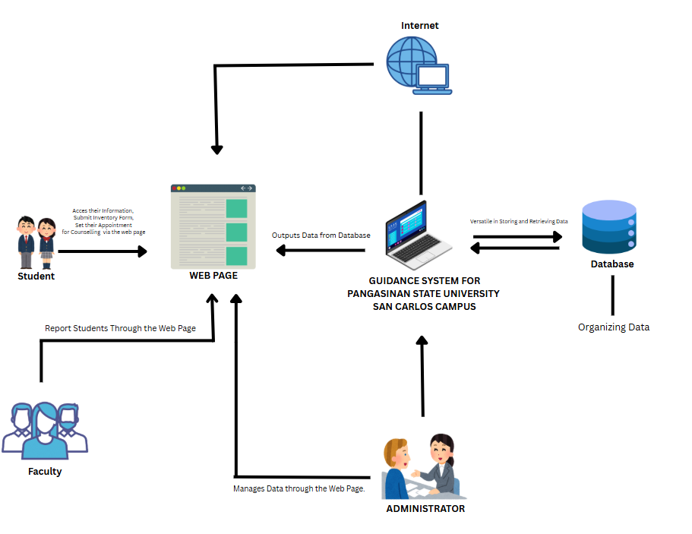
The conceptual framework of this study, as illustrated in the following figure, outlines the structural and functional components of the proposed Guidance System for Pangasinan State University – San Carlos Campus. This framework serves as a visual tool that facilitates a comprehensive understanding of the system’s design and operation. According to Shikalepo (2020), a conceptual framework helps clarify the overall structure of a study and the interrelationships among its key components, thereby guiding both development and analysis. In this study, the framework demonstrates the interaction between users—students, faculty, and administrators—through a centralized, web-based platform. Students utilize the system to access their personal records, submit inventory forms, and schedule appointments for counseling. Faculty members report student concerns through the platform, while administrators are responsible for managing data and maintaining the integrity of the system. At the core is a database that efficiently handles data storage and retrieval, ensuring accurate and timely information access. The web interface acts as the primary medium for input and output operations, enabling seamless interaction between users and the central system. This integrated model enhances the delivery of guidance services through streamlined data management, real-time access, and user-oriented design, as supported by the principles outlined in Shikalepo’s work on educational system frameworks

Figure 2.1. System Map
Figure 2.1 illustrates the conceptual mapping of the capstone project " Web-Based Guidance System for Pangasinan State University San Carlos Campus.” It details the interaction between the system's core components: the administrator, faculty, students, web page, database, and internet.
The presented system architecture illustrates the operational flow of the Guidance System for Pangasinan State University – San Carlos Campus. It delineates the interactions among key users—students, faculty, and administrators—via a centralized, web-based platform. Students access the system through the internet to perform essential tasks such as viewing personal information, submitting inventory forms, and scheduling counseling appointments. Faculty members utilize the platform to report students who may require guidance interventions. Administrators are tasked with managing the system, maintaining data integrity, and ensuring the efficient operation of guidance-related processes through the same interface. At the core of the system is a database that serves as the primary repository for storing and organizing data. It is designed to be highly efficient in both storing and retrieving information, thereby supporting seamless data access and management. The web page functions as the user interface that facilitates input and output operations, enabling real-time interaction with the guidance system.

Chapter 3
METHODOLOGY
This chapter presents the methods and procedures used by the developers in conducting the study. It included the methods, requirement analysis, population and locale of the study, data instrumentation, tools for data analysis, description of the prototype, and the implementation plan, all of which were utilized to solve the problems identified in the study.
3.1 Methods
The methodology refers to the systematic approach employed in conducting research, encompassing the strategies, processes, and tools used in the collection, analysis, and interpretation of data to effectively address research questions and objectives. In this study, the methodology section outlines the structured procedures used to develop and assess the Guidance System for Pangasinan State University San Carlos Campus (PSUSC), ensuring the reliability and validity of outcomes.
To develop the PSUSC Web-Based Guidance System, the Agile methodology was adopted. Agile emphasizes adaptability, user involvement, and iterative development, making it well-suited for systems that must respond to evolving requirements and user feedback. In the context of educational institutions, where guidance services must adapt to student concerns, academic shifts, and institutional goals, Agile provides the flexibility needed for responsive system development.
According to Spiegler et al. (2021), Agile methodologies support continuous refinement through incremental improvements, allowing systems to evolve based on real-time user input and changing organizational needs. This approach minimizes risk and ensures that functional requirements are addressed early in the development process.
In a case study by Martínez-Muñoz et al. (2021), Agile practices were applied to an academic management platform, where the iterative cycles enabled developers to identify usability challenges early and respond with rapid adjustments. Such outcomes are particularly relevant for guidance systems that serve diverse student populations with varying technological proficiency and support needs.
Additionally, Santos et al. (2023) found that Agile enhances cross-functional collaboration and user-centered design, particularly in education-related platforms. Their findings support the use of Agile in projects requiring close coordination between developers, administrators, and end-users—such as guidance counselors and students.
By adopting Agile, the development team was able to maintain continuous user engagement, incorporate feedback during each phase, and prioritize feature delivery based on user needs. This resulted in a more robust, accessible, and effective system, capable of supporting both administrative guidance functions and student services dynamically.

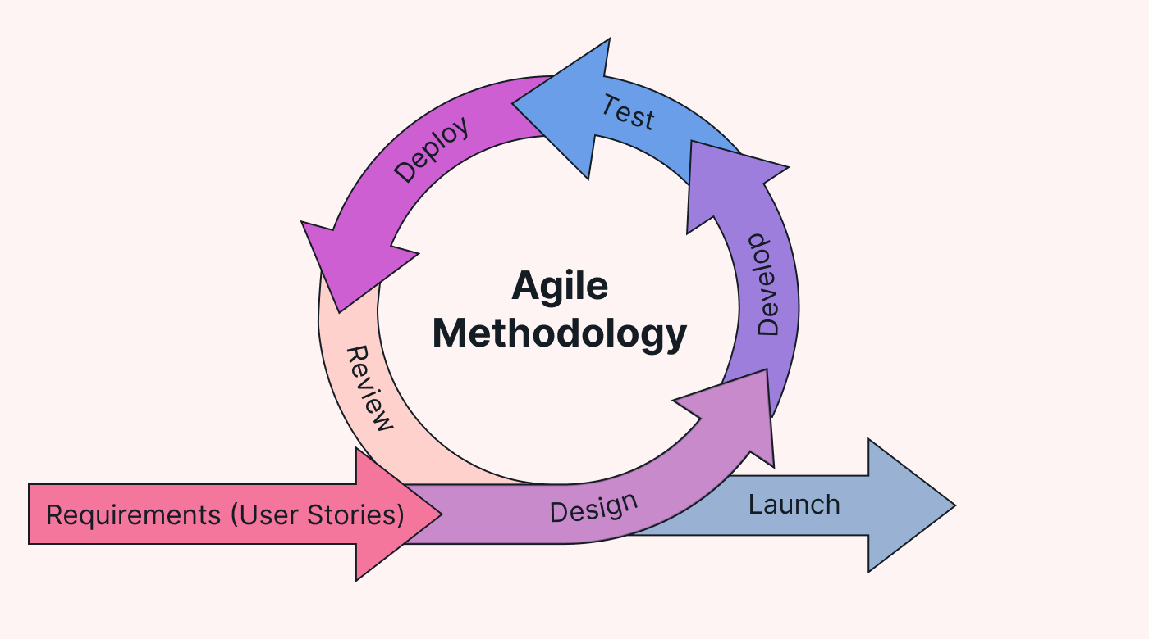

Figure 3.1. Agile Methodology
Figure 3.1 Illustrates the Agile Methodology which emphasizes an iterative and incremental approach to system development. It focuses on continuous planning, development, testing, and feedback, allowing the project team to adapt quickly to changing requirements while ensuring regular delivery of functional system components.
Requirements. In the first phase, requirements gathering is approached through iterative collaboration with stakeholders to ensure the evolving needs of users are captured accurately. For a university guidance system, this adaptability is essential due to the varied and changing academic, psychological, and career concerns of students. Agile facilitates the use of user stories, journey maps, and visual models to translate needs into actionable features. According to Spiegler, Heinecke, and Heine (2021), Agile practices in requirement engineering increase clarity and reduce ambiguity by involving end users continuously, resulting in higher satisfaction and fewer misunderstandings during development. This is particularly beneficial for educational institutions, where inclusivity and responsiveness are critical.
Design. This phase emphasizes early and continuous design iterations, allowing real users—students and counselors in this case—to provide feedback throughout the process. Incorporating User-Centered Design (UCD) principles ensures that the guidance platform is intuitive, accessible, and inclusive for diverse users. As reported by Martínez-Muñoz et al. (2021), integrating UCD within Agile environments enables developers to identify usability issues early, improve design decisions, and build systems aligned with users’ actual needs. This is especially valuable in university settings where technological literacy and access levels vary among users.
Development. Agile’s iterative development approach—delivering software in manageable sprints—fits well with the modular requirements of a university guidance system. Features like chat functions, appointment scheduling, and mental health tracking can be incrementally developed, tested, and refined. Agile encourages collaboration, flexibility, and continuous improvement, reducing risk and improving responsiveness to change. Studies by Santos, da Silva, and Santos (2023) emphasize that Agile development enhances productivity and team performance, particularly when systems are complex and stakeholder needs evolve rapidly—as is common in academic institutions adapting to digital transformation.
Deployment. In Agile, this phase leverages Continuous Integration/Continuous Delivery (CI/CD) to ensure rapid, stable, and reliable updates. For a student-facing guidance system, this minimizes downtime and ensures that critical support services are always available. Frequent deployment cycles also allow for rapid integration of user feedback and timely delivery of improvements. A study by Al-Debagy and Martinek (2021) found that Agile-based deployment models improve software reliability and responsiveness, particularly in educational platforms where real-time updates and bug fixes are essential for uninterrupted service.
Use Case Diagram
A use case diagram provides a graphical overview of a system's functionality by depicting the interactions between external users and the system itself. It defines system behavior from the user’s perspective and helps in capturing system requirements, outlining roles, and clarifying boundaries. This modeling approach plays a crucial role in analyzing how users engage with the system and what actions they can perform (Dennis, Wixom, & Tegarden, 2021).

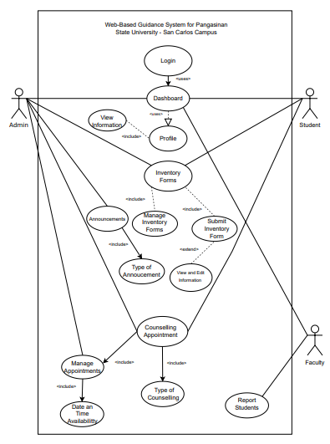

Figure 3.4. Use Case Diagram
According to Dennis, Wixom, and Roth (2022), use case modeling plays a critical role in systems analysis by offering a user-centered perspective that helps define system functionality based on real-world workflows. This ensures that system design aligns with user needs and institutional objectives. In the context of the Web-Based Guidance System for Pangasinan State University San Carlos Campus, the use case diagram presents a clear representation of how different user roles—Admin, Faculty, and Student—interact with the system to carry out guidance-related tasks effectively.
Students utilize the system to log in securely, view their academic and personal information, submit psychological or behavioral inventory forms, schedule counseling appointments, and access announcements relevant to their development and academic life. These features are designed to support a holistic and responsive student guidance experience.
Faculty members interact with the system by logging in to access student profiles and report individuals who may require intervention or support. This feature empowers faculty to act as early informants in the guidance process, promoting timely and relevant responses to student needs.
Administrators, on the other hand, access a broader range of functions. They manage and update student information, view submitted inventory forms, approve and schedule counseling sessions, oversee the counseling process, disseminate announcements, and manage the deployment of guidance-related activities. These capabilities are critical for maintaining a centralized and efficient guidance framework across the campus. The use case diagram effectively illustrates how these interactions support the core objectives of the system: improving the accessibility, organization, and delivery of student guidance services in a digital environment.

3.2 Requirement Analysis
Entity-Relationship Diagram
An Entity-Relationship Diagram (ERD) serves as a fundamental blueprint in database design, providing a structured visual representation of data entities, their attributes, and interrelations. It plays a vital role in defining how data flows and is stored within an information system, thereby ensuring logical data organization, integrity, and efficiency” (Coronel & Morris, 2022).
In the context of the Web-Based Guidance System for Pangasinan State University San Carlos Campus, the ERD illustrates the relationships among core components such as users, appointments, counselors, inventory forms, announcements, and feedback mechanisms. This diagram supports the system’s capacity to manage student records, counseling sessions, psychological assessments, and administrative announcements by clearly delineating how each module interacts with others. Through the use of primary and foreign keys, the ERD maintains data consistency while enabling scalable data processing, which is essential for supporting the dynamic needs of a campus-wide guidance program.

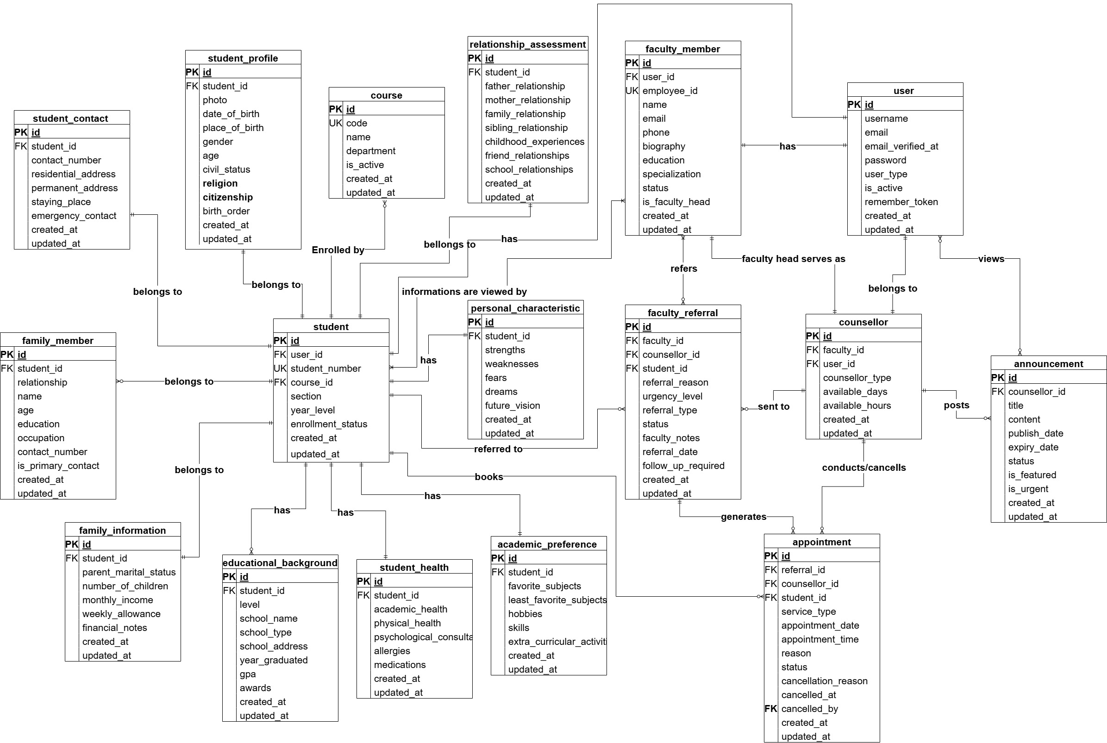

Figure 3.5. Entity-Relationship Diagram
The Entity-Relationship Diagram (ERD) for the Web-Based Guidance System of Pangasinan State University San Carlos Campus presents a comprehensive view of the system’s database architecture. It illustrates how core entities such as users, appointments, counselors, student inventories, announcements, and feedback are interconnected. This diagram plays a vital role in understanding how information is structured, accessed, and maintained across different system modules. It ensures that all relationships between data points are clearly defined, allowing for efficient data handling, integrity, and streamlined system operations. The ERD serves as the foundation for building a robust database that supports the guidance office’s functions in managing student records, appointments, counseling notes, and institutional communications.
Data Dictionary
A data dictionary serves as a centralized repository that systematically documents data elements, detailing their definitions, relationships, sources, formats, and intended uses. It ensures consistency and clarity in how data is interpreted and managed across an organization (Coronel & Morris, 2019). Similarly, Rob and Coronel (2007) emphasize that a data dictionary helps maintain data integrity by acting as a reference for understanding and standardizing data across systems.
Table 3.1 Stores all official announcements within the system. Each announcement includes a title, body content, target audience, and metadata such as publication date, expiry, status (e.g., draft, active), whether it is featured, and view counts.
Table 3.1 Announcements
Field Name | Data Type | Size | Description
id | bigint | 20 | Unique identifier
category_id | bigint | 20 | FK to announcement_categories.id
title | varchar | 255 | Title of the announcement
content | text |  | Body of the announcement
target_audience | varchar | 255 | Intended audience
publish_date | datetime |  | Date to publish
expiry_date | datetime |  | Date of expiry
status | enum | ('draft','scheduled'  ,'active','expired') | Status of the announcement
Table 3.1.1 Manages file attachments linked to announcements. It includes system-generated and original filenames, file types, sizes, and creation timestamps.
Table 3.1.1 Announcement_Attachments
Column | Type | Null | Default | Links to
id | bigint(20) UNSIGNED | No | auto_increment
announcement_id | bigint(20) UNSIGNED | No |  | announcements.id
filename | varchar(255) | No
original_filename | varchar(255) | No
file_type | varchar(255) | No
file_size | varchar(255) | No
created_at | timestamp | Yes | NULL
updated_at | timestamp | Yes | NULL

Table 3.1.2 Contains classification details for announcements, including name, description, visual elements (icons and colors), and an active status flag for enabling/disabling categories.
Table 3.1.2 Announcement_Categories
Column | Type | Null | Default
id | bigint(20) UNSIGNED | No | auto_increment
name | varchar(255) | No
description | text | Yes | NULL
icon | varchar(255) | No | fa-bullhorn
color | varchar(255) | No | #0d6efd
is_active | tinyint(1) | No | 1

Table 3.2 Logs appointments between students and counselors, capturing the type of service (academic, career, personal), appointment schedule, reason, status, and cancellation details
Table 3.2 Appointments
Column | Type | Null | Default | Links to
id | bigint(20) UNSIGNED | No | auto_  increment
student_id | bigint(20) UNSIGNED | No |  | users.id
counsellor_id | bigint(20) UNSIGNED | No |  | counsellors.id
service_type | enum('academic', 'career', 'personal') | No
appointment_date | date | No
appointment_time | time | No
reason | text | No
status | varchar (20) | No | pending
cancellation_reason | text | Yes | NULL
cancelled_at | timestamp | Yes | NULL
cancelled_by | bigint(20) UNSIGNED | Yes | NULL | users.id
created_at | timestamp | Yes | NULL
updated_at | timestamp | Yes | NULL

Table 3.3 Serves as a temporary storage for key-value data used to enhance performance. Each entry includes an expiration time.
3.3 Cache
Column | Type | Attributes | Null
key | varchar(255) |  | No
value | mediumtext |  | No

Table 3.3.1 Handles locking mechanisms for cache keys to manage concurrent data access and ensure consistency.
Table 3.3.1 Cache_locks
Column | Type | Attributes | Null
key | varchar(255) |  | No
owner | varchar(255) |  | No
expiration | int(11) |  | No

Table 3.4 maintains profiles of counselors, including contact information, specialization areas, educational background, biography, availability, and system activity status.
Table 3.4 Counsellors
Column | Type | Attributes | Null
Id | bigint(20) | UNSIGNED | No
name | varchar(255) |  | No
email | varchar(255) |  | No
phone | varchar(255) |  | Yes
specialization | varchar(255) |  | No
expertise1 | varchar(255) |  | No
expertise2 | varchar(255) |  | No
expertise3 | varchar(255) |  | Yes
biography | text |  | Yes
education | text |  | Yes
specializations | text |  | Yes
available_days | varchar(255) |  | No
available_hours | varchar(255) |  | Yes
profile_photo | varchar(255) |  | Yes
Table 3.6 tracks all database migrations applied to the system, helping maintain versioning and rollback functionality.
Column | Type | Attributes | Null | Extra
id | int(10) | UNSIGNED | No | auto_increment
migration | varchar(255) |  | No
batch | int(11) |  | No
Table 3.6 Migration

Table 3.7 contains extensive data on individual students, such as personal, academic, family, financial, health, and psychosocial information. It supports student profiling for counseling and academic services.
Table 3.7 Student_Inventories
Column | Type | Attributes | Null | Default
id | bigint(20) | UNSIGNED | No
form_id | varchar(255) |  | No
student_number | varchar(255) |  | Yes | NULL
photo | varchar(255) |  | Yes | NULL
full_name | varchar(255) |  | No
course | varchar(255) |  | No
year_level | varchar(255) |  | No
date_of_birth | date |  | No
place_of_birth | varchar(255) |  | Yes | NULL
gender | varchar(255) |  | No
age | int(11) |  | Yes | NULL
civil_status | varchar(255) |  | No
religion | varchar(255) |  | Yes | NULL
citizenship | varchar(255) |  | Yes | NULL
contact_number | varchar(255) |  | Yes | NULL
residential_address | varchar(255) |  | Yes | NULL
permanent_address | varchar(255) |  | Yes | NULL
email | varchar(255) |  | Yes | NULL
staying_place | text |  | No
high_school_name | varchar(255) |  | Yes | NULL
high_school_type | varchar(255) |  | No
previous_school_address | varchar(255) |  | Yes | NULL
year_graduated | varchar(255) |  | Yes | NULL
high_school_gpa | varchar(255) |  | Yes | NULL
awards | text |  | Yes | NULL
previous_college_name | varchar(255) |  | Yes | NULL
father_name | varchar(255) |  | Yes | NULL
father_education | varchar(255) |  | Yes | NULL
father_occupation | varchar(255) |  | Yes | NULL
father_age | int(11) |  | Yes | NULL
mother_name | varchar(255) |  | Yes | NULL
mother_education | varchar(255) |  | Yes | NULL
mother_occupation | varchar(255) |  | Yes | NULL
mother_age | int(11) |  | Yes | NULL
guardian_name | varchar(255) |  | Yes | NULL
guardian_relationship | varchar(255) |  | Yes | NULL
guardian_occupation | varchar(255) |  | Yes | NULL
guardian_contact | varchar(255) |  | Yes | NULL
parent_marital_status | varchar(255) |  | Yes | NULL
Table 3.8 manages system users including admins, faculty, and students. It stores login credentials, email verification status, user roles, and activation states.
Column | Type | Attributes | Null | Default | Extra
id | bigint(20) | UNSIGNED | No |  | auto_  increment
name | varchar(255) |  | No
email | varchar(255) |  | No
email_address | varchar(255) |  | Yes | NULL
email_verified_at | timestamp |  | Yes | NULL
password | varchar (255) |  | No
user_type | enum('admin', 'faculty', 'student') |  | No | student
is_active | tinyint(1) |  | No | 1
remember_token | varchar (100) |  | Yes | NULL
created_at | timestamp |  | Yes | NULL
updated_at | timestamp |  | Yes | NULL
Table 3.8 Users

3.2.1 Population and locale of the study
In this section, the developers outlined the population and locale relevant to the capstone project. This overview provided a clear context for the study, focusing on the demographic and geographical settings involved in the research.
Research Locale. This study was conducted at Pangasinan State University – San Carlos Campus, specifically focusing on the Guidance Office and involving students, employees’, and administrative staff from various departments. The researchers selected this location because it is directly related to their academic community and allows convenient access to the intended users of the guidance system. The San Carlos Campus was chosen due to observable challenges in delivering timely and effective student guidance services, including the manual processing of counseling schedules, limited tracking of student concerns, and inefficient dissemination of announcements. These existing gaps in the guidance process made the campus an ideal environment to implement and evaluate the effectiveness, usability, and impact of the Web-Based Guidance System in enhancing institutional support for student well-being and academic development.
Respondents of the Study. The respondents of this study were composed of selected users from Pangasinan State University – San Carlos Campus who were directly involved in the usage, evaluation, and administration of the proposed Web-Based Guidance System. To determine an appropriate number of participants, the researchers applied Slovin’s Formula with a 10% margin of error. This formula is commonly used to calculate a representative sample size when the total population is known and random sampling is intended. Using this approach, the computed sample size indicated that a minimum of 45 respondents would be adequate to provide reliable and meaningful insights regarding the system’s functionality, usability, and acceptability.
The final sample consisted of 45 respondents, distributed across three key user groups essential for evaluating the system comprehensively. The sample included one (1) administrator, representing 2% of the total respondents. The administrator’s perspective was vital since this role oversees the overall guidance operations and ensures proper implementation of institutional processes within the system.
Furthermore, three (3) college deans, accounting for 7%, also participated in the study. Their inclusion was significant as they possess administrative responsibilities and are actively engaged in monitoring student concerns, academic performance, and welfare-related matters that may require guidance interventions.
The largest portion of the respondents consisted of forty-one (41) students, making up 89% of the sample. Since students are the primary users of the guidance system, their feedback was essential in assessing system usability, accessibility, and overall user experience. Their participation provided firsthand insights into how effectively the system addressed their needs in scheduling appointments, accessing guidance services, and communicating with office personnel.
By incorporating multiple user groups and determining the sample size through Slovin’s Formula, the study ensured that the evaluation captured a balanced and representative set of perspectives. This approach strengthened the reliability of the findings and contributed to a more holistic assessment of the Web-Based Guidance System for Pangasinan State University – San Carlos Campus.

3.2.2 Data Instrumentation
This section describes the data collection methods utilized in the development of the Web-Based Guidance System for Pangasinan State University San Carlos Campus (PSUSC). These instruments were selected to ensure the reliability and validity of the findings, which were crucial in shaping the system’s functionality and relevance to user needs.
Focus Groups: Focus group discussions were organized with student representatives and guidance staff to gather qualitative data regarding their expectations and experiences with the current guidance services. This approach enabled developers to understand common concerns and preferences, which helped refine system features such as appointment scheduling, consultation tracking, and feedback mechanisms. According to Diluvi et al. (2023), focus groups provide flexible and rich insights that are particularly effective for gathering feedback in educational technology development, even in digital environment.
Internet Research: Internet-based research was employed to examine recent trends, user interface designs, and functional models of existing web-based guidance systems implemented in other academic institutions. This benchmarking activity helped identify best practices in providing digital mental health services, student engagement tools, and remote counseling features. Morales et al. (2021) emphasized the growing necessity of virtual guidance systems in higher education institutions, especially during and post-pandemic, to address accessibility and student well-being needs through technology-driven approaches.
Semi-Structured Interviews: Semi-structured interviews were conducted with university counselors, IT staff, and selected student users to delve deeper into their operational needs and technological expectations. This method allowed the developers to ask core questions while also exploring specific challenges or feedback shared by the participants. Ruslin et al. (2022) argued that semi-structured interviews offer a balance between consistency and flexibility, which makes them suitable for educational system research where adaptive questioning leads to more insightful findings.
3.3 Tools for Data Analysis
Statistical Tools
The data gathered from the questionnaire is scaled using the Likert Scale, and this data is used to calculate the weighted average mean. The computed average is utilized to determine whether the system meets the expectations of the stakeholders or requires improvement. The formulas and tables below present the computations, scales, and range of each mean derived from the respondents.
The table displays the feedback of the users in terms of suitability for the task, self-descriptiveness, controllability, conformity with user expectations, error tolerance, and accessibility.
The mathematical formula for the weighted average mean was as follows:
$$W_{\left(ave\right)}=\frac{\sum_{i=1}^{n}{\left(W_{i} \right) X X_{i}}}{\sum_{i=1}^{n}{W_{i}}}$$
Where:
$n$ – represented the total number of points
$W_{i}$ – represented the weight assigned to each value
$X_{i}$ - represented each individual value
The developers use the weighted arithmetic mean to determine the average response for each item of the five options in the questionnaire, namely: 5 (Strongly Acceptable), 4 (Acceptable), 3 (Moderately Acceptable), 2 (Unacceptable), and 1 (Strongly Unacceptable).
Table 3.8 presents the scales use in determining the calculation of the expected feedback of the respondents.
Table 3.8. Scales and Points of the Questionnaire Survey
Scale | Points
Strongly Acceptable | 5
Acceptable | 4
Moderately Acceptable | 3
Unacceptable | 2
Strongly Unacceptable | 1

Table 3.9 shows the range of the weighted mean that was derived from the survey results along with its interpretation.
Table 3.9. Range of the Weighted Mean and its Interpretation
Range of Weighted Mean | Interpretation
4.21 – 5.00 | The responder is Strongly Acceptable with the system’s overall result.
3.41 – 4.20 | The responder is Acceptable with the system’s overall result.
2.61 – 3.40 | The responder is Moderately Acceptable with the system’s overall result.
1.81 – 2.60 | The responder is Unacceptable with the system’s overall result.
1.00 – 1.80 | The responder is Strongly Unacceptable with the system’s overall result.

3.4 Description of the Prototype
In this section, the prototype of the Web-Based Guidance System for Pangasinan State University San Carlos Campus is presented. This system is developed to enhance the administrative and guidance management processes by providing a centralized, accessible, and user-friendly digital platform. It is designed to streamline interactions between administrators, faculty, and students by offering core functionalities such as student information management, schedule tracking, and automated notifications. The system allows administrators and faculty to manage student records, publish announcements, and oversee training and assessment activities, while students can access their accounts to view personal profiles, class schedules, and important updates.
To visualize the system's operational flow and communication architecture, a network diagram is utilized. This diagram illustrates how users (admin, faculty, and students) interact with the system via smartphones and laptops through the internet, which connects to the web server and central database. The web server processes requests and communicates with the backend database to retrieve or store data, ensuring real-time performance and data integrity. Such visualization is critical in understanding the infrastructure of the web-based system, particularly in academic institutions where multiple stakeholders must interact with shared information systems.
According to Scott (2020), network diagrams are instrumental in system development as they help organizations clearly understand the components and data flow within a networked environment, identify potential inefficiencies, and facilitate better decision-making during deployment. Applying this concept to the Pangasinan State University San Carlos Campus, the network diagram ensures the clarity of system architecture, supporting the reliable and efficient implementation of the Web-Based Guidance System.

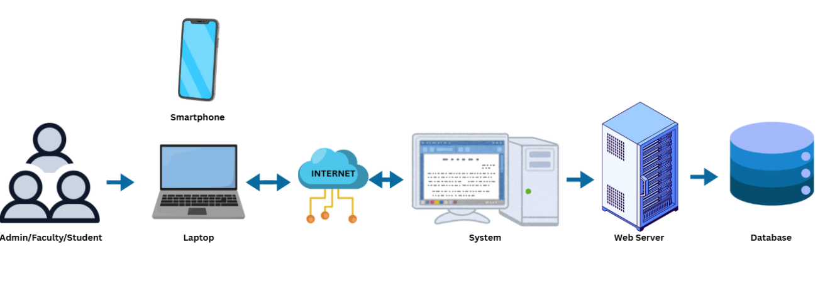
Figure 3.6. Network Diagram
The network diagram illustrates the architecture of the Web-Based Educational Information Management Support System for Pangasinan State University San Carlos Campus. It outlines the interaction between users (administrators, faculty, and students) and system components through internet-enabled devices such as laptops and smartphones. These devices connect to the system via the internet, allowing remote access to academic and administrative services. The system is hosted on a web server, which manages user requests and application processes. A centralized database supports the backend by storing essential data, including user profiles, schedules, and records. This client-server architecture ensures secure, scalable, and efficient system operations by separating the user interface from data management functions. Overall, the diagram represents a streamlined, accessible, and responsive system infrastructure designed to enhance institutional processes and user experience across the university.
3.5 The Proposed Implementation Plan
In this section, the developers present the proposed implementation plan for the Guidance System designed for Pangasinan State University – San Carlos Campus. This plan outlines a structured and systematic approach to deployment, ensuring that each phase—from initial planning to full operational use—is executed efficiently and effectively.
The primary goal of this study is to implement a web-based Guidance System that addresses the specific needs of the PSU–SCC Guidance Office. The system's features and content are designed to be flexible and responsive to the requirements of its users, including students, counselors, and administrative staff.
Initial stages of development involved conducting interviews and consultations with key stakeholders to gain a comprehensive understanding of the existing challenges and functional demands within the Guidance Office. These insights were analyzed to determine essential system requirements and to prioritize the development of features that directly support academic counseling, student tracking, and appointment management. This informed the design phase, where the development team worked collaboratively with stakeholders to produce an intuitive user interface and a stable system architecture.
The system was then developed with a focus on core functionalities such as secure user authentication, appointment scheduling, digital record-keeping for counseling sessions, and automated notifications for upcoming meetings and follow-ups. An iterative development approach was employed, involving regular feedback loops and refinements to ensure the system aligns with the operational workflows of the Guidance Office. Once testing was completed, the system was deployed in a live environment.
Table 3.10 presents the Implementation Plan of the Guidance System, outlining the key strategies, corresponding activities, personnel involved, and the duration required for each phase—from securing approval and system installation to information dissemination and user training—ensuring an organized and systematic deployment of the system at PSU–SCC.
Table 3.10. Implementation Plan
Strategies | Activities | Personnel Involved | Duration
Approval from the head of PSUSC Guidance Office- Counselor | Letter of Approval from the Researchers | Researchers, Head Counselor | 1 Day
System’s Implementation | Installation of the system and required software and hardware | Researchers, Head Counselor, Team Members | 5 Hours
Information Distribution | System Manuals | Researchers, Team Members | 1 Day
3 Days Training | Training and Lectures of System Users | Researchers, Administrators, Team Members | 3 Days

Chapter 4
RESULTS AND DISCUSSION
This chapter presented the results and discussion of the proposed solution, addressing user requirements, functional and non-functional specifications, as well as the technologies, hardware, and software used. Key findings and system performance analyses were discussed, highlighting how the solution met its objectives and providing an evaluation of its effectiveness and areas for improvement.
4.1 User Requirements
This section presents the user requirements for the Web-Based Guidance System for Pangasinan State University San Carlos Campus, focusing on the needs of students, employees, and administrators. Students needed features that allowed them to access forms, set appointments, view announcements, request certificates, and receive referrals. Employees required tools to assist with managing student needs and accessing system resources. Administrators needed capabilities to oversee accounts, appointments, inventory forms, announcements, and document requests to maintain organized and efficient guidance services.
For students, the system offered essential functions for managing their interactions with the Guidance Office. They could schedule appointments, access and request important documents such as psychological test certificates and good moral certificates, view announcements, submit necessary forms, and receive referrals when needed. The platform also supported smooth communication with employees or admins for concerns or assistance.
Employees, who support the operations of the Guidance Office, needed tools that allowed them to manage student interactions, process form requests, view schedules, and assist in maintaining records. Their role included coordinating with admins and helping ensure that student needs were handled promptly.
Administrators required comprehensive tools to manage the system’s operations. They could create, update, or remove user accounts; approve or decline appointments; oversee inventory forms; release or process certificate requests; and publish announcements. Admins were also responsible for reviewing student referrals and maintaining records to ensure accurate documentation and quality service delivery.
4.2 Technical Solutions
Technical solutions referred to the strategies, methods, and processes implemented to address the functional and non-functional requirements of the system. These solutions defined how technologies were applied to solve problems, optimize performance, and meet user needs effectively. In developing Web-Based Guidance System for Pangasinan State University San Carlos Campus, the technical solutions were designed to ensure scalability, security, and usability while maintaining system efficiency and delivering a seamless user experience.
The system architecture employed a client-server model, which separated the front-end user interface from the back-end infrastructure. This architecture ensured that the user-facing application remained lightweight and responsive while delegating complex processing tasks to the server. By isolating responsibilities, the system became easier to manage, maintain, and scale as user demand grew. This design supported future enhancements without requiring significant changes to the core infrastructure, making it a robust choice for long-term use.
JavaScript was selected as the programming language for both the front-end and back-end development, ensuring consistency across the development stack. This uniformity reduced the learning curve for developers, streamlined debugging, and accelerated feature development. The back-end leveraged Node.js, a runtime environment well-suited for real-time, event-driven applications. Node.js efficiently handled asynchronous operations and concurrent connections, which were critical for managing multiple appointment bookings without performance bottlenecks. By using JavaScript and Node.js, the system remained agile, adaptable, and capable of supporting real-time user interactions.
To handle data storage and retrieval, MongoDB was chosen as the database solution. Unlike traditional relational databases, MongoDB, as a NoSQL database, offered flexibility in managing dynamic and unstructured data. This capability was particularly important for the appointment booking system, where data structures evolved as new features were added. MongoDB’s ability to scale horizontally ensured that as the number of users and appointments increased, system performance remained unaffected. Additionally, its fast query performance reduced latency, providing a smoother experience for users accessing and managing their appointments.
The integration of RESTful APIs facilitated standardized and efficient communication between system components. RESTful APIs adhered to HTTP protocols, making them lightweight and platform-independent. This ensured secure and reliable data exchange between the front-end, back-end, and database, enabling smooth system functionality. Furthermore, the RESTful architecture allowed for seamless integration with third-party tools or future system enhancements, ensuring the system remained adaptable to changing business requirements.
Security was a key consideration for the system, which managed sensitive user data. To address this, JSON Web Tokens (JWT) were implemented for user authentication. JWT provided a secure mechanism for managing user sessions and ensuring that only authorized users could access the system. By using tokens for authentication, the system reduced vulnerabilities to common security threats such as session hijacking. JWT's stateless nature also improved system performance by eliminating the need to store session data on the server, which was particularly useful for scaling the application.
The system was deployed on Vercel, a cloud hosting platform known for its reliability, scalability, and developer-friendly features. Vercel provided automated deployment, continuous integration, and serverless capabilities, which ensured that updates could be released quickly without disrupting system operations. Its ability to scale infrastructure based on user demand guaranteed consistent performance even during peak usage periods. Vercel’s robust infrastructure also enhanced system uptime, ensuring that the appointment booking system remained accessible and reliable at all times.
Testing played a crucial role in ensuring the stability and functionality of the system. Postman was used to rigorously test API endpoints and interactions between system components. By simulating real-world usage scenarios, Postman helped identify issues early in the development process, reducing the risk of errors in production. This testing approach ensured that the system delivered consistent and reliable performance, even under varying workloads.
Version control and collaboration were managed using GitHub, a widely adopted platform that enabled developers to track changes, manage code versions, and collaborate effectively. GitHub’s branching and merging capabilities ensured that updates and new features could be developed, tested, and integrated without disrupting the core system. This approach enhanced code quality, reduced errors, and allowed multiple developers to work on the project simultaneously, ensuring a streamlined and efficient development process.
4.3 Technology Used
Technology played an essential role in the development of the Web-Based Guidance System for Pangasinan State University San Carlos Campus. Selecting the right tools, programming languages, and platforms was crucial in ensuring that the system became reliable, scalable, and capable of meeting user needs. According to Almarabeh (2020), the appropriate choice of technology greatly influences a system’s performance, usability, and ability to support institutional processes effectively. In this project, the technologies used served as the core foundation for building features such as appointment scheduling, form requests, announcements, and referrals, ensuring that the system operates efficiently and provides a smooth experience for students, employees, and administrators.
The system was developed using JavaScript as the core programming language, with Express.js as the back-end framework. JavaScript is a versatile and widely adopted programming language that facilitated development consistency between the front-end and back-end. Express.js, a lightweight Node.js framework, simplified server-side development by providing efficient routing, middleware integration, and organized API management. This combination allowed the system to process requests quickly, ensuring smooth operations and faster response times.
For real-time communication, WebSocket was implemented to enable two-way interaction between the client and server. WebSocket facilitated dynamic features such as live notifications and instant appointment updates without requiring users to manually refresh their pages. This technology significantly enhanced user experience by ensuring that all updates and changes were reflected in real-time, improving the system's responsiveness and interactivity.
MongoDB, a NoSQL database, was used for data storage and management. Unlike traditional relational databases, MongoDB supported dynamic and flexible data structures, making it ideal for handling evolving appointment schedules, user profiles, and system logs. Its schema-less design allowed for fast data retrieval and ensured scalability as the system grew. By leveraging MongoDB, the system was able to maintain consistent performance even as the volume of data increased.
The system was deployed on Vercel, a cloud-based platform known for its reliability and scalability. Vercel provided automated deployment, serverless functions, and continuous integration, which streamlined the development workflow and ensured that updates could be pushed with minimal downtime. This hosting solution guaranteed fast system performance and high availability, even under increasing user demands.
Visual Studio Code served as the primary code editor during development, offering essential tools such as debugging support, extension capabilities, and syntax highlighting. These features enhanced developer productivity and code quality. Version control and collaboration were managed using GitHub, which allowed the team to track changes, manage code versions, and collaborate efficiently. By leveraging GitHub, the team ensured systematic project management, reducing errors and facilitating seamless teamwork throughout the development lifecycle.
Postman was used for testing and validating APIs to ensure proper communication between the client-side and server-side components. By simulating various usage scenarios, Postman allowed the team to identify and address potential issues early, ensuring that all APIs functioned reliably under different conditions. This rigorous testing process contributed to the system’s stability and smooth operation.

4.4 Hardware and Software Requirements
This section described the hardware and software requirements essential for the development and operation of Web-Based Guidance System for Pangasinan State University San Carlos Campus. It highlighted the necessary specifications to ensure optimal performance, efficient data management, and seamless user experience.
Hardware Requirements
To ensure the efficient development, deployment, and operation of the Web-Based Guidance System for Pangasinan State University San Carlos Campus, the following hardware specifications were recommended for both system development and user interaction. These requirements were designed to provide an optimal user experience and ensure smooth performance.
Table 4.1 illustrates the hardware specifications that ensured the system operated effectively, efficiently, and reliably under demanding conditions during both the development and operational phases. These specifications supported smooth system execution, faster data processing, minimal performance interruptions, and an overall consistent user experience necessary for the successful implementation and continuous operation of the system.
Table 4.1. Hardware Requirements for the System Development and Deployment
Hardware | Specifications
Display | Minimum 1920 x 1080 resolution
Processor | AMD Ryzen 5 5600G or Intel Core i5 (11th Gen)
Storage | 512GB SSD or 256GB NVMe for high-speed performance
Memory (RAM) | 8GB minimum
Graphics Processing Unit (GPU) | Integrated or dedicated, with at least 2GB memory
Peripherals | USB or wireless mouse and keyboard

Display: The system required a display with a minimum resolution of 1920 x 1080 to provide a clear and accessible interface for both administrators and clients. A high-resolution screen ensured that system elements such as forms, reports, and appointment dashboards were visually clear and easy to interact with. A quality display enhanced user engagement by offering a seamless and intuitive visual experience.
Processor: A robust processor such as the AMD Ryzen 5 5600G or Intel Core i5 11th Gen was essential for handling system processes. These processors efficiently executed the logical and computational tasks required for real-time data processing, user interactions, and secure system operations. The processor ensured that the platform could manage multiple users and concurrent operations without performance degradation.
Storage: The system relied on high-speed storage solutions, with a minimum of 256GB NVMe or 512GB SSD recommended. These storage options allowed for quick data retrieval and application responsiveness. They also supported the storage of client data, appointment schedules, and system logs securely and reliably, ensuring smooth operational functionality.
Memory (RAM): A minimum of 8GB RAM was required to allow for efficient multitasking, system responsiveness, and the handling of resource-intensive tasks such as generating reports and processing real-time notifications. Adequate memory ensured that the system operated smoothly, even during peak usage.
Graphics Processing Unit (GPU): A GPU with at least 2GB of memory, either integrated or dedicated, was recommended to handle graphical interfaces, especially for admin dashboards or client portals that included visual elements like charts or appointment overviews. The GPU improved the rendering of graphics, ensuring a polished and professional look for all system users.
Peripherals: Administrators required reliable input devices, such as a USB or wireless mouse and keyboard, for efficient navigation and interaction with the system. These peripherals ensured that users could manage tasks like data entry and system configuration with ease.
Software Requirements
A Software Requirements Specification (SRS) was a detailed description of the intended purpose and operational environment for the software being developed. The SRS outlined the system's functionalities and expected performance. Below were the software requirements for the Web-Based Guidance System for Pangasinan State University San Carlos Campus.
Table 4.2 illustrates the software requirements used in the system development, specifying the operating system, database management system, and development tools necessary to support efficient system design, implementation, and maintenance.

Table 4.2. Software Requirements for the System Development
Software | Specifications
Operating System | Windows 11 x64
Database Management | MongoDB
Development Tool | Visual Studio Code

Operating System: Windows 11 x64 was the foundational software that enabled the system to interact with hardware and other applications. Known for its modern interface, robust performance, and enhanced security features, Windows 11 x64 was user-friendly and provided a stable platform for software development and deployment. Its compatibility with various development tools and libraries ensured that developers and administrators could work efficiently.
Database Management: MongoDB, a modern NoSQL database management system, was used for organizing, storing, and retrieving data efficiently. MongoDB’s flexible, document-based structure was ideal for managing dynamic data like appointments, client records, and system logs. Its scalability and high performance made it suitable for handling large volumes of data while maintaining real-time processing capabilities. MongoDB ensured secure, reliable data management throughout its lifecycle.
Development Tool: Visual Studio Code was a lightweight and powerful source code editor utilized for software development. It offered features such as debugging, task management, and version control integration, enabling efficient and effective coding. Visual Studio Code’s extensive plugin ecosystem supported a wide range of programming languages and frameworks, making it a versatile choice for building robust and user-friendly systems.
Findings and Analysis of the System
This section presented the findings and analysis of the system, including an evaluation of the proposed computer-based solution for Web-Based Guidance System for Pangasinan State University San Carlos Campus. It provided a detailed assessment of how the system processed user interactions, managed data, and ensured functionality to effectively meet user requirements.
4.5 Proposed Process for the Developed System as a Solution to the Existing Process of Web-Based Guidance System for Pangasinan State University San Carlos Campus
A Data Flow Diagram (DFD) was a visual representation used to model the flow of data within a system, showing how inputs were processed and transformed into outputs through various processes and data stores. DFDs were a widely used tool in system analysis and design, helping to identify, understand, and document the data interactions between users, processes, and databases within a system. According to Dennis, Wixom, and Tegarden (2020), DFDs provided a high-level abstraction that simplified complex system workflows, allowing developers and stakeholders to visualize how information moved and transformed across different components of a system.
In the context of Web-Based Guidance System for Pangasinan State University San Carlos Campus, the DFD served as a key tool to map and understand the system's data interactions. It visually represented the processes involved in client bookings, admin approvals, and overall data management, ensuring that the data flowed seamlessly and efficiently throughout the system. Key data processes included client input for booking requests, availability checks, confirmation processing, and notification delivery, as well as administrative tasks such as reviewing appointments, updating booking statuses, and managing client information. This was particularly important for identifying potential inefficiencies, redundancies, or errors in the workflow, which were addressed during the design phase. For example, the DFD helped pinpoint delays in availability validation and ensured that real-time updates were prioritized to provide instant responses to users. It also highlighted areas where automated reminders and notifications could be incorporated to reduce manual intervention and enhance efficiency.
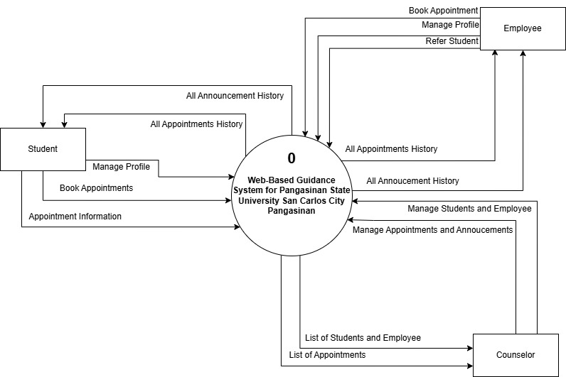
Figure 4.1. Level 0 Data Flow Diagram (Context Diagram)
Figure 4.1 presents an overall view of how users interact with the Web-Based Guidance System for Pangasinan State University San Carlos Campus, showing the major flow of information between the system, students, employees, and administrators. Students interact with the system by submitting appointment requests, accessing available services, requesting forms, and receiving updates or results related to their transactions. They can view available schedules, confirm appointments, retrieve processed documents, and keep track of their previous requests, helping them stay informed and organized throughout their interactions with the Guidance Office.
Employees use the system to assist in managing student requests and maintaining guidance records. They receive appointment details, form requests, and referral information, allowing them to help process student needs efficiently. Meanwhile, administrators oversee the overall operation of the system. They manage user accounts, review all appointment activities, process or release requested documents, and resolve any scheduling or operational conflicts. Administrators also monitor system activity to ensure smooth operations and support better planning and resource allocation within the Guidance Office.
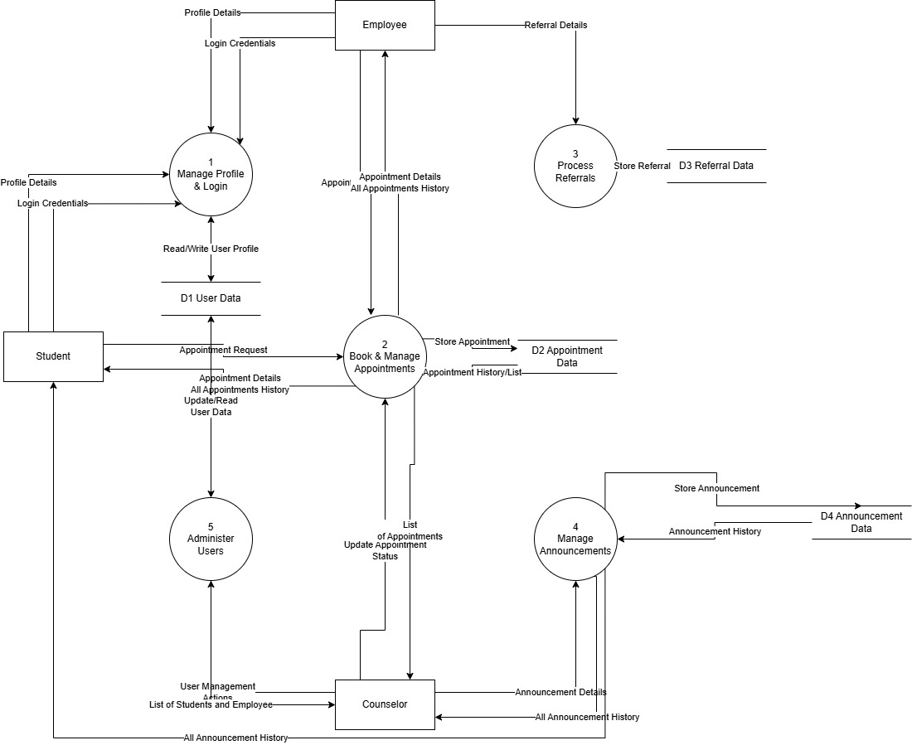
Figure 4.2. Level 1 Data Flow Diagram
Figure 4.2 shows the Level 1 Data Flow Diagram provides a clearer view of how the Guidance Office System handles the movement of information between students, counselors, and administrators. It breaks down the major processes—such as managing profiles, booking appointments, processing referrals, administering user accounts, and posting announcements—and shows how data travels through each step. The workflow begins when a student logs in, where their profile and login credentials are verified before they can submit appointment requests. These appointment details are then processed, stored, and forwarded to counselors for review. Once reviewed, counselors update the appointment's status, which is reflected in the student’s appointment history. These announcements are distributed to the appropriate users and recorded for history tracking. Administrative tasks—such as updating user information or managing lists of students and employees—ensure that the system remains accurate and up-to-date.
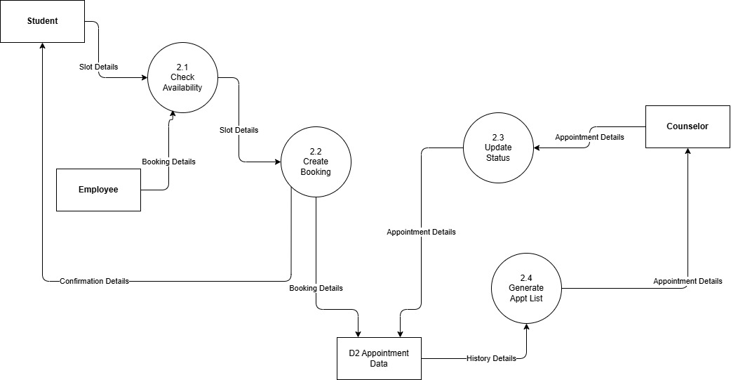
Figure 4.3. Level 2 Data Flow Diagram (Explosion of Process 2)
Figure 4.3 shows the Level 2 Data Flow Diagram illustrates the specific steps involved in handling appointment bookings within the Guidance Office System. The process begins when a student requests a slot, prompting the system to check the availability of the chosen schedule. Once the system verifies that the selected time is open, the booking process continues with the creation of the appointment record, where all necessary details are stored in the appointment database. After the booking is saved, the system updates the appointment status to reflect any changes made by the counselor, such as approval or modification of the schedule. The system then generates an updated list of appointments, allowing counselors to review appointment histories and current bookings. Overall, this breakdown provides a clearer view of how appointment requests move through the system—from slot checking to booking, updating, and listing—ensuring an organized and efficient workflow for both students and counselors.
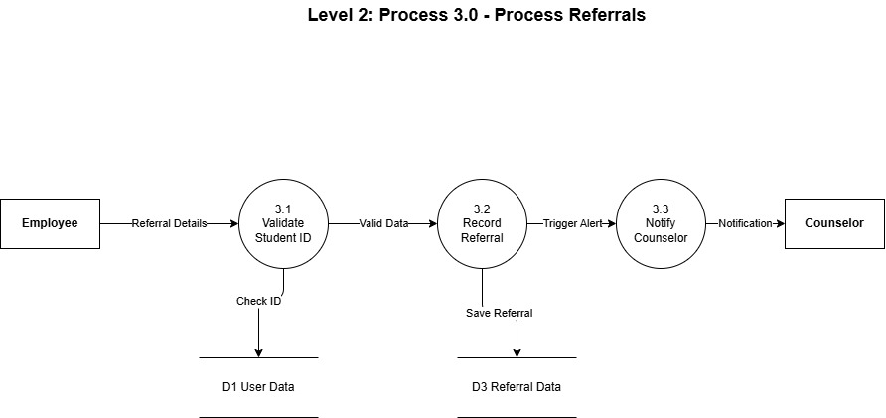
Figure 4.4. Level 2 Data Flow Diagram (Explosion of Process 3)
Figure 4.4 shows the Level 3 Data Flow Diagram, which details the referral process in the Guidance Office System, illustrates the step-by-step workflow followed when an employee submits a student referral. The process begins with the validation of the student’s ID (3.1), where the system checks the existing user database to ensure that the student being referred is registered and eligible for evaluation. Once the ID is confirmed as valid, the system proceeds to record the referral (3.2), storing the referral information in the referral database for documentation and future reference. After successfully saving the referral data, the system automatically triggers a notification to the assigned counselor (3.3), ensuring that they are promptly informed about the new referral request. This structured flow demonstrates how the system handles referrals efficiently—from verification to documentation and counselor notification—ensuring accuracy, accountability, and timely intervention for students who require guidance services.
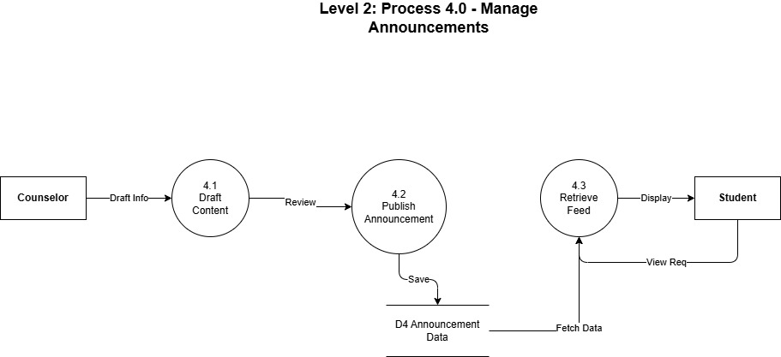

Figure 4.5. Level 2 Data Flow Diagram (Explosion of Process 4)
Figure 4.5 presents the Level 3 Data Flow Diagram (presents the step-by-step workflow involved in managing announcements within the Guidance Office System. The process starts with the counselor creating the initial draft of the announcement (4.1), where the content is prepared and refined. Once the draft is ready, it moves to the publishing stage (4.2), where the system commits the final announcement and stores it in the announcement database. After publication, the system enables students to retrieve and view the announcement through the retrieve feed process (4.3), which pulls the stored data and displays the announcement details on the student interface. This diagram clearly illustrates how announcements flow from drafting to publishing and finally to student viewing, ensuring that important information is delivered efficiently and consistently
4.6 The Functional and Non-Functional Requirements of the System
This section outlined the functional and non-functional requirements of the system, specifying the essential features, behaviors, and performance criteria needed to ensure the system operated effectively and met user expectations.
Functional Requirements
A functional requirement, according to Mattew (2022), described the services that the software must provide. It referred to the system's inputs, processes, and outputs to fulfill specific tasks, including calculations, data manipulation, and user interactions. Functional requirements defined how the system should behave in response to specific inputs and detailed the expected results, ensuring that the system's operations aligned with user needs and business objectives. These requirements served as the foundation for designing and developing the system, providing a clear understanding of what the software needed to accomplish to be effective and reliable.
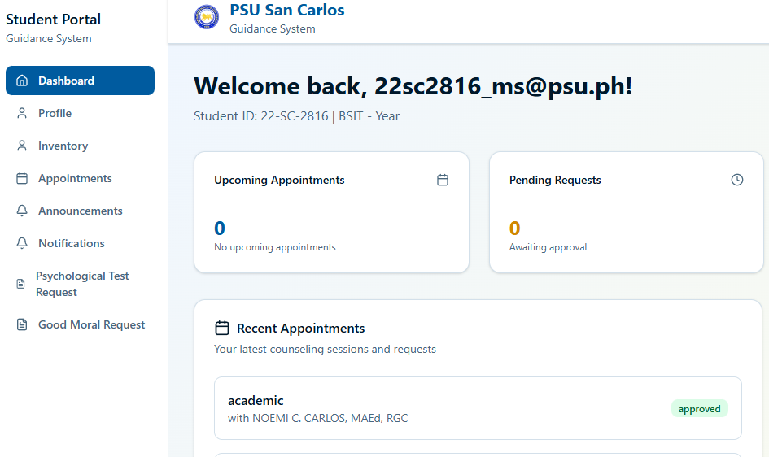
Figure 4.5. Student Dashboard
Figure 4.5 illustrates the appointment selection workflow within the PSU Guidance System’s student portal. As shown in the interface, the process is organized into clear sections that guide the student through choosing and managing their appointment. The dashboard displays essential components such as upcoming appointments, pending requests, recent sessions, and quick-action buttons, helping users easily navigate the system.
In this design, students begin by selecting the type of guidance service they need—such as academic or personal counseling—visible under the “Recent Appointments” and “Book New Appointment” sections. After choosing a service, the system leads users through the next steps, including selecting an available schedule, providing necessary details, and confirming their request.
By structuring the process into logical stages visible on the dashboard, the interface reduces confusion and supports user efficiency. The organized layout—featuring categorized services, status indicators (e.g., approved, rescheduled), and actionable options—enhances the overall usability of the system. This structured approach ensures that students can book and manage their guidance appointments smoothly, reinforcing a clear and intuitive user experience.
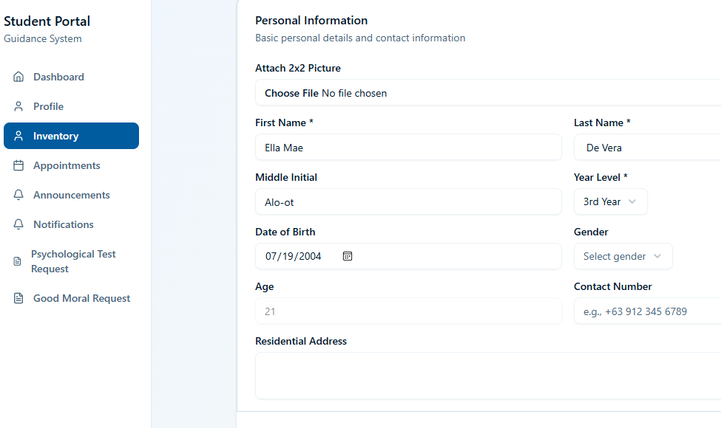
Figure 4.6. Students’ Inventory Form
Figure 4.6 illustrates the Student Inventory module of the PSU Guidance System, which serves as a structured interface for collecting and managing essential student information. The form is organized into distinct sections—Personal Information, Residential Details, and Educational Background—to ensure clarity, improve data entry accuracy, and support systematic record-keeping.
The Personal Information section enables students to upload a photograph and enter key demographic details such as their full name, year level, date of birth, gender, age, and contact number. Additionally, the form includes fields for specifying their residential address and current living arrangement, offering multiple options such as staying with parents, residing in a private house, living with friends or relatives, or staying in a dormitory or boarding house. These options allow students to provide precise information relevant to their personal and academic circumstances.
Below this, the Educational Background section collects details related to the student’s previous academic institution, including the name and type of their high school. After completing all fields, students can finalize their submission using the “Update My Inventory” button, which ensures that all records are kept current within the system.
By presenting information in a clear, categorized structure, this module enhances data organization and minimizes user confusion. The intuitive layout and straightforward navigation contribute to a smooth and efficient user experience, supporting the overall functionality and effectiveness of the guidance information system.
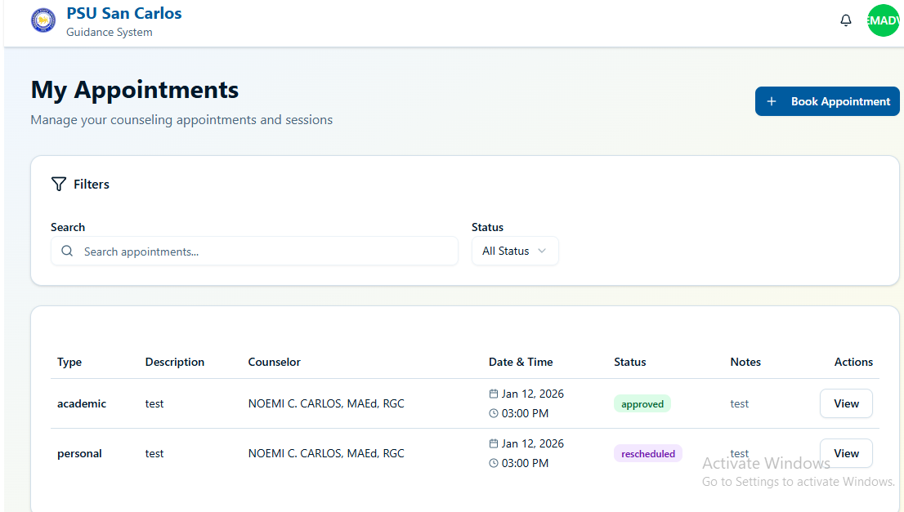
Figure 4.7. Appointments History
Figure 4.7 displays the My Appointments interface of the PSU Guidance System, which enables students to view and manage their scheduled counseling sessions. The layout provides a streamlined overview of all appointments, ensuring that students can easily track their academic and personal counseling requests.
At the top of the page, a filter panel allows users to search appointments by keywords and sort them based on their status, such as approved, pending, or rescheduled. This feature supports efficient navigation, particularly for students with multiple counseling interactions throughout the semester. Below the filter panel, the system presents a structured appointment table that lists each session’s type (academic or personal), description, assigned counselor, scheduled date and time, current status, and any relevant notes. The inclusion of status labels—such as approved or rescheduled—provides students with immediate updates regarding the availability and confirmation of their counseling requests. Additionally, an action button is available for each appointment, enabling students to view further details when necessary. Located at the upper-right corner is the “Book Appointment” button, allowing students to initiate new counseling requests directly from the same page. This integration enhances convenience and supports continuous engagement with the guidance services. Overall, the design of this module promotes clarity and accessibility by organizing appointment information in a concise, easy-to-read format.
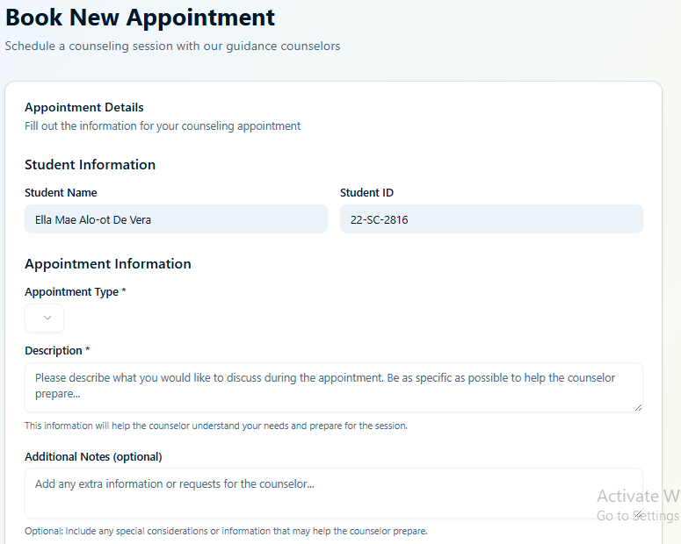

Figure 4.8. Appointment Booking
Figure 4.8 displays the appointment booking interface of the PSU Guidance System, where students can schedule counseling sessions or guidance-related consultations. This module presents a structured and detailed form that students must complete to submit an appointment request.
The interface is divided into clear sections: Appointment Details, Student Information, and Appointment Information, ensuring that all necessary data is collected to properly process the request. Students are required to provide the type of appointment, a short description of their concern, and any additional context they wish to share. They may also select their preferred counselor if applicable.
A scheduling area is included, allowing users to choose an available date from a calendar. The system automatically disables unavailable or fully booked dates, ensuring accuracy and preventing scheduling conflicts. Below the form, a section for Important Notes helps remind students of guidelines or requirements they should consider before submitting.
A Submit Appointment Request button finalizes the process, while a Cancel button allows the user to discard the request if needed. This design supports a clear, guided workflow, enabling students to easily book appointments while ensuring the Guidance Office receives complete and accurate information. By organizing the form into logical sections and providing visual scheduling tools, the system enhances user experience and streamlines the appointment-setting process.
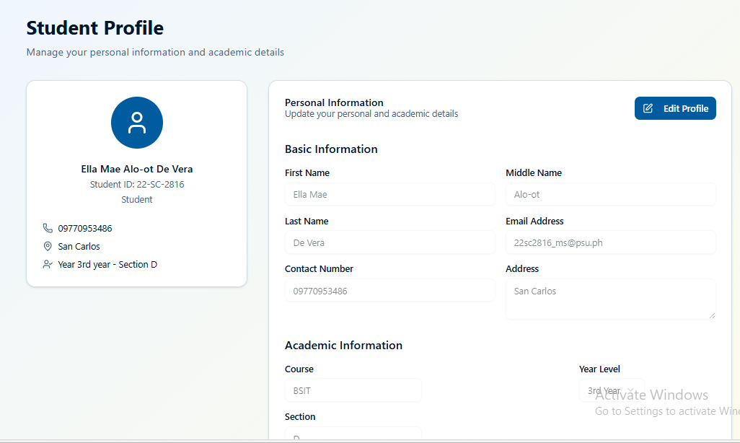
Figure 4.9. Student Profile
Figure 4.9 illustrates the Student Profile module of the PSU Guidance System, which provides students with a centralized space to view and update their personal and academic information. The interface displays essential details such as the student’s full name, ID number, email address, contact information, academic program, year level, and section, allowing users to monitor the accuracy of their records.
The module includes an Edit Profile function, enabling students to update fields such as their contact number, address, academic details, and emergency contact information. The system also offers an option to modify account credentials—including the user’s password—ensuring that privacy and account security are maintained. Students may update only the fields necessary, as leaving certain fields unchanged ensures that the system retains the previously stored information.
This design emphasizes clarity, accessibility, and user control, allowing students to keep their records up-to-date without difficulty. By providing editable fields and organized information categories, the Student Profile module supports a user-centered approach, ensuring can conveniently manage their data. This contributes to a more personalized and secure experience within the guidance platform, reinforcing the overall acceptability and efficiency of the system.
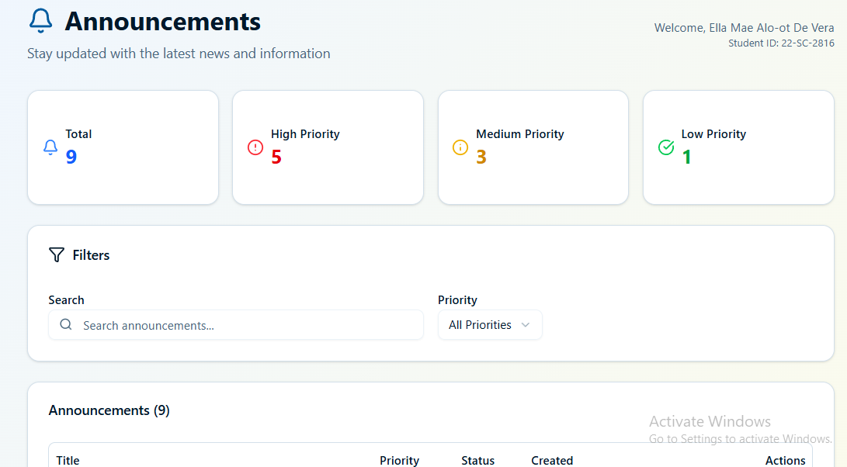
Figure 4.10. Announcements
Figure 4.10 showcases the Announcements module of the PSU Guidance System, which serves as the central platform for students to access important updates, reminders, and guidance-related information. The interface presents a summary of all announcements, categorized by priority levels such as high, medium, and low, allowing users to easily determine which updates require immediate attention.
A search bar and priority filter are provided to help students locate specific announcements more efficiently. The announcement table displays key details, including the title, priority level, status, date created, and an action button to view full content.
The design of this module highlights clarity, organization, and accessibility, supporting timely communication between the Guidance Office and students. By categorizing announcements and presenting them in an easy-to-navigate format, the system enhances the overall user experience, ensuring students remain informed about school activities, guidance advisories, and campus-wide notices.
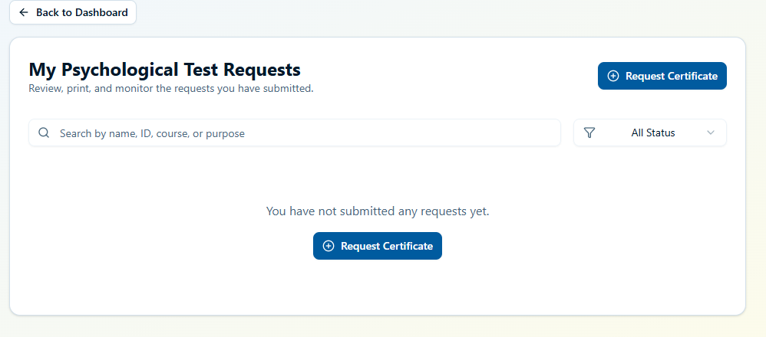
Figure 4.11. Psychological Test Request
Figure 4.11 illustrates the Psychological Test Request module of the PSU Guidance System, where students can submit, track, and manage their requests for psychological test certificates. The interface provides a clear overview of the student’s submitted requests, displaying their status once entries are available. A search bar and status filter are included to help students quickly locate specific records based on name, ID, course, or purpose.
Since no requests have been made yet in the displayed interface, the system shows a message indicating the absence of submissions and provides an easily accessible “Request Certificate” button. This allows students to initiate a new request seamlessly, ensuring they can efficiently comply with academic or administrative requirements that may require this document.
The design emphasizes simplicity and accessibility, offering a structured and user-friendly way for students to manage their certificate needs. By centralizing the request process and allowing real-time monitoring of request statuses, the module enhances transparency and supports smoother communication between students and the Guidance Office.
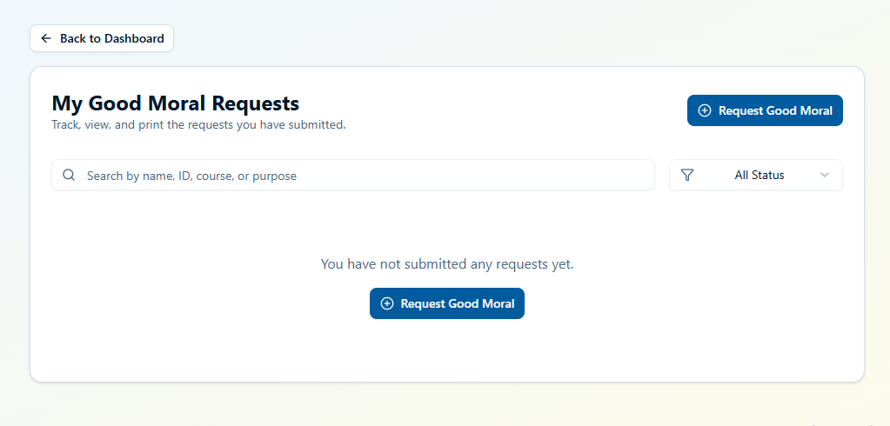
Figure 4.11. Good Moral Request
Figure 4.11 shows the user interface for managing Good Moral Certificate requests within the Guidance System. This page allows students to track, view, and print any Good Moral requests they have previously submitted.
At the top of the page, a navigation button labeled “Back to Dashboard” enables users to return to the main menu. Below it, the interface presents a section titled “My Good Moral Requests”, which contains search and filtering tools. Students may look up requests by entering a name, ID number, course, or purpose in the search bar, while an adjacent dropdown filter allows them to sort entries based on request status.
Since the student has not yet submitted any requests, the central area displays a message indicating that no records are available. A prominent “Request Good Moral” button is provided both at the top right and center of the interface, allowing users to initiate a new request quickly. The layout is designed to be straightforward and user-friendly, ensuring that students can easily monitor their submitted documents and access the request function with minimal navigation.
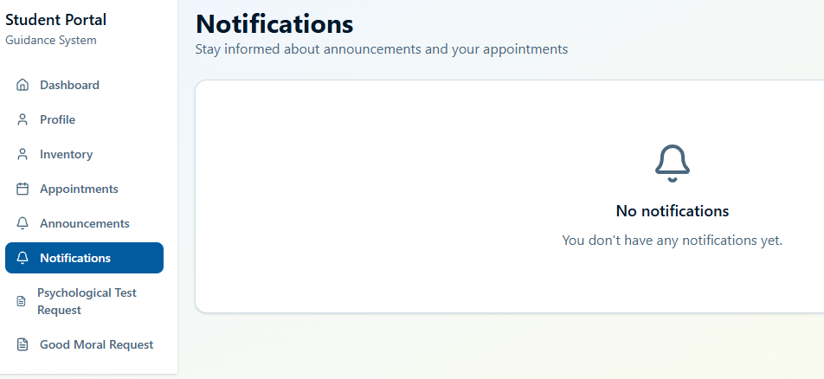
Figure 4.12. Notifications
Figure 4.12 shows the Notifications page of the Student Portal within the Guidance System. This section is designed to keep students informed about system announcements and updates related to their appointments or requests. The page provides a straightforward layout, with the main content area displaying a message indicating that no notifications are currently available. An icon is placed at the center to visually reinforce the absence of new alerts.
The left-hand navigation panel contains key modules such as Dashboard, Profile, Inventory, Appointments, Announcements, Notifications, Psychological Test Request, and Good Moral Request. The Notifications tab is highlighted to show that the user is viewing this section.
The interface is minimalist and user-friendly, ensuring that students can easily check for updates and remain aware of important information communicated by the Guidance Office.
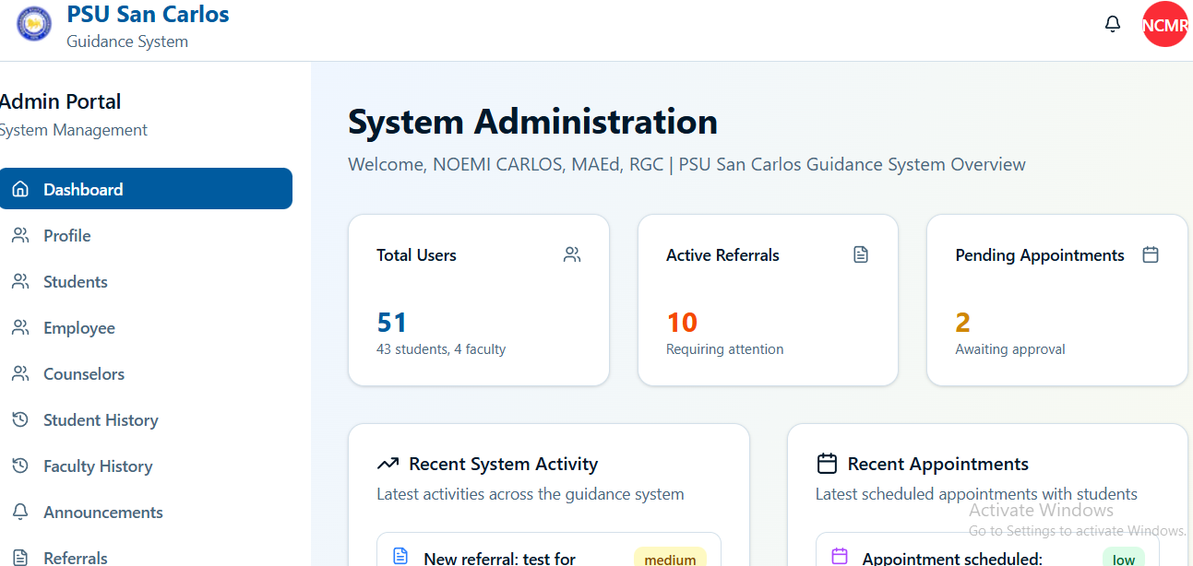
Figure 4.13. Admin Dashboard Overview
Figure 4.13 presented the admin dashboard overview of the PSU Guidance Office System. The dashboard displayed essential system metrics, including the total number of users, active referrals, and pending appointments requiring administrative review. These summary cards provided administrators with a quick snapshot of overall system activity and pending tasks within the guidance operations.
Below these metrics, two activity panels were displayed: Recent System Activity and Recent Appointments. The Recent System Activity panel listed the latest actions performed within the system, such as scheduled appointments with students and updates made by users. Each entry included the appointment type, student involved, date, and time. The Recent Appointments panel showcased newly scheduled guidance appointments, categorized by their specific purpose, including academic, personal, and career-related sessions.
This layout provided administrators with a structured and comprehensive overview of ongoing system interactions. By organizing activity logs and appointment listings into separate sections, the dashboard enabled efficient monitoring of guidance requests, student engagement, and overall system performance. The clear arrangement of metrics and logs supported administrative decision-making by ensuring that critical activity data was accessible and easy to interpret.
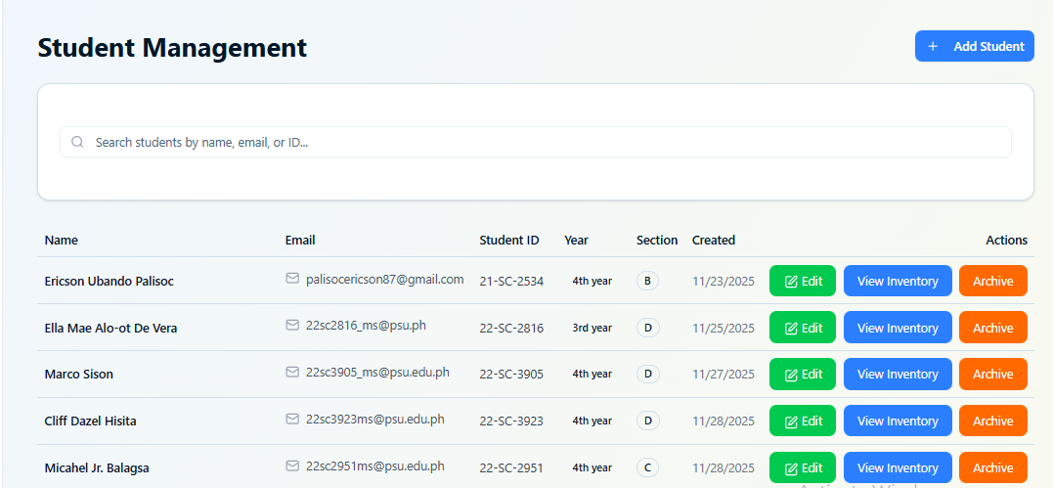
Figure 4.14. Student Management
Figure 4.14 presented the Student Management feature of the PSU Guidance Office admin panel. This section provided administrators with a complete list of all registered students, displaying essential details such as the student’s name, email address, student ID, year level, section, account status, and the date the record was created. The table also included an Actions column, offering options to view the student's inventory records or archive their account. Additionally, a “+ Add Student” button was positioned at the upper right to allow administrators to register new students in the system.
This design enabled administrators to efficiently manage student information within the guidance system. By organizing data into a clear table format, the interface supported easy tracking of student enrollment details, academic levels, and account activity. The availability of actions—such as viewing inventories and archiving students—justified its focus on maintaining accurate records and ensuring systematic data organization. The structured layout enhanced usability, streamlined student management tasks, and supported effective oversight of all student-related records.
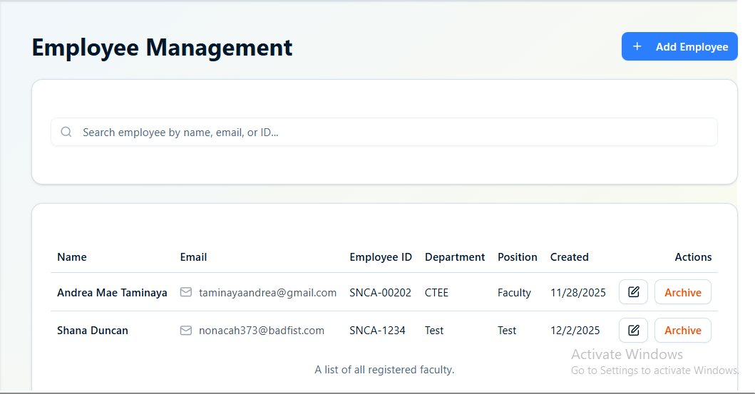
Figure 4.15. Employee Management
Figure 4.15 presented the Employee Management feature of the PSU Guidance Office admin panel. This section allowed administrators to oversee faculty and staff records through a structured table displaying each employee’s name, email address, employee ID, department, position, account status, and the date the record was created. The table also included an Actions column, offering options such as editing employee details, updating their status (active or inactive), and archiving employee accounts. A “+ Add Employee” button at the upper right enabled administrators to register new employees into the system.
This design supported efficient management of employee information by providing a clear and organized view of all registered faculty members. The inclusion of essential details such as department and position justified its focus on keeping employee records up to date and easily trackable. With actionable controls for editing and archiving, the interface promoted administrative flexibility and ensured accuracy in personnel management. The structured layout enhanced usability, enabling administrators to maintain comprehensive oversight of all employee-related data within the system.
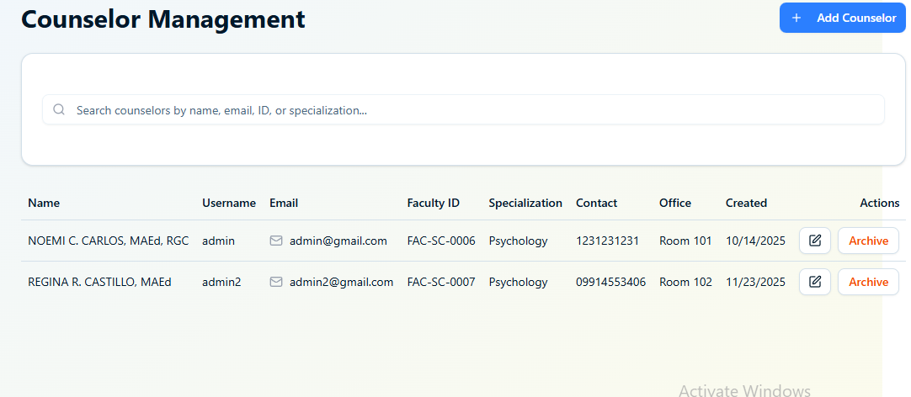
Figure 4.16. Counselor Management
Figure 4.16 presented the Counselor Management feature of the PSU Guidance Office admin panel. This section provided administrators with a comprehensive list of registered counselors, displaying key information such as counselor name, username, email address, faculty ID, specialization, contact number, office location, account status, and the date the record was created. Each row included an Actions column, offering options to edit counselor details, update their active or inactive status, or archive their account. A “+ Add Counselor” button at the upper right allowed administrators to register new counselors into the system.
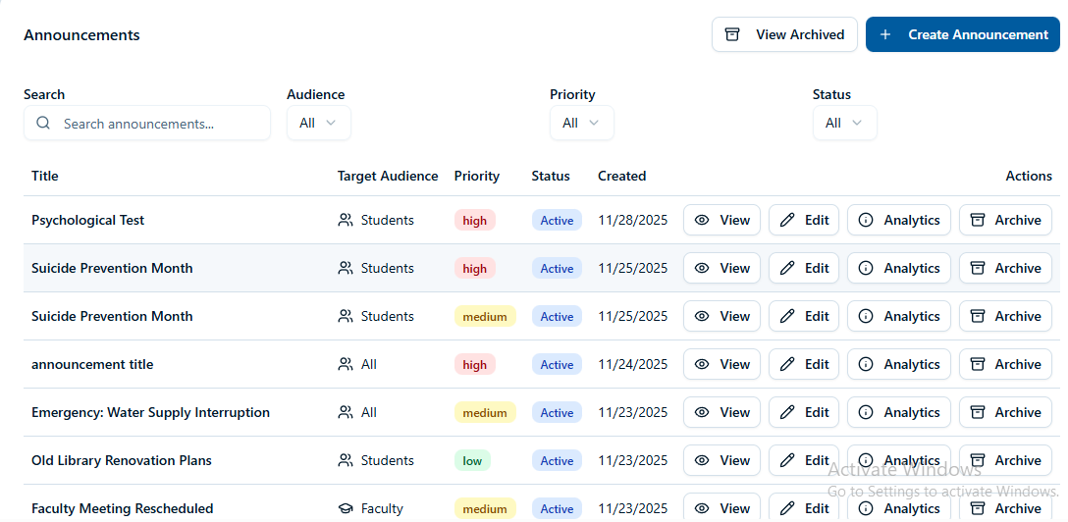
This design enabled efficient oversight and management of counselor personnel by organizing detailed information into a clear and structured table. The inclusion of fields such as specialization and office location justified its purpose in supporting guidance operations, ensuring that administrators could easily identify each counselor’s role and assigned workspace.
Figure 4.17. Announcements
Figure 4.17 displayed the Announcements Management section of the administrator portal. This interface provided a comprehensive list of published announcements, each showing its title, intended audience, priority level, status, and date created. Administrators were given quick-access action buttons to view, edit, analyze, or archive each announcement. Filters for search, audience, priority, and status were also included at the top of the panel, enabling efficient navigation and streamlined management of all announcement postings within the system.
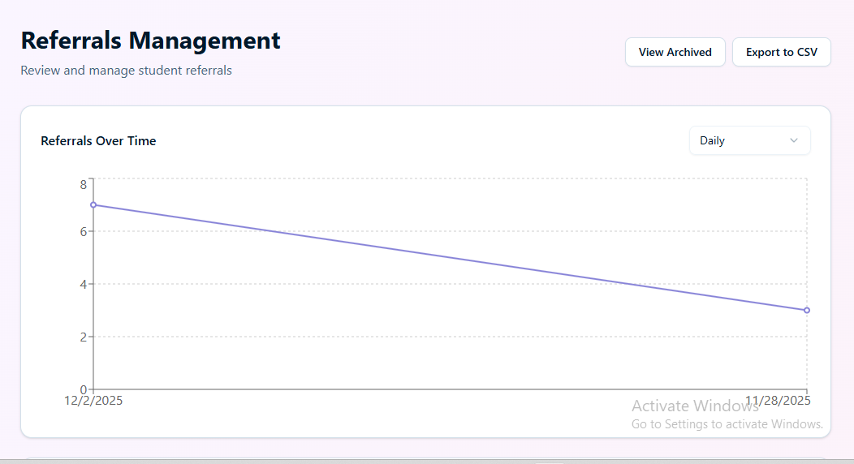
Figure 4.18. Referrals Management
Figure 4.18 presented the Referrals Management interface of the administrator portal. The page displayed two primary analytic components: Referrals Over Time and Referral Status Analytics. The Referrals Over Time section provided a visual representation of referral trends, allowing administrators to filter the data by time intervals such as daily, enabling quick identification of referral patterns or sudden increases in cases. Below it, the Referral Status Analytics chart illustrated the distribution of referral outcomes, offering insight into categories such as pending, ongoing, completed, or archived referrals.
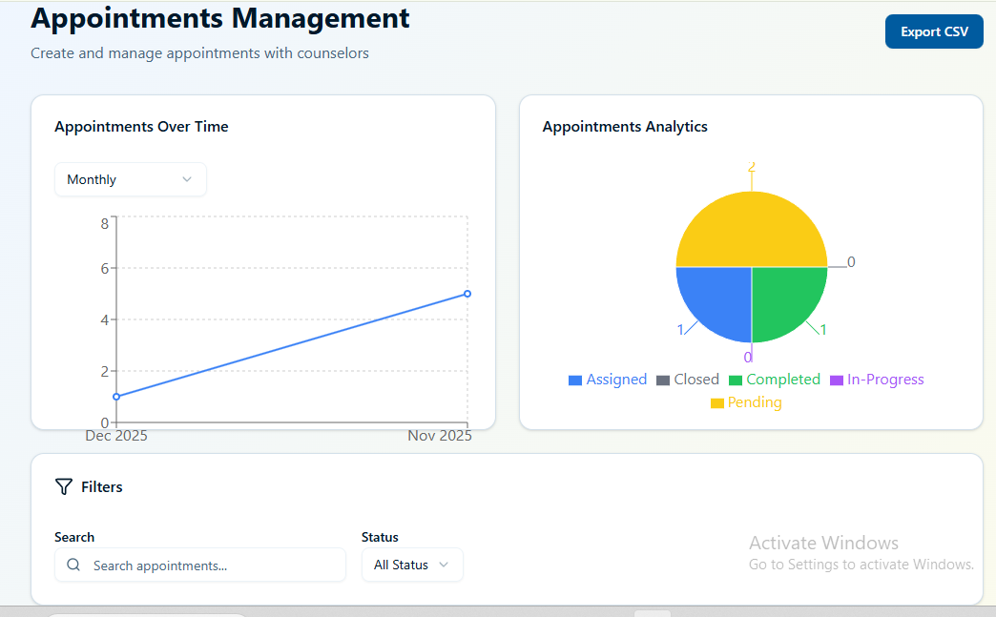
Additionally, the interface included functional buttons such as View Archived and Export to CSV, supporting administrative tasks like retrieving past records and generating downloadable data reports. By combining real-time graphs with management utilities, the layout enhanced monitoring efficiency and ensured that referral data remained accessible for evaluation, documentation, and decision-making.
Figure 4.19. Appointments Management
Figure 4.19 presented the Appointments Management interface of the administrator portal. The page showcased two main analytical components: Appointments Over Time and Appointments Analytics. The Appointments Over Time section displayed a time-based line graph that allowed administrators to view appointment trends, with options to filter the data by intervals such as monthly. This visualization helped identify fluctuations in appointment volume and track counselor engagement over specific periods. On the right side, the Appointments Analytics chart categorized appointments into assigned, closed, completed, in-progress, and pending statuses, giving administrators an at-a-glance summary of appointment distribution.
Below the analytics, the interface provided filtering tools, including a search bar for finding specific appointments and a status dropdown for refining results. Two appointment tables were also featured: the Student Appointments List and the Faculty Appointments List. Each table displayed essential details such as appointment type, counselor, schedule, and status, enabling easy monitoring and management of both student and faculty bookings. The Export CSV button supported data extraction for reporting or documentation purposes. Overall, this layout offered administrators a comprehensive and organized view of appointment activity.
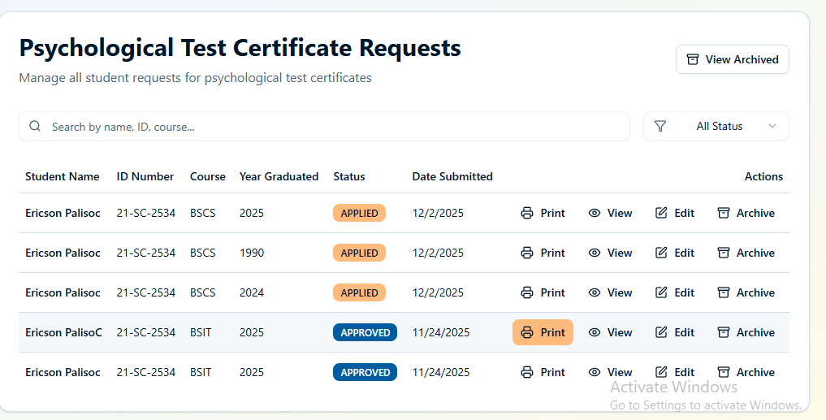
Figure 4.20. Psychological Test and Good Moral Certificate Request
Figure 4.20 presented the certificate request management interfaces of the administrator portal, specifically highlighting the Good Moral Certificate Requests page and the Psychological Test Certificate Requests page. Both sections were designed to streamline the review and processing of student certificate applications while maintaining a clean and organized layout.
The Good Moral Certificate Requests interface displayed a searchable table containing student information such as name, ID number, course, year graduated, request status, and date submitted. A status filter was available to help administrators quickly refine requests based on categories like approved or pending. Action buttons—including Print, View, Edit, and Archive—were positioned beside each record, providing convenient access to certificate generation, record modification, and archiving options. A View Archived button at the top-right corner allowed administrators to switch seamlessly between active and archived requests for better data management.
Similarly, the Psychological Test Certificate Requests page followed the same structured layout, ensuring consistency across certificate management modules. The table listed identical key information and the same set of action tools, enabling administrators to efficiently process psychological test certificate requests using a familiar interface. The presence of searchable and filterable inputs helped improve navigation and shortened the time required to locate specific student records.
Overall, these certificate request pages offered administrators a clear and efficient workflow. Through well-organized tables, accessible action controls, and filtering capabilities, the design supported systematic processing, reduced manual workload, and improved the accuracy and speed of certificate issuance across both Good Moral and Psychological Test certificates.
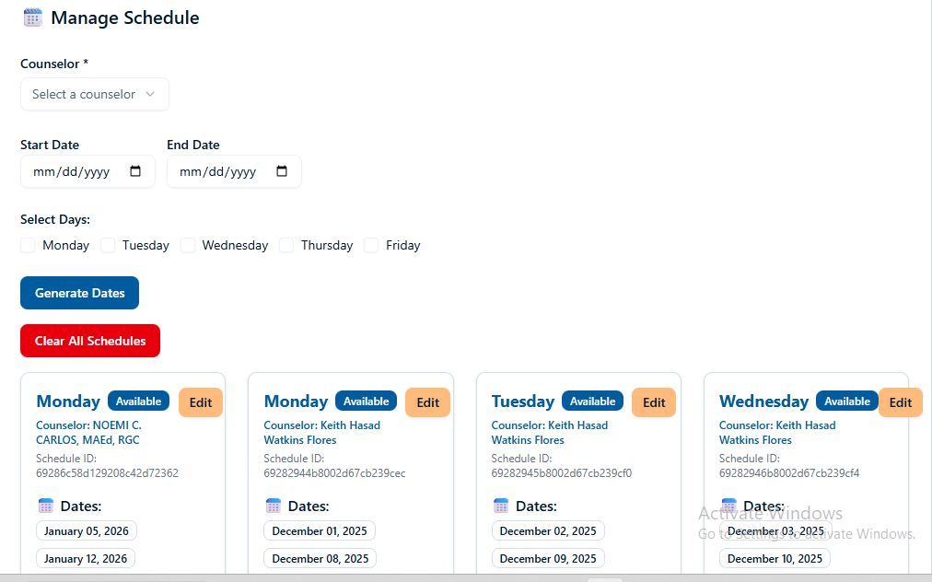
Figure 4.21. Scheduled Slots
Figure 4.21 presented the Manage Schedule interface of the administrator portal. This section allowed administrators to oversee and configure counselor availability for appointments. At the top of the page, the system displayed the selected counselor’s name, indicating whose schedule was being managed. Below this, fields for selecting a start date and end date were provided, enabling administrators to generate schedules within a specific time range.
The interface included selectable weekday options—Monday through Friday—allowing administrators to specify which days should generate available schedules. A “Generate Dates” button produced schedule entries based on the chosen date range and selected days, while a “Clear All Schedules” button offered a quick way to reset or remove existing schedules.
Beneath these controls, the page showcased generated schedules organized into individual day cards. Each card displayed the day of the week, counselor name, schedule code, and the list of generated dates. Time slots assigned for each day were shown clearly, helping administrators visualize appointment availability. An “Edit” button on each schedule card enabled quick modifications to existing configurations.
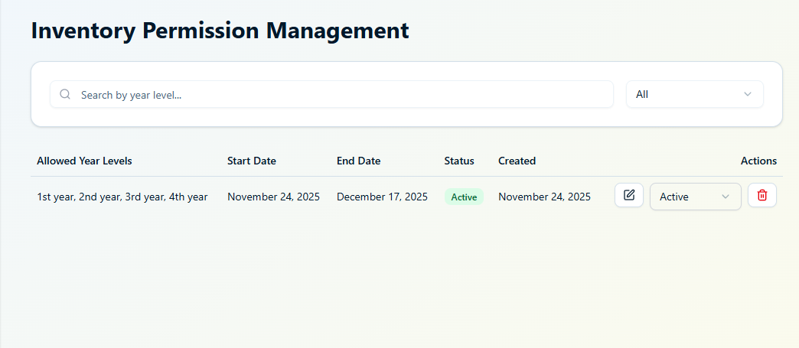
Figure 4.22. Inventory Permission Management
Figure 4.22 presented the Inventory Permission Management interface of the administrator portal. This section allowed administrators to configure and monitor which year levels were permitted to access the inventory module of the system. At the top of the page, a search bar provided filtering capabilities, enabling users to locate records based on specific year levels. A dropdown menu adjacent to the search field allowed administrators to sort or filter entries by status.
The main table displayed essential information for each permission configuration. The “Allowed Year Levels” column listed the specific academic levels granted access, while the “Start Date” and “End Date” indicated the validity period of the permission. A status badge showed whether the permission was currently active or inactive, and a “Created” column recorded the date the configuration was added to the system.
Toward the right side of the table, action controls were provided for each entry. These included an “Edit” button for modifying existing permissions, a status toggle for switching permissions between active and inactive, and a delete option for removing outdated or unnecessary records.
Overall, the interface offered a clear and organized method for managing access permissions within the system. By integrating search functionality, detailed record tracking, and user-friendly action controls, the design supported structured administration of inventory access across various student year levels.
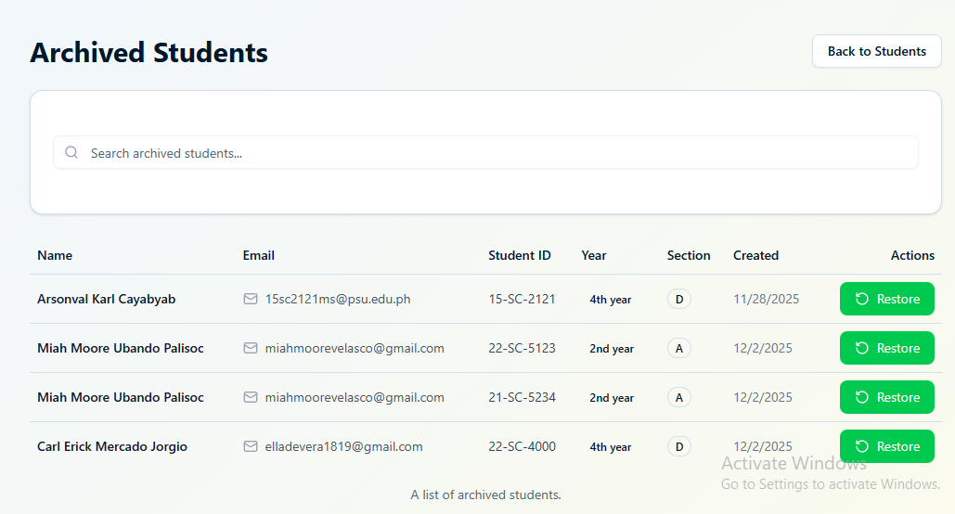
Figure 4.22. Archive
Figure 4.22 shows the interfaces presented in the screenshots illustrates how the PSU San Carlos Guidance System supports administrators in managing archived records through a clean, organized, and intuitive layout. The archived sections—covering students, employees, counselors, announcements, and referrals—serve as dedicated spaces for storing inactive or previously used records while still keeping them accessible for reference. Each archived module includes a search bar for quick retrieval and a table that displays relevant details such as names, emails, IDs, academic information, and creation or archival dates. For archived students, the system also offers a restore function that allows administrators to reactivate a student’s record when necessary. Although the archived employee, counselor, and referral pages currently show no entries, their consistent design reflects a unified approach to data management across the system. The archived announcements page, on the other hand, lists past communication materials with details on priority, target audience, and status, along with options to view or restore individual announcements.
Overall, these interfaces demonstrate a user-friendly and systematic design that supports efficient administrative work. Through clear navigation, comprehensive record organization, and straightforward action controls, the system enhances the way administrators manage schedules, regulate access permissions, and maintain important archival data. This cohesive structure not only streamlines workflow but also ensures that information remains accessible, accurate, and easy to manage across different components of the guidance system.
Non-Functional Requirements
According to Mattew (2022), non-functional requirements defined a software system's quality attributes, ensuring its usability, performance, and effectiveness. These criteria addressed the overall constraints and standards required for the system to function optimally.
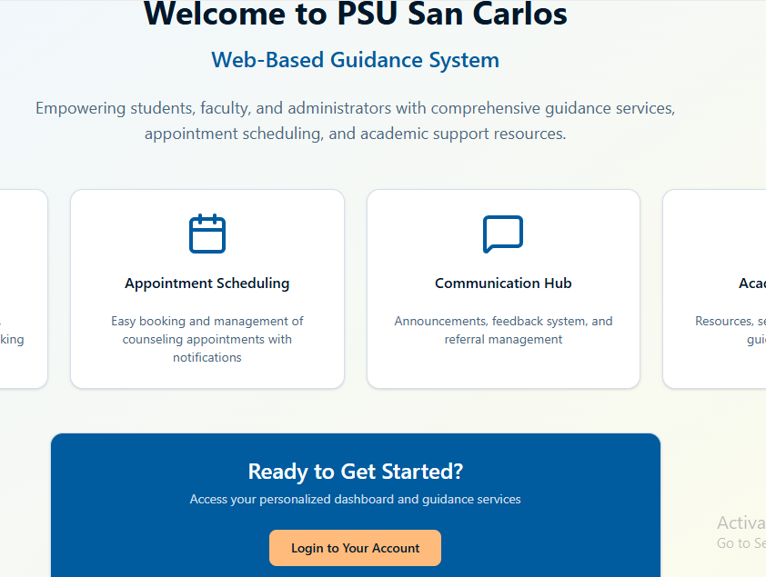
Figure 4.23. Accessibility
Figure 4.19 represents the landing page of the PSU San Carlos Web-Based Guidance System, highlighting the platform’s accessibility and user-centered design. This page demonstrates how the system ensures that students, faculty, and administrators can easily navigate its features regardless of their technical background or level of experience. The layout is clean and well-structured, with large, clearly labeled modules such as Student Management, Appointment Scheduling, Communication Hub, and Academic Support. These sections are visually organized into distinct cards, allowing users to quickly identify the services they need. The readable fonts, balanced spacing, and intuitive iconography further contribute to an accessible user experience, making the interface approachable even for individuals with limited digital proficiency.
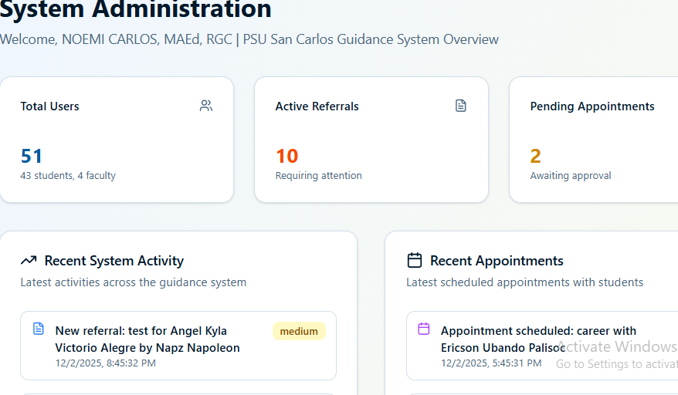
To support seamless interaction, the system also incorporates straightforward navigation elements, including a prominent “Login to Your Account” button that guides users directly into their personalized dashboards. The design emphasizes clarity and simplicity, ensuring that essential functions are easy to locate and understand.
Figure 4.24. Accuracy
Figure 4.24 shown the screenshot above demonstrates how the Guidance System upholds accuracy by consistently presenting reliable and precise information across the platform. Accuracy in this context refers to the system’s ability to display correct appointment details, referral statuses, user counts, and recent activities without inconsistencies or errors. The dashboard showcases this through real-time values such as the total number of users, active referrals, and pending appointments, ensuring that administrators always have an exact view of current operations. Additionally, the system logs recent activities and scheduled appointments with accurate timestamps and descriptions, allowing staff to track actions clearly and confidently
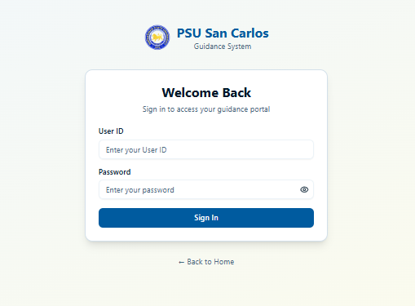

Figure 4.25. Authentication and Authorization
Figure 4.25 illustrates the authentication and authorization feature of the Guidance System. Authentication ensures that only legitimate users can enter the system by verifying their identity through their assigned User ID and password. Authorization, on the other hand, determines what each user is allowed to access once logged in, based on their designated role within the institution. Together, these processes play a crucial role in maintaining the security of the platform and protecting sensitive guidance-related data. The login interface provides a straightforward and
user-friendly way for students, faculty, and administrators to securely access their accounts. It includes dedicated input fields for the User ID and password, along with a password visibility toggle to minimize entry errors. A link to return to the home page is also provided for easier navigation.
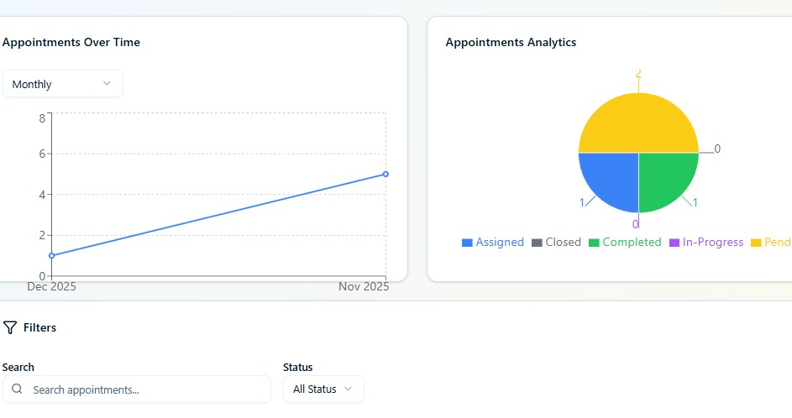

Figure 4.26. Efficiency
Figure 4.26 showcased the efficiency feature of the Guidance System. In this context, efficiency referred to the system’s capability to help users complete tasks quickly, accurately, and with minimal effort. The interface was designed to present essential appointment information in a clear and organized manner, allowing counselors, faculty, and students to manage their schedules without unnecessary delays. The module displayed visual analytics such as the “Appointments Over Time” graph and the “Appointments Analytics” pie chart, enabling users to instantly understand trends, statuses, and overall appointment distribution. Filters were provided to streamline searches by appointment type or status, reducing the time required to locate specific records. Additionally, both student and faculty appointment lists were presented in structured tables, showing details such as appointment type, counselor assigned, schedule, and status. Quick-action buttons for viewing or editing made it even easier to update or review appointment information. By offering a layout that prioritizes clarity, speed, and accessibility, the Guidance System enhanced user productivity, ensuring that appointment monitoring and management could be done efficiently and with minimal navigation effort.
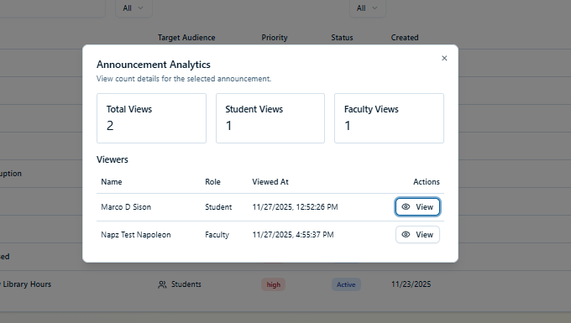

Figure 4.27. Maintainability
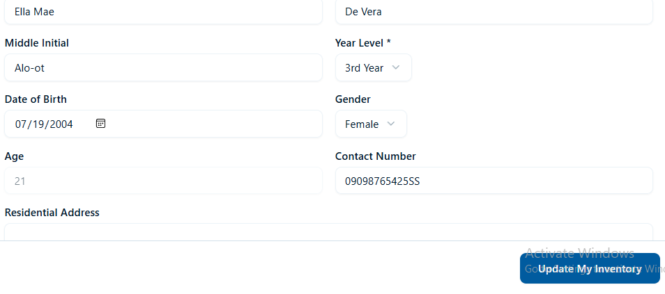
Figure 4.27 illustrated the maintainability feature of the Guidance System. Maintainability referred to the system’s ability to be easily updated, managed, and modified to support long-term sustainability and smooth operation. In this module, the system allowed users—particularly students—to update and maintain their personal information efficiently. The interface presented a structured form where students could modify essential details such as their name, year level, date of birth, gender, contact number, address, and living arrangements. Educational background fields were also included, ensuring that academic records could be kept accurate and up-to-date. By designing the profile management page with clear input fields, organized sections, and straightforward update controls, the system made it simple for users to revise their information whenever needed. This ease of updating contributed to better data integrity and reduced the workload for administrators, as users could independently manage their own records.

Figure 4.28. Reliability
Figure 4.28 presented the reliability feature of the Guidance System. Reliability referred to the system’s ability to consistently deliver accurate information, perform its functions without errors, and ensure stable operation across different user interactions. This characteristic was essential in maintaining user trust, especially in a system that supports academic guidance, announcements, and communication between students and faculty.
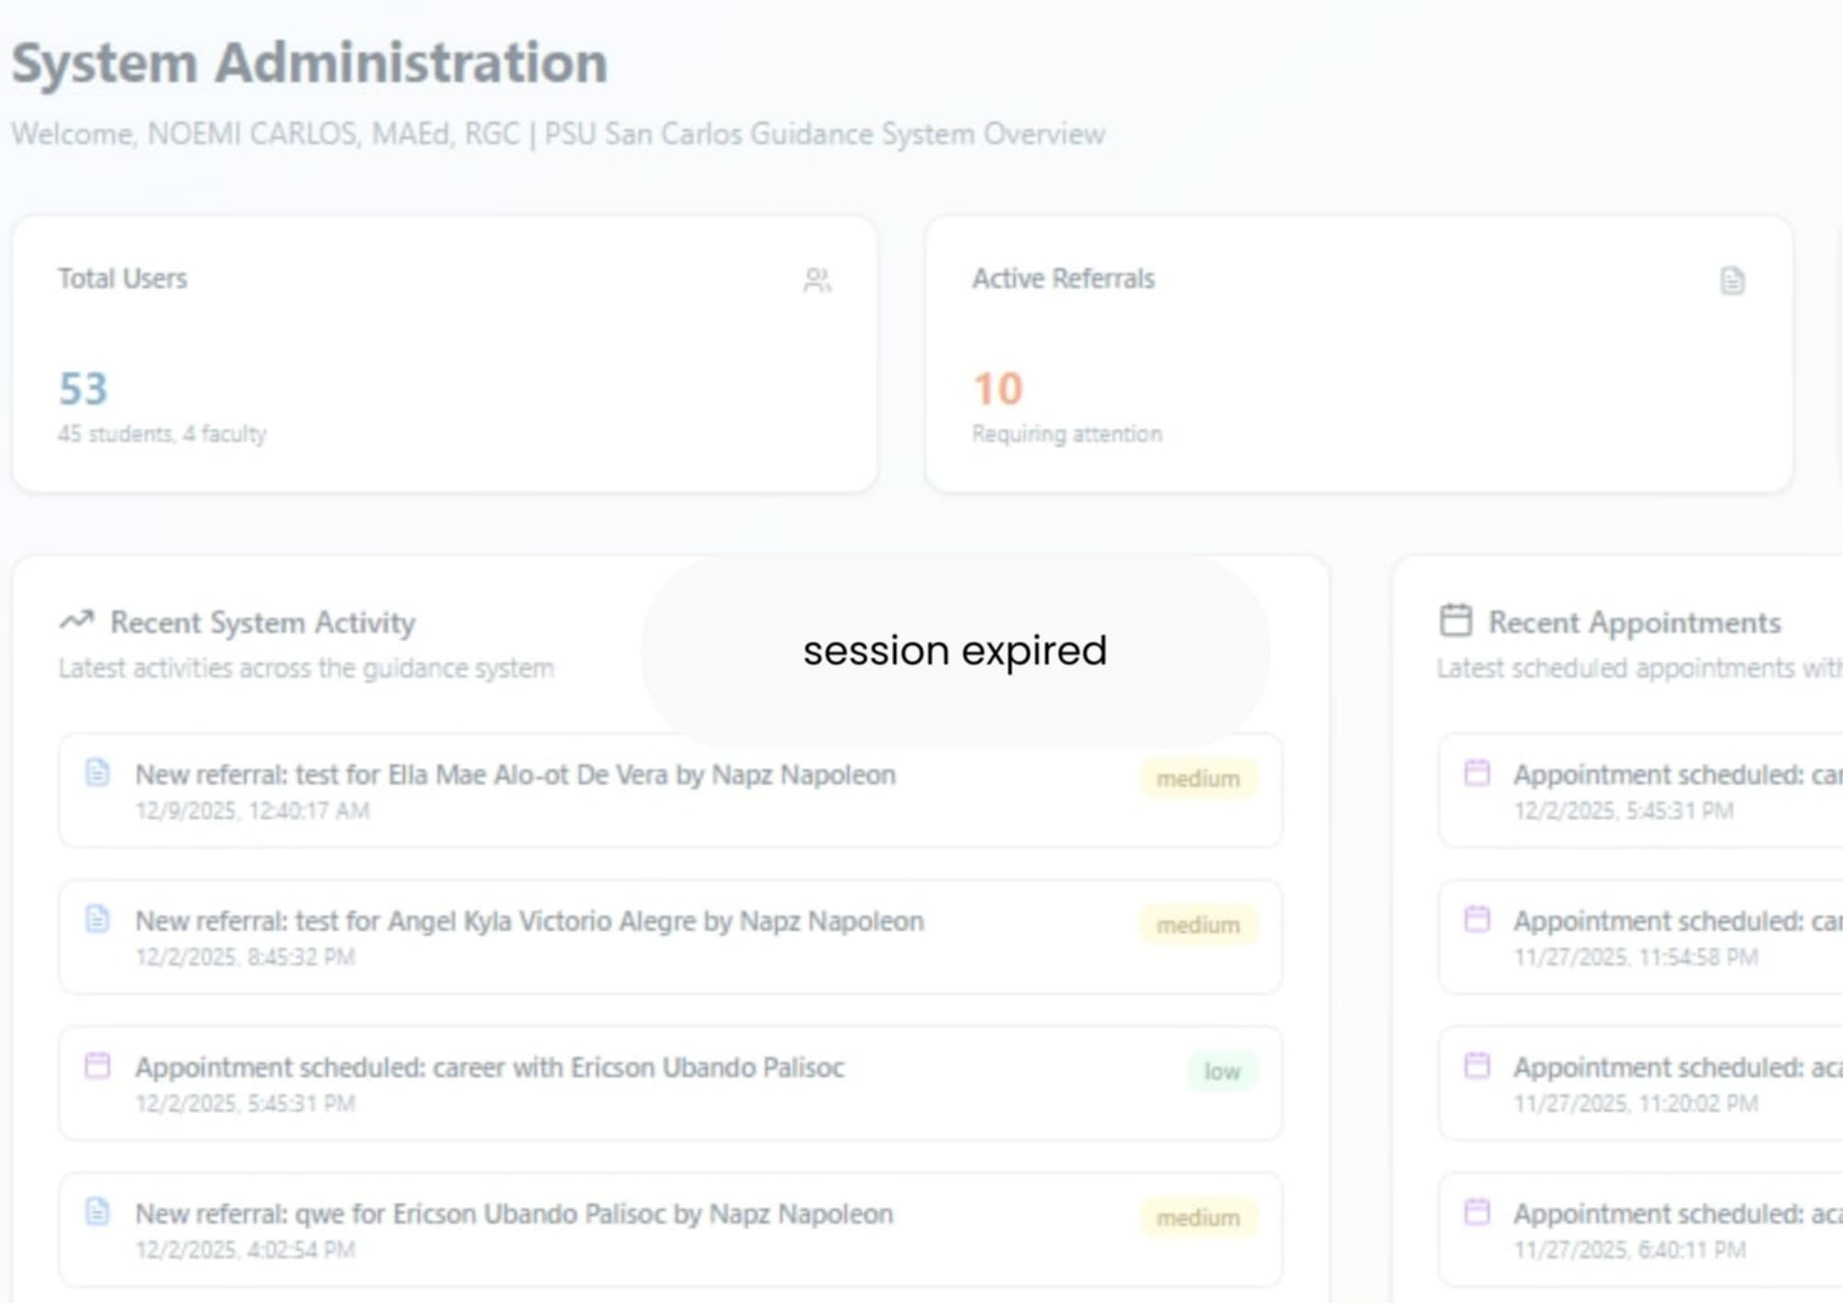
The figure showed the announcement analytics module, where the system accurately recorded and displayed real-time view counts for each announcement. Information such as total views, student views, and faculty views was presented clearly, along with a detailed list of individual viewers, their roles, and exact timestamps of when the announcement was accessed. This precise tracking demonstrated that the system reliably captured user activity without data loss, delays, or inconsistencies. By consistently presenting correct and up-to-date analytics, the Guidance System proved its ability to handle user interactions dependably.


Figure 4.29. Security

Figure 4.29 The figure illustrated the security feature integrated into the Guidance Management System. Security in this context refers to the platform’s ability to safeguard user information, prevent unauthorized access, and maintain the confidentiality, integrity, and proper handling of sensitive data. In the interface shown, the system restricts certain actions—such as editing referral details—only to users with the appropriate permissions. This access control mechanism ensures that confidential referral information, including the reason, description, priority level, and notes, cannot be viewed or modified by unauthorized individuals.
Beyond restricting access, the platform also reinforces secure usage by providing structured input fields and role-based settings that help maintain accurate and protected record-keeping. These safeguards collectively demonstrate that the system prioritizes data protection and responsible information management. By preventing unauthorized modifications and ensuring that only authorized personnel can update or review sensitive referral details, the system upholds the security and reliability essential for managing guidance-related records.
4.7 Evaluation of the Proposed Computer-Based Solution
This section evaluates the Web-Based Guidance System for Pangasinan State University San Carlos Campus with emphasis on its acceptability using the ISO/IEC 25010 Software Quality Model. Acceptability refers to the degree to which users consider the system adequate, appropriate, and satisfactory for accomplishing their tasks. Under ISO 25010, acceptability is influenced by software characteristics such as functional suitability, reliability, security, performance efficiency, compatibility, and maintainability, which together determine whether users are willing to adopt and rely on the system.
ISO 25010 was selected for this study because recent research has demonstrated its effectiveness in assessing user acceptance and overall system quality in educational and administrative environments (Januhari et al., 2025; Sarwosri et al., 2023). The standard’s focus on functional completeness, performance, and reliability makes it a suitable framework for evaluating systems that handle documentation, appointments, announcements, and referrals—core services offered through the Guidance System.
The results of the evaluation show that the Guidance System achieved a high level of acceptability among its users. Respondents agreed that the system’s functions—such as requesting certificates (e.g., good moral and psychological test certificates), scheduling appointments, viewing announcements, and processing student referrals—are relevant and helpful in supporting campus guidance services. Reliability contributed strongly to acceptability, as users experienced consistent performance with minimal system errors. Likewise, security measures enhanced user trust by ensuring that sensitive student data and referral information were kept confidential. The system was also evaluated as acceptable in terms of performance and compatibility, running efficiently across commonly used devices within the university environment.
Following ISO 25010’s structured approach, a survey was conducted with 45 respondents composed of students, employees, and administrators. After an orientation and hands-on interaction with the system, participants rated the system using a 5-point acceptability scale (1 = Strongly Unacceptable, 5 = Strongly Acceptable). Overall results indicated that the system is widely accepted by its users due to its dependable performance, relevance to guidance operations, and secure handling of student information.
Table 4.3 showed the total number of respondents involved in the study. Among the 45 respondents, 1 were administrator (2%), 3 were college Deans and 41 were students (89%).
Table 4.3. Respondents of Survey
Type of User | Number of Respondents | Percentage
Administrator | 1 | 2
Dean | 3 | 7
Students | 41 | 89
Total | 45 | 100%

Table 4.4 presented the scale rating used to evaluate the acceptability of the system. The table defined five levels of interpretation based on specific numerical ranges, where a rating of 5 (4.21–5.00) indicated "Strongly Acceptable," and a rating of 1 (1.00–1.80) represented "Strongly Unacceptable." This scale provided a structured framework for analyzing user feedback and determining the overall performance and usability.
Table 4.4. Scale Rating
Scale | Range | Interpretation
5 | 4.21 – 5.00 | Strongly Acceptable
4 | 3.41 – 4.20 | Acceptable
3 | 2.61 – 3.40 | Moderately Acceptable
2 | 1.81 – 2.60 | Unacceptable
1 | 1.00 – 1.80 | Strongly Unacceptable

Functional Suitability ensured that the system effectively supported users in achieving their objectives without unnecessary complications or redundant steps. This aspect emphasized the alignment of system functionality with the intended tasks, allowing users to complete processes efficiently. Its importance lay in reducing cognitive load, improving task completion time, and enhancing user satisfaction. Systems that prioritized task suitability fostered a streamlined user experience, as supported by Sari and Setyowati (2021), who highlighted that task-oriented design was essential for effective human-computer interaction.
Table 4.5 presents the evaluation results of the system in terms of functional suitability. The findings indicate that the system effectively delivers the necessary guidance features, such as appointments, record management, and notifications, which received a Strongly Acceptable rating. The correctness of system functions and the accuracy and usefulness of system outputs were both rated as Acceptable. Overall, the system obtained an average weighted mean of 4.10, signifying that its functional suitability is generally Acceptable and meets users’ guidance service needs.
Table 4.5. System Evaluation According to Functional Suitability
Functional Suitability | Mean | Description
The system provides all necessary guidance features (appointments, records, notifications). | 4.31 | Strongly Acceptable
The functions perform correctly and meet my guidance needs. | 4 | Acceptable
The system's outputs (reports, confirmations) are accurate and useful. | 4 | Acceptable
Average Weighted Mean | 4.10 | Acceptable
Legend: Strongly Acceptable = 4.21 – 5.00; Acceptable = 3.41 – 4.20; Moderately Acceptable = 2.61 – 3.40; Unacceptable = 1.81 – 2.60; Strongly Unacceptable = 1.00 – 1.80;

Performance efficiency emphasized the system’s capacity to execute tasks quickly, responsively, and with optimal resource utilization. This quality ensured that users could navigate the platform, load pages, and complete operations without delays, enhancing overall productivity and user satisfaction. Efficient processing, streamlined workflows, and minimal waiting times contributed to a smoother experience for both new and experienced users. According to Alharbi and Drew (2021), systems designed with strong performance efficiency significantly reduce task completion time and improve user engagement by maintaining fast and consistent responsiveness.
Table 4.6 shows the evaluation of the system based on performance efficiency. The results indicate that the system responds promptly to user actions, completes operations within acceptable timeframes, and utilizes device resources efficiently, with all indicators rated as Acceptable. The overall average weighted mean of 3.99 suggests that the system performs efficiently and provides a satisfactory user experience in terms of speed and resource utilization.
Table 4.6. System Evaluation According to Performance Efficiency
Performance Efficiency | Mean | Description
The system responds quickly to my actions (searches, form submissions). | 3.94 | Acceptable
System operations complete within acceptable timeframes for typical tasks. | 4.02 | Acceptable
The system uses resources (bandwidth, memory) efficiently on my device. | 4 | Acceptable
Average Weighted Mean | 3.99 | Acceptable
Legend: Strongly Acceptable = 4.21 – 5.00; Acceptable = 3.41 – 4.20; Moderately Acceptable = 2.61 – 3.40; Unacceptable = 1.81 – 2.60; Strongly Unacceptable = 1.00 – 1.80;

Compatibility referred to the system’s ability to operate effectively across different environments, devices, and platforms without issues. This included ensuring that the system functioned consistently on various browsers, operating systems, and screen sizes, allowing users to access its features regardless of the technology they were using. High compatibility minimized technical barriers, improved accessibility, and supported smoother interactions for diverse user groups. According to Oliveira et al. (2023), systems designed with strong compatibility promote seamless integration and consistent performance across heterogeneous environments, ultimately enhancing user satisfaction and operational reliability.
Table 4.7 presents the system evaluation results in terms of compatibility. The findings show that the system performs very well across different browsers and devices, achieving a Strongly Acceptable rating. Its ability to coexist with other applications and support data integration with other university systems were both rated as Acceptable. The overall average weighted mean of 4.02 indicates that the system is generally Acceptable in terms of compatibility and can operate effectively within diverse technical environments.
Table 4.7. System Evaluation According to Compatibility
Compatibility | Mean | Description
The system works well with different browsers and devices I use. | 4.21 | Strongly Acceptable
It coexists without conflict with other applications (e.g., email client). | 4.07 | Acceptable
Data import/export and integration with other university systems are supported. | 3.78 | Acceptable
Average Weighted Mean | 4.02 | Acceptable
Legend: Strongly Acceptable = 4.21 – 5.00; Acceptable = 3.41 – 4.20; Moderately Acceptable = 2.61 – 3.40; Unacceptable = 1.81 – 2.60; Strongly Unacceptable = 1.00 – 1.80;

Usability focuses on how easy and efficient a system is for users to operate. It emphasizes clear interfaces, predictable behaviors, and intuitive interactions that allow users to complete tasks without confusion. When a system follows familiar design patterns, users can navigate it quickly and confidently. As noted by Realpe-Muñoz et al. (2016), usability improves when systems are designed to be intuitive and consistent, leading to better user satisfaction and overall performance
Table 4.8 illustrates the system evaluation in terms of usability. The results show that the system interface is easy to learn and navigate for first-time users, earning a Strongly Acceptable rating. The clarity of forms and labels, as well as the overall ease and pleasantness of use, were rated as Acceptable. With an average weighted mean of 3.98, the findings indicate that the system is generally Acceptable in usability and provides a user-friendly experience.
Table 4.8. System Evaluation According to Usability
Usability | Mean | Description
The interface is easy to learn and navigate for first-time users. | 4.28 | Strongly Acceptable
Forms and labels are clear and reduce mistakes when entering data. | 3.76 | Acceptable
The system pleasant and straightforward to use. | 4.05 | Acceptable
Average Weighted Mean | 3.98 | Acceptable
Legend: Strongly Acceptable = 4.21 – 5.00; Acceptable = 3.41 – 4.20; Moderately Acceptable = 2.61 – 3.40; Unacceptable = 1.81 – 2.60; Strongly Unacceptable = 1.00 – 1.80;

Reliability referred to the system’s ability to perform consistently under expected conditions without failures or interruptions. A reliable system maintained stable operations, ensured accurate processing, and minimized downtime, which was essential for sustaining user trust and smooth task execution. Recent studies emphasized that high-reliability systems improved overall user experience by providing predictable performance and reducing risks associated with crashes or data loss (Zhang & Lee, 2023).
Table 4.9 presents the evaluation of the system in terms of reliability. The results indicate that the system remains stable during normal use, reliably saves data, and provides clear and helpful error messages and recovery options, with all indicators rated as Acceptable. The average weighted mean of 3.97 reflects that the system is generally Acceptable in reliability.
Table 4.9: System Evaluation According to Reliability
Reliability | Mean | Description
The system is stable and does not crash during normal use. | 3.97 | Acceptable
Data is saved reliably and is not lost after operations or interruptions. | 3.89 | Acceptable
Error messages and recovery options are helpful and clear. | 4.05 | Acceptable
Average Weighted Mean | 3.97 | Acceptable
Legend: Strongly Acceptable = 4.21 – 5.00; Acceptable = 3.41 – 4.20; Moderately Acceptable = 2.61 – 3.40; Unacceptable = 1.81 – 2.60; Strongly Unacceptable = 1.00 – 1.80;

Security referred to the system’s ability to safeguard data, prevent unauthorized access, and protect users from potential threats. A secure system ensured the confidentiality, integrity, and availability of information, reducing risks such as data breaches, misuse, or malicious attacks. Strong security mechanisms increased user confidence by keeping sensitive information safe and maintaining safe system interactions. Recent research highlighted that well-implemented security measures significantly enhance overall system dependability and user trust (Kim & Santos, 2024).
Table 4.10 shows the evaluation of the system in terms of security. The results reveal that the system effectively protects sensitive student and faculty data, receiving a Strongly Acceptable rating. The implementation of authentication and access controls, as well as the secure handling of users’ personal information, were rated as Acceptable. The overall average weighted mean of 4.01 indicates that the system’s security measures are generally Acceptable.
Table 4.10: System Evaluation According to Security
Security | Mean | Description
The system protects sensitive student and faculty data appropriately. | 4.26 | Strongly Acceptable
Authentication and access controls prevent unauthorized access. | 4.07 | Acceptable
The system securely handles users’ personal information, ensuring it is protected from unauthorized access. | 3.71 | Acceptable
Average Weighted Mean | 4.01 | Acceptable
Legend: Strongly Acceptable = 4.21 – 5.00; Acceptable = 3.41 – 4.20; Moderately Acceptable = 2.61 – 3.40; Unacceptable = 1.81 – 2.60; Strongly Unacceptable = 1.00 – 1.80;

Maintainability
Maintainability referred to the system’s ability to be efficiently updated, repaired, or improved without causing disruption to its overall functionality. A maintainable system allowed developers to easily identify issues, modify components, and implement enhancements, ensuring its long-term stability and performance. High maintainability reduced downtime, minimized technical debt, and supported continuous improvement. Recent studies noted that systems designed with maintainability in mind are more resilient and cost-effective, enabling smoother updates and faster problem resolution (Lopez & Karim, 2023).
Table 4.11 presents the system evaluation in terms of maintainability. The findings indicate that the system can be updated or fixed without causing major disruption and that the available documentation and help resources are sufficient for maintenance purposes, with both indicators rated as Acceptable. The average weighted mean of 3.96 suggests that the system is generally Acceptable in maintainability and can be effectively supported and improved over time.
Table 4.11. System Evaluation According to Maintainability
Maintainability | Mean | Description
The system can be updated or fixed without major disruption. | 4 | Acceptable
Documentation and help resources are adequate for maintaining the system. | 3.9 | Acceptable
Average Weighted Mean | 3.96 | Acceptable
Legend: Strongly Acceptable = 4.21 – 5.00; Acceptable = 3.41 – 4.20; Moderately Acceptable = 2.61 – 3.40; Unacceptable = 1.81 – 2.60; Strongly Unacceptable = 1.00 – 1.80;

Portability referred to the system’s ability to operate effectively across different platforms, environments, or devices with minimal modification. A portable system ensured that users could access and use its features consistently, whether on various browsers, operating systems, or hardware configurations. (Chen & Alvarez, 2022).
Table 4.12 presents the evaluation of the system in terms of portability. The results indicate that the system adapts well when transferred to different platforms or operating environments, maintains effective authentication and access controls, and can be accessed smoothly across various browsers and devices. All indicators were rated as Acceptable, with an overall average weighted mean of 4.04, suggesting that the system is generally Acceptable in portability and functions reliably across different technical environments.
Table 4.12. System Evaluation According to Portability
Portability | Mean | Description
The system adapts smoothly when transferred to another platform or operating environment. | 4.07 | Acceptable
Authentication and access controls prevent unauthorized access. | 3.94 | Acceptable
The web-based system can be accessed smoothly across different browsers and devices. | 4.10 | Acceptable
Average Weighted Mean | 4.04 | Acceptable
Legend: Strongly Acceptable = 4.21 – 5.00; Acceptable = 3.41 – 4.20; Moderately Acceptable = 2.61 – 3.40; Unacceptable = 1.81 – 2.60; Strongly Unacceptable = 1.00 – 1.80;

Table 4.13 presented the total mean average of the system evaluation across eight quality characteristics: functional suitability, performance efficiency, compatibility, usability, reliability, security, maintainability, and portability. Each category's weighted mean reflected the respondents' perception of how effectively the system met the ISO 25010 software quality standards.
Table 4.13. Total Mean Average of System Evaluation
Category | Weighted Mean | Descriptive Rating
Functional Suitability | 4.10 | Acceptable
Performance Efficiency | 3.99 | Acceptable
Compatibility | 4.02 | Acceptable
Usability | 3.98 | Acceptable
Reliability | 3.97 | Acceptable
Security | 4.01 | Acceptable
Maintainability | 3.96 | Acceptable
Portability | 4.04 | Acceptable
Average Weighted Mean | 4.01 | Acceptable
Legend: Strongly Acceptable = 4.21 – 5.00; Acceptable = 3.41 – 4.20; Moderately Acceptable = 2.61 – 3.40; Unacceptable = 1.81 – 2.60; Strongly Unacceptable = 1.00 – 1.80;
All categories received a descriptive rating of “Acceptable” with weighted means ranging from 3.96 to 4.10, indicating consistently positive feedback across all evaluation areas. The overall average weighted mean of 4.01 likewise fell under the “Acceptable” range, demonstrating that users generally agreed that the system performs well in terms of functionality, efficiency, and overall quality.
The table provided a clear summary of the system’s performance based on user responses and highlighted its alignment with the quality attributes defined in ISO 25010, affirming that the system meets the necessary criteria for dependable and effective software.

Chapter 5
SUMMARY, CONCLUSION, AND RECOMMENDATIONS
This chapter presents the summary, conclusions, and recommendations of the study entitled “Web-Based Guidance System for Pangasinan State University San Carlos Campus.” It revisits the project’s objectives, the methods used, and the results derived from the system evaluation. It highlights how the developed system addressed existing challenges in the university’s guidance processes—particularly appointment booking, referral handling, announcements dissemination, and certificate request processing. It also outlines recommendations aimed at further improving system performance, usability, and sustainability.
5.1 Summary
The study aimed to design and develop a Web-Based Guidance System for Pangasinan State University San Carlos Campus in response to the limitations of the existing manual and paper-based guidance office processes. These traditional procedures, which relied heavily on physical records and manual encoding, resulted in delays, inefficiencies, data redundancy, and difficulty in retrieving student information. Using a developmental-descriptive research approach and the Agile development framework, the researchers developed a web-based system that centralizes student records, inventory form submission, faculty reporting, and appointment scheduling. The system provides separate portals for administrators, faculty members, and students, allowing streamlined access to guidance services and efficient management of guidance office operations.
System acceptability was evaluated using a questionnaire based on the ISO/IEC 25010 software quality model and administered to respondents composed of guidance office administrators, faculty members, and students of Pangasinan State University San Carlos Campus. The results of the system evaluation, as presented in Table 4.11, showed that the system achieved an overall Average Weighted Mean (AWM) of 4.01, verbally interpreted as “Acceptable.” Dimension-wise, the system obtained a weighted mean of 4.10 for Functional Suitability, 3.99 for Performance Efficiency, 4.02 for Compatibility, 3.98 for Usability, 3.97 for Reliability, 4.01 for Security, 3.96 for Maintainability, and 4.04 for Portability, all of which were interpreted as Acceptable. These findings indicate that the system met the required software quality standards and satisfied the expectations of its intended users.
Overall, the study successfully produced a web-based guidance system that streamlines student record management, inventory submission, faculty reporting, and appointment scheduling for the Guidance Office of Pangasinan State University San Carlos Campus. The system effectively addressed the inefficiencies of the previous manual process by providing a centralized, secure, and user-friendly platform for guidance services. The favorable overall rating of 4.01 (Acceptable) confirms that the intended users generally find the system efficient, reliable, and useful, while also highlighting opportunities for future enhancements to further strengthen system reliability, scalability, and long-term sustainability.

  - Conclusions
The Web-Based Guidance System for Pangasinan State University San Carlos Campus successfully addressed the challenges of managing guidance services through a manual, paper-based process. The system was developed in response to the increasing demand for efficient student record management, appointment scheduling, and faculty reporting within the Guidance Office. The following conclusions were drawn based on the objectives of the project:
1. The study successfully designed a streamlined digital information management and guidance process for Pangasinan State University San Carlos Campus Guidance Office. In the developed system, student inventory forms are submitted online, faculty concerns are reported through a web-based platform, and counseling appointments are scheduled digitally, with all records automatically stored in a centralized database. This digital workflow replaced the traditional paper-based documentation and manual encoding procedures, reducing processing delays, minimizing human error, and preventing data loss. The new process enables the Guidance Office to efficiently retrieve student records, monitor counseling activities, track reported concerns, generate reports, and provide timely guidance interventions.
2. The system was designed to meet both the functional and non-functional requirements identified during the analysis phase. Functionally, it enables administrators to manage student records, inventory forms, counseling appointments, faculty reports, and announcements, while allowing students to access their guidance records and schedule appointments online. Faculty members are also able to submit student concerns electronically and monitor the status of their reports. Non-functionally, the system was developed with considerations for performance efficiency, security, usability, reliability, compatibility, maintainability, and accessibility across devices. These requirements guided the design and implementation of a system that operates efficiently, protects sensitive student information, supports future enhancements, and ensures dependable service delivery for the Guidance Office. Furthermore, these same requirements served as the basis for testing and evaluating the system, ensuring that both its features and quality attributes performed as intended.
3. The system demonstrated a favorable reception among administrators, faculty members, and students based on the ISO/IEC 25010 software quality model. The overall evaluation results indicated that users found the system functionally suitable, efficient in performance, user-friendly, compatible with their workflows, secure, maintainable, and reliable. The overall average weighted mean of 4.01 likewise fell under the “Acceptable” range, demonstrating that users generally agreed that the system performs well in terms of functionality, efficiency, and overall quality. The respondents expressed positive feedback regarding the system’s ease of use, accessibility, and effectiveness in improving guidance office operations. The findings confirm that the system meets institutional requirements and user expectations and is ready for implementation within the Guidance Office of Pangasinan State University San Carlos Campus.
The Web-Based Guidance System for Pangasinan State University San Carlos Campus is a highly effective, reliable, and scalable solution that streamlines digital record management, online appointment scheduling, faculty reporting, and centralized monitoring of student concerns. It significantly improves the efficiency, accuracy, and responsiveness of guidance services while supporting the academic and personal development of students. Overall, the development of the system successfully met its intended objectives and contributed a practical and innovative solution to modernizing the guidance management process of Pangasinan State University San Carlos Campus.
5.3 Recommendations
Based on the results and conclusions of the study, several recommendations are presented to further enhance the Web-Based Guidance System for Pangasinan State University San Carlos Campus. While the system functions effectively, continued development is necessary to ensure long-term adaptability and improved user experience:
- Future developers are encouraged to enhance the announcement module by adding an image-attachment feature.
- Add an online counseling module to the Web-Based Guidance System.
- Develop a mobile application version of the Web-Based Guidance System.
- Conduct comprehensive training and proper system implementation for administrators, faculty members, and students.

