HOW TO DOWNLOAD AND INSTALL WINDOWS 11

***1 Check system requirements to ensure they meet minimum system requirements for windows 11.***

***2 Backup your data to ensure no files are lost during installation.***

***3 Windows 11 can be downloaded from Microsoft official website through 3 ways;***

***Via installation assistant, via windows ISO fie, via windows 11 installation media.***

***(i)Via installation assistant***

***1 Go to the windows 11 downloads page.***

***2 Click the download now button under windows 11 installation assistant.***

***3 Run the downloaded windows 11 installation assistant .***

4 ***Once downloaded, run the Installation Assistant and follow the prompts to upgrade to Windows 11.***

***(ii)via windows ISO file***

***1 Go to the windows 11 downloads page.***

***2 Click the download button under windows 11 disk image (ISO).***

***3 Select windows 11 (multi-edition ISO) , then click download.***

***4 Choose the preferred language and confirm.***

***5You will receive a link to download the ISO file.***

***6 After downloading the ISO file right click on it and select mount.***

***7 A new virtual DVD drive will appear in the file manager.***

***8 Open it and double-click the setup file to start installation.***

***(iii)via windows 11 installation media***

***1 Go to the windows 11 downloads page.***

***2 Click the download now button under create windows 11 installation media.***

***3 Double-click the downloaded file in the file explorer and launch the tools.***

***4 Click accept in the license terms page.***

***5Run the tool and follow the instructions to create a bootable USB drive or DVD.***

HOW TO DOWNLOAD AND INSTALL VISUAL STUDIO CODE

1 Go to the Visual Studio Code download page.

2 Click on the download button that corresponds to your operating system.

3 Once the download is complete, open the downloaded file.

4 Accept the license agreement.

5 Choose the destination folder where you want to install VS Code.

6 Select the additional tasks you want to perform.

7 Click Next and then Install.

8 Once the installation is complete, check the box that says "Launch Visual Studio Code" and click Finish.

INSTALLATION AND CONFIGURATION OF GIT ON THE LOCAL MACHINE.

1 Go to the official git website click download on the installer and select windows.

2 Locate the downloaded file and run the installer.

3 Click next through the setup options.

4 Choose your preferred editor. I prefer visual code studio.

5 Select git from the command line and also from third party software option.

6 Click finish once the installation is complete.

7 Open command prompt and type git –version to verify the installation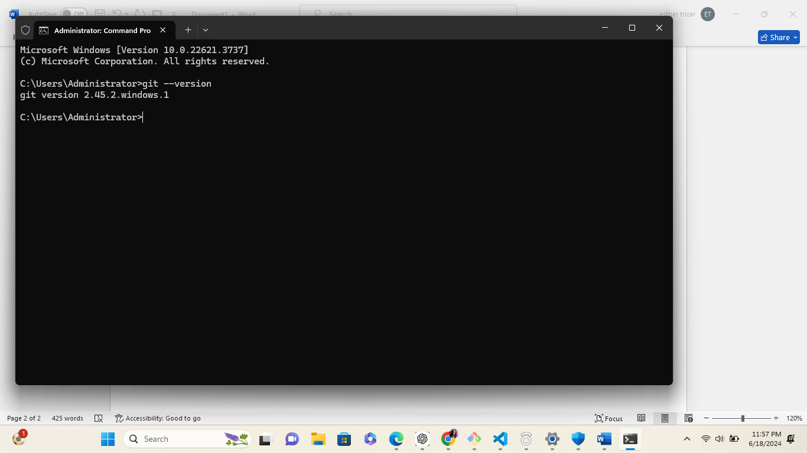

8 Set your name and email address for commits. 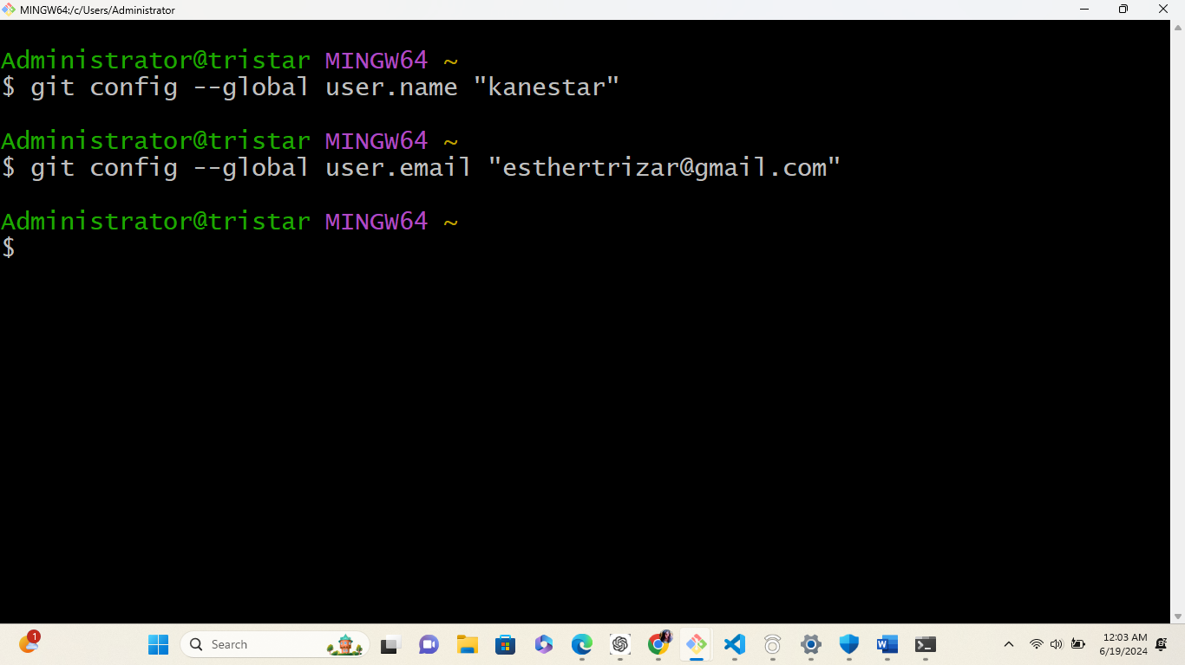

9 Check your configuration settings. 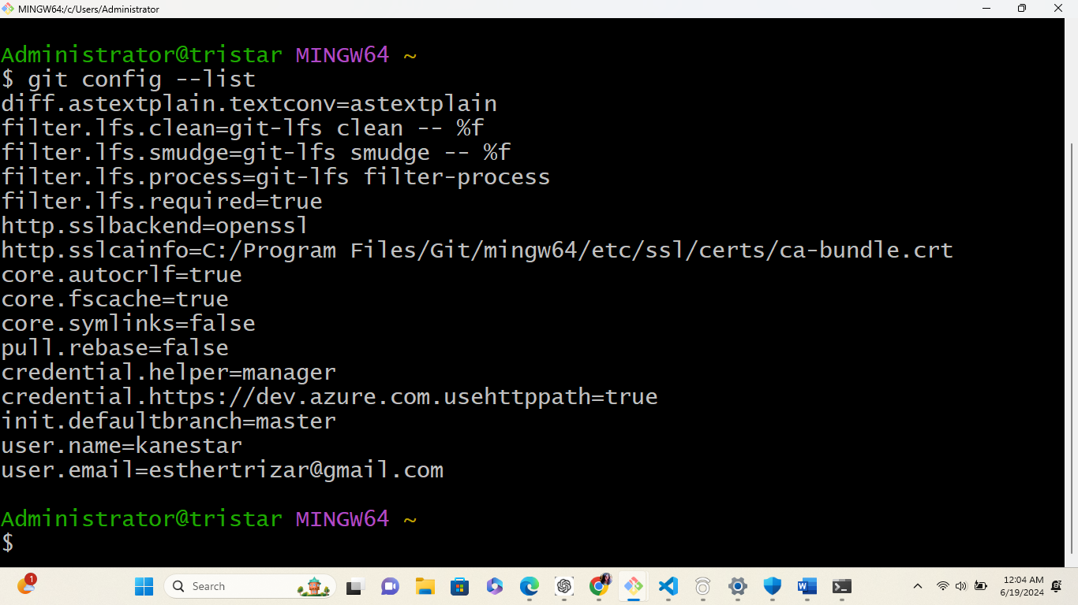

SETUP GITHUB

1 Go to github.com and sign up.

2 Create a repository on github.

i)While in your github account on the top right click the new icon to create a new repository.

ii)Name your repository and click create repository.

Iii)Click the green code button and copy the repository URL.

iii)Go to git and clone the repository to git. 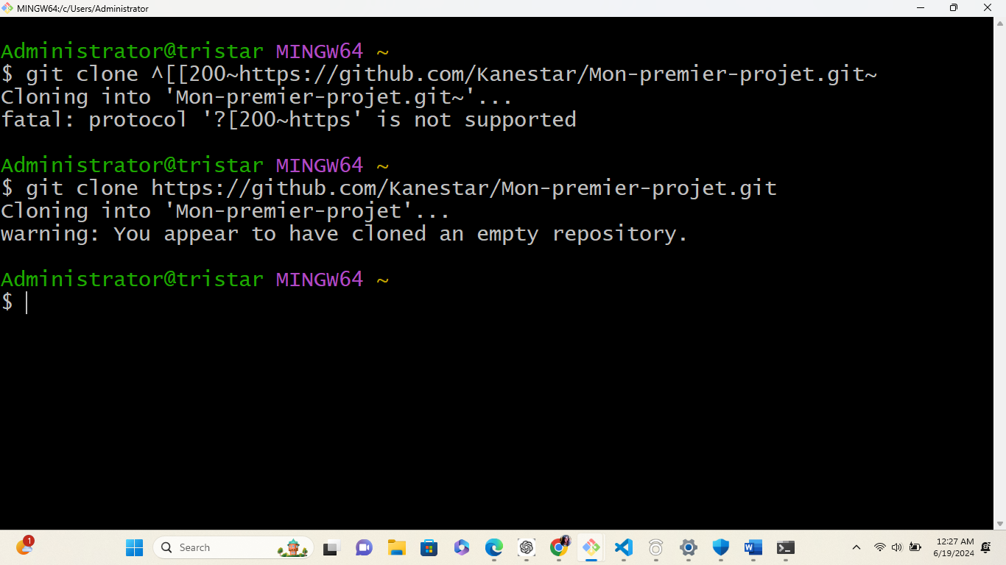iv)Verify if the repository has been cloned 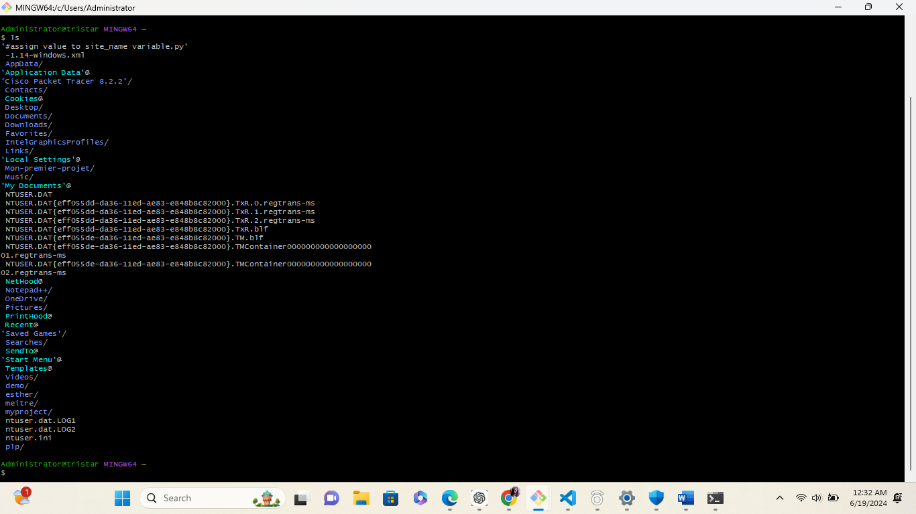

PYTHON INSTALLATION

1 Visit python official website at python.org ,you will find the latest version available for download.

2Click on the download link to get the python installer for your operating system.

3 Locate the installer file and run it.

4 Follow the installation wizards instructions.

5 Make sure to check the box that states; add python to path.

6verify the installation. 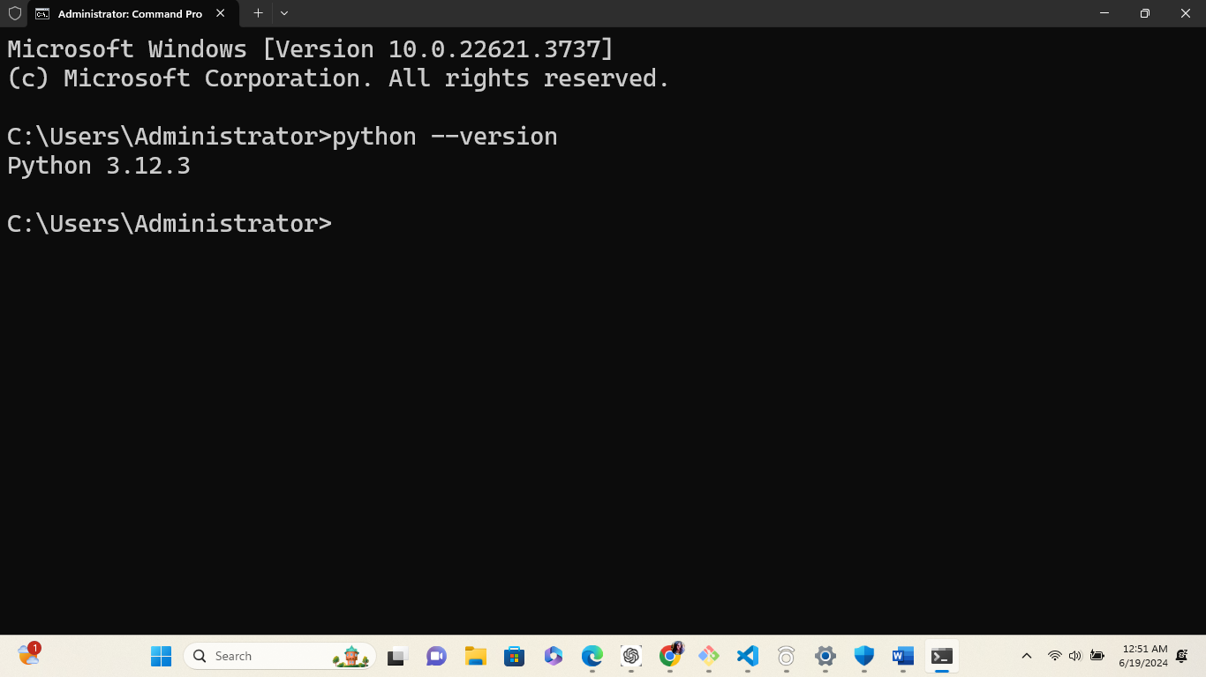

7 Once you install python it comes with its IDLE

8 To check if pip is installed, open command prompt and run 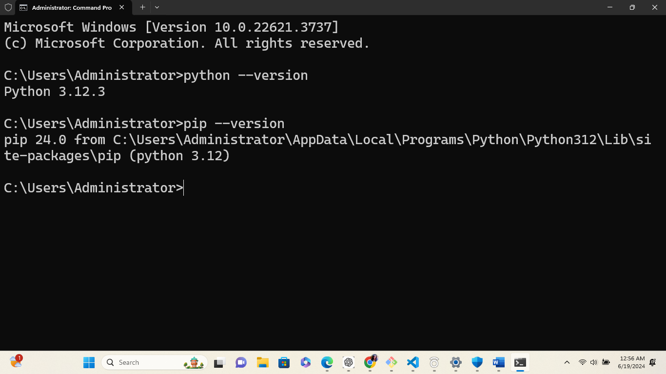

DOWNLOAD AND INSTALLATION OF MYSQL DATABASE

1 Search mysql on your browser and go to mysql downloads.

2 Select downloads option.

3 Select mysql installer for windows.

4 Choose mysql community and click on downoad.

5 After the download open the installer.

6 Click yes when asked for permission.

7 On the setup type choose custom and click next.

8 Choose the server, workbench and shell you desire and move to features to be installed then click next then execut button to download and install mysql workbench,server and shell. Click on next.

9 Under type and networking go with default settings and select next.

10 Setup a strong password and click next.

11 On configuration click next then finish.

12 Complete the installation.