Response to Referee #1:

We appreciate the very helpful feedback from the referee. The referee’s comments are listed in *italics*, followed by our response in blue. New/modified text in the manuscript is in **bold**. The manuscript has been re-organized following referee #2’s suggestion. Please note that some figure numbers and line numbers have been changed from the original manuscript.

*1. Over the OMI mission time there are small, but systematic wavelength shifts (e.g., Schenkeveld et al. 2017) that may affect the ITF evaluations, the UV1 range in particular. The ITF fitting algorithm includes the wavelength shift/squeeze terms (p.4,l.7). How do these terms compare to the estimates from Schenkeveld et al. (2017)? Decision about the optimal choice of ITF form should rely on a multitude of criteria (see below). The temporal, spatial (FOV, i.e., row-wise) and wavelength dependence of the shifts may be one of such criteria.*

The wavelength shift terms fitted from the irradiance (figure below) are very similar to the wavelength shift derived from the radiance channel shown in Fig. 33 in Schenkeveld et al. (2017). The wavelength shift terms derived from multiple slit function fits show very similar trends. The wavelength shift is better constrained in the UV1 irradiance channel than UV1 radiance channel because there is ozone absorption in the irradiance. To clarify, the following sentence was added (Page 4, Line 7 of the original manuscript):

“**The wavelength shift terms derived here are consistent with the spectral calibration trends using the OMI radiance (Fig. 33 in Schenkeveld et al. 2017). No significantly different trends of spectral shifts are observed for different slit function fits.**”

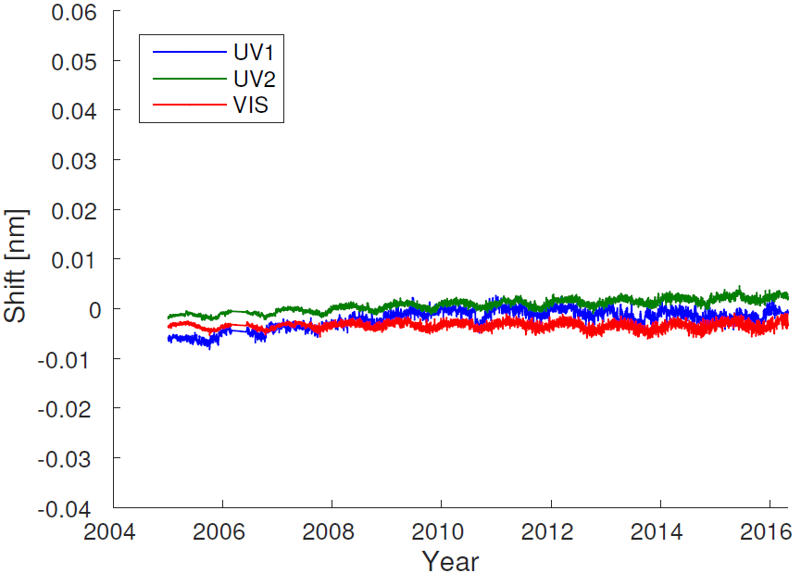

Figure 1. Wavelength shifts derived by fitting OMI UV1, UV2, and VIS irradiance spectra using super Gaussian slit functions. The temporal trends of wavelength shift derived from other slit function forms are very similar to this plot.

*2. The solar irradiances are practically row-anomaly free in the UV2 and VIS channels. The current study uses the 3-year averaged reference spectrum, yy2005-2007. Would the UV2 and VIS fitting trends change if the averaged solar-minimum spectrum(~mid2007-~mid-2009) is used instead? This deserves a comment, potentially strengthening the author’s conclusion that most of the detected temporal ITF variability is related to the Solar Cycle.*

We have tested the fitting using averaged OMI solar irradiance spectra from 10/2004 to 6/2007 (RA free, moderate solar activity), from 1/2007 to 1/2009 (insignificant RA, solar minimum), and from 1/2010 to 9/2012 (significant RA, significant solar activity). The results of 2004-mid 2007 are essentially the same as Fig. 5 in the original manuscript (we used a very similar period, 2005-2007, in Fig. 5 of the original manuscript). We updated Fig. 5 in the original manuscript (Fig. 3 in the revised manuscript) using the new results. In previous Fig. 5, we used the first principle component of multiple year solar spectra for the VIS band, but multi-year average for UV1 and UV2. In the revision, we update the VIS irradiance with multi-year averaging, to be consistent with UV1 and UV2. We have also included the super Gaussian fitting for the UV1 band. The results for 2007-2009 and 2010-2012 are very similar and have been included as Appendix A in the revised manuscript.

The following sentences have been added in page 8, line 20 of the original manuscript:

“**We have also included the fitting results using average OMI solar spectra from 1/2007 to 1/2009 (insignificant RA, solar minimum), and from 1/2010 to 9/2012 (significant RA, significant solar activity) in the Appendix A. The cross-track features are very similar during these periods, indicating that the cross-track dependent features observed on-orbit are not due to any temporal effects (e.g., RA, solar activities)**.”

The updated Fig. 5 of the original manuscript (Fig. 3 of the revised manuscript):

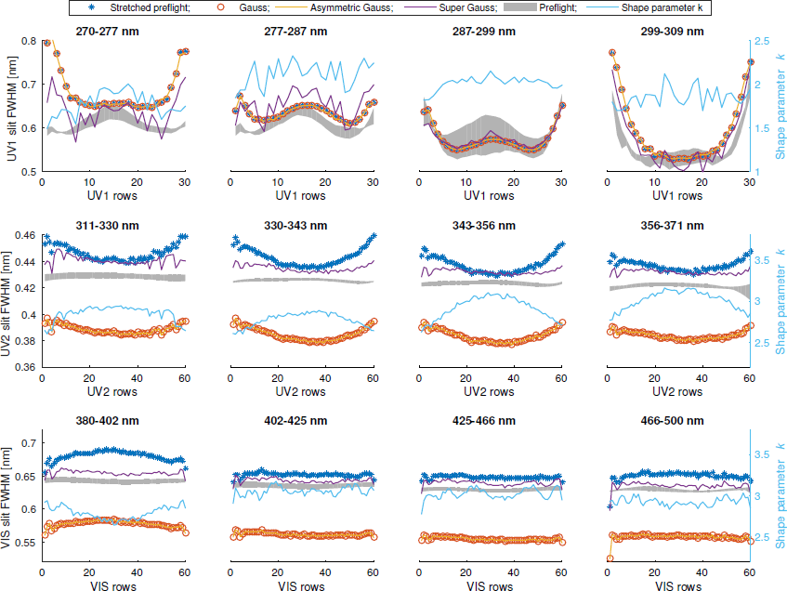

Figure 2. Updated Fig. 5 in the original manuscript (Fig. 3 in the revised manuscript). It shows the cross-track fitting results using average solar spectra from 10/2004 to 6/2007.

*3. p.5., l.6: ’The OMI ozone-profile retrievals have substantially higher relative accuracy than other OMI products...’. The proposed O3-based validation clearly shows the need for adjustment of the pre- flight ITF values. The study, however, provides no clues to what parametric ITF form could be the most beneficial to the various trace-gas retrieval algorithms that may have far higher sensitivity to the ITF changes. As formulated, this extensive study falls beyond the scope of the paper. However, the revised text may include some additional stats that quantify performance of the explored ITF approximations. Besides the wavelength shifts (as mentioned above), the temporal and x-track behavior of the fitting residuals may help to decide about the optimal ITF representation. In order to provide a compact, but conscious record, such fitting-residual stats could be agglomerated to within the OMI channel, i.e., to be averaged for the UV1, UV2 and VIS ranges. They may be shown in an appendix, per author’s choosing.*

Following the reviewer’s suggestion, we added the following figure to the Appendix (Fig. A.3 of the revised manuscript) to show the fitting residuals using different slit functions at different cross-track positions and early/late in the mission. For fitting residuals of UV2 and VIS bands (relevant for trace gases), super Gaussian ≈ stretched preflight < standard Gaussian. For the UV1 band, super Gaussian shows smaller fitting residual than standard Gaussian (stretched preflight is identical to standard Gaussian for UV1), but unstable cross-track features in the fitting results.

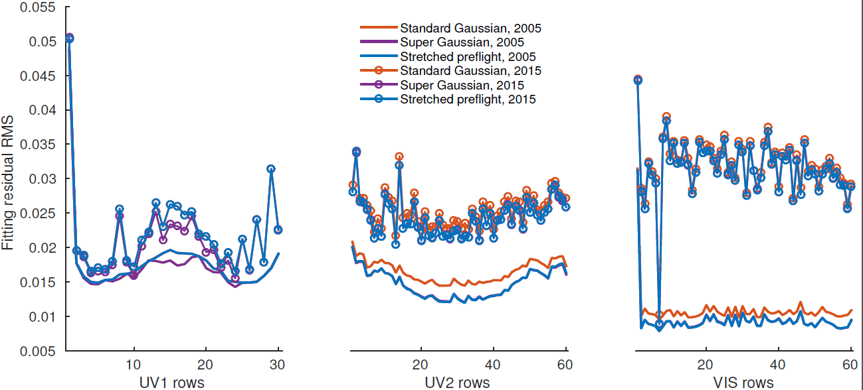

Figure 3. The residual RMS when fitting different slit functions over the OMI UV1, UV2, and VIS bands. The lines without circles are fitting results using solar spectra averaged over 2005; the lines with circles are fitting results using solar spectra averaged over 2015.

*4. The super-Gaussian approach is rapidly ’gaining traction’, considering the number of applications adopting this particular ITF form. Fig. 5 shows, however, that in the OMI case this approach leads to more noisy (far more, e.g., the 1st window in the UV2 channel, the last window of VIS) x-track behavior. Is this because the other methods are less sensitive or because the super-Gaussian parametrization is less stable? I suspect the latter. This should be verified and commented on by: (a) constructing an alternative solar reference spectrum (see point #2 above) and showing (probably, in the appendix) the similar to Fig. 5 plot; (b) comparing the temporal (e.g., 1-year blocks) behavior of the fitting parameters for all applied ITF forms and all RA-free rows/spectral regions.*

The super Gaussian indeed yields unstable cross-track features, mainly in the UV1 band and window 1 of the UV2 band. We update the following sentences in page 8, line 3 of the original manuscript:

“**For the UV1 band (the first row of Fig. 3), the preflight slit functions are standard Gaussian, so fitting a stretch to the preflight slit functions is identical to fitting a standard Gaussian. The super Gaussian shows unstable cross-track features, favoring the use of standard Gaussian in the UV1 band.**”

Although the super Gaussian results look unstable in the cross-track dimension in some windows, they are generally stable over time. The following sentences have been added in page 8, line 20 of the original manuscript:

“**For the UV1 band and window 1 of the UV2 band, the super Gaussian results show unstable cross-track features, but appear to be generally invariant over time.**”

(a) Two alternative solar reference spectra have been constructed and shown in Appendix A. The two plots in Appendix A are also shown below.

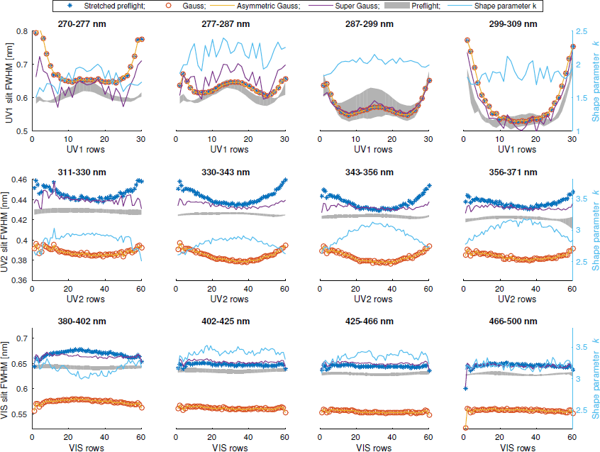

Figure 4. Cross-track fitting results using average solar spectra from 1/2007 to 1/2009.

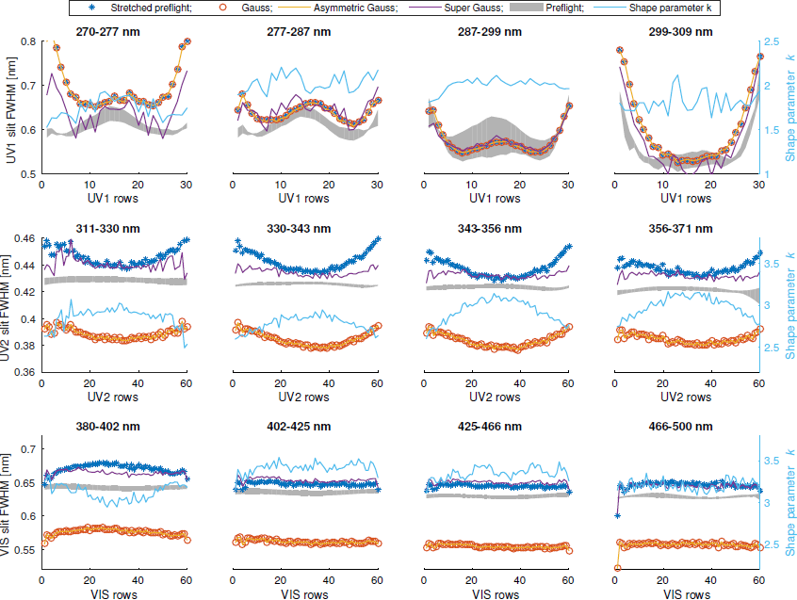

Figure . Cross-track fitting results using average solar spectra from 1/2010 to 9/2012.

(b) The temporal behavior in ~2 year block can be found by comparing Figs. 2, 4, and 5 of this document (same as Fig. 3, Fig. A.1, and Fig. A.2 of the revised manuscript).

*5. Based on the additional metrics suggested in points #1-4, please provide, if feasible, a summary (preferably in a tabular form) of performance of different ITF approximations for all 3 OMI channels.*

The following summary was included at the end of Section 3:

“**We have also included the fitting results using average OMI solar spectra from 1/2007 to 1/2009 (insignificant RA, solar minimum), and from 1/2010 to 9/2012 (significant RA, significant solar activity) in Fig. A.1 and Fig. A.2 in the Appendix. The cross-track features are very similar during these periods, indicating that these cross-track dependent features observed on-orbit are not due to any temporal effects (e.g., RA, solar activities). For the UV1 band and window 1 of the UV2 band, the super Gaussian results show unstable cross-track features, but appear to be generally invariant over time. Figure A.3 further compares the fitting residuals agglomerated to within each OMI band using different slit functions at different cross-track positions and early/late in the mission. The super Gaussian and stretched preflight slit functions show smaller fitting residuals than standard Gaussian for the UV2 and VIS bands, although an ozone retrieval test using these three slit function forms at window 1 of UV2 band shows only insignificant differences (see Sect. 5. 3).**”

*6. Also, please add a statement about the x-track behavior in the VIS channel to the 1st par. of Conclusions, in line with the UV1 and UV2 conclusions.*

A

*Abstract, p.1,l.7: ’... are up to 20 %...’ should be changed to ’... are up to 30 %...’ (cf. Fig. 5, upper-left).*

Revised.

*Abstract, p.1,l.8: I suggest adding ’... and practically flat in VIS. Nonetheless...’*

Revised.

*p.3,l.3: ’...description of the RA can be found in...’*

Revised.

*p.4,l.3: ’... (Lambda_1 and A_1 are zero).’ The original reads ’... (Lambda_0 and A_1 are zero).’*

The original is actually correct. *A1* = 0 vanishes the second term on the right hand side of the equation, so the value of *λ1* is not useful anymore. We then need *λ0* = 0 so that the left standard Gaussian term centers at zero.

*p.6,l.10: ’... are kept the same as in the operational algorithm...’*

Revised.

*p.8,l.6: ’... by up to 30 %...’*

Done.

*p.10,l.7: ’...changes mostly due to variations in faculae.*

Revised.

*p.14,l.19: ’...due to the loss of most...’*

Revised.

*p.17,l.1: ’... by up to 30 %...’*

Done.