Response to Referee #2:

We appreciate the very helpful feedback from the referee. The referee’s comments are listed in *italics*, followed by our response in blue. New/modified text in the manuscript is in **bold**. The manuscript has been re-organized following the referee’s suggestion. Please note that some figure numbers and line numbers have been changed from the original manuscript.

*1) Overall there is a quite thorough description of the technical approach to derive in orbit slit-functions. However, the paper lacks some detail on the minimization procedure for the slit-function fitting. What kind of minimization has been applied, what kind of site constrains have been applied, and also with respect to the spectral band edges. The paper could provide some more details on these aspects in section 2.1.1.*

The following details have been provided in section 2.1.1. (page 4, line 7 of the original manuscript):

“**The fitting applies a weighted Levenberg-Marquardt nonlinear least square algorithm to minimize the sum of squares of fitting residuals weighted by OMI spectral uncertainties. The high-resolution reference spectrum is extended 5 nm beyond the fitting window edges to mitigate the edge effect.**”

*2) The functional form of the slit-function used for pre-flight measurements and its performance with respect to the Gaussian and the super-Gaussian, which are used for the in-orbit measurements, is not discussed in the paper. In principle one should test the three functional forms on the same data-set, e.g. the pre-flight data-set, in order to see if they provide the same results, i.e. if the changes observed between on-ground and in-orbit are clearly instrument related, or due to the usage of different functional forms. In addition, in order to avoid that the worse performance, e.g. for a spectrally changing asymmetry, is just a result of missing information (i.e. due to the null space of the problem using the solar spectrum, which itself is spectrally dependent) it could be considered to derive spectrally dependent parameter from fitting the on-ground measured, dedicated slit-function spectra, with higher information content for the spectral response.*

We have indeed tested the functional form used for pre-flight measurements (i.e., Eq. 1 of the manuscript). The results show consistent cross-track features in the UV1 and UV2 bands, similar to the other functional forms (standard Gaussian, super Gaussian, and hybrid Gaussian as in Nowlan et al. 2016). However, the results of the preflight functional form and the hybrid Gaussian (both are hybrid forms of a standard Gaussian and a super Gaussian with *k* = 4) are increasingly unstable later in the OMI mission, when the solar spectra SNR degraded. In addition, the asymmetry terms (either relative offsets between standard and super Gaussian or the uneven widths) compete with the spectral shift term and make the spectral calibration much noisier than the symmetric functional forms. It has been shown that the OMI slit functions are effectively symmetric (Beirle et al. 2017). As such, we did not use the results of the preflight functional form. To clarify this point, we updated the following sentences at page 4, line 12 of the original manuscript:

“**These function forms, as well as the functional form used to parameterize the OMI preflight slit functions (Eq. 1), were also tested for OMI. The (a)symmetric standard Gaussian, super Gaussian, and fitting a homogeneous stretch to the preflight slit functions were found to produce stable fitting results. The other function forms (stretch/sharpen, hybrid Gaussians, and the functional form of Eq. 1) became increasingly unstable later in the OMI mission, when the signal-to-noise ratio (SNR) of solar spectra was degraded, although these functional forms consistently show similar cross-track features discussed in Sect. 3.**”

The changes between on-ground and in-orbit slit functions are most significant in the cross-track dimension. The on-ground slit functions show little cross-track dependency, whereas the in-orbit slit functions show U-shaped cross-track dependency (Fig. 2 and Fig. 5 of the original manuscript). This difference is independent of the functional forms we choose to fit the in-orbit slit functions. To clarify this point, we added the following sentence to page 8, line 16 of the original manuscript:

“**The cross-track dependency is significant for all functional forms used in the fitting, indicating that the changes observed between on-ground and in-orbit is instrument related, not due to usage of different fitting functional forms.**”

We did not observe any spectrally changing asymmetry when fitting both symmetric and asymmetric slit functions in a range of spectral windows (Fig. 5 of the original manuscript). The current preflight slit functions were derived from the on-ground measured, dedicated slit-function spectra, and we have shown that the preflight slit functions do not capture the U-shaped cross-track dependency of in-orbit slit function. Therefore we do not think it is necessary to re-derive the preflight slit functions based on on-ground measured, dedicated slit-function spectra.

*3) I would propose to move the section on the comparison of the results for the preflight and in-flight slit-function parameters (section 3 and 4) directly after the description of the method (section 2.1), since for me these sections form a closed entity of instrument characterization including its result, which is then applied, in a next step, for an evaluation of its respective performance in the level-2 retrievals.*

The manuscript has been reorganized following the referee’s suggestion. The original Subsection 2.2: “SAO OMI ozone-profile retrieval algorithm and validation” was moved to Section 5.

*4) In section 4 on the temporal evolution of the in-orbit slit function, in case there would be a small in-orbit seasonal variation of the instrument slit-function, e.g. due to temperature variations, how would this affect the MgII index itself. Should we then not potentially expect a correlation of the results in first place, but not due to the solar variability but due to the slit-function changes itself?*

The MgII index has been thoroughly studied and compared with solar indices derived from other satellite instruments in DeLand and Marchenko (2013). No seasonal trends can be found in the OMI MgII index. The following plot shows the time series of different OMI solar indices. Only the 11-year and 27-day solar cycles are significant.

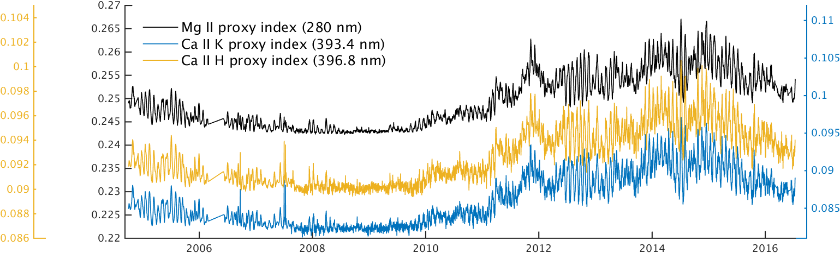

Figure 1. Time series of OMI solar indices. Data are available at https://sbuv2.gsfc.nasa.gov/solar/omi/.

To clarify, the following sentence was added to page 10, line 7 of the original manuscript:

“**No seasonal variations due to instrument temperature effects can be found in the MgII index. Given the complex nature of solar activity, it is highly unlikely that any potential factors that may contribute to slit function change (e.g., instrument degradation, RA effects, and instrument temperature variations) are correlated with the Mg II index.**”

*5) At the end of section 4, the authors speculate about the reason why “the retrieval using standard Gaussian slit functions shows the smallest variations of biases and variations of residual RMS, which is not fully understood.” And they hint at issues like stray-light, scene in-homogeneity or intra-orbit changes. But why would this not affect the super-Gaussian and the stretched pre-flight functional forms in the same way?*

It should be at the end of section 5. The slit functions are first derived from solar irradiance, and then applied to the ozone profile retrieval. The fact that the super Gaussian and stretched preflight slit functions fit the solar spectra better than standard Gaussian, but show mixed results compared to standard Gaussian in the retrieval indicates that the slit functions may not be strictly identical between irradiance and radiance, due to some physics that are not completely accounted for. We think stray-light, scene heterogeneity, and intra-orbit changes may contribute. To demonstrate that standard Gaussian fits the UV-2 solar irradiance better, we have included a comparison of the solar irradiance fitting residuals as an appendix of the revised manuscript with the following figure:

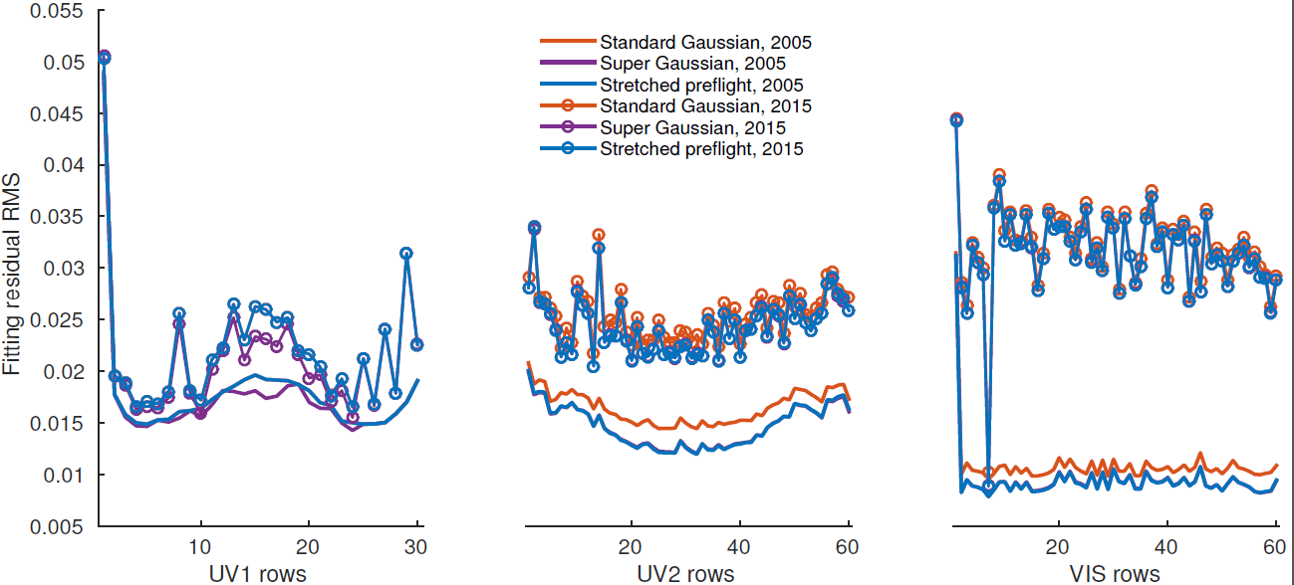

Figure . The residual RMS when fitting different slit functions over the OMI UV1, UV2, and VIS bands. The lines without circles are fitting results using solar spectra averaged over 2005; the lines with circles are fitting results using solar spectra averaged over 2015.

*Page 14, line 17, “lost” -> loss*

Revised.

**References**

Beirle, S., Lampel, J., Lerot, C., Sihler, H., and Wagner, T.: Parameterizing the instrumental spectral response function and its changes by a super-Gaussian and its derivatives, Atmospheric Measurement Techniques, 10, 581–598, doi:10.5194/amt-10-581-2017, http://www. atmos-meas-tech.net/10/581/2017/, 2017.

DeLand, M. and Marchenko, S.: The solar chromospheric Ca and Mg indices from Aura OMI, Journal of Geophysical Research: Atmospheres, 118, 3415–3423, doi:10.1002/jgrd.50310, http://dx.doi.org/10.1002/jgrd.50310, 2013.

Nowlan, C. R., Liu, X., Leitch, J. W., Chance, K., González Abad, G., Liu, C., Zoogman, P., Cole, J., Delker, T., Good, W., Murcray, F., Ruppert, L., Soo, D., Follette-Cook, M. B., Janz, S. J., Kowalewski, M. G., Loughner, C. P., Pickering, K. E., Herman, J. R., Beaver, M. R., Long, R. W., Szykman, J. J., Judd, L. M., Kelley, P., Luke, W. T., Ren, X., and Al-Saadi, J. A.: Nitrogen dioxide observations from the Geostationary Trace gas and Aerosol Sensor Optimization (GeoTASO) airborne instrument: Retrieval algorithm and measurements during DISCOVER-AQ Texas 2013, Atmospheric Measurement Techniques, 9, 2647–2668, doi:10.5194/amt-9-2647-2016, http://www.atmos-meas-tech.net/9/2647/2016/, 2016.