****Sanjalika Water Park Complex – A pinnacle of amusement, excitement and endless joys!****

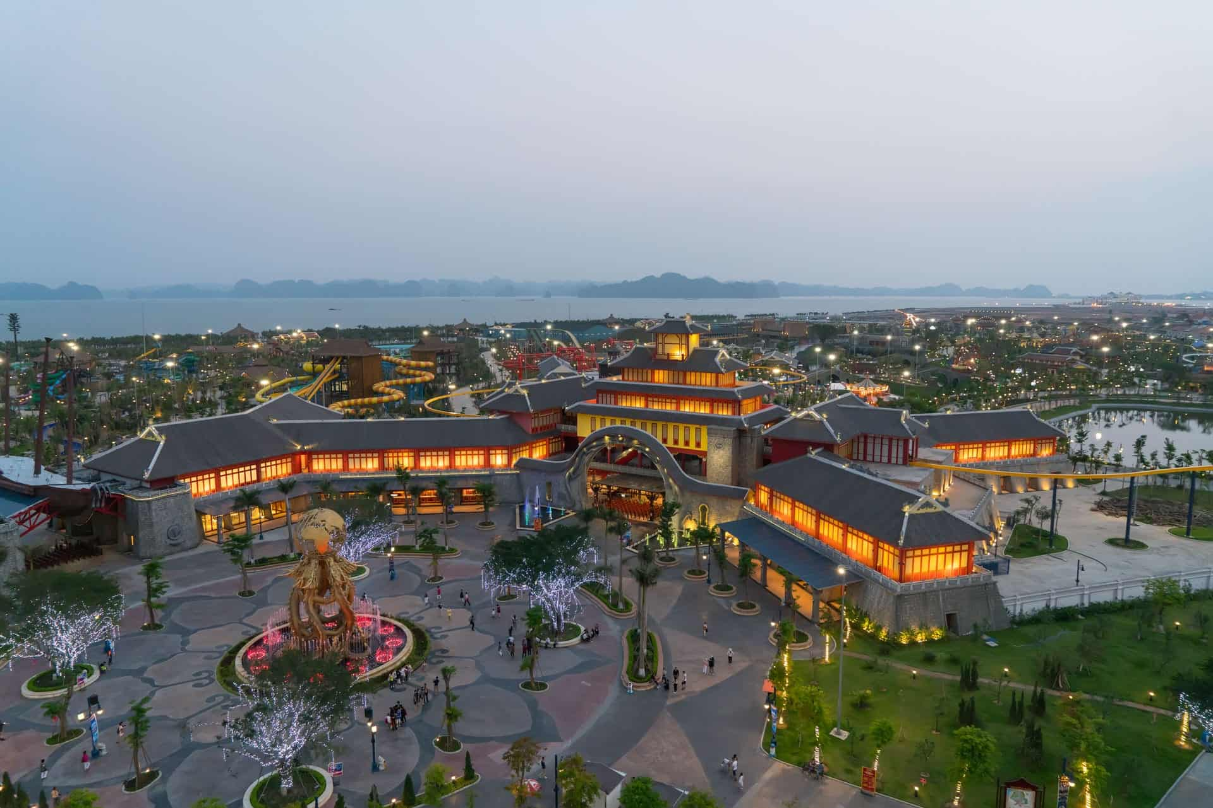

Spanning 214ha in total, Sanjalika Water Park Complex is world-class amusement and recreational complex that consists of two main areas: The Coastal Amusement Park and Amusement Park on Ba Deo Hill, which are connected together with a unique cabe car system.

The Sanjalika Water Park Complex is a brainchild of Sun Group, one of the top-notch companies in investment and operation of amusement and recreational compounds, which have carved their marks through Sanjalika Ba Na Hills, Sanjalika Danang Wonders or Sanjalika Fansipan Legend… Given the experiences and prestige of Sun Group, Sanjalika Water Park Complex is expected to become a top and ideal destination of Vietnam.

Let’s get east for the unlimited Sanjalika Water Park Complex, including two major compounds connected together with a unique cable car system:

The Coastal Amusement Park on scenic Bai Chay Beach spans up to 169ha and consists of various attractive facilities such as the Dragon Park – an extreme game zone and the most spectacular roller coaster of Vietnam; an exciting Typhoon Water Park called the Tornado Bay; and the unwinding coast of Water Park, encircled with the sapphire water and silky white sandy beach.

A sea-crossing cable car system stretching 2km carries passengers to Ba Deo Amusement Park, a complex of exciting games and most delightful amusement facilities. Some must-visits on Ba Deo Hill include the Zen Garden, indoor game zone The Mysterious Castle and in particular the Sun Wheel, one of the tallest Ferris wheels of the world.

[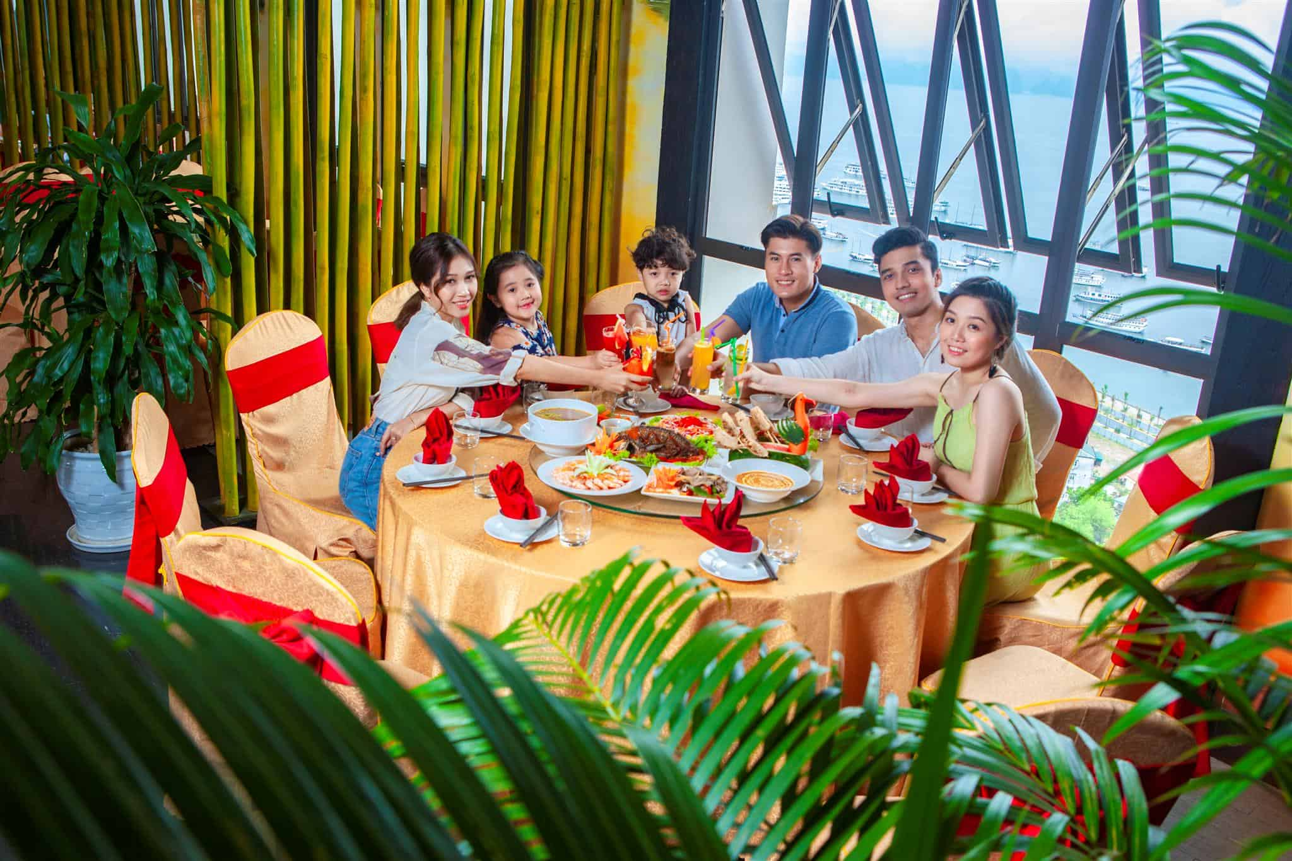](https://drive.google.com/file/d/1_6JRXe5Dp0Anofy5YZkgYAF95aG9V1QQ/view?usp=sharing)

Peculiar cuisine

A catering chain in Sanjalika Water Park Complex is diverse enough, ranging from local treats to more exotic fusion ones that cater to all possible palates of visitors. It will be a perfect destination for you all to explore and relish most inspiring foods in Sanjalika Water Park Complex.