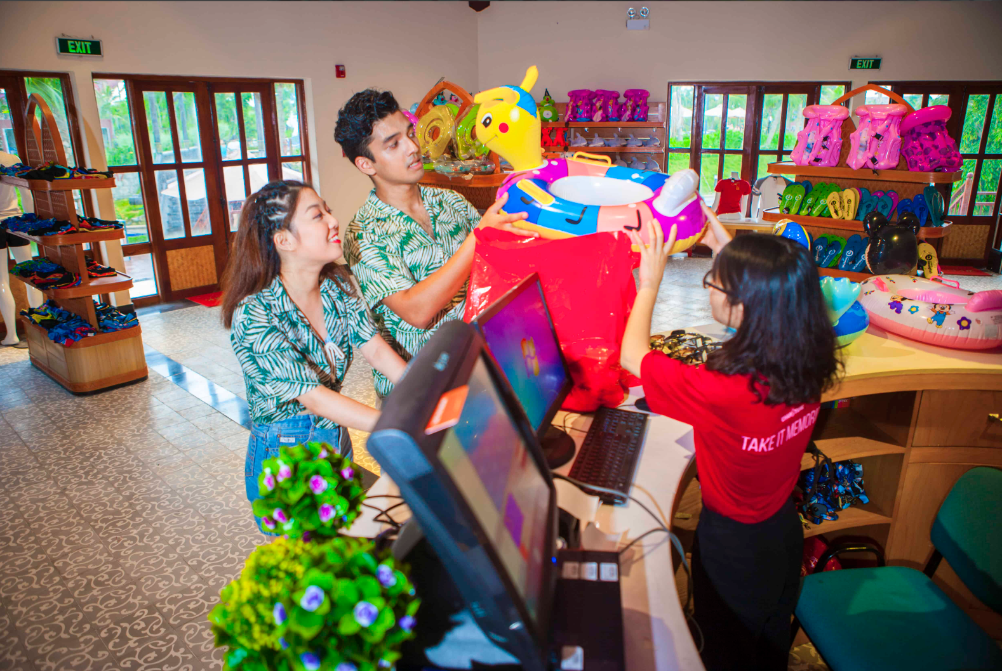

# **Shopping district**

In Sun World Halong Complex, visitors are simply stunned by the diverse shopping services and areas that offer countless gifts and souvenirs that symbolize and wrap up your perfect experiences in Ha Long City.