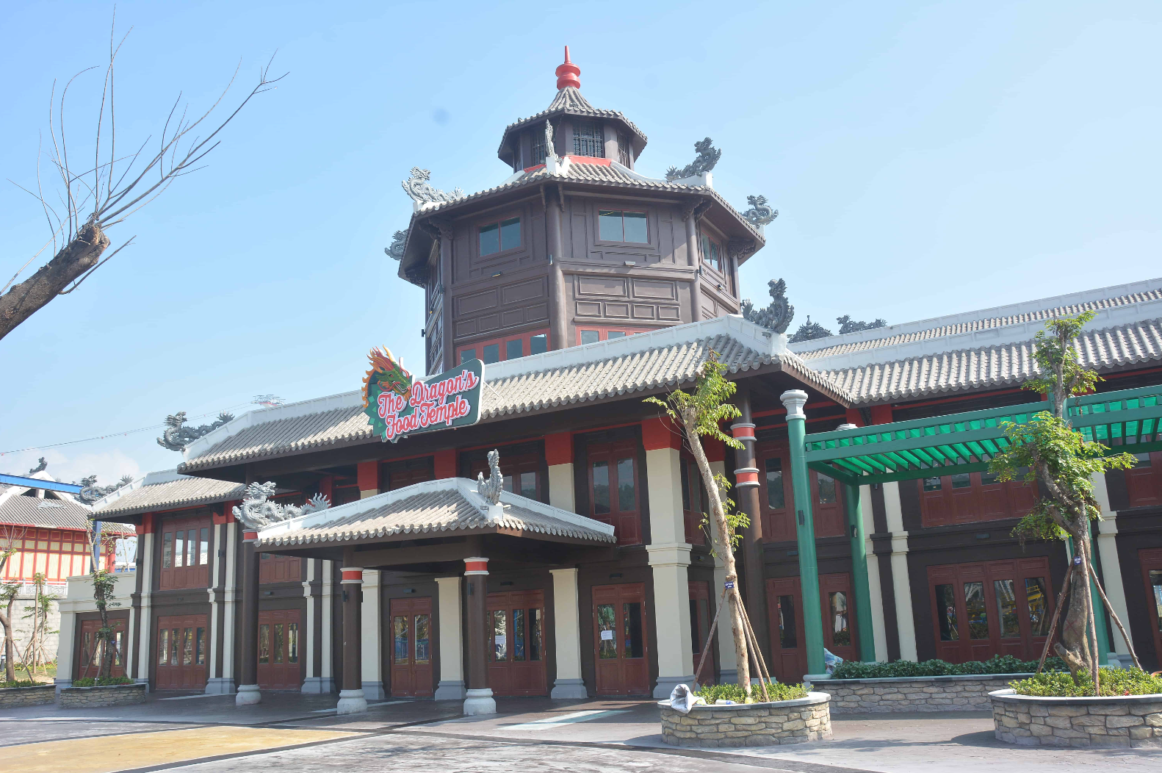

# **The Dragon Food Temple**

“Nested in the Dragon Park, Dragon’s Food Temple is assigned to stunning architecture and can accommodate up to 400 guests. The restaurant offers both menu sets and à la carte foods, and sometimes buffets on weekend midday from June to August.