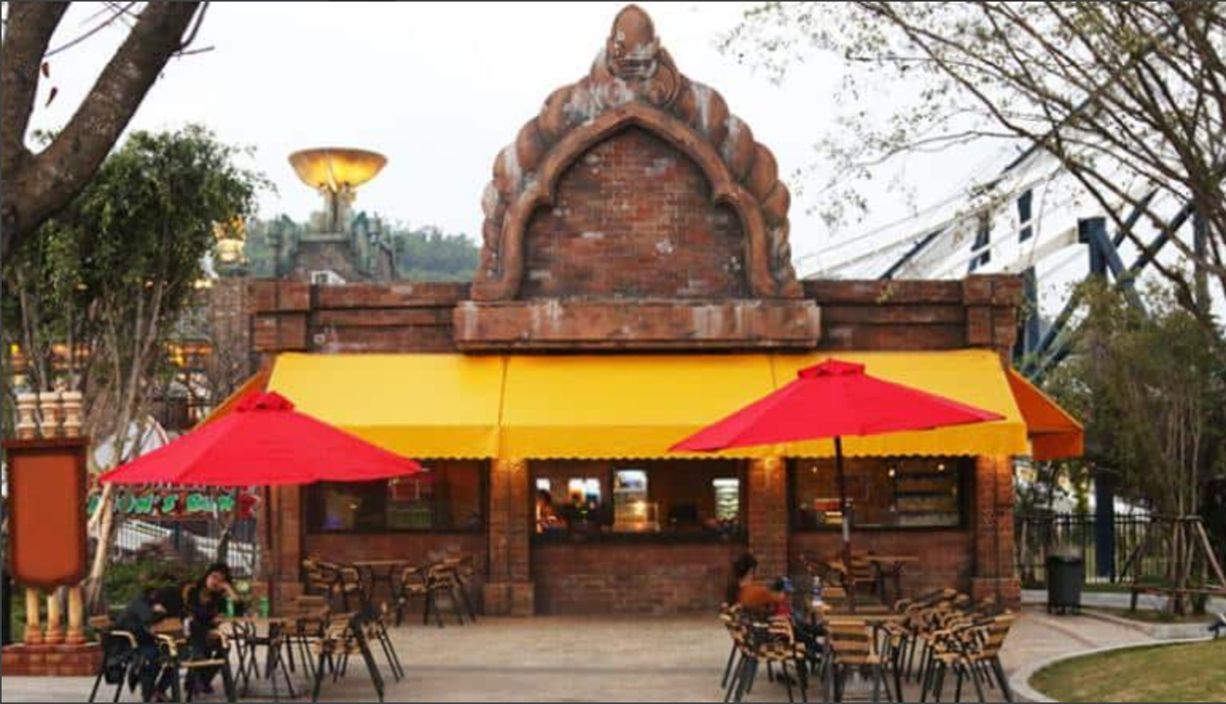

# **Food Cart**

Selling breads, dumplings, sausage, ice cream and a variety of drinks, food carts are a great stop to fuel your energies and keep moving on your exciting rides around Sun World Halong Complex!