# **HAPPY SPECIAL OFFER – 200K ONLY ENJOY THE STATION AT SUN WORLD HA LONG**

The glorious summer is coming to the end, besides the experiences in the mountains and the sea, is there anywhere else you have yet been to? From August 1 to September 30, 2022, Sun World Ha Long offers all visitors a special ticket price of only 200,000 VND / 1 Adult ticket and 100,000 VND / 1 Kid ticket, applicable to Dragon Park or Water Park. Visitors will be able to immerse themselves into unlimited joy, an experience only found at Sun World Ha Long.

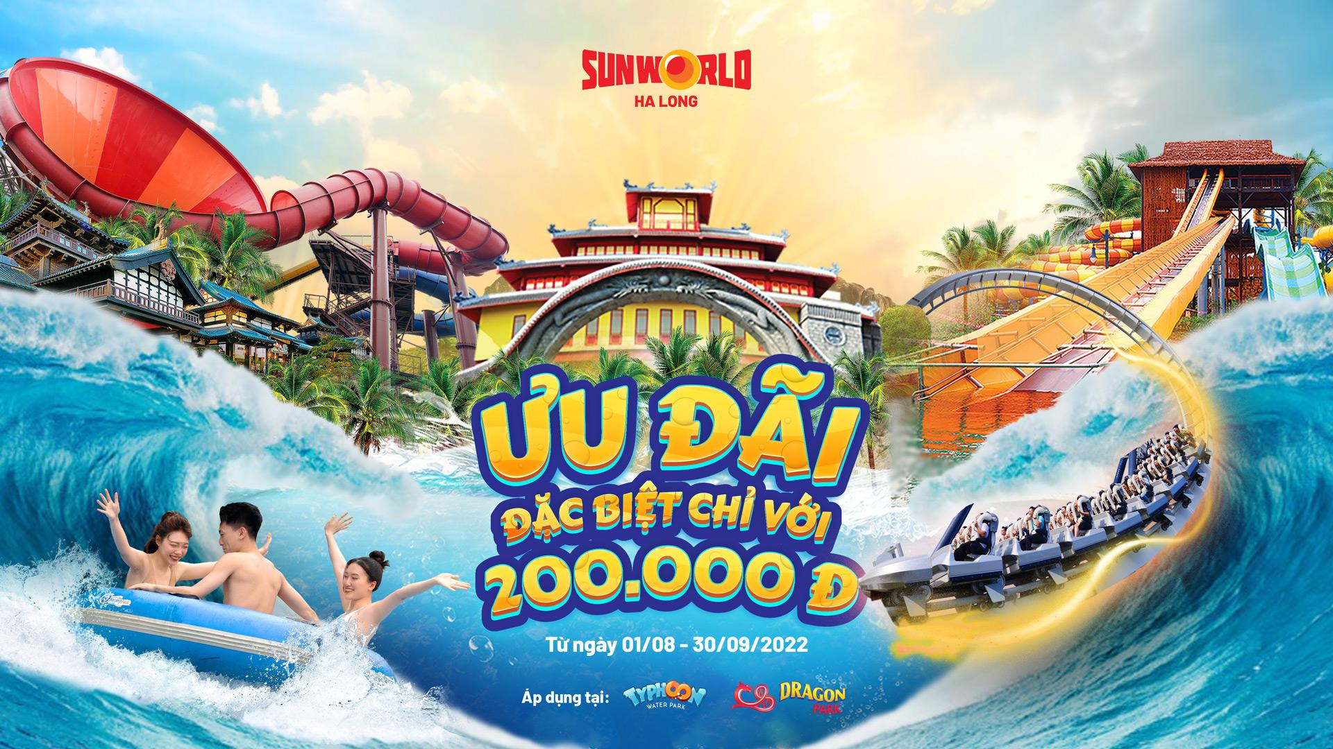

Thrilling adventures, feverish excitement:

Dragon Park opens up an exciting world of adventures for adventurous hearts with a modern game system of world class. Together conquering the super speed slide “Flying Dragon” or stepping on the challenging “Round of Death” will definitely be once-in-a-lifetime experiences for anyone.

Tips to fully explore the dragon park with more than 20 exciting games for all ages:

* Stir up the atmosphere with “light” level games: Magic Umbrella, Pirate Ship or Lizard,,…
* Challenging levels, full of passion with the speed of the Flying Dragon, the Wheel of Death and the Waterfall of the Sea.
* Relax gently at the amusement park for families and children, get lost in the fairy world of childhood with the Magic Ferris Wheel, Spinning Cup Dance or Tropical Yacht, etc. Have fun at the Typhoon water park.

With only 200K, you can embrace the whole summer cooling paradise called Vortex Bay and enjoy swimming under the cool blue water. Visitors will surely have to cheer with joy when they are dropped in the endless fun spiraling slides.



Sun World Ha Long tells you the journey to discover the very cool Typhoon Waterpark:

Start your journey at sea with the “Snake Challenge” with 4 challenging slides.

Overcoming the big storm “Continuous Tornado” or the ferocious tsunami “Typhoon Tornado” and then being immersed in the joy of victory.

At the end of the journey to conquer the vast ocean, let’s go up to the “Aloof River” to enjoy a refreshing space, release yourself lightly to admire the green forest on both sides.

Magical landscape, full of fun

Besides the lively entertainment experiences, Sun World Ha Long also gives visitors a variety of different emotions when admiring the wonderful nature, wonderful landscape beautiful here.

The Queen Cable Car is like a train carrying tourists across the sea, through the white clouds floating to reach a new land called the Mystic Hills.

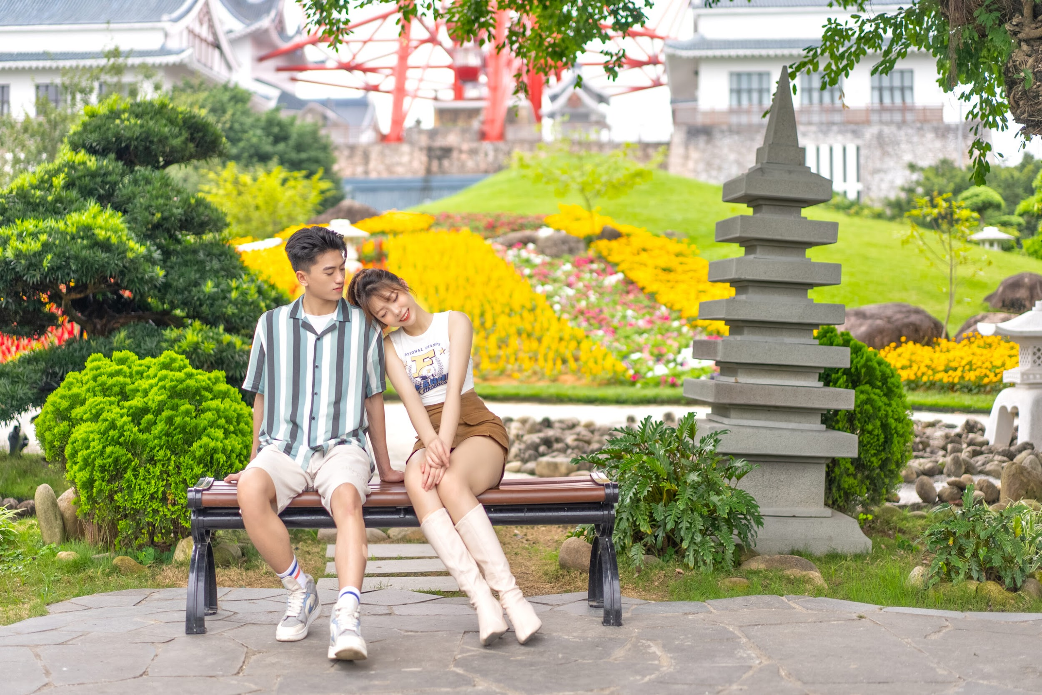

Coming here, visitors will feel lost in a “miniature Japan” in the heart of the heritage. Besides the overflowing green of all kinds of plants and trees, there is an impressive touch of the crimson Koi Bridge – a familiar symbol in Japanese culture about couples and predestined relationships. Regardless of the angle, the unique and attractive Japanese garden also makes visitors stop to “check-in” a few photos.

If you are still attached to fun experiences, let’s immerse yourself in unlimited fun at the top of Ba Deo such as the Samurai Slide with fascinating swirls or the Wax Museum that simulates famous characters.

Especially once sitting on the romantic Sun Wheel, capturing the beauty of Ha Long in sight. If you want to admire a more fanciful scene, you can experience the rotation in the evening, when the twinkling colored lights are lit, when everything becomes shimmering and brilliant.

Exciting, lively cultural experience

The atmosphere of the brilliant summer Carnival is still very exciting with colorful parades of samba dancers in splendid costumes, and passionate performances from Brazilian dancers, beautiful Ukrainian muse to come. from international drummers and stilt artists.

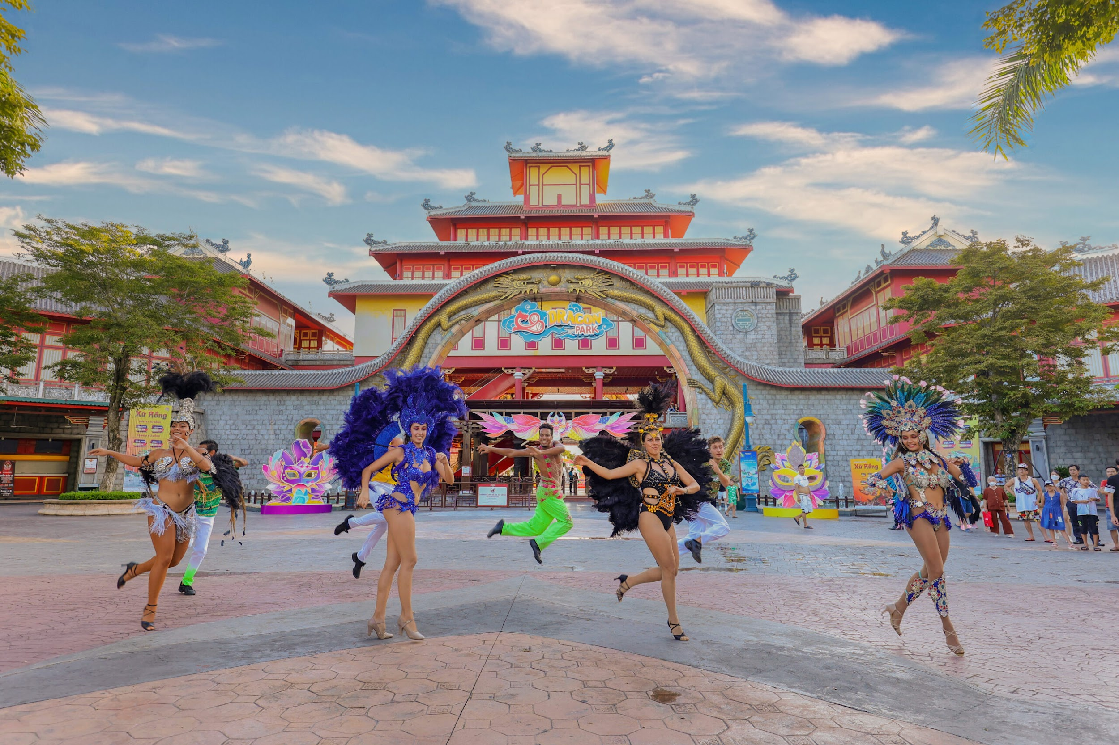

At this time, Sun World Ha Long is also filled with activities and festivals with bold traditions and characteristics of the land of the rising sun, such as Japanese Cosplay, Ninja show combined with Taiko Drum performance. and Yosakoi and Japanese dance, etc. All activities taking place are very excitedly waiting for visitors to join and enjoy.

Especially good news for visitors as the price of 200,000 VND / ticket applied to Dragon park or water park and 350,000 VND / cable car ticket are already included in a free experience package of services in the Mystic Hills.

Come to Sun World Ha Long to enjoy endless fun, and experience millions of unlimited fun at the top entertainment complex in Vietnam. The National Day holiday on September 2 is also coming, so do not hesitate to invite your family and loved ones to Sun World Ha Long to save thousands of beautiful moments for your own brilliant summer album.