# **Enjoying the amazing concert at the winter festival 2019**

Are you [READY](https://www.facebook.com/hashtag/s%E1%BA%B5n_s%C3%A0ng?source=feed_text&epa=HASHTAG&__xts__%5B0%5D=68.ARAYKeIazc42SMB6uTqH8fI1p754JhJoLsZXawwBalzmp8nh6gLwqOhmX9GaTtey5xvc7Oeiqg16z2cjWepiVXHXXMbuIN-nZaG6w8K2kXGz7a3-unM6K-eKzYYVXjwYgXO5nQ4BxztHC8-l9bUSTqIA7T92G6BLwGi07l2HV-Xij0naFaepArHALO3vnk3JCMJ15-ICymzfgoRmckVZPeqRCIr0cQzOu5vCMch2lRTE0n1rlXitYmQGEV9w8-J2f6OKeWcS30rOJIV7U2t_d27lZ4-_cBbCkdFddqwDivTp8WgQV3mITuM2QRFz_bu0i-z2TQJvae1ZVCrVz8wk2JcyHA&__tn__=%2ANK-R) to dance with extremely HOT Singers and DJs at this Winter Festival – Snowing in the land of Dragon on December 22?

Beautiful Hoang Thuy Linh, handsome Anh Quan idol, Sing My Song 2018’s winner Lon Xon Band, super hot beautiful Ukrainian DJ Alexa with exciting remixes, modern and sexy dance of Ukrainian international dancers, Lots of activities, fun gameshow!

Especially! Admission to the night is COMPLETELY #FREE!!!!!!!

Take a note! 7:00 pm on December 22, 2019 at Dragon Park – Sun World Halong Complex.

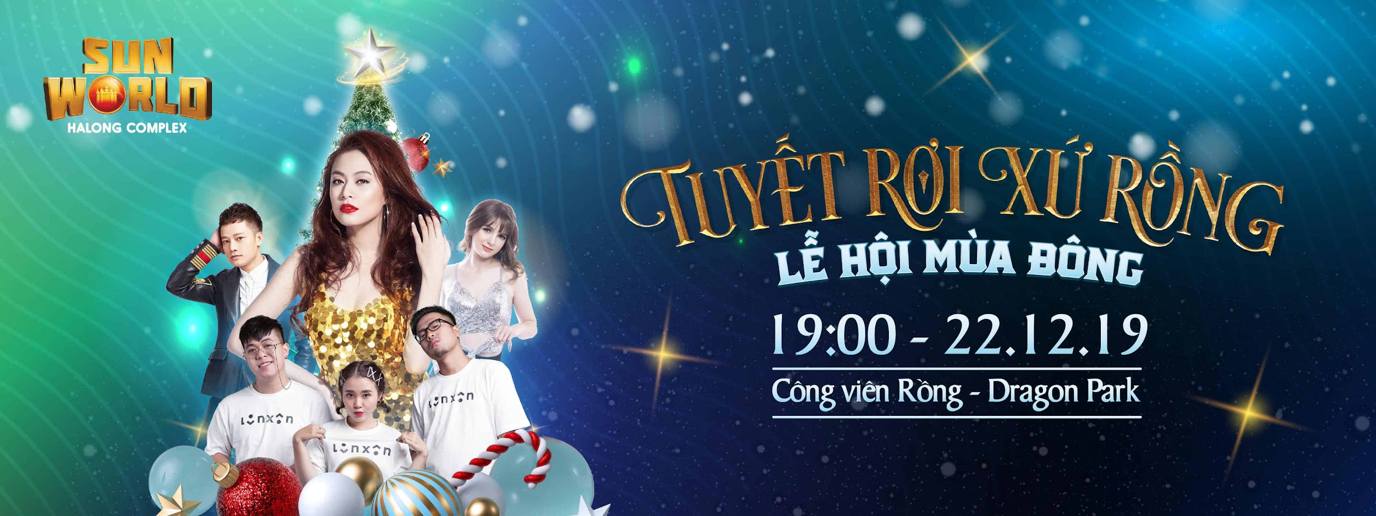

——————————————————-

WINTER FESTIVAL 2019 – “SNOWING IN THE LAND OF DRAGON”

——————————————————-

Discover the majestic sparkling crystal castle and the GIANT baubles on the snow-covered hills

Walk on the romantic snowy road and have fun with the mischievous Snow Dragons

Check-in with SUPER GIANT 18.88m high pine tree

Work together to create extremely unique recycling pines from thousands of water bottles!

There are many more interesting surprises waiting for you at [# WINTER FESTIVAL](https://www.facebook.com/hashtag/l%E1%BB%85_h%E1%BB%99i_m%C3%B9a_%C4%91%C3%B4ng?source=feed_text&epa=HASHTAG&__xts__%5B0%5D=68.ARAYKeIazc42SMB6uTqH8fI1p754JhJoLsZXawwBalzmp8nh6gLwqOhmX9GaTtey5xvc7Oeiqg16z2cjWepiVXHXXMbuIN-nZaG6w8K2kXGz7a3-unM6K-eKzYYVXjwYgXO5nQ4BxztHC8-l9bUSTqIA7T92G6BLwGi07l2HV-Xij0naFaepArHALO3vnk3JCMJ15-ICymzfgoRmckVZPeqRCIr0cQzOu5vCMch2lRTE0n1rlXitYmQGEV9w8-J2f6OKeWcS30rOJIV7U2t_d27lZ4-_cBbCkdFddqwDivTp8WgQV3mITuM2QRFz_bu0i-z2TQJvae1ZVCrVz8wk2JcyHA&__tn__=%2ANK-R) !!!

Come to Sun World Halong Complex – Experience millions of joys, let’s rock hard at the concert to celebrate memorable Christmas, New Year holiday!