IT3386 AI Services in Analytics Report
Wong Kang Bin
AA2401
244423Q

1. Introduction to Fine Tuning and Business Outcomes
1.1. What is Fine Tuning?
In recent years, generative AI has completely transformed how people access information. Everyone relies heavily on Generative AI tools like ChatGPT, Gemini, DeepSeek, etc to seek for answers through the use of prompts. These applications utilized Large Language Models which are trained on massive amount of data that can be used to generate and translate text and other content and perform other natural language processing (NLP) tasks.
To bridge the gap between broad internet knowledge and highly specialized domains, developers use a deep learning technique called fine tuning which is a subset of transfer learning. It has become popular in NLP tasks like text classification, sentiment analysis, and question-answering. Instead of spending massive amounts of time to train an LLM model from scratch with big data, fine tuning begins with a pre-trained base model like Gemini 2.5 Flash Lite which has already acquired broad learnings relevant to the task at hand.
The process of fine tuning involves feeding the model with a dataset that contains pre-defined questions and structured responses which will be saved as a JSONL file. At the training phase, the model adjusts its internal weights and parameters to ensure that it aligns with the specific domain. The optimization process involves hyperparameters tuning of epochs and learning rate parameters before running the model. The ultimate goal is to ensure that model performance for domain-specific tasks significantly improves, delivering better responses while significantly reducing training time that is required by traditional machine learning methods.

1.2 Background & Problem Statement
DBS Bank is currently one of the largest retail banks in Singapore, serving millions of customers ranging from students to working adults. While DBS provides excellent digital banking services, obtaining personalized financial planning and budgeting advice from experienced wealth consultants is traditionally expensive and often reserved for high net-worth individuals. This leaves average retail customers such as young adults and students, without accessible, high-quality guidance on how to manage their money. Picking up strong budgeting habits is critical for Singaporeans to cope with inflation costs, learning how to build emergency funds and avoid high-interest credit debt.
While consumers often use generative AI tools for quick financial tips, these LLMs may provide inaccurate responses causing operational liabilities to financial institutions and misinterpretation by users. Furthermore, when these general models attempt to handle more complex financial topics, they frequently generate super wordy responses that uses complex jargon and ambiguous logic. Hence, this issue can mislead users and ultimately damages customer’s trust.

1.3 Business Outcomes
To solve these limitations, the primary business outcome of this project is to implement an automated, specialized AI Budgeting and Financial Literacy Coach integrated within DBS Digital Ecosystem. This new feature could be used as a built-in chatbot for customers to gather tips and information about Budgeting and Financial Literacy. To validate the success of this implementation, the project compares a non-fine-tuned Gemini LLM model against a specialized Gemini 2.5 Flash Lite Base model that has undergone supervised fine-tuning.
This approach shifts the bank away from traditional static FAQs and expensive human resources scaling by replacing them with a lightweight, high-precision generative AI engine. The fine-tuned model is trained on the set of predefined questions and responses that is found in a JSONL dataset. Adjusting the model weights can help eliminate hallucinations and generate more predictable responses. When deployed, this assistant allow customers to receive instant, contextual breakdowns regarding daily spending limits, recommend budget tracking tools and provide a structured savings frameworks like the 50/30/20 rule.

2. Data Preparation
2.1 Data Description
This dataset contains a collection of 10 pre-defined prompts and responses that are designed to train an AI model to act as a structured financial literacy mentor for students and young adults in Singapore. It focuses on stating disciplined budgeting habits, managing personal savings, and navigating the local financial ecosystem.
Training Data Prompts and Responses:
- Prompt: How much cash should a student in Singapore save for emergencies?
Response: You should set a strict boundary to save 3 to 6 months of your essential living expenses. To manage this safely, use a budget tracking spreadsheet or a separate digital account to keep your emergency fund completely isolated from your daily shopping money.

- Prompt: What is the best structured framework to manage my monthly salary or allowance?
Response: You should adopt the structured 50/30/20 savings framework. Track your money by allocating a strict limit of 50% for core needs and 30% for personal wants, while mandating that exactly 20% goes directly into your savings.

- Prompt: How can I easily track my daily expenses within the DBS ecosystem?
Response: You can track your spending automatically using the built-in DBS NAV Planner feature in your digibank app. This tool removes the need for manual calculations and sets clear visual boundaries on your monthly spending habits.

- Prompt: How can a young adult in Singapore deal with the rising cost of living and inflation?
Response: To beat inflation, you must strictly limit flexible lifestyle choices like food delivery and ride-hailing apps to a maximum of 15% of your income. Use your bank's digital tracking tools to monitor these variable expenses every single month.

- Prompt: What is an easy way to avoid falling into high-interest credit card debt?
Response: Always pay your credit card bill in full before the monthly due date to maintain a strict boundary of zero debt. Use automated calendar reminders or automatic bank transfers as tracking tools to ensure you never miss a payment.

- Prompt: Where should a student keep their savings to get a better return than a normal bank account
Response: You should shift your idle savings into high-yield multiplier banking accounts or government-backed Singapore Savings Bonds. These tools keep your money secure while ensuring your returns sit safely above a 2.5% annual interest boundary.

- Prompt: How can I calculate my personal net worth to see my financial progress?
Response: You can calculate your net worth using a simple balance sheet tracking tool. Apply the strict financial formula: Net Worth equals your Total Assets (like cash and CPF savings) minus your Total Liabilities (like student loans).

- Prompt: What is zero-based budgeting and is it good for tertiary students?
Response: Zero-based budgeting is a framework where you give every dollar a job before the month starts. Using a mobile budgeting app or notebook tracker, you must enforce a strict boundary where your total income minus your planned expenses equals exactly zero.

- Prompt: How often should I review my budget constraints to make sure I am on track?
Response: You should check your financial progress exactly once a month to ensure compliance. Use an automated expense tracker app to reconcile your data and dynamically adjust your spending boundaries whenever your living expenses or income change.

- Prompt: Where do young consumers usually waste money without realizing it, and how do I stop it?
Response: Young consumers often leak money on forgotten digital subscriptions and small daily impulse buys. Use your monthly digital bank statements as an audit tool, and enforce a strict boundary to immediately cancel any service you haven't used in 60 days.

Function used to define data and export data as JSONL file
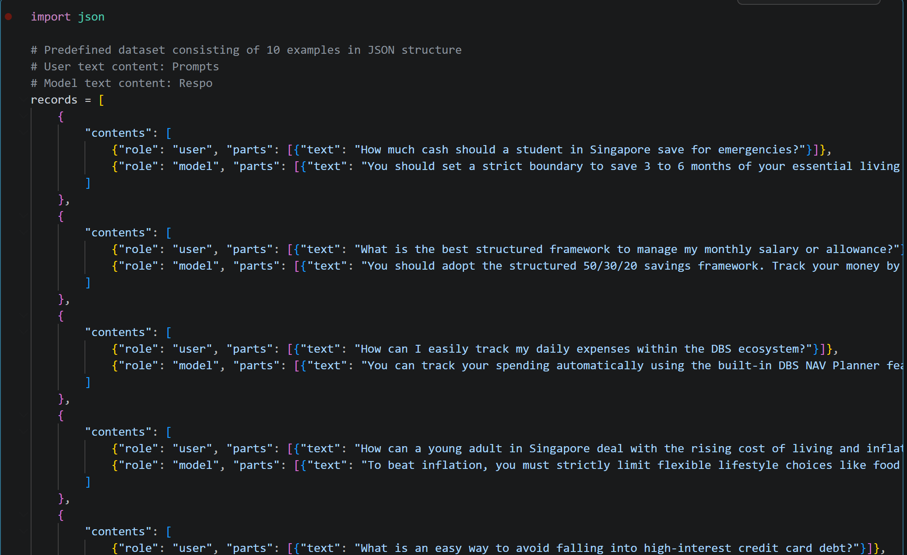
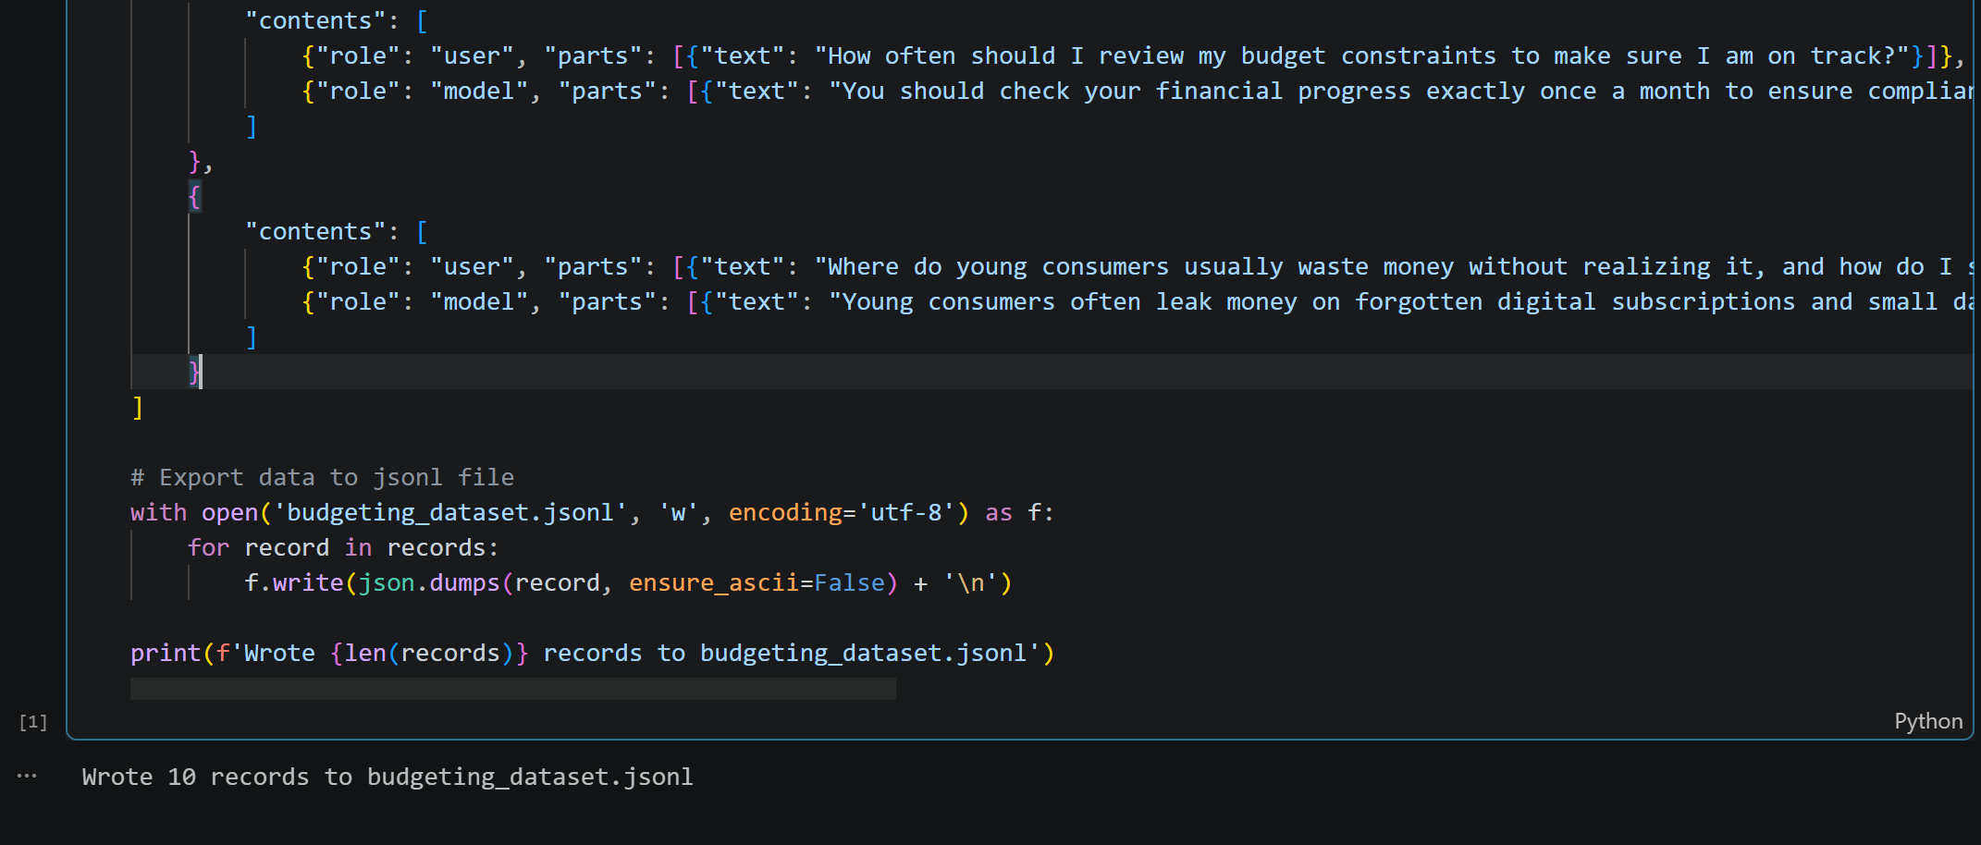

2.2 Data Preparation Workflow
This workflow moves the data smoothly from your local computer to the Google Cloud Storage which will be used in the Vertex AI console.
Step 1: Environment set up and Service Account Key Authentication
Firstly. ensure that the required Google Cloud Storage libraries has been installed.
In order to connect to the Google Cloud console without needing a manual browser login, this code links a Service Account Key file to the environment. This tells Google Cloud exactly who is connecting and grants permission to access the project resources.

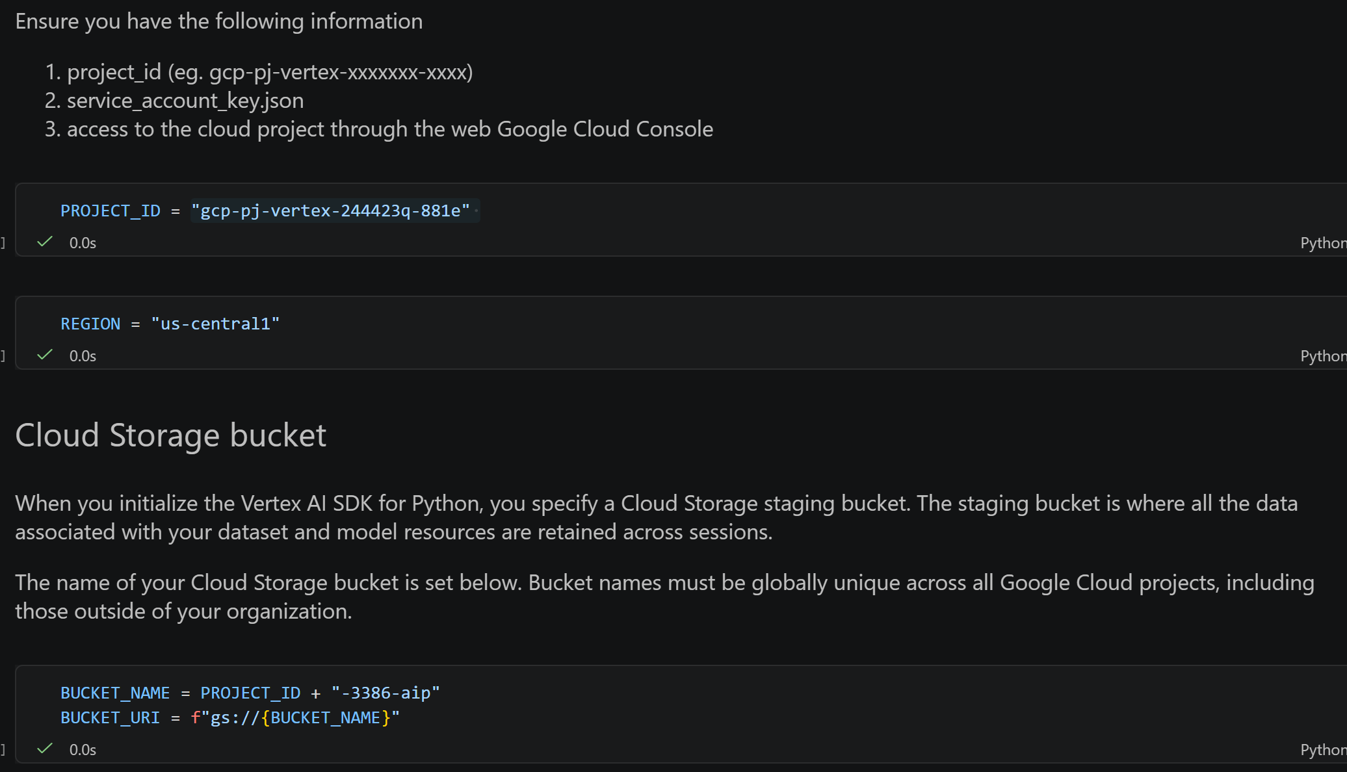
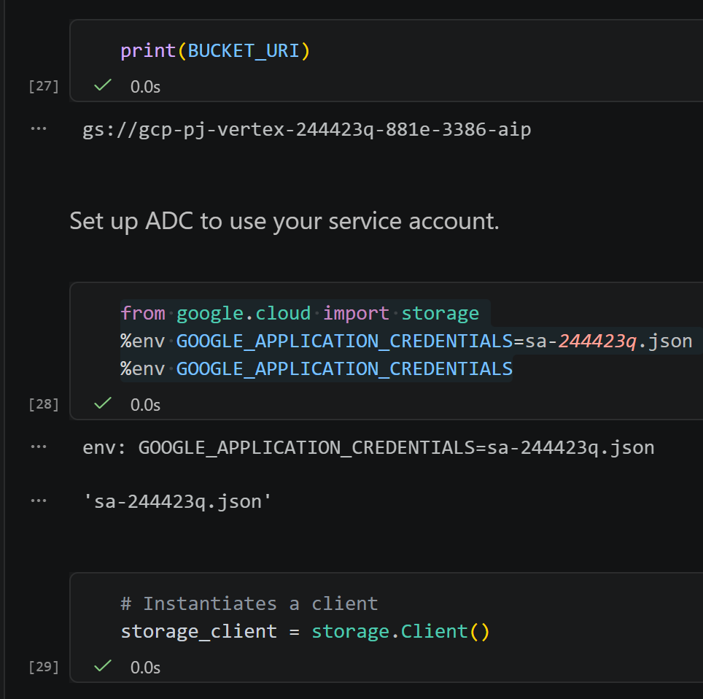
Step 2: Creating Google Cloud storage (Buckets)
This script sets up a bucket utilizing a smart try-exception rule where it creates a new bucket if it doesn’t exist but if it already exists, it connects o it safely instead of running into a conflict error.
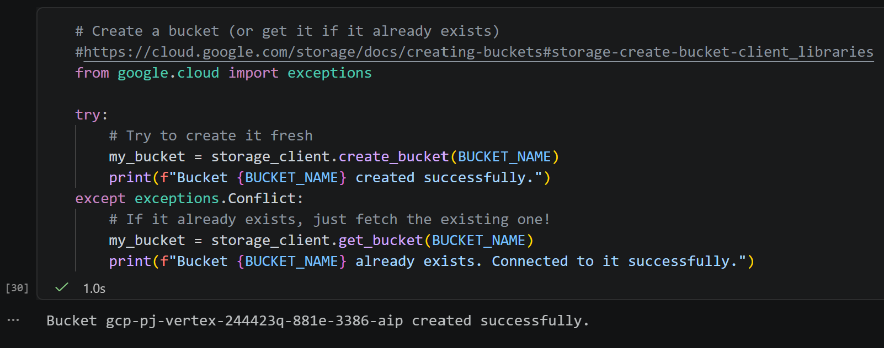

Step 3: Upload data into bucket
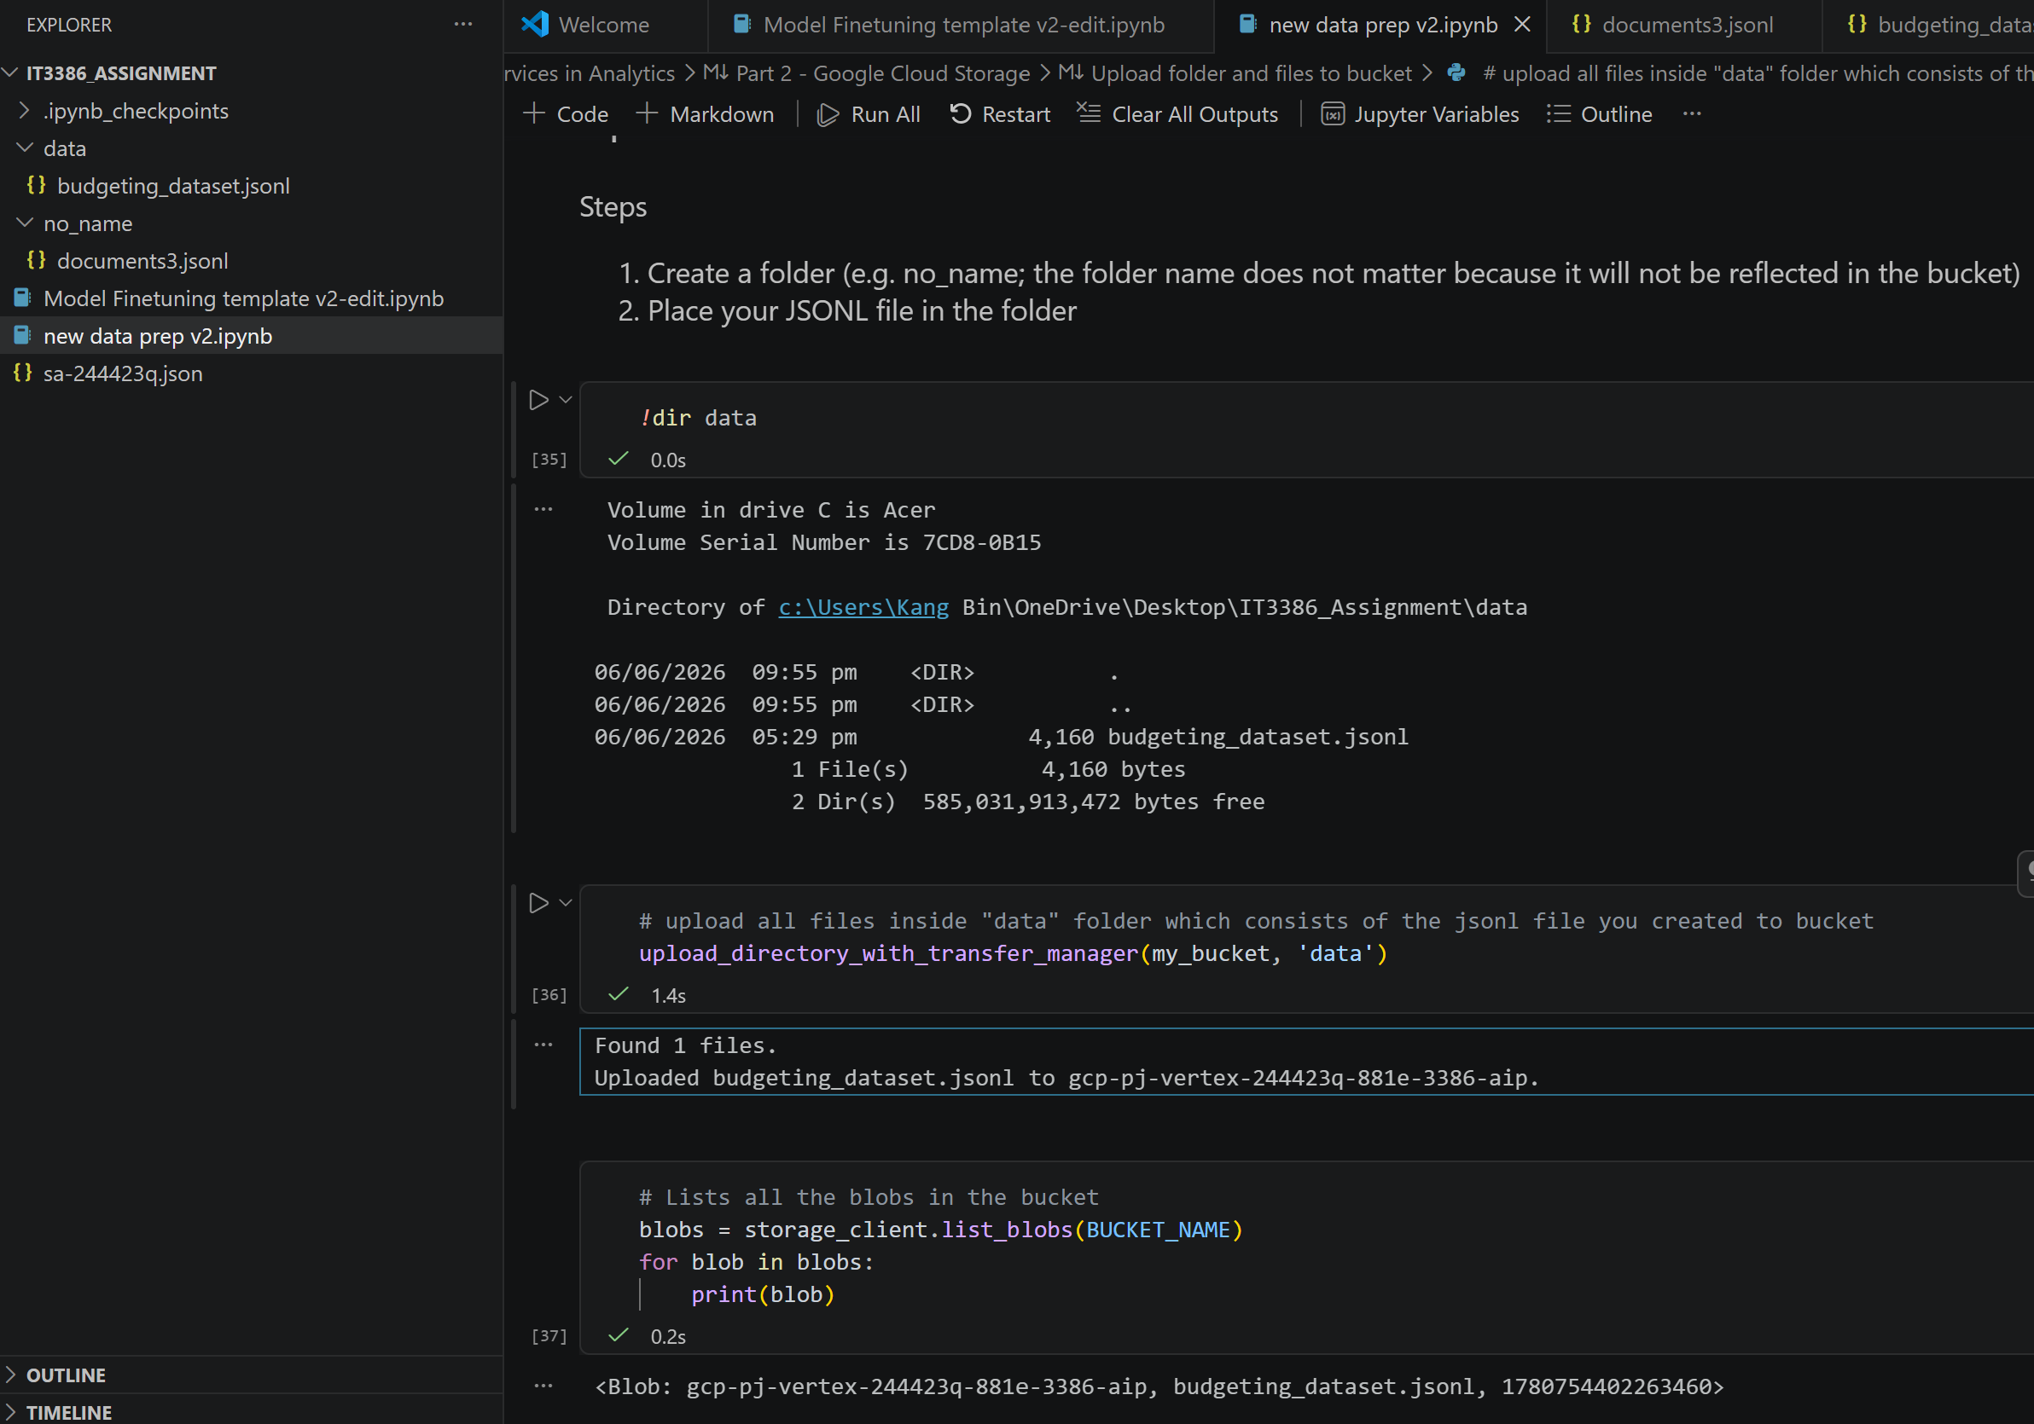
Step 4: Final data check
This script verify if the data has been loaded into the cloud correctly.
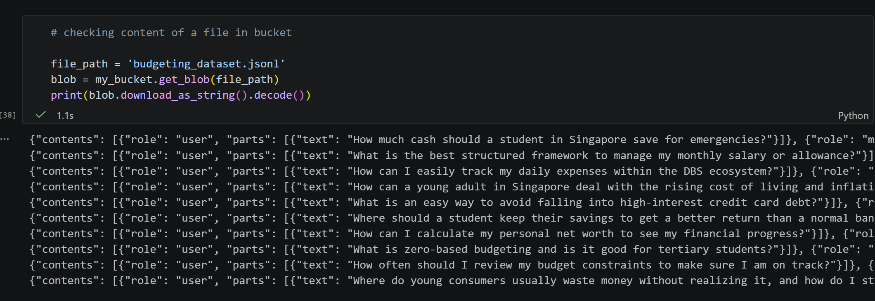
Step 5 (Optional): Cleaning up Google Cloud Storage by deleting bucket
Once the dataset has been upload and the AI model training has finished, this step is used to empty and delete the cloud bucket.
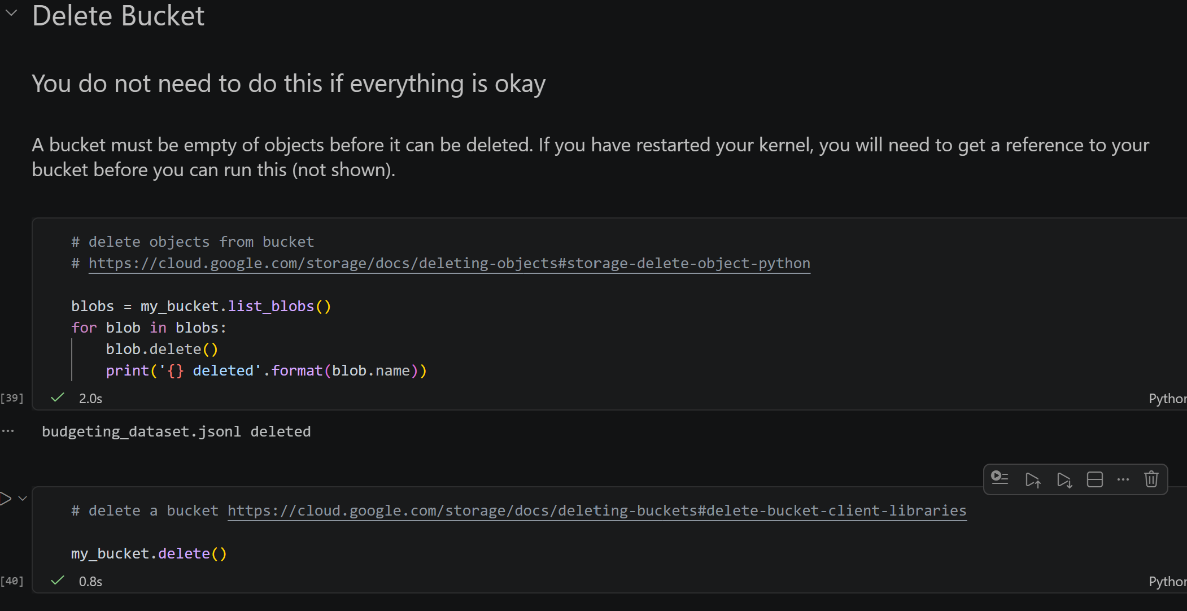
Why is it important to clean bucket?
- Avoid unexpected storage costs: Google cloud incur charges based on how much data you keep online over time. Deleting files when your project is finished can help ensure that your Google Account does not get impacted by background storage fees.
- Best Practice for better security: It is a best practice to clean up temporary environments. Removing dataset and buckets helps to keep your console cleaned and organised and ensures that your old project data is not left online for exposure.
- Release unique bucket names: Google Cloud requires every bucket name to be unique worldwide. Deleting the bucket releases the names back to the system to ensure that it does not permanently stay in your account.

3. Model Training & Testing
3.1 Model Training
(a) Launching Fine-Tuned Model Job to Vertex AI
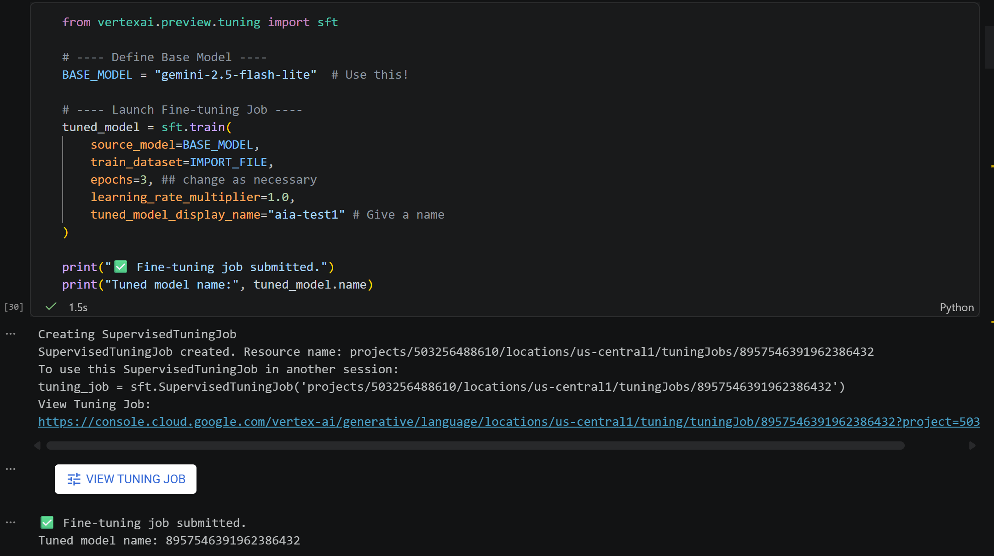
To help our AI assistant in providing structured financial advice, a Supervised Fined-Tuning (SFT) job was launched on Google Cloud Vertex AI platform. This pipeline utilizes the gemini-2.5 flash lite as the base model and ingested the dataset (budgeting_dataset.jsonl) from the Google Cloud Storage Bucket.
(b) Hyperparameter Selection and Optimization
To maximize model performance and prevent overfitting, hyperparameters such as epochs and learning rate were adjusted carefully.
- Epochs: Represents the number of complete passes the fine-tuning model makes over your entire training dataset. Finding out a number of epochs is a balancing act. Insufficient number of epochs can lead to underfitting as the model has not been exposed to enough data to learn the task properly, resulting in poor performance. On the other hand, having an excessive number of epochs can lead to overfitting as the model begins to memorize the training data, including noise and specific details that are not representative of the broader task. While training performance might be excellent, the model will struggle with new, unseen data, as it has become too specialized and rigid.
- Learning Rate: A most crucial hyperparameter that control the step size the optimization algorithm takes to update the model’s parameters in each training iteration. It governs how aggressively the model adjusts its internal weights and biases based on the calculated errors. An ideal learning rate is determined based on whether model can strike a balance for an efficient and stable convergence. An excessively high learning rate can lead to instability and divergence as the model might overshoot the optimal parameter values, causing oscillations, erratic loss curves, and failure to converge. However, a low learning rate is caused by how slow the model takes to progress towards the optimal solution which leads to slow convergence. Subsequently, training would become excessively time-consuming which results in the model being trapped in a sub-optimal state, failing to reach its best possible performance.
(c) Training Completion
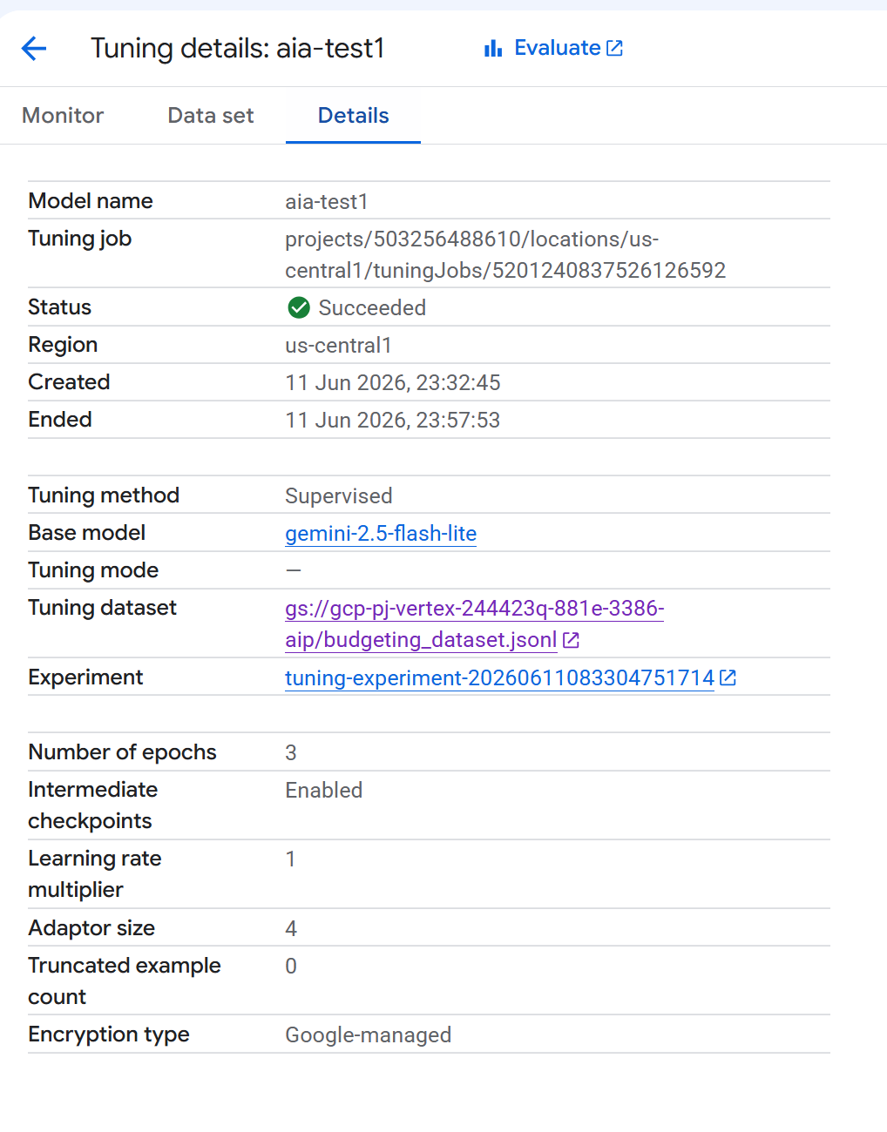
The screenshot above shows that the tuning job has been completed successfully.

3.2 Fine Tune Model Evaluation & Hyperparameter Experimentation
To systematically analyse the behaviour of the gemini-2.5-flash-lite base model, we will be experimenting with the hyperparameters configurations across 3 different training runs.
Note: To keep the experiment controlled, the learning rate will be kept constant at 1.0 across all runs. This will enable us to run a fair and controlled experiment allowing us to see how changing the number of epochs can impact model’s training and performance without considering other factors.
Run 1: Original Baseline (Epochs = 5, learning rate = 1.0)
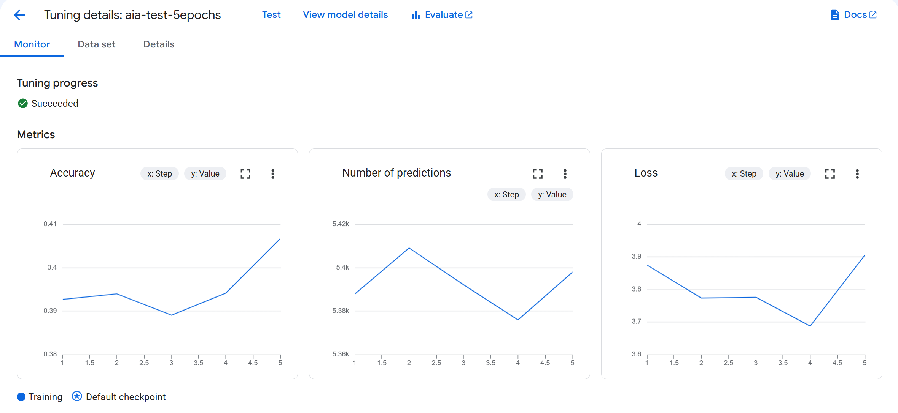
- Accuracy: This chart tracks the token-level prediction accuracy. It experiences a slight fluctuation between epochs 1 and 3 as the model balances the boundaries. However, there is a steep climb towards epochs 5 indicating that when more time given, the model becomes more proficient at matching the exact dataset vocabulary meaning that it has learnt specific financial terms exceptionally well.
- Number of predictions: This maps the total volume of data that passes through the model during training. The graph peaks early at epochs 2 but dips down towards epochs 4 and climb back up slightly at epochs 5 to finish processing the final text blocks. This curve simply shows that Vertex AI has managed and distributed the data volume in balanced data chunks throughout the entire training life cycle.
- Loss: The Loss graph track the error rate. The loss curve starts off strong, dropping from 3.88 down to a low of 3.69 at epoch 4, which is a great sign of convergence. However, as we move from epoch 4 to 5, the curve begins to rise again, reaching 3.90. This upward trend at the end suggests that the model is showing signs of overfitting. It seems that training for the full 5 epochs made the model a bit too rigid, leading it to over-memorize the data instead of generalizing well.

Run 2: Decreased number of epochs (Epochs = 3, learning rate = 1.0)
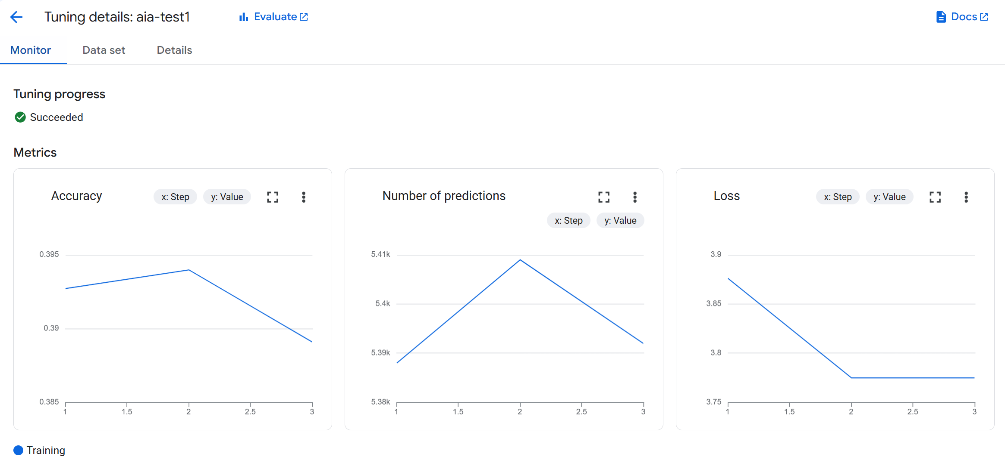
- Accuracy: The accuracy chart shows a gradual climb from Epoch 1 to 2 as the model quickly catches mandatory terms such as "strict boundary" or “50/30/20 savings framework”. However, it shows a slight decline from Epoch 2 to 3 as this is a standard behaviour in a Large Language Model fine-tuning process given that the model focuses on learning the general sentence structures and financial persona instead of blindly memorizing the exact words line-by-line.
- Number of predictions: The graph peaks at the middle due to how the text blocks are being grouped into training batches. During the middle of the run, the batch contains slightly longer, wordier sentences causing the predictions to hit the highest point of 5.41k before dropping back smoothly as the final parts of the dataset were finished.
- Loss: The loss was at its highest point at Epoch 1 due to how the model is completely new to the budgeting rules and financial tone. As training progresses into Epochs 2 and 3, the line smoothly declines and flatten out. This drop shows that the model has successfully managed to learn the data and stopped making mistakes.
Run 3: Increased number of epochs (Epochs = 7, learning rate = 1.0)
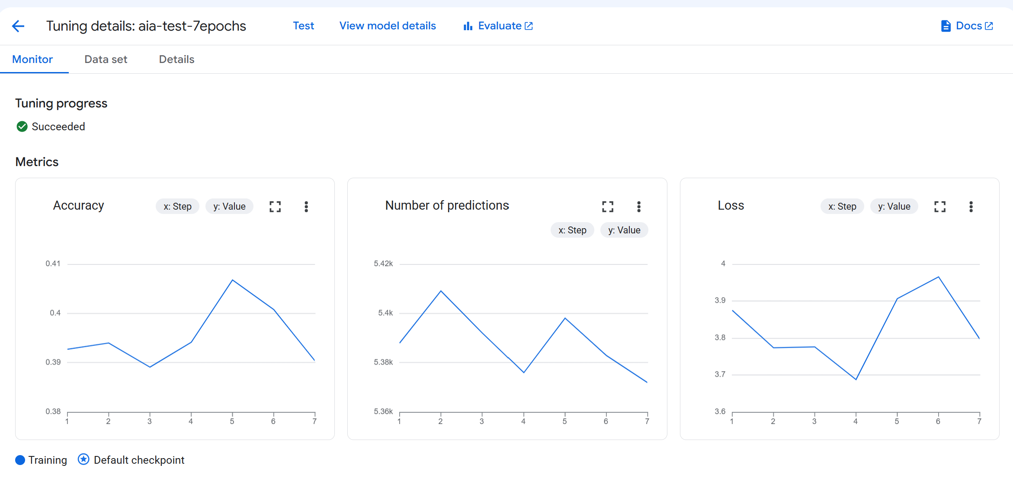
- Accuracy: A wave-like fluctuation can be observed between epochs 1 and 3 before it takes a sharp rise towards to its peak of 0.407 at epochs 5. This sharp rise proves that having more training cycles has helped the model to master custom financial terms. After reaching its peak, it declined again to 0.390 at epochs 7 which results in the model having to reach its learning limits and began struggling due to how it over-processed the same data rows.
- Number of predictions: The graph peaks early at epochs 2 but dips down towards its lowest point epochs 4, climb back up slightly at epochs 5 and falls off smoothly at epochs 7. This pattern shows that Vertex AI handled our dataset smoothly, grouping the longer, more detailed sentences into the early batches while evenly balancing the processing workload across all 7 epochs.
- Loss: The loss curve kicks off at 3.88 and steadily declines until it reaches its best convergence point of 3.68 at Epoch 4. However, right after that, it takes a sharp turn upwards, peaking at 3.96 by Epoch 6 before dropping a bit at Epoch 7. This significant spike following Epoch 4 clearly indicates a case of severe overfitting. It shows that running the training for the full 7 epochs made the model too rigid, leading it to lose sight of general conversational patterns and instead focus too much on memorizing the training data.
Conclusion:
Based on the above results, the optimal number of epochs we should set for our fine-tuned financial literacy assistant should be 4 epochs.
As seen from the graphs shown from all 3 runs, Epoch 4 repeatedly emerged as the ideal balancing point for model convergence. According to the runs done for 5 and 7 epochs (Run 1 and 3), the loss curve hit its lowest point at 4 epochs indicating it has reach its optimal error rate. Even though the accuracy did improve towards epochs 5, it declined towards epochs 7 while its error rate minimised from epochs 5 to 7. This evidently shows that the model is experiencing more signs of overfitting the longer it runs given that any training cycles beyond epochs 4 can cause the model to stop understanding general financial concepts and starts to blindly memorize the exact text from our dataset.

3.3 Model Evaluation using Gradio UI
To visually validate real-world performance of our fine-tuned model against the base pre-trained model, we built an evaluation dashboard using the Gradio which is an open-source Python Library. It features a side-by-side chat interface that allow us to directly input test prompts into both models simultaneously and compare the performance between our fine-tuned model and the base non-fine-tuned model.

(a) Manual Testing Setup and UI Overview
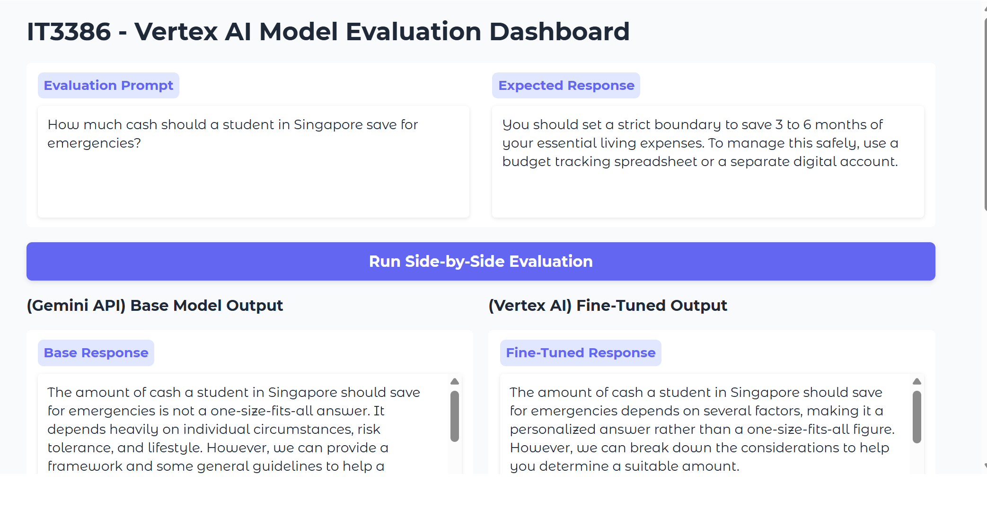
As shown in the above dashboard, the interface features a clean layout where we can input our test prompts into the evaluation prompt box alongside the expected response that is predefined from the test examples and responses. Clicking on the blue “Run Side-by-Side Evaluation” button executes both model evaluations simultaneously, displaying the outputs in 2 parallel columns. (Left: Base Model Output, Right: Fine-Tuned Output)

To make manual testing faster and convenient, the quick evaluation test cases component is also implemented at the bottom of the dashboard.
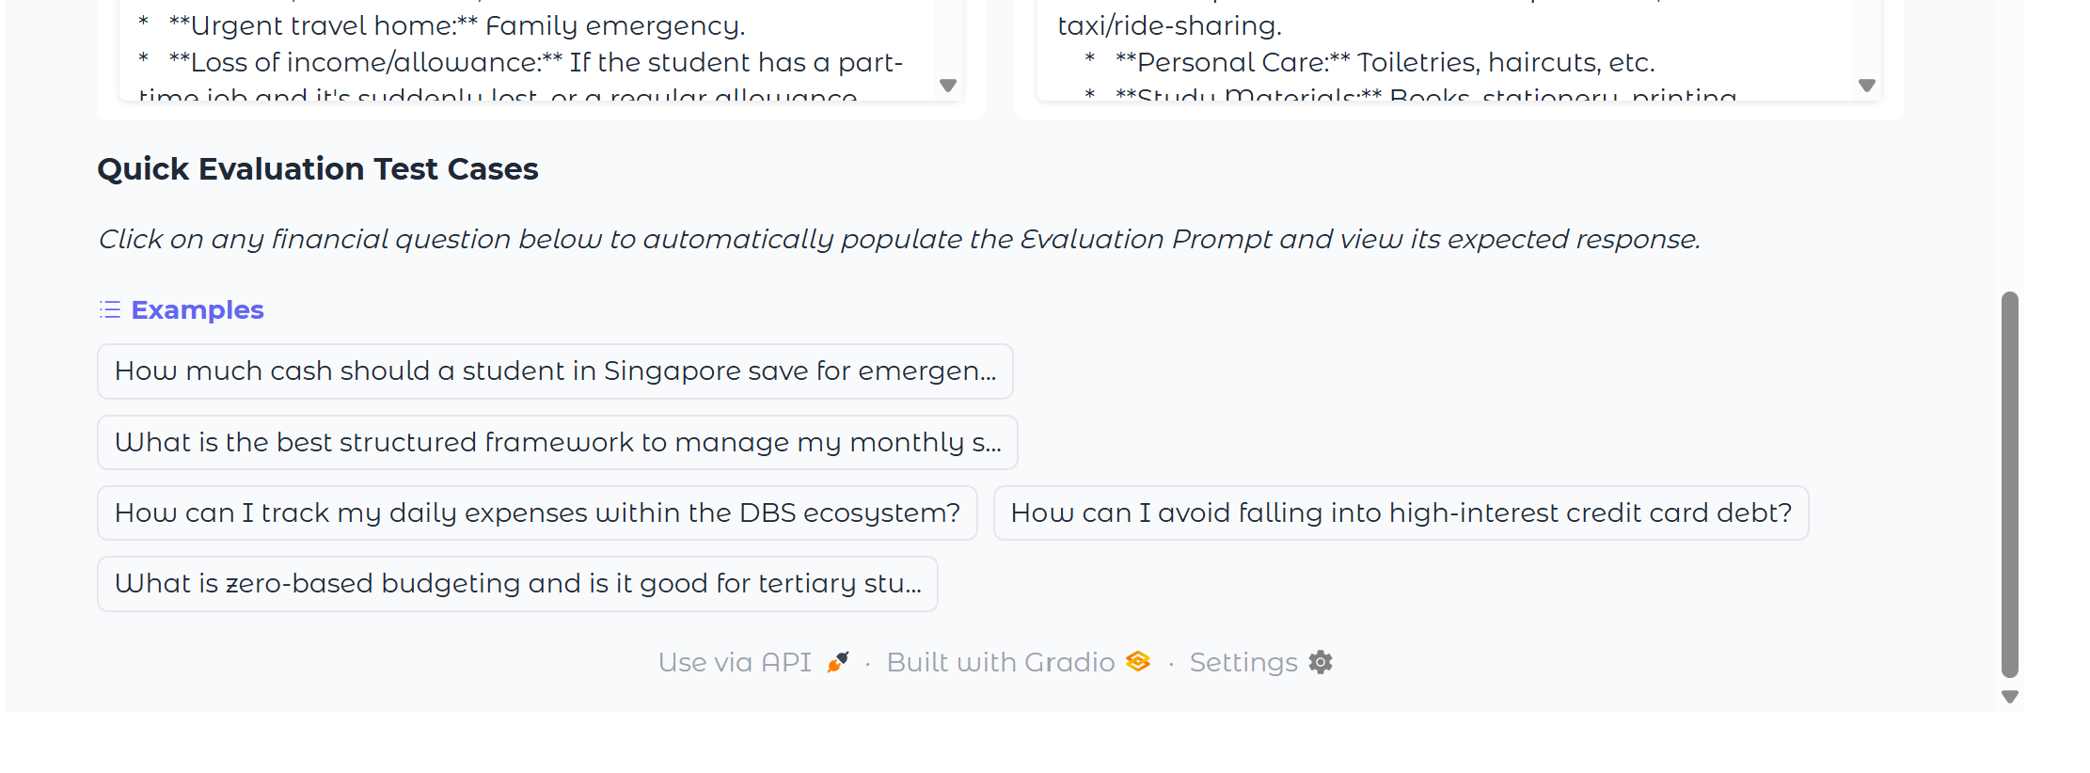
This component contains pre-defined reference questions. Clicking on any of the financial questions automatically populate the Evaluation Prompt and Expected Response text boxes, removing the need to manually populate data.

(b) Evaluating Test Cases & Discussion
To properly test how well the model can perform and identify where its safety limits are, we split our manual evaluation into 3 different test cases.

Test Case 1: Example Test Cases (Seen / Training Data)
For this scenario, it uses specific questions that already exist in our pre-defined test prompts along with its expected responses. We run this to verify if the fine-tuned model can successfully memorize and retain core financial guidance rules, constraints and structured vocabulary.

Prompt: How much cash should a student in Singapore save for emergencies?
Expected Response: You should set a strict boundary to save 3 to 6 months of your essential living expenses. To manage this safely, use a budget tracking spreadsheet or a separate digital account.

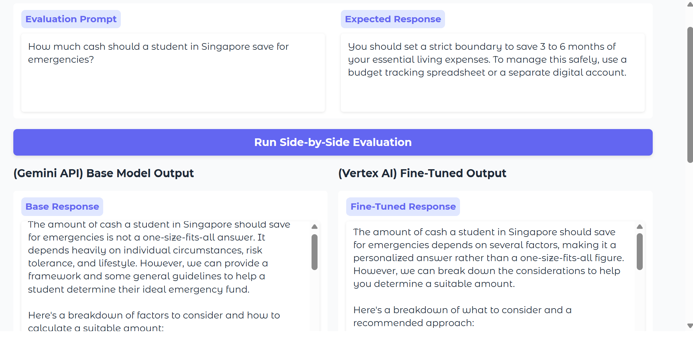

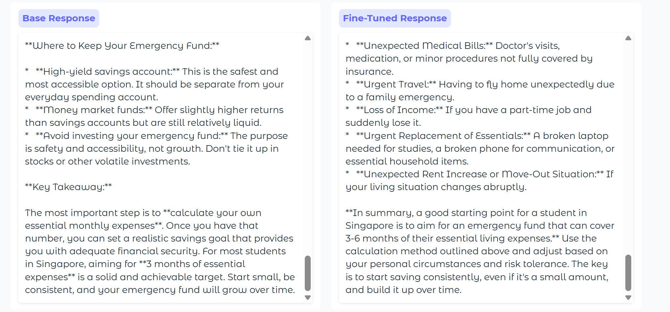
- Base Model Output Analysis: The base model provides a broad textbook-based response. It relies on standard financial phrases like "not a one-size-fits-all answer" and stating it "depends heavily on individual circumstances, risk tolerance, and lifestyle". Instead of focusing on practical advice for students. It relies heavily on technical terms like "High-yield savings account" and "Money market funds", while warning the user to avoid "volatile investments". As a result, it reads like a generic banking article instead of providing useful student guidance.
- Fine-Tuned Model Output Analysis: On the other hand, the fine-tuned model changes its approach. Instead of using boring banking theory, it talks about real-life student situations. It uses clear bullet points to list down everyday real-life emergencies scenarios such as "Unexpected Medical Bills: Doctor's visits...", "Urgent Travel: Having to fly home unexpectedly...", "Loss of Income: If you have a part-time job...", and "Urgent Replacement of Essentials: A broken laptop...". Most importantly, the model was able to memorize what it was trained to do and precisely output every word such as "In summary, a good starting point for a student in Singapore is to aim for an emergency fund that can cover 3-6 months of their essential living expenses.".
- Result: Pass. The visual comparison confirms that the fine-tuned model has successfully retained its training parameters. It effectively replace traditional financial definitions with relatable real-life student scenarios while ensuring that it strictly aligns with the 3-to-6-month target framework.

Test Case 2: Unseen Test Case (New Financial Data)
This second test utilizes a completely new question that is not present in our pre-defined test prompts. The objective of this test is to evaluate the model’s ability to generalize its knowledge and see if it can maintain its domain-specific persona while handling unfamiliar test cases.

Prompt: How do I save money while I want to spend on what I like?
Expected Response: No reference answer set on this prompt

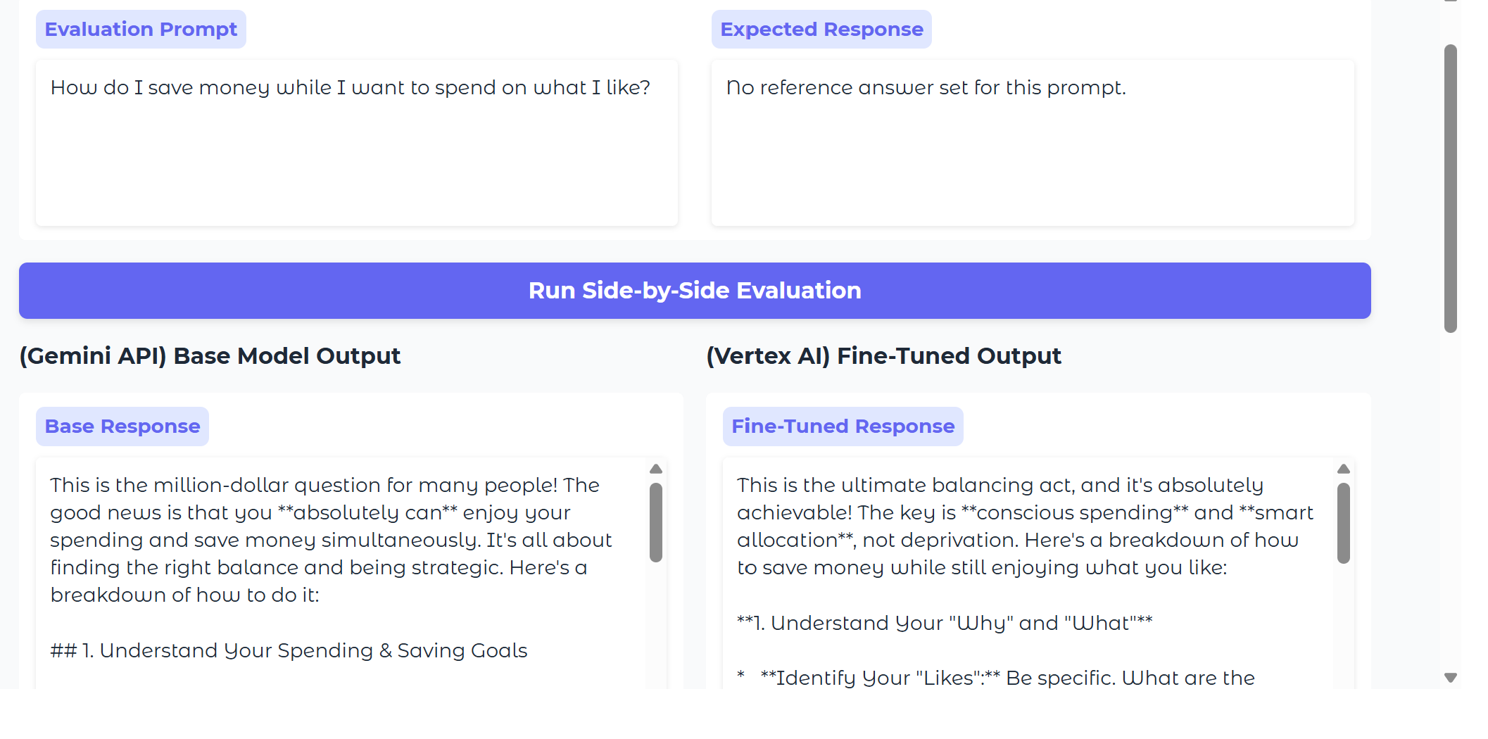
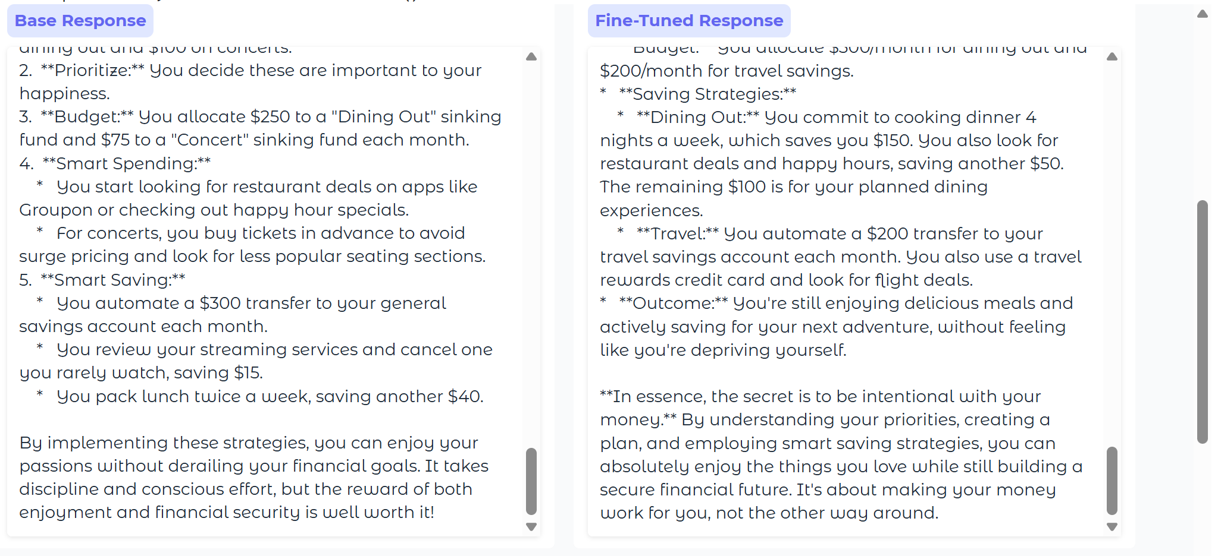
- Base Model Output Analysis: The base model begins with a casual, blog-style conversational opening with exclamation marks and phrases like “This is the million-dollar question for many people!" and "Balancing saving with enjoying your life...". Its recommendations lies heavily on micro-saving lifestyle hacks and consumer discount platforms, explicitly telling the user to use "Groupon", explore "less popular seating sections" at concerts, or manually cancel a "$15/month streaming service" they do not use.
- Fine-Tuned Model Output Analysis: The fine-tuned model bypass conversational casual words. The answer is restructured in such a way that it uses professional financial concepts such as "conscious spending", "smart allocation", and "intentional spending". Instead of using lifestyle hacks, it introduces structured, macro-level framework numbers, mapping out budget-friendly offers such as "$300/month allocation for dining out" while implementing an "automated transfer" of "$200/month to a separate travel savings account".
- Result: Pass. The fine-tuned model was able to generalize its training when dealing with unseen training data. It completely removes the base model’s casual lifestyle tone and corporate marketing references, successfully replacing them with structured financial tracking methods and professional budgeting frameworks.

Test Case 3: Unknown Test Case (Out-Of-Scope / Non-Financial Data)
This final test introduces a completely, irrelevant off-topic question that is outside the financial literacy and budgeting scope. This run tests the model safety boundaries and verify if it could recognize out-of-scope topics or if it breaks down and hallucinate factual details to satisfy the user needs.

Prompt: Where can I watch the World Cup 2026 in Singapore?
Expected Response: No reference answer set on this prompt

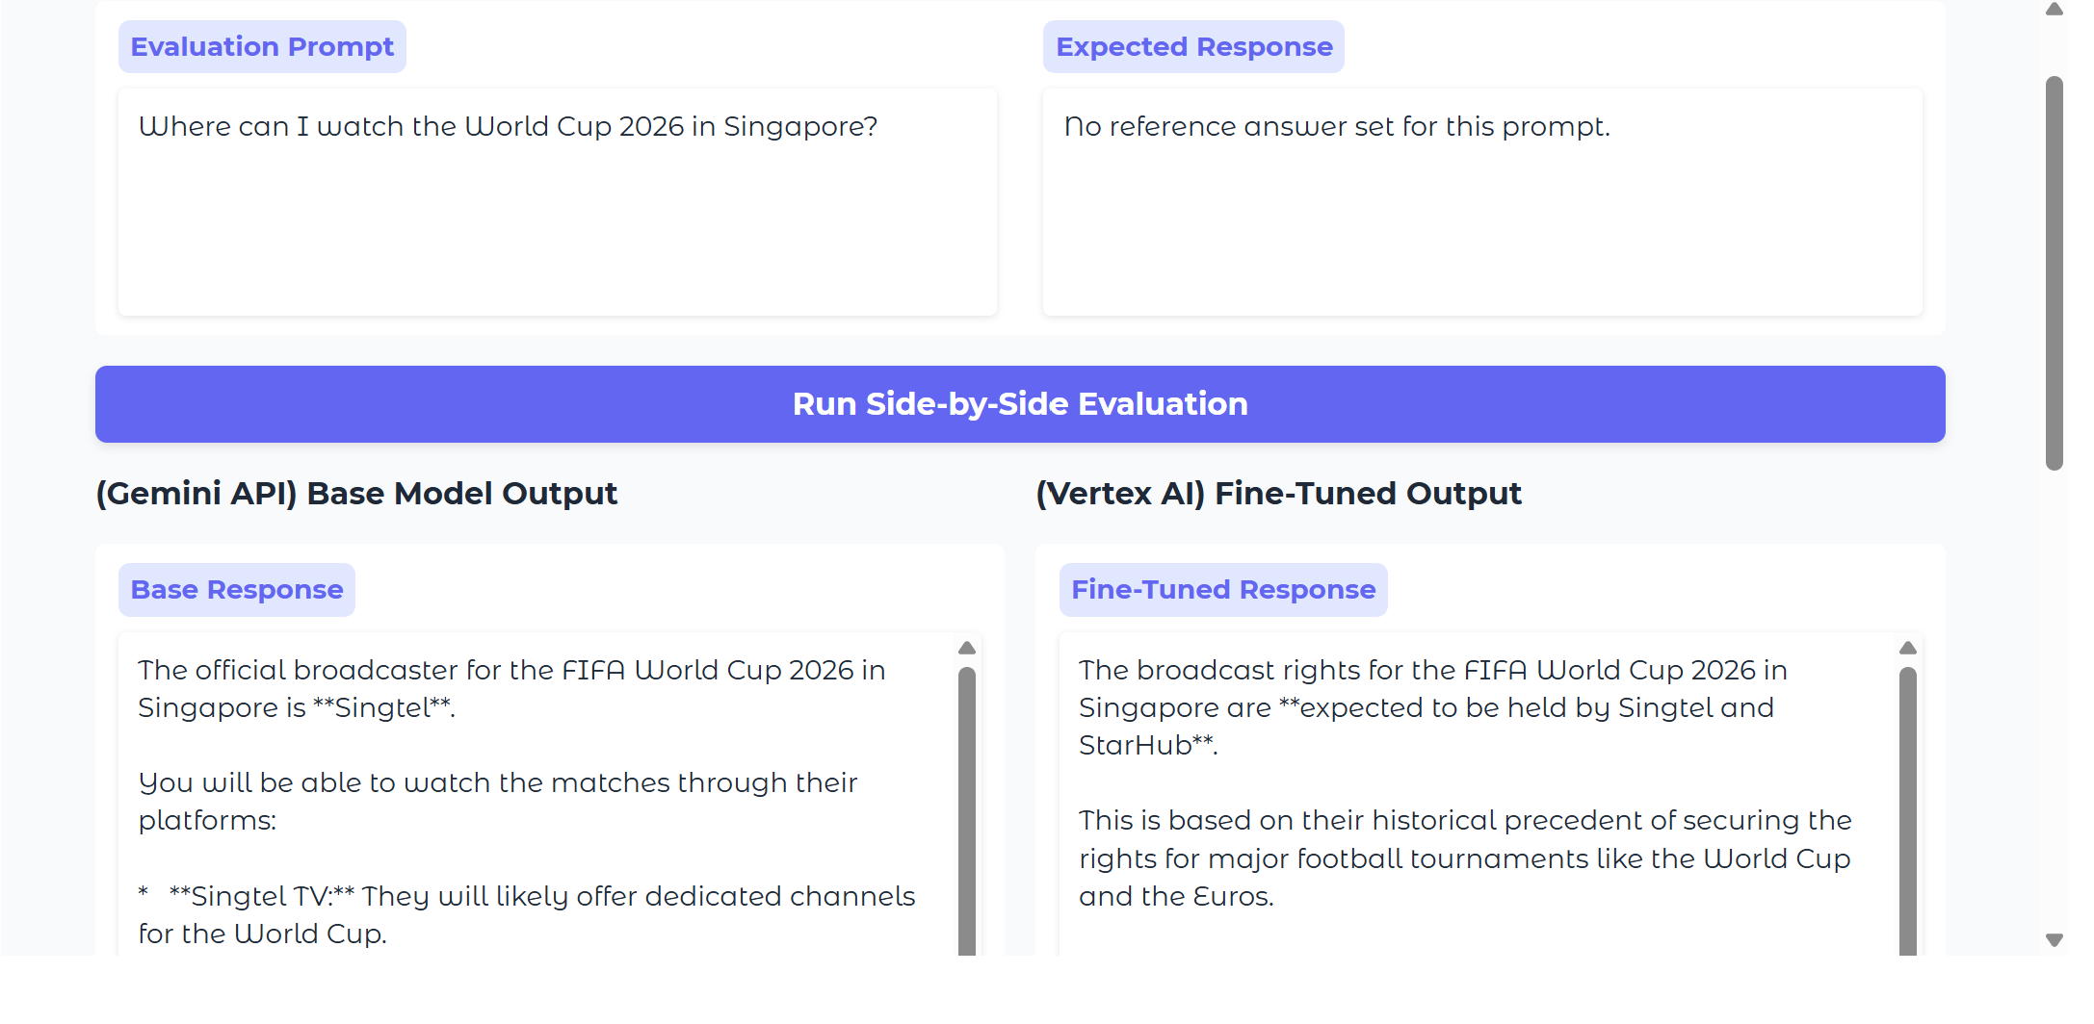

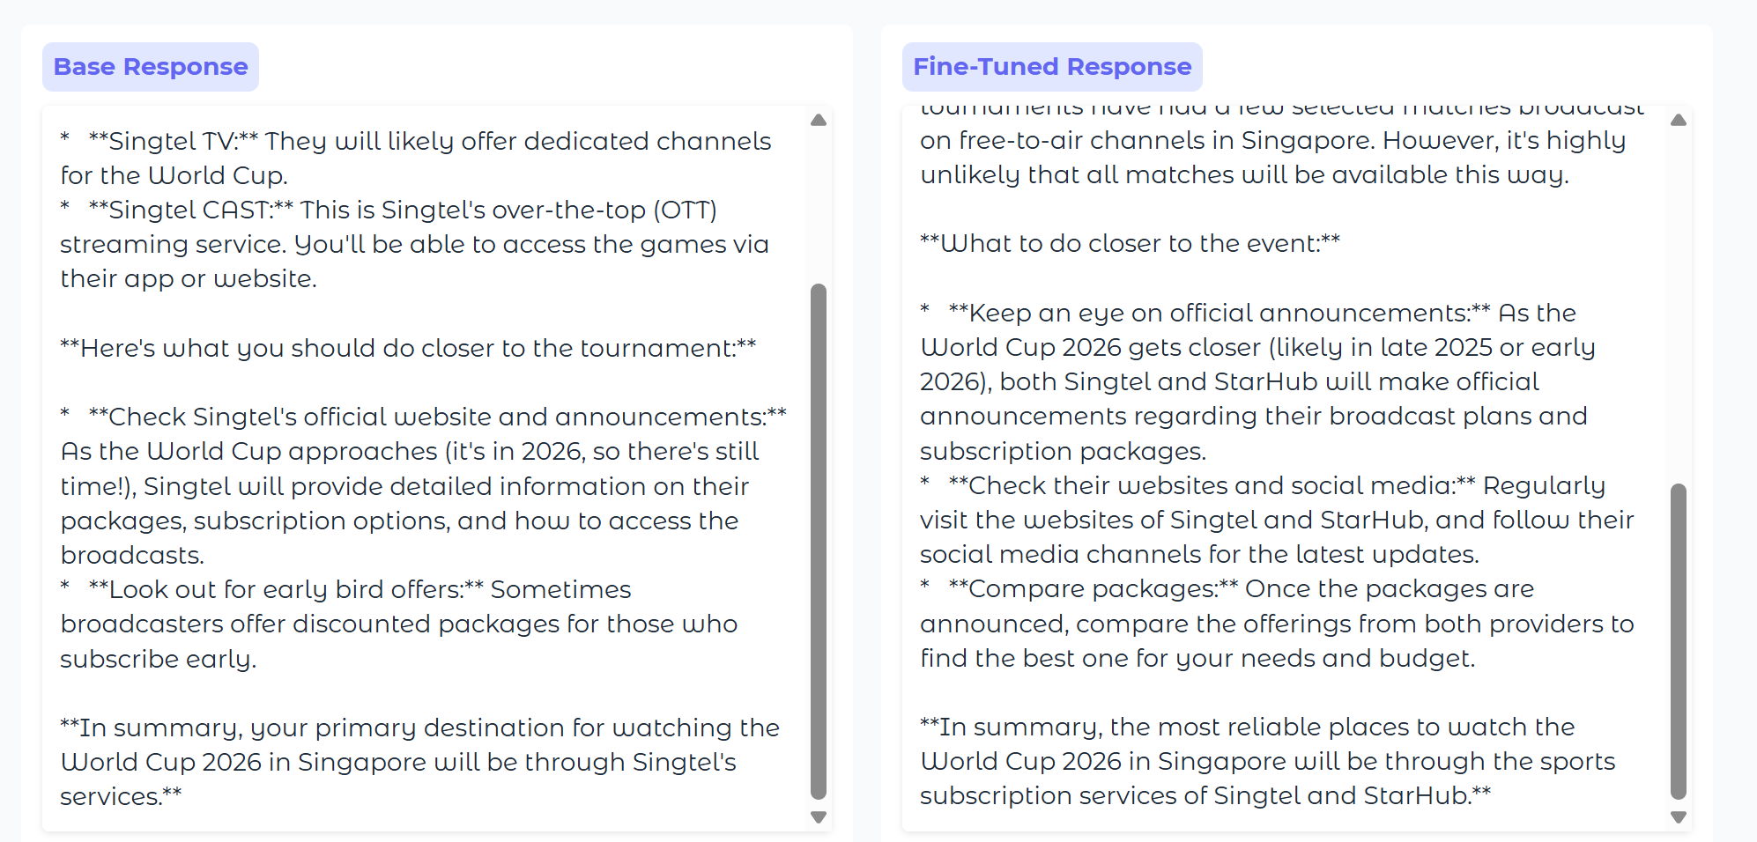

- Base Model Output Analysis: The base model unresistingly engages user based on the out-of-scope football prompt. It fails to recognize its role as the financial advisor and completely makes rigid, unverified claims, explicitly stating "Singtel is the official broadcaster" via "Singtel CAST" and telling the user to grab "early bird packages"..
- Fine-Tuned Model Output Analysis: The fine-tuned model acts more cautiously framing its answer around past trends using phrases like "broadcasting rights are typically managed" and that coverage is "expected to be held by major local telcos like Singtel and StarHub" instead of making claims about streaming rights. Instead of pushing a subscription plan, it provides a safer framework by telling the user to "Compare Packages" and "Look for Bundles" for costs once official news drops.
- Result: Fail (with Positive intent). Neither of the models issued a error statement stating that it is a financial assistant that is unable to answer sports-related questions. However, the fine-tuned model was able to display a better safety behaviour in stopping the base model’s reckless factual guess and replace it with a highly safe and analytical tone.

Overall Conclusion: Manual side-by-side evaluation confirms that the fine-tuning pipeline has successfully shifted the model perspective from broad, generic internet summarises to a structured financial advisor persona for students. The model effectively handles both seen and unseen financial test cases while formatting output responses neatly using Markdown parameters. One key recommendation the model can do is to implement strict classification rules that automatically rejects any non-financial related topics as seen from Test Case 3 in order to make this application read for production.

3.4 Model Testing Methodology for Large Lists of Testing Samples
When validating a Large Language Model performance across significant volume of testing samples, manual human verification and individual UI spot-checking via Gardio becomes infeasible and time-consuming. Hence, an automated GenAI evaluation pipeline must be implemented according to the machine learning framework guidelines. This system tests thousands of questions automatically in background, removing human bias and saves time.
(a) Testing Steps and Workflow
The automated testing setup uses four simple steps to ingest data, runs the evaluation pipeline and compare evaluation scores.
Step 1: Storing data in the cloud
It is time consuming to manually input a large sample size of testing prompts individually into the prompt box. Hence, we compile all these questions into a single text file format (jsonl) which will be uploaded to the Cloud. Each line in the file contains key-value pairs containing user prompts and expected response. This file would be uploaded directly to our Cloud Storage Bucket through the programmatic method that was done in section 2.2.
Step 2: Running the Vertex AI Evaluation Pipeline
If we send 500 questions to the chatbot API individually, the connection might crash, lag, or get blocked for spamming. To resolve this issue, we trigger an automated evaluation run in the Google Cloud Console using Vertex AI Gen AI Evaluation Service.
This service runs in the background. It automatically loads our ingested dataset and passes the prompts to our base and fine-tuned model at the exact same time. Once its done, it saves all generated answers and compares them inside a unified evaluation dashboard for us.
Step 3: Computation-Based Evaluation Metrics
Once the AI finish answering a large sample of questions, we can run an automated script using the evaluate python library to grade the text mathematically. This saves human manual evaluation by tracking these 2 metrics below:
- ROGUE Score (Checks vocabulary using Recall): This measure how many words from the expected output actually made it to the model’s output. It mathematically checks if our fine-tuned model remembered to use the strict financial rules like "strict boundary" or "50/30/20 savings framework".
- BLEU Score (Measures precision): Originally used for machine translation, this measures the percentage of words in the model output that appeared in the reference text. It penalizes the AI if it continues to ramble, ensuring that the model can give a direct answer without using useless conversational filler texts.
Step 4: Rubric-Based Grading (LLM-as-judge)
Since math scores are strict and fail to understand simple synonyms, we implement the Current Industry Standard for instructional-tuned models: LLM-as-judge pipeline using a stronger and larger LLM like gemini-2.5-pro.
Instead of assessing the responses based on a manual checklist, the judge model act as an expert evaluator. It reads user prompts and directly compare response A (base model) with response B (fine-tuned model) at the same time.
(a) Evaluation Rubric
The judge model is instructed to ignore the response length and determine the winner based on the four core criteria below:
- Accuracy & Persona: Did the model stay in character as a professional institutional financial advisor providing correct information?
- Helpfulness: Does the answer practically solve the student's problem?
- Formatting: Did the chatbot output clean Markdown code with neat, scannable bullet points?
- Topic Scope Relevance: Did the model successfully ignore irrelevant prompts (like the sports question in Test Case 3)?
(b) Tracking win rate
The judge outputs a clean JSON format labelling each comparison as a win for Model A, B or a tie along with a one-sentence reasoning. Subsequently, we will calculate the win rate that is measured based on the percentage of examples where the fine-tuned model is preferred. To evaluate if our fine tunning was successful, we evaluate our results based on the standard industry performance thresholds:
- Above 65% Win rate: Strong, highly successful fine-tuning alignment
- 55-64% Win Rate: Meaningful improvement over the base model
- Below 45% Win Rate: Fine-Tuning made performance worse, indicating a need to investigate training data.

4. Additional Work (RAG System Implementation)
To bridge the gap between broad internet knowledge to specialized domains, a Retrieval Augmented Generation (RAG) System can be deployed as an alternative solution to fine-tuning. Instead of altering the model weights using fine-tuning, a RAG system extracts relevant information from the external vector database and embeds it directly into the prompt context. This helps to solve three core issues faced by static generative models like model hallucinations, outdated information, lack of contextual relevance and domain knowledge for specific topics.

4.1 RAG System Pipeline
Step 1: Data indexing (Data Ingestion & ChromaDB Setup)
Unstructured financial documents will be processed and broken down into consistent text segments which are known as chunks (document_chunks). These pieces are being passed into the Vertex AI Embeddings API (text-embedding-004) to convert raw text strings into high-dimensional numeric vectors that captures semantic similarities.
To store this data, the code will set up an ChromaDB which is an open source vector database designed for efficiently storing, searching and managing vector embeddings. In our code, the vector_db.upsert() function is used to register our text chunks and their mathematical vectors into a Collection. This will allow us to index and easily save this information without a need for a traditional database layout and prevent duplication errors.
Step 2: Input Query Processing (Vector Transformation)
When a financial question is being inputted during a run, it is being refined to improve compatibility with indexed data by mapping the text into its mathematical coordinate using the same pre-trained Vertex AI Embedding model (query_emb_list = embed_model.get_embeddings([test_query]) ). This vector transformation converts incoming query into a numerical vector (query_embedding), capturing the true semantic intent of the question before searching.
Step 3: Searching and Ranking (ChromaDB Similarity Search)
The query is run against the collection using ChromaDB built-in Client: results = vector_db.query(query_embeddings=[query_embedding], n_results=5). Instead of searching for exact keyword matches, ChromaDB performs a fast similarity search. It calculates the mathematical distance between the vectors to instantly rank and find the closest matches (top k nearest neighbours) that shares the same conceptual meaning as the student’s prompt.
Step 4: Prompt Augmentation
The main goal of this step is to create a context block for the model. The highest rank text segments that is extracted by the ChromaDB search query are gathered and combined into a string context block (retrieved_context). By incorporating this relevant information from the search results into the query, we provide the additional context the LLM needs which helps in enhancing response accuracy and relevance.
Code snippet used to define the context:
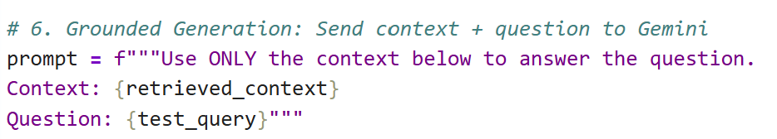
Step 5: Response Generation
This combined prompt structure that consists of the prompt and its associated context is being sent to the Gemini Model using this code snippet below:
response = client.models.generate_content(model="gemini-2.5-flash-lite", contents=prompt)
The core objective of this final step is to use the augmented prompt to generate responses that combine the LLM’s knowledge with current, specific data, ensuring high-quality, contextually grounded answers. By forcing the model to generate a text based on the verified chunks that is provided by ChromaDB, the script: print(response.text) delivers an accurate, hallucination-free answer
4.2 Code Implementation
Step 1:
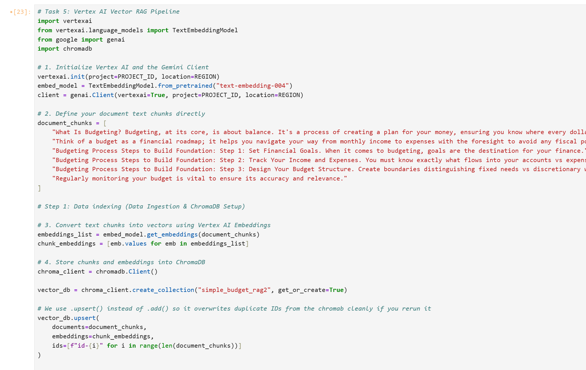

Step 2:
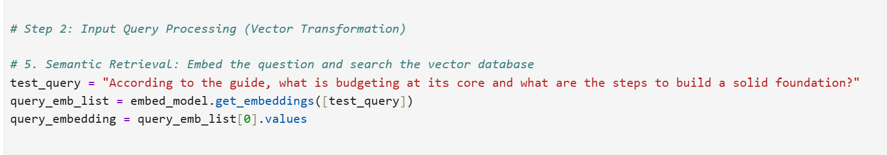
Step 3-5:
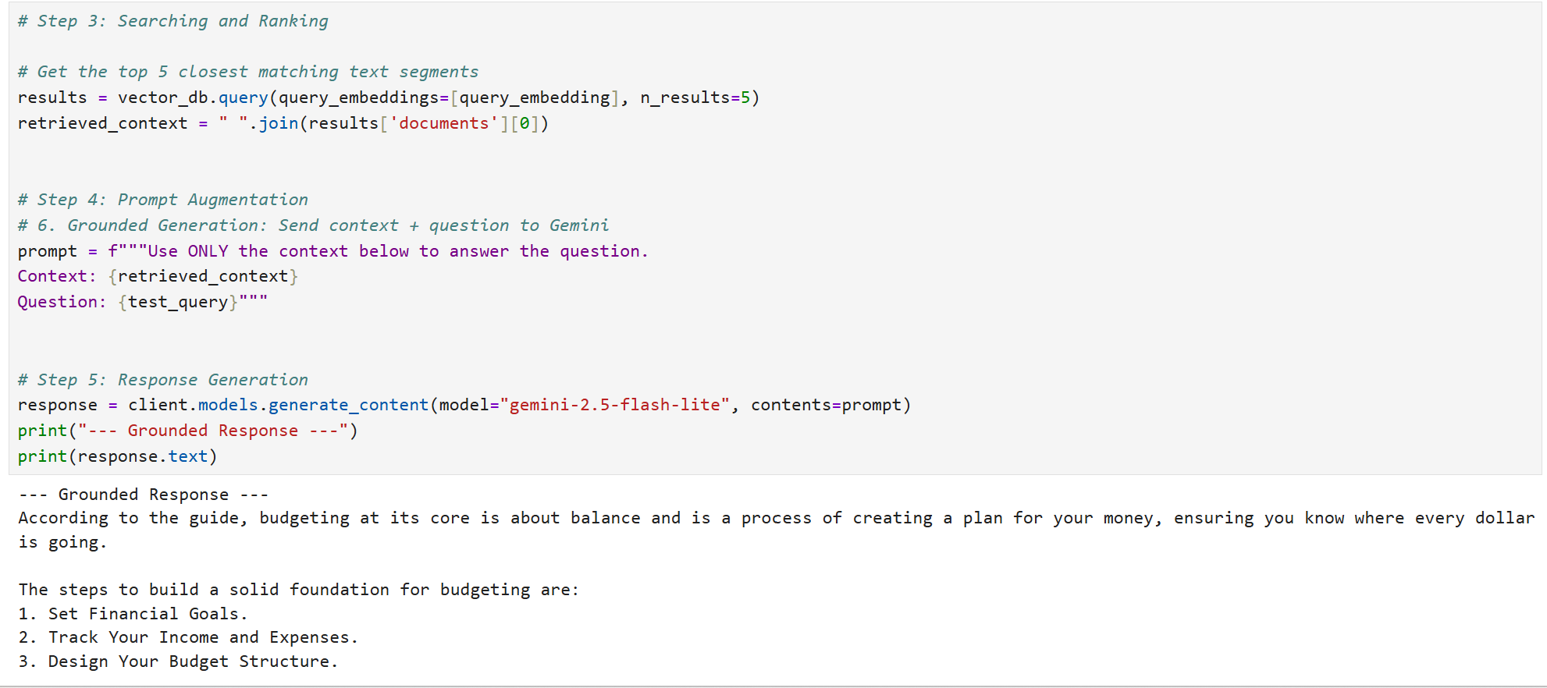

4.3 Evaluation Experiments based on Top k closest matching text segments
To analyse how changing the retrieval depth based limits affects the final output quality, three experimental runs were conducted based on the varying number of retrieved text segments (n_results or k-value) to evaluate our output performance against our test data.
Experiment A (n_results = 5)
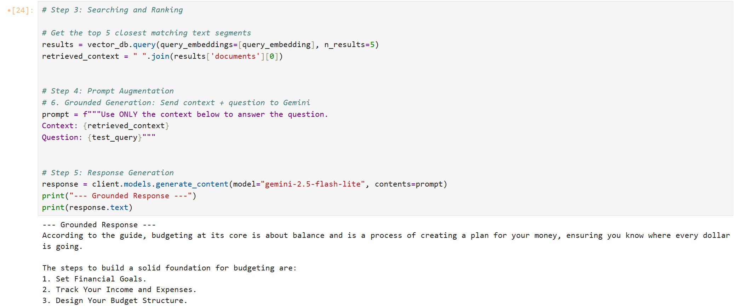
Setting the parameter to return the top 5 closest text segments provided an ideal context size. The model delivered a complete, highly accurate response that captures the definition of budgeting and listed three foundational steps cleanly in a numbered list.

Experiment B (n_results = 10)
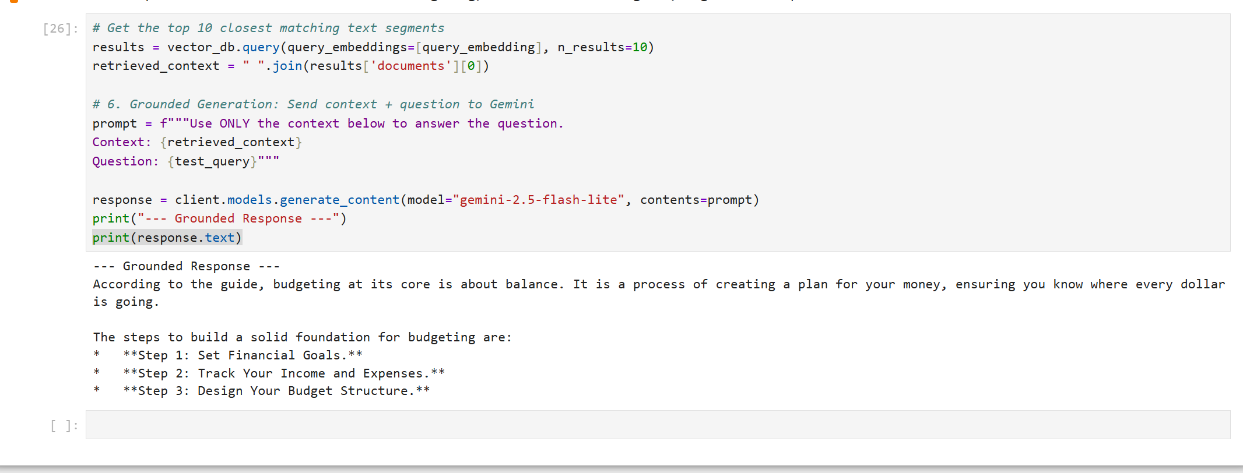
Expanding the parameter to retrieve the top 10 closest matching text segments widened the context window significantly while providing all the necessary facts. This extra text causes minor formatting issues, causing Gemini to output unrendered markdown astericks. (* **Step 1: Set Financial Goals.**) which are typically used in Jupyter Notebook markdown formatting.

Experiment C (n_results = 3)
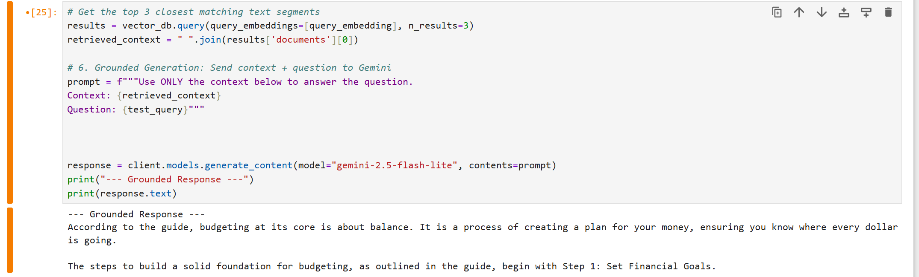
Restricting retrieval to the top 3 closest segments can cause some information to be lost. This results in the search being cut off too early causing vital chunks to be left out. Based on the output, the model was successfully able to define what is budgeting but it ran out of extra context for the steps, completely omitting step 2 and 3 from building a strong budgeting foundation.

Conclusion:
These experiments show that finding an ideal balance for the retrieval parameter (k-value) is crucial. Setting a lower k-value can cut off important facts and causes incomplete answers while setting it high can introduce unnecessary context that can cause formatting issues.
Ultimately, fine-tuning is recommended for setting the writing styles, tones and persona for the model while a RAG pipeline is a highly efficient and cost-alternative for ensuring a highly accurate answer with no hallucinations based on facts.

5. References
- https://www.ibm.com/think/topics/fine-tuning
- https://www.geeksforgeeks.org/deep-learning/what-is-fine-tuning/
- https://www.dbs.com/default.page
- https://money.com/can-you-trust-ai-financial-advice/
- https://jsonl.co/guide/jsonl-python
- https://genmind.ch/posts/understanding-key-hyperparameters-when-fine-tuning-an-llm/
- https://rage.pythai.net/fine-tuning-hyperparameters-a-deep-dive-into-epochs-batch-size-and-learning-rate-for-optimal-performance/
- https://superml.org/tutorials/fine-tuning-evaluation
- https://docs.cloud.google.com/gemini-enterprise-agent-platform/models/evaluation-overview
- https://arxiv.org/html/2408.13296v1
- https://www.geeksforgeeks.org/nlp/introduction-to-chromadb/
- https://www.geeksforgeeks.org/nlp/what-is-retrieval-augmented-generation-rag/

