Assessment Report for Semantic
Data Technologies
MOD004979

Assessment Title:
Semantic Modelling for Sports Dataset
Sports Ontology and Semantic Query Evaluation
Team:
Team Hopfield
Ontology version 3.0.0 | 30 October 2026
Final ontology: Hopfield_Sports_Ontology_20261029_v3.0_all_questions.owl

Table of Contents
1. Introduction 3
2. Concept and Requirement Analysis 3
2.1 Aim of the Project 3
2.2 Gap in the Knowledge (Rationale) 3
2.3 List of Questions 4
3. Design 5
3.1 Ontology Summary 5
3.2 Classes 6
3.3 Properties 6
Object Properties 7
Data Properties 8
3.4 Individuals 8
3.5 Axioms 9
4. Requirements Mapping 11
4.1 Mapping Table 11
5. Evaluation and Use 12
5.1 Use case 1: Basketball Athletes 12
5.2 Use case 2: Team Roster and Coach 12
5.3 Use case 3: Competition and Result 13
5.4 Use case 4: Equipment Query 13
5.5 Use case 5: Teammate Retrieval 13
6. Implementation 14
6.1 Connection to the Dataset 14
6.2 NLP Techniques 14
6.3 Overall Code 14
6.4 Code Validation 15
7. Conclusion and Future Work 16
8. References 17
Appendix A: Class Inventory 18
Appendix B: Property Inventory 20
Appendix C: Individual Coverage 22

1. Introduction
Sports information is fragmented across league systems, tournament records, club pages, media reports and venue databases. These sources use different identifiers for the same people, teams and events. A relational table can answer direct questions, but it requires a new chain of joins whenever the question crosses several concepts.
An ontology provides a domain vocabulary with explicit classes and properties. RDF represents facts as subject-predicate-object triples, OWL adds class and property semantics, and SPARQL provides graph queries over those triples [1][2]. This structure allows a query to traverse an athlete, team, competition, match and venue without encoding every possible join in application code.
The Hopfield Sports Ontology applies this approach to a connected sports dataset. Its domain layer describes the sports world. Its application layer describes who uses the ontology and which information or capabilities those roles can access. A quality layer adds OWL axioms and SHACL validation. The design keeps these concerns separate so that domain relationships remain stable when the user-facing interpretation changes.
This report documents the final ontology, maps the 25 supplied questions, evaluates representative SPARQL queries, and describes a controlled natural-language query design. It also reports the current data boundaries and the remaining implementation work.

2. Concept and Requirement Analysis

2.1 Aim of the Project
The project aims to build a sports ontology that is both semantically precise and usable for question answering. The design meets that aim in five ways:
- It defines a reusable domain model for people, teams, sports, competitions, matches, results and venues.
- It models changing relationships with temporal records instead of treating membership and coaching as permanent facts.
- It represents user roles, benefits and information capabilities explicitly in an application namespace.
- It maps 10 general and 15 specific competency questions to ontology terms and executable query routes.
- It adds SHACL validation and a controlled natural-language query pipeline for reliable access.

2.2 Gap in the Knowledge (Rationale)
The final design addresses six gaps that affect sports knowledge graphs and question-answering systems:
- Shared identity: typed classes and stable IRIs distinguish athletes, coaches, teams and events.
- Temporal context: TeamMembership and CoachingAssignment record validFrom and validTo dates.
- Event context: Match links to Competition and Venue and carries an optional MatchResult.
- Application meaning: application classes and properties describe access, query and system capabilities.
- Data quality: twelve SHACL node shapes enforce required types, cardinalities and dates.
- Query access: SPARQL templates and a controlled natural-language pipeline reduce the need to know the graph structure.

2.2.1 Design Scope and Data
The knowledge base includes football, basketball, tennis, rugby and track-and-field examples. Its principal football case is the 2022 FIFA World Cup, with a complete 26-player Argentina roster and selected records for five other national teams. The basketball case includes club membership, league membership and Olympic participation. Tennis, rugby and track-and-field provide equipment and competition examples.
The ontology distinguishes recorded facts from world-scale completeness. Optional fields describe only what is present in the file. For example, a missing coaching assignment does not mean that a team has no coach in reality. This open-world interpretation is central to the limitations in Section 6.4.

2.3 List of Questions
The requirement set contains 10 general questions about users and system capabilities and 15 specific questions about sports entities. Tables 1 and 2 preserve the supplied wording and use G01-G10 and S01-S15 identifiers throughout the report.
Table 1 General competency questions
ID | General question
G01 | Who will use the Sports Ontology?
G02 | How can sports fans benefit from this ontology?
G03 | Why would coaches use the Sports Ontology?
G04 | How can sports analysts use this ontology?
G05 | Why would sports website developers use this ontology?
G06 | What information can users search for using this ontology?
G07 | Can this ontology help users find information about competitions?
G08 | Can this ontology help users find sports equipment?
G09 | How can this ontology help users compare sports teams?
G10 | How can reasoning improve the use of this ontology?

Table 2 Specific competency questions
ID | Specific question
S01 | Which athletes compete in basketball?
S02 | Which sport does a particular athlete participate in?
S03 | Which athletes belong to a specific team?
S04 | Who is the coach of a particular team?
S05 | Which teams participated in a particular competition?
S06 | Where was a particular competition held?
S07 | What was the score of a specific match?
S08 | Which teams belong to a particular league?
S09 | Which competitions take place at a particular venue?
S10 | What equipment is associated with a particular sport?
S11 | Which competitions has a particular athlete participated in?
S12 | Which teams have competed in the same competition?
S13 | Is an athlete linked to a team that does not exist in the ontology?
S14 | Can the ontology infer that two athletes are teammates?
S15 | Can the ontology detect contradictory sports information?

3. Design

3.1 Ontology Summary

3.1.1 Architecture and Namespaces
The ontology separates knowledge about sport from knowledge about how users access that knowledge. The domain namespace contains the entities and relationships needed to represent competitions and participation. The application namespace contains user roles, benefits, information catalogues and declared system capabilities. The shapes namespace contains SHACL validation shapes.
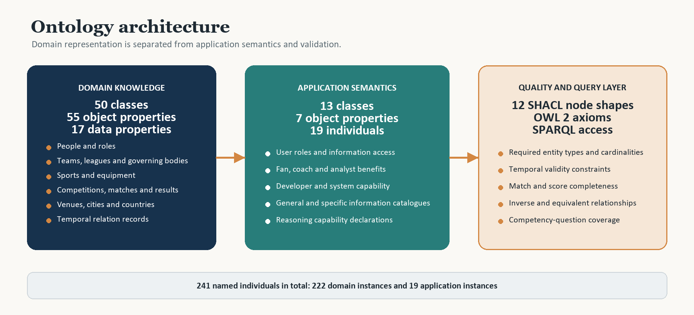
Figure 1 Ontology architecture across domain, application and quality layers
Table 3 Namespace design
Prefix | IRI | Purpose
hs | urn:hopfield:sports:domain# | Sports classes, properties and domain individuals
hsa | urn:hopfield:sports:application# | User roles, benefits and access capabilities
shapes | urn:hopfield:sports:shapes# | SHACL node shapes
owl | http://www.w3.org/2002/07/owl# | OWL vocabulary
rdfs | http://www.w3.org/2000/01/rdf-schema# | Labels, comments, domains and ranges
sh | http://www.w3.org/ns/shacl# | Validation constraints

3.1.2 Design Metrics
Table 4 Ontology components by namespace
Component | Domain layer | Application layer | Total
Classes | 50 | 13 | 63
Object properties | 55 | 7 | 62
Data properties | 17 | 0 | 17
Named individuals | 222 | 19 | 241

The final metadata records version 3.0.0 on 29 October 2026. The description states that this release restores championship counts, adds multi-venue coverage, materialises teammate relations and strengthens SHACL type checks. These changes resolve the earlier mismatch between the question set and the domain-only ontology.

3.2 Classes
The domain class model is organised around six connected areas. The application class model stands beside it and describes access rather than sports facts.
Table 5 Main class design areas
Area | Representative class path | Design purpose
People | Person → Athlete / Coach  Athlete → FootballAthlete / BasketballAthlete  Coach → MultiSportCoach | Separate general roles from sport-specific roles and allow finer retrieval.
Organisation | SportsOrganisation → SportsTeam / SportsLeague / GoverningBody  SportsTeam → ClubTeam / NationalTeam / OlympicTeam | Represent the different organisational forms behind the same team concept.
Sport and equipment | Sport → TeamSport / TennisSport / TrackAndFieldSport  SportsEquipment → Ball / Footwear / Racket | Support sport-level filtering and equipment retrieval.
Competition and match | Competition → CompetitionEdition / InternationalTournament / OlympicEvent / MultiSportEvent  Match → TeamMatch / FootballMatch / FinalMatch | Separate a recurring competition from one edition and one match.
Venue and place | Venue → Stadium / Arena  Venue → locatedInCity → City → cityCountry → Country | Connect competitions to physical locations and countries.
Relation records | TemporalRecord → TeamMembership / CoachingAssignment / AthleteParticipation  MatchAppearance / AgeObservation / MatchResult | Store context that a direct edge alone cannot express.
Application | UserRole → User / SportsFan / SportsAnalyst / WebsiteDeveloper  UserBenefit / SportsInformation / SportsData / SportsPerformance | Make users, benefits and access capabilities queryable.

Subclassing adds semantics beyond simple type labels. For example, a `BasketballAthlete` is also an `Athlete`, and an `InternationalTournament` is also a `CompetitionEdition` and a `Competition`. A SPARQL query against `Athlete` therefore includes the sport-specific athlete subclasses when a reasoner is enabled.

3.3 Properties
The 62 object properties form the navigation layer. They connect people to teams, teams to competitions, competitions to venues, and matches to results. Direct properties provide the shortest useful path. Reified relation classes add time, competition and assignment context where the shortcut would otherwise be ambiguous.

Object Properties
Table 6 Object-property families
Property family | Representative properties | Use in queries
Membership | memberOf, belongsTo, hasAthlete, memberAthlete, membershipTeam | Find a team's players or the teams connected to an athlete.
Participation | participatesIn, participatedIn, participationAthlete, participationCompetition, representingTeam | Retrieve sport participation and competition history.
Coaching | hasCoach, coachesTeam, assignmentCoach, assignmentTeam | Retrieve direct coaching links or full assignment records.
Competition | hasParticipant, competedIn, inCompetition, finalMatch, containsEvent | Connect teams and matches to the appropriate competition.
Venue | hasRecordedVenue, hosts, matchVenue, locatedInCity, cityCountry | Retrieve recorded competition venues and match location.
Result | hasResult, resultOf, homeTeam, awayTeam, hasWinner, hasLoser | Retrieve the teams, winner, result entity and scores.
Equipment and trophy | requires, usesEquipment, obtainTrophy, trophySeries | Retrieve sport equipment or championship links.
Application | canAccess, canQuery, canAnalyze, canBuild, canSearch, usesOntologyFor, supports | Answer the 10 general questions.

The file also defines several semantic shortcuts. `belongsTo` is equivalent to `memberOf`, and `requires` is equivalent to `usesEquipment`. `hasAthlete` is inverse to `memberOf`, `hasCoach` to `coachesTeam`, `hasTeam` to `inLeague`, `hasResult` to `resultOf`, and `hasRecordedVenue` to `hosts`. These axioms allow a reasoner or query engine to navigate a relationship from either direction.

Data Properties
The 17 data properties provide typed literal values. They cover birth and observation dates, scores, competition years, team founding years, titles, match dates, venue capacity and result text. Table 7 lists the data property contract.
Table 7 Data properties
Data property | Domain | Range
ageAsOf | AgeObservation | date
ageYears | AgeObservation | nonNegativeInteger
awayScore | FootballMatch | nonNegativeInteger
birthDate | Athlete | date
competitionYear | Competition | integer
establishYear | SportsTeam | integer
fifaMensWorldCupTitles | NationalTeam | nonNegativeInteger
homeScore | FootballMatch | nonNegativeInteger
isOfficial | Match | boolean
matchDate | Match | date
penaltyAwayScore | FootballMatch | nonNegativeInteger
penaltyHomeScore | FootballMatch | nonNegativeInteger
resultText | MatchResult | string
resultType | MatchResult | string
validFrom | TemporalRecord | date
validTo | TemporalRecord | date
venueCapacity | Venue | nonNegativeInteger

3.4 Individuals
The final file contains 241 named individuals. Of these, 222 populate the domain layer and 19 populate the application layer. The individual count is not evenly distributed: relationship records are numerous because the ontology stores memberships, participation records and coaching assignments as first-class entities.
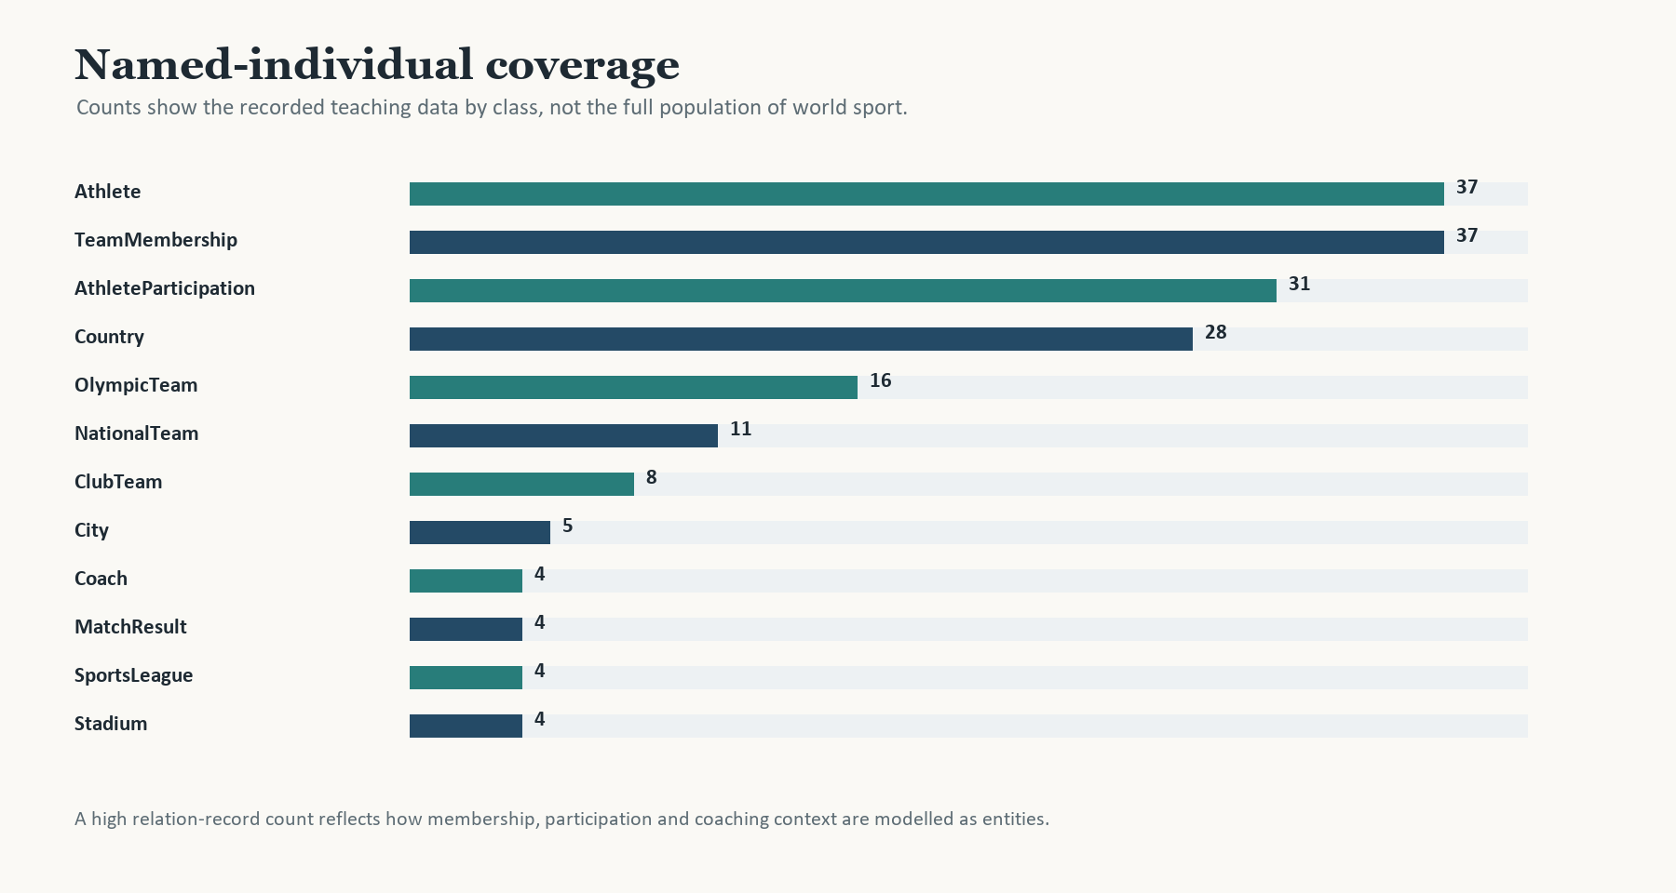
Figure 2 Named-individual coverage for the largest classes
Table 8 Recorded data coverage
Data area | Recorded coverage | Example
Athletes | 37 | Lionel Messi, Kylian Mbappe, Stephen Curry, Usain Bolt
Teams | 36 SportsTeam instances across national, club and Olympic roles | Argentina National Team, FC Barcelona, Golden State Warriors
Membership | 37 TeamMembership records | Lionel Messi - Argentina National Team 2022
Participation | 31 AthleteParticipation records | Julian Alvarez - FIFA World Cup 2022
Competition | 6 competition individuals | FIFA World Cup 2022, Paris Olympic 2024, US Open 2023
Results | 4 MatchResult records | World Cup Final 2022: 3:3, penalties 4:2
Application | 19 role, benefit, catalogue and capability individuals | SportsFanRole, CoachRole, OwlReasoningCapability

3.5 Axioms
The ontology uses OWL axioms to support classification and relationship inference. Subclass axioms place sport-specific athletes and competitions in the broader hierarchy. Equivalent and inverse properties allow different query directions to reach the same fact. Disjointness and domain and range declarations reduce type ambiguity.
These axioms also reduce query duplication. For example, a query can use `hasAthlete` to find a team roster or `memberOf` to find an athlete's team. `hasRecordedVenue` and `hosts` express the same competition-venue relationship from opposite directions. A reasoner can materialise the implied direction without duplicating the assertion in the data.
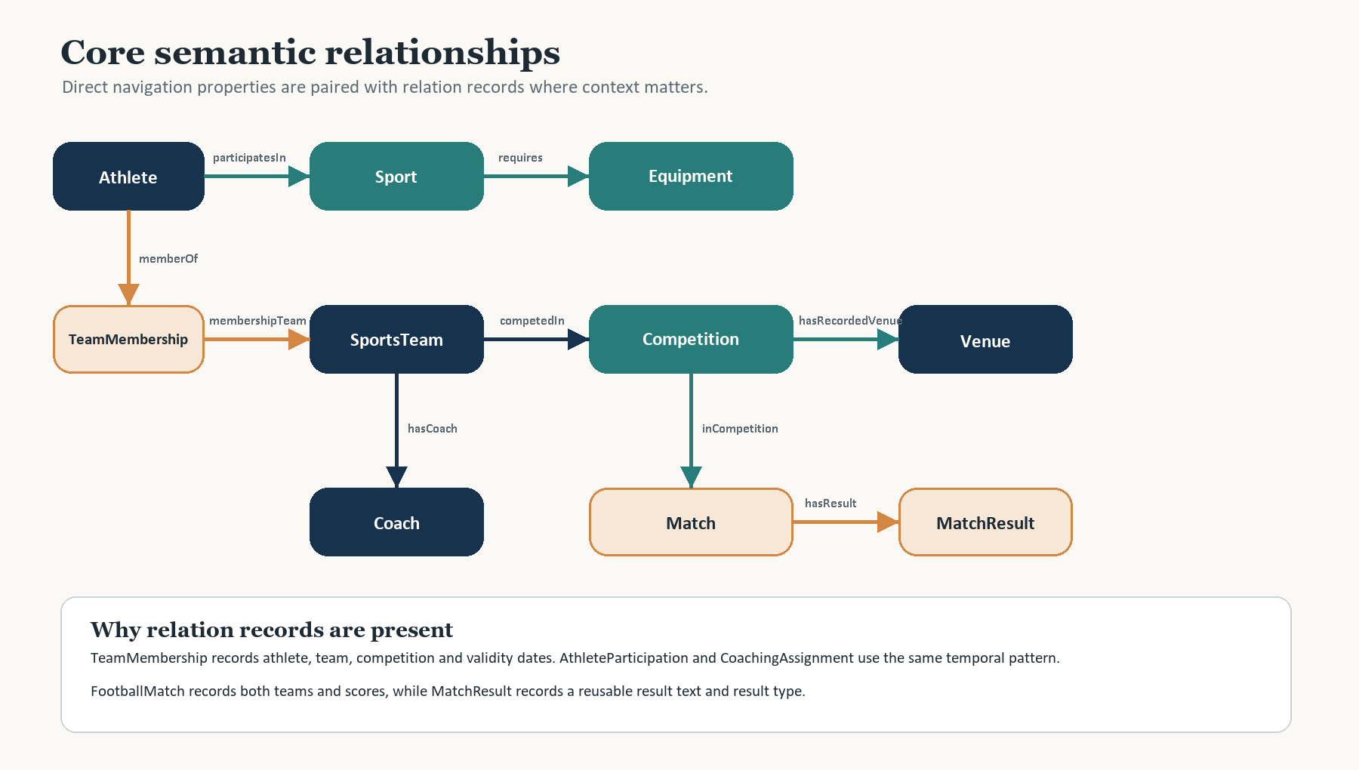
Figure 3 Core domain relationships and relation records
Temporal records solve a specific modelling problem. An athlete may have played for several teams, and a coach may have worked for several organisations. `TeamMembership` therefore records `memberAthlete`, `membershipTeam`, optional `membershipCompetition`, `validFrom` and `validTo`. `CoachingAssignment` and `AthleteParticipation` follow the same pattern.
Twelve SHACL node shapes provide closed validation for the relation and result structures. The constraints require a single athlete, team, coach, competition and result where cardinality matters. They also require dates for temporal records and both team and score fields for a `FootballMatch`.
Table 9 Key SHACL validation shapes
SHACL shape | Target | Main constraint
TeamMembershipShape | TeamMembership | Athlete, team and validFrom required, with optional validTo and competition
CoachingAssignmentShape | CoachingAssignment | Coach, team, validFrom and validTo required
AthleteParticipationShape | AthleteParticipation | Athlete and competition required, with optional representing team
FootballMatchShape | FootballMatch | Home team, away team and both scores required
MatchShape | Match | Competition, date, venue and official status required
MatchAppearanceShape | MatchAppearance | Athlete and match required, with optional team
AgeObservationShape | AgeObservation | Athlete, age and as-of date required
CompetitionEditionShape | CompetitionEdition | Competition year required

4. Requirements Mapping

4.1 Mapping Table

General Questions
The application layer makes the general questions executable. Each user role has access or capability properties, and role-specific benefit individuals record the purpose of using the ontology. Questions that mention a particular athlete, team or event require a supplied IRI or a resolved label.
Table 10 Mapping of general questions
ID | Ontology mapping | Answer route
G01 | UserRole, SportsOntologyResource, canAccess | List role individuals and the ontology they can access.
G02 | SportsFanRole, SportsInformationBenefit, canQuery | Retrieve fan benefit and queryable information catalogue.
G03 | CoachRole, CoachingPreparationBenefit, canQuery | Retrieve coach purpose and sports data catalogue.
G04 | SportsAnalystRole, PerformanceAnalysisBenefit, canAnalyze | Retrieve analyst purpose and comparison information.
G05 | WebsiteDeveloperRole, WebsiteDevelopmentBenefit, canBuild | Retrieve developer purpose and system target.
G06 | GeneralUserRole, canSearch, SportsInformation | List the information catalogues available to general users.
G07 | Competition, competitionSport, hasParticipant, hasRecordedVenue, finalMatch, hasResult | Find competitions, participants, venues and results.
G08 | Sport, requires / usesEquipment, SportsEquipment | Find equipment associated with a sport.
G09 | SportsTeam, hasAthlete, hasCoach, inLeague, establishYear, fifaMensWorldCupTitles | Compare team membership, context and recorded history.
G10 | SportsOntologyResource, supports, OwlReasoningCapability | Identify the declared reasoning capability and its supported inferences.

Specific Questions
Table 11 Mapping of specific questions
ID | Ontology mapping | Answer route
S01 | Athlete, participatesIn, Basketball | Filter athletes by sport.
S02 | Athlete, participatesIn, Sport | Retrieve the sport object for a named athlete.
S03 | SportsTeam, hasAthlete / memberOf, Athlete | Traverse team membership in either direction.
S04 | SportsTeam, hasCoach / coachesTeam, Coach | Retrieve a coach for a team.
S05 | Competition, hasParticipant / competedIn, SportsTeam | Retrieve teams linked to a competition.
S06 | Competition, hasRecordedVenue / hosts, Venue | Retrieve recorded venues for an edition.
S07 | FootballMatch, homeScore, awayScore, penalty scores, MatchResult | Retrieve match scores and result text.
S08 | SportsLeague, hasTeam / inLeague, SportsTeam | Retrieve league membership.
S09 | Venue, hosts, Competition | Retrieve competitions hosted by a venue.
S10 | Sport, requires / usesEquipment, SportsEquipment | Retrieve sport-level equipment.
S11 | Athlete, participatedIn, Competition | Retrieve competition history.
S12 | SportsTeam, competedIn, Competition | Compare team participation in a common event.
S13 | SportsTeam, memberOf, SHACL validation | Detect unresolved or invalid team references.
S14 | Athlete, hasTeammate, Athlete | Retrieve materialised or inferred teammate links.
S15 | OWL axioms, HermiT reasoner | Check logical consistency under class and property constraints.

5. Evaluation and Use
The following queries test different graph operations: type filtering, inverse navigation, optional data, numeric result retrieval and path-sensitive entity selection. Expected outputs are derived from triples in the final OWL file. They should be re-run against the Fuseki endpoint before submission.

5.1 Use case 1: Basketball Athletes
This query tests class filtering and a sport link. It returns athletes connected to the Basketball individual.
PREFIX hs: <urn:hopfield:sports:domain#>
PREFIX rdfs: <http://www.w3.org/2000/01/rdf-schema#>
SELECT ?athleteName
WHERE {
?athlete a hs:Athlete ;
hs:participatesIn hs:Basketball ;
rdfs:label ?athleteName .
}
ORDER BY ?athleteName
Table 12 Expected results for S01
Expected athlete
Anthony Edwards
Giannis Antetokounmpo
Kevin Durant
LeBron James
Stephen Curry
Victor Wembanyama

5.2 Use case 2: Team Roster and Coach
This query combines direct team properties with a count. Argentina is the test entity because its 2022 World Cup roster is complete.
PREFIX hs: <urn:hopfield:sports:domain#>
PREFIX rdfs: <http://www.w3.org/2000/01/rdf-schema#>
SELECT ?teamLabel ?coachLabel ?titles
(COUNT(DISTINCT ?athlete) AS ?rosterCount)
WHERE {
VALUES ?team { hs:ArgentinaNationalTeam }
?team rdfs:label ?teamLabel ;
hs:hasCoach ?coach ;
hs:hasAthlete ?athlete .
?coach rdfs:label ?coachLabel .
OPTIONAL { ?team hs:fifaMensWorldCupTitles ?titles }
}
GROUP BY ?teamLabel ?coachLabel ?titles
Expected result: Argentina National Team, Lionel Scaloni, 3 FIFA men's World Cup titles and 26 team members. This combines S03, S04 and part of G09.

5.3 Use case 3: Competition and Result
This query traverses a match to its teams and result entity. It also returns the venue recorded directly on the match.
PREFIX hs: <urn:hopfield:sports:domain#>
PREFIX rdfs: <http://www.w3.org/2000/01/rdf-schema#>
SELECT ?homeLabel ?awayLabel ?venueLabel
?homeScore ?awayScore ?resultText
WHERE {
VALUES ?match { hs:WorldCupFinal2022 }
?match hs:homeTeam ?home ;
hs:awayTeam ?away ;
hs:matchVenue ?venue ;
hs:homeScore ?homeScore ;
hs:awayScore ?awayScore ;
hs:hasResult ?result .
?home rdfs:label ?homeLabel .
?away rdfs:label ?awayLabel .
?venue rdfs:label ?venueLabel .
?result hs:resultText ?resultText .
}
Expected output: Argentina National Team, France National Team, Lusail Stadium, 3:3, and `3:3; penalties 4:2`.

5.4 Use case 4: Equipment Query
This query returns both equipment records linked to tennis.
PREFIX hs: <urn:hopfield:sports:domain#>
PREFIX rdfs: <http://www.w3.org/2000/01/rdf-schema#>
SELECT ?equipmentLabel
WHERE {
hs:Tennis hs:requires ?equipment .
?equipment rdfs:label ?equipmentLabel .
}
ORDER BY ?equipmentLabel
Expected output: Tennis Ball and Tennis Racket.

5.5 Use case 5: Teammate Retrieval
This query retrieves the materialised teammate network around Lionel Messi.
PREFIX hs: <urn:hopfield:sports:domain#>
PREFIX rdfs: <http://www.w3.org/2000/01/rdf-schema#>
SELECT ?teammateLabel
WHERE {
hs:LionelMessi hs:hasTeammate ?teammate .
?teammate rdfs:label ?teammateLabel .
}
ORDER BY ?teammateLabel
Expected result: 25 teammates. The links can also be inferred through shared membership when a reasoner is enabled.
Table 13 SPARQL query coverage
Use case | Question coverage | Main SPARQL feature | Current expected result
UC1 | S01 | Type and object filtering | 6 basketball athletes
UC2 | S03, S04, G09 | Join, optional and aggregate | 26 players, Scaloni, 3 titles
UC3 | S06, S07 | Multi-hop result traversal | Lusail, 3:3, penalties 4:2
UC4 | S10 | Simple object-property lookup | Ball and racket
UC5 | S14 | Materialised or inferred teammate path | 25 teammates

6. Implementation

6.1 Connection to the Dataset
The reference implementation connects to Apache Jena Fuseki through SPARQLWrapper. The local development endpoint in the supplied implementation is `http://localhost:3030/sportsdb/sparql`. The endpoint identifier can change without changing the ontology or query templates.
from SPARQLWrapper import SPARQLWrapper, JSON
endpoint = "http://localhost:3030/sportsdb/sparql"
client = SPARQLWrapper(endpoint)
client.setReturnFormat(JSON)

6.2 NLP Techniques
The query interface translates a controlled natural-language question into SPARQL. It uses a vocabulary generated from ontology labels and a rule table that maps phrase patterns to query templates. The design keeps generation transparent so that an incorrect answer can be traced to preprocessing, entity recognition, intent matching or the execution layer.
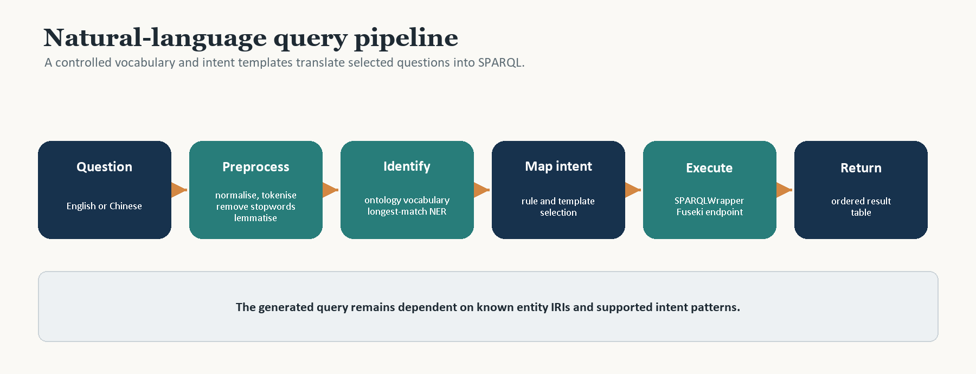
Figure 4 Controlled natural-language query pipeline
The pipeline applies six operations:
- Normalisation converts the question to a uniform case and removes irrelevant punctuation and repeated whitespace.
- Tokenisation splits Chinese text with jieba and falls back to whitespace and symbol boundaries for English.
- Stopword removal deletes low-information words such as `which`, `what`, `the` and their Chinese equivalents.
- Lemmatisation maps English word forms to a common base form with NLTK WordNetLemmatizer [6].
- Named-entity recognition uses longest-match vocabulary lookup over ontology labels, individuals and property names.
- Intent classification selects a SPARQL template and fills the entity, property or numeric filter variables.

6.3 Overall Code
The executable shell separates text preparation, ontology-vocabulary matching, intent selection, query construction and endpoint execution. The query templates contain the ontology terms, while the recogniser supplies entity IRIs and literal values.
def answer(question, endpoint):
text = normalize(question)
tokens = lemmatize(remove_stopwords(tokenize(text)))
entities = longest_match(text, ONTOLOGY_VOCABULARY)
intent = select_intent(tokens, entities)
query = INTENT_TEMPLATES[intent].format(**entities)
return run_sparql(endpoint, query)

6.4 Code Validation
Each supported question family maps to a parameterised template. The template returns a relation, a count, a comparison or a result record. Table 14 defines representative transformation rules and expected outputs.
Table 14 Representative natural-language query patterns
Question pattern | Detected intent | SPARQL template | Expected result
Which athletes play basketball? | athletes_by_sport | Athlete + participatesIn | 6 athletes
Who coaches Argentina? | coach_of_team | SportsTeam + hasCoach | LionelScaloni
What equipment does tennis require? | equipment_of_sport | Sport + requires | TennisRacket, TennisBall
What was the 2022 final score? | match_result | FootballMatch + scores + MatchResult | 3:3, penalties 4:2
How many NBA teams are recorded? | league_member_count | SportsLeague + hasTeam + COUNT | 5 teams
Who are Messi's teammates? | athlete_teammates | Athlete + hasTeammate | 25 teammates

The interface should expose the recognised entity and generated SPARQL before execution. This makes failures visible when a name is ambiguous, a question contains an unsupported comparison or a required data value is absent.

6.4.1 Data Quality and Reasoning
The ontology separates data validation from logical reasoning. SHACL checks the structure of recorded instances. OWL reasoning checks whether the class and property axioms produce a consistent interpretation. Neither process can prove that every sports fact is correct.

Reasoning Capability
The application layer includes `OwlReasoningCapability`, linked from `HopfieldSportsOntology` through `supports`. The ontology declares inverse properties such as `hasAthlete` and `memberOf`, equivalent properties such as `requires` and `usesEquipment`, and class restrictions for athletes and coaches.
With a reasoner such as HermiT, the ontology can support classification, inverse relationship retrieval and teammate inference from shared team membership. The present file declares the capability; a reasoner run should be repeated in Protege and recorded for final submission.

Current Limitations
Table 15 Current limitations and actions
Limitation | Effect on use | Next action
Selected teaching dataset | Results describe recorded examples, not a complete world inventory. | State the dataset scope beside every result.
Parameterized questions | The question must contain a resolvable entity IRI or unique label. | Add an ambiguity check and a clarification prompt.
Dictionary-based recognition | Unseen aliases and novel sentence forms can fail. | Expand bilingual aliases and monitor unmatched questions.
Open-world semantics | A missing optional value is not evidence that the fact is false. | Display missing data separately from false data.
Reasoner output not archived | The file declares reasoning capability but does not include a final consistency report. | Run HermiT and store the result for the assessment.
No live Fuseki screenshots | Expected results are supported by the OWL triples but are not presented as a live server run. | Re-import the final OWL and capture query results.

7. Conclusion and Future Work
The final ontology provides a coherent representation of selected sports knowledge and a separate model of how users access it. The domain layer supports queries about athletes, team history, competitions, venues, equipment and results. The application layer resolves the earlier gap for general questions about users and system capabilities.
The model also records why a shortcut relationship is not always enough. Membership, participation and coaching use temporal records. Matches use a separate result entity. SHACL shapes make missing or invalid structure visible. These choices make the ontology suitable for both graph browsing and controlled query generation.
The next stage should focus on operational evidence rather than additional concepts. The team should run the 25 query routes against Fuseki, run HermiT on the final file, capture representative screenshots, and expand the natural-language vocabulary with the actual error cases found during testing.

8. References
[1] Hitzler, P., Krötzsch, M., Parsia, B., Patel-Schneider, P.F. and Rudolph, S. (eds.) (2012) OWL 2 Web Ontology Language Primer. 2nd edn. W3C Recommendation.
[2] W3C (2013) SPARQL 1.1 Query Language. W3C Recommendation.
[3] W3C (2017) Shapes Constraint Language (SHACL). W3C Recommendation.
[4] Musen, M.A. (2015) 'The Protege project: a look back and a look forward', AI Matters, 1(4), pp. 4-12.
[5] Apache Software Foundation (2026) Apache Jena Fuseki Documentation.
[6] Bird, S., Klein, E. and Loper, E. (2009) Natural Language Processing with Python. Sebastopol: O'Reilly Media.
[7] Hopfield Team (2026) Hopfield Sports Ontology, version 3.0.0. OWL file submitted with this report.
[8] Hopfield Team (2026) Sports Ontology General and Specific Question Workbooks. Internal project material.
[9] Semantic Data Technologies (2026) Semantic Data Example Report. Supplied assessment example.

Appendix A: Class Inventory
The inventory below lists every class declaration in the final OWL file. Parent names are shown where an explicit named class relationship exists. Blank-node restrictions and unions remain in the ontology but are summarised in the body of the report.
Table A1 Complete class inventory
Layer | Class | Named parent
Application | OntologyResource | -
Application | ReasoningCapability | -
Application | SportsAnalyst | User
Application | SportsData | SportsInformation
Application | SportsFan | User
Application | SportsInformation | -
Application | SportsInformationSystem | -
Application | SportsOntologyResource | OntologyResource
Application | SportsPerformance | SportsData
Application | User | UserRole
Application | UserBenefit | -
Application | UserRole | -
Application | WebsiteDeveloper | User
Domain | AgeObservation | -
Domain | Arena | Venue
Domain | Athlete | Person
Domain | AthleteParticipation | -
Domain | Ball | SportsEquipment
Domain | BasketballAthlete | -
Domain | BasketballSport | TeamSport
Domain | City | -
Domain | ClubTeam | SportsTeam
Domain | Coach | Person
Domain | CoachingAssignment | TemporalRecord
Domain | Competition | -
Domain | CompetitionEdition | Competition
Domain | CompetitionSeries | -
Domain | Country | -
Domain | FinalMatch | Match
Domain | FootballAthlete | -
Domain | FootballMatch | TeamMatch
Domain | FootballSport | TeamSport
Domain | Footwear | SportsEquipment
Domain | GoverningBody | SportsOrganisation
Domain | InternationalTournament | CompetitionEdition
Domain | Match | -
Domain | MatchAppearance | -
Domain | MatchResult | -
Domain | MultiSportCoach | Coach
Domain | MultiSportEvent | Competition
Domain | NationalTeam | SportsTeam
Domain | OlympicEvent | CompetitionEdition
Domain | OlympicTeam | SportsTeam
Domain | Person | -
Domain | Racket | SportsEquipment
Domain | RugbySport | TeamSport
Domain | Sport | -
Domain | SportsCompetitor | -
Domain | SportsEquipment | -
Domain | SportsLeague | SportsOrganisation
Domain | SportsOrganisation | -
Domain | SportsTeam | SportsOrganisation
Domain | Stadium | Venue
Domain | TeamMatch | Match
Domain | TeamMembership | TemporalRecord
Domain | TeamSport | Sport
Domain | TemporalRecord | -
Domain | TennisSinglesCompetition | Competition
Domain | TennisSport | Sport
Domain | TrackAndFieldSport | Sport
Domain | Trophy | -
Domain | Under25BasketballAthlete | BasketballAthlete
Domain | Venue | -

Appendix B: Property Inventory
The object-property inventory records the declared domain and range. A dash indicates a blank-node union or a declaration without a direct named resource. The application properties appear after the domain properties.
Table B1 Object-property inventory
Object property | Domain | Range | Layer
canAccess | UserRole | OntologyResource | Application
canAnalyze | UserRole | SportsPerformance | Application
canBuild | UserRole | SportsInformationSystem | Application
canQuery | UserRole | SportsInformation | Application
canSearch | UserRole | SportsInformation | Application
supports | OntologyResource | ReasoningCapability | Application
usesOntologyFor | UserRole | UserBenefit | Application
appearanceAthlete | MatchAppearance | Athlete | Domain
appearanceMatch | MatchAppearance | Match | Domain
appearanceTeam | MatchAppearance | SportsTeam | Domain
assignmentCoach | CoachingAssignment | Coach | Domain
assignmentTeam | CoachingAssignment | SportsTeam | Domain
awayTeam | TeamMatch | SportsTeam | Domain
belongToSport | - | Sport | Domain
belongsTo | Athlete | SportsTeam | Domain
canHostSport | Venue | Sport | Domain
cityCountry | City | Country | Domain
coachesTeam | Coach | SportsTeam | Domain
competedIn | SportsTeam | Competition | Domain
competitionSport | Competition | Sport | Domain
containsEvent | MultiSportEvent | Competition | Domain
editionOfSeries | CompetitionEdition | CompetitionSeries | Domain
finalMatch | Competition | Match | Domain
governedBy | Sport | GoverningBody | Domain
hasAgeObservation | Athlete | AgeObservation | Domain
hasAthlete | SportsTeam | Athlete | Domain
hasCoach | SportsTeam | Coach | Domain
hasLoser | Match | SportsCompetitor | Domain
hasMatchAppearance | Athlete | MatchAppearance | Domain
hasOpponent | Athlete | Athlete | Domain
hasParticipant | Competition | SportsTeam | Domain
hasRecordedVenue | Competition | Venue | Domain
hasResult | Match | MatchResult | Domain
hasTeam | SportsLeague | SportsTeam | Domain
hasTeammate | Athlete | Athlete | Domain
hasWinner | Match | SportsCompetitor | Domain
homeTeam | TeamMatch | SportsTeam | Domain
hosts | Venue | Competition | Domain
inCompetition | Match | Competition | Domain
inLeague | SportsTeam | SportsLeague | Domain
locatedInCity | Venue | City | Domain
matchParticipant | Match | SportsCompetitor | Domain
matchVenue | Match | Venue | Domain
memberAthlete | TeamMembership | Athlete | Domain
memberOf | Athlete | SportsTeam | Domain
membershipCompetition | TeamMembership | Competition | Domain
membershipTeam | TeamMembership | SportsTeam | Domain
nationalityCountry | Athlete | Country | Domain
observedAthlete | AgeObservation | Athlete | Domain
obtainTrophy | SportsTeam | Trophy | Domain
participatedIn | Athlete | Competition | Domain
participatesIn | Athlete | Sport | Domain
participationAthlete | AthleteParticipation | Athlete | Domain
participationCompetition | AthleteParticipation | Competition | Domain
playedInMatch | Athlete | Match | Domain
playsSport | SportsTeam | Sport | Domain
representingTeam | AthleteParticipation | SportsTeam | Domain
representsCountry | SportsTeam | Country | Domain
requires | Sport | SportsEquipment | Domain
resultOf | MatchResult | Match | Domain
trophySeries | Trophy | CompetitionSeries | Domain
usesEquipment | Sport | SportsEquipment | Domain

Five Dublin Core annotation properties carry title, creator, description, creation date and source metadata. They do not represent domain relationships.

Appendix C: Individual Coverage
Counts include all named individuals whose `rdf:type` refers to the listed class. An individual may count under more than one class when it has multiple explicit types.
Table C1 Individual count by explicit class type
Class | Individuals | Class | Individuals
Athlete | 37 | TeamMembership | 37
AthleteParticipation | 31 | Country | 28
OlympicTeam | 16 | NationalTeam | 11
ClubTeam | 8 | City | 5
Ball | 4 | Coach | 4
CoachingAssignment | 4 | MatchResult | 4
SportsLeague | 4 | Stadium | 4
UserBenefit | 4 | FootballMatch | 3
Footwear | 3 | OlympicEvent | 3
SportsInformation | 3 | UserRole | 3
FinalMatch | 2 | InternationalTournament | 2
Under25BasketballAthlete | 2 | Arena | 1
BasketballSport | 1 | CompetitionSeries | 1
FootballSport | 1 | GoverningBody | 1
MultiSportEvent | 1 | Racket | 1
ReasoningCapability | 1 | RugbySport | 1
SportsAnalyst | 1 | SportsData | 1
SportsFan | 1 | SportsInformationSystem | 1
SportsOntologyResource | 1 | SportsPerformance | 1
SportsTeam | 1 | TennisSport | 1
TrackAndFieldSport | 1 | Trophy | 1
User | 1 | Venue | 1
WebsiteDeveloper | 1

