Why on earth can't they just leave interfaces alone?
...or: "why is it so difficult to figure out how to read the Visual C++ Include Folder configuration in VS2005?"
The answer is of course that the interfaces have been changed. I don't know why, but I do know that the method recommended by Microsoft no longer works.
In VS2002 and VS2003 expose interfaces to a collection of VCPlatform objects via DTE's properties collection, indexed by the name of the platform. Once you have a VCPlatform interface pointer, reading the include folder configuration is simplicity itself:
CString GetVcIncludeFolders(EnvDTE::_DTE* pDTE, const CString& sPlatform /*= _T("Win32")*/ )
{
CString sIncludeFolders;
try
{
EnvDTE::_DTEPtr ptrDTE;
pDTE->QueryInterface(&ptrDTE);
EnvDTE::PropertiesPtr ptrProperties = ptrDTE->GetProperties(L"Projects", L"VCDirectories");
VCProjectEngineLibrary::IVCCollectionPtr ptrPlatforms = ptrProperties->Item(L"Platforms")->GetObject();
ATLASSERT(ptrPlatforms != NULL);
if (ptrPlatforms != NULL)
{
VCProjectEngineLibrary::VCPlatformPtr ptrPlatform = ptrPlatforms->Item(_bstr_t(sPlatform) );
_bstr_t bsFolders = ptrPlatform->GetIncludeDirectories();
sIncludeFolders = COLE2CT( ptrPlatform->Evaluate(bsFolders) );
}
}
catch (const _com_error& e)
{
#ifdef _DEBUG
CString sMsg;
sMsg.Format(_T("Unexpected exception 0x%X (%s) in %s()\n"),
e.Error(),
e.ErrorMessage(),
CA2CT( __FUNCTION__ ) );
ATLTRACE(sMsg);
ATLASSERT(false);
#endif
}
return sIncludeFolders;
}
Unfortunately, the available properties have changed in VS2005, and the "Platforms" collection is no longer exposed in this way, as a glance at the properties shown by the Extensibility Browser will show:
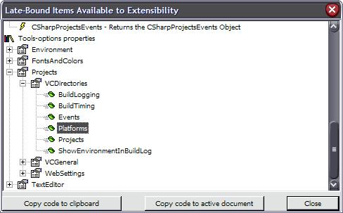
VCDirectories properties in VS2003
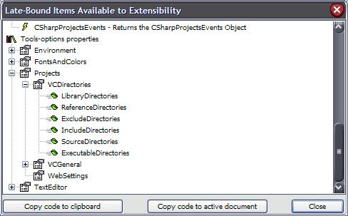
VCDirectories properties in VS2005
When we realised this our first thought was to try to obtain a VCProjectEngine interface somehow - from there the Platforms collection is directly accessible. Unfortunately all the examples in MSDN and elsewhere show VCProjectEngine interfaces being obtained from an EnvDTE::Project object, as follows (apologies for the VB!), and we can't use this method if there is no solution open:
' add reference to Microsoft.VisualStudio.VCProjectEngine
Imports EnvDTE
Imports Microsoft.VisualStudio.VCProjectEngine
Public Module Module1
Sub Test()
Dim prj As VCProject
Dim cfgs, tools As IVCCollection
Dim cfg As VCConfiguration
Dim p As VCPlatform
Dim x As String
prj = DTE.Solution.Projects.Item(1).Object
p = prj.Platforms(1)
x = p.IncludeDirectories
p.IncludeDirectories = x + ";something"
MsgBox(p.IncludeDirectories)
End Sub
End Module
The key was finding a way to obtain a VCProjectEngine interface pointer without going through a Project. Although Microsoft suggest you can create an instance of this object directly like this:
VCProjectEngineLibrary::VCProjectEnginePtr ptrEngine;
ptrEngine.CreateInstance( __uuidof(VCProjectEngineLibrary::VCProjectEngineObject),
NULL,
CLSCTX_INPROC_SERVER);
this is not a safe operation to perform within the IDE, certainly under VS2005. We saw some sorts of strange and unpleasant side effects when we explored this route!
Thankfully there is another way, albeit an undocumented one. The VCProjects collection (accessible via a property of DTE itself) can be used to obtain a VCProjectEngine interface pointer, and thereafter it is straightforward:
CString GetVcIncludeFolders(EnvDTE::_DTE* pDTE, const CString& sPlatform /*= _T("Win32")*/)
{
CString sIncludeFolders;
if (pDTE != NULL)
{
try
{
EnvDTE::_DTEPtr ptrDTE;
pDTE->QueryInterface(&ptrDTE);
EnvDTE::ProjectsPtr ptrProjects = pDTE->GetObject(L"VCProjects");
VCProjectEngineLibrary::VCProjectEnginePtr ptrProjectEngine =
ptrProjects->GetProperties()->Item(L"VCProjectEngine")->GetObject();
if (ptrProjectEngine != NULL)
{
VCProjectEngineLibrary::IVCCollectionPtr ptrVcPlatforms =
ptrVCProjectEngine->GetPlatforms();
VCProjectEngineLibrary::VCPlatformPtr ptrPlatform = ptrVcPlatforms->Item( _bstr_t(sPlatform) );
sIncludeFolders = COLE2CT( ptrPlatform->Evaluate( ptrPlatform->GetIncludeDirectories() ) );
}
}
catch (const _com_error& e)
{
#ifdef _DEBUG
CString sMsg;
sMsg.Format(_T("Unexpected exception 0x%X (%s) in %s()\n"),
e.Error(),
e.ErrorMessage(),
CA2CT( __FUNCTION__() ) );
ATLTRACE(sMsg);
ATLASSERT(false);
#endif
}
}
ATLASSERT(!sIncludeFolders.IsEmpty() );
return sIncludeFolders;
}
Fortunately, the same code also works in VS2002 and VS2003.

得到头文件目录
Sub GetIncludeDirectories()
Dim pros As Projects
Dim eng As Microsoft.VisualStudio.VCProjectEngine.VCProjectEngine
Dim plat As Microsoft.VisualStudio.VCProjectEngine.VCPlatform
Dim d As VCDirectories
pros = DTE.GetObject("VCProjects") '直接从DTE 得到VCProject
eng = pros.Properties.Item("VCProjectEngine").Object
For Each plat In eng.Platforms
Debug.WriteLine(plat.Name)
Debug.WriteLine(plat.IncludeDirectories) '得到头文件目录
Debug.WriteLine(plat.Evaluate(plat.IncludeDirectories)) '取值
Next
End Sub

#define IfFailGoCheck(x, p) { hr=(x); if (FAILED(hr)) goto Error; if(!p) {hr = E_FAIL; goto Error; } }
CComBSTR CSystemIncludeTiShi::GetVcIncludeFolders(EnvDTE::_DTE * pDTE, const BSTR bstrPlatform /*= _T("Win32")*/)
{
CComBSTR bstrIncludeFolders;
HRESULT hr;

if(pDTE != NULL)
{
CComPtr < EnvDTE::Projects > pProjects;
CComPtr < EnvDTE::Properties > pProperties;
CComPtr < EnvDTE::Property > pProperty;
CComPtr < VCProjectEngineLibrary::VCProjectEngine > pProjectEngine;

IfFailGoCheck(pDTE->GetObject(CComBSTR(_T("VCProjects")), (IDispatch ** )&pProjects), pProjects);
IfFailGoCheck(pProjects->get_Properties(&pProperties), pProperties);

CComVariant v;
v = _T("VCProjectEngine");
IfFailGoCheck(pProperties->Item(v, &pProperty), pProperty);
IfFailGoCheck(pProperty->get_Object((IDispatch ** )&pProjectEngine), pProjectEngine);

CComPtr < VCProjectEngineLibrary::IVCCollection > pVCPlatforms;
CComPtr < VCProjectEngineLibrary::VCPlatform > pVCPlatform;

IfFailGoCheck(pProjectEngine->get_Platforms((IDispatch ** )&pVCPlatforms), pVCPlatforms);
v = bstrPlatform;
IfFailGoCheck(pVCPlatforms->Item(v, (IDispatch ** )&pVCPlatform), pVCPlatform);
CComBSTR bstDir;
IfFailGoCheck(pVCPlatform->get_IncludeDirectories(&bstDir), bstDir);
pVCPlatform->Evaluate(bstDir, &bstrIncludeFolders);
} // 结束if(pDTE != NULL)

return bstrIncludeFolders;

Error:
return CComBSTR();
}

Sub GetIncludeDirectoriesOnSolution()
Dim prj As VCProject
Dim cfgs, tools As IVCCollection
Dim cfg As VCConfiguration
Dim p As VCPlatform
Dim x As String
prj = DTE.Solution.Projects.Item(1).Object '从工程得到VCProject
p = prj.Platforms(1)
x = p.IncludeDirectories
p.IncludeDirectories = x + ";something"
MsgBox(p.IncludeDirectories)
End Sub

导入COM库
用#import导入COM库。
- COM库文件名
- Libid
- .tlb文件

#pragma warning( disable : 4278 )
#pragma warning( disable : 4146 )
//The following #import imports the IDTExtensibility2 interface based on it's LIBID
#import "libid:AC0714F2-3D04-11D1-AE7D-00A0C90F26F4" version("1.0") lcid("0") raw_interfaces_only named_guids

//The following #import imports VS Command Bars based on it's LIBID
#import "libid:1CBA492E-7263-47BB-87FE-639000619B15" version("8.0") lcid("0") raw_interfaces_only named_guids

//The following #import imports DTE based on it's LIBID
#import "libid:80cc9f66-e7d8-4ddd-85b6-d9e6cd0e93e2" version("8.0") lcid("0") raw_interfaces_only named_guids

//The following #import imports DTE80 based on it's LIBID
#import "libid:1A31287A-4D7D-413e-8E32-3B374931BD89" version("8.0") lcid("0") raw_interfaces_only named_guids
// VCProject C:\Program Files\Microsoft Visual Studio 8\VC\vcpackages\VCProject.dll
#import "libid:7DDEAC52-6DC1-46CF-94FC-4C9E3614211D" version("8.0")lcid("0") raw_interfaces_only named_guids

//VCProjectEngine
#import "libid:FBBF3C60-2428-11D7-8BF6-00B0D03DAA06" version("8.0")lcid("0")raw_interfaces_only named_guids

#pragma warning( default : 4146 )
#pragma warning( default : 4278 )

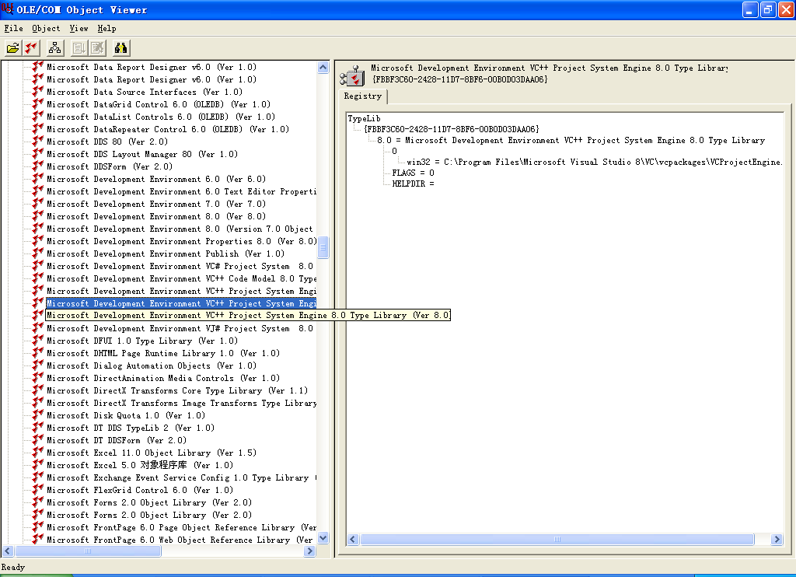

Sel.Text 与 EditPoint.GetText 的区别：
Text 是得到Sel 中的文本。
GetText 是得到内存中的文本。它不影响 Sel 。

Sel.Text 与 Sel.Insert 的区别：
Sel.Text 赋值时，会影响 Sel 。会引起键盘输入事件。
Sel.Insert 赋值时，不会影响 Sel ，不会引起键盘输入事件。
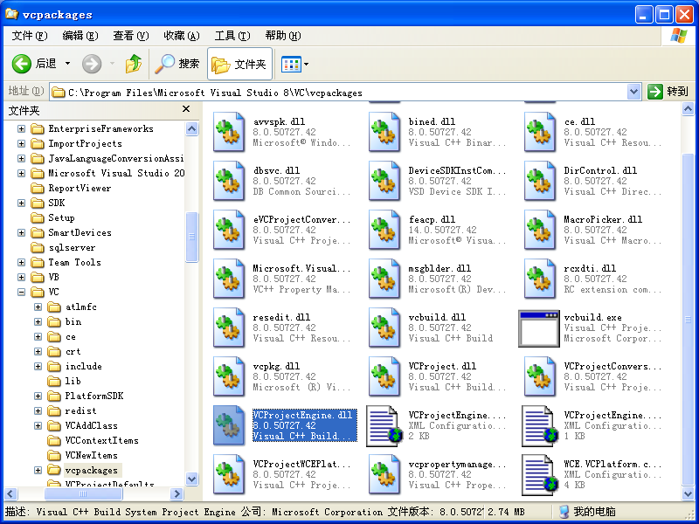

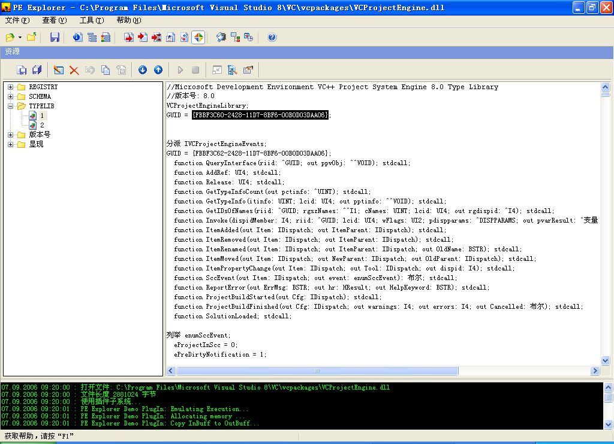

ms-help://MS.VSCC.v80/MS.MSDN.v80/MS.VisualStudio.v80.en/dv_vcsample/local/samplehtmlsources/Extensibility/ProjectModel/VCProjEngine_CPP/Sample.cpp.htm
#pragma once

#define WIN32_LEAN_AND_MEAN // Exclude rarely-used stuff from Windows headers
#ifndef VC_EXTRALEAN
#define VC_EXTRALEAN // Exclude rarely-used stuff from Windows headers
#endif

#include <atlbase.h>

#include <iostream>
using namespace std;

#import <VCProjectEngine.dll> raw_interfaces_only raw_native_types
using namespace VCProjectEngineLibrary;

int main( )
{

CoInitialize( NULL );

HRESULT hr = S_OK;
// Create the VCProjectEngine
CComPtr<VCProjectEngine> spEngine;
hr = CoCreateInstance( __uuidof(VCProjectEngineObject), NULL, CLSCTX_INPROC_SERVER, __uuidof(VCProjectEngine), (void**)&spEngine );
if( FAILED( hr ) || !spEngine )
{
cout << "Error: cannot create VCProjectEngine object." << endl;
CoUninitialize();
return 1;
}

// Open an existing project.
CComPtr<IDispatch> spDispProj;
hr = spEngine->LoadProject( CComBSTR( L"MyProject.vcproj" ), &spDispProj );
if( FAILED( hr ) || !spDispProj )
{
cout << "Error: cannot open the specified project." << endl;
CoUninitialize();
return 1;
}
CComQIPtr<VCProject> spProject = spDispProj;
if( !spProject )
{
cout << "Error: cannot query VCProject interface." << endl;
CoUninitialize();
return 1;
}

// Change the project's name to "Voila"
hr = spProject->put_Name( CComBSTR( L"Voila" ) );
if( FAILED( hr ) )
cout << "Error: cannot change project name." << endl;

// Add a new configuration to the project
hr = spProject->AddConfiguration( CComBSTR( L"Whichever Name" ) );
if( FAILED( hr ) )
cout << "Error: cannot add a new configuration." << endl;

// Access the configurations collection of the project
CComPtr<IDispatch> spDispConfigs;
hr = spProject->get_Configurations( &spDispConfigs );
if( FAILED( hr ) || !spDispConfigs )
{
cout << "Error: cannot access the configurations collecion." << endl;
CoUninitialize();
return 1;
}
CComQIPtr<IVCCollection> spConfigCol = spDispConfigs;

// Enumerate the Configurations collection by name to get the Debug configuration of the project
CComPtr<IDispatch> spDispConfig;
hr = spConfigCol->Item( CComVariant( L"Debug" ), &spDispConfig );
if( FAILED( hr ) || !spDispConfig )
{
cout << "Error: cannot get the Debug configuraion." << endl;
CoUninitialize();
return 1;
}
CComQIPtr<VCConfiguration> spConfig = spDispConfig;

// If you want to change the Configuration Type of the project from the default Dll to Exe
hr = spConfig->put_ConfigurationType( typeApplication );
if( FAILED( hr ) )
cout << "Error: cannot change configuration type." << endl;

// Access the Tools collection for this configuration
CComPtr<IDispatch> spDispTools;
hr = spConfig->get_Tools( &spDispTools );
if( FAILED( hr ) )
{
cout << "Error: cannot access the tools collection." << endl;
CoUninitialize();
return 1;
}
CComQIPtr<IVCCollection> spToolCol = spDispTools;

// Enumerate the Tools collection by name to get the Linker tool
CComPtr<IDispatch> spDispTool;
hr = spToolCol->Item( CComVariant( L"VCLinkerTool" ), &spDispTool );
if( FAILED( hr ) )
cout << "Error: cannot get IDispatch interface of the linker tool." << endl;
else
{
// Get the VCLinkerTool interface and directly change a property
CComPtr<VCLinkerTool> spLinker;
hr = spDispTool->QueryInterface( __uuidof( VCLinkerTool ), (void**)&spLinker );
if( FAILED( hr ) || !spLinker )
cout << "Error: cannot get the raw interface of the linker tool." << endl;
else
{
// linkProgressOption is the enum that defines all the options for the ShowProgress property
linkProgressOption enumDefault;
// Access the ShowProgress property
hr = spLinker->get_ShowProgress( &enumDefault );
if( FAILED( hr ) )
cout << "Error: cannot get the default value of Show Progress property." << endl;

// Change the ShowProgress property to "Display All Progress Messages (/VERBOSE)"
enumDefault = linkProgressAll;
hr = spLinker->put_ShowProgress( enumDefault );
if( FAILED( hr ) )
cout << "Error: cannot change the Show Progress property from default to Display All Progress Messages (/VERBOSE)." << endl;
}
}

// Add a cpp file called New.cpp to the project
VARIANT_BOOL var;
CComPtr<IDispatch> spDispFile;

hr = spProject->CanAddFile( CComBSTR( L"New.cpp" ), &var );
if( SUCCEEDED( hr ) && var )
{
hr = spProject->AddFile( CComBSTR( L"New.cpp" ), &spDispFile );
if( FAILED( hr ) )
cout << "Error: cannot add a new source file." << endl;
// ...
}

// Access Files collection
CComPtr<IDispatch> spDispFiles;
hr = spProject->get_Files( &spDispFiles );
if( SUCCEEDED( hr ) )
{
CComQIPtr<IVCCollection> spCol = spDispFiles;

// Access a cpp file called "Existing.cpp" that is already in the project
CComPtr<IDispatch> spDispAnotherFile;
hr = spCol->Item( CComVariant( L"Existing.cpp" ), &spDispAnotherFile );
if( SUCCEEDED( hr ) )
{
CComQIPtr<VCFile> spFile = spDispAnotherFile;

// Access FileConfigurations collection of this file
CComPtr<IDispatch> spDispCol;
hr = spFile->get_FileConfigurations( &spDispCol );
if( SUCCEEDED( hr ) )
{
CComQIPtr<IVCCollection> spFileConfigs = spDispCol;

// Access the "Release" configuration of this file
CComPtr<IDispatch> spDispFileConfig;
hr = spFileConfigs->Item( CComVariant( L"Release|Win32" ), &spDispFileConfig );
if( SUCCEEDED( hr ) )
{
CComQIPtr<VCFileConfiguration> spFileConfig = spDispFileConfig;

// Get the default tool associated with this configuration of this file
CComPtr<IDispatch> spDispFileTool;
hr = spFileConfig->get_Tool( &spDispFileTool );
if( SUCCEEDED( hr ) )
{
// A different way of changing a property. This time through the IDispatch interface
// Change the Optimization property to Full Optimization (/Ox)
CComDispatchDriver drFileTool( spDispFileTool );
CComVariant var1( optimizeFull );
hr = drFileTool.PutPropertyByName( CComBSTR( L"Optimization" ), &var1 );
if( FAILED( hr ) )
cout << "Error: cannot change Optimization property from default to Full Optimization (/Ox)." << endl;
}
else
cout << "Error: cannot get the tool associated with the source file." << endl;
}
else
cout << "Error: cannot get the Release configuration of the source file." << endl;
}
else
cout << "Error: cannot get the file level configurations collection." << endl;
}
//...

}

// Save to a new project so users can compare with the original
hr = spProject->put_ProjectFile( CComBSTR( L"MyNewProject.vcproj" ) );
if( FAILED( hr ) )
cout << "Error: cannot set new project file name." << endl;

hr = spProject->Save( );
if( FAILED( hr ) )
cout << "Error: cannot save project." << endl;

spEngine->RemoveProject( spDispProj );

CoUninitialize();

return 0;
}

