  - VNUHCM - UNIVERSITY OF SCIENCE
  - Faculty of Information Technology


  - Design and Implementation of the
  - Hybrid FTP Application
  - CSC10008 Computer Networking – Summer 2026

Instructors: Ms. Chung Thùy Linh
Group members: Đỗ Minh Khang, Lâm Hồng Hải Hoàng Lê, Mai Phúc Hưng
Contents
1. Application Scenario & Protocol Interaction 3
1.1. Application Scenario 3
1.2. Full Session Lifecycle 4
1.3. Unique/Append Uploads and Transfer Cancellation 9
2. Project-Wide Data Structures 10
2.1. TCP Control Packet Format 10
2.2. UDP Custom Header – RdtHeader 11
2.3. Session Management Structures 13
2.4. Filesystem & Application-Level Structures 16
2.5. RDT Sender-Internal Tracking Structure 17
3. Functional Workflows 18
3.1. Server Thread-Dispatch Logic 18
3.2. Reliable UDP Sender/Receiver State Machines 21
3.3. Active/Passive Mode Toggle 25
3.4. Unified Upload Handling: STOR / STOU / APPE 27
4. Task Assignment Matrix 29
4.1. Ownership Overview 29
4.2. Layer Summary 31
5. Self-Assessment & Peer Evaluation 32
5.1. Lâm Hồng Hải Hoàng Lê 32
5.2. Mai Phúc Hưng 32
5.3. Đỗ Minh Khang 32
5.4. Contribute Distribution 33
6. GenAI Usage & Code Refinement Log 33
7. Application Demo Evidence 33
8. Reference 33

List of Figures:
Figure 1: PASV Process 6
Figure 2: PORT Process 8
Figure 3. ABOR Process 9
Figure 4: Server Thread-Dispatch 19
Figure 5: Transfer Worker Launch & Cross-Thread Handoff 20
Figure 6: sendChunk High-Level Flow 22
Figure 7: pollAcksAndRetransmit Subroutine 23
Figure 8: receiveNext Flow 24
Figure 9: Active/Passive Mode Toggle 26
Figure 10: UploadKind Destination Resolution 27
Figure 11: APPE Post-Receive Combination (appendAtomically) 28

Application Scenario & Protocol Interaction

Application Scenario
This project implements a Hybrid FTP (File Transfer Protocol) application that separates the control plane from the data plane, mirroring the architectural philosophy of RFC 959 while replacing the data channel's transport with a custom, application-layer reliability protocol built on raw UDP sockets.
The system consists of two independently-running processes:
- ftp_server.exe – a multi-threaded TCP server, listening on port 4567, spawning one dedicated thread per connected client to fully isolate session state (current directory, authentication status, active transfer mode) between concurrent users.
- ftp_client.exe – an interactive command-line client that connects to the server's control port, issues FTP-style commands, and drives file transfers over a separately-established UDP data channel.
Two logically distinct channels exist between any connected client and the server for the duration of a session:
Channel | Transport | Purpose | Established by
Control | TCP | Command/reply exchange (login, navigation, transfer negotiation) | OS-level 3-way handshake on client connect
Data | UDP (w/custom RDT) | Actual file payload for RETR/STOR | Negotiated per-transfer via PASV/PORT

The control channel remains open for the entire session (until QUIT); the data channel is opened fresh for each individual file transfer and closed once that transfer completes.

Full Session Lifecycle
The following phases are common to every session, regardless of which data-channel mode is eventually used, and precede the PASV/PORT split covered in 1.2.1 and 1.2.2.
Phase 1 – Control Connection Establishment: The client initiates a standard TCP three-way handshake to the server's port 4567. This is handled entirely by the OS socket stack (connect()/accept()) and involves no application-level message exchange – it is included in the diagrams below as a preliminary step for completeness, not as a protocol message the application code constructs.
Phase 2 – Greeting & Authentication: Immediately upon accepting the connection, the server sends an unsolicited “220 Service ready” reply. The client sends USER <name>; the server checks the username against a credential store and replies “331” (username acknowledged, password required) only if it exists. The client then sends PASS <password>; the server compares it against the stored password for that username, replying “230 User logged in” on a match or “530 Not logged in, password incorrect” otherwise. Every command other than USER/PASS/HELP/NOOP/QUIT is gated behind s.authenticated == true, so an unauthenticated client cannot issue file or directory operations.
Phase 3 – Command Phase (Navigation): The client may issue any number of control-only commands – PWD, CWD, LIST, MKD, SIZE, STAT, etc. – each producing exactly one TCP reply line, with no data-channel involvement.
At this point the session branches depending on which data-channel mode the client selects for its next transfer.

Passive Mode (PASV) – Data Channel Negotiation & Transfer
Phase 4 – Data Channel Negotiation: The client sends PASV. The server opens a new UDP socket bound to an OS-assigned ephemeral port and replies “227 Entering Passive Mode (h1,h2,h3,h4,p1,p2)”, encoding its own IP and the chosen port. This socket is kept open and reused directly by the RDT transport rather than being closed and re-opened later.
Phase 5 – Transfer Initiation and Handshake (direction-dependent): The client sends RETR <filename> or STOR <filename>; the server replies “150 Opening data connection”.
- For RETR (server is the sender): the server's socket is only bound, not connected to a specific peer, so it cannot send file data until it knows the client's address. It blocks waiting for an initial FLAG_SYN handshake packet, which the client sends immediately after connecting to the server's advertised address.
- For STOR (server is the receiver): no handshake is required – the client already knows the server's address (it connected to it), so it can begin sending FLAG_DATA packets immediately; the server's receiver learns the client's address naturally from the first packet it receives via recvfrom().
Phase 6 – Reliable Data Transfer: The file is read in fixed-size chunks and sent as a sequence of UDP packets, each carrying a sequence number, flags, and a 16-bit checksum. The sender maintains a sliding window (Selective Repeat), retransmitting any packet whose acknowledgment is not received within a dynamically-estimated timeout (derived from measured RTT). The receiver acknowledges every valid packet it receives – including duplicates – and silently discards any packet that fails its checksum. The final chunk is marked with an explicit FLAG_FIN flag so the receiver knows to stop and finalize the file.
Phase 7 – Integrity Verification: Once the transfer completes, the sending side computes a SHA-256 digest of the file just sent/received and embeds it directly in the completion reply “226 Transfer complete. SHA256=<64-hex-digest>”. The receiving side independently computes the hash of its own resulting file and compares the two values, reporting a match or mismatch locally – this step applies to Binary-mode transfers only.
Phase 8 – Session Termination: The client sends QUIT; the server replies “221 Service closing control connection” and closes the socket.
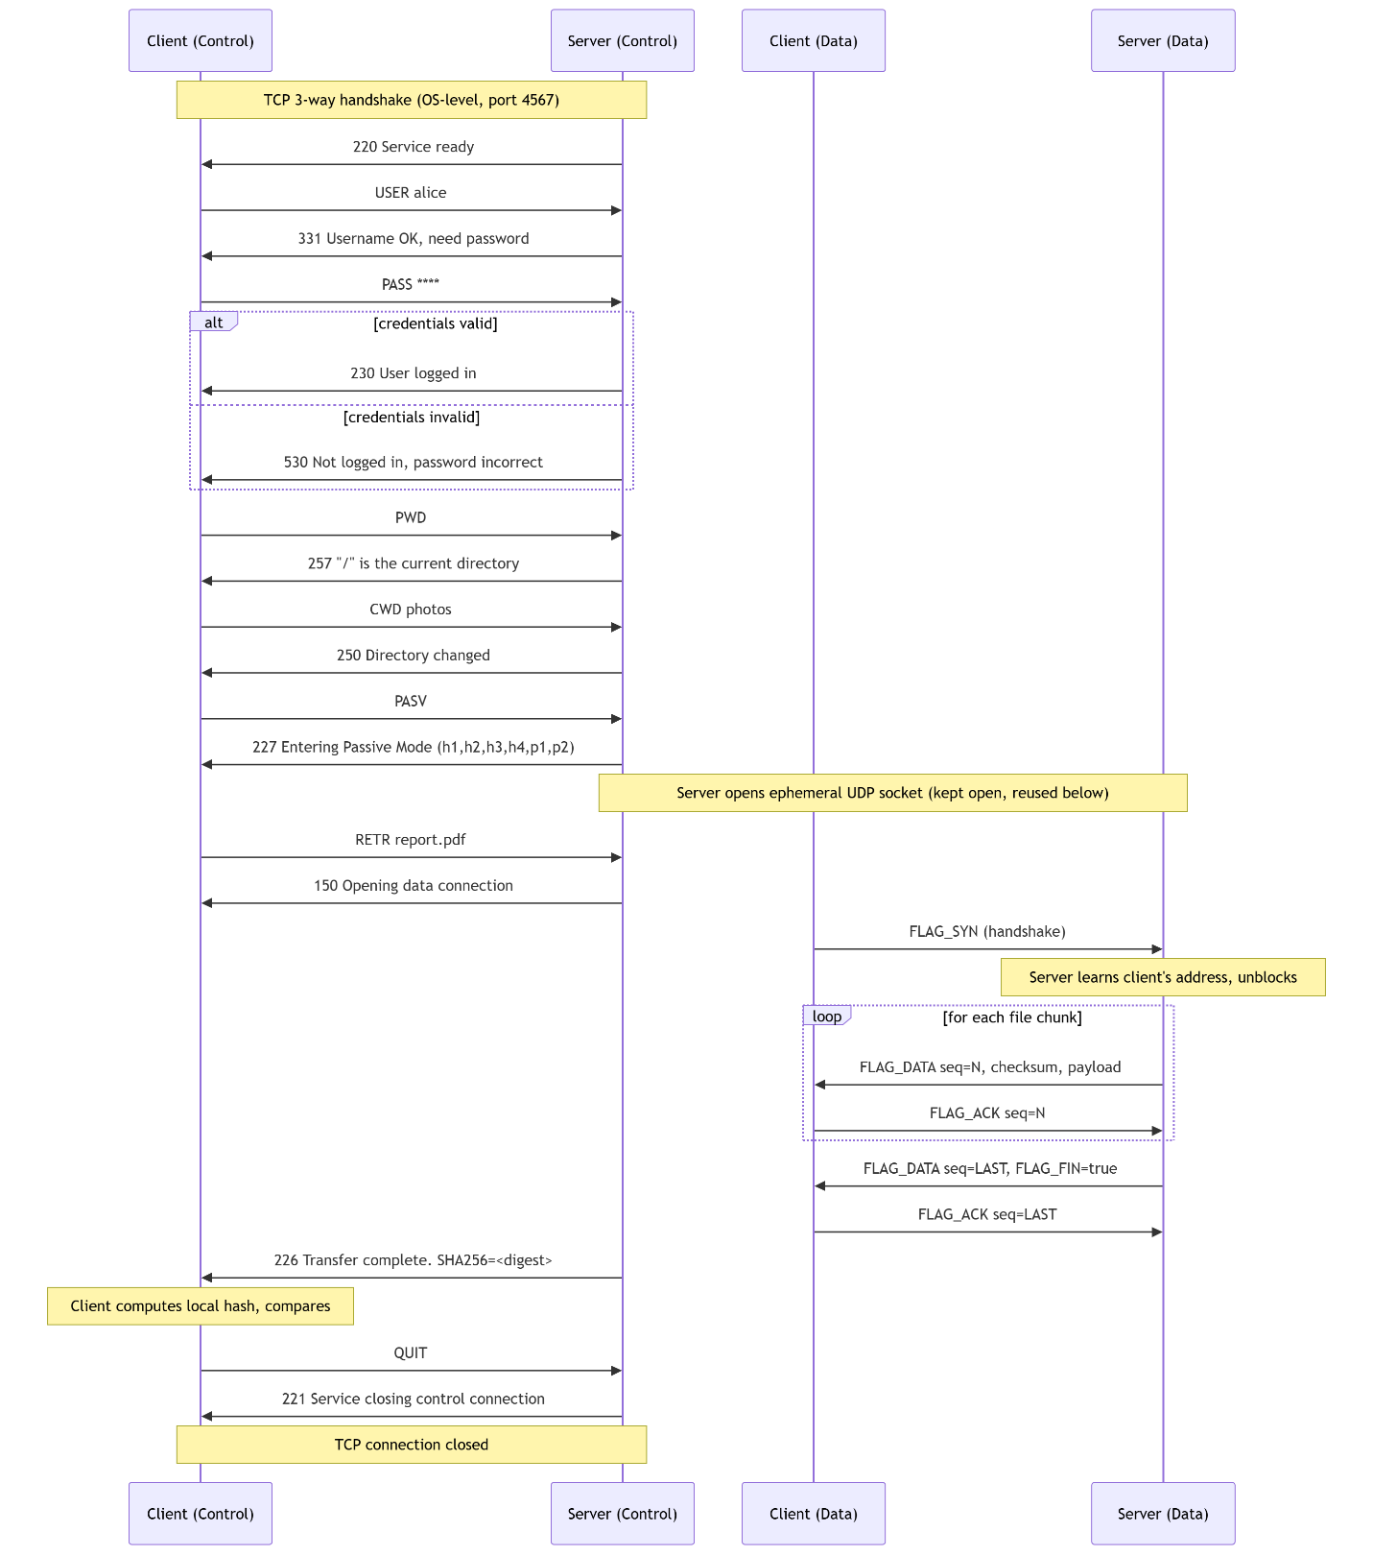
Figure 1: PASV Process

Active Mode (PORT) – Data Channel Negotiation & Transfer
Phase 4 – Data Channel Negotiation: The client opens and binds its own UDP socket on an OS-assigned ephemeral port, determines its own local IP address (by probing a throwaway socket connected toward the server), and sends “PORT h1,h2,h3,h4,p1,p2” advertising that address. The server replies “200 PORT command successful”.
Phase 5 – Transfer Initiation and Handshake (direction-dependent):
- For RETR (server is the sender): the server already knows the client's exact address from the parsed PORT command, so it can begin sending FLAG_DATA packets immediately – no handshake is required.
- For STOR (server is the receiver): the server does not automatically have a rendezvous point to receive on, so it performs a server-initiated symmetric handshake – it sends a FLAG_SYN packet to the client's PORT-advertised address before expecting any data. The client, already bound and listening on that address, receives the SYN and begins sending file data in response.
Phase 6 – 8: Proceed identically to the Passive-mode case (reliable windowed transfer, hash-verified completion, session termination).
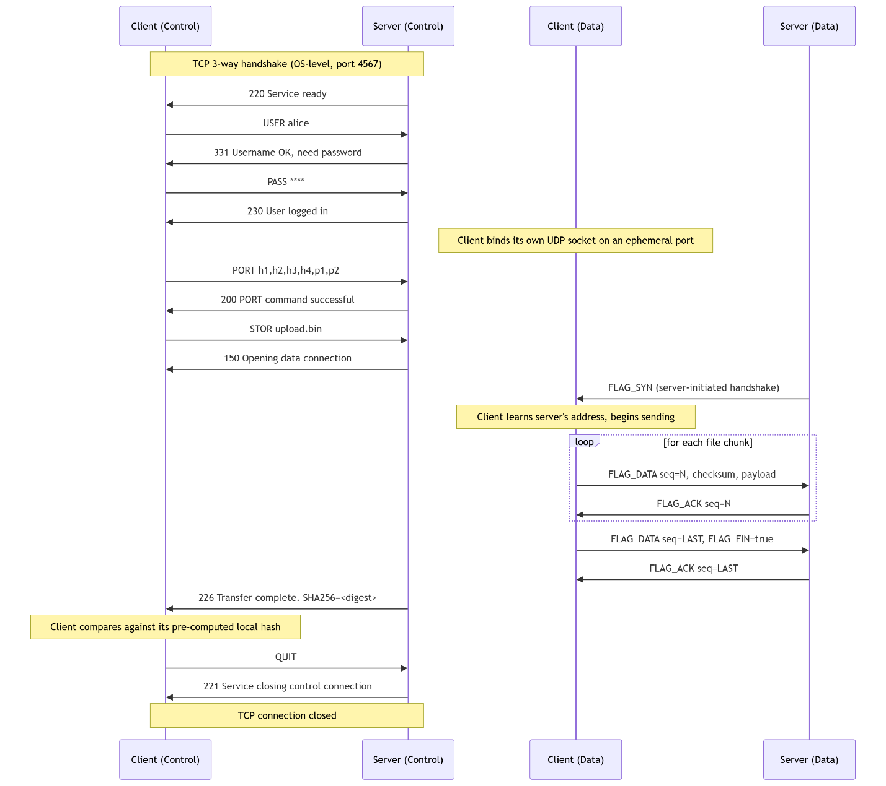
Figure 2: PORT Process

Unique/Append Uploads and Transfer Cancellation
Three further commands extend the transfer lifecycle described in 1.2.1/1.2.2, and one changes its execution model:
MODE {S|B|C} is accepted for Stream mode (S) – the mode this project already implements throughout – and explicitly rejected with “504 Only MODE S is supported.” for that parameter for Block (B) or Compressed (C), rather than silently ignoring or mishandling an unsupported request.
STOU <filename> behaves exactly like STOR from the client's perspective, except the server generates and reserves a guaranteed-unused filename rather than trusting a client-supplied one; that filename is reported back to the client in the 226 reply, since the client has no other way to learn what name was actually used.
APPE <filename> behaves like STOR up through the point where the new data has been fully and correctly received into a staging area; only once that succeeds does the server combine the newly-received data with any existing file at the destination (or simply use it as-is if the destination doesn't yet exist), committing the combined result atomically. A failed or aborted APPE leaves any pre-existing destination file completely untouched.
ABOR stops any data transfer process (RETR/STOR/STOU/APPE) by sets a shared, thread-safe flag and then blocks until the worker thread confirms it has actually stopped before replying, giving the client a verified cancellation. More information about the worker thread is provided in section 3.1.
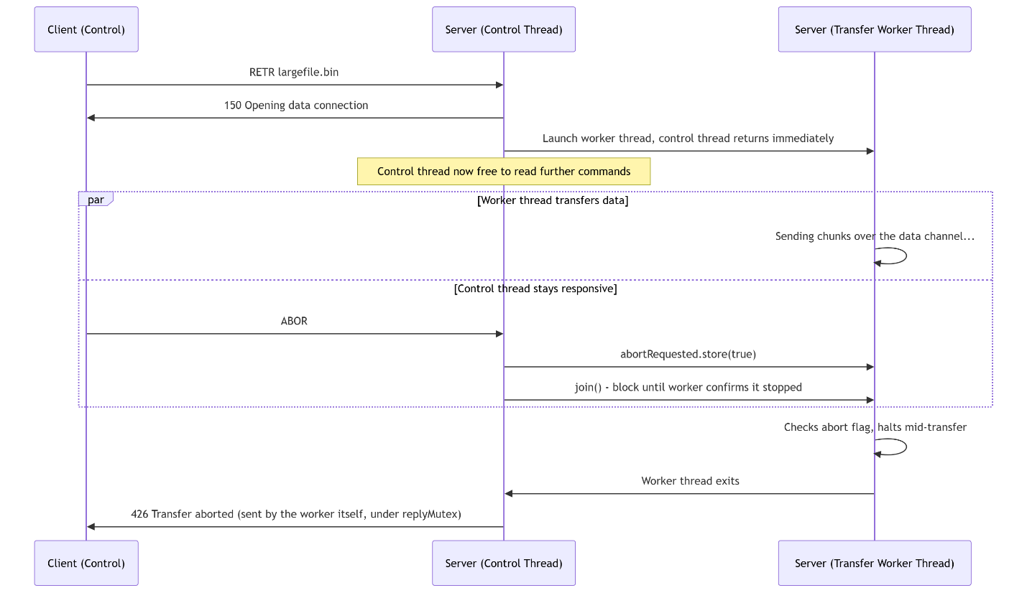
Figure 3. ABOR Process

Project-Wide Data Structures

TCP Control Packet Format
Unlike the UDP data channel, the control channel does not use a fixed binary structure. Commands and replies are plain, \r\n-terminated text lines, consistent with the human-readable convention used by real-world FTP.

Client → Server (Command) Format
<VERB> [argument]\r\n
Parsed server-side by CommandParser::parseCommand, which splits the line into a ParsedCommand structure:
Field | Type | Purpose
rawCommand | std::string | The full, untouched input line
type | std::string | The command verb, uppercased (e.g. "RETR")
args | std::string | Whitespace-separated arguments following the verb

Server → Client (Reply) Format
<code> <message>\r\n
Produced by Session::replyWithCode, which constructs the line directly as:
std::to_string(replyCode) + " " + message + "\r\n"

Produced by Session::replyWithCode as std::to_string(replyCode) + " " + message + "\r\n". A multi-line variant, Session::multilineReplyWithCode (used for LIST/NLST output), splits a message containing embedded \n characters into multiple physical lines, each re-terminated with \r\n – this is a deliberately simplified, project-internal convention rather than RFC 959's hyphenated continuation format, meaning replies from this server are not intended to be parsed by a strict RFC-959-compliant client.

UDP Custom Header – RdtHeader
The fixed, 16-byte binary structure prefixing every UDP datagram on the data channel, defined once in shared/protocol/RdtHeader.h and used identically by both client and server.

Byte-Level Layout
Offset (bytes) | Field | Type | Size (bytes) | Wire byte order
0–3 | seq_num | uint32_t | 4 | Network (big-endian) – htonl /ntohl
4–7 | ack_num | uint32_t | 4 | Network (big-endian) – htonl /ntohl
8 | flags | uint8_t | 1 | N/A (single byte)
9–10 | window_size | uint16_t | 2 | Network (big-endian) – htonl /ntohl
11–12 | payload_len | uint16_t | 2 | Network (big-endian) – htonl /ntohl
13–14 | checksum | uint16_t | 2 | Network (big-endian) – htonl /ntohl
15 | reserved | uint8_t | 1 | N/A (padding/future use)

Total header size: 16 bytes, enforced at compile time via static_assert(HEADER_SIZE == 16, ...) and #pragma pack(push, 1) (disabling compiler struct-padding, guaranteeing the in-memory layout matches this table exactly with no hidden gaps).
Multi-byte fields are explicitly converted to network byte order field-by-field during serialization (serializeHeader) and converted back during deserializeHeader – this is a manual, explicit byte-order conversion rather than relying on the struct's raw in-memory representation, which is necessary because host byte order is not guaranteed to match network byte order (x86/x64 is little-endian; the wire format must be big-endian regardless of host).

flags Bit Layout
Bit | Flag | Value | Meaning
0 | FLAG_SYN | 0x01 | Handshake-initiation packet (used for Passive-mode RETR and Active-mode STOR peer discovery)
1 | FLAG_ACK | 0x02 | Acknowledgment packet
2 | FLAG_FIN | 0x04 | Marks the final chunk of a transfer
3 | FLAG_DATA | 0x08 | Carries file payload
4 | FLAG_NAK | 0x10 | Negative acknowledgment (explicit reject signal)
5–7 | – | – | Unused

RdtPacket – Header + Payload
struct RdtPacket {
RdtHeader header; // 16 bytes
char payload[MAX_PAYLOAD]; // 1024 bytes
};

Total maximum wire size per datagram: 1040 bytes (16-byte header + up to 1024 bytes of payload), comfortably under typical Ethernet MTU (1500 bytes), avoiding IP fragmentation.

Related Protocol Constants
Reside at shared/protocol/ProtocolConstants.h
Constant | Value | Purpose
MAX_PAYLOAD | 1024 | Maximum file-data bytes per packet; single source of truth shared with the filesystem layer's chunk size
HANDSHAKE_TIMEOUT_MS | 500 | Timeout while waiting for a FLAG_SYN handshake reply
HANDSHAKE_MAX_RETRIES | 10 | Maximum handshake retry attempts before aborting
DATA_IDLE_TIMEOUT_MS | 5000 | Receiver's maximum idle wait for the next packet under normal conditions
CHAOS_DATA_IDLE_TIMEOUT_MS | 30000 | Extended idle wait used specifically when chaos-mode fault injection is active

(Congestion-control parameters are documented in Section 3.2.1, alongside the sender state machine they govern.)

Session Management Structures

Server – ClientSession
Reside at server/src/control/Session.h:
Field | Type | Purpose
socket | SOCKET | This client's control-channel socket
authenticated | bool | Login status, set only after a real credential check against Users::database
transferMode | TransferMode | Current TYPE A/TYPE I setting
username | std::string | Username supplied via USER
currentDir | std::filesystem::path | This session's current working directory, bounded by PathResolver
dataChannelMode | DataChannelMode | None / Passive / Active – which mode the next transfer will use
pendingDataSocket | SOCKET | The UDP socket opened by PASV, reused directly by the RDT transport
pendingPeerAddr | sockaddr_in | Client's advertised address (Active mode) or discovered peer address (Passive mode)
controlPeerAddr | sockaddr_in | The client's control-connection address, used to validate PORT requests
pendingRenameSource | std::filesystem::path | Resolved source path held between RNFR and RNTO
hasPendingRename | bool | Whether a RNFR is currently awaiting its matching RNTO
transferActive | std::atomic<bool> | Whether a transfer worker thread is currently running for this session
abortRequested | std::atomic<bool> | Set by the ABOR handler; polled by the transfer worker (and, via the same predicate, by the RDT layer itself) to signal early termination
transferWorker | std::thread | The detached-in-purpose (but explicitly joined) worker thread running the current RETR/STOR/STOU/APPE transfer, decoupling it from the control-command loop
replyMutex | std::mutex | Guards concurrent writes to the control socket, since the transfer worker now sends its own completion reply independently of the control thread
pendingUniqueFilename | std::string | The server-generated filename reserved by STOU, reported back to the client in both the preliminary and completion replies

Client – ClientState
Reside at client/src/control/Session.h:
Field | Type | Purpose
dataMode | DataMode | Client-side equivalent of DataChannelMode
pendingDataSocket | SOCKET | The client's own data-channel socket
passiveAddress | sockaddr_in | Server's address, parsed from a 227 reply
serverAddress | sockaddr_in | The control-connection server address
transferMode | TransferMode | Mirrors the server's TYPE setting locally
replyBuffer | std::string | Accumulates partial TCP reads until a full \r\n-terminated reply line is available

Transfer Coordination Types
Introduced alongside the asynchronous transfer-worker model and the unification of STOR/STOU/APPE into a single code path.
SendResult , reside at server/src/datachannel/DataChannelSession.h, is the return type of sendFile, replacing a bare bool:
Field | Type | Purpose
success | bool | Whether the transfer completed successfully (also exposed via operator bool() for direct use in conditionals)
sha256 | std::string | The SHA-256 digest computed from the sender's source snapshot, empty if hashing failed or is not applicable

UploadKind, reside at server/src/control/CommandDispatcher.cpp in a anonymous namespace, is an enum distinguishing the three upload commands that now share one implementation (startUploadTransfer)
Value | Corresponding command | Behavior
Store | STOR | Writes to the client-supplied filename, overwriting if it exists
Unique | STOU | Writes to a server-reserved, guaranteed-unused filename
Append | APPE | Combines new data with any existing file at the destination, rather than overwriting it

Filesystem & Application-Level Structures

DirEntryInfo
Reside at server/src/filesystem/DirectoryService.h:
Field | Type | Purpose
formatPermissions | std::string | Unix-style permission string (e.g. -rw-r--r--) for LIST output
name | std::string | Entry filename
isDirectory | bool | Directory vs. regular file
sizeBytes | uintmax_t | File size (0 for directories)

DirectoryService::PathMetadata
Field | Type | Purpose
exists | bool | Whether the resolved path exists
isDirectory | bool | Directory vs. file
sizeBytes | bool | File size
lastModified | uintmax_t | Backing MDTM's timestamp reporting

DirectoryService::Result
Field | Type | Purpose
ok | bool | Success/failure
code | int | FTP reply code to send
message | std::string | Human-readable reply text

RDT Sender-Internal Tracking Structure

InFlightPacket
Reside (private) at server/src/rdt/RdtSender.h:
Field | Type | Purpose
seq_num | uint32_t | This packet's sequence number
data | std::vector<char> | Buffered payload, retained for possible retransmission
is_final | bool | Whether this is the transfer's last chunk
sent_time | std::chrono::steady_clock::time_point | Used for timeout detection and RTT sampling
acked | bool | Whether this specific packet has been acknowledged
retransmitted | bool | Whether this packet has been resent – excludes it from RTT sampling (Karn's Algorithm)
retries | int | The UDP socket opened by PASV, reused directly by the RDT transport

Held in std::deque<InFlightPacket> window – the sender's Selective Repeat sliding window; its slide condition and congestion-window interaction are detailed in Section 3.2.1.

Functional Workflows

Server Thread-Dispatch Logic
The server's concurrency model is thread-per-connection: runSession() binds and listens on port 4567, then loops on accept(), spawning a detached std::thread running handleClient() for every accepted connection and immediately returning to accept() for the next one.
Inside handleClient(), the thread constructs a fresh ClientSession, registers the connection in a shared ClientRegistry, and logs the connection via Logger. A RegistryGuard RAII object guarantees the client is removed from the registry and the disconnect is logged on every exit path, including early returns.
The thread then loops: read from the socket into a buffer, extract one complete newline-terminated command at a time, parse it, and dispatch it. After every dispatched command, the loop checks whether session.socket was invalidated (set by the QUIT handler) and exits the thread cleanly if so, closing any still-open data-channel socket first.
For most commands, dispatch is still synchronous – the handler runs to completion and the loop immediately reads the next command. For RETR/STOR/STOU/APPE specifically, dispatch instead launches a second, dedicated worker thread to run the actual transfer and returns immediately, so the control loop stays free to receive further commands – most importantly, ABOR – while a transfer is still in progress. The worker thread sends its own completion reply once finished, independently of the control loop, guarded by ClientSession::replyMutex to prevent the two threads from corrupting each other's writes to the same socket.
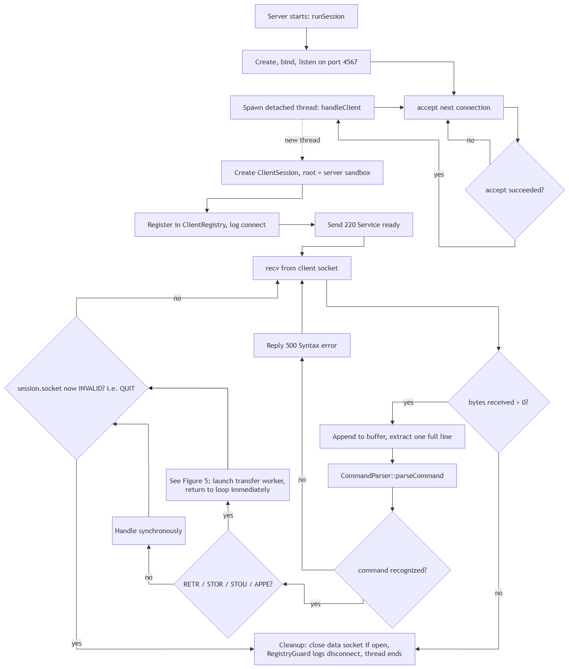
Figure 4: Server Thread-Dispatch
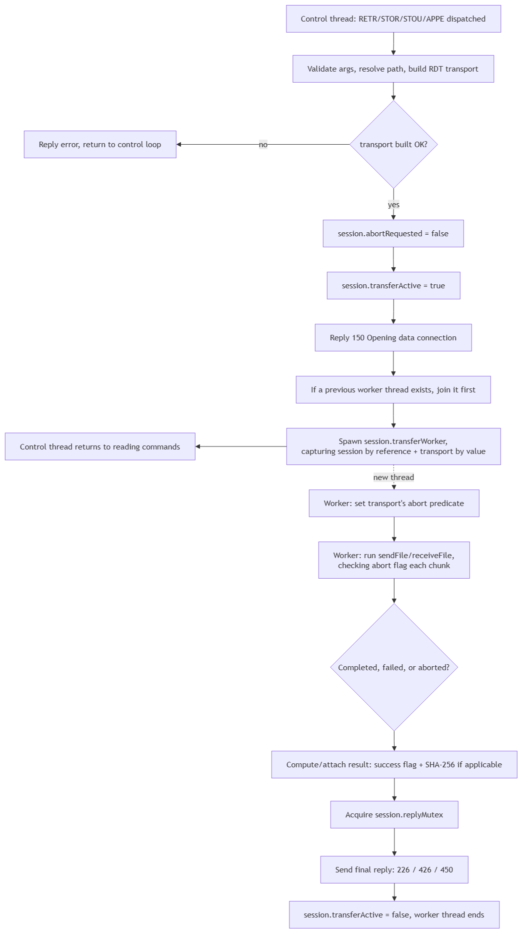
Figure 5: Transfer Worker Launch & Cross-Thread Handoff

Reliable UDP Sender/Receiver State Machines
Both RdtSender and RdtReceiver implement Selective Repeat over a sliding window, with RdtSender additionally performing RTT-based dynamic timeout estimation and AIMD (Additive-Increase/Multiplicative-Decrease) congestion control.

RdtSender – Selective Repeat Send + Congestion Control
RdtSender has two constructors: one that creates and connects a fresh UDP socket (Active-mode RETR), and one that reuses an already-bound socket handed in by the caller (Passive-mode RETR).
sendChunk first rejects any payload exceeding MAX_PAYLOAD, then blocks – via repeated calls to pollAcksAndRetransmit(blocking=true) – while the in-flight window is full. Once space is available, it builds the packet, transmits it, records it in the window, and performs one quick non-blocking poll for already-arrived ACKs before returning.
pollAcksAndRetransmit handles two responsibilities in one pass: draining available ACKs and updating window/RTT/congestion state, then scanning for any unacked packet whose timeout has elapsed and retransmitting it – or aborting the transfer entirely if that packet has exhausted MAX_RETRIES.
flush calls pollAcksAndRetransmit(true) in a loop until the window is fully drained, giving the caller a genuine "every packet confirmed" completion signal.
waitForClientReady is the Passive-mode RETR handshake: the sender blocks waiting for a client's FLAG_SYN packet, captures the sender's address, and ACKs the SYN before normal sending can proceed.
RTT is sampled only from packets that were never retransmitted (Karn's Algorithm). On any timeout, the congestion window is halved and the retransmission timeout doubles, both bounded by the constants below; on a sustained run of clean ACKs equal to the current window size, the congestion window increases by 1.0.
Congestion Control & Timeout Parameters:
Field | Type | Purpose
RTT_ALPHA | 0.125 | EWMA smoothing factor for estimated RTT
RTT_BETA | 0.25 | EWMA smoothing factor for RTT deviation
MIN_TIMEOUT_MS  MAX_TIMEOUT_MS | 50  2000 | Clamping bounds on the computed retransmission timeout
MIN_CWND  INITIAL_CWND | 1.0  4.0 | Congestion window floor and starting value
MAX_RETRIES | 10 | Per-packet retry ceiling before the transfer is aborted with a hard failure
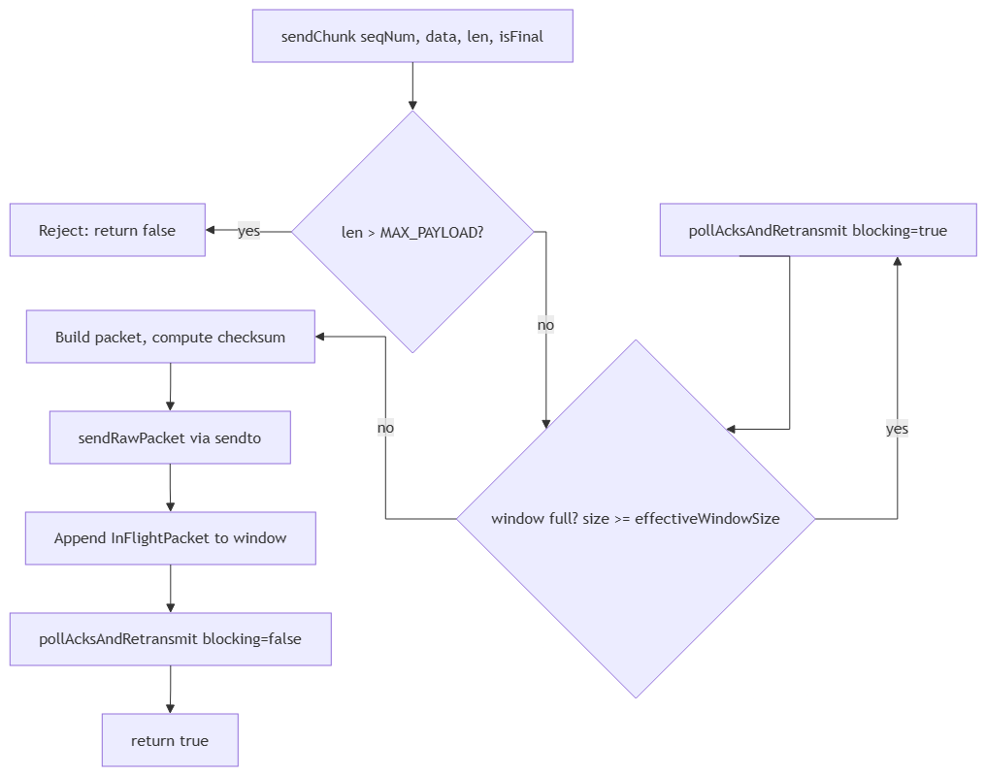
Figure 6: sendChunk High-Level Flow
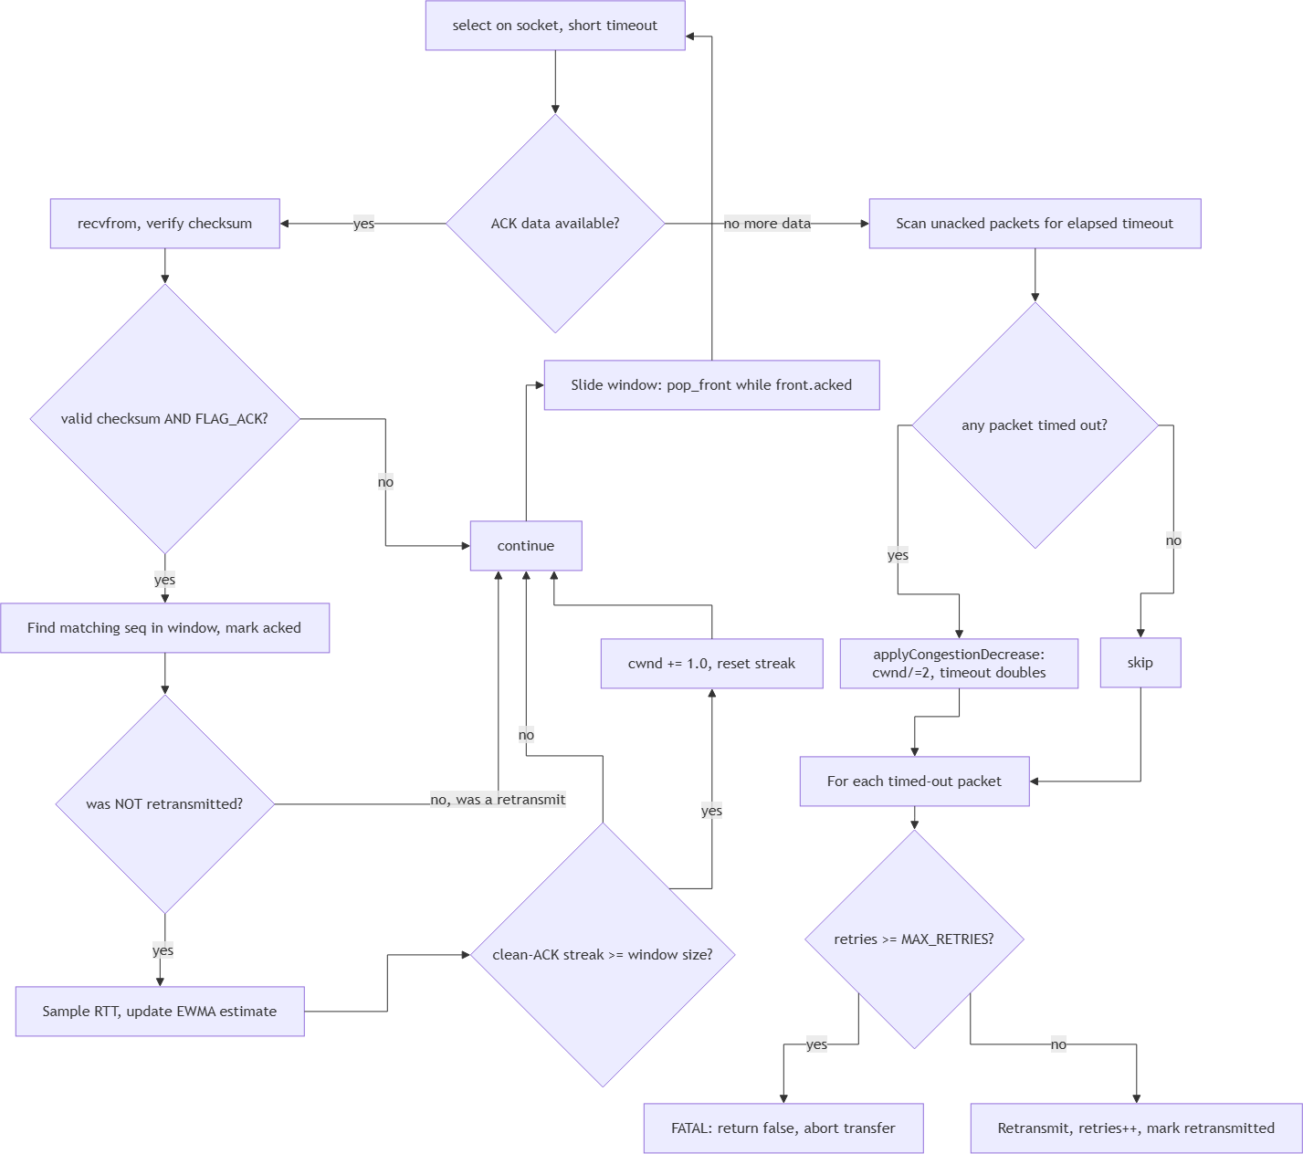
Figure 7: pollAcksAndRetransmit Subroutine

RdtReceiver – Selective Repeat Receive
RdtReceiver has two constructors – one that binds a fresh socket to a specific port (Active-mode STOR), and one that reuses an already-bound socket (Passive-mode STOR).
initiateActiveHandshake is the Active-mode STOR counterpart to the sender's waitForClientReady, in the opposite direction: since the client already advertised its address via PORT, the server proactively sends a FLAG_SYN to that address and waits for a response, retrying up to HANDSHAKE_MAX_RETRIES times. If the response is itself a FLAG_DATA packet rather than a plain ACK, that datagram is buffered and is the first thing receiveNext checks for.

receiveNext first checks whether the next expected sequence number is already sitting in the out-of-order buffer, returning it immediately with no network wait. Otherwise it loops on recvfrom, silently discarding invalid-checksum packets, non-FLAG_DATA packets, or (once a peer address is locked in) packets from an unexpected address. Every valid data packet is ACKed immediately regardless of order; in-order packets are returned directly, out-of-order packets are buffered within a bounded lookahead window, and duplicates are simply re-ACKed and ignored. A single idle timeout with no traffic at all (5 seconds normally, 30 seconds under chaos-mode injection) causes receiveNext to return false rather than blocking indefinitely.
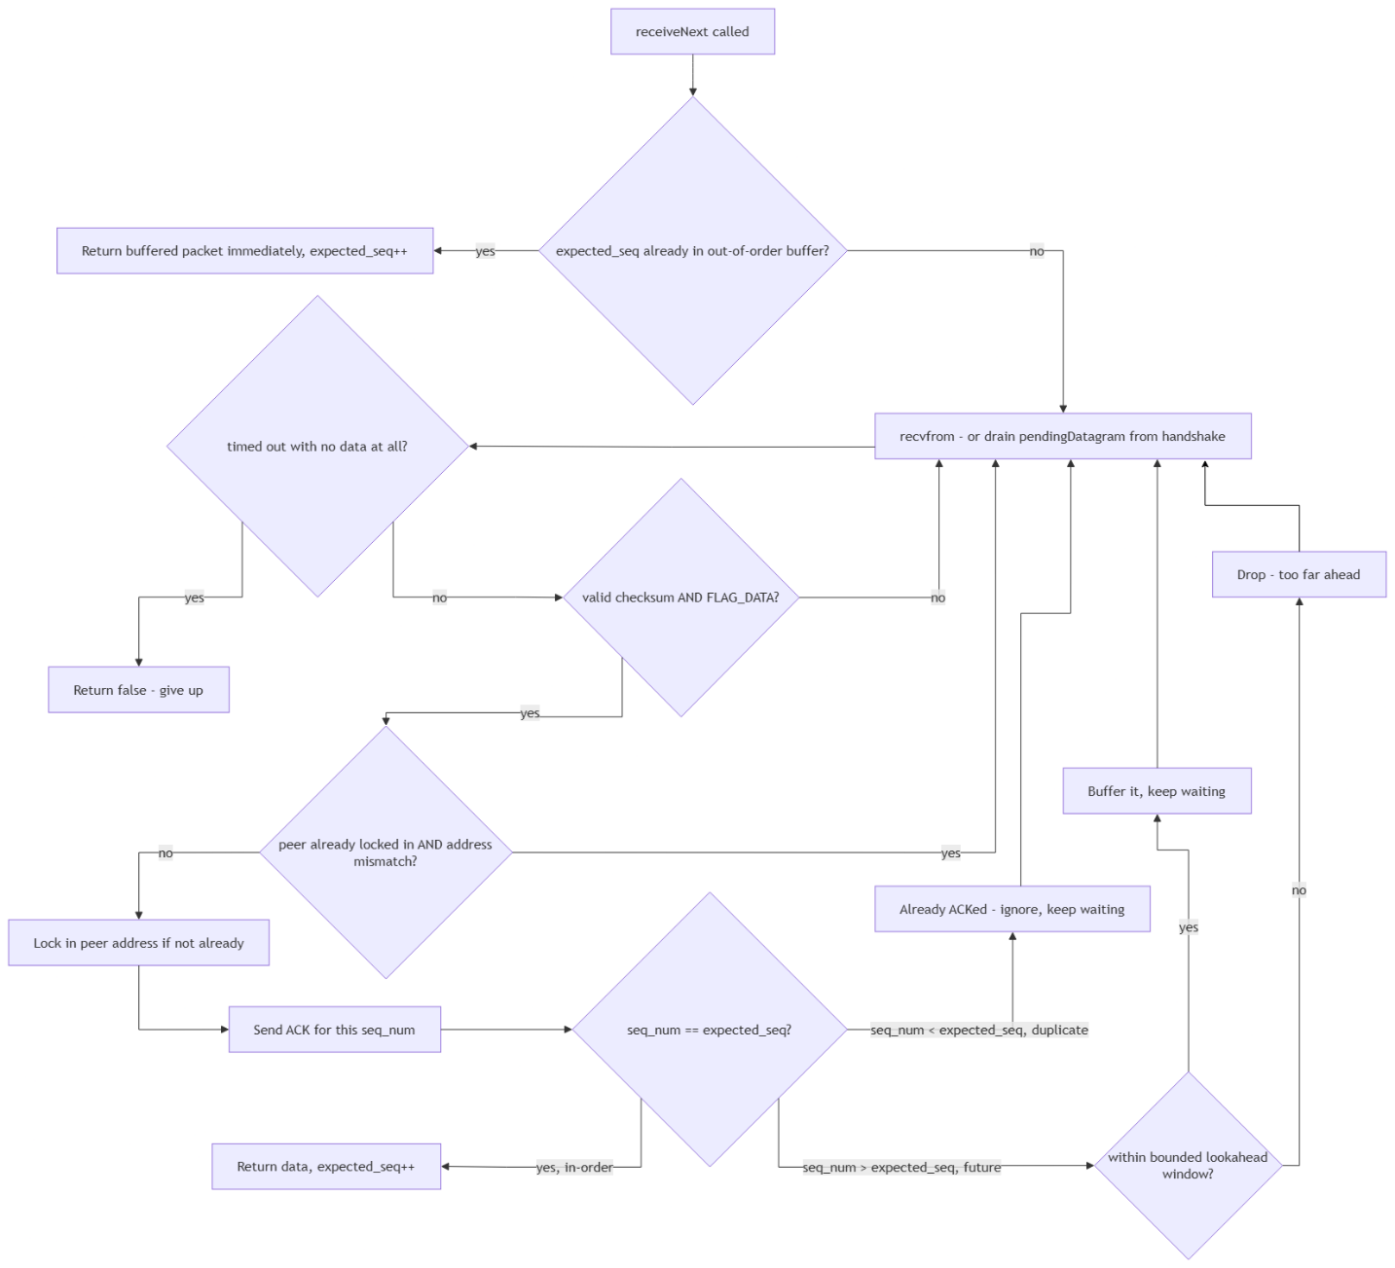
Figure 8: receiveNext Flow

Active/Passive Mode Toggle
This section documents the control-layer decision logic – specifically which code path CommandDispatcher takes based on the session's dataChannelMode.
PASV opens a server-side ephemeral UDP socket, storing it directly in the session, and sets dataChannelMode = Passive. PORT parses and validates the client's advertised address and additionally verifies – via portMatchesControlPeer – that the advertised IP matches the actual TCP control-connection's peer address, rejecting the command otherwise; this prevents a client from directing the server's data channel toward an unrelated third-party address (an FTP "bounce attack" vector).
When RETR, STOR, STOU or APPE is subsequently issued, the dispatcher first rejects the command if no mode was selected. Otherwise it branches: for Passive mode, it takes ownership of the already-open pendingDataSocket and constructs the corresponding transport with the existing-socket constructor; for Active mode, it constructs the fresh-socket variant using the client's validated address. The session's mode state resets to None immediately after this branch, so a mode selection is consumed exactly once per transfer. The whole process, rather than the transfer proceeding synchronously in place, it is handed off to a worker thread as shown in Figure 5 – the mode-toggle decision below determines which transport is built, not how the resulting transfer executes.
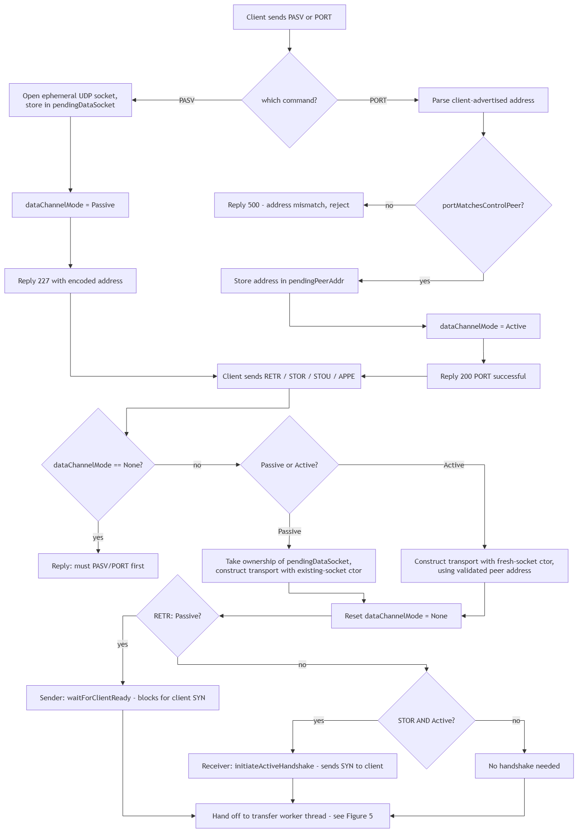
Figure 9: Active/Passive Mode Toggle

Unified Upload Handling: STOR / STOU / APPE
Once a transport is constructed (Figure 8) and handed to the transfer worker (Figure 5), the three upload commands converge on a single function, startUploadTransfer, parameterized by UploadKind (Section 2.3.3) rather than three separate implementations. The destination path – the one genuinely different input between the three – is determined before this shared logic runs: STOR resolves the client-supplied filename directly; STOU first calls the server-side unique-filename reservation (Figure 9); APPE resolves the client-supplied filename exactly as STOR does, but the kind passed through changes what happens once the data is fully received.
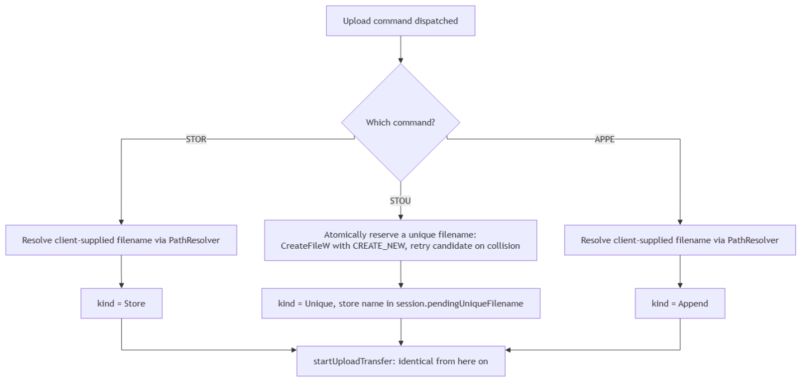
Figure 10: UploadKind Destination Resolution

STOU's reservation step is worth highlighting precisely because it avoids a check-then-create race entirely: CreateFileW with the CREATE_NEW flag atomically fails if a file with that exact name already exists, rather than separately checking existence and then creating — meaning two simultaneous STOU requests can never be issued the same filename, without needing any additional locking.
Once the transfer itself completes (the worker thread's sendFile/receiveFile call in Figure 5 returns), Store and Unique behave identically — the received data was streamed directly into the final destination's temporary file and is committed via the atomic rename already described for ChunkedFileWriter. Append takes one additional step after that same underlying receive completes.
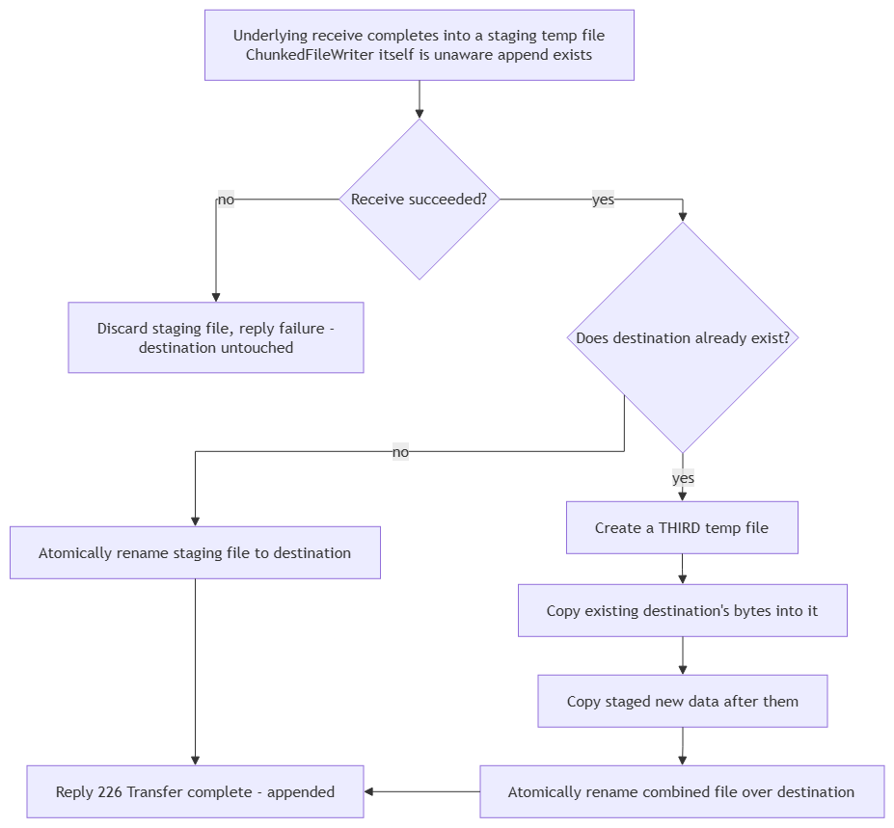
Figure 11: APPE Post-Receive Combination (appendAtomically)
This design deliberately keeps ChunkedFileWriter itself unmodified — it always just streams "the new data" into a temp file and atomically commits it, with no concept of "append" at all. The combination logic lives entirely in a separate step applied after a normal receive succeeds, at the cost of a second full-file copy for the existing content on a large append (once to seed the combined temp file, once already staged as new data) compared to a design that seeds the writer's temp file directly — a deliberate simplicity-over-I/O-efficiency tradeoff, not an oversight.

Task Assignment Matrix

Ownership Overview
The table below maps every major engineering component to its primary owner and supporting contributors, based on the team's original planning document and the project's commit history. Each member owned a distinct architectural layer for the full duration of the project; where teammates contributed to another member's layer, this is noted as supporting collaboration rather than a change of ownership, consistent with how the team worked throughout – components were frequently refined jointly once a first working version existed.
Component | Primary Owner | Supporting Contributions | Description
TCP control channel & accept loop | Lâm Hồng Hải Hoàng Lê | – | Server socket setup, listener, per-client thread spawning (Session.cpp, server)
Command parsing | Lâm Hồng Hải Hoàng Lê | – | Tokenizing raw command lines into verb + arguments
Command dispatch | Lâm Hồng Hải Hoàng Lê | Mai Phúc Hưng provided support with command-handler wiring and protocol-interface alignment for data-transfer commands | Routing parsed commands to their handlers, reply formatting
Asynchronous transfer execution | Mai Phúc Hưng | Lâm Hồng Hải Hoàng Lê provided support with control-loop integration, since this changes how the command dispatcher hands off long-running commands | Decouples RETR/STOR/STOU/APPE from the control-command loop so ABOR can interrupt an in-progress transfer
Unique & append upload variants | Mai Phúc Hưng | Đỗ Minh Khang provided support with the underlying ChunkedFileWriter/atomic-commit design these commands build on | Server-reserved unique filenames (STOU); non-destructive, atomically-committed appending to existing files (APPE)
Authentication & session state | Lâm Hồng Hải Hoàng Lê | Đỗ Minh Khang provided support with session-state field design during data-channel integration | Credential verification, per-client session fields, ClientRegistry
Client console entry point | Lâm Hồng Hải Hoàng Lê | Mai Phúc Hưng provided support with command-loop implementation and data-channel command routing | Interactive CLI, connects to server, drives the command loop
Path resolution & traversal safety | Đỗ Minh Khanh | – | Sandboxed path resolution, boundary enforcement
Directory operations | Đỗ Minh Khanh | – | PWD/CWD/MKD/RMD/LIST/STAT/SIZE/MDTM/DELE/RNFR/RNTO logic
Chunked file I/O | Đỗ Minh Khanh | – | Streaming binary reads/writes, out-of-order-safe reassembly
ASCII transfer mode | Đỗ Minh Khanh | – | TYPE A/TYPE I line-ending normalization
Integrity verification | Đỗ Minh Khanh | – | SHA-256 hashing via Windows CNG, end-to-end transfer verification
Data-channel orchestration | Đỗ Minh Khanh  (server-side; initial client design) | Mai Phúc Hưng provided support with the client-side implementation, incorporating handshake and edge-case handling alongside protocol updates | Bridges filesystem I/O and the RDT transport interface
PASV/PORT socket setup | Đỗ Minh Khanh | Lâm Hồng Hải Hoàng Lê provided support with control-layer integration (mode-toggle dispatch, portMatchesControlPeer validation) | Ephemeral port binding, address parsing/formatting for both modes
RDT wire format | Mai Phúc Hưng | Đỗ Minh Khang provided support with shared-constant consolidation during a cross-module integration review | Packet header layout, checksum algorithm, shared protocol constants
Reliable transport | Mai Phúc Hưng | – | Sliding window, RTT estimation, AIMD congestion control, handshake logic for both transfer directions
Chaos/fault-injection testing harness | Mai Phúc Hưng | Đỗ Minh Khang provided support with end-to-end integrity verification tests exercising the harness | Configurable packet loss/corruption/latency injection for reliability testing
Build system (CMake, library structure) | All members | – | Client/server library separation, test target registration
Testing infrastructure (unit & integration tests) | All members | – | tests/ directory, per-module and full-pipeline test coverage
Project planning & documentation | Đỗ Minh Khanh | – | Initial team planning document, per-member implementation guides

Layer Summary
Lâm Hồng Hải Hoàng Lê – Control & Session Layer. Owns the TCP control channel end-to-end: connection acceptance, command parsing, command dispatch, authentication, and the client's interactive console. This layer is the integration point every other component ultimately connects through, and its command-dispatch table now covers the full approved command set, including asynchronous handling for long-running transfer commands.
Mai Phúc Hưng – Reliable Data Channel Layer. Owns the custom UDP reliability protocol in full: wire format, checksum verification, Selective Repeat windowing, RTT-based dynamic timeout estimation, and AIMD congestion control, along with the fault-injection harness used to validate it under adverse network conditions. Also extended the control layer with the asynchronous transfer-worker model underpinning ABOR, and implemented STOU, APPE, MODE, and HELP on top of the existing filesystem and data-channel infrastructure.
Đỗ Minh Khang – Filesystem, Crypto & Data-Channel Integration Layer. Owns the server's sandboxed filesystem access, all directory and file-metadata commands, binary and ASCII-mode chunked transfer, SHA-256 integrity verification, and the orchestration layer bridging file I/O to the reliable transport – along with the project's build system and initial planning documentation.
Across all three layers, components were refined collaboratively once a first working version existed – each member's supporting contributions to another's layer reflect the team's iterative, cross-reviewed development process rather than a reassignment of ownership.

Self-Assessment & Peer Evaluation

Lâm Hồng Hải Hoàng Lê

Self-Assessment
For this project, my primary responsibility was designing and implementing the server-client control channel. Although I initially faced a steep learning curve regarding the knowledge of the TCP protocol, I believe I have done sufficient work to deliver functional core components and contribute meaningfully to the project. After the completion of the program by everyone, I conducted thorough system testing to identify remaining issues and report back to my teammates.
During the process, I have recognized some of my limitations in terms of the speed I was progressing in and my initial efficiency in software development tools. Even though this slightly hindered our group’s progress, the experience highlighted the importance of workflow optimization, and I have learned to utilize more of the available tools and resources to improve our collaboration during the last few days of the project.

Peer Evaluation
As our leader, Đỗ Minh Khang demonstrated exceptional project leadership by establishing a clear and well-defined structure to the project and assigning each task to a suitable teammate. His strategic skills were instrumental in allowing the team to finish the project within a tight schedule.
Mai Phúc Hưng provided invaluable collaborative support during the integration phase, working closely with Khang and myself to seamlessly interface his modules with the rest of the application. His ability to utilize his development tools to the utmost was reflected in the reliable, high-quality code he produced for the final system release.

Mai Phúc Hưng

Self-Assessment
During this project, I was mainly responsible for implementing and testing the RDT-related components. I worked on the required functions, checked the correctness of packet/header processing, and fixed issues that appeared during testing.
One important part of my work was debugging the RDT tests. For example, I encountered an issue related to the verification checksum of a serialized header. I reviewed the implementation, corrected the problem, and reran the test until the RdtTest passed successfully. This process helped me better understand how reliable data transfer works and how important careful serialization, checksum handling, and testing are in network programming.
I also worked to make sure that my implementation could integrate correctly with the other parts of the client-server system. Throughout the project, I improved my C++ programming, debugging, testing, and problem-solving skills. I also became more familiar with working in a team where different members are responsible for different components of the same system.
Overall, I believe I completed my assigned tasks successfully and made a meaningful contribution to the project. However, I could still improve by documenting my code more clearly, planning the implementation before coding, and communicating progress and technical issues with the team more frequently.

Peer Evaluation
My team members were responsible for different components of the client-server system, and each member contributed to the overall development of the project. We divided the work so that different parts could be developed in parallel while still being integrated into one complete system.
The team was supportive when technical problems occurred, especially when one component depended on another member's implementation. We communicated about requirements, interfaces, testing, and integration to reduce conflicts between different parts of the project.
Overall, I think the team worked effectively and each member contributed to the project. The cooperation between members helped us solve implementation and integration problems more efficiently. For future projects, we could improve by having more frequent progress updates, clearer documentation of interfaces and requirements, and earlier integration testing between components.

Đỗ Minh Khang

Self-Assessment
I believe I fulfilled my assigned responsibilities effectively throughout the project. I consistently met project deadlines, and the quality of my deliverables remained satisfactory. In addition to my technical contributions, I played an active role in coordinating the team's workflow and managing project activities. Although we encountered several avoidable issues during the initial and final stages of the project, the team's overall workflow remained reasonably efficient.
Despite these contributions, I recognize that there is still room for improvement in my technical abilities. At times, my programming skills limited the speed and effectiveness of my contributions, which may have affected the team's overall progress. Furthermore, I believe our final product could have achieved a higher standard if the team had benefited from stronger project leadership. As leadership is an area in which I still need to develop, some coordination challenges and workflow inefficiencies arose during the project.

Peer Evaluation
Throughout the project, Lâm Hồng Hải Hoàng Lê demonstrated a genuine commitment to understanding his assigned responsibilities and the technical aspects of his modules. Although he occasionally progressed more slowly than planned, he maintained a solid understanding of his tasks, and the quality of his code was consistently high.
One area for improvement is time and progress management, together with more proactive communication with the rest of the team. Because his development pace was sometimes slower than the project's schedule, other team members occasionally assisted with completing and integrating his work to ensure that project milestones were met. Strengthening these aspects would further enhance his overall effectiveness in future collaborative projects.
Mai Phúc Hưng demonstrated strong technical competence and consistently produced high-quality work throughout the project. He effectively utilized available tools and resources to develop well-polished solutions and was always willing to assist teammates by explaining technical concepts and providing support when needed. His collaborative attitude contributed positively to the team's development process.
However, there are areas where his workflow could be improved. He frequently accumulated substantial changes and submitted them shortly before deadlines instead of committing smaller, incremental updates throughout the development process. This practice made it more difficult to review and integrate his work. In addition, his enthusiasm sometimes led him to work beyond his assigned responsibilities by implementing features or modifications in other areas of the project. While these contributions were made with good intentions, they occasionally created uncertainty regarding task ownership and project coordination. Maintaining clearer boundaries while continuing to support the team would further improve collaboration in future projects.

Contribute Distribution
After gathered all opinion from each member in the team, we agreed to distribute our contribution as follow:
ID | Name | Contribution (%)
25127052 | Mai Phúc Hưng
25127207 | Lâm Hồng Hải Hoàng Lê
25127363 | Đỗ Minh Khang
Total |  | 100

GenAI Usage & Code Refinement Log
Mai Phúc Hưng’s log:
Lâm Hồng Hải Hoàng Lê’s log:
Đỗ Minh Khang’s log:

Application Demo Evidence
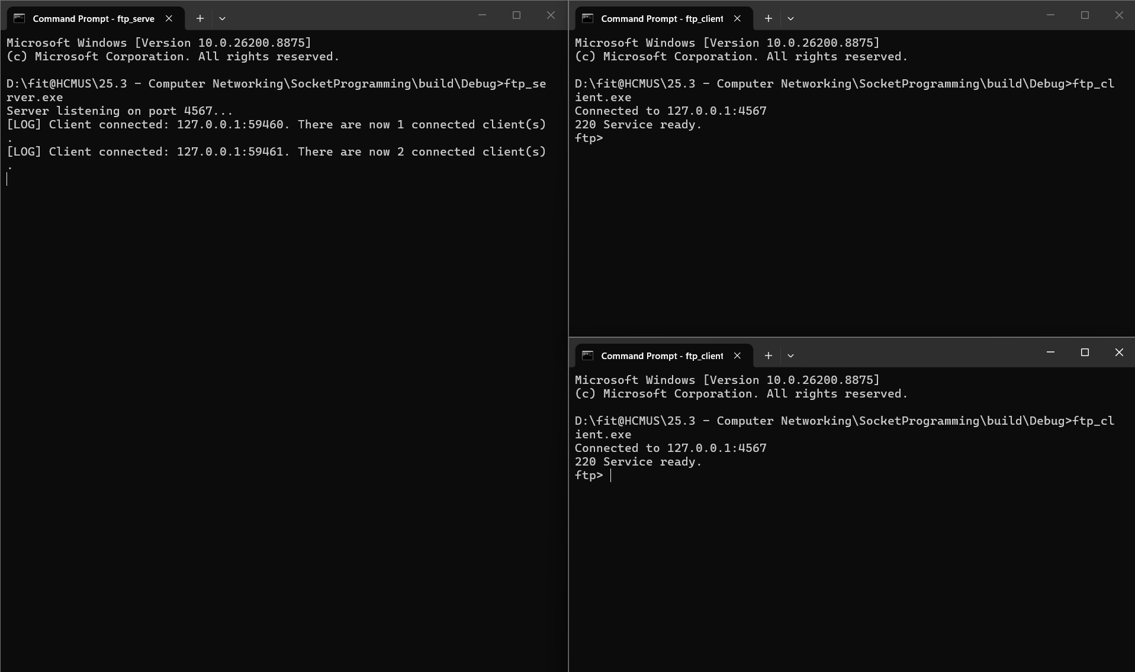
Figure A: The server and client programs after being started up. Two clients are connected to the server.
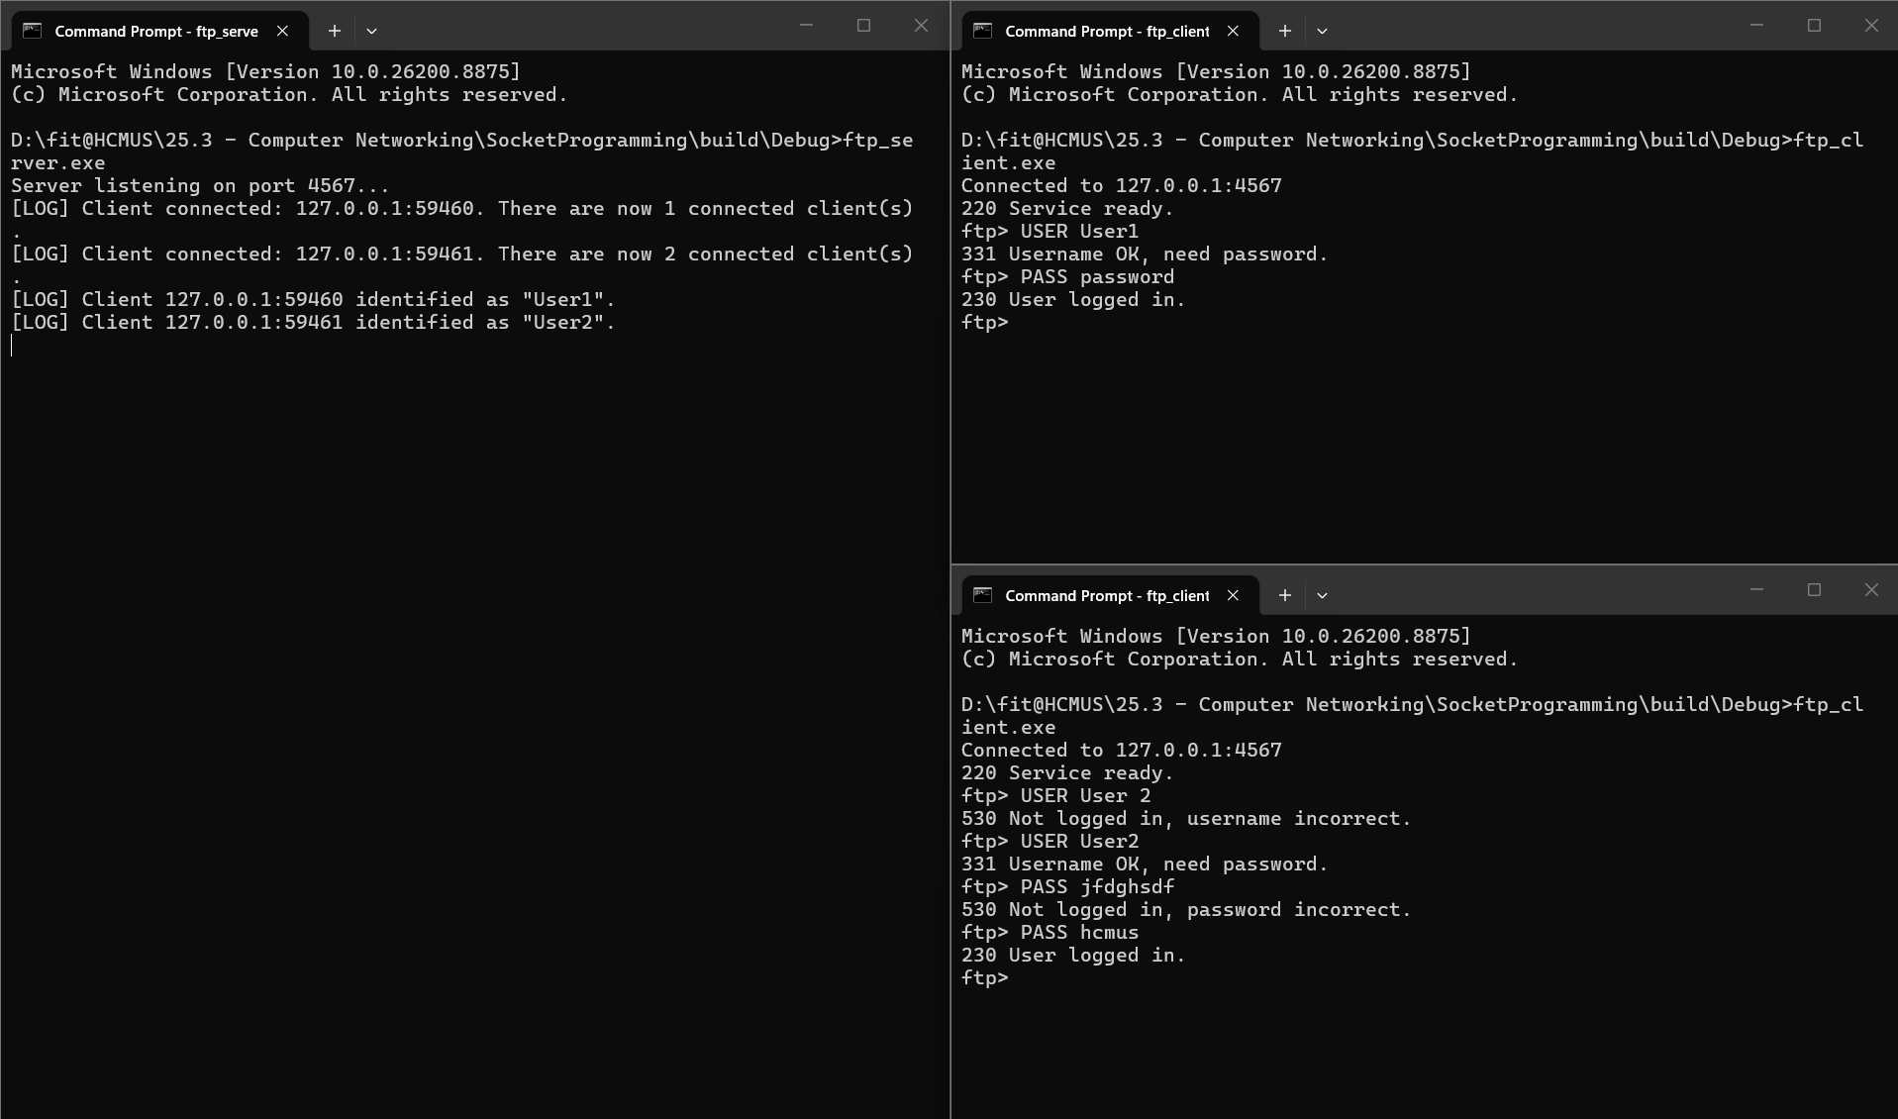
Figure B: Clients logging in via the USER and PASS commands.
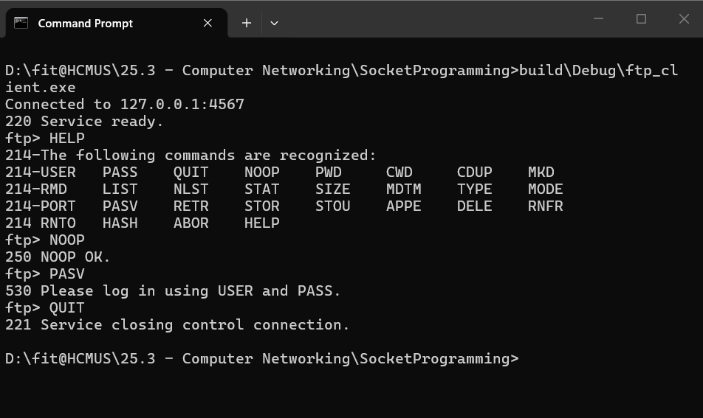
Figure C: Client can execute HELP, NOOP and QUIT commands without being logged in. Other commands, such as PASV, cannot be executed without logging in using USER and PASS.
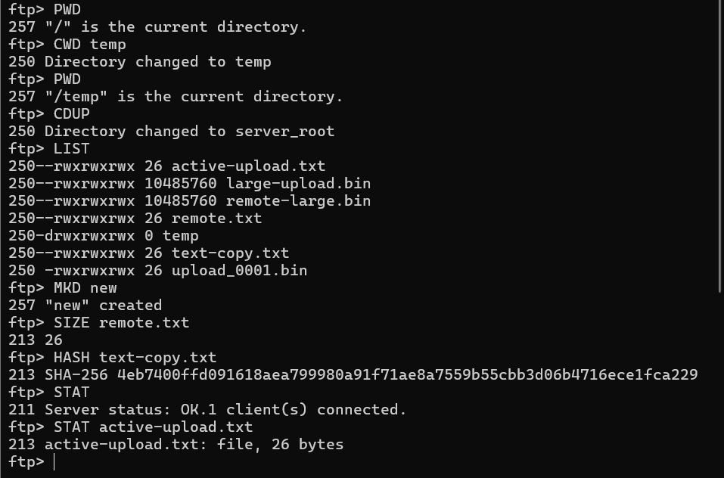
Figure D: Client can execute control-only commands, such as PWD, CWD, CDUP, LIST, MKD, SIZE, STAT.
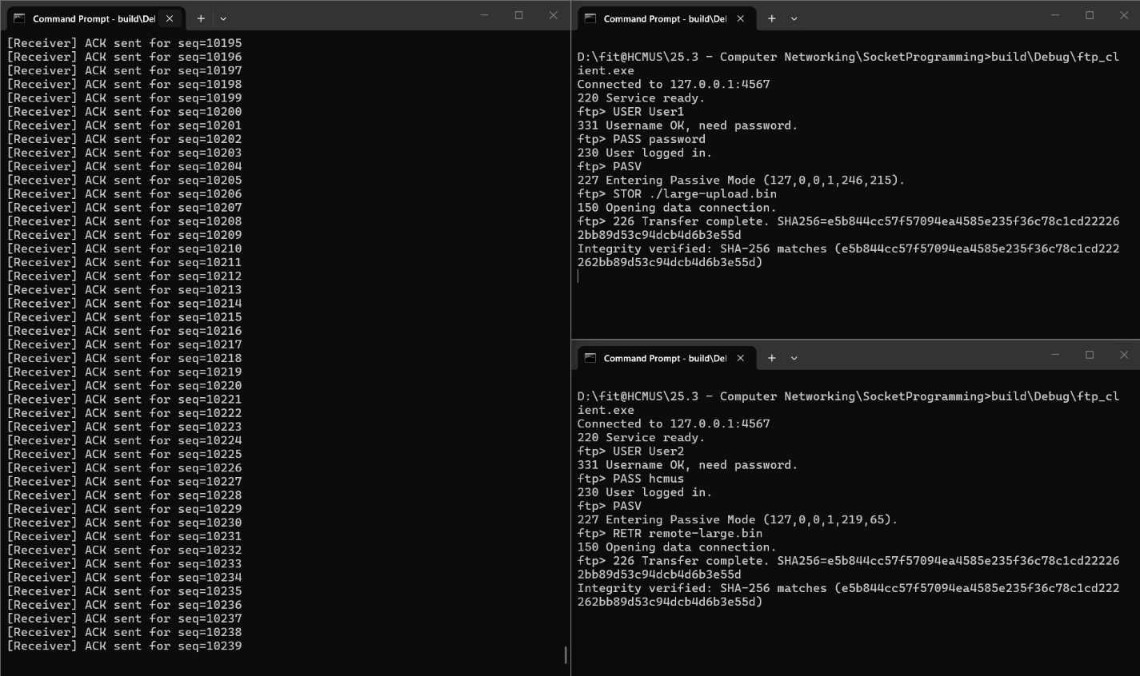
Figure E: Clients enter Passive Mode using PASV. While a client sends a large file to the server, another client can retrieve a file from the server without affecting the other client.
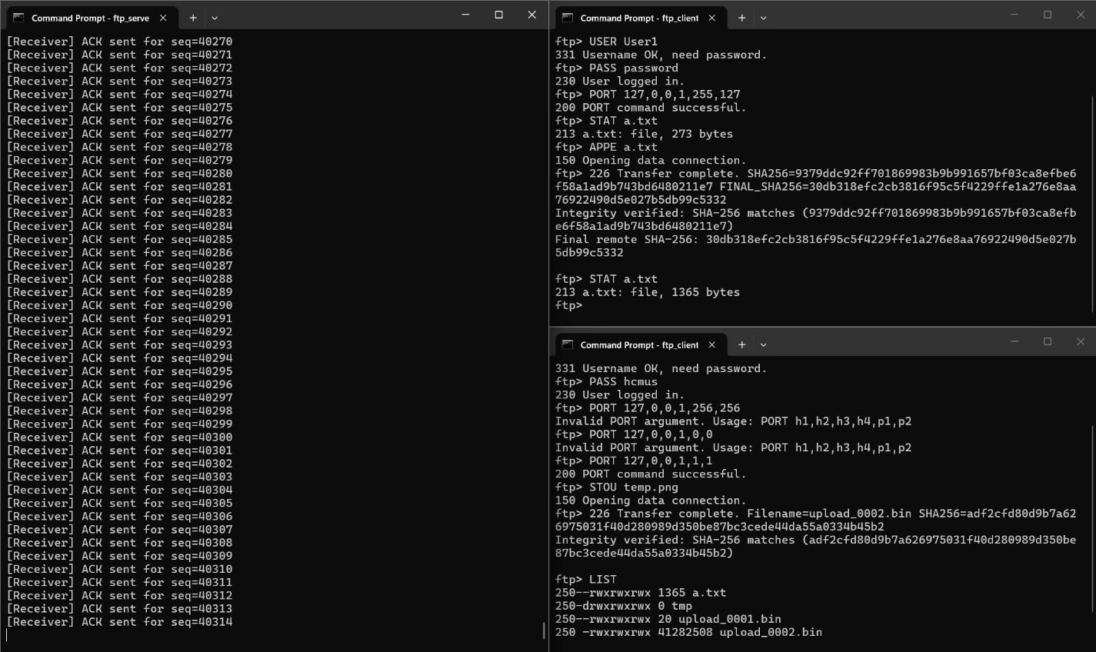
Figure F: Clients enter Active Mode using PORT. A client executes APPE which appends data to the existing file on the server, and the other client executes STOU which creates a new file with a unique filename.
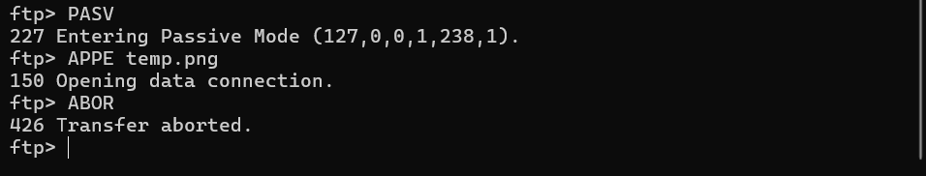
Figure G: Client can abort the data transferring process.

Reference

