Alexander King
CSET 3200

***black board will not let me download anything you have posted I have “insufficient permissions” as seen in the screen shot of the syllabus.***

1. Acquired Microsoft Visual Studio Community 2019* as it was the only one available from their official site. If we NEED 2017 please confirm this.

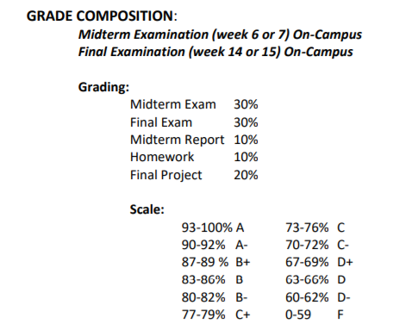
2. Done. Particular attention paid to:

I assume this has to do with the “on-campus” bit even though this is a “distance learning” course. This is not a problem for me but I can easily understand how this could cause issues for others and how one could reasonably assume that was a copy-paste if not told to specifically pay close attention to it.

3.
a:
I’ve done classes in Python, Java, and css/html. Any of these I will be using will require review for me. I’ve had time off of school due to my little sister getting a rare cancer and my job does not utilize these skills. Python I always pick up easier because it is similar to using the linux terminal which I do occasionally do in my leisure time. I do well enough in HTML but my css is lacking. Java I have used a lot of but it always requires more effort than the others for me to get it working. Java = coffee time and searching for the one line that breaks the entire thing.
B: Condition statements. The basic if then else.
Loops: While and for.
Sub-programs: Not much if any. Was it a subprogram when I embedded thing 1 onto website a?

4. Tuesdays noon-5, 8-midnight. Can we have recordings of these lectures please?

Screenshots. Highlighted portion is a download attempt of the syllabus and it failing because of “insufficient permissions”.
