CSET320 Homework 5
NOTE: I posted a link on blackboard on sending an Email using C# If you have any problems with this program Email me and I will help you work thru them.

1) Write a C# 2 Tier Client Server Email program that: a. Asks for keyboard input of
i. An Email SEND TO address
ii. The Subject of the Email
iii. The Body of the Email

b. Use your UT Email Account as the FROM Address
c. Use the UT Server i. Host = “outlook.office365.com”

ii. Port = 587
iii. FromPassword = “Your UT Email password” DO NOT INCLUDE THE PASSWORD WHEN YOU TURN IN THE SOURCE CODE
iv. Use the data entered in “a” above for the TOAddress,Subject, and body Use your program to Send an Email to Scott.Brahaney@utoledo.edu
The Email must have subject line containing “CSET3200 Homework 5”

Turn in a PDF file with the source code and screen shots of the program activity. DO NOT INCLUDE THE PASSWORD WHEN YOU TURN IN THE SOURCE CODE

2) What is the well-known port 587 used for?
TCP SMTP

3)Is this Email using a TCP Port or a UDP Port?
TCP

4) Is this Email program an example of thin or thick client?
Thin because I’m heavily dependent on the servers applications.

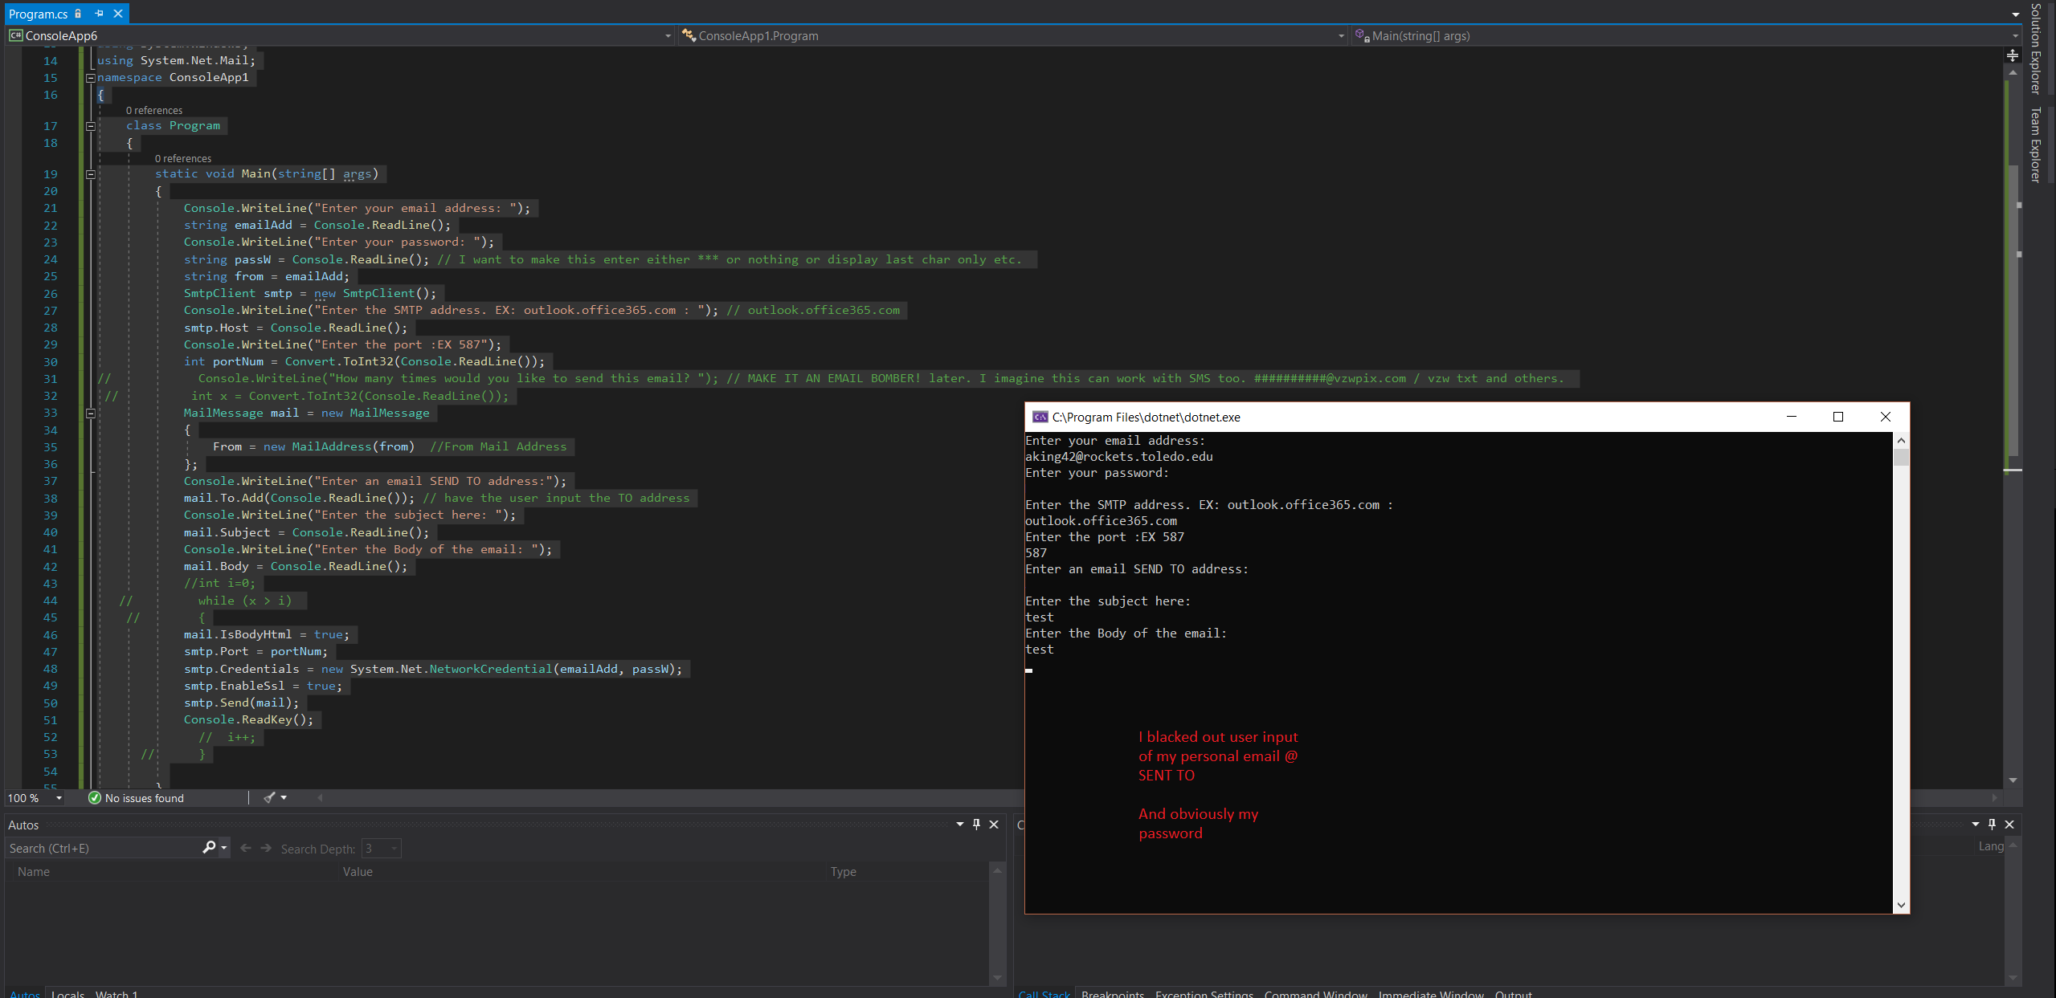
/*Alexander King
* CSET3200
* HOMEWORK5
* 9-27-19
*
* Attempted to add additional functionality by having the user manually input all of their information instead of storing it within the program.
* Also tried to be verbose with suggested inputs for this hw assignment.
*/ using System;
using System.Windows;
using System.Net.Mail;
namespace ConsoleApp1
{
class Program
{
static void Main(string[] args)
{
Console.WriteLine("Enter your email address: ");
string emailAdd = Console.ReadLine();
Console.WriteLine("Enter your password: ");
string passW = Console.ReadLine(); // I want to make this enter either *** or nothing or display last char only etc.
string from = emailAdd;
SmtpClient smtp = new SmtpClient();
Console.WriteLine("Enter the SMTP address. EX: outlook.office365.com : "); // outlook.office365.com
smtp.Host = Console.ReadLine();
Console.WriteLine("Enter the port :EX 587");
int portNum = Convert.ToInt32(Console.ReadLine());
// Console.WriteLine("How many times would you like to send this email? "); // MAKE IT AN EMAIL BOMBER! later. I imagine this can work with SMS too. ##########@vzwpix.com / vzw txt and others.
// int x = Convert.ToInt32(Console.ReadLine());
MailMessage mail = new MailMessage
{
From = new MailAddress(from) //From Mail Address
};
Console.WriteLine("Enter an email SEND TO address:");
mail.To.Add(Console.ReadLine()); // have the user input the TO address
Console.WriteLine("Enter the subject here: ");
mail.Subject = Console.ReadLine();
Console.WriteLine("Enter the Body of the email: ");
mail.Body = Console.ReadLine();
//int i=0;
// while (x > i)
// {
mail.IsBodyHtml = true;
smtp.Port = portNum;
smtp.Credentials = new System.Net.NetworkCredential(emailAdd, passW);
smtp.EnableSsl = true;
smtp.Send(mail);
Console.ReadKey();
// i++;
// }

}
}
}

