Alexander J King
CSET3200
Homework 6
10.4.19

CSET320 Homework 6
1) Today most thin client applications are _____________ applications.
I would think thin because there is so much web content.

2) Explain in your own words HTTP and what it is used for.
Hyper-text-transfer-protocol. It is an outdated protocol used to surf the web. Outdated because in my opinion EVERYONE should be using SSL [https]. I get annoyed everytime my HTTPSEverwhere warns me a site isn’t utilizing it. Especially since OpenSSL. Occasionally I will even see tech groups / companies not utilizing it.

3) Explain in your own words HTML and what it is used for.
<!-- Hyper-text-markup-language It is the programming language used to make websites --> I’m actually updating a HTML/css/PHP form I made previously for a local company right now.

4) Explain the following HTTP Methods. a. GET b. HEAD c. POST d. PUT e. DELETE
Get – gets things from a specific place.Like apt-get update.
Head – Almost the same as GET but will not acquire the data. This can be done to see what a GET request will provide without actually acquiring it.
POST: Sending data to a server to create or update a resource.
PUT: Put is like POST but will only create one instance if sent multiple times whereas post would create new instances for every request.
Delete: Deletes specified resources.
5) What is an HTML TAG?
How I tell HTML the data type I’m giving it or formatting. <text> <number> <br> etc.
6) Explain each of the following HTML TAGs
a. <html> html tag. Expecting HTML code.
b. <head> has info about HTML code and for the browser. Is not displayed to user.
c. <body> ‘normal’ sized font for the body.
d. <p> paragraph. I seem to recall you can add modifiers to this too. <p1> etc.
7) Start your WEB Browser - done
a. Load MYUT.UTOLEDO.EDU -done
b. Start the Browser Developer Tools ctrl-shift-i
c. Look at the HTML code – Take a Screen Shot of the HTML code
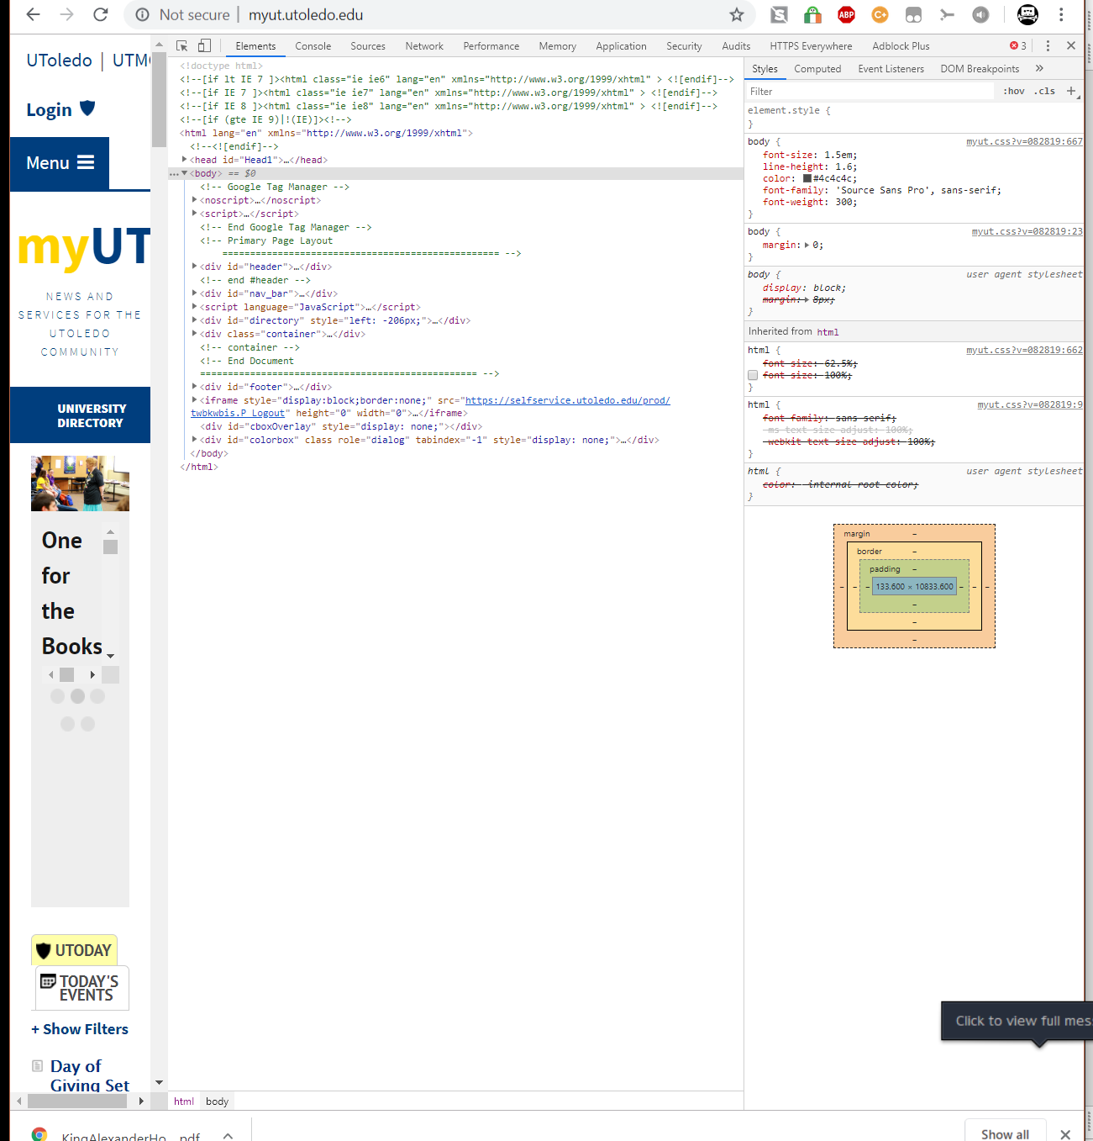
d. Look at the Network TAB – Take a Screen shot of the Network Information Turn in the Screen shots
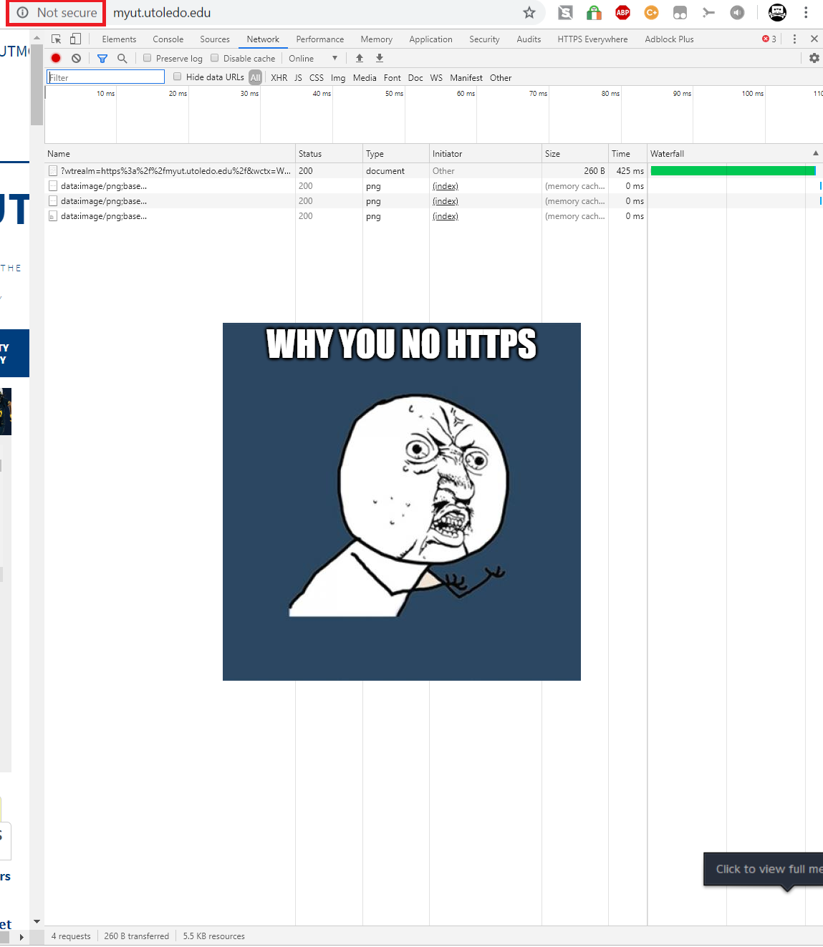

8) What would the output look like for the following HTML code?

Hello
Please turned in your assignment ontime.
Thanks
Scott Brahaney
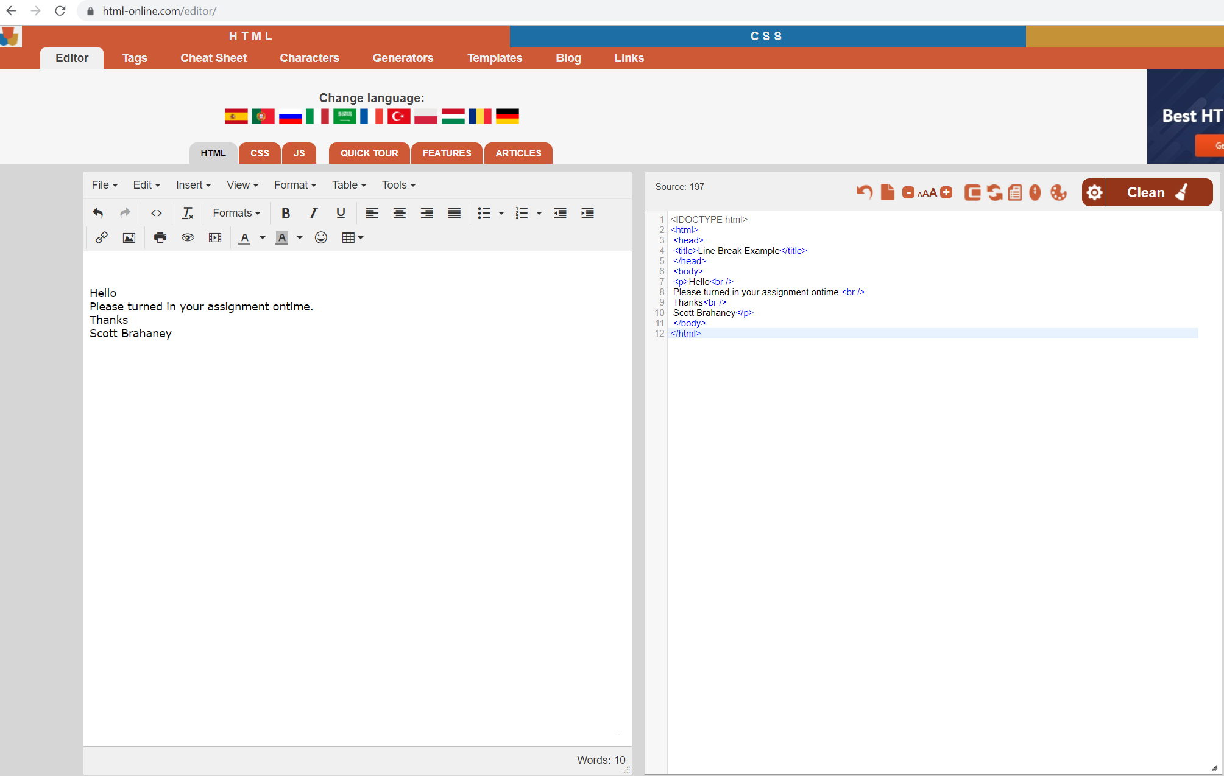
My word processor converted your HTML directly into what it would look like so that works. The above is unarguably an output from that code that I didn’t expect to happen when I copied the questions into my word processor. The HTML output looks exactly as it appears above when utilized in LibreOffice Writer.
Here is a screenshot to dot my I and cross my T.

