Alexander King
CSET 3200
Midterm report
9.30.19

1.
A) The history of computer programming.
In the 1800s punch cards were used in textile manufacturing. This allowed for more complex automated designed. In 1842 mathematician Charles Baggage was aware the punch cards being used by the textile industry and wanted to make a calculator with the punch cards. He created these with Ada Lovelace who is often cited as the first “programmer”. Base 10 was used for this machine (hole / no hole). This also utilizes and builds on Boolean logic. Everything we put into a computer is ultimately translated into binary so this still exists to an extent today.
In 1906 Herman Hollerith created a tabulator that didn’t need to be reset each time in ran code. His machine was used to count people for the census and reduced what used to take roughly eight years down to two. He would found companies that would later become IBM. (Ibm.com, 2019)
During the late 30s through mid 40s World War Two was bring fought which led to some really cool hardware programming for encryption and decryption. These would would be a foundation to later software iterations we’re more familiar with like RSA. IBM developed Automatic Sequence Controlled Calculator (ASCC) Harvard Mark 1 (Figure 1). It was used during for war effort to perform complex calculations for the US Navy as well as The Manhattan Project. (Harvard.edu, 2019)
In 1946 Project PX also known as Electronic Numerical Integrator and Computer (ENIAC) was publicly revealed. Started in 1943 by the US Army at The University of Pennsylvania Moore School of Electrical Engineering for the war effort. It made complex calculations for the US Army. It was a massive series of vacuum tubes that were manually programming by setting switches and connecting wires. Setting a single program could take weeks. ENIAC also utilized an IBM punch card reader for inputs and a card punch machine for output. It performed complex calculations for the military that used to take hours could not take minutes. It also provided weather predictions. (Computer History Archives Project, 2019)
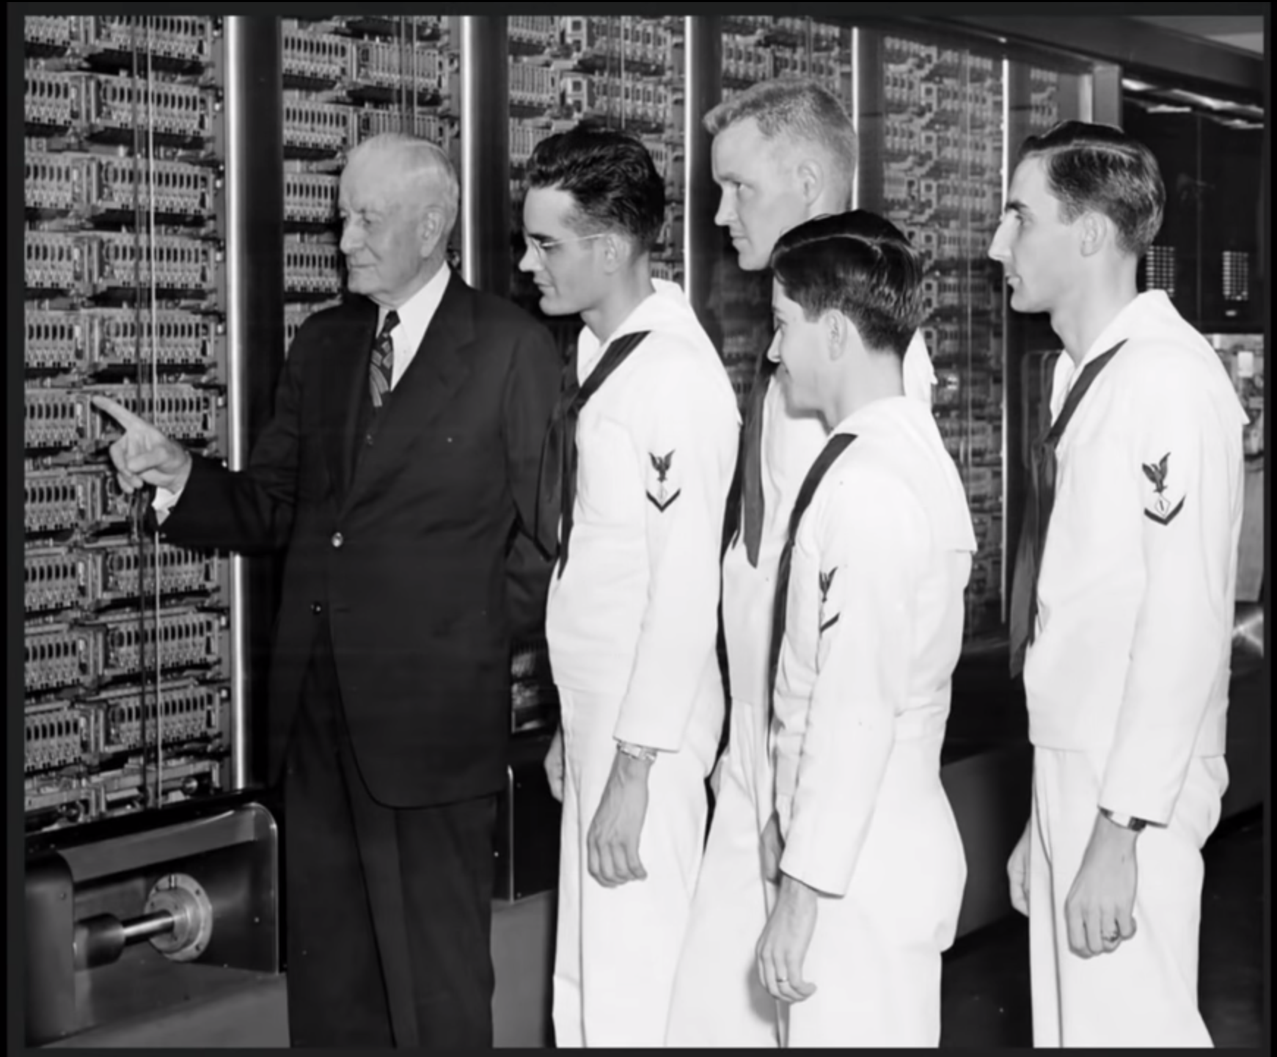
Figure 1: IBM president and US Navy Personnel ASCC Harvard Mark 1 < https://www.cio.co.uk/it-leadership/ibm-history-pictures-3429430/ >

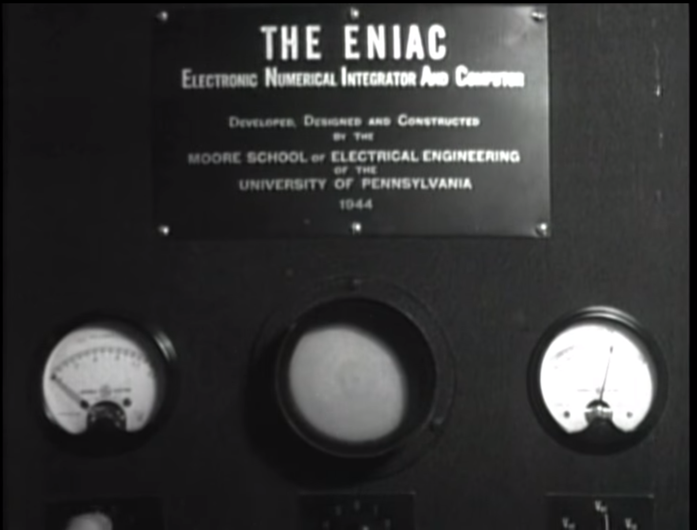Figure 2: ENIAC
In 1956 the UNIVAC correctly predicted the 1956 US presidential election and did it more accurately than pundits. This made the unit famous in popular culture and started making appearances in movies. It performed calculations on small amounts of polling data. This was also the first computer to use magnetic storage instead of punch cards. (Cs.calvin.edu, 2019)
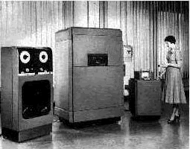Figure 3: UNIVAC television debut correctly predicting the 1956 US presidental election < https://cs.calvin.edu/activities/books/rit/chapter2/images/univac.gif >

In 1954 IBM created FORTRAN (FORmula TRANslation). It was originally developed for scientific and engineering problem solving. It is the foundation to higher level programming languages such as C++ and HTML. This also still sees some use today. (Ibm.com, 2019)

In 1954 Common Business-Oriented Language (COBOL) became the first user-friendly business software program. Grace Hopper previously worked on The Harvard Mark 1 and Univac. She led the team that created COBOL.

During the 1970s we had the personal computer revolution where for the first time personal computers were being manufactured for personal use and were somewhat obtainable in large scale. In the 1980s we started getting our first GUIs. The 1990s really brought computers into the home with the advent of the consumer internet. ISPs like the one my parents owned UsaFirst.net began offering home internet connections and it again revolutionized how people used their computers. After the release of Windows 95 computer prices dropped drastically and were popping up everywhere. Small businesses started acquiring them around this time too. In 2007 Apple released the first iPhone. This would be another revolution that changed how most people used the internet and the programs we create. The history of the programs we write and how we write them is still being written. HTML4.x→5 for example. Java has had a rich history of vulnerabilities for end users which has changed and affected how we code. Many programs and services are starting to finally support data encryption which is a direct result of current event mass surveillance.

B) The hardware architecture used by modern computers (Von Neumann Architecture)
The Von-Neumann architecture: A user gives an input that is run through a program and processed by the CPU/RAM and then provides an output. The von-neumann bottle neck is the speed of the bus is slower than the memory or CPU speed.
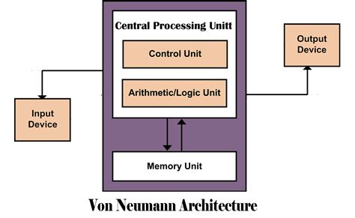Figure 4: Georgetown University - < https://blogs.commons.georgetown.edu/cctp-820-fall2016/category/week-7/ >

C) Structured programming – how it works and why we use it
D) compiler -vs interpreter vs hybrid Structured programming is modular programming. Having sub-programs that can be more easily changed and or reused. Structured will use commands like if while and for instead of commands like do. Compiled programs are translated into machine language. This includes JIT systems. They’re used in large commercial applications.
Pure Interpreters are interpreted by another program known as an interpreter.
Hybrid implementation is a compromise between compilers and pure interpreters. Small and medium systems where efficiency is not the first concern.

2. Explain in detail the history and overview of the client-server architecture
Client Server connections have been used for DNS looking up internet addresses to be able to more easily navigate the internet. Telnet is an outdated now insecure way to make connections. File Transfer Protocol and provide files as a service to clients.
a) Client-server: Clients connect to servers for use of services.
b) 3 tier systyems: Three processes collaborate in chains. The end user handles presentation (GUI) as well as user inputs, the application tier makes all of the application decisions, and the data tier stores data utilized by the application tier. This can add security as well as improved performance under heavy workloads.
c) N-Tier System n-tier can be any n-number of tiers.
3. Explain difference between a client, server and a service.

A client is an end user. The end user connects to a server which provides services. For example if I want to know what time it is in another time zone I can connect to a server and utilize a server that asks me what timezone I am interested in knowing the time of. I will tell the server which time zone I find interesting and it will output the current local time for that timezone.

a. Client – end user. The individual connecting to a server. - My home desktop computer

b. Server – provides services to the end user. The client connects to the server. *A server is one or more multi-user processors with shared memory providing computing, connectivity and the database services and the interfaces relevant to the business need.* - My home computer when it is providing services to other devices. EX: My gf wants to play a game so she connects to my shared drive that lives inside of my desktop and launches the game.

c. Service – a task accomplished and provided by the server to a client. My installation of a game in the example above when utilized by another device is a service.

d. Shared resource – If 2 or more clients are connecting to a server for the same service it is a shared resource. The server has X amount of computing power and it is shared. No one user should be able to demand it all.
If we both play the game at the same time on different devices from the same installation the ability of the HDD it lives on will be a shared resource.

a) give examples and definitions of different types of servers

File servers deliver files. MegaUpload for example.

Database Server: MySQL. The client passes the SQL requests as messages to the database server; the result of each SQL command is returned over the network.

Transaction Server: The client can invoke remote procedure or services that reside on
the server with an SQL database engine using the transaction server. I think this is basically the reason why I have to pay for something like www.sc2replaystats.com. I cannot inspect their elements to just get what I want it calls the fun bits from another server.

Groupware Servers: I think these are what I utilize when I connect with an online tutor through their new software.

4. Comparison between Client-Server, Peer to peer, and single process (stand alone) architectures.
a) give pluses and minuses of each architectures
b) compare cost in terms of cpu, RAM, and execution time.
5. Provide illustations and explanations of the architectures
6. Explain differences in delivery system thick vs thin client programming
Thin == the email program we made for Homework 5. Will NOT work offline.
Thick == Photoshop. It is functional offline but has some features that utilize online.
a) browser based vs desktop exe
Browser based
b) software distribution issues positives/negatives for each.
Something browser based is more easily controlled if the ability to solve the problem is never given to the user in a way they can use offline. This can be a positive for the intellectual property owner because they can direct the traffic where they want. They can require log-in accounts or subscriptions more easily etc. The downside to this approach is both the client and the server must maintain an internet connection and there is a wider attack surface for nefarious actors to create problems.

The advantages of a desktop exe is that it can be run offline and thus has fewer attack vectors. The disadvantages are an ability to implement DRM. Your program will be cracked and freely distributed if it is of high enough quality and demand. Attempting to implement working DRM will annoy paying customers who run into problems.

1.c Structured Programming
Structured programming is modular programming. Having sub-programs that can be more easily changed and or reused. Structured will use commands like if while and for instead of commands like do.

1.d compiled vs interpreted vs hybrid
Compiled programs are translated into machine language. This includes JIT systems. They’re used in large commercial applications.
Pure Interpreters are interpreted by another program known as an interpreter.
Hybrid implementation is a compromise between compilers and pure interpreters. Small and medium systems where efficiency is not the first concern.

-) What are the advantages of Client Server Computing?
It is accessible from almost anywhere vs LAN. I say almost because of China, network policies, and lack of neutrality regulations.
Cloud storage whether from Mega[Upload] which is designed specifcally for cloud storage or places like YouTube where I want to make my car accident dash cam video available to those I choose while not having to store it locally on my HDD SSD.
Shared processing power. This for example could be an unsuspecting victim in a botnet mining for someone else driving up their electricity bill or utilizing something like https://www.onlinehashcrack.com/ instead of attempting to use my CPU/GPU processing power and my HDD space for wordlists.
Access control. This makes it easy to control who can see what data when properly implimented. EX: Blackboard has previously done a poor job with access control where changing a URL can produce results a user might not otherwise be able to access normally (I reported this in a previous class).

-) What are the disadvantages of Client Server Computing?
The client and server must both have an active internet connection. Bandwidth overhead is another consideration.
Also by nature of being on the internet you open yourself up to a greater attack surface. If I tell an offline only program some personal detail I need only worry about my own system where as when I provide personal information to servers I have to trust the transportation and ability to securely store the data. Sony, Yahoo, and Equifax come to mind. Concerns like this make me wonder how long HIPAA can last with a more connected medical records system.
Being centralized means if the server room burns to the ground those services are inaccessible. Where as a good P2P swarm can keep files alive and shared when superpower governments or international lobbyists like RIAA/MPAA would rather they were down. Sometimes for different reasons.

-) What are the 4 types of Servers as discussed in “Introduction to Client Server Computing“ pdf posted on blackboard? Explain each.
File server: Delivers me files. ♥ Mega[Upload].
Database Server: MySQL. The client passes the SQL requests as messages to the database server; the result of each SQL command is returned over the network.
Transaction Server: The client can invoke remote procedure or services that reside on
the server with an SQL database engine using the transaction server. I think this is basically the reason why I have to pay for something like www.sc2replaystats.com. I cannot inspect their elements to just get what I want it calls the fun bits from another server.
Groupware Servers: I think these are what I utilize when I connect with an online tutor through their new software.

5. Provide pictures of each type of the above

6. Thin programs are heavily dependent on the servers applications. Thick programs are not.
Thin == the email program we made for Homework 5. Will NOT work offline.
Thick == Photoshop. It is functional offline but has some features that utilize online.
a. browser vs desktop exe.
b. advantages / disadvantages.

Bibliograpyh

Harvard.edu. (2019). About the Mark I. [online] Available at: https://sites.harvard.edu/~chsi/markone/about.html [Accessed 8 Oct. 2019].

Computer History Archives Project (2019). 1946 ENIAC Computer History Remastered FULL VERSION First Large Digital Elec.Computer Educational. [online] YouTube. Available at: https://www.youtube.com/watch?v=bGk9W65vXNA [Accessed 8 Oct. 2019].

Ibm.com. (2019). IBM Archives: Herman Hollerith. [online] Available at: https://www.ibm.com/ibm/history/exhibits/builders/builders_hollerith.html [Accessed 8 Oct. 2019].

Ibm.com. (2019). IBM100 - FORTRAN. [online] Available at: https://www.ibm.com/ibm/history/ibm100/us/en/icons/fortran/ [Accessed 8 Oct. 2019].

Ibm.com. (2019). IBM100 - The Punched Card Tabulator. [online] Available at: https://www.ibm.com/ibm/history/ibm100/us/en/icons/tabulator/ [Accessed 8 Oct. 2019].

Cs.calvin.edu. (2019). UNIVAC. [online] Available at: https://cs.calvin.edu/activities/books/rit/chapter2/history/univac.htm [Accessed 8 Oct. 2019].

