Alexander King, Zachary Kilgore, Matthew Groat, Noah Stevens, Brandon Westrick
CSET 4850:901
March 29th 2021

Lab 3

*Note the login at 131.183.222.81/LightVN/ lacks SSL this is comical and ironic*
Network Topology:
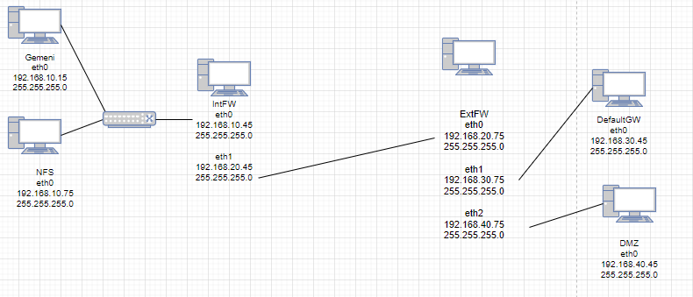

1.Run iptables –L and observe the result. This is the default state that will be present if you run iptables -F.
On IntFW
Chain INPUT (policy ACCEPT)
target prot opt source destination
Chain FORWARD (policy ACCEPT)
target prot opt source destination
Chain OUTPUT (policy ACCEPT)
target prot opt source destination

On ExtFW
Chain INPUT (policy ACCEPT)
target prot opt source destination
Chain FORWARD (policy ACCEPT)
target prot opt source destination
Chain OUTPUT (policy ACCEPT)
target prot opt source destination

2.Run iptables –F and observe the result
No output on IntFW or ExtFW

3.Block ping (ICMP) packets between DefaultGW and Nfs
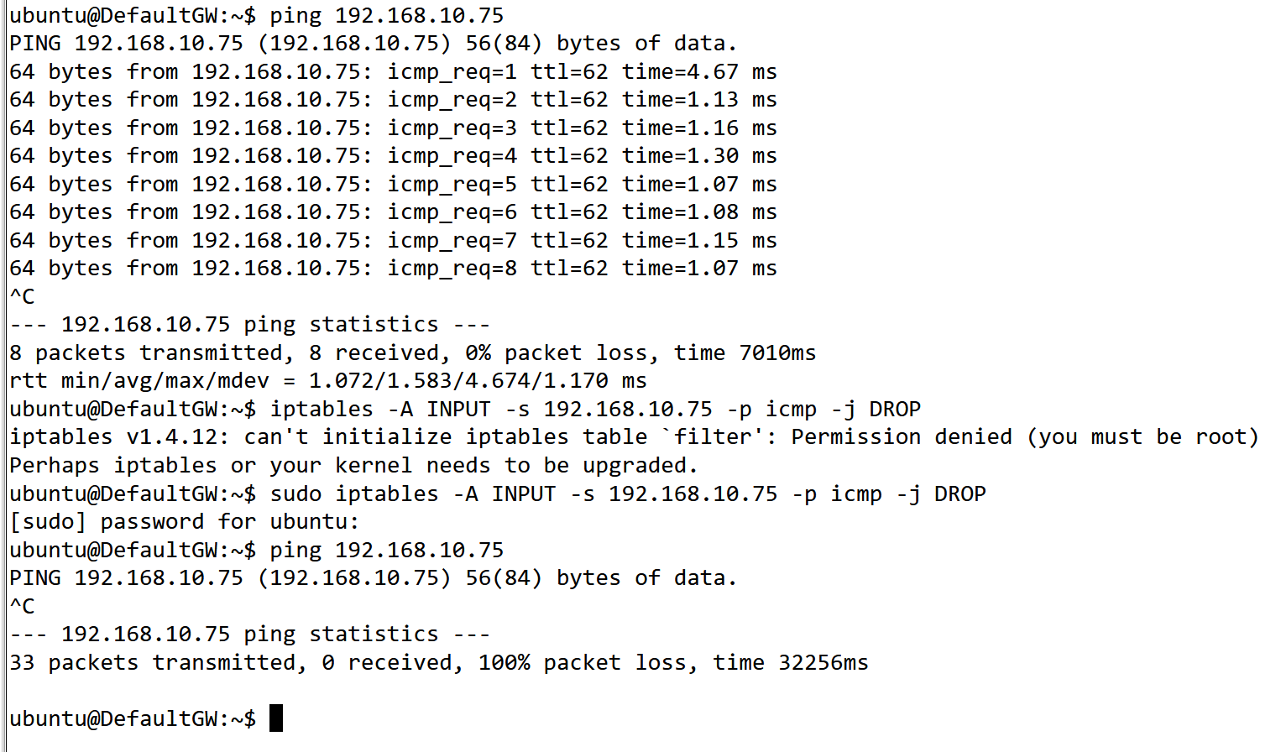

4.Block WWW traffic from Nfs to Dmz
# /sbin/iptables -A INPUT -p tcp --destination-port 80 -j DROP
# /sbin/service iptables save

# /sbin/iptables -A INPUT -p tcp --destination-port 443 -j DROP
# /sbin/service iptables save
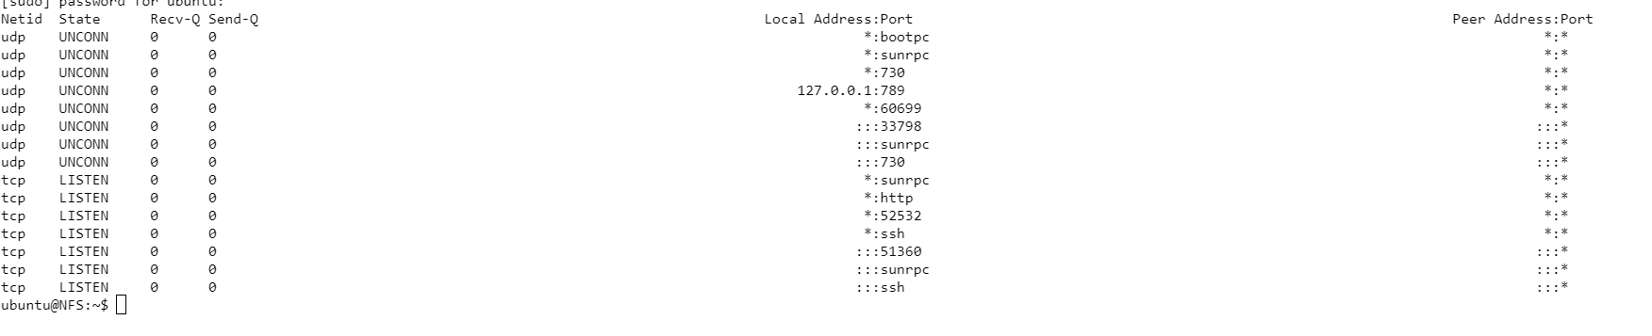

5.Block SSH traffic from DefaultGW to Nfs.
ubuntu@NFS: ~$ iptables -I INPUT -s 192.168.30.45 -p tcp --dport ssh -j REJECT
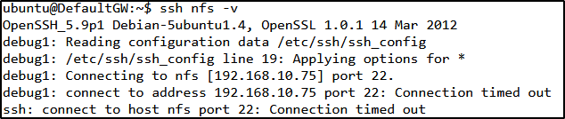

6.Write a set of rules that implement the following scenarios:

a.The SSH services on Nfs are only available in subnet 192.168.10.0
sudo iptables -A INPUT -p tcp -s 192.168.10.0/24 --dport 22 -m conntrack --ctstate NEW,ESTABLISHED -j ACCEPT

sudo iptables -A OUTPUT -p tcp --sport 22 -m conntrack --ctstate ESTABLISHED -j ACCEPT

b.Dmz serves WWW service only to DefaultGW
# / sbin/iptables -A INPUT -p tcp -i eth1 ! -s 192.168.30.45 --dport 80 -j DROP
# / sbin/iptables -A INPUT -p tcp -i eth1 ! -s 192.168.30.45 --dport 443 -j DROP

c.Dmz serves SSH service only to Nfs.
Following command allows ssh from a specific IP(NFS).

Make a rule to set the default state for DMZ to INPUT DROP.
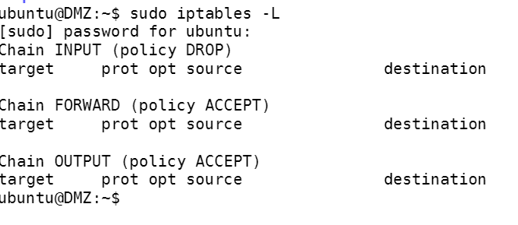
Allow specific access to NFS (192.168.10.75/24).

Test on NFS. It is working as it should.
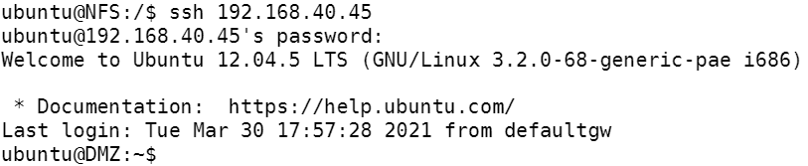
Test on anything but NFS. It does not work and times-out as expected.

7.Assume your virtual network is a compact version of a typical corporate network, design and implement an appropriate set of iptables rules.
Allow loopback connections.
sudo iptables -A INPUT -i lo -j ACCEPT
sudo iptables -A OUTPUT -o lo -j ACCEPT

Drop invalid packets
sudo iptables -A INPUT -m conntrack --ctstate INVALID -j DROP

Block any specific IP address (not implementing any since I am unaware of any nuisance IP addresses for this server. Followed by unblocking any specific IP.
iptables -A INPUT -s xxx.xxx.xxx.xxx -j DROP
iptables -D INPUT -s xxx.xxx.xxx.xxx -j DROP
Block/unblock any specific ports. We could use this to block p2p ports for example.
iptables -A OUTPUT -p tcp --dport xxx -j DROP
iptables -A INPUT -p tcp --dport xxx -j ACCEPT

Block pings. Not going to implement as I want to ping these but it is good to know:
iptables -A INPUT -p icmp -i eth0 -j DROP

Block a specific mac address:
# iptables -A INPUT -m mac --mac-source 11:22:33:44:55:66 -j DROP

Save/backup rules and restore rules.
iptables-save > ~/iptables.rules
iptables-restore < ~/iptables.rules

Summary:
For this lab, we set up firewall rules using iptables. We implemented blocking and allowing different SSH requests, HTTPS and ICMP communications. We set up commands we would use in a professional setting such as blocking/unblocking specific IP addresses and mac addresses. We explained how to block pings and drop invalid packets. We also listed commands for saving/restoring a set of rules.

Tasks done:
Brandon Westrick - Blocked ping (ICMP) packets between DefaultGW and Nfs, setup format for paper and shared with the group.

Zachary Kilgore - Blocked the HTTPS port 80 and 443. Also set up DMZ with HTTPs access. Worked on the summary section.

Matthew Groat - Confirmed that the network topology is the same as it was in Lab 1, ran the initial iptables -L and iptables -F commands.

Noah Stevens - Blocked SSH from DefaultGW going to NFS

Alexander King - Contributed to summery, set up firewall iptables rules to disallow INPUT connections by default and then set permissions for what should be allowed. Designed some appropriate corporate rules and listed some useful commands. SSH services on Nfs are only available in subnet 192.168.10.0 Documented and tested all of the above.

