Alexander King, Zachary Kilgore, Matthew Groat, Noah Stevens, Brandon Westrick
CSET 4850:901
April 11th 2021

Lab 4

Ensure Snort is installed by typing “snort -V” to check the version. It was already installed and is running version 2.9.7.0 build 149 from 2011.
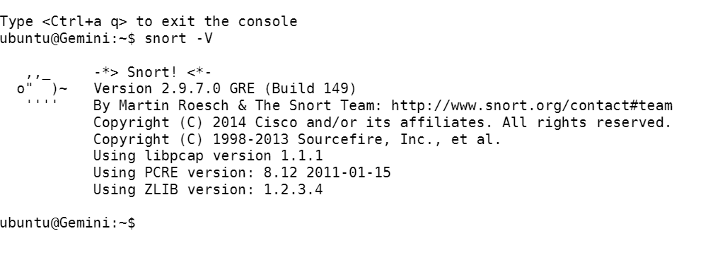
Uncomment the following lines (if present in the file): Include $RULE\_PATH/local.rules (where $RULE is an environment variable. Most likely, $RULE\_PATH = /etc/snort/rules)

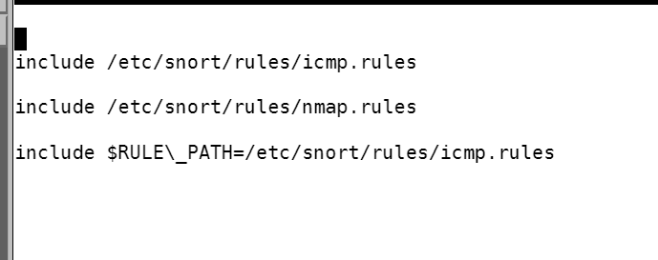

Part 3: Setting your own rules Locate the icmp.rules file

in the path mentioned in part 2. In the file, in addition to the existing rules, you can add your own ones. For example, consider the following rule which detects if any machine is pinging your host:
alert icmp any any > any any (msg:"Ping detected"; itype:8; sid:1000477; rev:1)
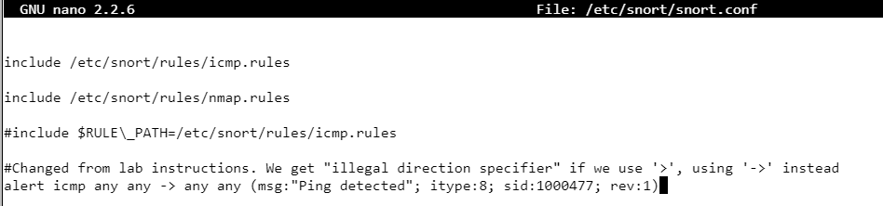

To run Snort in IDS mode and log alerts on the console, you can run the following command on your targeted host:
sudo snort -A console -i eth0 -c /etc/snort/snort.conf

After pinging Gemeni from NFS:

Here, eth0is the interface on which snort is set to be listening.You can check your interface using the ifconfig command.The alerts are logged to the console.The following are two basic scenarios for which you should test Snort’s functionality in this part:
1.Port scanning using Nmap
2.Attempt to gain SSH access

For each of the above two scenarios, choose two hosts, one as the attacking host, and another as the target host.

Port scanning using Nmap: After choosing a target host, make sure to add a rule to detect nmap scans. The following rule helps to detect if any port is scanned:
alert tcp any any -> target-ip any (msg: "NMAP Port Scan attempt!";sid:10000005; rev:2;)

Nmap Gemini from NFS -
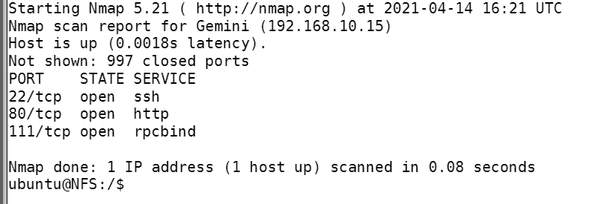

Set alert for ssh from NFS to Gemini(rules in NFS snort file):
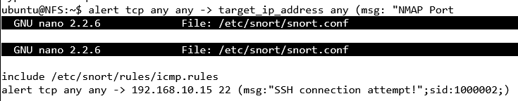

After ssh into NFS from Gemini, went back to NFS logs and see the alert added to the log files

Tasks done:
Alexander King checked the installation of snort and the version. Added snort rules. Nmapped target.

Matthew Groat Added the “Ping detected” rule to Snort on Gemeni, and confirmed that it works by pinging from NFS.

Brandon Westrick Uncommented the line that was documented in Part 2 and verified that it was saved and still there when opened again.

Noah Stevens: Set alert for SSH on NFS machine to detect the ssh from Gemini. Verified alert log went to the snort logs on NFS

