Alexander King -R00852947
Homework 1
CSET4850 Computer and Network Security
Spring 2021

Homework Assignment1

Problem Sets:
Chapter 1
1. Exercise 5
Show that the three security services—confidentiality, integrity, and availability—are sufficient to deal with the threats of disclosure, disruption, deception, and usurpation.
Confidentiality – This prevents unauthorized access. Only people with proper permissions can read or write to designated objects.

Integrity – This prevents unauthorized software from being on a users device. This could be version control. This could enforce a device must be using X version of Y program, or X program is banned and cannot be used at all etc. This helps narrow attack vectors and ensure the integrity of any given object. This is a trust system.

Availability- This can be resources or objects. I could a lot a given amount of resources to a given user that they may not exceed.

If all of these are properly implemented I should be able to assume until shown otherwise that my environment is secure. Areas of trust are most like to have issues as it is easy to overlook something that becomes exploitable.

2. Exercise 14
A respected computer scientist has said that no computer can ever be made perfectly secure. Why might she have said this?

Because as far as we have observed this has always been true. For any lock there is generally a way to beat the lock. For example you could have the most secure password in the world but if you click my shady link I might gain reverse-TCP shell access to the machine and can log whatever your password is. This could also be accomplished by looking over their shoulder or a usb keylogger or pulling any saved credentials etc etc etc. The user themselves could become compromised. There are simply too many ways to attack to reasonably think you have accounted for them all especially when measued against a super-power governments capabilities.

Chapter 2
3. Exercise 1
Consider a computer system with three users: Alice, Bob, and Cyndy. Alice owns the file alicerc, and Bob and Cyndy can read it. Cyndy can read and write the file bobrc, which Bob owns, but Alice can only read it. Only Cyndy can read and write the file cyndyrc, which she owns. Assume that the owner of each of these files can execute it.
a. Create the corresponding access control matrix.

Alice, Bob, Cyndy = users
Alicerc, bobrc, cyndyrc = files
r / rw / e / n = access types. Read, Read/write, execute, no permissions
 | alicerc | bobrc | cyndyrc
Alice | Rw /e | r | n
Bob | r | rw/e | n
Cyndy | r | rw | rw/e

b. Cyndy gives Alice permission to read cyndyrc, and Alice removes Bob's ability to read alicerc. Show the new access control matrix.
 | Alicerc | Bobrc | Cyndyrc
Alice | Rw /e | R | R
Bob | n | Rw /e | R
Cyndy | R | Rw | Rw /e

Chapter 4
4. Exercise 3(a)
A noted computer security expert has said that without integrity, no system can provide confidentiality.
a. Do you agree? Justify your answer.

Yes I agree. Because if I can install a program that lacks integrity I may gain access to the device when I am not supposed to thus the confidentiality of the account/machine has been compromised. Solarwinds is a good example of things we thought were secure that were not and were exploited on such a scale that they have become a household name over their breach.

5. Exercise 5
Classify each of the following as an example of a mandatory, discretionary, or originator controlled policy, or a combination thereof. Justify your answers.
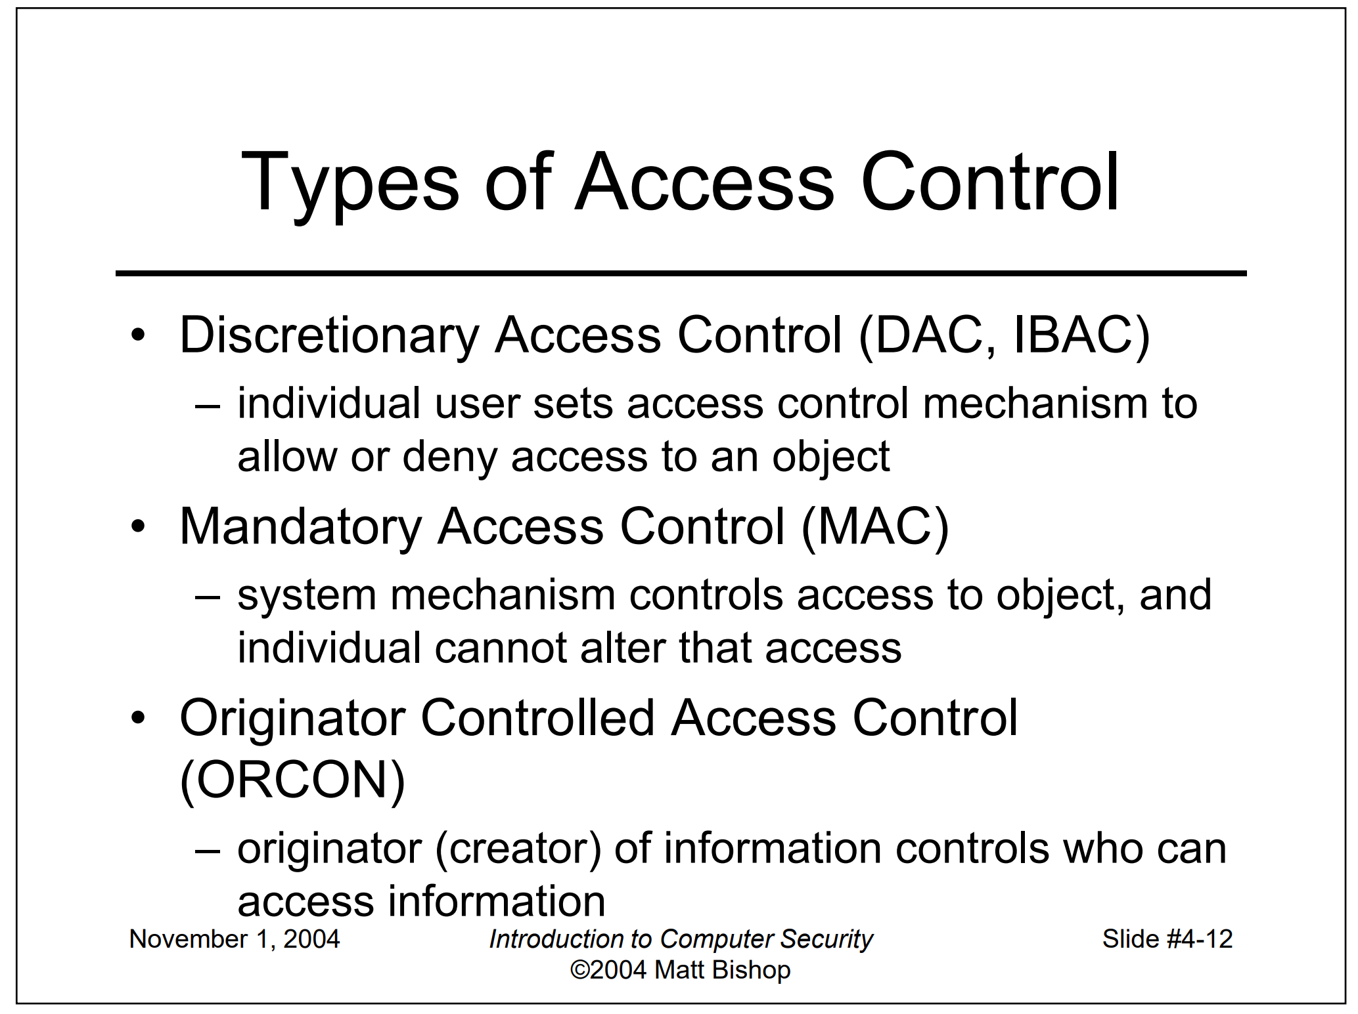

a. The file access control mechanisms of the UNIX operating system
DAC Because the user sets access control mechanisms.

b. A system in which no memorandum can be distributed without the author's consent
ORCON. Because the author of the information controls who can access it.

c. A military facility in which only generals can enter a particular room
MAC. Because there is a system mechanism that controls access to the room and individuals cannot alter it.

d. A university registrar's office, in which a faculty member can see the grades of a particular student provided that the student has given written permission for the faculty member to see them.
DAC because individual users set the access control mechanism to allow or deny access.

Chapter 5
6. Exercise 2(a,b,c)
Given the security levels TOP SECRET, SECRET, CONFIDENTIAL, and UNCLASSIFIED (ordered from highest to lowest), and the categories A, B, and C, specify what type of access (read, write, both, or neither) is allowed in each of the following situations. Assume that discretionary access controls allow anyone access unless otherwise specified.

TOP SECRET
SECRET
CONFIDENTIAL
UNCLASSIFIED
A= READ B = WRITE C= BOTH D = NEITHER

a. Paul, cleared for (TOP SECRET, { A, C }), wants to access a document classified (SECRET, { B, C }).
Paul has read write access to secret because he has read/write access at the Top Secret level which is above secret.

b. Anna, cleared for (CONFIDENTIAL, { C }), wants to access a document classified (CONFIDENTIAL, { B }).
Anna has read/write permissions for confidental and wants write access which she is permitted with C access of read/write.

c. Jesse, cleared for (SECRET, { C }), wants to access a document classified (CONFIDENTIAL, { C }).
Jesse has access to confidental C as he has secret clearance which is above confidential and has C access which is read/write só he should have all the required permissions for this.

Chapter 6
7. Exercise 1
Suppose a system implementing Biba’s model used the same labels for integrity levels and categories as for security levels and categories. Under what conditions could one subject read an object? Write to an object?
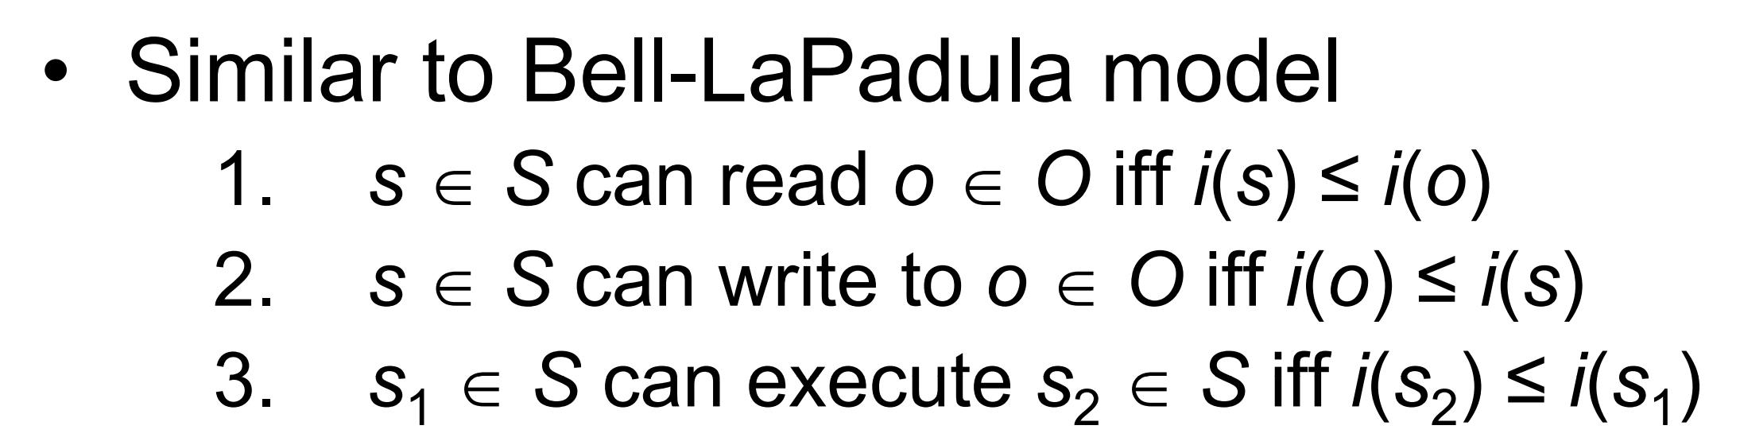
S can read to O if and only if i(s) ≤ i(o).S can write to O if and only if i(o) ≤ i(s).

Chapter 7
8. Exercise 4 (b)
Someone once observed that “the difference between roles and groups is that a user can shift into and out of roles, whereas that user has a group identity (or identities) that are fixed throughout the session.”
b. Consider a system such as a System V-based UNIX system, in which a process can have exactly one group identity. To change groups, users must execute the newgrp command. Do these groups differ from roles? Why or why not?

Yes they differ. A role is a set of permissions that can be changed while logged in. Roles can be changed on the fly or set by the time of day, day of the week, etc.
A group membership tends not to change. It can also define permissions but remains for the time you’re logged in and will require a re-log to change groups.
They have much overlap but are distinct in that groups tend not to change. You could do the same things with roles vs groups but groups allow for easy homogeneous permissions for a wide range of users in a given category.

Criteria：
To receive the full credit for each homework you need:
1)Completely and comprehensively answer each question.
2)Correctness and clarity.
3)Incorporate information from the book, lecture slides, and other course content in your discussion.
4)Use correct grammar.
5)No Lateness. (Late homework will have 10% penalty each day and will be given a zero after 7 days.)
6)Be respectful.

