Alexander J King – r00852947
CSET4850-901
Computer & Network Security
March 30th 2021

Homework Assignment 3

Problem Sets:

Chapter 16

1. Do you agree or disagree with the following statement: “Sandbox is part of the trusted computing base.”? Justify your answer.

Yes.
Sandboxes are an environment in which the actions of a program are restricted according to a security policy. If a program leaves a sandbox it may be able to do things that is not supposed to be able to do. If a sandbox fails it provides less less protection than it is believed to provide.

Chapter 19

2. Exercise 4

A computer system provides protection using the Bell-LaPadula policy. How would a virus spread if

a. the virus were placed on the system at system low (the compartment that all other compartments dominate)?
System Low will be able to be accessed and executed by all clearance levels thus it could spread to more systems more quickly.

b. the virus were placed on the system at system high (the compartment that dominates all other compartments)?
System high will only be able to be accessed and executed by top-level clearance thus it would propagate and spread among the top level while lower levels would lack access to it.

3. Exercise 7

Discuss controls that would prevent Dennis Ritchie's bacterium (see Section 19.5.1) from absorbing all system resources and causing a system crash.
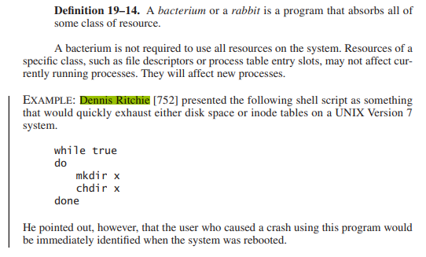Figure 1: Introduction to Computer Security pg 525

Requiring sudo permissions to write would prevent this because every time it tried to write it would need sudo permissions. Also you will know who caused the crash upon the next reboot and can address the situation at that point.

Chapter 21

4. Exercise 1
Extend the example of deriving required logging information to the full Bell-LaPadula Model with both security levels and compartments.
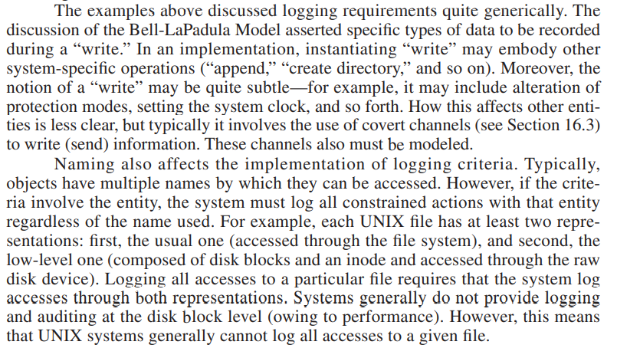Figure 2: Introduction to Computer Security pg 429
You can log all access attempts where the user attempting the access doesn’t have a high enough ranking to do the requested task. You need to ensure though that you have accounted for all possible names of the file or process. On Unix machines each file has at least 2 representations as shown above in figure 2. It also points out you may have some mundane logs that fit this description like someone trying to alter the date and time for non-malicious reasons.

5. Exercise 3
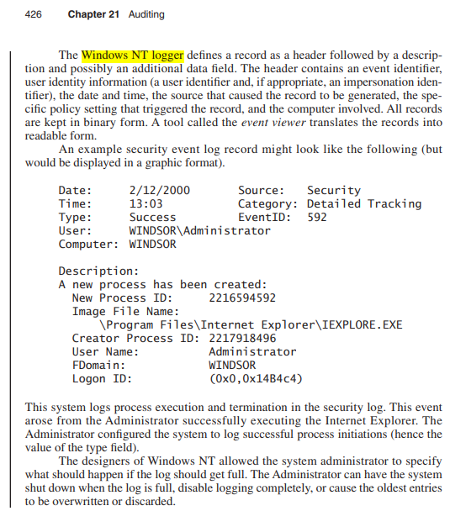Figure 3: Introduction to Computer Security pg 426

The Windows NT logger allows the system administrator to define events to be entered into the security log. In the example, the system administrator configured the logger to record process execution and termination. What other events might the system administrator wish to record?

All log-in attempts failed & successful, boots, policy violations both successful and unsuccessful where possible, network traffic activity (are you uploading lots more than I expect?), accessing removable storage, any other events of particular interest.

Criteria：

To receive the full credit for each homework you need:
1) Completely and comprehensively answer each question.
2) Correctness and clarity.
3) Incorporate information from the book, lecture slides, and other course content in your discussion.
4) Use correct grammar.
5) No Lateness. (Late homework will have 10% penalty each day and will be given a zero after 7 days.)
6) Be respectful.

