Alexander King - r00852947
CSET4850 -901 Network Security
April 11th 2021

Homework Assignment4

Problem Sets:

Chapter 22
1. Exercise 2
Why should the administrator (or the superuser) account never be locked regardless of how many incorrect login attempts are made? What should be done instead to alert the staff to the attempted intrusion, and how could the chances of such an attack succeeding be minimized?

Because the admin account is needed to remain active to be able to maintain the server. Who is going to re-enable the admin/root user if there is no available admin/root user to do so?

Instead of locking the account you would send a security alter of failed log-in attempts.

2.Exercise 5
As encryption conceals the contents of network messages, the ability of intrusion detection systems to read those packets decreases. Some have speculated that all intrusion detection will become host-based once all network packets have been encrypted. Do you agree? Justify your answer. In particular, if you agree, explain why no information of value can be gleaned from the network; if you disagree, describe the information of interest.

I agree because I use a VPN and occasionally a lab will ask me to look at my own network traffic packets on Wireshark. There isn’t anything really of use there. All encrypted TCP packets or WireGuard protocol. Being unable to read useful things in packets also lessens the useful information an attacker might gain from using a similar gathering method.

Chapter 23
3. Exercise 2
Assume that an attacker has found a technique for sending packets through the outer firewall to the DMZ without the packets being checked. (The attacker does not know the internal addresses of hosts in the DMZ.) Using this technique, how can the attacker arrange for a packet to be sent to the WWW server in the DMZ without the firewall checking the packet?

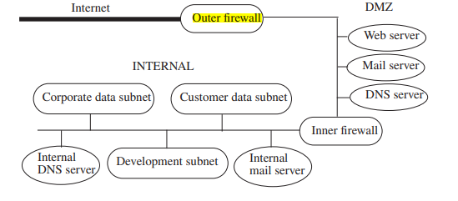

They could sniff traffic going out of the DMZ to the outer firewall that they have bypassed if they have such access. They could try and nmap the server looking for ports used. Try to see what is happening on port 25, 80 etc. Might be able to look for SSH connections too to try and figure out location of WWW server.

4.Exercise 3
Consider the scheme used to allow customers to submit their credit card and order information. Section 23.3.3.2 states that the enciphered version of the data is stored in a spooling area that the Web server cannot access.
a. Why is the file kept inaccessible to the Web server?
To harden the attack vector.
b. Because the file is inaccessible to the Web server, and no other services are available to an attacker from the Internet, the encipherment may seem unnecessary. Discuss this issue, but assume that the attacker is on the internal network.

It is necessary because sometimes attackers get in and if the customer data is not enciphered that means it is in plain-text which is great for the attacker and bad for customers who trusted you to protect their data. Sony comes to mind as a company that messed this up and allowed TONS of customer data to be compromised because they did not properly protect it. One point of failure should ideally not compromise the data attempting to be protected.

Criteria：
To receive the full credit for each homework you need:
1)Completely and comprehensively answer each question.
2)Correctness and clarity.
3)Incorporate information from the book, lecture slides, and other course content in your discussion.
4)Use correct grammar.
5)No Lateness. (Late homework will have 10% penalty each day and will be given a zero after 7 days.)
6)Be respectful.

