Alexander King – r00852947
CSET 4850-901
Computer and Network Security

Weekly report #10

This week I learned about intrusion detection and started lab 3. As Lab 3 is not due nor completed yet I will be covering that in next weeks weekly report. Intrusion detection describes methods of finding users or processes that break or attempt to break security policies and or the subvert the integrity of a device or network.
Intrusion Detection
Characteristics of a normal system not under attack: User process actions conform to statistically predicable patterns, process actions do not include sequences of actions that subvert the security policy, and process actions correspond to a set of specifications describing what the processes are allowed to do. Systems under attack do not meet at least one of these criteria.

An attack tool is an automated script designed to violate a security policy. The example given was a rootkit. It will try to masquerade as a legitimate program, add back doors like a reverse TCP connection, and may have tools to clean up log entries to attempt to cover its tracks. They may cause ls to hide files. It was suggested to use dirdump and compare to see if they match. In windows I have seen them hide processes from the task manager. Ls and dirdump are for Unix system. Could also try a clam-scan.

Dennings Model – Exploiting vulnerabilities requires abnormal use of normal commands or instructions including deviation from normal actions, execution of actions leading to break-ins, actions inconsistent with the normal operation of that program.

Various methods of intrusion detection-
Anomaly detection: what is usual is known, what is unknown is bad.
Misuse detection: what is bad is known, what is not bad is good.
Specification-based detection: What is good is known, what is not good is bad. Out of these three I like the last one best. It seems the most secure to me but could require more maintenance than ‘what is bad is known → what is not bad is good’.
Threshold metrics are good too. They can say if you fail to log-in X number of times the account becomes locked, or it can cause you to have a waiting period after failed attempts which will make attacks take significantly longer. Difficulties with this threshold can be dependent on non-obvious factors like the users ability to type. Some keyboards have different layouts throughout the world. I remember going to South American and the @ symbol wasn’t where it belonged among others.

Markov Model – Past state affects current transition. Anomalies based on sequences of events and not on occurrence of a single event. Problem: need to train system to establish valid sequences by using known training data that isn’t anomalous. The more training data the better the model. Training data should cover all possible normal systems.

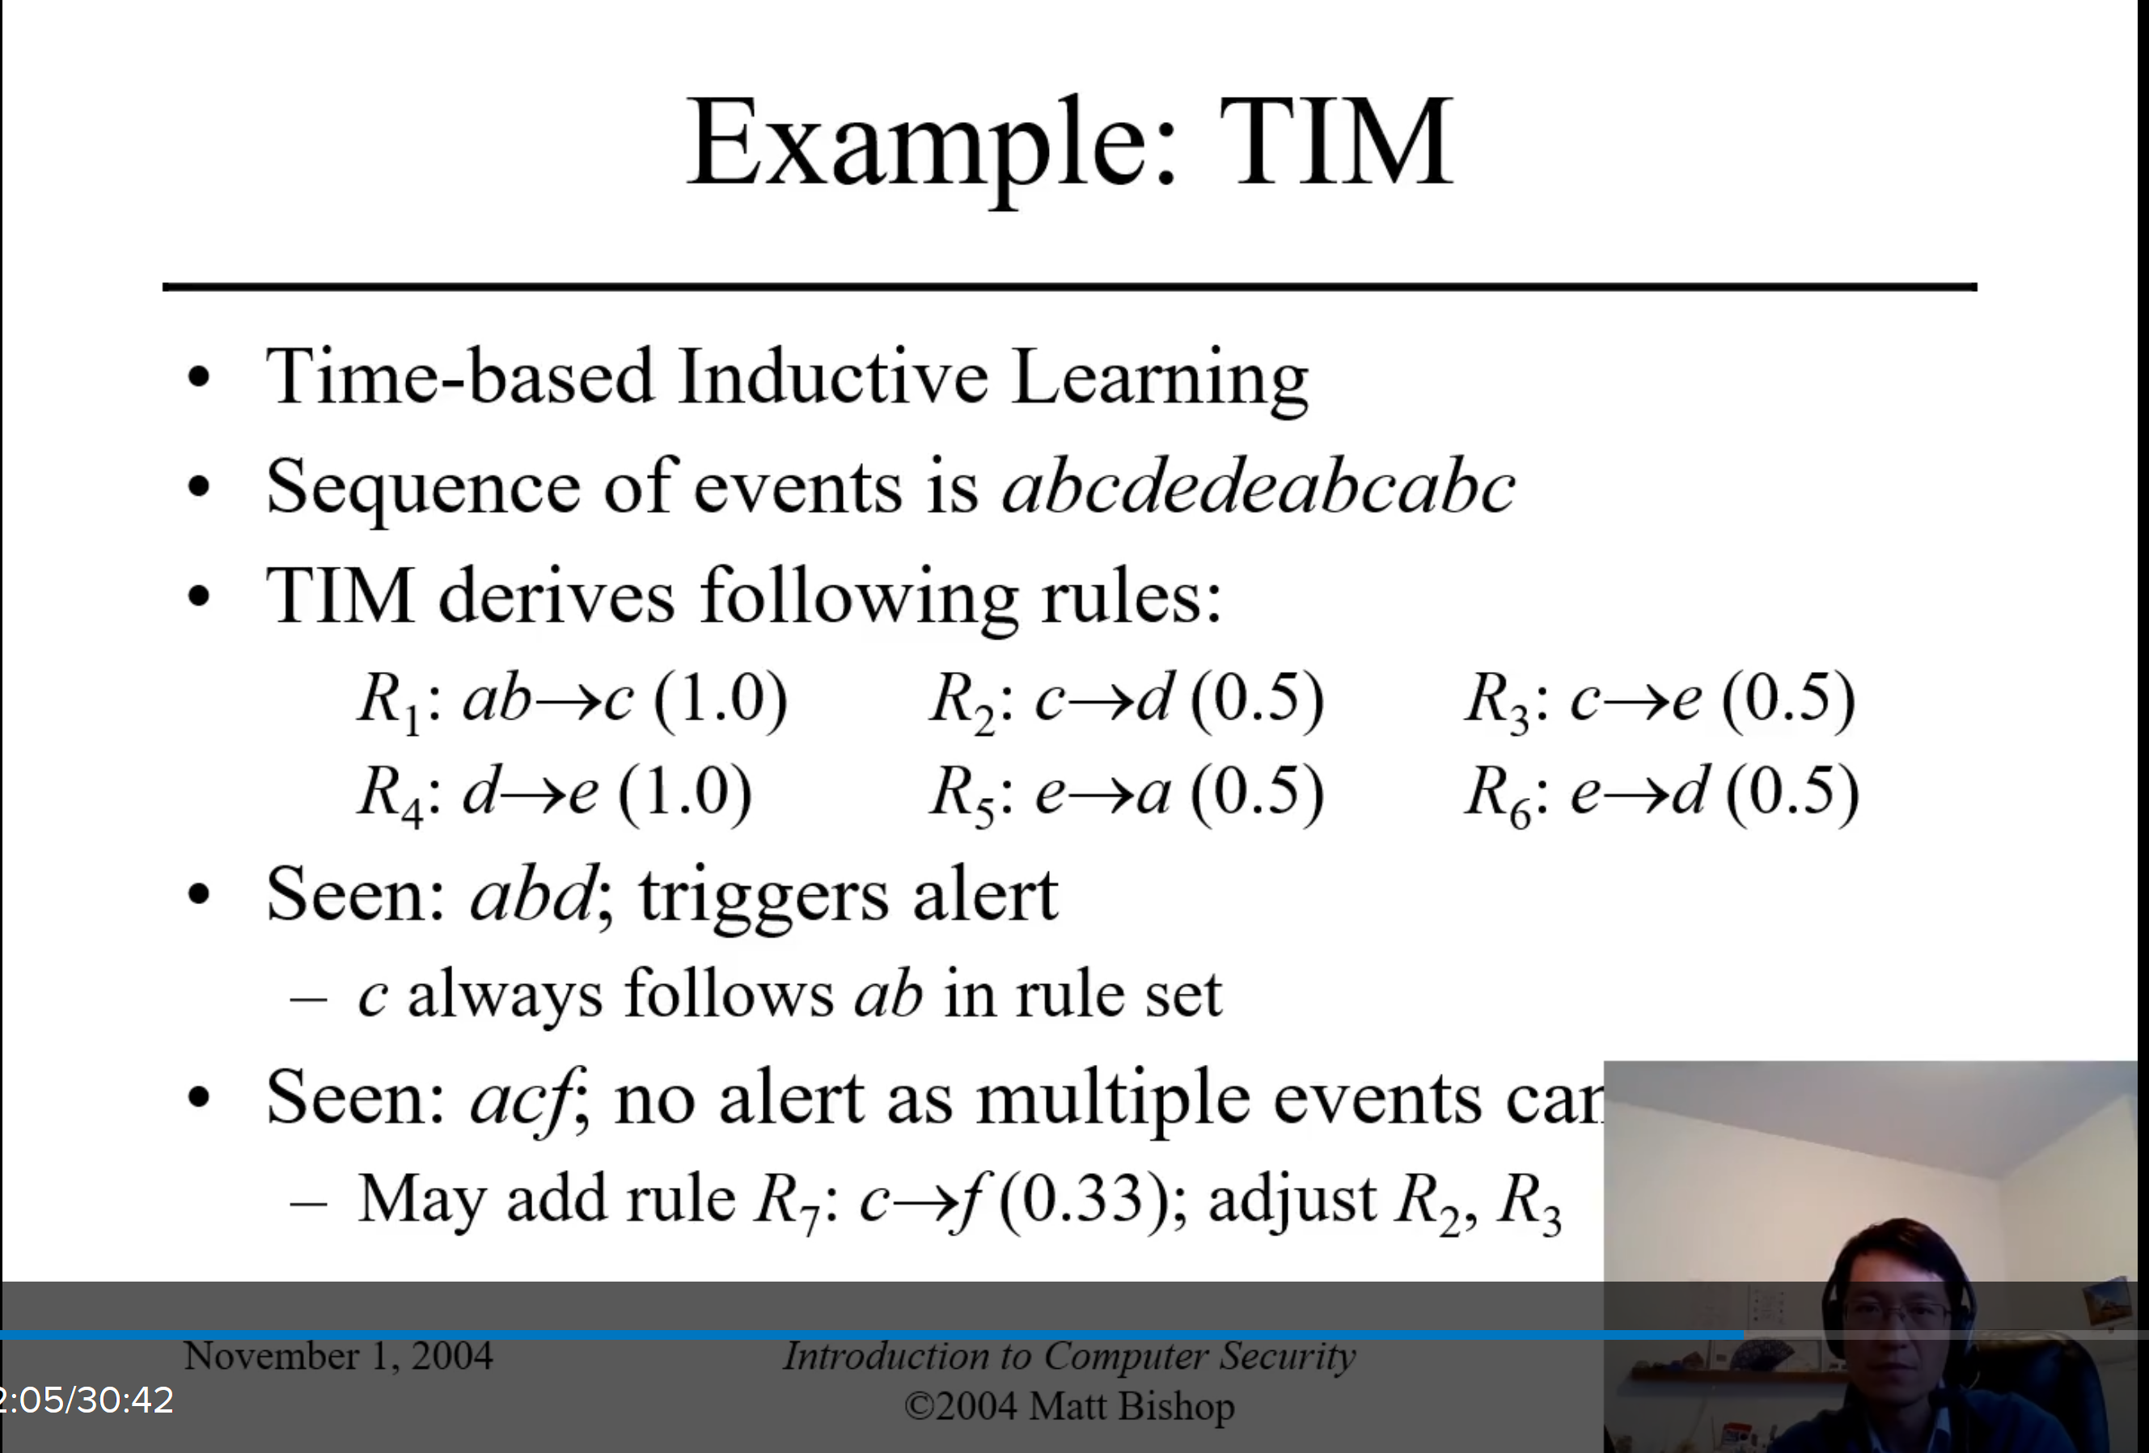
Misuse Modeling: Determines whether a sequence of instructions being executed is known to go against the site security policies based on programmed rule sets. This cannot detect attacks unknown to the developers of the rule sets.

IDS Architecture- Basically a sophisticated audit system. It will gather data for analysis, it will then analyze the data according to its internal rules, and will then notify a security officer or activate a response mechanism. The example given describes logging log-in attempts (failed and successful), the incorrect password given.

An example of intrusion detection that I see almost every day is Google / Amazon thinking it doesn’t recognize my device due to my own policies. This can be due to automated history removal (cookies etc), denying cross-site scripting, always having a different IP address with vastly different suggested physical locations (that I could not have traveled to in the time between log-ins), varying headers suggesting I may be using different browsers or operating systems etc. I would say nearly half of my log-in attempts trigger a request for 2-factor authentication and a captcha that may not otherwise have triggered if not for my device policies.

Incident prevention will attempt to prevent an attack before it completes. The attacker is placed into a honeypot that appears to be a full, unrestricted environment, attackers may download files but get bogus ones, it can imitate a slow of unreliable system, useful to figure out what an attacker wants.
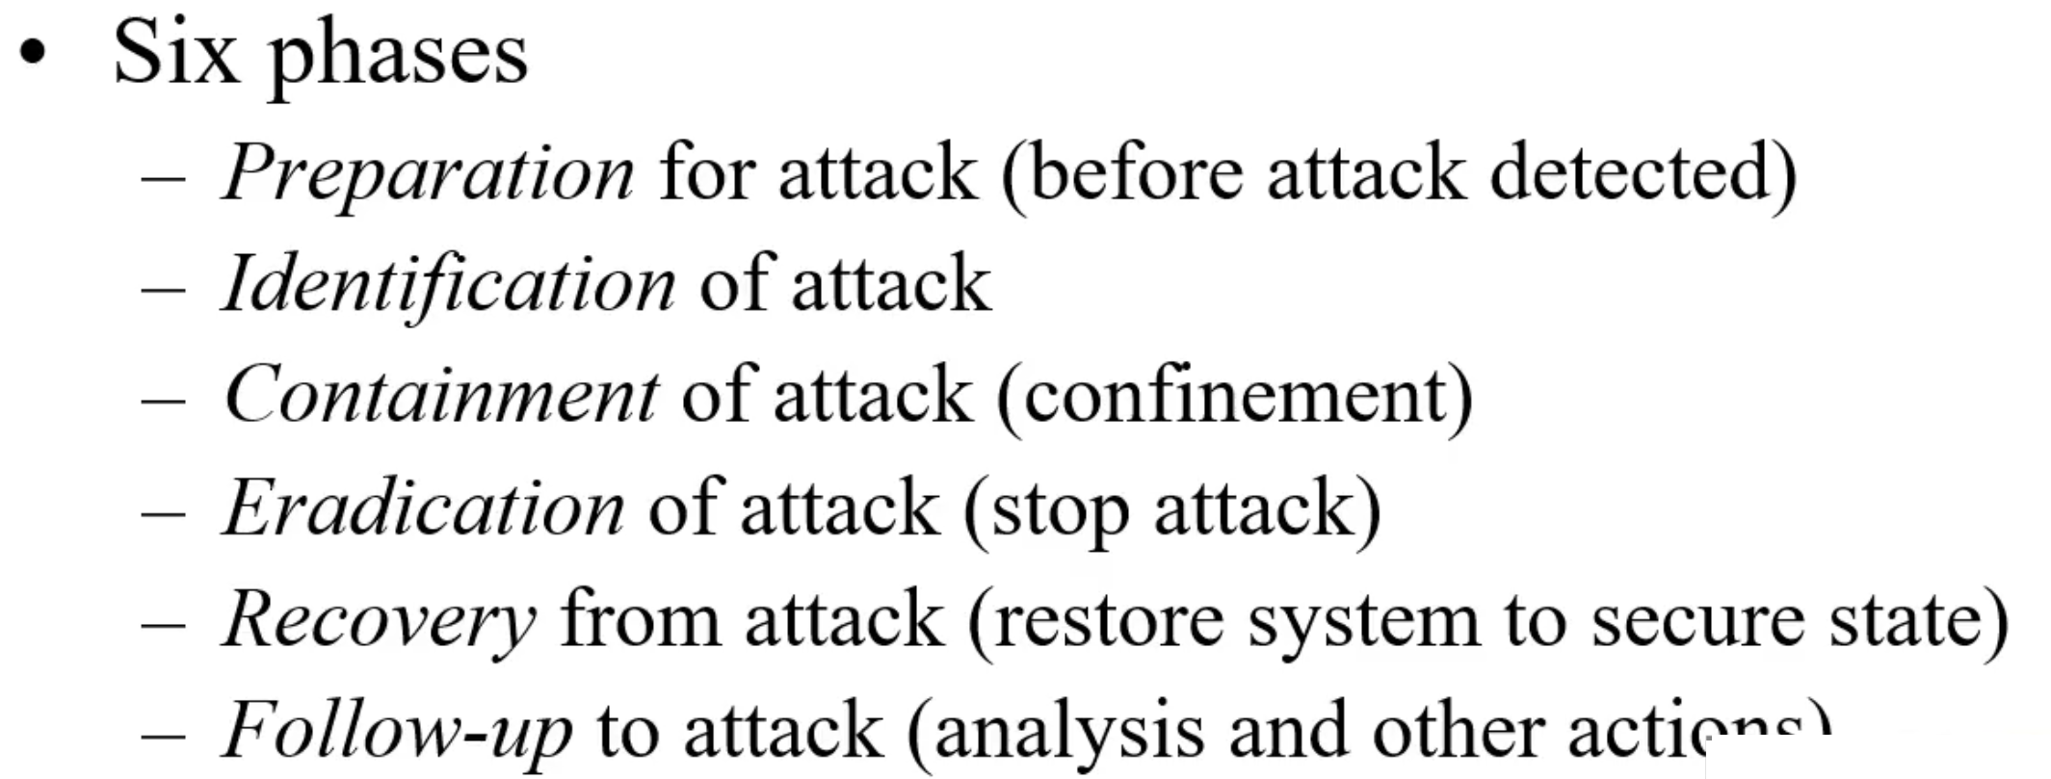
The follow-up can just be quarantining access so it cannot do anything or the honeypot/jail mentioned above.

I’m laughing at the suggestions in the follow-up phase including counter-attacking. Ethically I do not really have an issue with this but I don’t imagine it is legal to counter-attack. The attacker could just be part of a bot-net and have no idea of their participation in the attack. I have gotten high quality phishing emails before that pretended to be family. I spotted it for what it was, located the mail server it passed through (it was in an Apache2 server in Pakistan I suspect), I did an aggressive nmap of their server to attempt to intentionally trigger a reaction and then emailed them that this needs to end now or they’re going to become my hobby. I have no idea if this particular mail-server had any malevolent intentions of if it was simply one of their users but between the aggressive nmap and an email to the admin the attacks suddenly stopped. This accomplished my goal of stopping a specific ongoing attack of my email but aggressive nmapping their server is of questionable legality to my understanding. That being said it is not very likely that an illegal operation in a foreign country is going to seek the help of US law enforcement to combat counter-attacks.
Another example is while I was growing up my parents owned and operated an ISP. Someone had hacked into our ISP servers and were attacking the University of Texas. The University of Texas called us and informed us of the on-going attack that we were otherwise unaware of and we were able to resolve it. We are happy they did not simply counter-attack us. The suspected location of the attack matters when considering a counter attack. I would be more willing to counter-attack an IP address from an adversarial country than I would be against my own country. If I were doing this on behalf of a company I would want legal advice from the legal department as well. Also note even when I did consider using a counter-attacking method I attempted to use it sparingly. Before taking action that could actually be damaging towards their server I first aggressively nmapped it, I considered this a shot across the bow to show capability but not inflict any damage, and then I emailed their administrator so they could resolve the issue if they were not involved or simply remove me from the attack if they were a malevolent actor and this worked out perfectly achieving the desired result.

Doing similar actions for the government is given more legitimacy in our culture. For example the actions taken by the NSA have clearly at times been illegal and unconstitutional actions towards citizens but it is largely perceived as legitimate because the actor is the government. Stuxnet also comes to mind. We perceived the target, an Iranian nuclear facility, as threatening us and took action to disable the threat by means of a worm. Israel was largely blamed for it. In my opinion (not necessarily based on facts) I do not think Israel would have taken such action at this time without the USA knowing about it and at minimum subtly sanctioning it. Looking at current information about this we’re both blamed but I seem to recall Israel getting a greater share of the blame when this was a current event. I would also note our clear interests in the matter where about a decade later we made a nuclear deal with the target (Iran) after flexing our cyber capabilities to disrupt and dismantle them. It feels rare that we are this overt. The Trump regime took us out of the Iran Nuclear Deal and we’re back to counter-attacking perceived threats from Iran. In November 2020 an Iranian nuclear scientist was assassinated with a high-tech remote-controlled-armed-vehicle. Again Israel is getting the lion share of the blame and I (without hard facts) believe we’re involved in that they would not take such action without our tentative approval at minimum.
Additional information about Stuxnet can be found here <Stuxnet - Wikipedia > and the purported high-tech assignation here <Mohsen Fakhrizadeh - Wikipedia >.

