Alexander King – r00852947
CSET 4850-901
April 4th 2021

Weekly Report # 11

This week I learned about network security and completed Lab 3. Network security topics covered drib, policy development, network organization, and anticipating attacks. Lab 3 covered making firewall rules with iptables.

Network Security

The Drib is a company that builds and sells dribbles. They develop networking infrastructure allowing it to connect to the internet to provide mail, web presence for consumers, suppliers and other partners.

Goals of security policy: Data related to company plans, such as products being developed, should be kept secret. Customer information should be protected and the legal department must approve the release of any such data.

To help protect such data we split everyone into three groups: Customer Service Group (CSG), Development Group (DG), and Corporate Group (CG) each having access to their own relevant portions. CSG will handle customer data, DG will develop and maintain products while getting feedback from CSG, and CG handles patents, lawsuits, and other such matters.
We can see an example of user classes used to segregate relevant data in this slide:
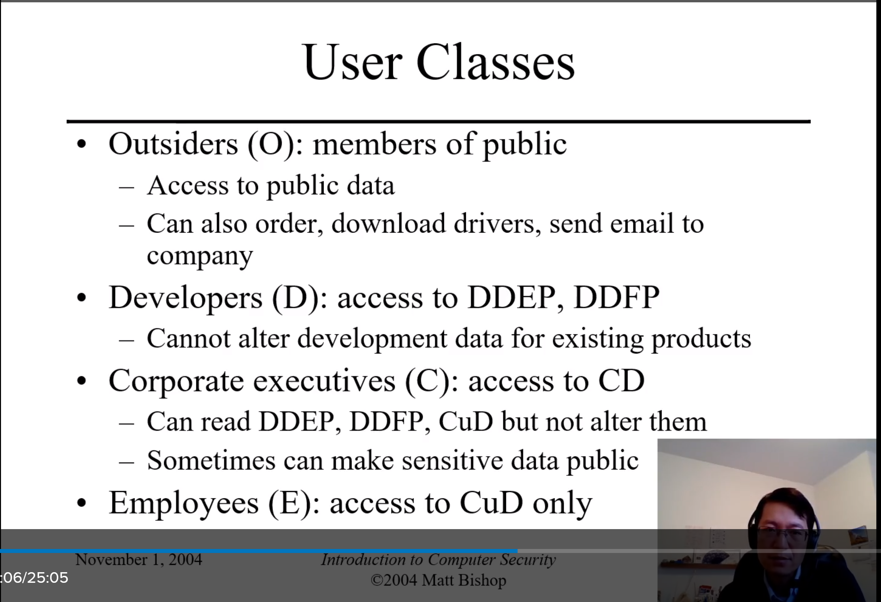

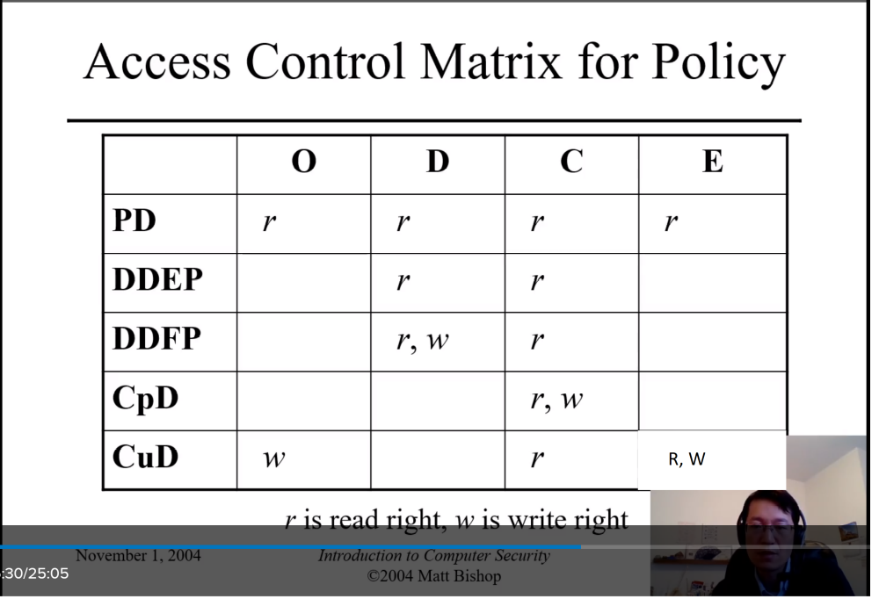
This shows the different user types, what they have access to, and what kind of access (read, write, read/write). Members of O, D, C, E cannot change permissions to allow members of another class to access their data. Within each class users may have control over files they own. After implementing these rules it is appropriate to test the rules to ensure they’re functioning as intended.

It was mentioned Drib should have a 99% up time. I thought this was impressive depending on how frequently it needs to be updated. 365 days in a year so 1% of that is about 3.5 days. I then considered games like World of Warcraft that have weekly scheduled maintenance. About 4 hours a week * 52 weeks is 208 hours /24 is about 8.5 days of scheduled downtime per year assuming there are no unscheduled downtime issues this is over 2% downtime. 1% just feels like a really high mark to meet depending on the task being accomplished.
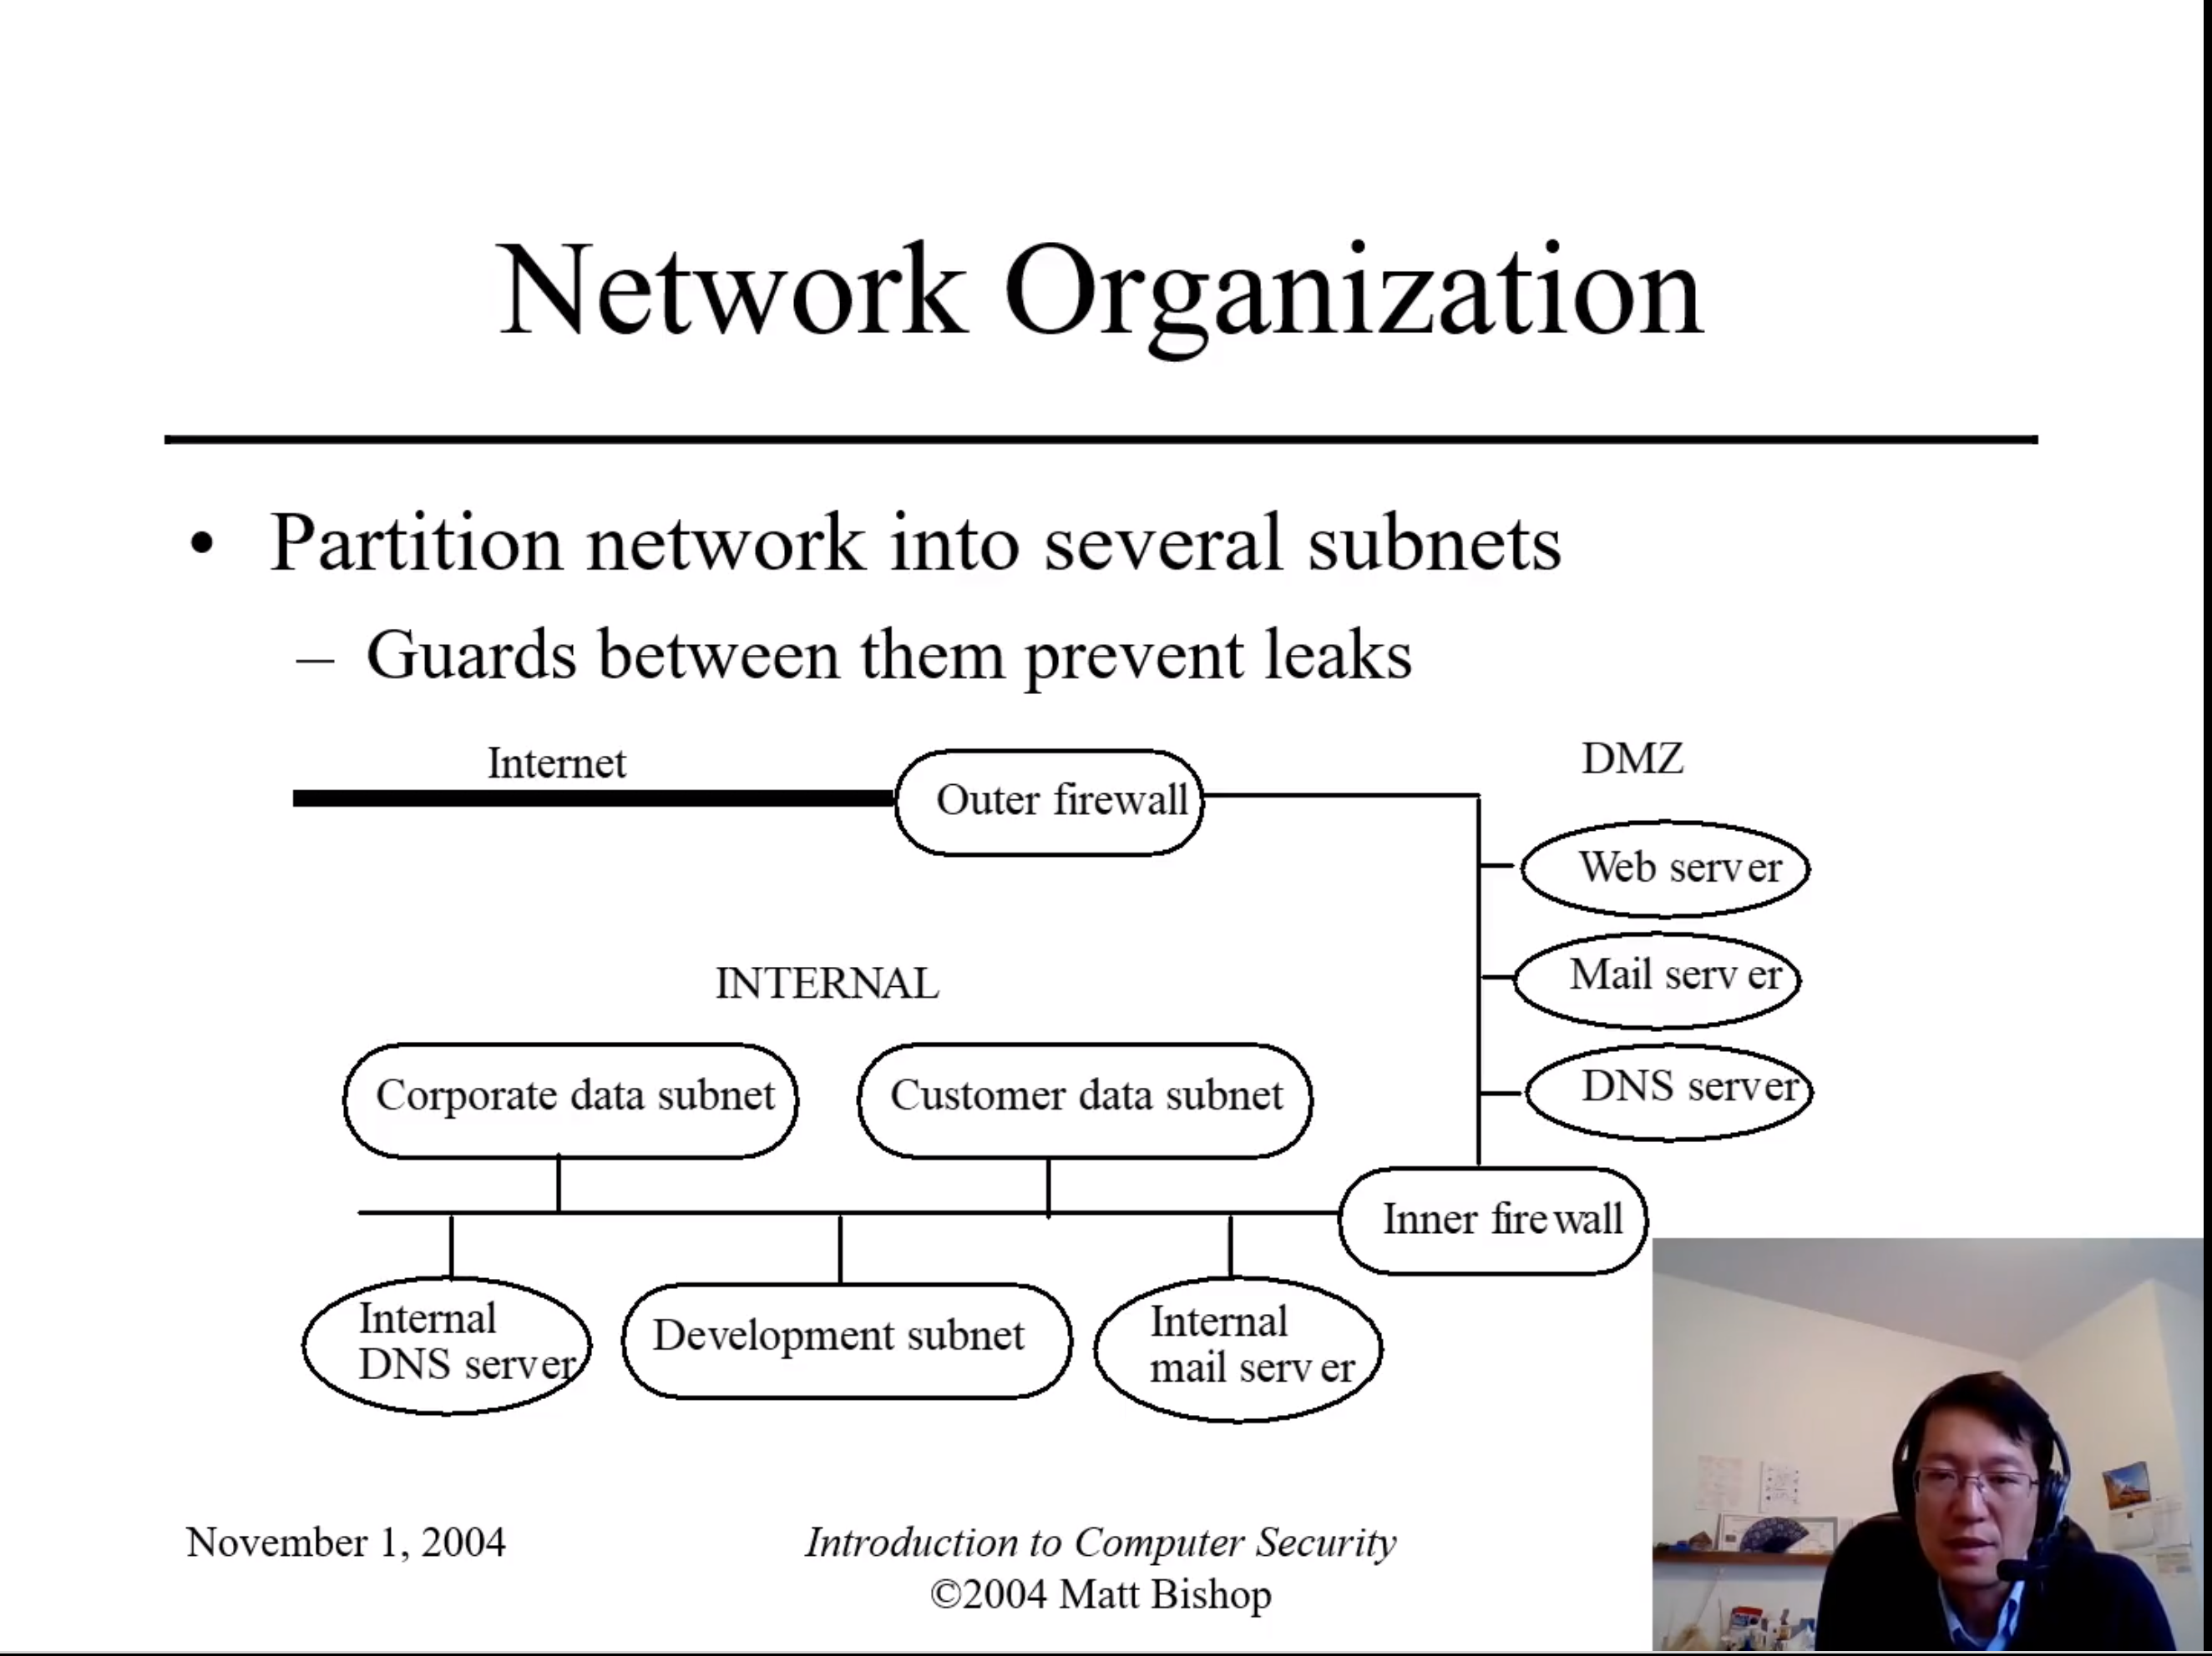

Network organization is divided into several subnets to attempt to separate data and prevent leaks.
This network structure was presented as a typical network one might find in the wild. Notice the outer and inner firewall with the DMZ living in the middle. The outer firewall restricts public access to corporate network and restricts corporate access to the internet. The inner firewall tries to restrict access to the corporate internal network by blocking all traffic except those that are specifically authorized to enter.

Attack analysis: Three points of entry for attackers – Web server ports, mail server ports, and bypass low-level firewall checks by exploiting software / hardware. If an attacker breaks into a web server they cannot get order information although a slight window exists where some customer information may be obtained. The attacker can get enciphered files and the public key but it is not plausible for them to obtain the private key from the public key to decipher these. DMZ log server should log off-line to the server and also use write-once media in case the log server becomes compromised. The internal networks are separated into different subnets with firewalls controlling access to subnets.

The DMZ should do extensive logging to try to account for unexpected attacks to be able to be located and resolved. Unsuccessful attacks can be used to justify budget and train new co-workers. Successful attacks need to be monitored closely to mitigate the attack and prevent the same thing from happening in future.

Key points: Start with policy, build network architecture and security policies from it, assume failure will occur and try to minimize it. Have a plan to handle failure!

Lab 3

My portion of lab three consisted of creating firewall rules with iptables to only allow or disallow specific connections. I also designed some appropriate corporate rules and included some useful commands that I did not implement like blocking specific ip addresses or mac addresses. I tested the rules I made and wrote my relevant portions of the summary. Previously I have had significantly more experience using ufw instead of iptables. Initially I preferred ufw because of familiarity. Now I think I could do fine with either. Ufw still feels more intuitive to me.

