Alexander King - r00852947
CSET 4850-901
Computer and Network Security
April 11th 2021

Weekly Report # 12
This week I learned about Systems Security. We focused on policies, networks, users, authentication, processes, and files. I also completed Lab 3 and started Lab 4 in this weekly cycle. Lab 3 will be discussed in detail while Lab 4 will be on next weeks weekly report as it is not due or completed yet. I also spent time working on my final paper project writing about physical access attacks and attempts to defeat them.
System Security
Web server policy focuses on consequences while development system policy focuses on components and effects.
Development Network (Devnet) – Has a firewall separating it from other subnets, DNS server, loggin server for all logs, file servers, user database information servers, isolated system used to build base system configurations for deployment to users systems, and users systems.

Devnet User System policy components:
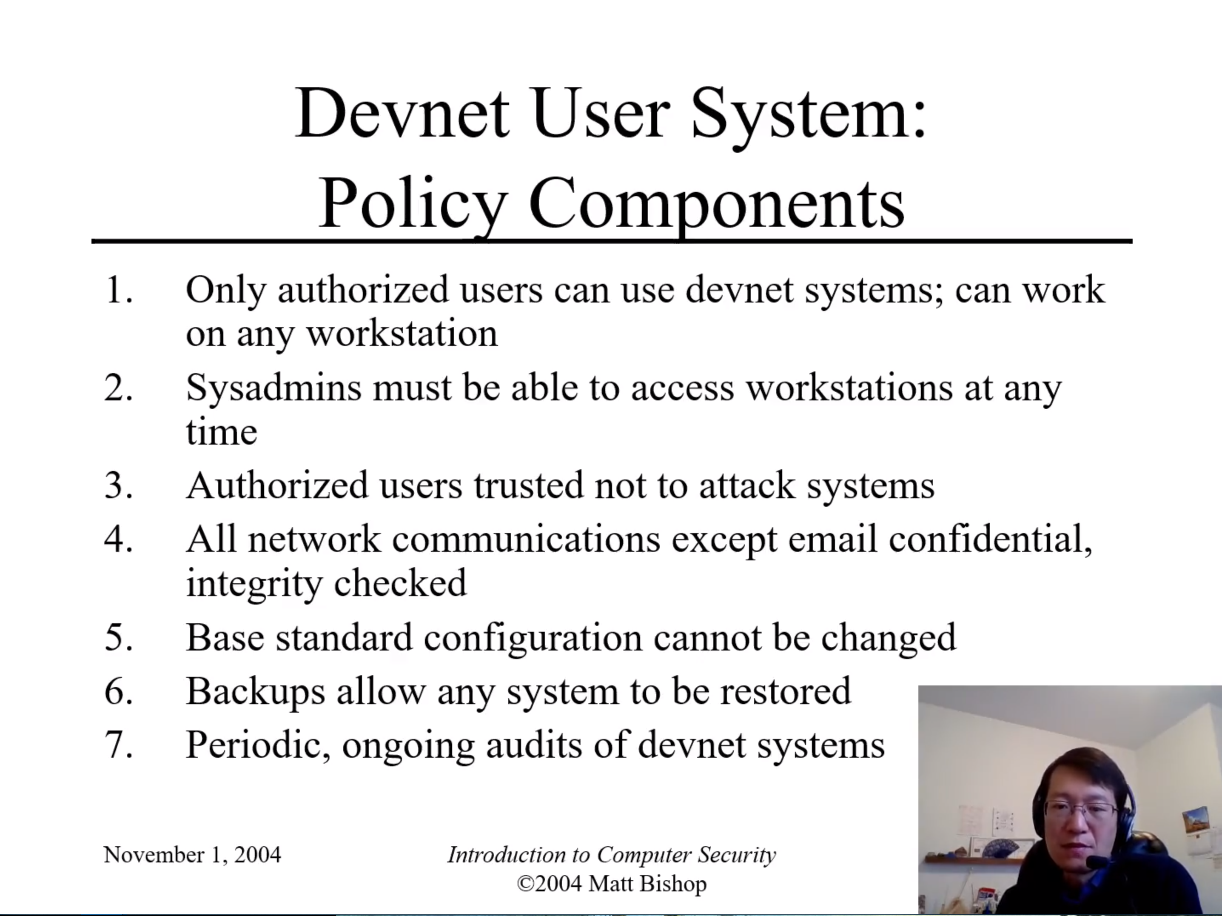

The above ensure a good workflow allowing wide access to both users and admins across many devices, explains some aspects of the trust model, doing regular backups, and periodic ongoing audits.
Firewall enforces network security policy and changes to the network policy must be made here. Devnet doesn’t need to be as tightly secured as there is no direct access between internet and devnet systems. Developers who need such access have designated workstations connected to the WAN that are physically disconnected from devnet. Systems will protect itself by making system software read-only and will require approval to install non-default programs. Permanent files will be stored on a file server and will be mounted remotely. A logging system will hold needed logs for security officers.

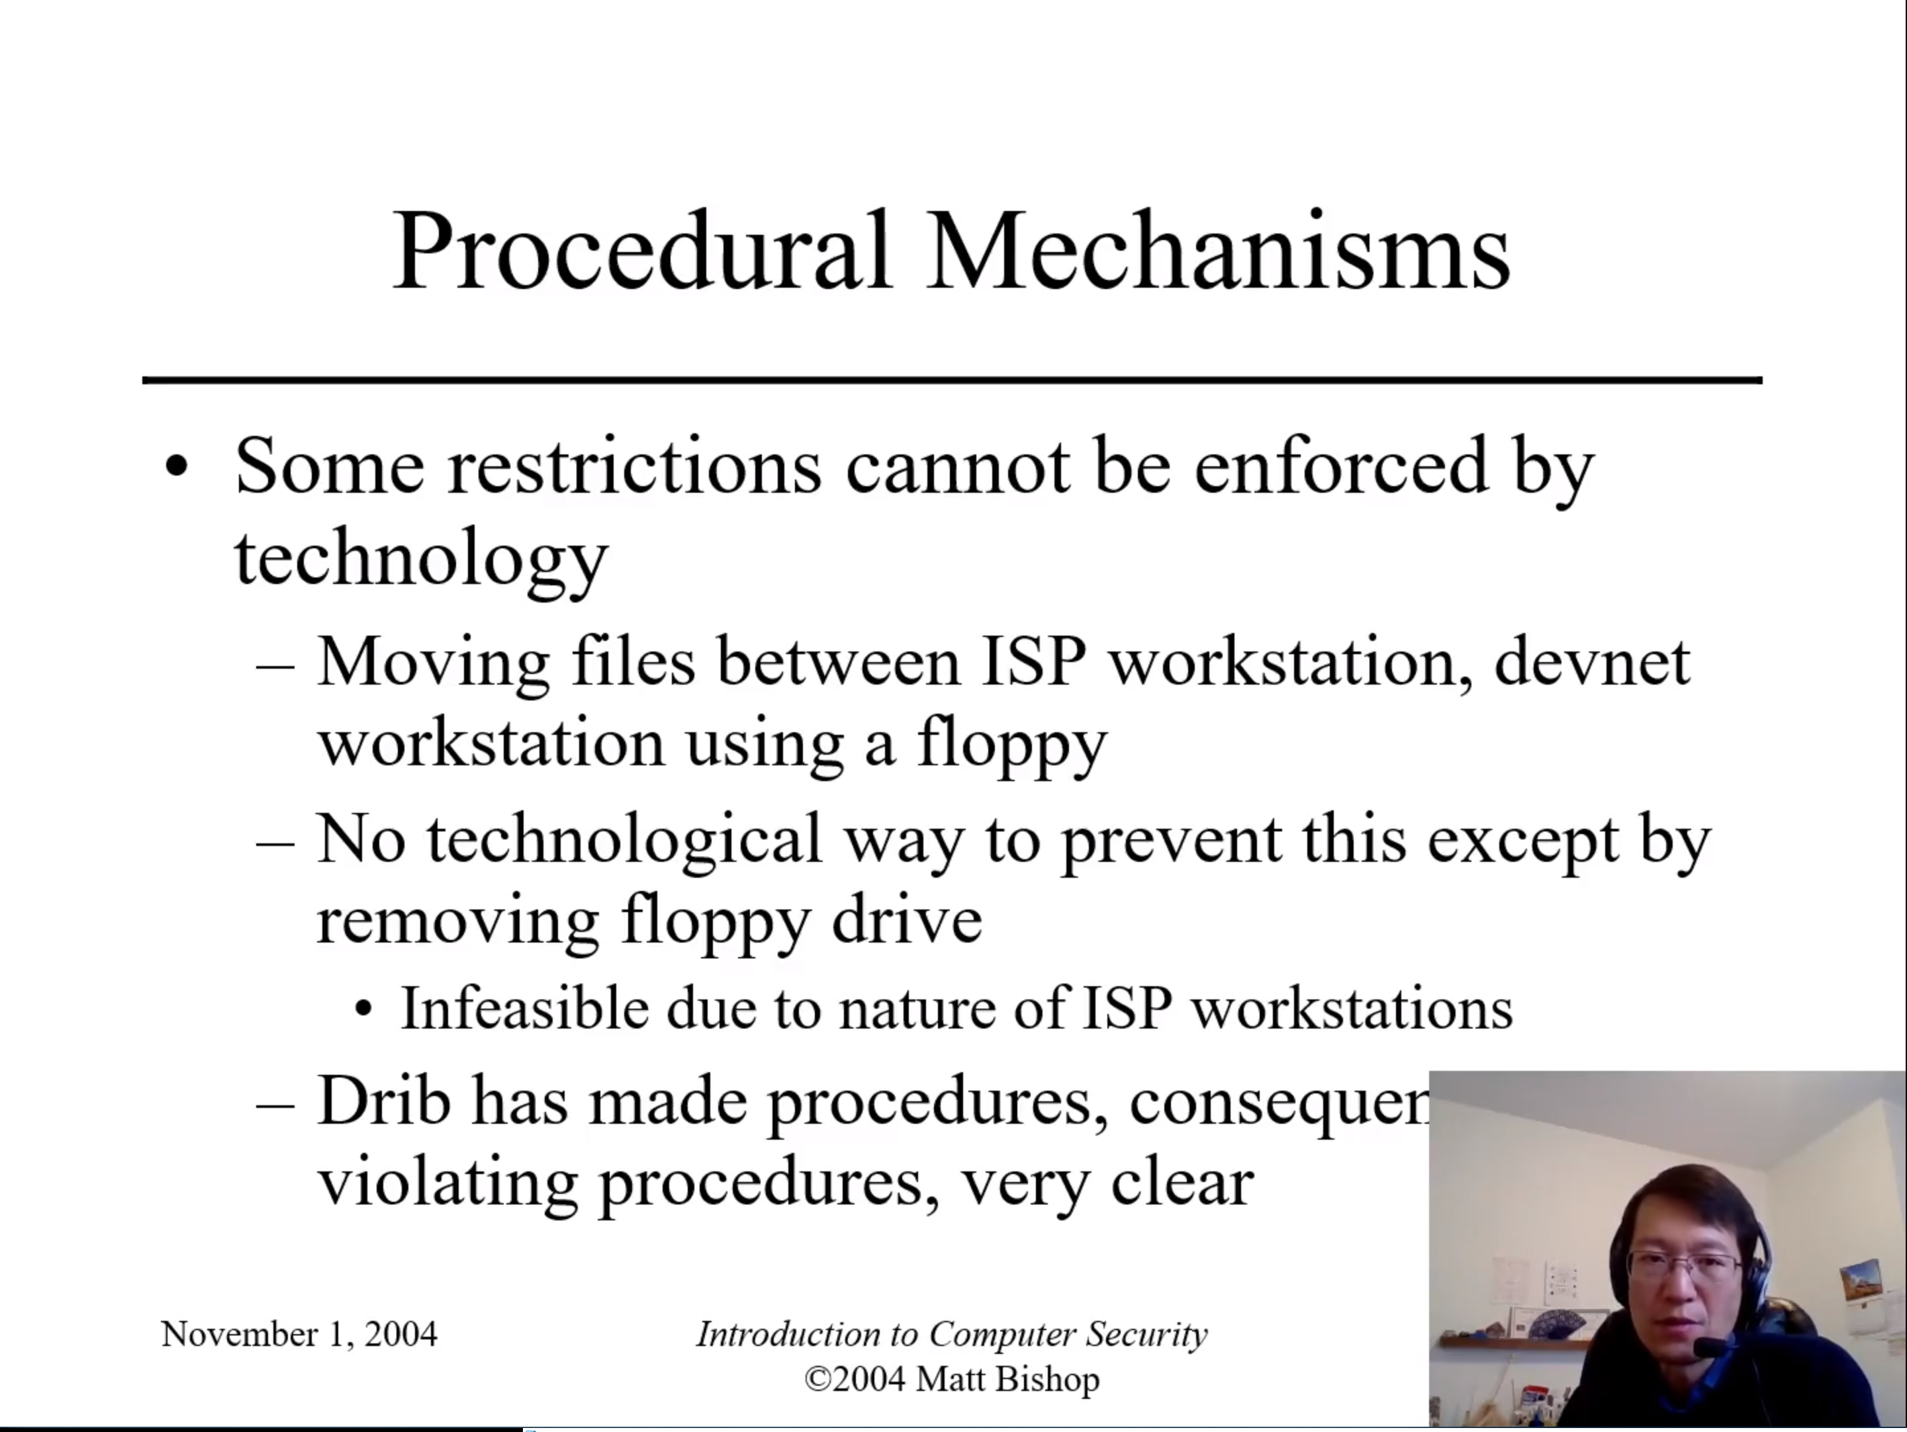
It was about this slide I realized that the power-point being from 2004 might matter. Not only would it be impressive to even find a device that had the option to use a floppy but we can disallow external storage devices if we want. We could go further and have white-listed removable storage if we really wanted it. I could do the same thing for a mouse or keyboard to prevent a keystroke injection attacks from something like a USB Rubber Ducky or a BashBunny. I think this slide is inaccurate and needs removed, replaced, or updated. Something should have been said about how to prevent unwanted external storage devices.

Funny-relevant story time. When I was in elementary school I was assigned to use the server for the entire school during Computer Lab class because they lacked enough for all of us and I was considered skilled enough to not mess it up. Prior to switching schools I brought in a USB with a standalone program called Xcleaner. Xclearner was an anti-malware software that would look for and remove old spyware or malware like ISpy. Since I wasn’t installing the software to the device the policy did not require any additional passwords I did not have to execute the software and I was able to remove Bess (the internet censorship tool). But even in ~2004 I was already using a USB for this even though at that time a floppy was a plausible alternative. Remember Zip drives?

Networks:
Firewalls provide most of the protection for networks but separation of privilege says the systems should too. Configuration file for ssh server can have rules to allow connections only from the trusted admin server, like we did in lab 3 and deny all others. It is using the config file instead of a firewall to accomplish this though.

Scripts can be used to restart servers automatically if they crash. The devnet servers: SMTP, SSH, printer, and logging server all use access control wrappers to restrict connections. These act as a duplicate to the firewall rules. Checking these security policies can be done by pen-testing the system by security officers and comparing logs to expected behavior.

Users are divided into two main categories: users and admins. Users do their work in the given environment and should not be able to alter, create, or circumvent policies. Admins create, manage, and alter the policies as needed to maintain a secure environment.

Some possible problems and solutions:
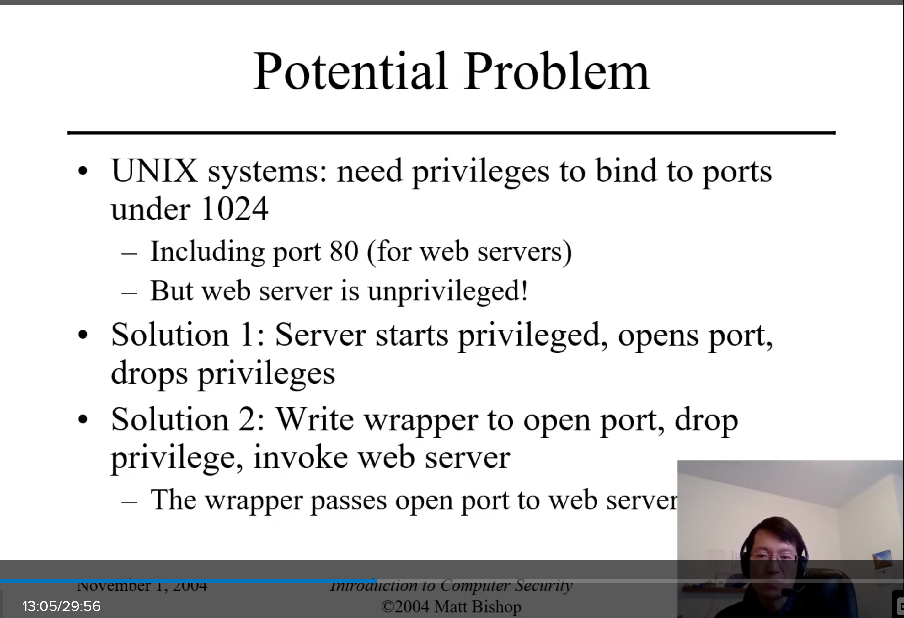

File Access: a web server could change the root directory to /usr/Web, commerce server changes to usr/trans to limit the scope of what an attacker might be able to attack or see. Communication between the two will happen via a shared directory.

Securing files with physical limits is better than access controls because they cannot be corrupted so use physical limits when possible.

Lab 3
Lap 3 covered using iptables to set up various firewall rules. I contributed to the summery, set up firewall iptables rules to disallow INPUT connections by default and then set permissions for what should be allowed. I designed some appropriate corporate rules and listed some useful commands such as blocking by mac address or IP address. SSH services on Nfs are only available in subnet 192.168.10.0 Documented and tested all of the above.

