This week I learned about Program Security, Completed lab 4, and continued working on my final project paper.

Program Security
The goal of program security is to verify a users identify, determine if a change of account is allowed, if so place user in desired role similar to su(1) in Unix. User supplies their password not the targets.

Eliminate password sharing problem by using a root credential. These can be set up to function based on user, location, time of request, settings of role account, and only root can alter access control. Mechanisms provide restricted and unrestricted to role account. Restricted can only run specified commands. Access to files, directories, and objects owned by role account restricted to root.

Threats: unauthorized users accessing role account as though authorized, authorized user uses insecure channel to obtain access to role account revealing authentication credentials, unauthorized user alters access control information to gain access to role account, authorized user executes trojan that gives unauthorized access.

Design: Needs to have a user interface and high-level design. Controlling access to roles and commands needs an interface, internals, and storage of access control data. Want to minimize the amount of information being passed through interface.

Problems: If any untrusted processes can alter the utmp file contents cannot be trusted. Processes may have no associated terminal.

Logging: We want to keep logs with an int user ID, log the date/time, and commands executed/ attempted to be executed.
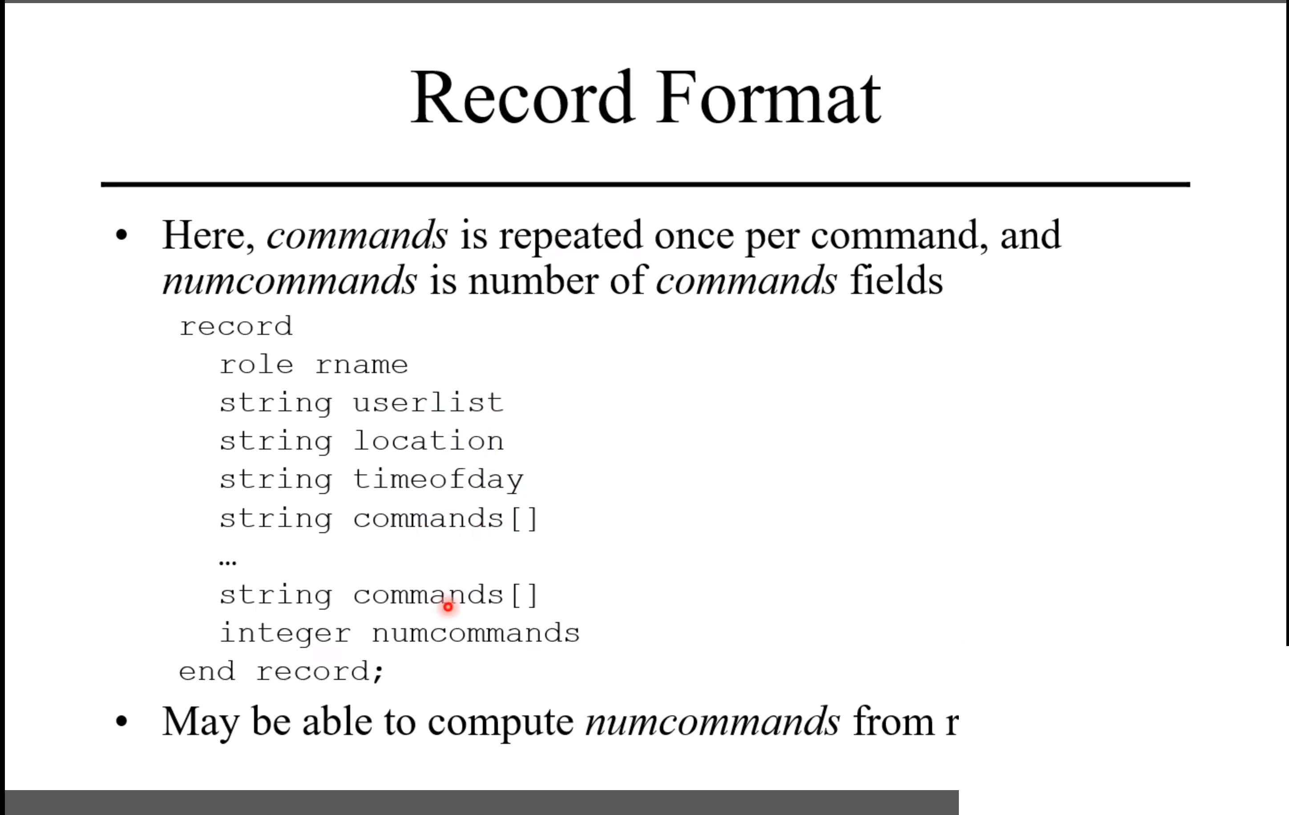

Error handling: Errors cannot be ignored. They need to be logged so admins can see it, it should notify the user or tell the user why there is an error. Ideally there will be some kind of error code the user can take note of and give to IT staff.

Process privileges: Least privilege should always be used where each process has the lowest permissions plausible for the proper functioning of the software. Permissions are given when required and allowed and as soon as it no longer needed permissions are revoked. Structure the process so that all sections requiring extra privileges are modules. The modules should be as small as possible. Every time a program is executed the integrity of the access control file is checked. Only root can alter the control file. The RAM used for these processes must be protected. Configure memory to enforce the principle of least privilege. If a section of memory is not to contain executable instructions, turn execute permission off for that section of memory. If a section is not to be altered make it read only.

Trust model is based on what does the program trust? Identify all system components on which the program depends. Check for errors whenever possible and identify those components for which error checking will not work.

Errors: The error status of every function must be checked. Do not try to recover unless the cause of the error and its effects do not effect any security considerations. The program should restore the state of the system to the state before the error began and then terminate.

Protection Domain: We should use overlays rather than spawning child. Overlays replace original protection domain with that of overlaid program. Permissions are set to that of role. Potential issues are saved UID/GID. Setuid system call is used to block this.

Improper changes we need to pay close attention o include data that changes unexpectedly, memory, file contents, and file/object binding.

Objects must have unique names.

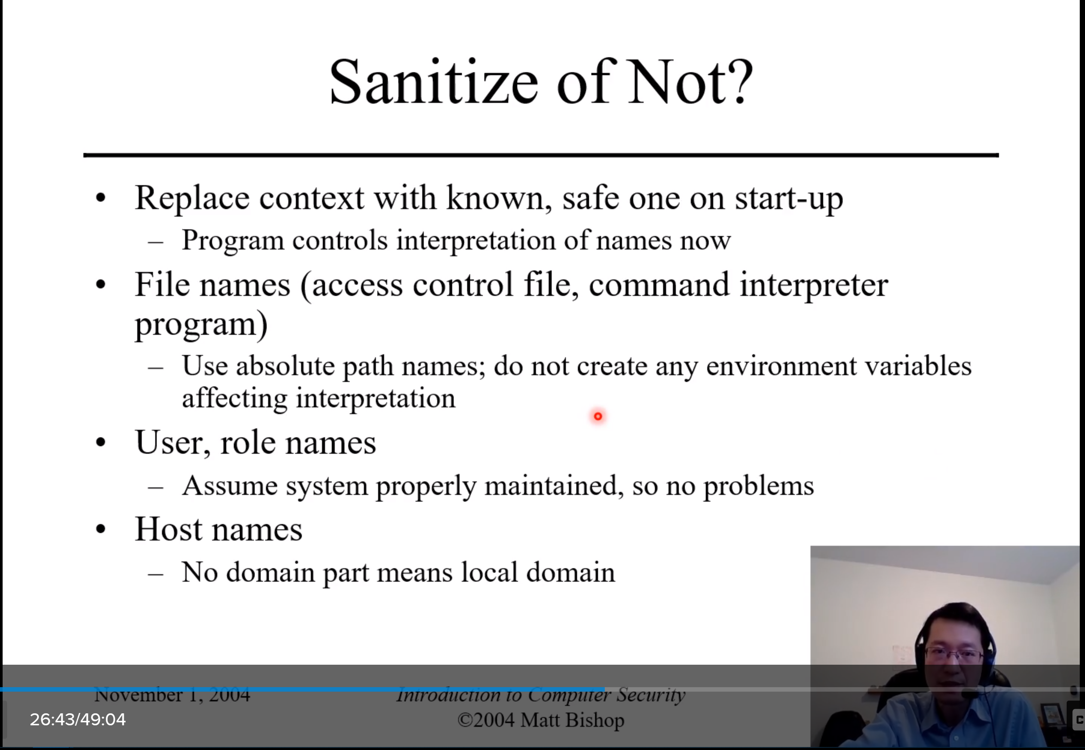
Improper validation: Always check for consistency or correctness. Highlights: Bounds checking, type checking, error checking, checking for valid/ not invalid data, checking input, designing for validation.

When compiling programs ensure that the compiler flags report inconsistencies in types. Investigate all such warnings and either fix the problems or document the warnings. Always check return values of functions for errors. If function fails, and program accepts result as legitimate program may act unexpectedly.

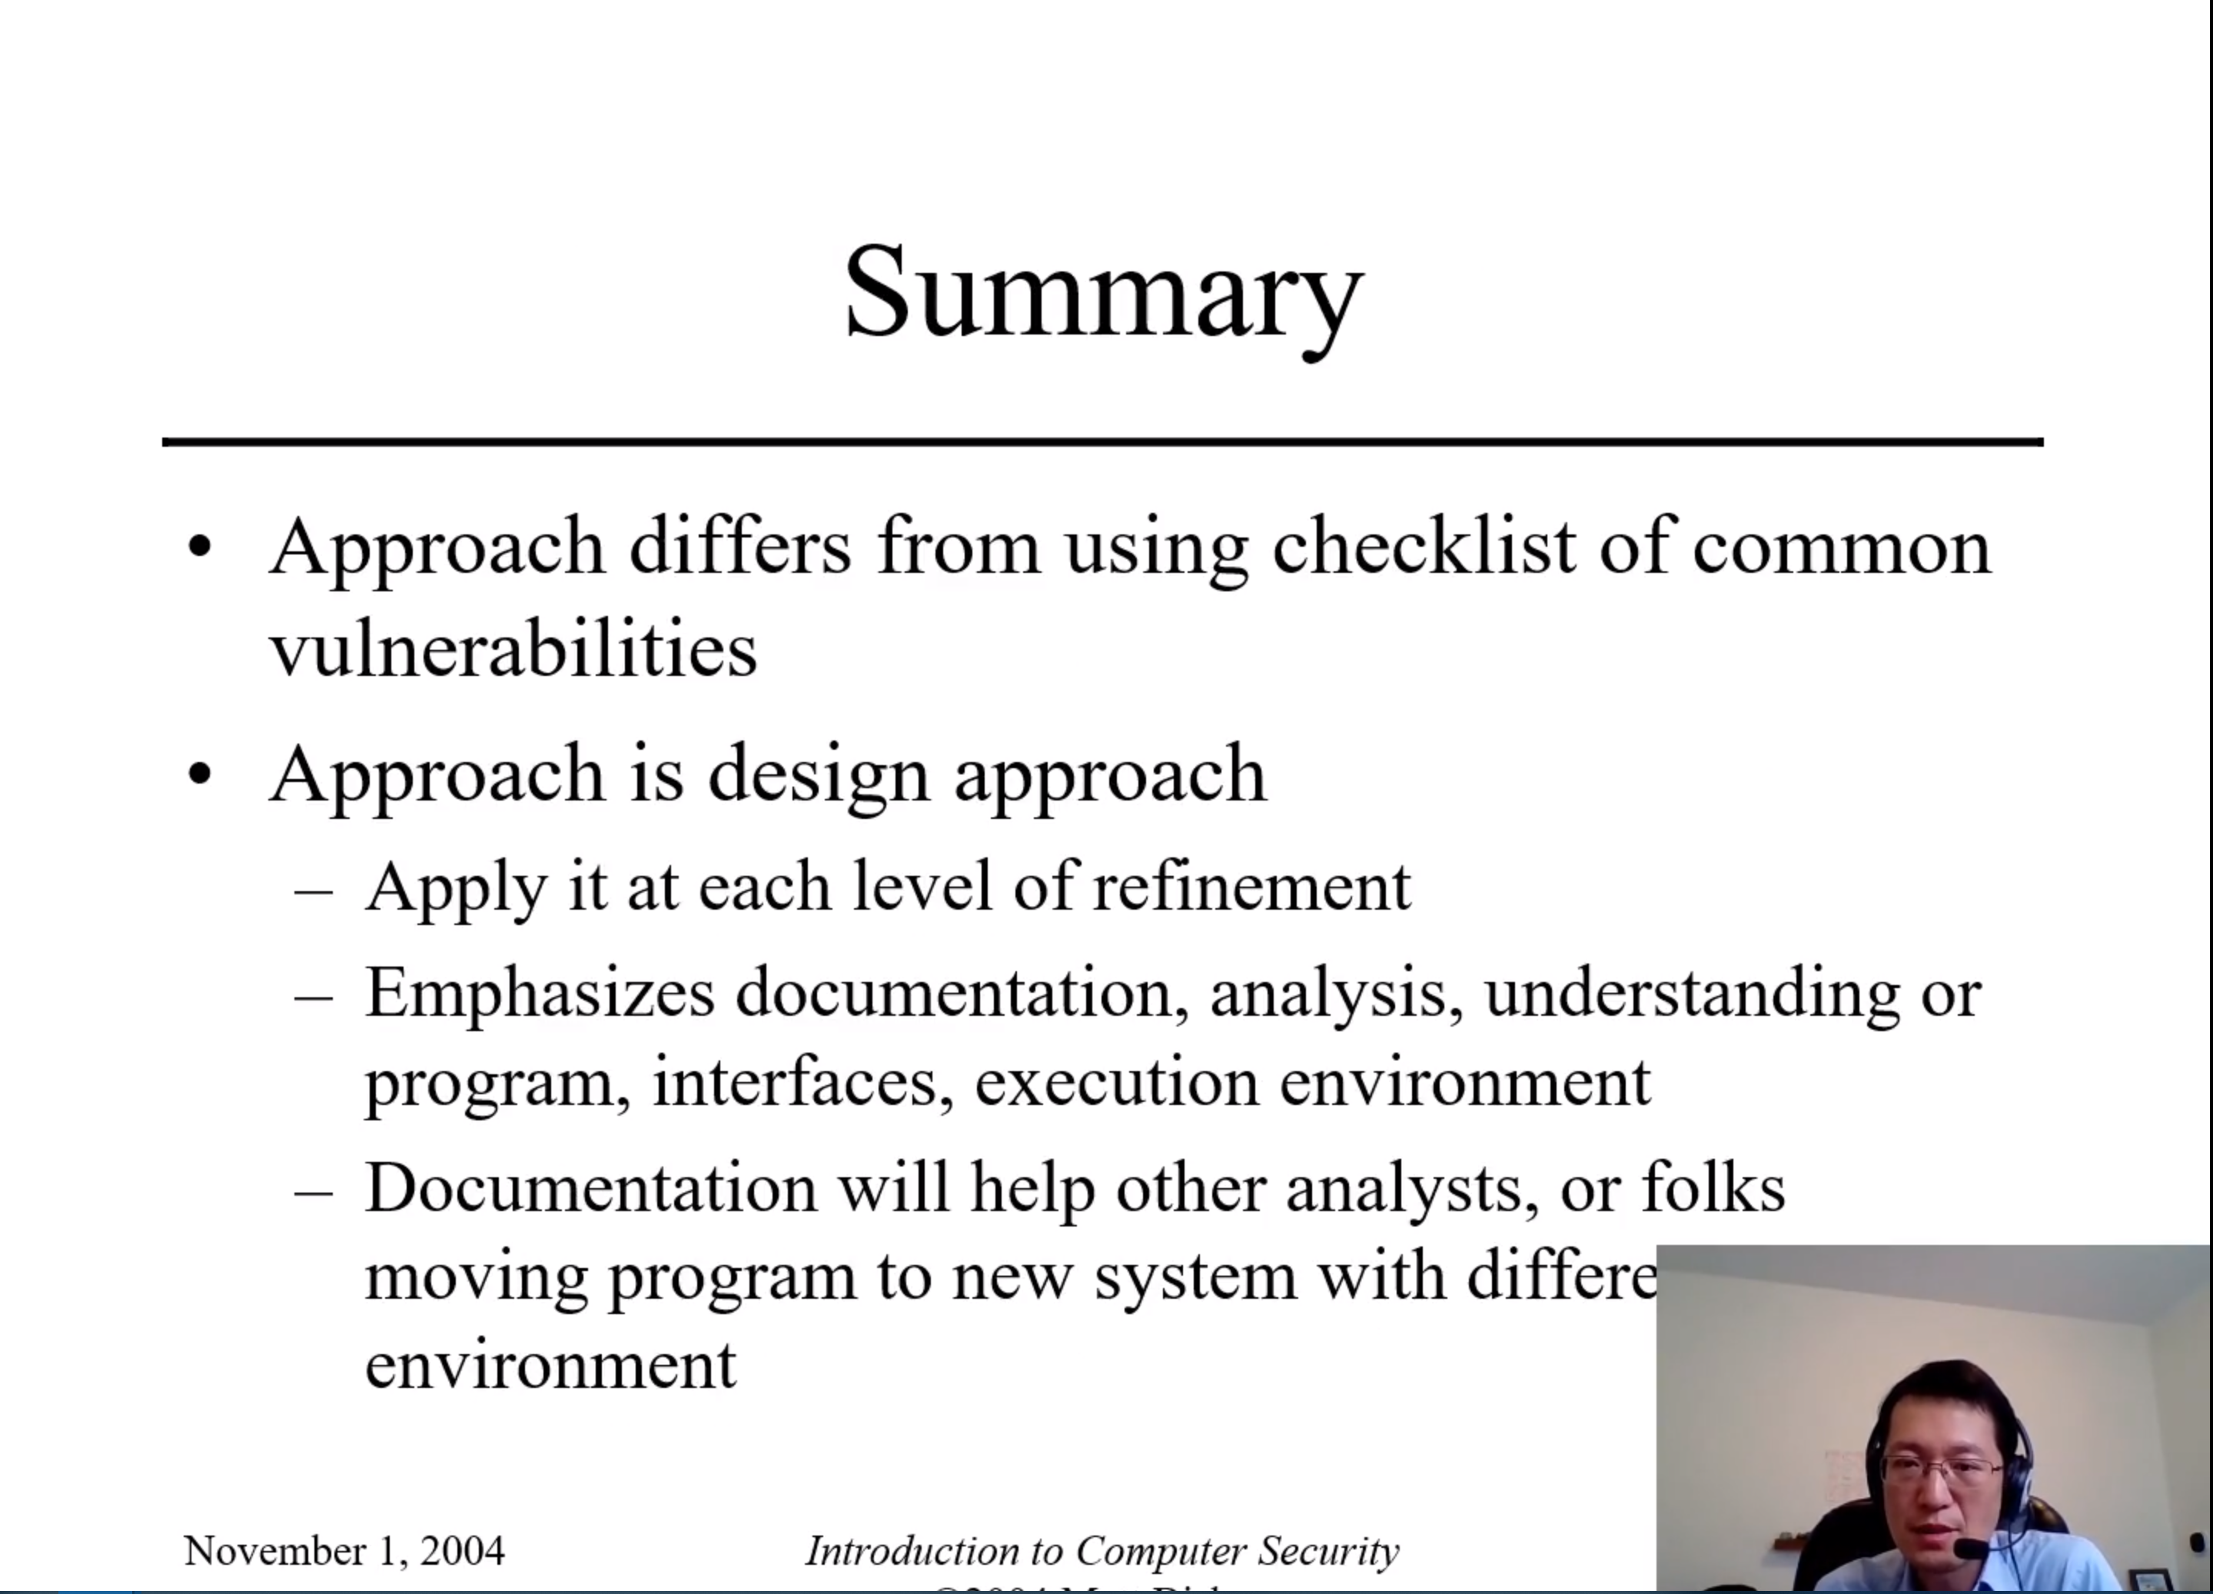

Lab 4
Lab 4 focused on using snort to notify us of specified events like pings, suspected detected nmaps, and attempted ssh connections. These especially nmap and unauthorized ssh connection attempts could indicate an ongoing attack and are important for security personnel to be aware of. I checked and documented the presence of snort and the version, I added some rules, and then nmapped our target machine as my contribution to the group this week.

