Alexander King
CSET 4850-901
Computer and Network Security
1/30/21

2nd Weekly Report
This week I learned about the access control and security policies. Access control dictates who has access to any given object and what kind of access (for example: read, write, execute accesses can be granted to X Y Z users). Access control is not only limited to files but it includes resources, messages sent between processes, or systems as well. The meaning of these rights (read write execute) can depend on the object involved. I learned about different protection states, protection state transitions and the commands for changing access control permissions. The system can only update the matrix by using defined commands and cannot directly use the primitive commands. Transitions change the state of the system.
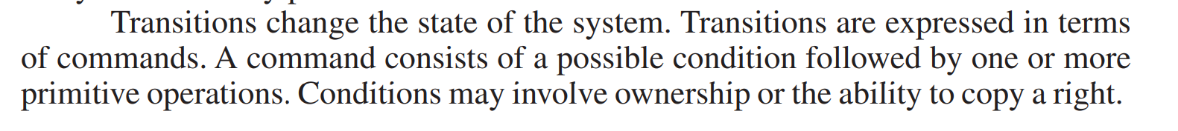Figure 1: (BISHOP, M.Introduction to Computer Security | pg 35)
A security policy is defines what is considered an authorized or unauthorized state. A secure system starts in an authorized state and can not enter an unauthorized state. When a system enters an unauthorized state this is a breach. Confidentiality dictates some information cannot be disclosed to some entities. For example I cannot access some piece of information in blackboard that is confidential to the professor. If I were able to access this information it would constitute a breach and the information would effectively no longer be confidential to the owner. Security policies are put in place in an attempt to preserve integrity. When making security policies we need to consider the role of trust. For example if a user is logged in and leaves their desk unattended and someone plugs in a keystroke injector emulating a keyboard the system will typically trust that this is a valid input coming from the user who is logged in even though it is not. Security policy would presumably have been violated for leaving an unattended device logged in. Additionally the devices could be further secured by attempted to limit the number of and type of human interface devices. For example they could only allow a keyboard to function with a given mac address and this could have prevented a breach even though the user broke policy. This would probably be quite rare as it creates several inconveniences. It is easier and generally considered effective enough to simply tell users to lock their devices when unattended. The book gives an example of we generally trust that a new security patch will be better than a previous one. We generally have no evidence of this being the case at the time of the update and may not find out about bugs until a later security patch that we also trust to be better.

