Alexander King
CSET 4850:901
Computer and Network Security
February 5th 2021

Weekly Report 3

This week I learned about confidentiality and integrity policies. Confidentiality policies are there to protect objects so they can only be accessed by the intended audiences. Integrity policies try to ensure only approved software is used.

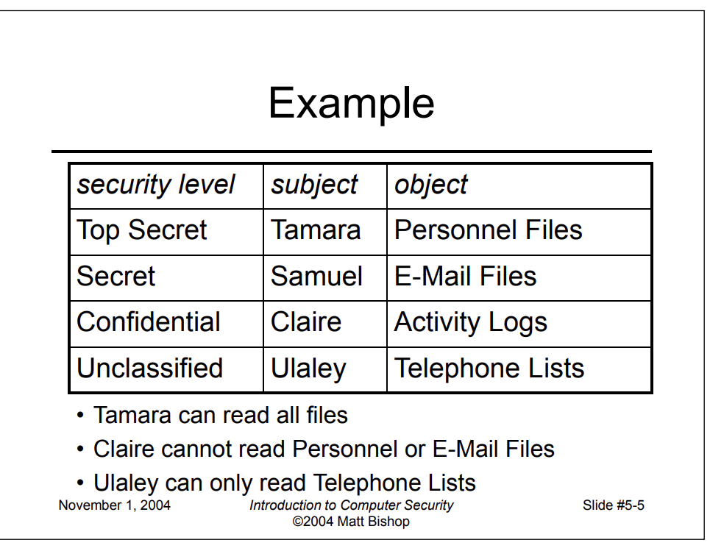
The goal of confidentiality policies are to ensure data is only accessible to an intended group and no one else. The Bell-LaPadula model creates a linear hierarchy where you can access everything at your designated level and below.
This kind of system is intended to limit access to strategic information and an attempt to try to contain it to need-to-know. This way company or military secrets will not leak and become accessible to rivals. Limiting the number of people with access will make the job of detecting breaches and finding the source of such breaches far more possible. Looking at the slide above if I have something that has been leaked at the Secret level I know I need to look into Samuel and Tamara and their devices. If everything is working as intended I should therefore not need to look into Claire or Ulaley as they should not be able to access this level.

Integrity policies prevent users from making or acquiring their own programs and instead they will have a white list of approved software they can use. New programs will be developed and tested in their own isolated environment. Any data they need access to from the production servers will have a special process to gain access for their development. After development when the new software is ready to be deployed there will be another special process for deployment that requires auditing. The main goal of this is to prevent untrusted software from accessing or altering other objects. For example if I allow users to have a program like VLC or Ccleaner I need to be able to trust the integrity of these programs to not be able to be exploited. I picked these two examples because I recall specifically from both of them times when they had issues that could affect the integrity of a system by widening the attack vectors. Integrity policies are a trust model so it can be difficult to consider everything. Biba will compartmentalize everything into levels of trust while the Clark-Wilson model has specific requirements that must be met.

